**LAB NO:06**

**OBJECTIVE:**To become familiar with RMI IIOP.

**LAB TASK:** Create RMI IIOP application in which take SENTENCE at runtime on the client application and let the server return its reverse.  
E.g. input could be: subject is distributed computing   
output should be: computing distributed is subject.

SERVER:

REMOTE INTERFACE:

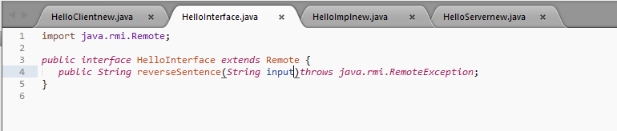

REMOTE OBJECT CLASS:

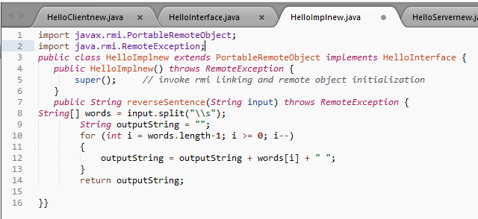

SERVER MAIN CLASS:

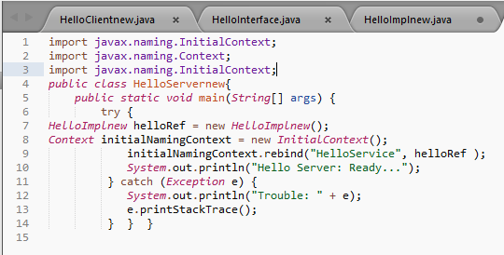

CLIENT:



CLIENT MAIN CLASS:

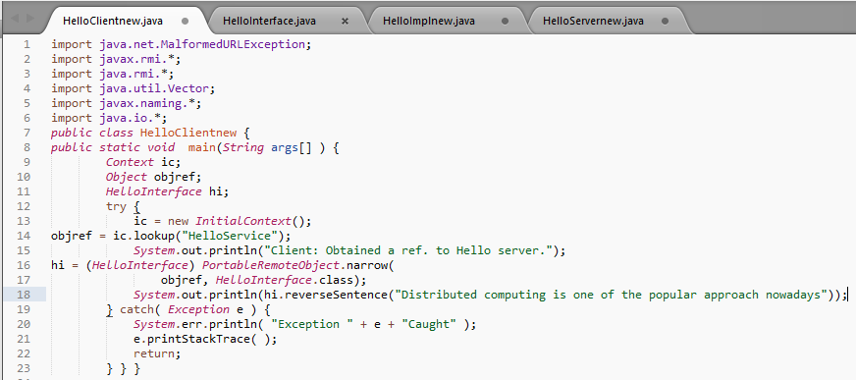

OUTPUT:

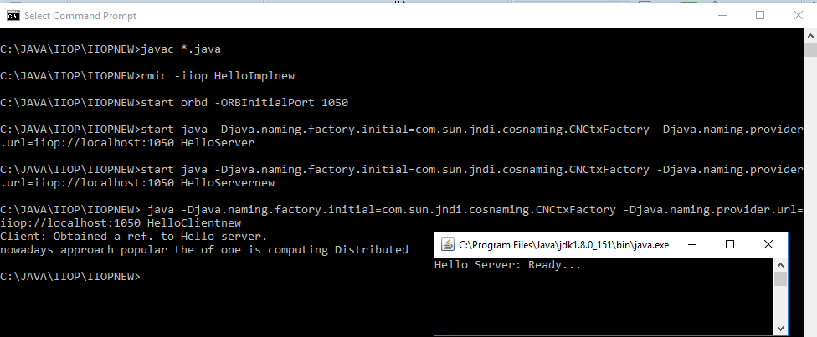

**CLASS TASK:** Create RMI IIOP application in which take words at runtime on the client application and let the server return its reverse.

SERVER:

REMOTE INTERFACE:

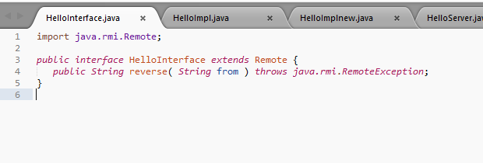

REMOTE OBJECT CLASS:

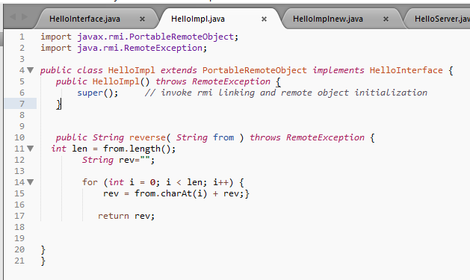

SERVER MAIN CLASS:

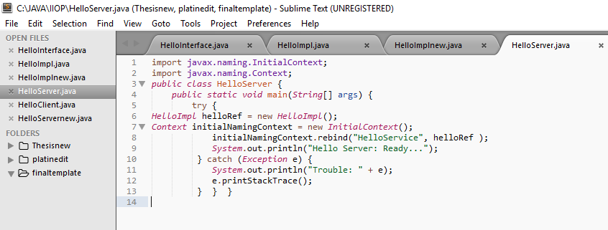

CLIENT: 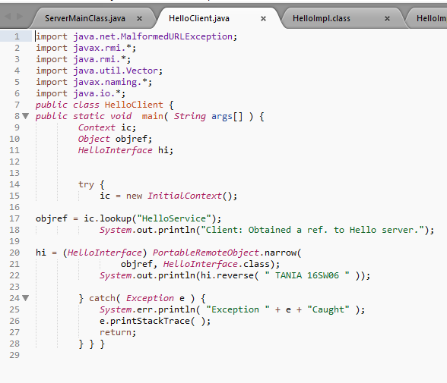

OUTPUT:SERVER STARTED

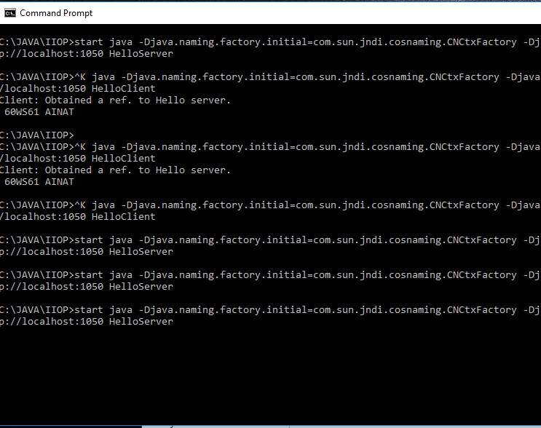

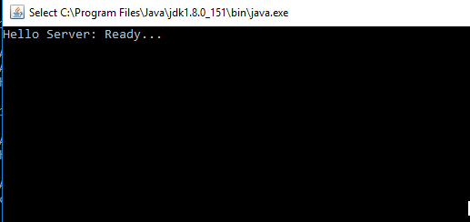

CLIENT:ON DIFFERENT PC

