**LAB NO:08**

**OBJECTIVE:** To learn XML schema and parsing an XML

document.

Create an XML document structuring information for a

store. (shopping store of your choice)

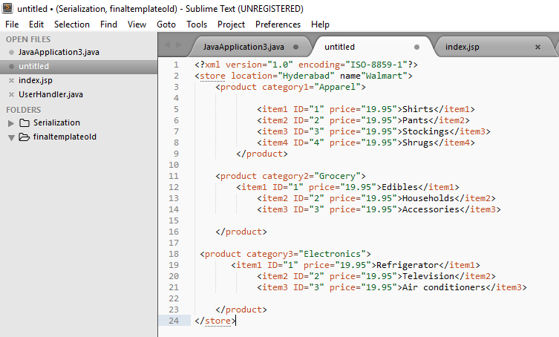

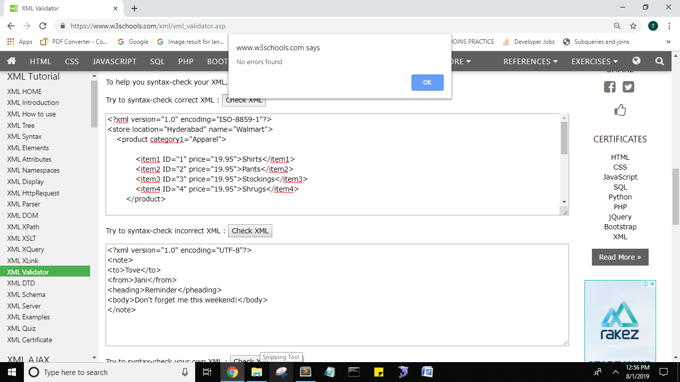

Create DTD for store XML Document. And validate on

**DTD:**

<!DOCTYPE store [

<!ELEMENT store (product)>

<!ATTLIST store name CDATA #REQUIRED>

<!ELEMENT product (item1,item2,item3)>

<!ATTLIST product category CDATA #REQUIRED>

<!ELEMENT item1 (#PCDATA)>

<!ATTLIST ID price CDATA #REQUIRED>

<!ELEMENT item2 (#PCDATA)>

<!ATTLIST ID price CDATA #REQUIRED>

<!ELEMENT item3 (#PCDATA)>

<!ATTLIST ID price CDATA #REQUIRED>

]>

Write XML Schema for the following XML document and

then validate the XML document along with its schema on

the following website:

<?xml version=“1.0” ?>

<movies>

<movie genre=“crime">

<title lang="en">The Godfather</title>

<year>1972</year>

<rating>9.2</rating>

</movie>

<movie genre=“horror">

<title lang="en">The conjuring</title>

<year>2013</year>

<rating>7.5</rating>

</movie>

<movie genre=“adventure">

<title lang="en">Everest</title>

<year>2015</year>

<rating>7.4</rating>

</movie>

</movies>

**XML SCHEMA:**

<?xmlversion="1.0"encoding="utf8">

<xmlns:xs="http://www.w3.org/2001/XMLSchema">

<xs:element name="movies">

<xs:complexType>

<xs:sequence>

<xs:element name="movie">

<xs:complexType>

<xs:sequence>

<xs:element name="title">

<xs:complexType>

<xs:simpleContent>

<xs:extension base="xs:string">

<xs:attribute name="lang" type="xs:string" use="required" />

</xs:extension>

</xs:simpleContent>

</xs:complexType>

</xs:element>

<xs:element name="year" type="xs:unsignedShort" />

<xs:element name="rating" type="xs:decimal" />

</xs:sequence>

<xs:attribute name="genre" type="xs:string" use="required" />

</xs:complexType>

</xs:element>

</xs:sequence>

</xs:complexType>

</xs:element>

</xs:schema>

4. Write an XML instance for following schema and then

parse that document in Java using either DOM or SAX API.

<?xml version=“1.0” ?>

<xs:schema xmlns:xs=“http://www.w3.org/2001/XMLSchema”>

<xs:element name="person“ type="persontype"/>

<xs:complexType name="persontype">

<xs:sequence>

<xs:element name="firstname“ type="xs:string"/>

<xs:element name="lastname" type="xs:string"/>

<xs:element name=“date_of_birth” type=“date”/>

</xs:sequence>

</xs:complexType>

<xs:complexType name=“date”>

<xs:sequence>

<xs:element name=“day” type=“xs:integer”/>

<xs:element name=“month” type=“xs:integer”/>

<xs:element name=“year” type=“xs:integer”/>

</xs:sequence>

</xs:complexType>

</xs:schema>

<http://www.utilities-online.info/xsdvalidation/#.UlFx2tKmhIg>

**Tania16SW06.txt**

XML:

**<?xml version="1.0" encoding="utf-8"?>**

**<person>**

**<firstname>TANIA</firstname>**

**<lastname>KHAN</lastname>**

**<date_of_birth>**

**<day>23RD</day>**

**<month>JANUARY</month>**

**<year>1997</year>**

**</date_of_birth>**

**</person>**

**MAIN CLASS:**

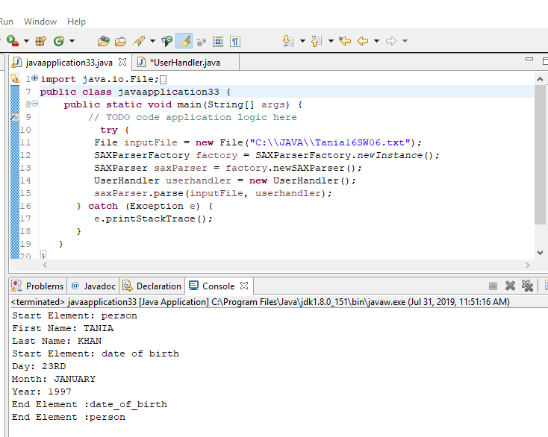

**USER HANDLER CLASS:**

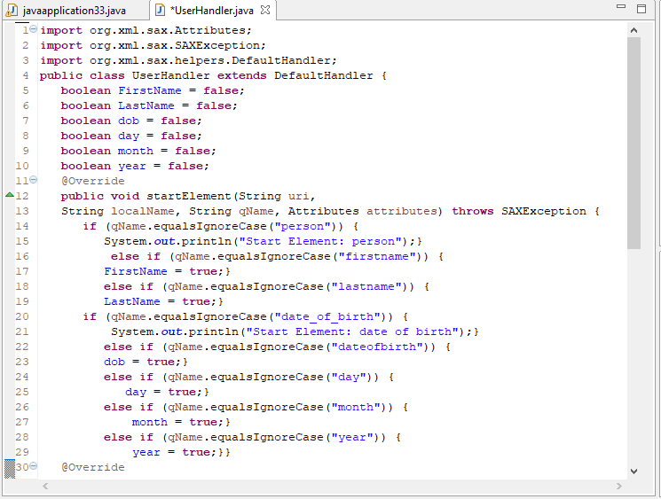

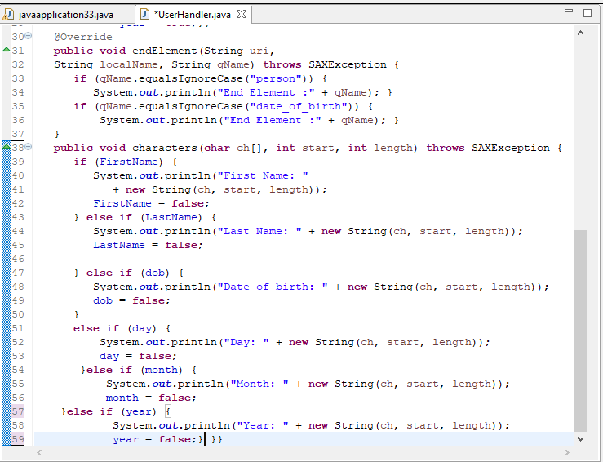

**OUTPUT:**

