**LAB NO:10**

**OBJECTIVE:**To implemet preserving user state in distributed applications

**TASK:**Create a simple login logout and profile page and use cookie to preserve user state but use MVC architecture.

Index.html

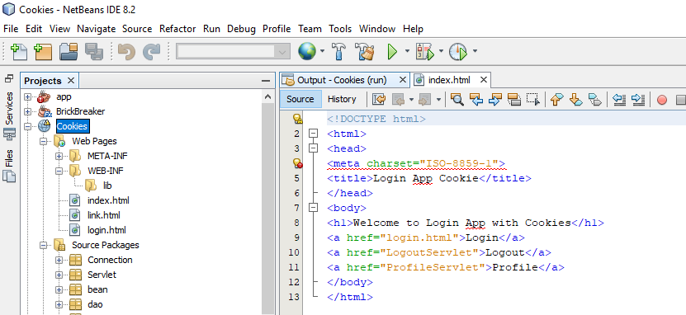

Link.html

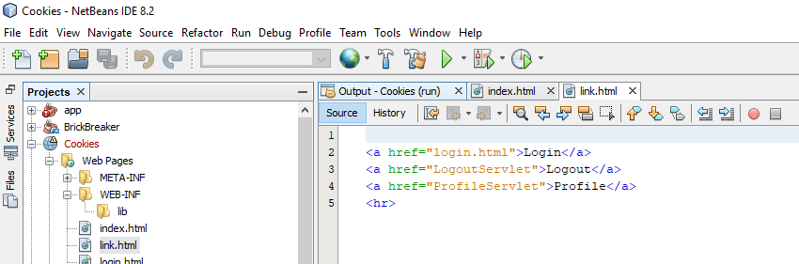

Login.html

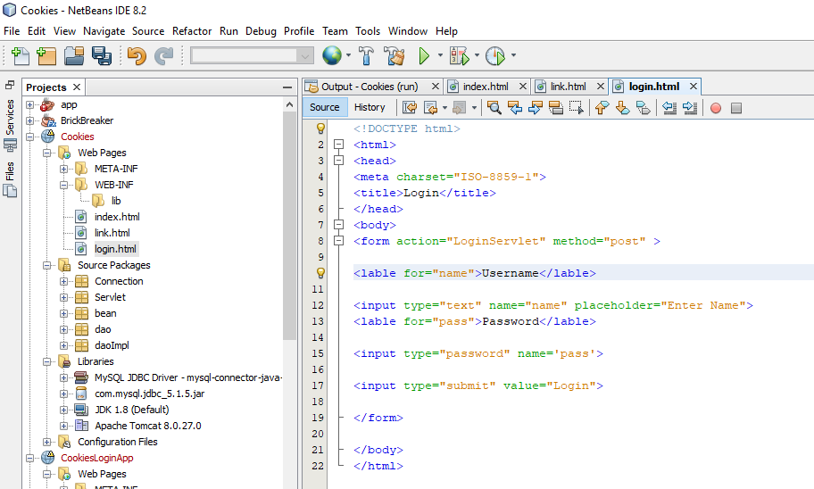

Package:Connection

DBConnection.java

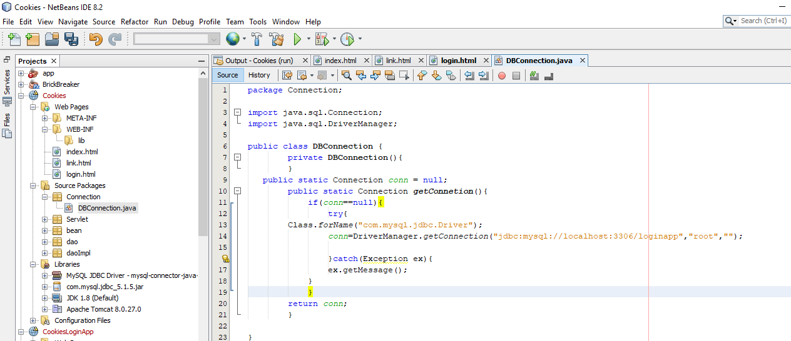

Package:Servlet

LoginServlet.java

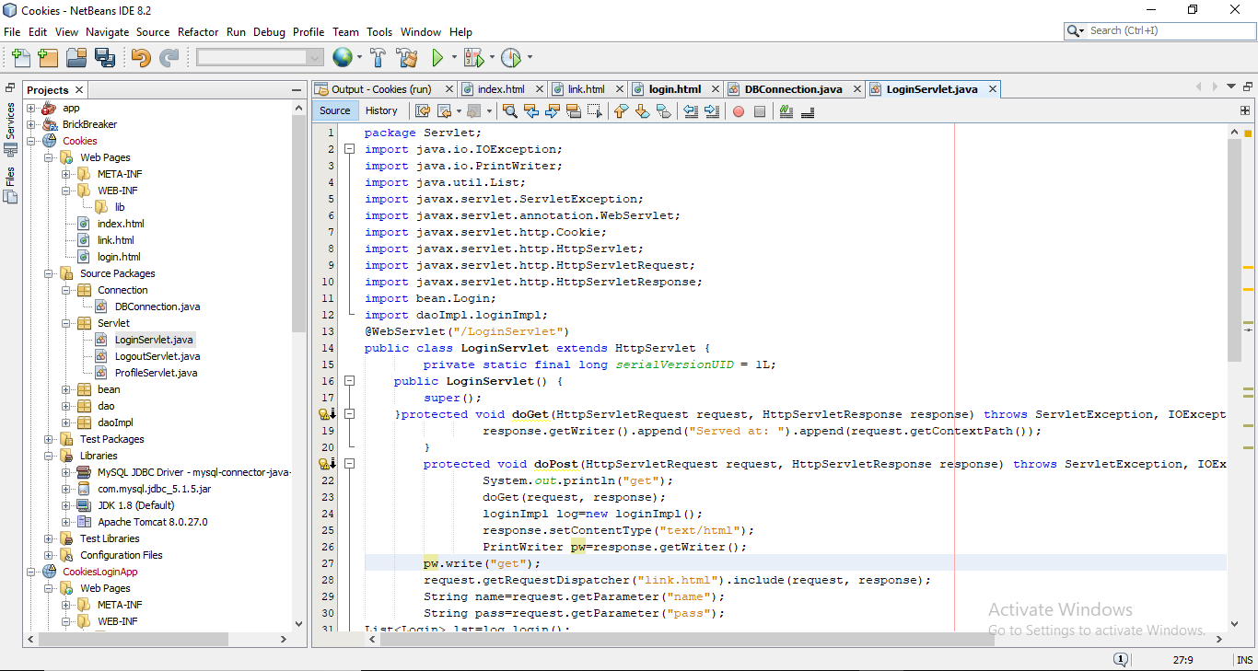

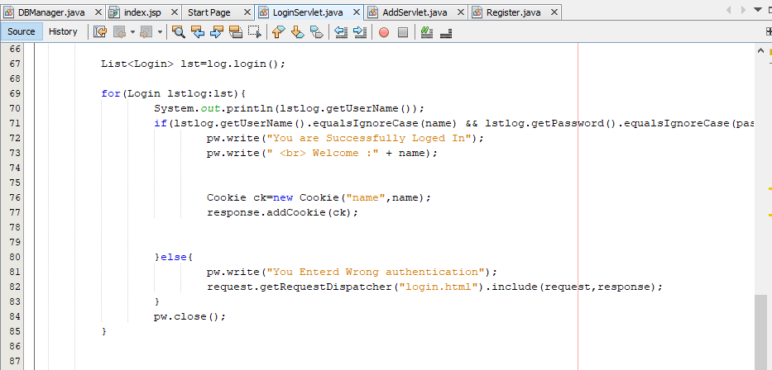

Package:Servlet

LogoutServlet.java

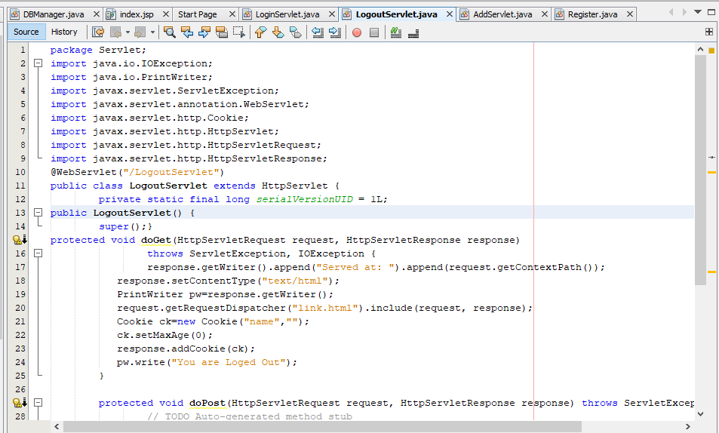

Package:Servlet

ProfileServlet.java

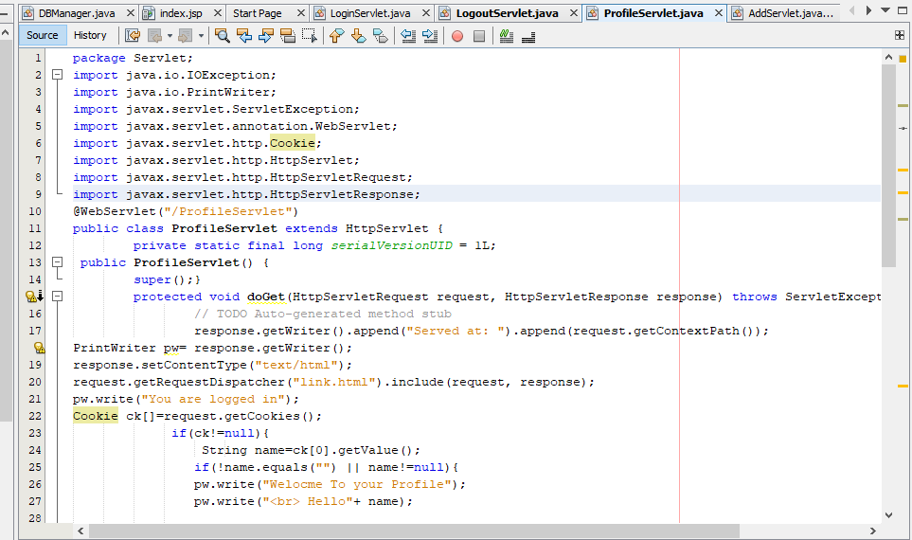

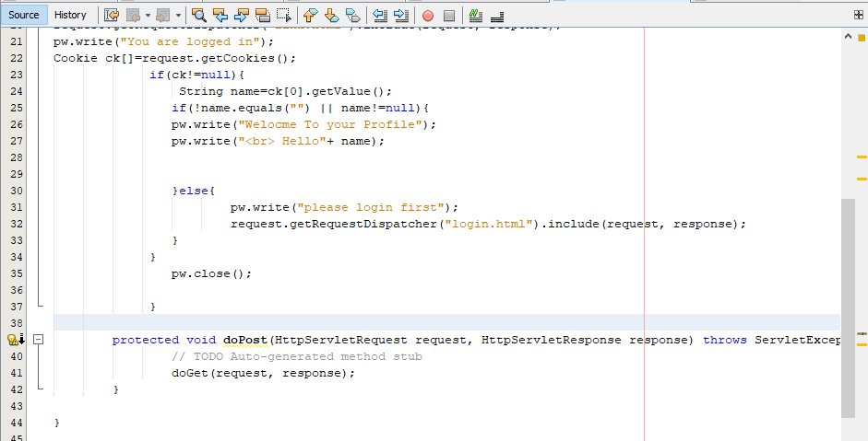

Package:Bean

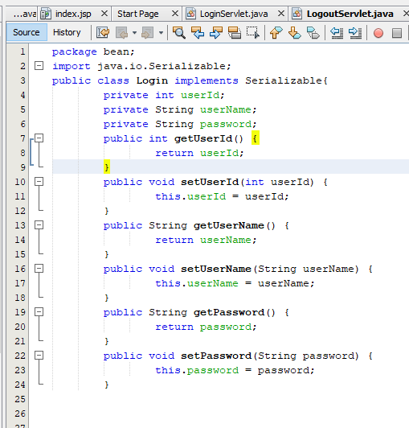

Package:dao

Login.java

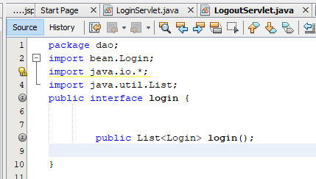

Package:daoImpl

LoginImpl.java

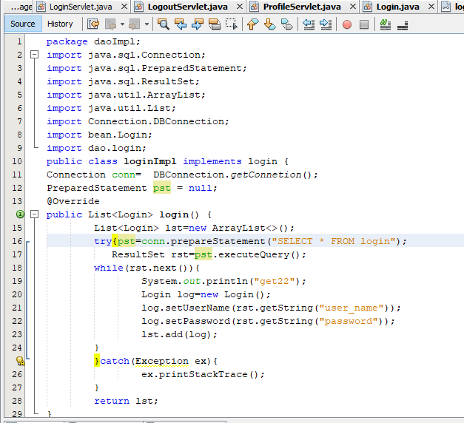

OUTPUT:

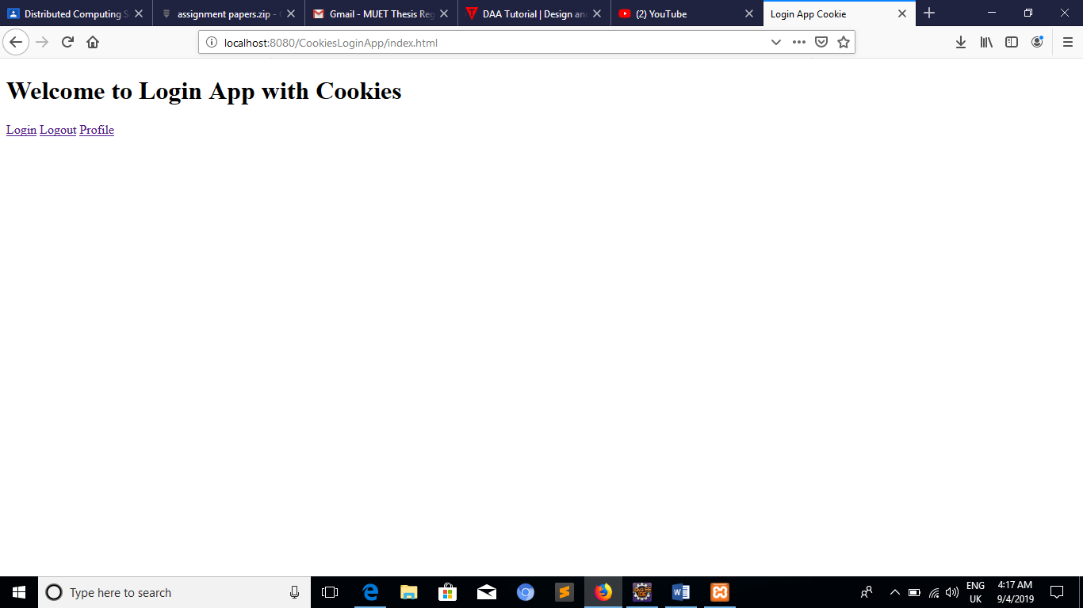

Login Profile page

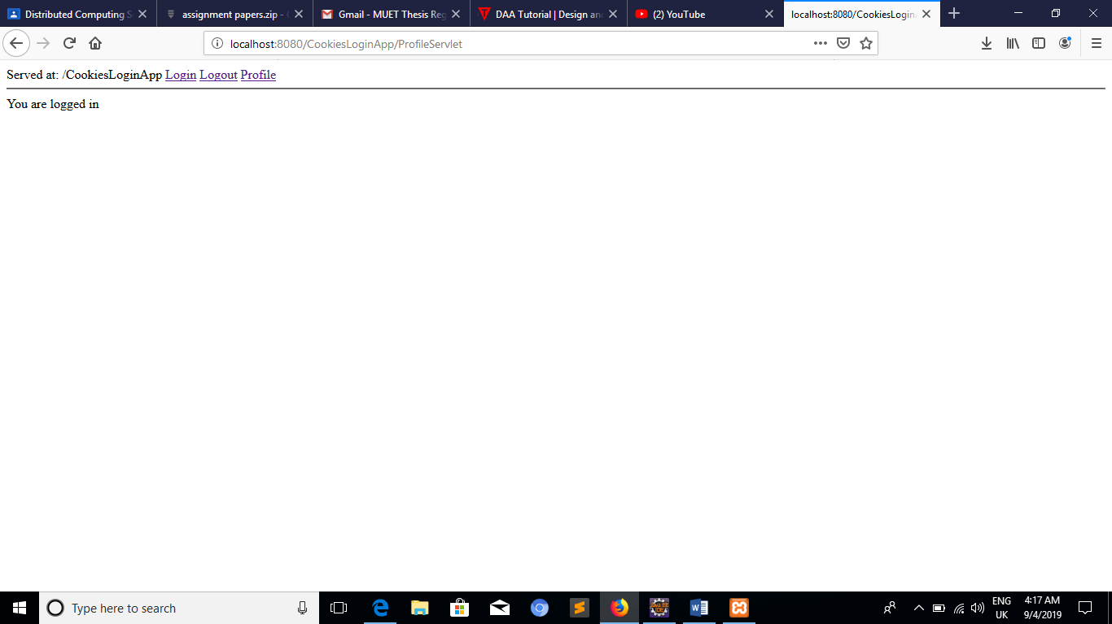

Logout page

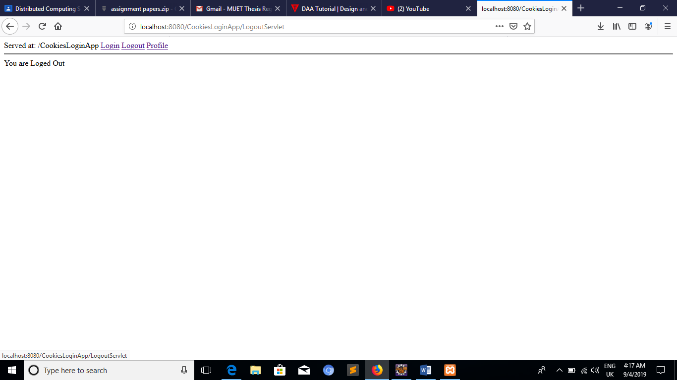

Table that check the username and password

