**Tania**

**Questionnaire**

**1. What was the App that your group created?**

**Answer:** The name of the application we created is "Book Manager Android App”.

# Agile / Scrum

1. **What did you learn about how the Agile and Scrum methodologies operate? Answer:**

Requirements are always creeping in Agile Methodology; it changes time to time and Programmer needs to make iterations as per client's requests.

On the other hand, Planning is done before starting a project in Scrum Methodology. All pre decided functionalities are divided into sprints. And each sprint holds one functionality of different parts of project. Sprints were made in team meetings and a backlog is created on which needs to be followed by group members.

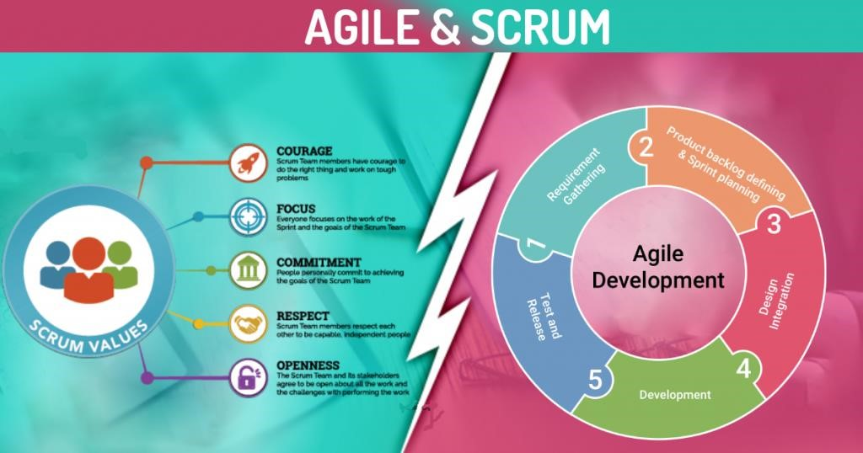

1. **In practice how effective did you find this methodology?**

**Answer:**

Both the methodologies have their own value depending on the requirements of the user. If the user is uncertain about what he exactly needs, in such case the agile methodology must be used but if all the criteria is crystal clear then scrum methodology would me a bonus

1. **What did you find was the strength of it?**

**Answer:**

In our group project Agile approach is more *versatile* as it includes all the essential components of a user-friendly application, *transparent* as the user have more control over different modules, *efficient* as it can work on standard hardware requirements and has more emphasis on *stakeholder satisfaction* and *responsiveness*.

1. **What were its weaknesses?**

**Answer:**

The drawbacks we noticed during this group project are:

* + 1. The criteria of agile methodology do not always flow towards the developer finitely.
    2. Documentation is minimal as there is lack in sufficient planning.
    3. The findings are mostly fragmented in this approach.

1. **What were the best features of the process?**

**Answer:**

The features of agile methodology which benefits our group app are:

* + Flexibility because of agility of the methodology.
  + Transparency as user has more control over the app.
  + Productivity of the agile methodology as app allows user to do customisation.

|  |  |  |  |
| --- | --- | --- | --- |
| Pros  +  +  +  +  +  + | Better time-to-market Increased profit and bigger market share  Reduced costs for bug fixing  Improved software quality  Increases employees  'productivity & satisfaction  Customer satisfaction | Cons  −  −  −  − | Vague hierarchy and blurred organisational structure  Incapability to perform regression testing Inflexibility to changing requirements  Poor communication within a team |
|  | | − | Inability to estimate the lead time |

1. **How did they appeal to you?**

**Answer:**

These features make us more comfortable with our client, as it allows the user to engage every stage of the app's growth process, which adds to the satisfaction of the client.

1. **What was the worst feature of the process?**

**Answer:**

The worst feature we found during the app building process is the constant creeping requirements from the client side. As new requirements and changes are making developing process more challenging.

1. **How would you change them?**

**Answer:**

According to our experience things must be sort out between the developer and the client which reduce the continuous creeping of the requirements?

# Group work

1. **What did you enjoy about this style of programming?**

**Answer:**

We really enjoyed working in agile methodology as our main style of programming, this allows to develop a unique relation between client and developer, as clients can request for modification in almost any stage of the development process, which ultimately improves the quality of the app with more productivity.

1. **What are the downsides for you of group work?**

**Answer:**

During the development of the application, new requirements or modifications came time to time, which was challenging for the project leader to equally assign tasks among the team.

1. **How did this session change your opinion of working in industry?**

**Answer:**

This whole group development session gave us the valuable experience of working in a practical setting, which things are not certain and how small tasks creates a deadlock for the next phases, as their output is the input of the next stage, thus team co-ordination is must throughout the whole process. This also reflects to maintain the interest of the client in the business.

# Source Control

1. **What form of Source Control did you use?**

**Answer:**

We used GitHub as the main source control of our application.

1. **What were its strengths?**

**Answer:**

The strengths for using GitHub are stated as follows:

* + It makes easy to contribute to the open-source project.
  + Work can be show cased using GitHub.
  + Changes can be easily tracked.
  + We have integration different options with other platforms on GitHub.

1. **What were its weaknesses?**

**Answer:**

The only weakness of using the GitHub source control platform relies on their security and pricing.

1. **How effective as a source control did you find it?**

**Answer:**

This source control has proven extremely effective because it can be easily incorporated with any cloud and effectively managed app versions.

1. **If you had to use it again what would you change?**

**Answer:**

Security requirement needs to be improved.

# Other

1. **Do you feel that this has been a worthwhile experiment?**

**Answer:**

In one word Yes. The entire process of development of software, working in a team, using flexibility of Agile methodology, following grantt chart for the completion of different tasks and their integration were worthwhile.

1. **Why? Why not?**

**Answer:**

We found it worthwhile experiment as it let us gain the practical experience of the Agile software development life cycle.

1. **If you had to give yourself a percent grade for your contribution to the project, and the process, what would it be? Bearing in mind that you might have produced little, yet done the hard yards. Or you made heaps, but it was really easy.**

**Answer:**

After analysing whole developing process, and the time and hard work done. We would like to give us an A**. We deserve it.**