**Car Listing Management System**

**Tania**

Contents

Client Details ………………………………………………………………………………….1

Project Proposal 2

Goals and Purposes 2

Scope of Project 3

Deliverables Concept 3

Specifications of Projects 3

Target Audience 3

Tasks for the project and Achievements 3

Requirements for Resource 4

Risks to Project 4

Detail Design 6

Home Page 6

Customer Page 7

Staff Page 7

Cars Page 8

Register Page 9

Login Page 10

Testing Project 10

Checking for Device Usability 10

Task 1

# **Client Details**

|  |  |
| --- | --- |
| Full Name | Kamal Preet Singh |
| Address | 34 Penrose, Aucland,3490 |
| Phone | +64220634384 |
| Email | Kamalpreet234@gmail.com |
| Project | Car listing Management System |

Task 2

# Project Proposal

## Goals and Purposes

The aim of this project is aware to customers to see different types of cars and see the prices of the cars. There is a regular user in this program. Any car information can be inserted, modified and deleted by the user.

## Scope of Project

Selling Cars is the scope of this project. And to demonstrate the available vehicles. New users can sign up for the program and can purchase vehicles.

## Deliverables Concept

Some deliverables will involve this project. These deliverables are outlined in the following table.

|  |  |
| --- | --- |
| **Deliverable** | **Description** |
| Final Report | This website totally about the different types of the cars. |
| Programme executable | This would be the project's executable code. |
| Documentation for the Consumer | This will demonstrate how the web application can be used. |
| Test Plan | This will include the project's test information. |

## Specifications of Projects

* Stable log-in and account registration.
* Editing and deleting accounts by the Administrator.
* A user can add, modify and update the details of any car.

## Target Audience

Normal users and anyone who is interested in buying cars from the age of 18 and up to 100 years will go.

## Tasks for the project and Achievements

The following table shows the Project Activities and Achievements

|  |  |  |  |  |  |  |  |  |  |  |  |  |  |  |  |
| --- | --- | --- | --- | --- | --- | --- | --- | --- | --- | --- | --- | --- | --- | --- | --- |
| Project Stages | Major Tasks | Week1-2 | | | | Week-2-3 | | | | | Week-3-4 | | | | |
| Planning | Study in Technology |  |  |  |  |  |  |  |  |  |  |  |  |  |  |
| Start Meeting Off |  |  |  |  |  |  |  |  |  |  |  |  |  |  |
| Proposal of Project |  |  |  |  |  |  |  |  |  |  |  |  |  |  |
| Proposal Documentation |  |  |  |  |  |  |  |  |  |  |  |  |  |  |
| Execution – 1 | Database Design |  |  |  |  |  |  |  |  |  |  |  |  |  |  |
| User Interface Design |  |  |  |  |  |  |  |  |  |  |  |  |  |  |
| Execution of Identity Process |  |  |  |  |  |  |  |  |  |  |  |  |  |  |
| Implementation of User Interface |  |  |  |  |  |  |  |  |  |  |  |  |  |  |
|
| Testing |  |  |  |  |  |  |  |  |  |  |  |  |  |  |

## Requirements for Resource

Following technology and methods of growth:

* Asp.net MVC Framework.
* Identity framework- ASP.
* Windows Operating System.
* 64-bit Processor and 4 GB RAM.

## Risks to Project

The following are the high-level risks defined that could impact the completion and progress of the project:

* The complexity and length of projects can be underestimated.
* The project must have exemplary protection because sensitive information is stored in the system.

Task 3

# Detail Design

## Home Page

This is the application's primary landing page. There are 6 menus on this navigation tab- Home, Car, Staff, Customer, Register and Login.

## Customer Page

Registered users can add new customers with the aid of this page, edit their details and remove the information, while unauthorized users can only view the data.

## Staff Page

Authorized users can add new staff details with the support of this page, edit their details and remove the information, while unauthorized users can only view the data.

## Register Page

The register page enables the user to register their profile to access the data to be added, modified and removed.

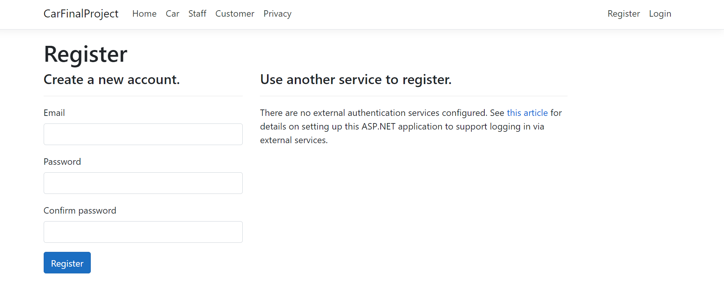

## Login Page

The login page will allow users to access the web application in full.

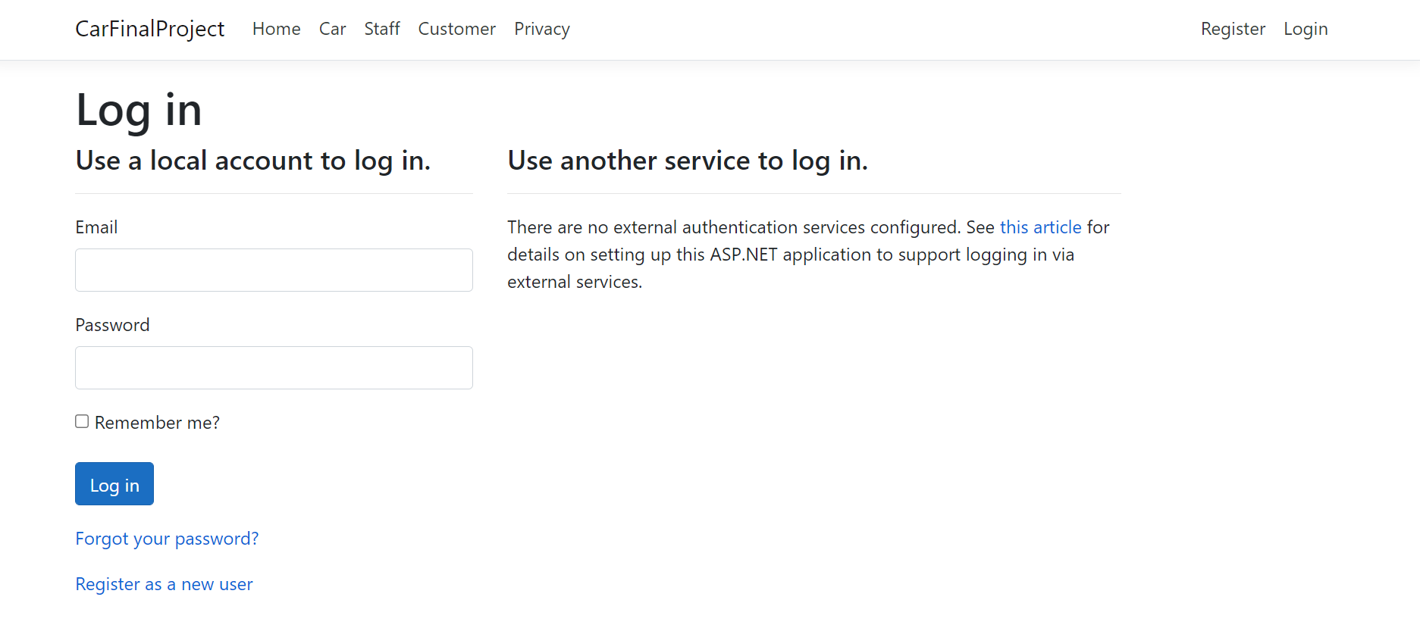

Section 2

Task 4

Coding

[..\..\CarFinalProject.sln](../../CarFinalProject.sln)

Task 5

Usability Testing

[Test Plan For Car Final Project.xlsx](Test%20Plan%20For%20%20Car%20Final%20Project.xlsx)

|  |  |  |  |  |
| --- | --- | --- | --- | --- |
| User | Task 1  Add staff | Task 2  Delete staff | Task 3  *login* | Comments |
| User 1 | Done | done | *done* |  |
| User 2 | Strongly agree | Strongly agree | Strongly agree | All working |
| User 3 | agree | agree | agree | agree |

# Testing Project

## Checking for Device Usability

|  |  |  |  |  |  |  |
| --- | --- | --- | --- | --- | --- | --- |
| **Tester** | | **Answer Scale** | | | | |
| **No.** | **Question** | **Strongly Disagree (1)** | **Disagree (2)** | **Normal (3)** | **Agree (4)** | **Strongly Agree (5)** |
| 1 | I think that I would like to use this system frequently |  |  |  |  |  |
| 2 | I found the system unnecessarily complex |  |  |  |  |  |
| 3 | I thought the system was easy to use |  |  |  |  |  |
| 4 | I think that I would need the support of a technical person to be able to use this system |  |  |  |  |  |
| 5 | I found the various functions in this system were well integrated |  |  |  |  |  |
| 6 | I thought there was too much inconsistency in this system |  |  |  |  |  |
| 7 | I would imagine that most people would learn to use this system very quickly |  |  |  |  |  |
| 8 | I found the system very cumbersome to use |  |  |  |  |  |
| 9 | I felt very confident using the system |  |  |  |  |  |
| 10 | I needed to learn a lot of things before I could get going with this system |  |  |  |  |  |

Task 6

Client Review Form

My developer’s name:  **Tania**

This form is intended to let you review the communication skills of your developer for this assignment. Your review will partly count towards their final mark. Do not take into account technical skills.

Grading scale

You must grade your developer for each item listed in the tables below. 1 being the lowest, 5 the highest.

|  |  |  |  |  |
| --- | --- | --- | --- | --- |
| **1** | **2** | **3** | **4** | **5** |
| Strongly disagree | Disagree | Ok | Agree | **Strongly agree** |

Review your developer

|  |  |  |
| --- | --- | --- |
| Item | Grade | Comment |
| Communicated clearly and effectively | A |  |
| Kept you informed of the progress | B | Yes |
| Met timelines | B | Yes |
| Responded promptly to problems | A+ | Yes |
| Met overall project objectives | A++ | Yes |
| Was open to new ideas and suggestions | A | Yes |
| Was easy to work with | B+ | Yes |

## Comments

Provide any extra comments on your developer’s communication skills and professionalism.

**Signed by Client**

|  |  |
| --- | --- |
| **Signature: Kamal** | **Date: 17/11/2021** |
| **Name: Kamal Preet singh** | **Title: Final Project** |
| **Contact details (email/Tel): Kamalpreet234@gmail.com** | |

# User Manual

## Guide to Quick Setup

As a web application, no complex configuration is needed for the targeted users. However, to access its functionality, registration via the website is required. The web application can be accessed via local host.

To register, just press the "Register!" button. To the Navbar.

# General Information

### System Overview

Any car information can be inserted, modified and removed in this application user. Only registered users have full web application access.

# System Summary

## System Configuration

## Car is a web application built using the Asp.net Core Web Application. It will run on most current web browsers and no special device configuration will be needed. It will need internet access to operate as a web application.

Section 3

Task 8

**Software Development Life Cycle**

#### Planning and requirement

In this foremost phase, you need a clear idea about the requirement gathering.

The first phase should be able to outline the following:

* The users of this software
* Details such as cost, functionality, and performance of the software
* Scope of the project
* Consider the project opportunities and risks involved

#### Software Design and prototyping

In this phase, the entire architecture of the project is designed. Based on the Software Requirement Specification (SRS), the designers develop the product’s best design architecture in this phase. Basically, the design phase concludes with more than one architecture that the stakeholders will review multiple times.

#### Software Development

This is the longest phase in the [software development cycle](https://ziniosedge.com/services/product-engineering/), and here is where the actual product development begins. Coding of the software is done in this stage based on the design document specification.

#### Testing

Testing involves in almost every phase in the modern SDCL methodologies. Once the coding is done, it undergoes testing for quality assurance.  Testing includes various functional testing like system testing, acceptance testing, unit testing, integration testing, and also non-functional testing.

#### Implementation

Once the software is successfully tested, implementation takes place. However, the project deployment strategy varies based on the business proposition of companies. Sometimes, the product will be released in a limited environment to collect feedback and use acceptability.  In this stage, other bugs (if any) are being reported and fixed.

#### Maintenance

In this phase, the issues experienced by end-users are resolved systematically. Based on the feedback and user experience report, adequate changes and updates will be pushed at this phase. Subsequently, maintenance is a continuing process across the life of the product in the market.

Task 9-

Project management

#### 1.Requirement gathering and analysis:

A feasibility analysis is conducted for the project and documented in the requirement specification document.

#### 2.Design:

Design specifications are created, studied, and evaluated in an effort to understand what the final product should look like, along with the actions needed to get there

#### 3.Implementation/Coding:

The coding of the software actually begins. All previous planning is put into action during this phase.

#### 4.Testing:

After the coding is completed, testing is performed to ensure that there are no errors before the software is delivered to the customer. An optional user acceptance test (UAT) can also be performed, where users try the software before distributing it to the greater public.

#### 5.Maintenance:

This phase relies on the customers to report on any additional issues that may have been encountered in the real world. The development team works to solve and modify the software based on this feedback.

Thank You !