Visualization-Based OSINT Intelligence Platform
Graphs, Link Charts, Timelines and Heat Maps for Evidence-Based Threat Investigation

Project Report
Cybersecurity / OSINT Threat Intelligence

GitHub Repository: github.com/Taniaa-p/OSINT-2

Name: Tania P
Roll no: 23110403
Reg no: 23011103038
Date: 19 October 2026

Table of Contents
Abstract
1. Problem Definition
1.1 Objectives · 1.2 Investigation questions · 1.3 Scope and requirements
2. Literature Survey
2.1 Comparison of visualization approaches · 2.2 Research gaps
3. OSINT Data Collection and Source Identification
3.1 Chain of custody · 3.2 Dataset profile
4. System Architecture
4.1 Data model
5. Evaluation of Visualization Techniques
5.1 Worked investigation: how the views support each other
6. Data Processing, Correlation and Analysis
6.1 Cleaning · 6.2 Correlation and hub suppression · 6.3 Graph · 6.4 Temporal · 6.5 Geographic · 6.6 Social network
7. Tool Implementation and Dashboard
8. Findings, Evidence and Validation
8.1 Key findings · 8.2 Cross-source validation · 8.3 Misinterpretation experiments · 8.4 Testing · 8.5 Limitations
9. Ethical and Legal Considerations
10. Impact and Significance
11. Future Work
12. Conclusion
References

Abstract
Open threat-intelligence feeds publish thousands of malicious indicators every day, but as flat lists. The intelligence an analyst needs is in the relationships the lists do not show: shared servers, campaign time spans, and concentrations of infrastructure. This project designs and implements a visualization-based OSINT analytics platform. It collected 3 public feeds (URLhaus, ThreatFox, OpenPhish) and enriched them with DNS, IP geolocation, an independent ASN registry service and RIR address statistics. From these it built a provenance-labelled knowledge graph of 50,391 entities and 145,463 relationships. It then compared four visualization families (graphs, link charts, timelines and heat maps), assigning each the investigative questions it answers best. Each view carries safeguards against misinterpretation. The safeguards were tested quantitatively. Without hub suppression, multi-tenant platforms such as raw.githubusercontent.com merge unrelated indicators into a false 'campaign' of 13,580 entities; with suppression the largest cluster is 368. Normalising hosting countries by allocated IPv4 space keeps only 3 of the raw top-10 countries (Spearman ρ = 0.362). Geolocation was cross-validated against registry data (76.0% country agreement, 98.7% ASN agreement). A literature survey of 16 recent papers identifies the research gaps the architecture addresses.

1. Problem Definition
Community threat-intelligence feeds such as abuse.ch URLhaus and ThreatFox, and phishing feeds such as OpenPhish, are among the most widely used open sources in security operations. Each publishes a flat list of indicators of compromise (IOCs): URLs, domains, IP:port pairs and file hashes, with timestamps, tags and reporter names. The questions an investigator actually asks are relational, temporal and spatial: Which indicators share infrastructure? Starting from one suspicious IP, what else is connected? When did a campaign start and peak? Where is the infrastructure hosted? A list answers none of these directly.
Visualization closes that gap, but each chart form can also mislead. A force-directed graph suggests a relationship wherever two nodes are drawn together. A heat map of raw counts mostly shows where hosting is cheap and plentiful. A timeline of report dates is easily read as attack dates. The problem therefore has two parts: (a) build an OSINT analytics platform that turns open data into entities, relationships, timestamps, locations and threat indicators, and visualises them; (b) choose and design each visualization so that it supports the investigative question it is used for and reduces the chance of misinterpreting the evidence.

1.1 Objectives
Table 1. Project objectives
# | Objective | Measured by
O1 | Collect a multi-source OSINT dataset with entities, relationships, timestamps, locations and threat indicators | 3 feeds + 4 enrichment sources; SHA-256 manifest
O2 | Clean, normalise and de-duplicate; extract typed entities | rejection counts by reason; entity counts
O3 | Correlate across sources into a provenance-labelled knowledge graph | cross-feed overlap; infrastructure clusters
O4 | Apply graph, temporal, geographic and social-network analytics | centrality, Louvain, bursts, normalised geo, SNA
O5 | Evaluate the suitability of graphs, link charts, timelines and heat maps | suitability matrix (Section 5)
O6 | Implement an interactive dashboard and automated reporting | Flask dashboard, HTML reports, GEXF/CSV export
O7 | Reduce, and quantify, the possibility of misinterpreting evidence | before/after experiments (Section 8.3)
O8 | Survey at least 10 research papers and identify research gaps | 16-paper comparison (Section 2)

1.2 Investigation questions
The investigation questions were fixed before any visualization was chosen, so each view could be judged against a concrete need rather than how it looks.
Table 2. Investigation questions
ID | Investigative question | Requirement on the view
IQ1 | Which indicators share infrastructure and probably belong to the same campaign? | Show connectivity and groups at a glance
IQ2 | Starting from one indicator, what is connected, and on what evidence? | Incremental, explainable expansion
IQ3 | When did activity start, peak and stop? Are there bursts? | Ordered time axis, volume, durations
IQ4 | Where is infrastructure hosted, and which countries/ASNs are over-represented relative to size? | Spatial density, normalisation
IQ5 | What is the operational (reporting) tempo across the week? | Two-dimensional time density
IQ6 | Which entities broker between clusters? | Structural importance (centrality)
IQ7 | How is coverage spread across the reporting community? | Social-network structure

1.3 Scope and requirements
- In scope: passive collection from URLhaus, ThreatFox and OpenPhish; passive enrichment through DNS, ip-api.com, the Team Cymru IP-to-ASN service and NRO RIR delegation statistics; free-text IOC extraction; correlation, analytics, visualization, reporting and export.
- Out of scope: active scanning or probing, visiting or downloading malicious URLs, malware execution, attribution of attacks to real people, personal social-media collection, takedown or blocking.
- Functional requirements: (F1) reproducible collection with a chain-of-custody manifest; (F2) no single failing source stops the pipeline; (F3) normalisation and de-duplication; (F4) typed entities and provenance-labelled edges; (F5) correlation with hub suppression; (F6) graph, temporal, geographic and SNA analytics; (F7) interactive graph, link chart, timeline and heat-map views with an evidence panel; (F8) reports and exports; (F9) full offline reproduction from a committed snapshot.
- Non-functional requirements: explainability (every on-screen link traceable to a source record), reproducibility, resilience, ethical collection only, and laptop-scale performance (full pipeline in minutes).
- Intended users: SOC and threat-intelligence analysts triaging malicious infrastructure.

2. Literature Survey
Sixteen peer-reviewed papers, mostly from 2020–2024, were reviewed across the five areas required by the brief: OSINT and threat intelligence, graph analytics and knowledge graphs, social-network analysis, geographic visualization and geolocation, and cyber-intelligence visualization and dashboards. Two further papers on misleading visualization and timeline design were added, because the brief asks how to reduce misinterpretation. Every reference was checked against its publisher or DOI record. Table 3 compares the visualization or analytical approach, methodology, dataset, findings and limitations of each paper. Section 2.2 derives the research gaps that the proposed architecture addresses.
Table 3. Comparison of surveyed research
Paper | Area | Approach / visualization | Methodology | Dataset | Key findings | Limitations
[L1] Yadav, Kumar & Singh (2023) | OSINT review | Survey of OSINT tools, techniques and cyber-security applications | Literature review | Published OSINT studies and tools | OSINT is used widely in cybercrime, forensics and social-network security; automation with ML/AI is the main trend | Visualization and evidence presentation get little attention; no evaluation framework
[L2] Browne, Abedin & Chowdhury (2024) | OSINT + AI | Systematic review of AI applied to OSINT | PRISMA systematic review | 163 research articles | Most work focuses on collection and classification (NLP, ML); applications span social media, dark web and threat intelligence | Few studies address explainability or how results are shown to analysts
[L3] Riebe, Biselli, Kaufhold & Reuter (2023) | OSINT ethics / privacy | Acceptance and privacy concerns of OSINT for cyber security | Representative population survey | Survey responses from the general public | Acceptance depends on purpose and transparency; collection of personal data raises strong privacy concerns | Survey of attitudes, not of tools; single national sample
[L4] Böhm, Menges & Pernul (2018) | CTI visual analytics | Graph-based persistence and interactive graph visualization of STIX threat intelligence | Prototype implementation and demonstration | Example STIX 2 threat-intelligence data | Graph views help analysts explore and enrich semi-structured CTI | Relies on structured STIX input; no geographic or temporal view; small evaluation
[L5] Sarhan & Spruit (2021) | Knowledge graphs / entity extraction | Open-CyKG: open information extraction + cyber NER to build a threat-intelligence knowledge graph | Neural OIE and NER, embedding-based canonicalisation | APT threat reports (unstructured text) | Automatically extracted triples form a queryable CTI knowledge graph; components beat baselines | Extraction errors propagate into the graph; no visualization or provenance for analysts
[L6] Yan, Yang, Shi, Fang, Li & Ye (2023) | Graph analytics | Survey of graph-mining methods for cyber security (centrality, community detection, GNNs) | Systematic survey | Published graph-based security studies and datasets | Graphs are a natural model for relations between security entities; graph mining improves detection and attribution | Focus on algorithms, not on how graphs are visualized or misread
[L7] Pete, Hughes, Chua & Bada (2020) | Social-network analysis | SNA of user-interaction networks in six dark-web forums | Network construction, centrality, community detection | Six dark-web forum datasets | Only a small subset of users is influential; forums differ in structure | Forum data only; links are replies, not verified relationships
[L8] Hu, Wang, Guin & Zhu (2018) | Geographic visualization | Spatio-temporal kernel density estimation for hotspot mapping | STKDE with predictive-accuracy evaluation | City crime incident records | Adding time to KDE improves hotspot prediction; bandwidth choice changes the map | Physical crime, not network infrastructure; parameter-sensitive
[L9] Gouel, Vermeulen, Beverly, Fourmaux & Friedman (2021) | Geolocation reliability | Longitudinal stability study of an IP geolocation database | Snapshot comparison; reproduction of a prior study | Weekly snapshots of a commercial geolocation database | Successive snapshots differ significantly; median error shifted >100 km and coverage by 30% | One database; ground truth limited to some address types
[L10] Jiang, Jayatilaka, Nasim, Grobler, Zahedi & Babar (2022) | Cyber dashboards | Systematic review of cyber situational-awareness visualizations | Systematic literature review | 54 publications | Most visualizations serve operational staff and the perception level; impact and projection are rarely shown | Review only; does not propose or test a visualization design
[L11] Komadina, Mihajlović & Groš (2022) | Security visualization | Design-space analysis of cyber-security visualizations | Classification by data, task, encoding, interaction, evaluation | 60 VizSec papers (2016–2021) | Provides a taxonomy of data, tasks and encodings used in security visualization and shows which combinations are under-explored | Limited to one venue and six years
[L12] Li, Dunn, Pearce, McCoy, Voelker, Savage & Levchenko (2019) | Threat-intel feeds | Metrics for comparing threat-intelligence feeds | Quantitative feed comparison against external measurements | Public and commercial IP and hash feeds | Feeds overlap little and have limited coverage and accuracy | No visualization; feeds analysed as sets, not as relationships
[L13] Bouwman, Griffioen, Egbers, Doerr, Klievink & van Eeten (2020) | Threat-intel feeds | Added value of commercial threat intelligence | Feed overlap analysis + 14 practitioner interviews | Two commercial vendors and four open feeds | Only 2.5–4% indicator overlap for the same 22 actors; analysts judge TI informally | Two vendors only; little on how TI is visualized
[L14] Kumarasinghe, Nabeel & Elvitigala (2024) | Hosting infrastructure | Forecasting malicious domains from the hosting infrastructure they share | Infrastructure-based features and classification | Domain, DNS and blocklist data | Shared low-reputation hosting predicts future malicious domains | Shared infrastructure can also join benign tenants; classification, not visual analysis
[L15] Lo, Gupta, Shigyo, Wu, Bertini & Qu (2022) | Misleading visualization | Taxonomy of misleading visualizations | Open coding of real-world reported charts | >1,000 visualizations reported as misleading | 74 types of issues; many arise from honest design choices, not deliberate deception | General charts; no security-specific safeguards
[L16] Di Bartolomeo et al. (2020) | Timeline visualization | Effect of timeline shape on task performance | Controlled online experiment | 192 participants; recurrent and non-recurrent event data | Shape changes task time but not accuracy; linear timelines are fastest for lookup | Synthetic tasks; no investigative context

2.1 Comparison of visualization approaches
Node-link graphs are the dominant form in cyber-intelligence work. [L11] classifies security visualizations by data, task and visual encoding, and graph-based CTI systems [L4, L5] and graph-mining methods [L6] model indicators, actors and infrastructure as linked entities. Link charts are the analyst-facing, incremental form of the same model: [L4] lets analysts explore STIX objects from a starting node. Graph analytics turns pictures into ranked evidence: centrality and community detection identify key actors [L6, L7]. Timelines support sequence and duration reasoning, and [L16] shows that a plain linear layout is fastest for lookup tasks, which is why this platform uses linear daily and Gantt timelines. Heat maps support density reasoning in space and time [L8]. However, [L8] shows that parameter choices change the hotspot map, and [L9] shows that the geolocation feeding such maps is itself unstable. Dashboards combine these views [L10], but most serve operational monitoring at the perception level rather than investigation [L10].
On data, [L12] and [L13] show that threat feeds overlap very little. Combining several feeds is therefore necessary, and corroboration across feeds is informative. [L14] shows that shared hosting is a strong signal of malicious infrastructure, but also that it connects unrelated tenants. On interpretation, [L15] shows that most misleading charts come from ordinary design choices such as aggregation, scaling and omitted context, and the OSINT literature [L1, L2, L3] stresses transparency and purpose limitation.

2.2 Research gaps addressed by this project
- G1 – Evidence provenance in the view. CTI graph and knowledge-graph systems [L4, L5] draw links but do not show, on the link itself, which source record created it, by what method and with what confidence. OSINT reviews [L1, L2] note that explainability is rarely addressed. → Every edge in this platform carries source, record ID, time, method and confidence, shown in an evidence panel.
- G2 – False links through shared infrastructure. Infrastructure-based correlation [L14] and graph mining [L6] link everything that shares a host, IP or provider. In open feeds, code-hosting and CDN platforms are shared by thousands of unrelated actors, and the effect on visual analysis is rarely measured. → Hub suppression, quantified before and after (Section 8.3).
- G3 – Normalisation and uncertainty in geographic views. Hotspot methods are parameter-sensitive [L8] and geolocation databases are unstable [L9]. Threat maps nevertheless typically plot raw counts from one provider. → Distinct-IP weighting, per-million-IPv4 normalisation, and cross-validation of geolocation against registry data.
- G4 – Temporal semantics. Timeline research [L16] studies layout but not the meaning of the timestamps. Feeds record when something was reported, not when it was active, and feed timeliness differs [L13]. → Explicit report-time labelling, window filtering, and exclusion of observation-only timestamps.
- G5 – Investigation-oriented, evaluated dashboards over multiple open feeds. Dashboards mostly target operational monitoring [L10]; feed studies [L12, L13] do not visualise relationships. → One provenance-labelled model over three feeds drives four coordinated views. The views are evaluated with quantitative misinterpretation experiments, from a hash-verified snapshot anyone can re-run.
- G6 – Ethics built into the tool. [L3] shows that acceptance of OSINT depends on transparency and privacy, but technical controls in tools are rarely described. → Pseudonymised reporters, defanged reports, passive-only collection.

3. OSINT Data Collection and Source Identification
The dataset had to contain entities, relationships, timestamps, locations and threat indicators. No single open source provides all five, so three primary feeds were combined with four enrichment sources. Table 4 lists every source, what it contributes, how it is accessed and how failure is handled.
Table 4. Open sources used
Source | Type | Contributes | Access method | Failure handling
abuse.ch URLhaus | Threat feed (malware URLs) | URLs, hosts, timestamps, status, tags, reporters | CSV export (recent, 30 days), no key | Retry ×3; marked failed in manifest; others continue
abuse.ch ThreatFox | Threat feed (IOCs) | IP:port, domains, URLs, hashes, explicit malware family, confidence | CSV export (recent), no key | As above
OpenPhish Community | Phishing feed | Phishing URLs (no timestamps) | Plain-text feed | As above; retrieval time marked as observation time
DNS (dnspython) | Enrichment | host → IP (A records), NXDOMAIN status | Standard resolver queries, 32 threads | Timeout/NXDOMAIN stored as status
ip-api.com | Enrichment | Geolocation, ASN, ISP, hosting flag | Batch API (100 IPs/request, ≤15 req/min) | Rate-limit headers honoured; failed batch logged
Team Cymru IP-to-ASN | Enrichment (independent) | ASN, BGP prefix, registry country | DNS TXT queries (origin.asn.cymru.com) | Missing value = no comparison
NRO RIR delegation stats | Reference data | IPv4 addresses allocated per country | Combined RIR file (57 MB, summarised) | Normalisation disabled if missing

3.1 Collection methodology and chain of custody
Every download is streamed to disk, hashed with SHA-256 and recorded in a manifest together with the source URL, UTC retrieval time, size and licence (Table 5). The download was then frozen as a gzip-compressed snapshot in data/snapshot/. Running the pipeline with OFFLINE=1 restores the snapshot, verifies every hash, and reproduces every number in this report without a single network request. Enrichment results are cached in SQLite and exported to the snapshot for the same reason.
Table 5. Chain-of-custody manifest of the analysed snapshot
Source | Retrieved (UTC) | Bytes | SHA-256 (first 24 hex)
urlhaus | 2026-10-19T17:13:43+00:00 | 7,869,800 | bc168ff83c81f1424c74424c
threatfox | 2026-10-19T17:13:44+00:00 | 1,543,610 | a435ade364277275c8df79d6
openphish | 2026-10-19T17:13:47+00:00 | 14,307 | 0447401a73d47149cef29e04

3.2 Dataset profile
Table 6. Dataset after collection and preprocessing
Measure | Value
Raw records parsed | 40,771
Clean records after normalisation | 39,655
Rejected (by reason) | outside_window: 135, duplicate: 980, invalid_host: 1
Hosts resolved via DNS | 1,555 of 2,316 non-platform domains
Distinct IP addresses | 10,578
IPs geolocated | 10,573 (100.0%)
Investigation window | 30 days ending 2026-10-19

The five required data dimensions are all present. Entities: URLs, hosts, registered domains, IPs, hashes, ASNs, countries, malware families and reporters. Relationships: hosted_on, subdomain_of, resolves_to, in_asn, located_in, associated_with and reported_by. Timestamps: first and last seen. Locations: latitude/longitude, country and ASN. Threat indicators: URL, domain, IP:port and hash IOCs with threat type and confidence.

4. System Architecture
The platform is a Python pipeline with a Flask presentation layer. It is organised as eight layers, each in its own package under src/ and each testable on its own. Figure 1 shows the architecture; Table 7 maps each layer to its implementation.
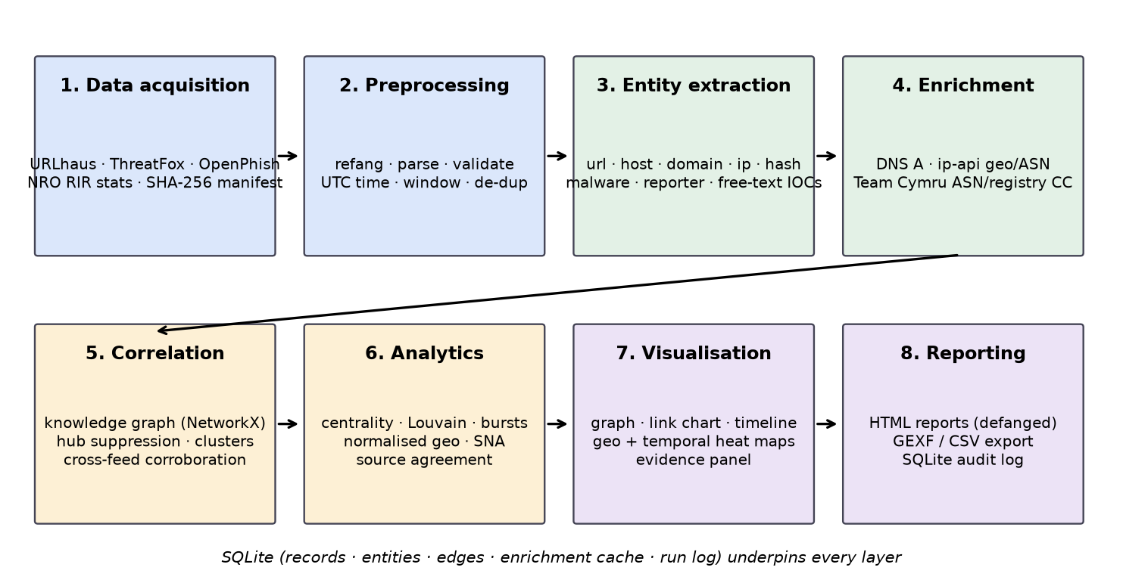
Figure 1. Layered architecture from data acquisition to reporting
Table 7. Architecture layers and implementation
Layer | Module | Responsibility | Key technique
Data acquisition | src/acquisition | Download feeds, manifest, snapshot, RIR stats | Streaming download, SHA-256, gzip snapshot
Preprocessing | src/preprocessing | Refang, parse, validate, UTC, window, de-dup | urllib, ipaddress, tldextract (bundled PSL)
Entity extraction | src/extraction | Typed entities + provenance edges; free-text IOC regex | Entity IDs '<type>:<value>' merge across feeds
Enrichment | src/enrichment | DNS, geolocation, two independent ASN sources | Threaded DNS, batch API, cache
Storage | src/storage | Records, entities, edges, cache, run log | SQLite
Correlation | src/correlation | Infrastructure graph, hub suppression, clusters, cross-feed | NetworkX connected components
Analytics | src/analytics | Centrality, Louvain, bursts, geo normalisation, SNA, agreement | NetworkX, pandas, z-scores
Visualization & reporting | src/web, src/reporting | Dashboard, evidence panel, HTML reports, GEXF/CSV | Flask, Cytoscape.js, Plotly, Leaflet, Jinja2

4.1 Data model
The knowledge graph uses typed nodes and typed, directed, provenance-labelled edges. An entity ID is '<type>:<value>' (for example ip:203.0.113.5), so an indicator reported by two feeds merges into one node automatically. That merge is the basis of cross-feed correlation. Every edge records the feed or method that created it, the source record ID, its time and its confidence. Feed attribution gets the ThreatFox confidence; tag-inferred family links get 50; DNS links get 90; geolocation links get 70. This is what lets the dashboard answer the question 'why are these two things connected?'.
Table 8. Relationship types in the knowledge graph
Relationship | From → To | Created by | Count
reported_by | indicator → reporter | feed record | 39,114
hosted_on | url → host/ip | feed record | 34,697
associated_with | indicator → malware | feed record | 32,771
subdomain_of | host → domain | feed record | 15,687
located_in | ip → country | ip-api | 10,573
in_asn | ip → asn | ip-api | 10,484
resolves_to | host → ip | DNS | 2,137

5. Evaluation of Visualization Techniques
Each candidate technique was evaluated against the investigation questions in Section 1.2, using the evidence from the literature (Section 2) and from this dataset. Table 9 is the resulting suitability matrix (●●● = primary fit, ●● = supporting, ● = poor fit). Table 10 lists, for each technique, how it can mislead and the safeguard implemented against it.
Table 9. Suitability of visualization techniques per investigative question
Question | Graph (overview) | Link chart | Timeline | Geo heat map | Temporal heat map
IQ1 shared infrastructure | ●●● | ●● | ● | ● | ●
IQ2 explain one indicator | ● | ●●● | ●● | ● | ●
IQ3 start / peak / stop | ● | ● | ●●● | ● | ●●
IQ4 where hosted | ● | ● | ● | ●●● | ●
IQ5 tempo | ● | ● | ●● | ● | ●●●
IQ6 brokers | ●●● | ●● | ● | ● | ●
IQ7 reporting community | ●●● (bipartite) | ●● | ● | ● | ●

Table 10. Strengths, failure modes and safeguards per technique
Technique | Best for | Weak for | How it misleads | Safeguard implemented
Graph (cluster overview) | Seeing groups, components, hubs; centrality | Large dense data (hairball); reading time | Proximity read as relationship; hubs merge unrelated campaigns | Hub suppression; only infrastructure edges form clusters; cap of 600 nodes; size = betweenness
Link chart (ego expansion) | Explaining one indicator; pivoting step by step | Global patterns | Expanding through a CDN floods the chart; enrichment links look like feed facts | Per-relation expansion cap with hidden count; dashed lines for DNS/geo, dotted for tag-inferred; hub border; evidence panel
Timeline | Sequence, bursts, campaign duration | Relationships, place | Report time read as attack time; old IOCs re-listed look new | 'Report time (UTC)' label; window filter; OpenPhish observation times excluded; z-score bursts
Geographic heat map / choropleth | Concentration in space | Causality, attribution | Raw counts mirror hosting size; one server with 10k URLs dominates; server location read as attacker location | Distinct-IP weighting; per-million-IPv4 normalisation; metric switch with warning; agreement rate shown
Temporal heat map (day × hour) | Periodicity, tempo | Exact sequence | Reporter working hours read as attacker hours | Caveat; UTC stated

5.1 Worked investigation: how the views support each other
To justify the selection in practice, the following investigation was run end to end on the snapshot using only the dashboard. Each step uses the view suited to the question at that point, and each safeguard is visible where it matters.
- Step 1 – Entry point (IOC extraction). An analyst pastes a defanged note containing 176.65.134[.]121. The extractor refangs it and finds it in the dataset as an entity reported by URLhaus (Figure 10).
- Step 2 – Link chart (IQ2). Expanding the IP shows 367 URL records hosted on it, on ports 8080, 7356, 7412, 7380. Only 15 per relation are drawn, and the chart states how many are hidden. The dashed edges show AS51396 (Pfcloud UG (haftungsbeschrankt)) and DE; dashed means they come from enrichment, not from the feed (Figure 4). The evidence panel shows that ip-api and Team Cymru agree on the ASN (AS51396) and that the registry country is DE.
- Step 3 – Graph (IQ1, IQ6). The IP belongs to cluster C0001, the largest infrastructure cluster after hub suppression: 367 indicators, family purity 0.978, dominated by Mirai. The IP is the highest-degree node in the suppressed graph (Table 12), so it is the pivot to act on first.
- Step 4 – Timeline (IQ3). The cluster was reported between 2026-09-19 and 2026-09-30. The timeline labels this as report time, so the analyst records 'reported active from …', not 'attack started on …'.
- Step 5 – Heat map (IQ4). Germany appears among the top hosting countries by distinct IPs. Switching to the normalised metric shows that Germany is not over-represented for its address space. This single server is therefore a hosting-abuse case, not evidence of a German hotspot.
- Step 6 – Report. The cluster report (Figure 11) lists every entity defanged, with its evidence trail and a stated confidence (single feed → medium), ready to send to the hosting provider's abuse contact.
Without the safeguards, the same walk would have gone wrong at three points. Expanding a GitHub-hosted indicator would have pulled in 13,580 unrelated entities. The country map would have suggested a German hotspot. The report dates could have been quoted as attack dates. With them, every statement in the final report can be traced to a source record.

6. Data Processing, Correlation and Analysis

6.1 Cleaning and normalisation
- Refanging: hxxp → http and [.] → . so defanged indicators match.
- Parsing: URLs are split into scheme, host, port and path; ThreatFox 'ip:port' into IP and port.
- Validation: hosts must be a valid IPv4/IPv6 address or a syntactically valid domain; invalid hosts are rejected and counted.
- Registered domain: a bundled public-suffix list gives deterministic registered domains (login.example.co.uk → example.co.uk) without a network call.
- Time and de-duplication: all timestamps are converted to ISO-8601 UTC; records outside the window are dropped; duplicates are dropped on (source, indicator).
- Family harmonisation: URLhaus tags are mapped to the ThreatFox family vocabulary (for example 'mirai' → Mirai), labelled 'tag-inferred' with lower confidence than explicit attribution.

6.2 Correlation and hub suppression
Correlation runs on an infrastructure graph containing only url, hash, host, domain and IP nodes, linked by hosted_on, subdomain_of and resolves_to edges. ASNs and countries never act as links, because one ASN can be a whole cloud provider. Before computing clusters, 637 hub nodes were suppressed. Hubs are known multi-tenant platforms (code hosting, CDNs, file sharing, dynamic DNS), plus any pivot whose two-hop neighbourhood spans more than 5 malware families. The connected components of what remains are candidate campaigns. The run found 5,019 clusters with at least two indicators.
Table 11. Highest-degree suppressed hubs
Suppressed hub | Reason | Connections
host:raw.githubusercontent.com | known multi-tenant platform | 13,572
host:github.com | known multi-tenant platform | 1,752
host:gitlab.com | known multi-tenant platform | 693
ip:125.21.240.67 | shared by 26 malware families | 304
host:cdn.discordapp.com | known multi-tenant platform | 150
domain:pages.dev | known multi-tenant platform | 142
host:www.dropbox.com | known multi-tenant platform | 87
host:drive.google.com | known multi-tenant platform | 80
domain:workers.dev | known multi-tenant platform | 59
domain:vercel.app | known multi-tenant platform | 34

6.3 Graph analytics
On the hub-suppressed infrastructure graph (48,306 nodes, 20,155 edges, 28,470 components), degree centrality and approximate betweenness centrality (k = 400, fixed seed) were computed, together with Louvain communities (modularity 0.999). The very high modularity confirms what the components show: once hubs are removed, the infrastructure splits into many tight, separate groups rather than one giant network. Table 12 lists the most central nodes, which an analyst should pivot on first.
Table 12. Most connected infrastructure after hub suppression
Rank | Entity | Type | Degree centrality
1 | 176.65.134.121 | ip | 0.0076
2 | 91.92.242.236 | ip | 0.00228
3 | 31.56.209.86 | ip | 0.00199
4 | 45.153.34.235 | ip | 0.00143
5 | 176.65.139.135 | ip | 0.00118
6 | 154.83.85.63 | ip | 0.00108
7 | 176.65.139.206 | ip | 0.00099
8 | 130.12.180.212 | ip | 0.00097

6.4 Temporal analytics
Daily counts of newly reported indicators (mean 1240.6 per day) were tested for bursts with a z-score threshold of 2.0, both overall and per family.
Table 13. Strongest per-family bursts
Family | Day | Indicators | z-score
Stealc | 2026-10-12 | 612 | 5.39
SmartLoader | 2026-10-06 | 13,770 | 5.38
Unknown Loader | 2026-10-18 | 220 | 5.32
Unattributed | 2026-10-08 | 1,596 | 5.19
IClickFix | 2026-10-18 | 138 | 4.4
Vidar | 2026-10-18 | 311 | 4.29
IClickFix | 2026-10-17 | 94 | 2.89
Vidar | 2026-10-19 | 213 | 2.84
Mozi | 2026-09-21 | 269 | 2.21
Mirai | 2026-10-03 | 416 | 2.15

6.5 Geographic analytics
10,573 IPs were geolocated. Countries were measured three ways: URL count, distinct IP count, and distinct IPs per million allocated IPv4 addresses (NRO statistics). Only countries with at least 5 IPs were ranked by the normalised metric, so tiny denominators cannot dominate.
Table 14. Top hosting countries by distinct IPs
Country | Distinct IPs | URLs | IPs per million IPv4
China (CN) | 4,955 | 7,970 | 14.45
United States (US) | 915 | 1,515 | 0.57
Canada (CA) | 639 | 2,209 | 9.42
Germany (DE) | 400 | 1,289 | 3.16
India (IN) | 378 | 830 | 9.0
Netherlands (NL) | 372 | 2,257 | 7.76
Hong Kong (HK) | 265 | 372 | 16.56
South Africa (ZA) | 192 | 341 | 7.06
Russian Federation (RU) | 189 | 343 | 4.18
Philippines (PH) | 185 | 548 | 29.51

6.6 Social-network analysis of the reporting community
Reporters (pseudonymised) and malware families form a bipartite network. Projected onto reporters, two reporters are linked when they report the same family. 102 reporters cover 118 families. The top 5 reporters contribute 81.8% of the attributed indicators, and 64 families are reported by only one person. For an investigator this matters: a family seen by a single reporter has no independent corroboration in this dataset, and coverage gaps follow the interests of a few contributors.

7. Tool Implementation and Dashboard
The pipeline runs from one CLI (python main.py run-all, or the individual collect / enrich / analyze / report / serve steps). The Flask dashboard provides eight views over the same data. Each view states, on the page, what it does and does not show. Screenshots below were taken from the running platform on the analysed snapshot.
Table 15. Technology stack
Technology | Use
Python 3, pandas, NetworkX | Pipeline, analytics, graph algorithms
SQLite | Records, entities, edges, enrichment cache, run audit log
Flask + Jinja2 | Dashboard and HTML reports
Cytoscape.js | Graph and link-chart rendering
Plotly.js | Timeline, choropleth, temporal heat map, ASN chart
Leaflet + leaflet.heat | Geographic heat map
dnspython, requests, tldextract, pycountry | Collection and enrichment
pytest; Git/GitHub (one commit per phase) | Testing and version control

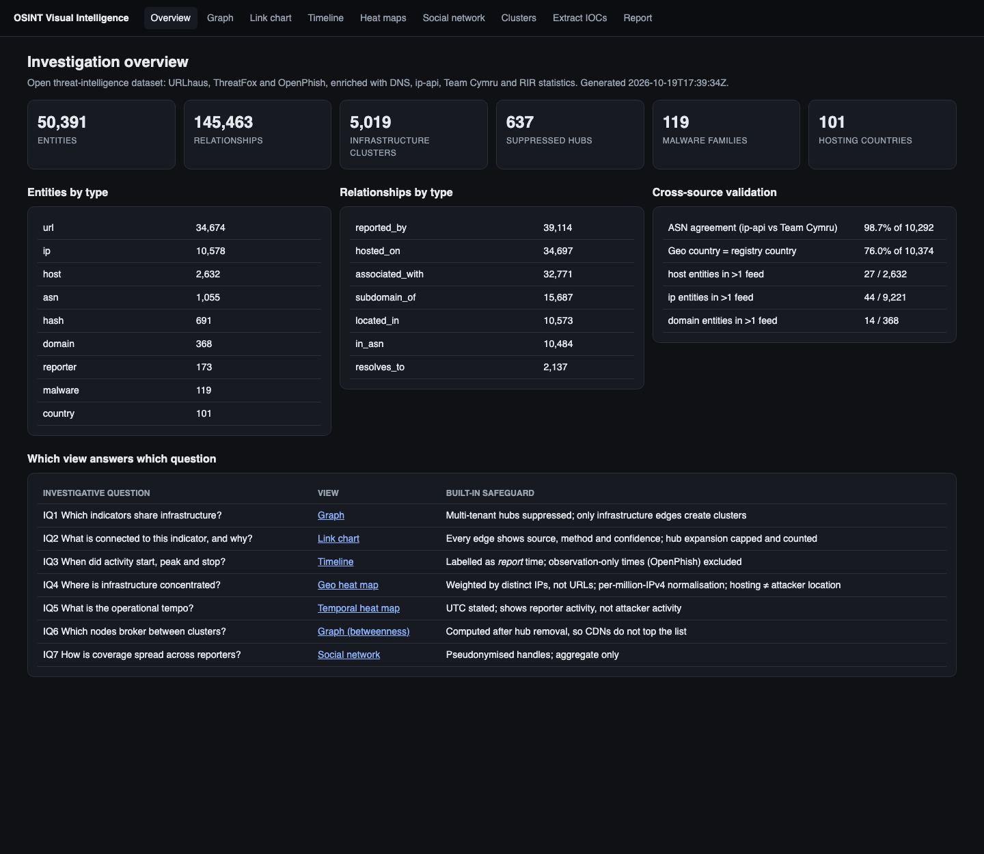
Figure 2. Overview: data volume, cross-source validation and the question-to-view guide
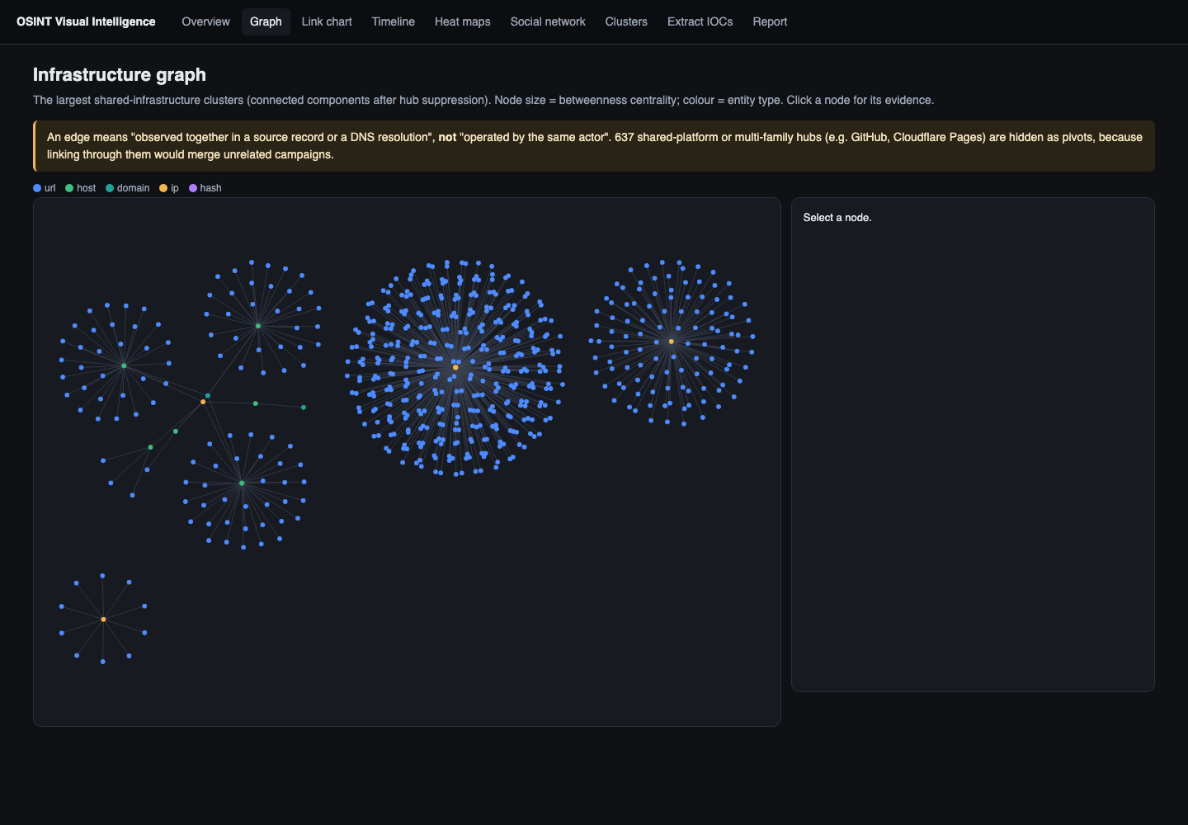
Figure 3. Infrastructure graph: largest clusters after hub suppression; node size = betweenness; the evidence panel shows a selected node's provenance
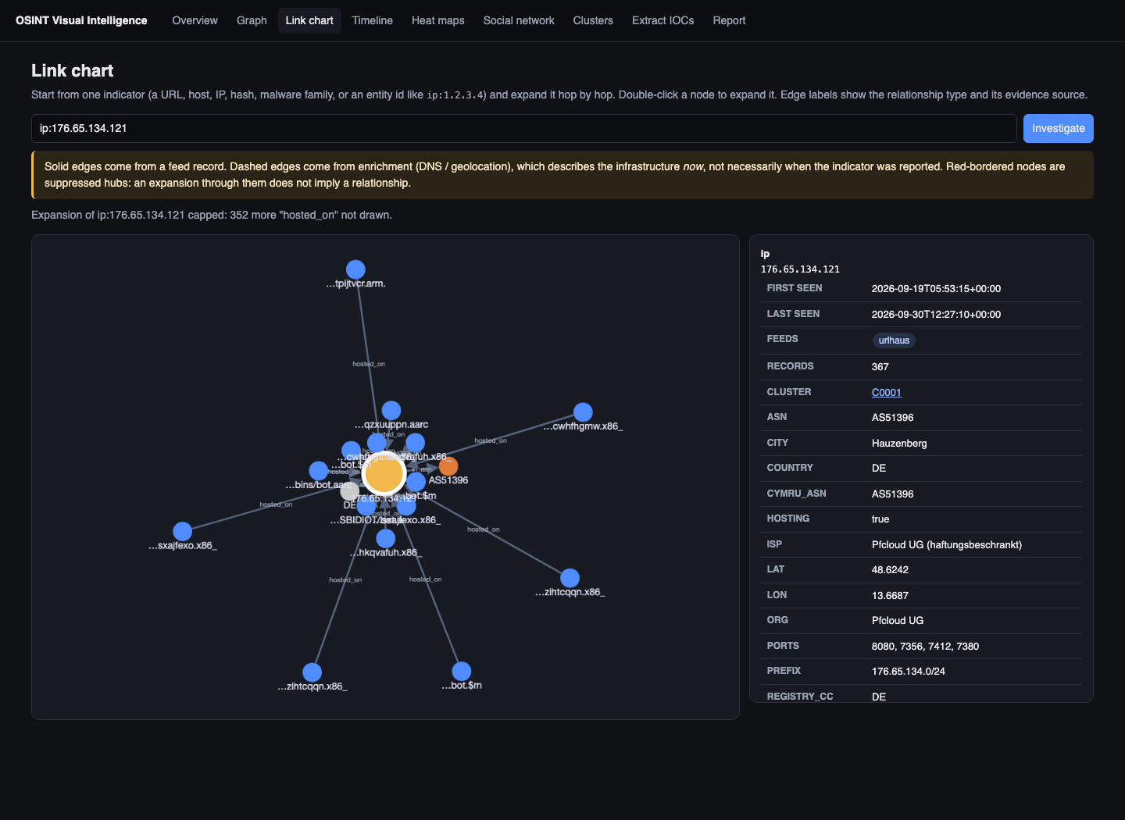
Figure 4. Link chart: expansion from one indicator; capped expansion with hidden-neighbour count; dashed enrichment edges
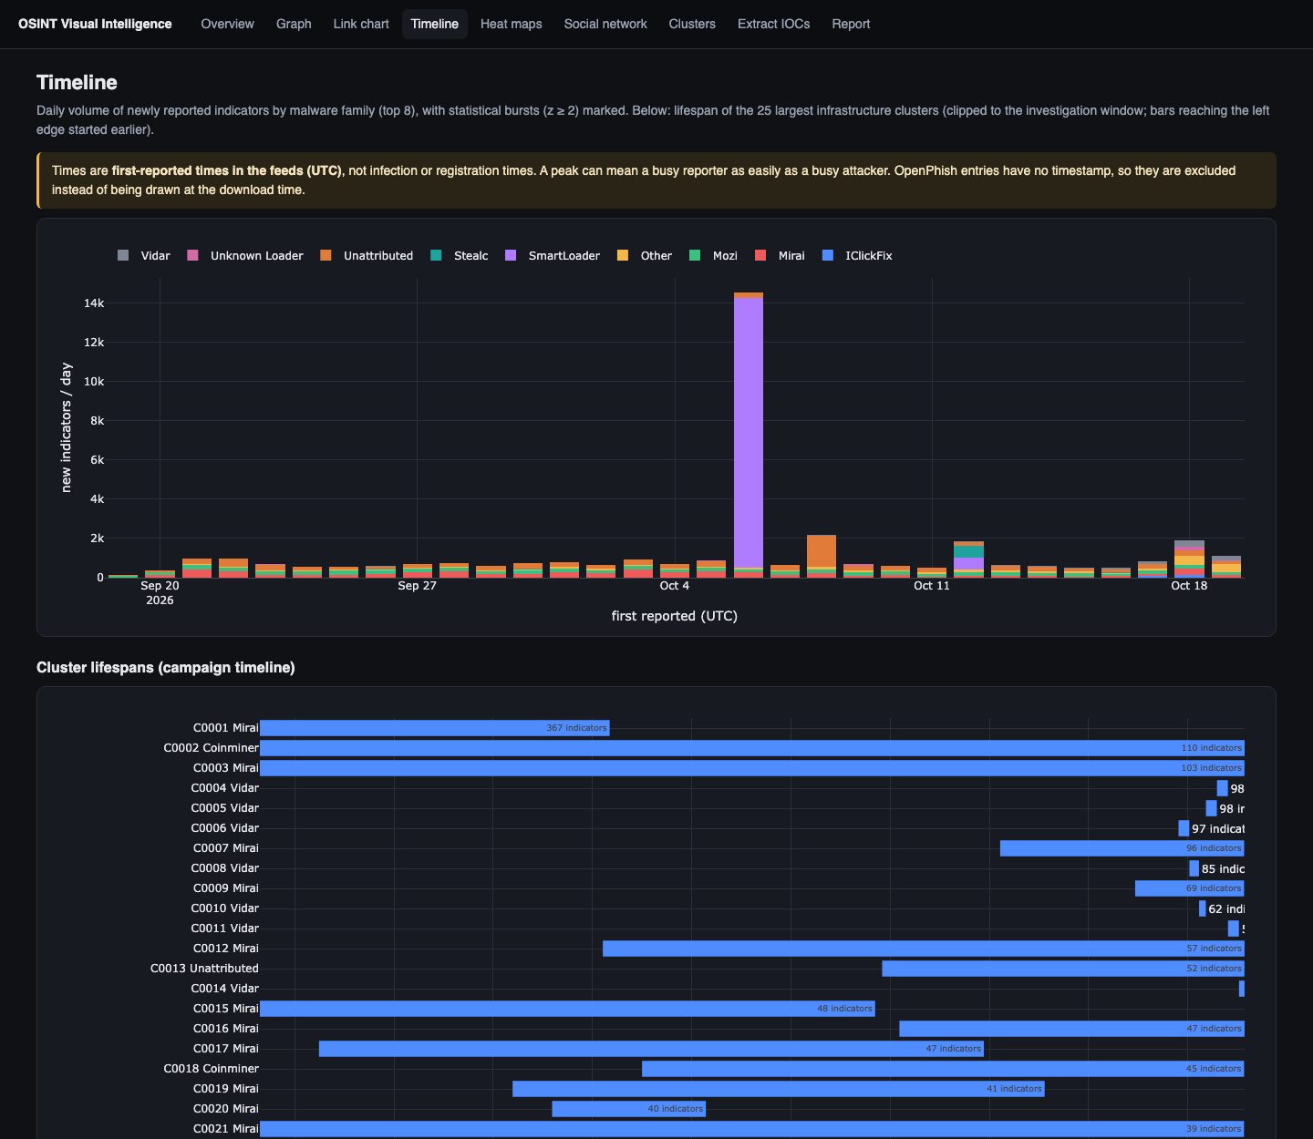
Figure 5. Timeline: daily new indicators by family with report-time caveat, and cluster lifespans
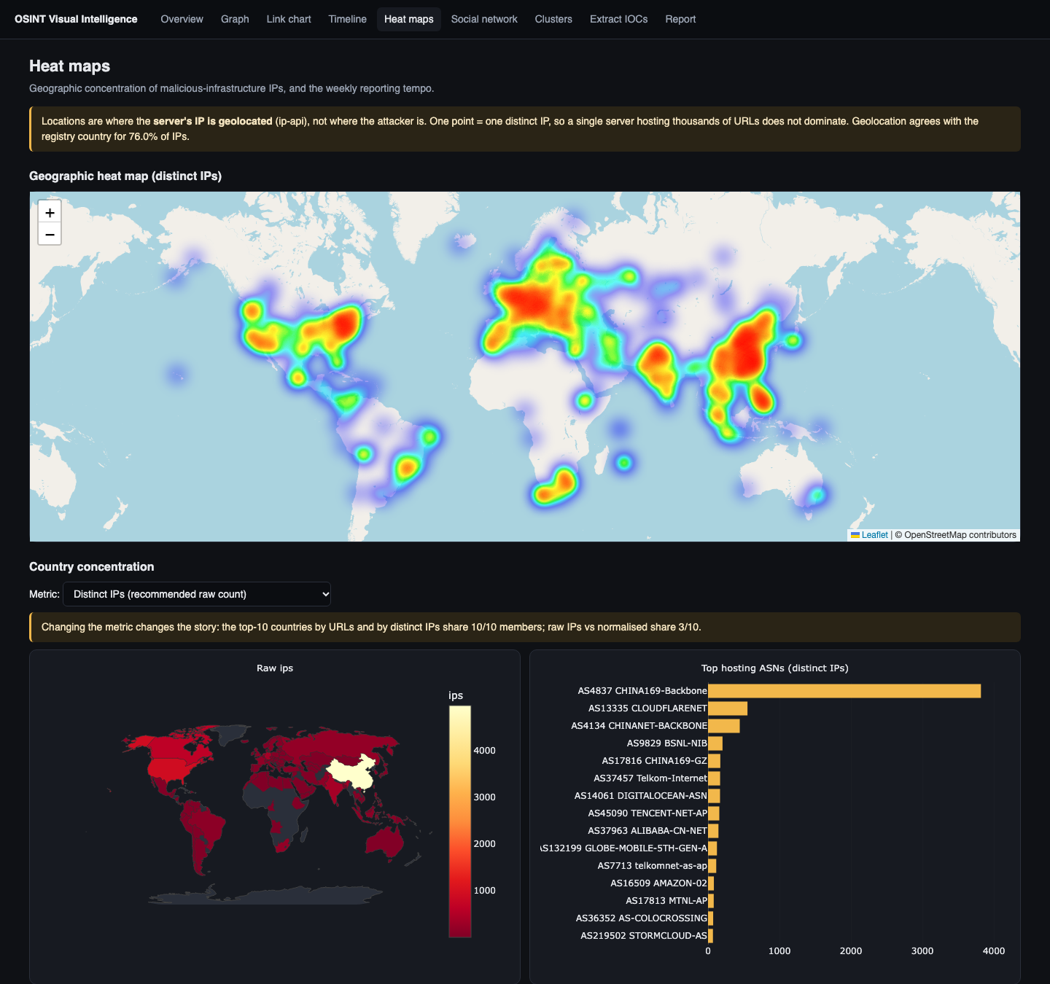
Figure 6. Geographic heat map weighted by distinct IPs, with country choropleth and hosting ASNs
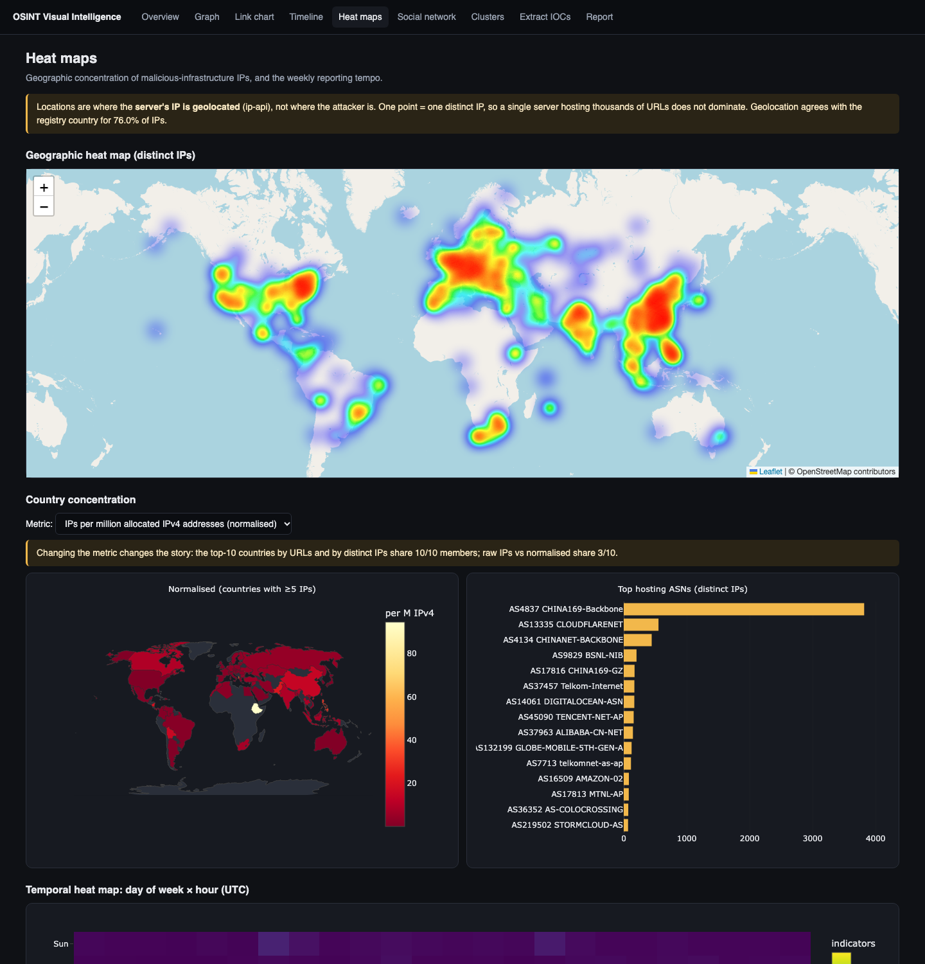
Figure 7. Choropleth after switching to per-million-IPv4 normalisation, and the day × hour temporal heat map
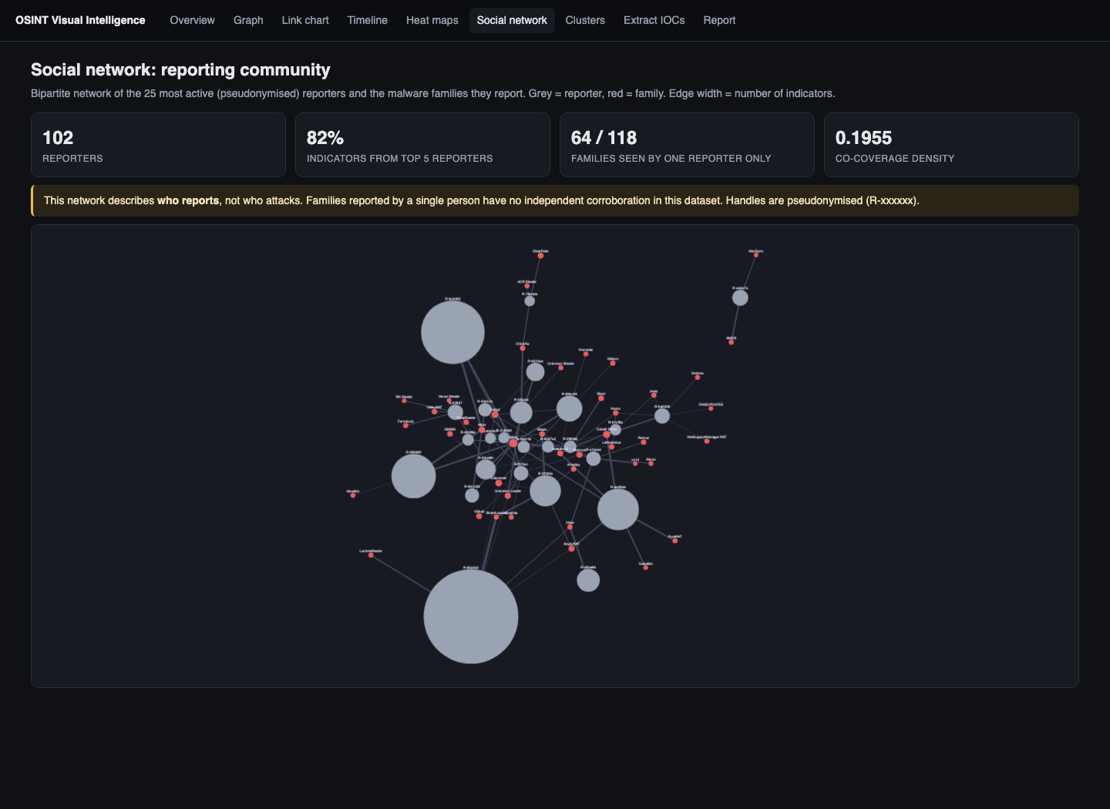
Figure 8. Social-network view of the (pseudonymised) reporting community
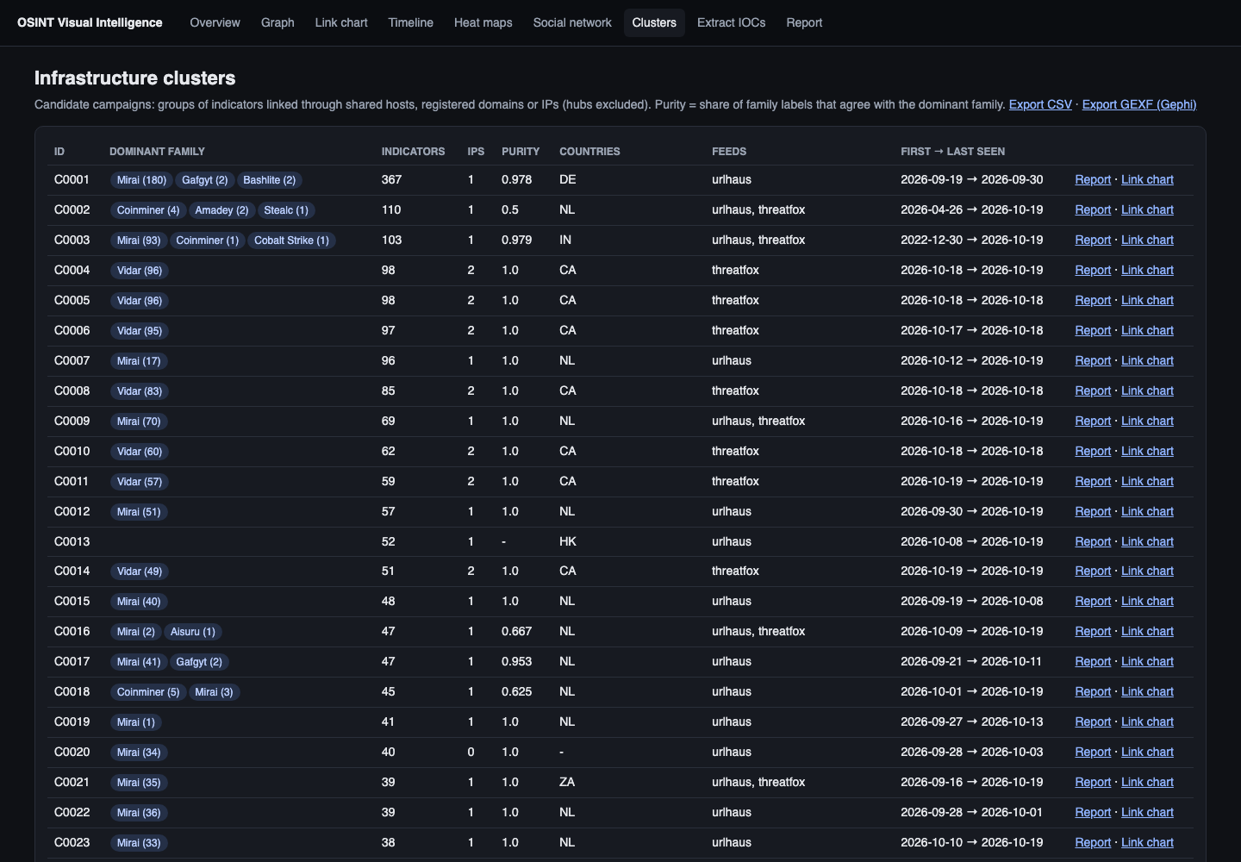
Figure 9. Cluster table with purity, feeds, period and links to reports
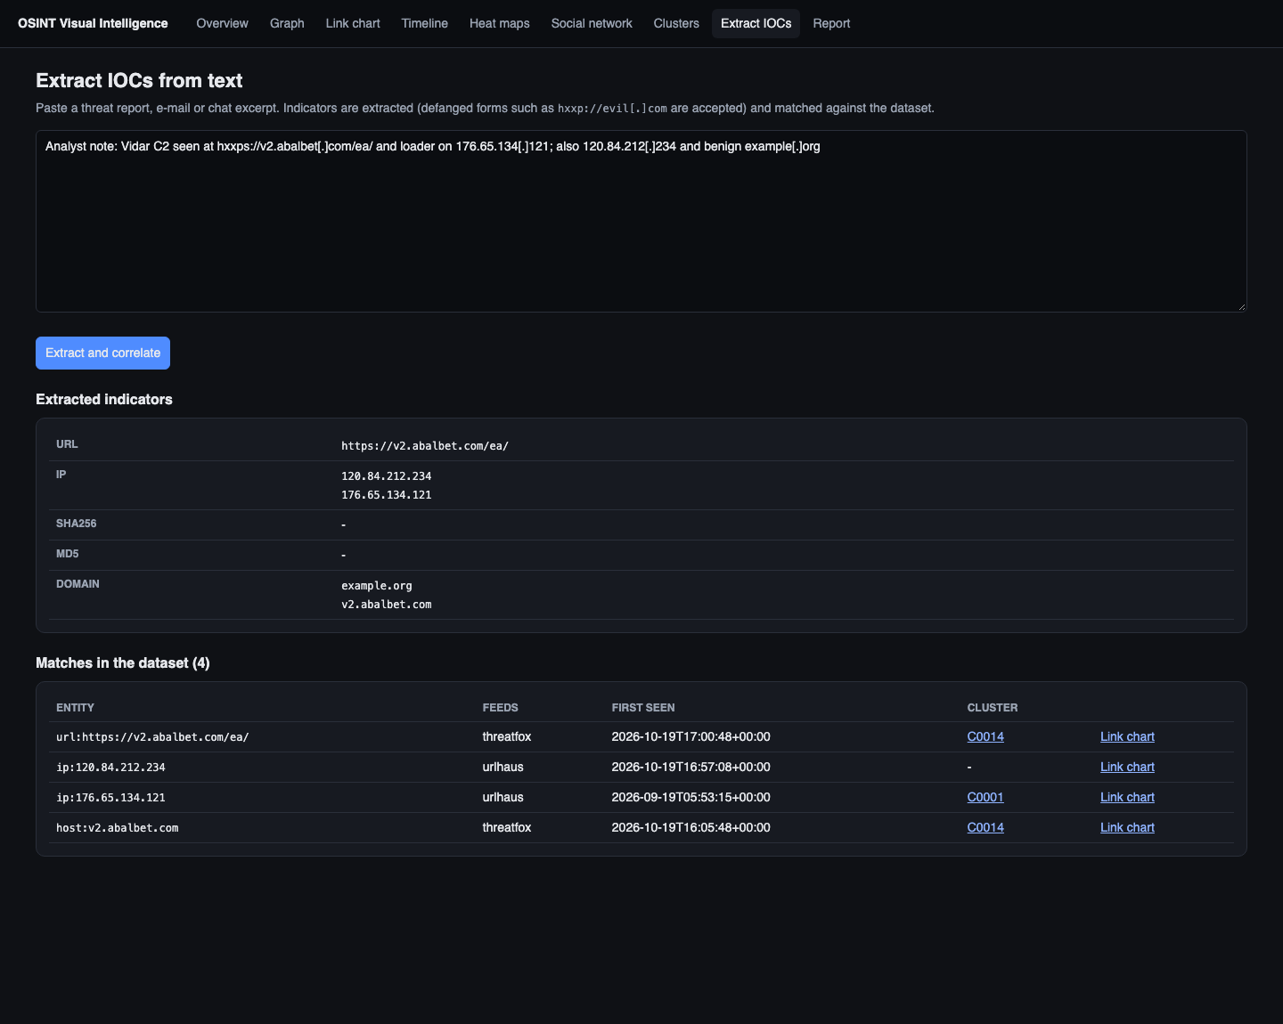
Figure 10. Free-text IOC extraction from a defanged report, correlated against the dataset
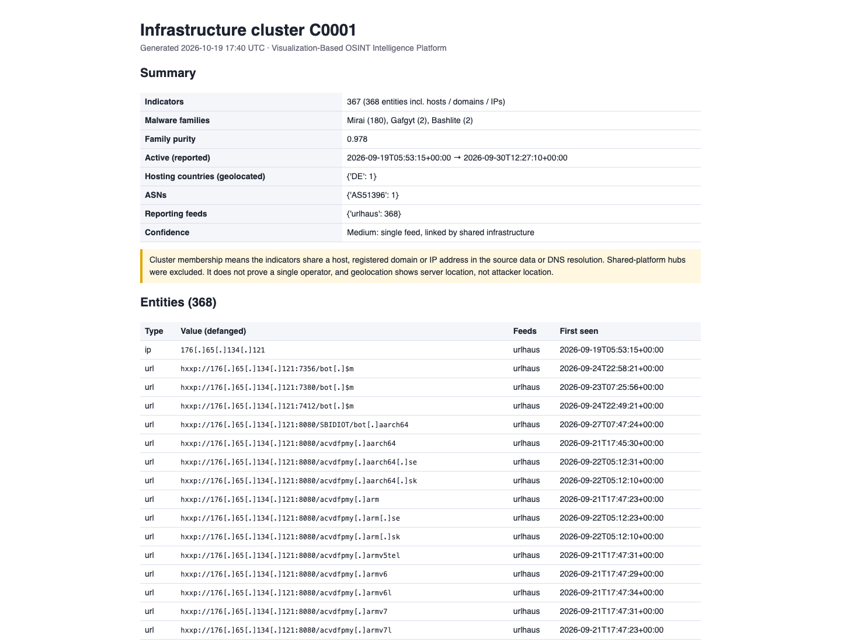
Figure 11. Automatically generated, defanged cluster investigation report with evidence trail

8. Findings, Evidence and Validation

8.1 Key findings
- Mass abuse of code hosting: The largest single burst in the window was SmartLoader (13,770 new URLs on 2026-10-06, z = 5.38). Almost all of these are hosted on raw.githubusercontent.com. The timeline shows the burst, but only the graph view reveals that the URLs share no infrastructure beyond GitHub itself. Read alone, the timeline would suggest one massive campaign server.
- Botnet distribution infrastructure: The largest genuine cluster (C0001) holds 367 indicators dominated by Mirai (purity 0.978), on 1 IP address(es) in DE. This is a typical IoT-botnet distribution pattern: many short-lived URLs on a small set of servers.
- Clusters are family-consistent: Clusters where all labelled nodes carry one family dominate (weighted purity 0.924). Infrastructure linkage alone, with no malware labels used, recovers family-consistent groups, so the clusters are meaningful campaign candidates rather than artefacts.
- Concentrated hosting: The ten most heavily used hosting ASNs hold 5,955 of 10,573 geolocated IPs. 3,408 IPs are flagged as hosting/datacentre and 7,165 as residential or other, which is consistent with compromised home routers in IoT botnets.
- Low feed overlap: Only 44 of 9,221 IPs and 27 of 2,632 hosts appear in more than one feed. The feeds are largely complementary rather than redundant, which supports combining them. It also means most indicators rest on a single source.

8.2 Cross-source validation
Every derived attribute that could be checked against an independent source was checked.
Table 16. Cross-source validation results
Check | Sources compared | Compared | Agreement | Interpretation
ASN of each IP | ip-api vs Team Cymru (BGP) | 10,292 | 98.7% | High: ASN attribution is reliable
Country of each IP | ip-api geolocation vs RIR registry country (Cymru) | 10,374 | 76.0% | Country-level location is mostly reliable; disagreements are shown as a caveat on the map [L9]
Indicator corroboration | URLhaus vs ThreatFox vs OpenPhish | 11,853 hosts+IPs | 71 multi-feed | Multi-feed entities flagged as higher confidence in reports
Cluster consistency | Infrastructure clusters vs ThreatFox/URLhaus family labels | 3,954 | purity 0.924 | Clusters align with independent family labels

Most frequent geolocation vs registry disagreements: CA vs US (584); DE vs US (104); NL vs DE (80); HK vs US (79); SG vs US (71). These are typically address blocks registered in one country and announced or used in another, which is exactly the uncertainty the map caveat warns about.

8.3 Misinterpretation experiments
Section 5 claims that each safeguard changes what an analyst would conclude. Three experiments test that claim on the real dataset.
Experiment A – hub suppression (graph). Without suppression the largest connected 'campaign' has 13,580 entities, glued together through platforms such as raw.githubusercontent.com. With suppression it has 368. An analyst working from the unsuppressed graph would have reported thousands of unrelated indicators as one operation.
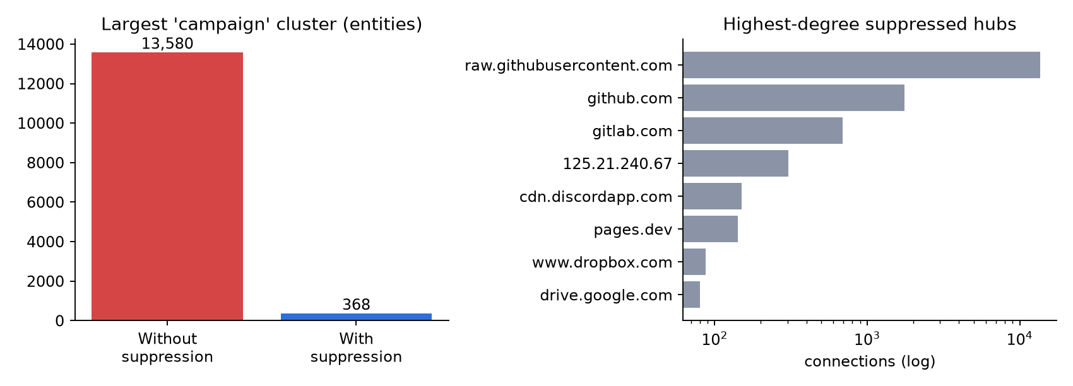
Figure 12. Experiment A: effect of hub suppression on the largest cluster, and the suppressed hubs with most connections
Table 17. Cluster structure with and without hub suppression
Metric | Without suppression | With suppression
clusters | 5,036 | 5,019
largest cluster | 13,580 | 368
labelled clusters | 3,968 | 3,954
mixed family clusters | 557 | 548
weighted purity | 0.933 | 0.924

Purity is slightly lower with suppression. Removing hubs splits the giant component into many small clusters, so small mixed clusters now count individually, while the giant cluster previously counted as one mostly-SmartLoader group. Purity alone would therefore have rewarded the false merge. This is why cluster size is reported together with purity.
Experiment B – metric choice (heat map). Ranking countries by URLs, by distinct IPs and by IPs per million IPv4 gives different answers. The top 10 by URLs and by distinct IPs share 10 countries (Spearman ρ = 0.954); distinct IPs and normalised share 3 (ρ = 0.362) across 68 countries. URLs and IPs agree on membership but not on order: the Netherlands is 2nd by URLs but 6th by distinct IPs, because a few Dutch servers host many URLs each. Normalisation changes the picture completely: the United States holds the second-most IPs but drops out of the top 10 relative to its very large address space, while smaller countries rise. The raw map answers 'where is most infrastructure', the normalised map answers 'which countries are over-represented for their size'. The dashboard keeps both, labelled, and warns that URL counts are inflated.
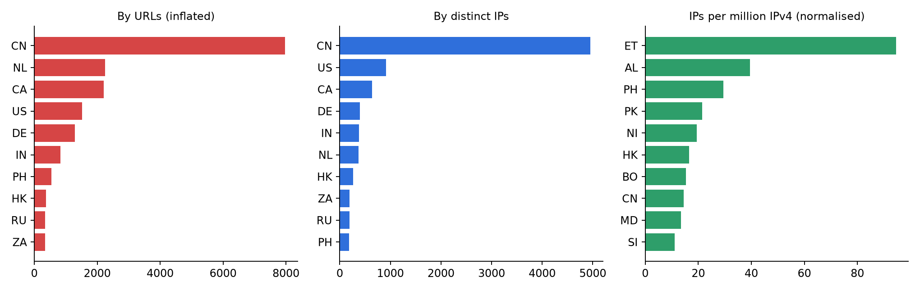
Figure 13. Experiment B: top-10 hosting countries under three metrics
Experiment C – time semantics (timeline). ThreatFox's 'recent' export re-lists indicators whose first sighting dates back to 2021–2022 because they were seen again. Plotting first-seen dates naively produced a false Cobalt Strike 'burst' in December 2022 during development. Restricting the timeline to the investigation window and labelling the axis as report time removed it. OpenPhish has no timestamps at all; drawing its 300 URLs at the download time would have created another artificial spike, so they are excluded from the timeline.
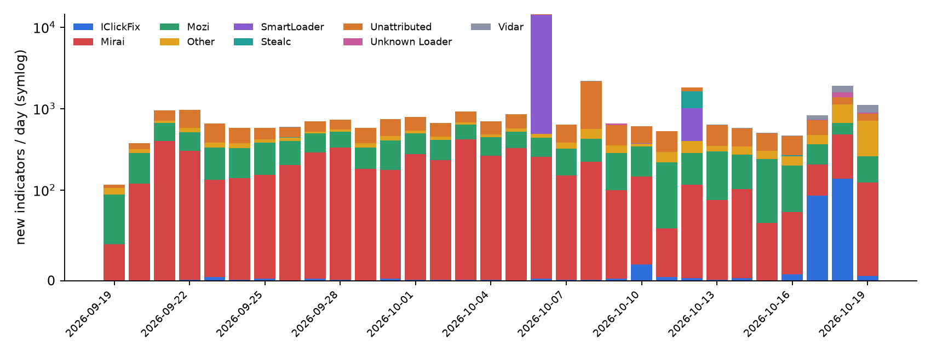
Figure 14. Daily newly reported indicators by family (symmetric-log scale)
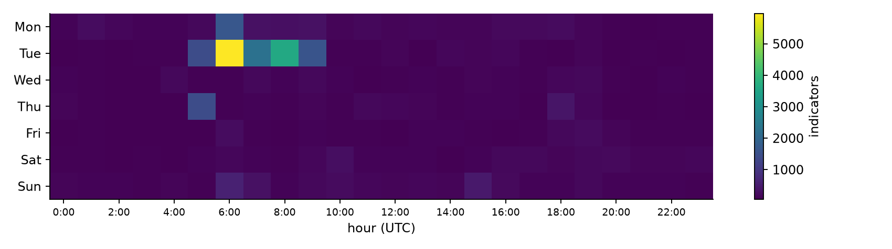
Figure 15. Temporal heat map: reports by weekday and hour (UTC)

8.4 Functional testing
A pytest suite (tests/test_pipeline.py, 10 tests, all passing) covers refang/defang, URL and ip:port parsing, registered-domain extraction, rejection of bad timestamps and duplicates, defanged free-text IOC extraction, provenance on extracted edges, reporter pseudonymisation, and both hub-suppression rules on a synthetic graph in which two unrelated families share one host. Every dashboard route and API was smoke-tested through Flask's test client. The offline mode was verified by restoring the snapshot and checking all SHA-256 hashes.

8.5 Limitations
- Reporting bias: Feeds reflect what volunteers report. Coverage follows reporter interest (Section 6.6), and absence from a feed is not evidence of safety.
- Enrichment time-lag: DNS and geolocation describe infrastructure at enrichment time, not at report time. Fast-flux hosts may have moved. Enrichment edges are therefore drawn dashed.
- Geolocation accuracy: ip-api is a single commercial geolocation database. It was cross-checked against registry country, but registry country is itself only an approximation of physical location.
- Family labels: mapping URLhaus tags to families is heuristic and is labelled 'tag-inferred'. Many indicators remain unattributed.
- Hub rules: the shared-platform list is curated by hand, and the family threshold (5) is a tunable parameter. Some legitimately shared criminal bulletproof hosting may be suppressed, and some unknown platforms may be missed.
- Service limits: the free ip-api tier is rate-limited (about 15 requests per minute) and intended for non-commercial use. A production deployment would need a licensed provider.
- No user study: the safeguards were evaluated through data experiments, not a user study with analysts.

9. Ethical and Legal Considerations
- Passive collection only: all data comes from public feeds and passive lookups (DNS, registry, geolocation). The platform never connects to, scans, downloads from or logs in to any indicator.
- Terms of service: abuse.ch data is published for free use under its terms of use; OpenPhish Community and ip-api free tiers are used for non-commercial, academic purposes within documented rate limits; all requests carry an identifying User-Agent.
- Privacy and minimisation: the platform analyses infrastructure, not people. Reporter handles are replaced by stable pseudonyms (R-xxxxxx) in every output and used only in aggregate. No WHOIS registrant data or other personal data is collected, in line with purpose limitation and data minimisation [L3], [R5].
- Safe handling of malicious content: the committed snapshot is gzip-compressed, so live malicious URLs are not clickable or indexed in the repository. HTML reports defang every indicator (hxxp, [.]).
- Responsible presentation: every view states what it does not show (hosting location ≠ attacker, report time ≠ attack time, link ≠ same operator). Cluster reports state their confidence and evidence. Results are triage aids to be verified by an analyst before any blocking or reporting [R7].
- Legal: no system is accessed without authorisation, which keeps the work clear of computer-misuse provisions such as the Information Technology Act, 2000 (India) [R6] and the US Computer Fraud and Abuse Act [R8]. This is a design intention, not legal advice.

10. Impact and Significance
- Integration: one pipeline replaces manual cross-referencing of three feeds and four enrichment services, producing a 50,391-entity knowledge graph in minutes on a laptop.
- Question-driven visualization: each investigative question is matched to the visualization that answers it best, with a written justification and failure modes.
- Measurably fewer misreadings: the experiments show that ignoring shared platforms, metric choice or time semantics would change the investigation's conclusions. The safeguards are therefore functional, not cosmetic.
- Evidence-grade outputs: every edge is traceable to a feed record or enrichment method, and every number in this report can be reproduced offline from a hash-verified snapshot.
- Interoperability: GEXF and CSV exports let analysts continue the work in Gephi or a spreadsheet.

11. Future Work
- Passive DNS history so that host → IP links are time-stamped at report time, removing the enrichment time-lag.
- A second geolocation provider and latency-based checks to quantify geolocation uncertainty per IP.
- Learning the hub threshold from data (for example the tenant count per IP from passive DNS) instead of a fixed list.
- A controlled user study with analysts comparing task accuracy with and without the safeguards.
- STIX 2.1 export and MISP integration for sharing clusters.
- Scheduled collection to build a longitudinal dataset and track clusters over months.

12. Conclusion
The project delivered a working, reproducible visualization-based OSINT intelligence platform. It turns three public feeds and four enrichment sources into a provenance-labelled knowledge graph of 50,391 entities and 145,463 relationships, analyses it with graph, temporal, geographic and social-network methods, and presents it through a graph, a link chart, a timeline and heat maps. The evaluation showed that no single technique answers every investigative question: graphs suit structure, link charts suit explanation, timelines suit sequence and heat maps suit concentration. Each also has a characteristic way of misleading. Building safeguards into the views (hub suppression, distinct-IP weighting and normalisation, report-time semantics, and evidence on every edge) changed the conclusions an analyst would draw from the same data. In particular, it prevented a false 13,580-entity 'campaign'. The findings were cross-validated against independent sources, and the limitations are stated explicitly.

Repository
Source code, phase-by-phase commit history, the frozen dataset snapshot and setup instructions: https://github.com/Taniaa-p/OSINT-2

References
Literature survey
[L1] A. Yadav, A. Kumar and V. Singh, "Open-source intelligence: a comprehensive review of the current state, applications and future perspectives in cyber security," Artificial Intelligence Review, vol. 56, pp. 12407–12438, 2023. doi:10.1007/s10462-023-10454-y
[L2] T. O. Browne, M. Abedin and M. J. M. Chowdhury, "A systematic review on research utilising artificial intelligence for open source intelligence (OSINT) applications," International Journal of Information Security, vol. 23, pp. 2911–2938, 2024. doi:10.1007/s10207-024-00868-2
[L3] T. Riebe, T. Biselli, M.-A. Kaufhold and C. Reuter, "Privacy concerns and acceptance factors of OSINT for cybersecurity: A representative survey," Proceedings on Privacy Enhancing Technologies, vol. 2023, no. 1, pp. 477–493, 2023. doi:10.56553/popets-2023-0028
[L4] F. Böhm, F. Menges and G. Pernul, "Graph-based visual analytics for cyber threat intelligence," Cybersecurity, vol. 1, art. 16, 2018. doi:10.1186/s42400-018-0017-4
[L5] I. Sarhan and M. Spruit, "Open-CyKG: An open cyber threat intelligence knowledge graph," Knowledge-Based Systems, vol. 233, art. 107524, 2021. doi:10.1016/j.knosys.2021.107524
[L6] B. Yan, C. Yang, C. Shi, Y. Fang, Q. Li, Y. Ye and J. Du, "Graph mining for cybersecurity: A survey," ACM Transactions on Knowledge Discovery from Data, vol. 18, no. 2, pp. 1–52, 2023. doi:10.1145/3610228
[L7] I. Pete, J. Hughes, Y. T. Chua and M. Bada, "A social network analysis and comparison of six dark web forums," in Proc. IEEE European Symposium on Security and Privacy Workshops (EuroS&PW), 2020, pp. 484–493. doi:10.1109/EuroSPW51379.2020.00071
[L8] Y. Hu, F. Wang, C. Guin and H. Zhu, "A spatio-temporal kernel density estimation framework for predictive crime hotspot mapping and evaluation," Applied Geography, vol. 99, pp. 89–97, 2018. doi:10.1016/j.apgeog.2018.08.001
[L9] M. Gouel, K. Vermeulen, R. Beverly, O. Fourmaux and T. Friedman, "IP geolocation database stability and implications for network research," in Proc. Network Traffic Measurement and Analysis Conference (TMA), IFIP, 2021.
[L10] L. Jiang, A. Jayatilaka, M. Nasim, M. Grobler, M. Zahedi and M. A. Babar, "Systematic literature review on cyber situational awareness visualizations," IEEE Access, vol. 10, pp. 57525–57554, 2022. doi:10.1109/ACCESS.2022.3178195
[L11] A. Komadina, Ž. Mihajlović and S. Groš, "Analysis of the design space for cybersecurity visualizations in VizSec," in Proc. IEEE Symposium on Visualization for Cyber Security (VizSec), 2022, pp. 1–11. doi:10.1109/VizSec56996.2022.9941422
[L12] V. G. Li, M. Dunn, P. Pearce, D. McCoy, G. M. Voelker, S. Savage and K. Levchenko, "Reading the tea leaves: A comparative analysis of threat intelligence," in Proc. 28th USENIX Security Symposium, 2019.
[L13] X. Bouwman, H. Griffioen, J. Egbers, C. Doerr, B. Klievink and M. van Eeten, "A different cup of TI? The added value of commercial threat intelligence," in Proc. 29th USENIX Security Symposium, 2020, pp. 433–450.
[L14] U. Kumarasinghe, M. Nabeel and C. Elvitigala, "Blocklist-Forecast: Proactive domain blocklisting by identifying malicious hosting infrastructure," in Proc. 27th Int. Symposium on Research in Attacks, Intrusions and Defenses (RAID), ACM, 2024, pp. 35–48. doi:10.1145/3678890.3678925
[L15] L. Y.-H. Lo, A. Gupta, K. Shigyo, A. Wu, E. Bertini and H. Qu, "Misinformed by visualization: What do we learn from misinformative visualizations?" Computer Graphics Forum, vol. 41, no. 3, pp. 515–525, 2022. doi:10.1111/cgf.14559
[L16] S. Di Bartolomeo, A. Pandey, A. Leventidis, D. Saffo, U. H. Syeda, E. Carstensdottir, M. Seif El-Nasr, M. A. Borkin and C. Dunne, "Evaluating the effect of timeline shape on visualization task performance," in Proc. ACM CHI Conference on Human Factors in Computing Systems, 2020, pp. 1–12. doi:10.1145/3313831.3376237
Data sources, tools and standards
[R1] abuse.ch, "URLhaus" and "ThreatFox" – data exports and terms of use. https://urlhaus.abuse.ch, https://threatfox.abuse.ch
[R2] OpenPhish, "Community Phishing Feed." https://openphish.com
[R3] ip-api.com, "Batch JSON API documentation." https://ip-api.com/docs/api:batch ; Team Cymru, "IP to ASN Mapping Service." https://www.team-cymru.com/ip-asn-mapping
[R4] Number Resource Organization, "NRO extended allocation and assignment statistics." https://ftp.ripe.net/pub/stats/ripencc/nro-stats/
[R5] Regulation (EU) 2016/679 (General Data Protection Regulation), 2016.
[R6] Government of India, The Information Technology Act, 2000 (as amended).
[R7] P. Cichonski, T. Millar, T. Grance and K. Scarfone, "Computer Security Incident Handling Guide," NIST SP 800-61 Rev. 2, 2012.
[R8] 18 U.S.C. § 1030, Computer Fraud and Abuse Act.
[R9] A. Hagberg, D. Schult and P. Swart, "Exploring network structure, dynamics, and function using NetworkX," in Proc. 7th Python in Science Conf. (SciPy), 2008, pp. 11–15.
[R11] V. D. Blondel, J.-L. Guillaume, R. Lambiotte and E. Lefebvre, "Fast unfolding of communities in large networks," J. Statistical Mechanics: Theory and Experiment, P10008, 2008 (Louvain algorithm used in Section 6.3).
[R10] M. Franz, C. T. Lopes, G. Huck, Y. Dong, O. Sumer and G. D. Bader, "Cytoscape.js: a graph theory library for visualisation and analysis," Bioinformatics, vol. 32, no. 2, pp. 309–311, 2016.

