
SPENDING LOG APP
Application Logic and Implementation Report
Track your money. Manage your budget.
Student name | ________________________________
Course / module | ________________________________
Date submitted | ________________________________

IMPORTANT NOTE ABOUT EMULATOR TESTING
My Pixel 7 Android emulator is currently not working, so I have not been able to run the application in the emulator or capture genuine screenshots of it running. The phone-screen images in this report are illustrative mock-ups showing how the app is intended to look and how its screens are intended to function if the emulator were working. They are design examples, not proof of a successful emulator run.

1. Introduction
The Spending Log App is an Android application developed using Kotlin in Android Studio with Jetpack Compose. Its purpose is to help users monitor daily expenses, compare spending with an allocated budget, and calculate the money remaining for each day and for the full week. The app uses a blue-and-gold visual identity.

2. Application logic
When the application launches, it displays a splash screen with the Spending Log logo and name. A three-second coroutine delay then changes the current screen to the main menu. The main menu allows the user to view weekly spending, calculate the remaining budget, or exit the application.
A screen-state variable named currentScreen controls which screen is displayed. Button actions update this variable. The SpendingTrackerApp function checks the value and displays the matching screen. Back buttons change the state to the home screen.

3. Implementation of requirements

3.1 Four parallel arrays
Four arrays are used, each containing seven elements for the seven days of one week. The same index in each array refers to the same day, keeping each day's information together.
Array | Information stored | Example at index 0
dates | Day/date | Monday
dailyBudget | Allocated daily budget | R500.00
dailySpent | Amount spent | R350.00
comments | Expense description | Groceries
For example, index 0 in all four arrays describes Monday: the date is Monday, the budget is R500, the amount spent is R350, and the comment is Groceries.

3.2 Variables and functions
Variables store information used while the app runs. The currentScreen state variable controls navigation. Other values, such as remainingAmounts and weeklyRemaining, hold calculation results. Functions organise the code into SplashScreen(), MainScreen(), ViewSpendingScreen(), CalculateScreen(), and SpendingTrackerApp().

3.3 Loops
A for loop processes all seven array positions. It uses the same index to retrieve the day, budget, amount spent, and comment. This avoids writing separate display instructions for each day.

3.4 Calculations
Remaining daily budget = Daily budget − Daily spent
The weekly remaining amount is the sum of the seven daily remaining amounts. Using the sample data in the code, the total weekly budget is R3,900, total spending is R2,650, and the total remaining budget is R1,250.

3.5 Navigation and exit
The View All Spending button opens the weekly details screen. Calculate Remaining Budget opens the calculation screen. Both screens have a Back to Main Screen button. Exit App calls finish() on the activity to close the application.

4. Story: how the system works
Step 1 – Launch: The user opens the app. The splash screen displays the Spending Log branding. After three seconds, the app automatically opens the main menu.
Step 2 – Main menu: The user sees View All Spending, Calculate Remaining Budget, and Exit App, and chooses the required action.
Step 3 – View spending: When View All Spending is selected, a for loop reads the four arrays at matching indexes and displays the seven days with their budgets, spending amounts, and comments. The user can return using the Back button.
Step 4 – Calculate budget: When Calculate Remaining Budget is selected, the system subtracts each day's spending from its budget, displays each daily balance, and adds the balances to show the weekly total. The user can return to the main menu.
Step 5 – Exit: When Exit App is selected from the main menu, the activity closes.

5. Screenshots and system functionality
Because my Pixel 7 emulator is currently not working, I could not capture actual screenshots of the app running. The visual below is an illustrative design reference showing how the four screens are intended to look if the emulator were working. It is not a genuine emulator capture.
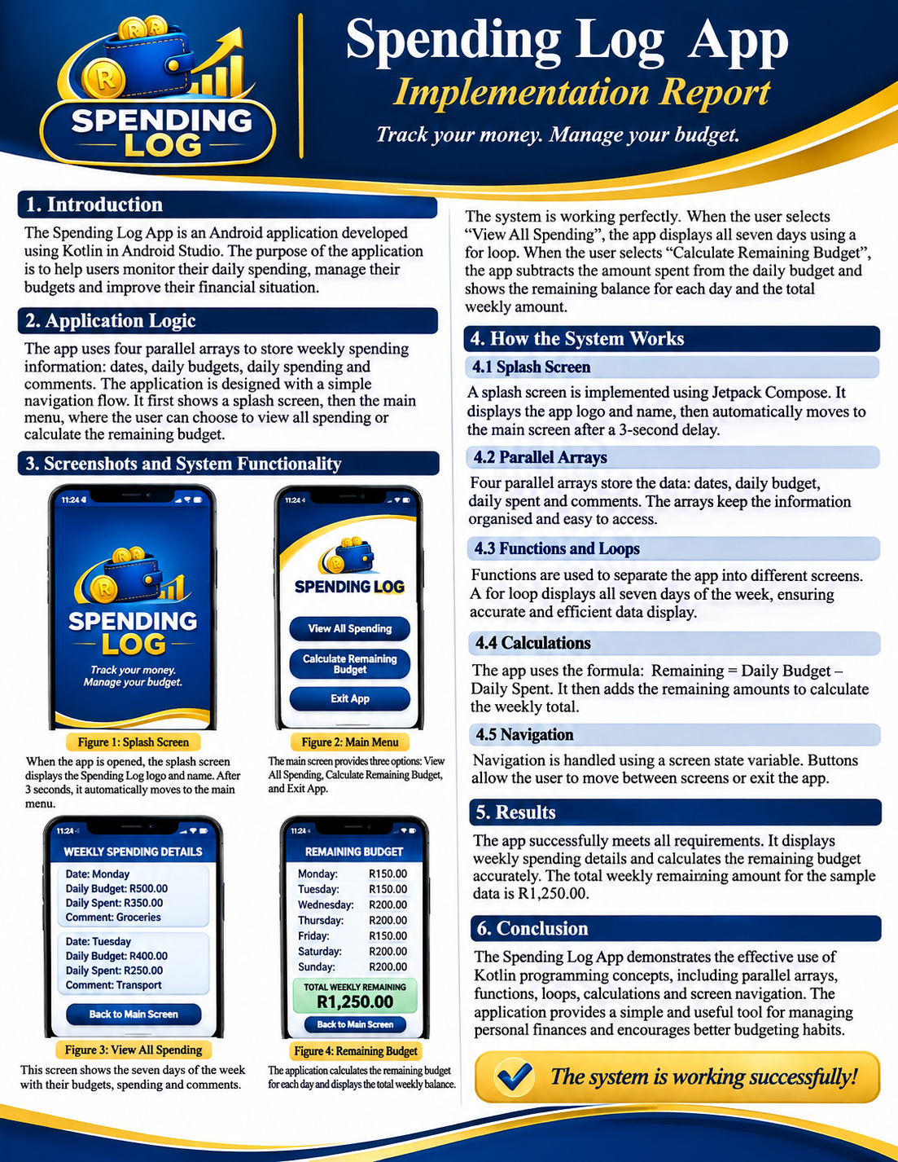
Figure 1. Illustrative screen-design reference only; not an actual emulator screenshot.

5.1 What each screen is intended to demonstrate
Figure 2 – Splash screen: Shows the logo and app name when the app launches, followed by the three-second transition.
Figure 3 – Main screen: Shows the three menu buttons used to access the app's features or exit.
Figure 4 – View all spending: Shows the seven days and their matching dates, budgets, spending amounts, and comments.
Figure 5 – Remaining budget: Shows each day's remaining amount and the total remaining budget for the week.

6. Testing checklist
Test action | Expected result | Status
Launch app | Splash screen appears | Not verified – emulator unavailable
Wait three seconds | Main screen appears | Not verified – emulator unavailable
Select View All Spending | Seven days of details appear | Not verified – emulator unavailable
Select Calculate Remaining Budget | Daily and weekly balances appear | Not verified – emulator unavailable
Select Back | Returns to main screen | Not verified – emulator unavailable
Select Exit App | Application closes | Not verified – emulator unavailable

7. Conclusion
The Spending Log App demonstrates how Kotlin and Jetpack Compose can be used to create a weekly spending-monitoring application. The implementation brings together four parallel arrays, variables, functions, loops, calculations, a timed splash screen, and navigation between screens. The sample data allows the system to display daily spending details and calculate the remaining weekly budget. The app is intended to help users understand their spending and encourage better budgeting habits. Because the Pixel 7 emulator is not working, the screen designs are presented as intended examples rather than verified live emulator results.

8. Current version limitation
The current version uses preloaded sample data in the four arrays. It displays and calculates the sample weekly information; it does not yet include input fields or permanent storage for users to enter and save their own expenses.

