**Study Of Processor**

**1. Introduction**

* **What is a Processor?**: A processor (CPU – Central Processing Unit) is often described as the "brain" of a computer. It executes instructions from software programs, performing basic arithmetic, logic, control, and input/output operations.
* **Role in Computing**: Processors are essential for the functioning of all digital devices, from smartphones and laptops to supercomputers and IoT devices.
* **Types of Processors**: Single-core, multi-core processors, and the emergence of specialized processors (like GPUs for graphic tasks, or NPUs for AI-based tasks) have enhanced performance across different fields.

**Importance**: A good processor enhances performance and power efficiency in everything from gaming and machine learning to real-time . 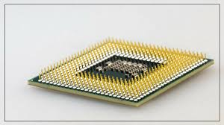

**Fig-1.1**

**2. History**

* **Inception of the Microprocessor**: The first microprocessor was Intel's 4004, released in 1971. It marked the beginning of modern computing. It had 2,300 transistors and operated at a speed of 740 kHz.
* **Key Milestones**:
  + 1974: Intel 8080, the foundation of modern CPUs.
  + 1978: Introduction of x86 architecture with the Intel 8086.
  + 1993: Intel Pentium processors, setting new standards for speed and multitasking.
* **Transition to Multi-core Processors**: Initially, processors were single-core, which limited their multitasking abilities. As computing demands grew, the transition to dual-core and multi-core processors happened, allowing systems to handle more tasks simultaneously.
* **Technological Evolution**: From large-scale integrated circuits to today’s ultra-small, power-efficient processors with billions of transistors packed into tiny chips.

**3. Available Technologies in the Field**

* **x86 Architecture**: Dominates the PC and server market, developed by Intel and AMD. These processors are used for general-purpose computing and are known for high performance but can be power-hungry.
* **ARM Architecture**: Used primarily in mobile devices (smartphones, tablets) and IoT due to its low power consumption. ARM processors are designed by ARM Holdings but are licensed to companies like Apple, Qualcomm, and Samsung for customization.
* **RISC vs. CISC**: ARM uses RISC (Reduced Instruction Set Computing) architecture, while x86 is based on CISC (Complex Instruction Set Computing). RISC focuses on efficiency and simplicity, while CISC allows for more complex instructions.
* **System on Chip (SoC)**: Integrates the CPU, GPU, memory, and other components into one chip, commonly used in smartphones (e.g., Apple A-series, Qualcomm Snapdragon).
* **Emerging Technologies**:
  + **Apple Silicon (M1/M2)**: These chips integrate CPU, GPU, and AI accelerators on a single chip for performance and efficiency.
  + **AMD's Ryzen Series**: Known for high multi-threaded performance, especially in gaming and productivity.
  + **Intel’s Alder Lake**: Combines performance and efficiency cores in one chip, optimized for handling different types of workloads.
  + 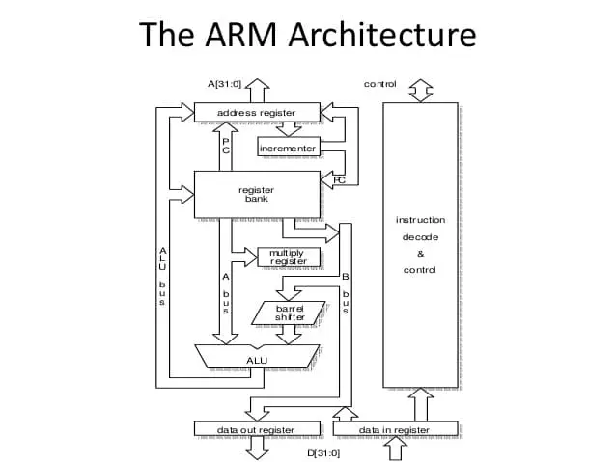

**4. Working and Basic Concepts**

* **Fetch-Decode-Execute Cycle**:
  + **Fetch**: The CPU fetches an instruction from memory.
  + **Decode**: The CPU interprets the instruction.
  + **Execute**: The CPU executes the instruction, performing the operation.
* **Key Components**:
  + **ALU (Arithmetic Logic Unit)**: Executes arithmetic and logical operations.
  + **Control Unit**: Directs the operation of the processor by interpreting instructions.
  + **Registers**: Small storage locations within the CPU that hold data and instructions.
  + **Cache**: A small, faster memory located in the CPU to store frequently used data and instructions for quick access.
* **Clock Speed**: Measured in GHz, it represents the number of cycles a CPU can perform per second. Higher clock speeds usually mean faster performance.
* **Instruction Sets (CISC vs. RISC)**:
  + **CISC (Complex Instruction Set Computing)**: Offers more complex instructions but can take more clock cycles to complete.
  + **RISC (Reduced Instruction Set Computing)**: Focuses on simpler instructions executed more efficiently.
* **Multi-core Processing**: Processors now have multiple cores, allowing them to perform multiple tasks in parallel, improving multitasking and performance.
* **Power Efficiency**: Modern processors aim for a balance between performance and power consumption, especially in mobile devices where battery life is critical.

**5. Study of Various Parameters (Cost, Speed, Performance)**

* **Cost**:
  + High-end processors like Intel’s i9 or AMD’s Ryzen 9 are expensive but offer exceptional performance for gaming, 3D rendering, and professional applications.
  + Low- to mid-range processors are more affordable and sufficient for regular computing tasks.
* **Speed**:
  + **Clock Speed**: Higher clock speeds generally lead to faster processing times, but this is not the only factor.
  + **Number of Cores**: Multi-core processors allow systems to divide workloads across cores for better efficiency.
  + **IPC (Instructions Per Clock)**: Refers to how many instructions a processor can execute per clock cycle. Higher IPC means better performance at the same clock speed.
* **Performance**:
  + Different benchmarks like Cinebench or Geekbench measure CPU performance for single-threaded and multi-threaded workloads.
  + For gaming, performance is often measured in FPS (Frames per Second), and high-performance processors tend to improve overall gaming smoothness and experience.

**6. Market Study**

* **Number of Users**:
  + The global PC processor market is dominated by Intel and AMD.
  + ARM-based processors dominate the smartphone market, used in more than 90% of smartphones globally.
* **Big Players**:
  + **Intel**: Leading provider in x86 processors for PCs and servers.
  + **AMD**: Gaining market share with Ryzen processors, known for strong multi-core performance.
  + **Qualcomm**: Leading ARM processor provider for mobile devices with their Snapdragon line.
  + **Apple**: Innovator with its custom ARM-based M1/M2 chips, offering high performance and efficiency.
* **Market Trends**:
  + Growth in cloud computing is driving demand for server processors.
  + AI and machine learning are creating new demands for specialized processors (e.g., NPUs, TPUs).
  + Gaming continues to push the demand for high-performance consumer processors.

**7. Future Advancements**

* **Quantum Processors**: Quantum computing represents a shift from classical binary computing to qubits, which can represent multiple states simultaneously. Companies like IBM and Google are leading research in this field.
* **Neuromorphic Processors**: Designed to mimic the human brain, these processors could revolutionize AI by offering more efficient data processing. Intel’s Loihi chip is an example.
* **Sub-5nm Process Technology**: As we approach the limits of Moore’s Law, new fabrication techniques are pushing the boundaries of miniaturization and performance in chips.
* **Integration with AI**: Processors are being designed with built-in AI accelerators to handle tasks like voice recognition and machine learning faster and more efficiently.

**8. Conclusion**

In summary, processors have undergone significant transformations since their inception. From the creation of the first microprocessor in 1971 to today’s advanced multi-core processors, their evolution has been rapid and impactful. Processors are integral to modern technology, powering devices from personal computers to complex supercomputers. The shift toward multi-core processors, energy-efficient designs, and specialized processors like GPUs and NPUs has further extended their capabilities.

The future holds exciting advancements in the processor industry, with emerging technologies like quantum processors, neuromorphic chips, and AI-accelerated computing. As semiconductor manufacturing processes continue to shrink, processors will become even more powerful and efficient, shaping the future of artificial intelligence, mobile computing, cloud services, and other industries. India's contributions, especially through organizations like C-DAC and government-led semiconductor missions, highlight the country’s potential to become a significant player in this field.

In conclusion, processors will remain the driving force behind technological innovation, pushing boundaries in computing power, efficiency, and specialized functionality. The next generation of processors will undoubtedly open new doors for advancements in many fields, from personal computing to space exploration.

**9. Indian Contributions to the Field**

* **C-DAC (Centre for Development of Advanced Computing)**: Played a significant role in developing India's first supercomputer, PARAM, which utilized indigenous processors.
* **Semiconductor Design**: Indian engineers have contributed to chip design for global giants like Intel, Qualcomm, and ARM.
* **Government Initiatives**: India's “Semiconductor Mission” aims to boost semiconductor production domestically, ensuring India is not only a consumer but a contributor to global processor development.

**10. References**

• **Intel Corporation**: "History of Intel CPUs: Milestones in Processor Development," retrieved from Intel’s official documentation.

• **AMD**: "AMD Ryzen Processors: A New Era of Computing," AMD’s official whitepapers and product descriptions.

• **ARM Holdings**: "RISC Architecture and the Future of Mobile Processors," ARM technical documentation.

• **Apple**: "M1 Chip: Technical Overview," retrieved from Apple’s press releases and technical overviews.

**Study Of Magnetic Disk**

**1. Introduction**

* **What is a Magnetic Disk?**: Magnetic disks are storage devices that store data using magnetic patterns. These disks are widely used in hard disk drives (HDDs) to store large amounts of data at a relatively low cost.
* **Importance in Data Storage**: Magnetic disks have been the backbone of data storage for decades, providing persistent storage for everything from personal computers to enterprise data centers.
* **Use Cases**: Magnetic disks are primarily used for secondary storage in computers, backup systems, and data centers due to their high capacity and durability.
* 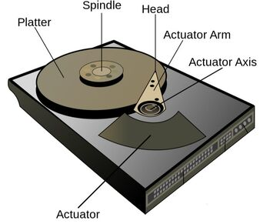

**2. History**

**Early Development**:

The concept of magnetic storage began in the 1950s with IBM's RAMAC (Random Access Method of Accounting and Control), which introduced the first magnetic hard disk drive in 1956. The RAMAC could store 5 MB of data and was about the size of two refrigerators.

**Evolution Over Time**:

The 1970s and 1980s saw significant improvements, with smaller, faster, and more reliable disk drives.

**Key Milestones**: Introduction of floppy disks, the standardization of interfaces like IDE and SATA, and the development of small form-factor drives for personal computers.

**Transition to Modern Hard Disk Drives (HDDs)**: Since the 1990s, HDDs have become the dominant form of magnetic disk storage, constantly evolving in capacity and performance.

**3. Available Technologies in the Field**

* **Hard Disk Drives (HDDs)**:
  + HDDs are the most common application of magnetic disks. They use rotating platters coated with magnetic material, with data being written and read by a magnetic head.
  + **Technological Improvements**:
    - **Perpendicular Magnetic Recording (PMR)**: Allows for denser data storage by recording bits perpendicular to the disk surface.
    - **Shingled Magnetic Recording (SMR)**: Another technique to increase data density by slightly overlapping tracks.
    - **Heat-Assisted Magnetic Recording (HAMR)**: Uses heat to reduce the amount of energy needed to change the magnetic state, allowing for even higher storage densities.
* **Floppy Disks**: Once a popular form of removable magnetic storage, now largely obsolete.
* **Tape Drives**: Used primarily for large-scale data backups and archiving in data centers.

**4. Working and Basic Concepts**

* **Structure of a Magnetic Disk**: A magnetic disk consists of one or more platters coated with a magnetic material. Data is written onto the disk by a write head that alters the magnetic polarity of the disk surface.
* **Data Access Mechanism**:
  + **Rotational Movement**: The disk spins at a constant speed (measured in RPM), while the read/write heads move across the disk surface to access data.
  + **Track and Sector Organization**: Data is organized into concentric circles called tracks, which are further divided into sectors. The drive uses an addressing system to locate specific data.
* **Data Storage Principle**:
  + The surface of the disk is divided into small regions called magnetic domains. Each domain can be magnetized in one of two directions, representing binary data (1s and 0s).
  + **Reading and Writing**: The read/write head either writes by aligning these domains or reads by detecting their magnetic orientation.
* **Caching Mechanism**: Modern HDDs use cache memory to temporarily store frequently accessed data, improving overall performance.

**5. Study of Various Parameters (Cost, Speed, Performance)**

* **Cost**:
  + Magnetic disks (HDDs) are much cheaper per gigabyte compared to solid-state drives (SSDs), making them suitable for large-scale storage needs.
  + The cost is influenced by factors such as capacity, RPM, and interface (SATA, SAS).
* **Speed**:
  + HDDs are generally slower than SSDs because they rely on mechanical components. The rotational speed (typically 5400 RPM or 7200 RPM) and seek time (how quickly the head can locate data) affect the overall speed.
  + **Data Transfer Rates**: Measured in MB/s, HDDs offer lower transfer speeds compared to SSDs due to mechanical limitations.
* **Performance**:
  + **Sequential vs. Random Access**: HDDs perform well in sequential data transfers but struggle with random access due to the need for physical movement of the read/write heads.
  + **Longevity and Durability**: HDDs are prone to mechanical failure but have a long lifespan when used in optimal conditions.

**6. Market Study**

* **Number of Users**:
  + Despite the rise of SSDs, magnetic disks (HDDs) continue to be widely used due to their low cost and high capacity.
  + In data centers, HDDs are still essential for storing large volumes of data, such as backup archives and cloud storage.
* **Big Players**:
  + **Seagate**: A leader in the production of HDDs, especially in enterprise storage solutions.
  + **Western Digital (WD)**: A major competitor offering both consumer and enterprise-grade HDDs.
  + **Toshiba**: Known for both consumer and industrial storage solutions.
* **Market Trends**:
  + There’s been a shift toward hybrid storage solutions, combining SSDs for speed and HDDs for large-scale data storage.
  + The gaming industry, media storage, and cloud services continue to drive demand for high-capacity magnetic disks.
  + HDD manufacturers are continually working to increase data density and reduce power consumption to maintain relevance in the market.

**7. Future Advancements**

* **Technologies in Development**:
  + **HAMR (Heat-Assisted Magnetic Recording)**: Expected to become more widespread, offering multi-terabyte storage capacities by heating the disk surface to enable higher data density.
  + **Microwave-Assisted Magnetic Recording (MAMR)**: Another promising technology aimed at increasing storage density using microwaves to reduce the energy needed for data writing.
* **Improved Reliability and Longevity**: New materials and manufacturing techniques are being explored to make magnetic disks more durable and resistant to wear and tear.
* **Hybrid Drives**: Combining HDDs with small SSDs to create SSHDs (Solid-State Hybrid Drives) that offer better speed than traditional HDDs while maintaining a lower cost than full SSDs.
* **Energy Efficiency**: Future advancements will focus on reducing the power consumption of HDDs, making them more suitable for large data centers.

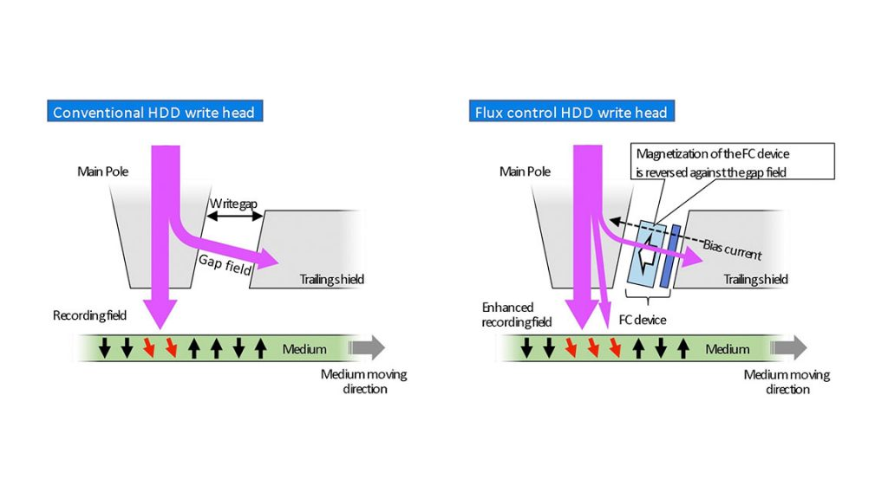

**8. Conclusion**

* Magnetic disks have been at the heart of data storage for decades, providing a balance of cost, capacity, and durability. While they may not match the speed of modern SSDs, their capacity and affordability make them indispensable in certain applications, especially where high-volume storage is required.
* As SSD technology becomes more affordable and widespread, magnetic disks will likely find their primary use in enterprise and archival storage solutions. However, with new advancements like HAMR and MAMR, magnetic disks could still play a crucial role in the future of data storage.
* The market for magnetic disks is expected to remain stable in data centers and backup systems, ensuring that this technology continues to evolve alongside newer storage solutions.

**9. Indian Contributions to the Field**

* **C-DAC’s Work**: India’s Centre for Development of Advanced Computing (C-DAC) has been involved in high-performance computing and storage technologies. C-DAC has played a role in research related to data storage, though more focus has been placed on overall computing infrastructure.
* **Government Initiatives**: India has been working to develop its semiconductor and storage industries, although magnetic disk manufacturing remains limited. Indian research institutions are contributing to the design of new storage architectures and data solutions.
* **R&D Collaborations**: Indian researchers and engineers have been collaborating with global giants in storage technology, contributing to advancements in magnetic disk technology, especially in software for storage management.

**10. References**

1. **IBM Archives**: "The History of Magnetic Disk Storage," retrieved from IBM’s official historical archives.
2. **Seagate**: "HAMR Technology: The Future of Magnetic Disk Storage," retrieved from Seagate’s official publications.
3. **Western Digital**: "Magnetic Disk Storage in the Data Age," whitepapers from Western Digital’s product information.
4. **IEEE Spectrum**: "Heat-Assisted Magnetic Recording: A Game Changer for HDDs," research papers from IEEE Spectrum.
5. **Tom’s Hardware**: "Comparing SSDs and HDDs: Cost, Speed, and Performance," technical reviews from Tom’s Hardware.

**Solid-State Drive**

**1. Introduction**

* **What is a Solid-State Drive (SSD)?**: An SSD is a type of non-volatile storage device that stores data on flash memory chips. Unlike traditional Hard Disk Drives (HDDs), SSDs have no moving parts, leading to faster data access, lower latency, and improved reliability.
* **Importance in Modern Computing**: SSDs have revolutionized data storage by providing significantly faster read/write speeds than HDDs, which has made them the go-to choice for personal computers, data centers, and enterprise applications.
* **Applications**: SSDs are used in personal computers, smartphones, data centers, servers, and cloud infrastructures due to their performance benefits and durability.

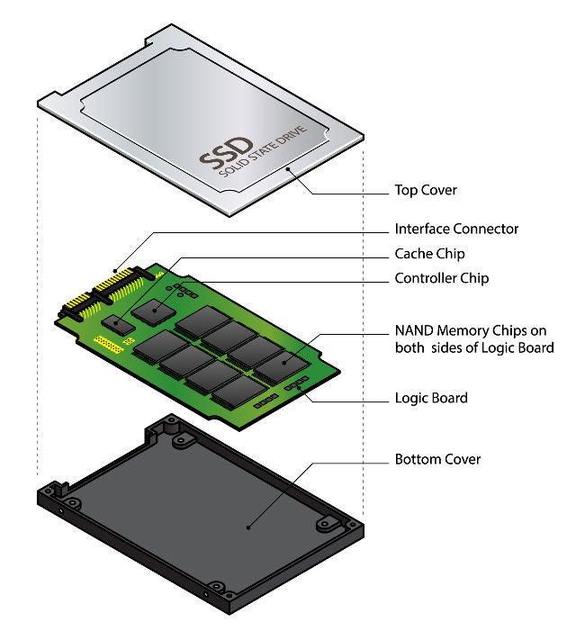

**2. History**

* **Early Development**:
  + The concept of solid-state storage dates back to the 1950s, but the first true SSDs emerged in the 1970s for specialized use in supercomputers.
  + Early SSDs were extremely expensive and had limited capacity.
* **1980s and 1990s**: SSDs were used in military and aerospace applications due to their ability to withstand extreme conditions. However, their high cost kept them out of the consumer market.
* **Consumer Market Entry**:
  + In the late 2000s, as flash memory prices dropped, SSDs began to enter the consumer market. Companies like Intel, Samsung, and SanDisk played key roles in making SSDs affordable and widely available.
  + **Key Milestones**:
    - 2007: Intel and Micron’s joint venture led to the development of NAND-based SSDs.
    - 2010: The widespread adoption of SSDs in laptops and desktops began, driven by performance improvements and cost reductions.
* **Present Day**: SSDs are now the standard in many devices, offering a faster, more reliable alternative to HDDs.

**3. Available Technologies in the Field**

* **NAND Flash Memory**:
  + **Single-Level Cell (SLC)**: Stores 1 bit of data per cell, providing the highest performance and durability, but at a higher cost.
  + **Multi-Level Cell (MLC)**: Stores 2 bits of data per cell, offering a balance between performance, endurance, and cost.
  + **Triple-Level Cell (TLC)**: Stores 3 bits per cell, increasing storage density but with reduced speed and durability compared to SLC and MLC.
  + **Quad-Level Cell (QLC)**: Stores 4 bits per cell, offering higher capacity at a lower cost but sacrificing speed and endurance.
* **3D NAND**: A newer technology where NAND cells are stacked vertically, increasing storage density and reducing costs without sacrificing performance.
* **NVMe (Non-Volatile Memory Express)**: A protocol designed for SSDs that leverages PCIe lanes for faster data access compared to older SATA-based SSDs.
* **SATA SSDs**: SSDs that use the traditional SATA interface, offering slower speeds than NVMe drives but still significantly faster than HDDs.
* 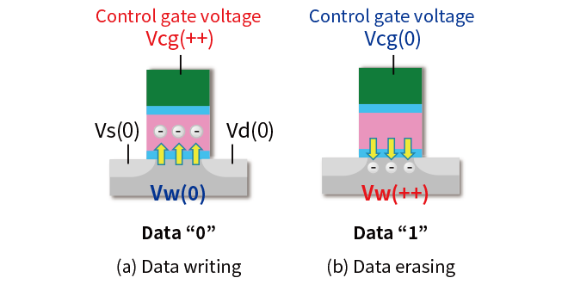

**4. Working and Basic Concepts**

* **How SSDs Work**:
  + **Flash Memory**: SSDs use NAND flash memory to store data in cells, where electrical charges represent data as 0s and 1s.
  + **Controller**: The controller in an SSD manages the read/write operations, error correction, and garbage collection (the process of reclaiming unused memory).
  + **Wear Leveling**: Since NAND flash memory has a limited number of write cycles, wear leveling ensures that data writes are distributed evenly across the cells to prolong the life of the SSD.
  + **TRIM Command**: This command enables the operating system to inform the SSD which blocks of data are no longer in use and can be erased, helping to maintain performance over time.
* **Key Differences from HDDs**:
  + SSDs have no moving parts, unlike HDDs which rely on spinning platters and read/write heads.
  + Data retrieval from SSDs is instantaneous, with no seek time or rotational latency as in HDDs.

**5. Study of Various Parameters (Cost, Speed, Performance)**

* **Cost**:
  + SSDs are more expensive per gigabyte compared to HDDs, though the price gap has been closing in recent years.
  + The cost varies depending on the type of NAND (SLC, MLC, TLC, QLC) and the interface (SATA, NVMe).
  + Larger capacities and faster speeds (especially in NVMe SSDs) tend to be more expensive.
* **Speed**:
  + **SATA SSDs**: Typically offer read/write speeds of around 500 MB/s, which is much faster than traditional HDDs (which max out at about 150 MB/s).
  + **NVMe SSDs**: Leverage PCIe lanes for significantly faster data transfer, often reaching speeds between 3,000–7,000 MB/s, depending on the model.
* **Performance**:
  + SSDs excel in random read/write operations and provide low latency, making them ideal for running operating systems, applications, and databases.
  + Performance degrades slightly with higher-density NAND types (e.g., QLC), though 3D NAND technology mitigates some of these issues.
  + SSDs offer superior energy efficiency, contributing to longer battery life in laptops and lower power consumption in data centers.

**6. Market Study**

* **Number of Users**:
  + SSD adoption has grown exponentially in recent years due to lower costs and widespread availability. They are now the standard in most laptops, desktops, and data centers.
  + According to market research, the global SSD market was valued at approximately $38 billion in 2020 and is projected to grow rapidly due to demand in cloud storage and enterprise solutions.
* **Big Players**:
  + **Samsung**: One of the leading SSD manufacturers, known for pioneering 3D NAND technology.
  + **Intel**: A key player in the development of NVMe SSDs and persistent memory technologies.
  + **Western Digital (WD)**: A major player in both consumer and enterprise SSD markets.
  + **Micron**: One of the leading manufacturers of NAND flash memory and SSDs, particularly in data centers.
  + **Kingston**: Popular in the consumer space for offering affordable, high-performance SSDs.
* **Market Trends**:
  + The transition from SATA to NVMe SSDs in consumer and enterprise markets.
  + Increasing demand for high-capacity SSDs, driven by the need for faster data processing in artificial intelligence (AI), machine learning (ML), and big data applications.
  + SSDs are becoming increasingly popular in gaming consoles, such as the PlayStation 5 and Xbox Series X, due to their speed advantages over HDDs.

**7. Future Advancements**

* **Next-Generation Storage Technologies**:
  + **Storage Class Memory (SCM)**: Technologies like Intel Optane combine the speed of SSDs with the persistence of DRAM, offering higher speeds and lower latency.
  + **QLC and Beyond**: More advanced NAND flash types like Penta-Level Cell (PLC) could further increase capacity but will require new methods to maintain acceptable speed and endurance.
  + **PCIe 5.0 and 6.0**: Upcoming PCIe generations will allow SSDs to reach even faster speeds, further reducing bottlenecks in data transfer.
* **Improved Longevity**: Research into reducing the wear on NAND cells will help extend the lifespan of SSDs, especially for enterprise use.
* **Energy Efficiency**: As data centers move toward sustainability, future SSDs will consume even less power, aiding in energy-saving goals.

**8. Conclusions**

* SSDs have fundamentally transformed how data is stored and accessed, offering significant improvements over traditional HDDs in speed, reliability, and energy efficiency. Their importance in personal computing, data centers, and cloud storage is undeniable.
* While HDDs still have a place in archival storage due to their lower cost per gigabyte, SSDs are the future of storage technology, especially with advancements in 3D NAND and NVMe protocols.
* The SSD market is expected to grow, driven by increased data generation and the demand for faster, more reliable storage solutions.
* Future advancements in SSD technology, including storage class memory and new NAND types, will push the boundaries of what SSDs can achieve in terms of speed, capacity, and durability.

**9. Indian Contributions to the Field**

* **R&D in SSD Technologies**: Indian engineers and researchers are contributing to the development of SSD technologies, particularly in optimizing NAND flash memory and controllers.
* **SSD Adoption in India**: As the IT and data storage industries grow, India is rapidly adopting SSDs, especially in cloud services, data centers, and enterprise computing.
* **Government Initiatives**: The Indian government has been investing in semiconductor and storage technology research, aiming to boost the country's capabilities in manufacturing and R&D related to SSDs.
* **Collaborations**: Indian tech companies and startups are collaborating with global players to develop innovative solutions in storage technology, contributing to the global SSD industry.

**10. References**

1. **Samsung**: "The Evolution of SSD Technology," retrieved from Samsung’s official whitepapers and product documentation.
2. **Intel**: "NVMe and PCIe SSDs: The Future of Data Storage," technical overviews from Intel’s official publications.
3. **Micron**: "3D NAND Technology: A Comprehensive Guide," Mic

### Study of Printers

#### 1. Introduction

Printers are indispensable devices used in homes, offices, and industries, converting digital information into physical copies. They have significantly evolved over time, catering to a wide range of needs, from basic document printing to advanced 3D object creation. Their widespread use for personal, professional, and industrial purposes highlights their versatility and importance in today’s technological landscape.

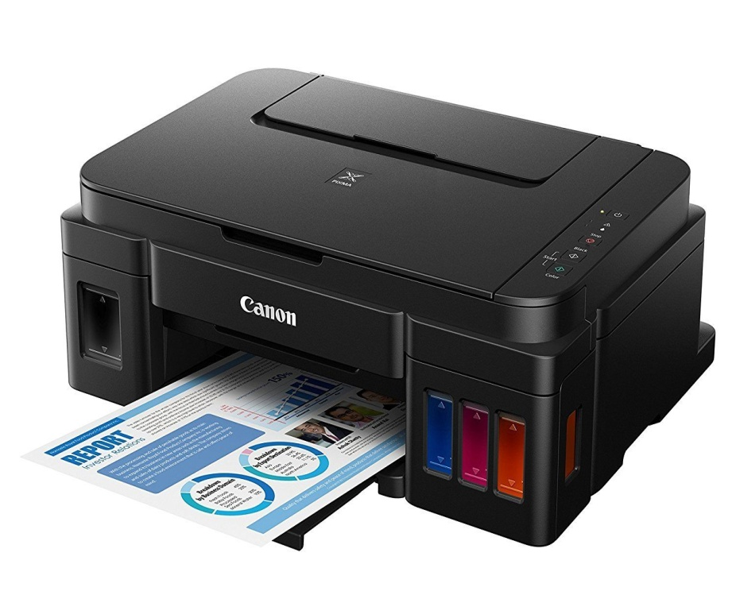

#### 2. History

The history of printers dates back to the 1950s when the first commercial printers were introduced, mainly designed to work with typewriters. These printers were primarily used for business documentation and required significant manual input. The introduction of the **dot matrix printer** in the 1970s marked a significant advancement, making it easier to print continuous sheets of data. Dot matrix printers were durable and versatile, making them suitable for multiple industries, including retail, logistics, and finance.

The **inkjet printer** was developed in the late 1970s but became commercially available in the 1980s. It revolutionized the printing industry by offering high-quality color printing at an affordable price for both businesses and personal use. This was followed by the **laser printer**, which first appeared in the 1970s but became more widely available in the 1990s. Laser printers offered higher speeds and sharper text quality, becoming the preferred choice for offices and commercial enterprises.

The latest breakthrough in printing technology is **3D printing**, which was developed in the 1980s but gained mainstream attention in the 2000s. This technology is pushing the boundaries of what can be "printed," from prototypes and small components to entire structures, using a wide range of materials like plastic, metal, and even biological matter.

#### 3. Available Technologies in the Field

* **Dot Matrix Printers**: These printers work by using an impact printing method, where a print head strikes an ink-soaked ribbon to transfer ink onto the paper. Although they have largely been replaced by more modern technologies, they are still in use in industries where multi-part forms are needed, such as in logistics and point-of-sale systems.
* **Inkjet Printers**: These printers operate by spraying tiny droplets of ink directly onto the paper. They are known for their high-quality color prints, making them popular for photo printing and small-scale document production. Inkjet printers are a popular choice for home users due to their affordability.
* **Laser Printers**: Laser printers use a laser beam and toner to produce high-speed, high-quality prints. They are especially efficient for monochrome document printing and are commonly used in offices. Although the upfront cost is higher than inkjet printers, their per-page cost is lower in the long term, especially for bulk printing.
* **Thermal Printers**: Often used for receipts and labels, thermal printers apply heat to special heat-sensitive paper. They are fast, quiet, and reliable for printing in environments like retail and healthcare, where physical receipts and labels are frequently needed.
* **3D Printers**: Using additive manufacturing technology, 3D printers create three-dimensional objects by layering materials like plastic, metal, or resin. This technology is expanding rapidly, being used in industries such as healthcare for producing medical devices, in manufacturing for creating prototypes, and even in construction for building houses.

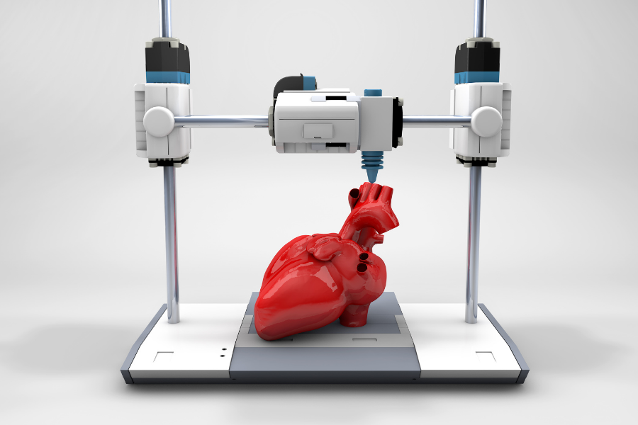

#### 4. Working and Basic Concepts

* **Inkjet Printers**: Inkjet printers work by ejecting microscopic droplets of ink onto the paper through nozzles. These droplets are controlled in terms of size and placement to produce images or text with high precision. Color inkjet printers use a combination of cyan, magenta, yellow, and black (CMYK) inks to create a wide range of colors.
* **Laser Printers**: In laser printing, a laser beam scans back and forth across a drum inside the printer, creating a static electricity pattern. The toner, which is a fine powder, sticks to the drum in these areas, and is then transferred onto the paper. The toner is melted onto the paper by a fuser to create the final print.
* **3D Printers**: 3D printers use a process called additive manufacturing, where an object is built layer by layer from a digital model. A range of materials, such as plastics, resins, or metals, can be used. The machine either extrudes the material or cures it with a laser, depending on the technology used.

#### 5. Study of Various Parameters: Cost, Speed, and Performance

* **Cost**: The initial cost of printers varies by technology. **Inkjet printers** are generally inexpensive but have a higher running cost due to the frequent need to replace ink cartridges. **Laser printers** are costlier upfront but offer lower per-page costs, especially for black-and-white documents. **3D printers** range from affordable home-use models to industrial-level machines that are significantly more expensive.
* **Speed**: **Laser printers** are the fastest, with some models capable of printing dozens of pages per minute. **Inkjet printers** are slower but provide better quality for color images. **Dot matrix printers**, although slower than modern printers, are still used in specific applications requiring multi-part forms. **3D printers** are generally slow, as they need to build objects layer by layer.
* **Performance**: **Laser printers** excel in sharp text quality, especially for monochrome documents. **Inkjet printers** offer better performance in color printing, making them ideal for photos and images. **3D printers** provide high precision and customization but are slower in output compared to traditional 2D printers.

#### 6. Market Study

* **Number of Users**: The global printer market is vast, with millions of devices sold annually. While traditional 2D printers have seen a decline in consumer demand due to the digital shift, they remain essential in businesses, educational institutions, and industries that require physical documentation. The rise of **3D printing** has added a new dimension to the market, with increasing applications across sectors like manufacturing, healthcare, and construction.
* **Big Players**: The printer market is dominated by companies like **HP**, **Canon**, **Epson**, and **Brother** for 2D printers. These companies offer a wide range of models catering to different needs, from personal use to large-scale enterprise solutions. In the 3D printing space, brands like **MakerBot**, **Ultimaker**, and **Stratasys** lead the innovation front.

#### 7. Future Advancements

* **Eco-friendly Printers**: Environmental sustainability is a key focus for future printer development. Efforts are being made to reduce the energy consumption of printers and develop **biodegradable** and **eco-friendly** inks and toners. Additionally, the use of recycled materials in printer construction and packaging is gaining traction.
* **3D Printing Innovations**: The future of 3D printing is focused on increasing the speed of production and expanding the range of materials that can be printed. Research is ongoing into **bioprinting** (printing human tissue), **metal printing** for manufacturing, and **construction-scale 3D printers** capable of building entire houses. These advancements will revolutionize industries from healthcare to construction.

#### 8. Conclusions

Printers have come a long way since the introduction of the first dot matrix models. With the growth of 3D printing and innovations in eco-friendly technologies, the printer industry continues to adapt to the demands of modern society. Whether for personal use or industrial applications, printers will remain crucial tools for creating both two-dimensional and three-dimensional outputs.

#### 9. Indian Contributions

India has made notable contributions to the global printer industry. **TVS Electronics**, a major player in the Indian market, has been instrumental in the development of **dot matrix printers**, which are widely used in sectors like banking, retail, and logistics. Indian companies are also involved in assembling and distributing printers, playing a crucial role in making printing technology accessible across the country. With a focus on affordable solutions, Indian manufacturers contribute to the digital infrastructure by ensuring the availability of cost-effective printing devices.

#### 10. References

1. "The History of Printing." Technology Chronicles, 2022.
2. "Advancements in 3D Printing Technology." Industrial Innovation Journal, 2021.
3. "Market Trends in the Printing Industry." Global Business Review, 2023.
4. HP Official Website. ([www.hp.com](http://www.hp.com))
5. TVS Electronics: Indian Contributions to Printing Technology. Economic Times, 2021.

Study of Monitors (CRT, LCD, LED)

#### 1. Introduction

Monitors are essential output devices used to display information from computers and other digital devices. Over the years, display technology has evolved significantly, from the early **Cathode Ray Tube (CRT)** monitors to modern **Liquid Crystal Display (LCD)** and **Light-Emitting Diode (LED)** displays. These advancements have revolutionized visual output, making monitors slimmer, energy-efficient, and capable of higher resolutions.

#### 2. History

The development of monitors began with the invention of **CRT** technology in the early 20th century. CRTs were widely used in televisions and computers due to their ability to display images by manipulating electron beams.

In the late 1960s and 1970s, **LCD** technology emerged from the work of engineers like George Heilmeier and Martin Schadt, initially used in smaller devices like calculators and watches. It wasn’t until the late 1990s that LCDs became widespread in computer monitors, replacing bulky CRTs.

The **LED** monitor, which is a subtype of the LCD, became popular in the 2000s due to its use of energy-efficient LED backlighting instead of the cold cathode fluorescent lamps (CCFLs) used in traditional LCDs.

#### 3. Available Technologies in the Field

* **CRT (Cathode Ray Tube) Monitors**: These use electron beams to excite phosphor-coated screens, producing images. Though large and heavy, CRTs were known for their color accuracy and deep contrasts.

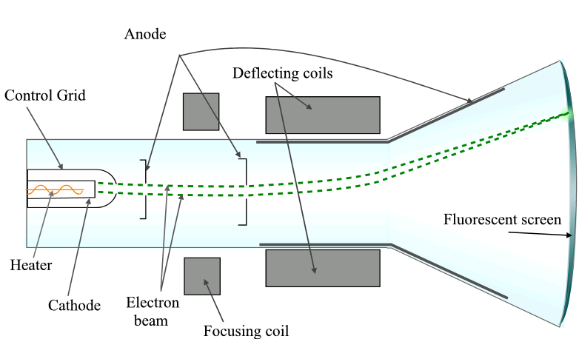

* **LCD (Liquid Crystal Display) Monitors**: These monitors use liquid crystals that modulate light from a backlight to display images. They are thin, lightweight, and more power-efficient than CRTs.
* **LED (Light-Emitting Diode) Monitors**: These are a subset of LCDs that use LED backlighting, providing better energy efficiency, higher brightness, and improved contrast. There are also **OLED** (Organic LED) displays that offer self-illuminating pixels, deeper blacks, and superior image quality.

#### 4. Working and Basic Concepts

##### **CRT Monitors**

CRT monitors work by firing electron beams at a phosphorescent screen. The inside of the screen is coated with tiny dots of red, green, and blue phosphor. Electromagnetic fields direct the electron beams to specific spots on the screen, and as these phosphor dots are hit by the beams, they glow, creating the image.

**Key Components of a CRT Monitor:**

* **Electron Gun**: Fires electron beams toward the screen.
* **Deflection Yoke**: Controls the direction of the electron beams using magnetic fields.
* **Phosphor Screen**: The surface where images are formed when hit by the electron beams.
* **Vacuum Tube**: The glass enclosure that houses the components and maintains a vacuum for electron flow.

##### **LCD Monitors**

LCDs work by controlling the orientation of liquid crystal molecules. These crystals don’t emit light directly, but instead, they block or allow light from a backlight to pass through, forming images on the screen. The light is polarized and passed through color filters (RGB) to create the image.

**Key Components of an LCD Monitor:**

* **Liquid Crystal Layer**: A matrix of liquid crystals arranged in tiny pixels, controlled to either block or allow light.
* **Backlight**: Provides the light source for the display, which passes through the liquid crystal layer.
* **Polarizing Filters**: Help control the light passing through the liquid crystals, improving contrast and visibility.
* **Color Filter**: Controls the color of each pixel by passing light through red, green, or blue filters.
* **TFT (Thin-Film Transistor) Matrix**: Controls the flow of current to each pixel, enhancing image quality and refresh rates.

##### **LED Monitors**

LED monitors are a type of LCD that replaces the traditional fluorescent backlight with an array of LEDs. This results in better energy efficiency, brightness, and color contrast. LED monitors can also be thinner than traditional LCD monitors due to the reduced size of the lighting mechanism.

**Key Components of an LED Monitor:**

* **LED Backlight**: Replaces the CCFL backlight, providing brighter and more uniform illumination.
* **Edge-lit or Full-array**: **Edge-lit** displays have LEDs along the edges, while **full-array** displays have LEDs spread uniformly behind the screen for better local dimming and contrast.
* **OLED**: Organic LEDs use organic compounds that emit light when an electric current is applied, eliminating the need for a backlight.

#### 5. Study of Various Parameters: Cost, Speed, and Performance

##### **Cost**

* **CRT Monitors**: CRT monitors were once expensive due to their complexity, but as LCD and LED technologies became mainstream, CRTs have been discontinued in favor of newer, more energy-efficient models.
* **LCD Monitors**: Initially expensive, LCD prices have significantly decreased over time due to advancements in manufacturing processes. They remain affordable across a wide range of resolutions and sizes.
* **LED Monitors**: LED monitors tend to be more expensive than traditional LCD monitors due to their superior technology and energy efficiency, though the price difference has diminished . 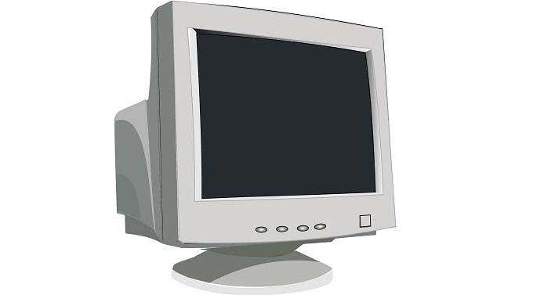

##### **Speed**

* **CRT Monitors**: CRTs have almost no input lag and extremely fast refresh rates, making them a favorite among gamers and graphic designers in the early days.
* **LCD Monitors**: Early LCDs suffered from slower refresh rates and ghosting effects, but modern LCDs have improved significantly, with refresh rates up to 240Hz and response times as low as 1ms.
* **LED Monitors**: LED monitors, especially those with higher refresh rates, are favored in gaming and professional environments where high-speed performance is crucial.

##### **Performance**

* **CRT Monitors**: Known for excellent color reproduction and contrast ratios, but bulky and power-hungry.
* **LCD Monitors**: Offer sharper images and consume less power. However, older models may have poor viewing angles and lower contrast compared to CRTs.
* **LED Monitors**: Superior in terms of brightness, contrast, and energy efficiency. **OLED** displays, in particular, provide the best performance with true blacks and vibrant colors.

#### 6. Market Study

The monitor market has seen significant growth, with a shift toward higher resolutions, better refresh rates, and energy-efficient technologies like **OLED** and **microLED**. The leading manufacturers include:

* **Samsung**: A leader in display technology, offering cutting-edge **QLED** and **OLED** monitors.
* **Dell**: Known for high-quality office and professional monitors, especially **UltraSharp** series.
* **LG**: Specializes in **OLED** monitors, which are known for exceptional picture quality.
* **Asus** and **Acer**: Popular among gamers for their high-performance **gaming monitors** with high refresh rates and adaptive sync technologies like **G-Sync** and **FreeSync**.

#### 7. Future Advancements

* **OLED and MicroLED**: Both technologies offer better color accuracy, deeper blacks, and lower power consumption. **MicroLED** is especially promising due to its potential for even thinner displays and improved durability.
* **Flexible Displays**: Flexible and rollable display technologies are under development, promising new form factors for monitors in the future.
* **8K Resolution**: With 4K resolution becoming standard, 8K monitors are entering the market, though they are still expensive and require significant computing power.

#### 8. Conclusions

The monitor landscape has shifted from CRT to LCD and LED, with each generation improving energy efficiency, image quality, and form factor. While **LCD** and **LED** technologies are the current standard, **OLED** is becoming increasingly popular for high-end applications due to its superior contrast and color reproduction. The future of monitor technology lies in **microLED**, **8K displays**, and potentially even **holographic** or **augmented reality** displays.

#### 9. Human-Made and Indian Contributions

In the field of monitor manufacturing, **human-made advancements** include innovations like **mini-LEDs**, **Quantum Dots**, and **Nano IPS** technologies, which provide improved color accuracy, brightness, and viewing angles.

Indian companies and manufacturers, although not heavily involved in cutting-edge display technology development, have contributed significantly to the **assembly** and **distribution** of affordable monitors for domestic and international markets. Brands like **Zebronics** and **Intex** offer budget-friendly options for consumers and educational institutions, ensuring wide access to computer technology.

### References

1. Heilmeier, G. H., & Zanoni, L. A. (1971). **Liquid crystal displays**. U.S. Patent No. 3,592,527.
2. Schadt, M., & Helfrich, W. (1971). Voltage-dependent optical activity of a twisted nematic liquid crystal. **Applied Physics Letters**, 18(4), 127-128.
3. "The Evolution of Display Technologies" by TechRadar (2023). Retrieved from https://www.techradar.com/news/display-technologies
4. "CRT to OLED: The History of Monitors" by PCMag (2022). Retrieved from https://www.pcmag.com/history-of-monitors

### Study of Cables and Connectors

#### 1. Introduction

Cables and connectors are fundamental components in electronic systems, enabling the transmission of data, power, and audio/video signals. From connecting peripherals to a computer to transferring high-definition content between devices, the variety of cables and connectors is vast, each designed for specific tasks. They play a crucial role in ensuring compatibility and functionality across devices in fields like computing, networking, audio-visual systems, and telecommunications.

#### 2. History

The development of cables and connectors dates back to the early days of electrical systems. One of the first cables, the telegraph cable, was laid in the mid-19th century for communication over long distances. In the 20th century, as electronics evolved, more specialized cables like **coaxial cables** (for radio frequency transmission) and **twisted pair cables** (for telephony) were developed. Over time, with the rise of personal computing and digital technologies, new standards such as **USB**, **HDMI**, and **Ethernet** emerged to meet the growing demand for faster, more efficient data transmission.

#### 3. Available Technologies in the Field

##### **Power Cables**

* **AC Power Cables**: These are standard cables used to connect devices to electrical outlets. They consist of two or three wires (live, neutral, and ground) inside an insulated jacket.
* **DC Power Cables**: Used to connect devices like laptops or other portable electronics to power adapters.

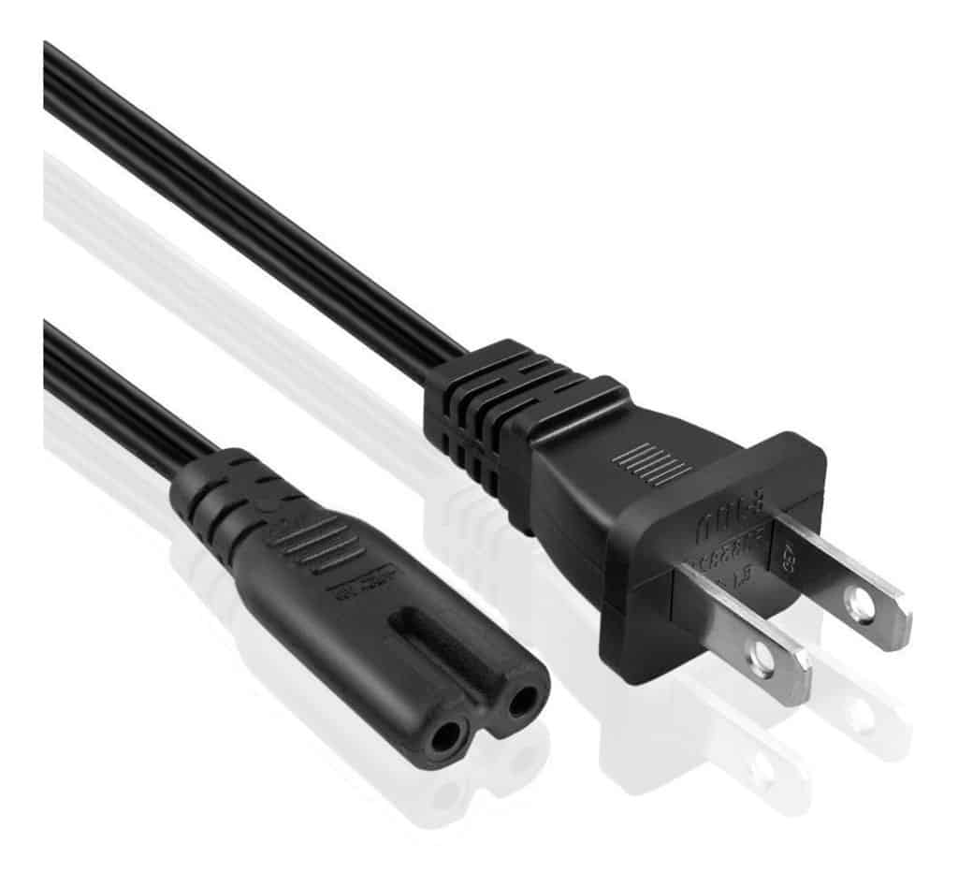

##### **Data Cables**

* **USB (Universal Serial Bus)**: Widely used for data transfer between computers and peripherals (like keyboards, mice, printers, etc.). USB has evolved into several versions, including **USB 1.0**, **USB 2.0**, **USB 3.0**, **USB 3.1**, and **USB-C**.
* **HDMI (High-Definition Multimedia Interface)**: A cable used to transmit high-definition video and audio between devices such as TVs, gaming consoles, and computers.
* **DisplayPort**: A digital display interface primarily used to connect video sources to display devices like monitors.
* **Ethernet Cables**: Used to establish wired networking connections. The most common types are **Cat5e**, **Cat6**, and **Cat7**, which differ in terms of data transmission speeds and shielding.

##### **Audio/Video Cables**

* **3.5mm Audio Jack**: Commonly used for headphones, speakers, and microphones.
* **RCA Cables**: Used for transmitting analog audio and video signals. Popular in older audio and video equipment.
* **Optical Cables (Toslink)**: Use light to transmit audio signals, typically between audio equipment like home theater systems.

##### **Specialty Cables**

* **Thunderbolt**: Combines data, video, audio, and power into a single connection. Often used in high-performance systems and peripherals.
* **FireWire**: Used for high-speed data transfer, particularly in older video cameras and storage devices. It has been largely replaced by USB and Thunderbolt.

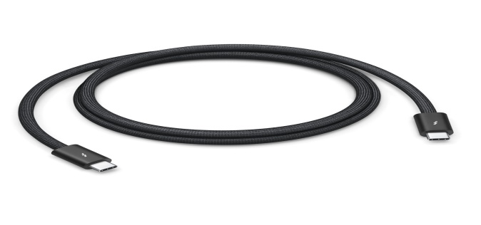

#### 4. Working and Basic Concepts

##### **Signal Transmission**

Cables transmit information in the form of electrical signals (analog or digital) or light signals (in fiber optic cables). The efficiency of a cable in transmitting signals depends on factors like the material used (copper, fiber optic, etc.), shielding to prevent interference, and the type of signal being carried.

##### **Connector Types**

* **Male and Female Connectors**: Male connectors are plugs that insert into female jacks. A basic example is the USB-A male plug and the USB-A female port.
* **Pins and Sockets**: Many connectors consist of pins and sockets, where the pins carry specific electrical signals, and the sockets correspond to these pins for a precise fit.
* **Form Factors**: The physical design of connectors often defines compatibility with devices. For instance, USB-C is a smaller, reversible design, while HDMI and DisplayPort are larger, rectangular connectors.

##### **Power Supply**

Power cables work by conducting electrical current between an external power source and an electronic device. Proper insulation and grounding are essential to prevent electrical shocks and ensure device safety.

##### **Data Transfer Protocols**

Each type of data cable follows a specific communication protocol, defining how data is packaged and transmitted. For example, **USB** follows a master-slave architecture where a host device controls the communication, while **Ethernet** relies on packet-based communication for networking.

#### 5. Study of Various Parameters: Cost, Speed, and Performance

##### **Cost**

* **USB and HDMI Cables**: Relatively inexpensive, with costs increasing for higher-quality, longer cables or specialized versions like USB-C or HDMI 2.1.
* **Ethernet Cables**: Prices vary depending on the category (Cat5e, Cat6, etc.) and length. Higher categories like **Cat7** are more expensive due to better shielding and faster speeds.
* **Optical Cables**: Tend to be pricier due to the technology used (light transmission).

##### **Speed**

* **USB 3.1**: Supports speeds up to 10 Gbps, much faster than previous versions.
* **Ethernet (Cat6)**: Supports speeds of up to 10 Gbps over short distances, while **Cat7** can achieve even higher speeds.
* **HDMI 2.1**: Can transfer data at speeds up to 48 Gbps, supporting 8K resolution at 60Hz.

##### **Performance**

* **USB-C**: Offers fast data transfer, power delivery, and even video output, making it versatile across various devices.
* **Fiber Optic Cables**: Provide the best performance for long-distance data transmission, as they are immune to electromagnetic interference and can handle high bandwidths.
* **Ethernet**: Performance varies based on the cable type, with **Cat6a** and **Cat7** providing the best performance for high-speed networking.

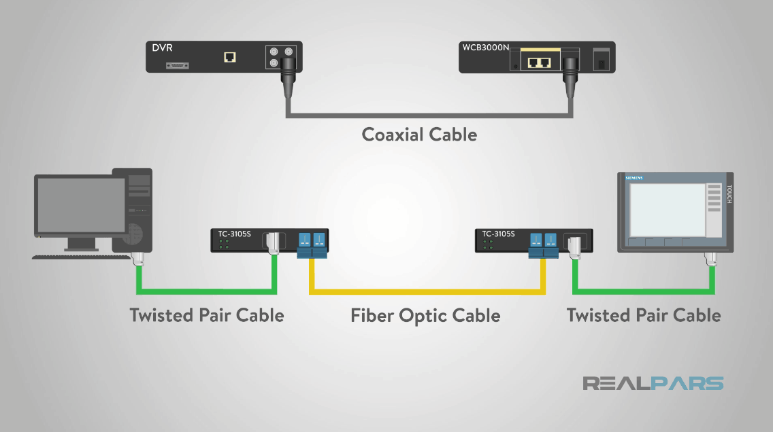

#### 6. Market Study

##### **Number of Users**

Cables and connectors are ubiquitous, used by millions of individuals and businesses worldwide. Every electronic device, from smartphones to computers, relies on one or more types of cables.

##### **Big Players**

* **Belkin**: A leading manufacturer of consumer cables, including USB, HDMI, and Ethernet.
* **Anker**: Known for high-quality USB-C, power cables, and data hubs.
* **Sony and Monster Cable**: Specialize in high-end audio/video cables.
* **Cisco**: A dominant player in networking cables and connectors, especially in enterprise-level Ethernet solutions.

#### 7. Future Advancements

* **Wireless Connectivity**: While cables remain critical for specific high-speed and power-demanding tasks, wireless technologies like **Bluetooth** and **Wi-Fi** are rapidly evolving, potentially reducing the need for physical cables.
* **USB 4.0**: Expected to offer speeds up to 40 Gbps, further reducing the need for multiple types of cables by consolidating power, data, and video transmission into one universal connector.
* **Quantum Cables**: Research is ongoing into quantum computing and communications, which could revolutionize data transfer at speeds beyond current physical cable limits.

#### 8. Conclusions

Cables and connectors remain indispensable in today's digital world, offering reliable and fast transmission of power, data, and media. As wireless technologies advance, cables continue to evolve, with innovations like USB-C, Thunderbolt, and HDMI 2.1 pushing the boundaries of performance. The field is marked by ongoing advancements that ensure compatibility across an ever-growing number of devices.

#### 9. Indian Contributions

India plays a significant role in the manufacturing and assembly of cables and connectors, particularly for domestic brands like **Intex**, **Zebronics**, and **Syska**. These companies offer affordable, reliable options for everyday users, contributing to the widespread availability of electronic peripherals in the country.

### References

1. "A Brief History of Cables and Connectors," CNET, 2021.
2. "USB Evolution and Future Trends," USB.org, 2023.
3. "The Role of Ethernet in Networking," Cisco Press, 2022.
4. "HDMI 2.1: A Technical Overview," TechRadar, 2023.
5. "The Future of Cables: USB 4.0 and Beyond," Wired, 2023.