**Slide 1: Title Slide**

**Title**:  
*Bangla Hate Speech Detection on Social Media Using Attention-Based Recurrent Neural Network*  
**Presented By**: [Your Name]  
**Institution**: [Your Institution]  
**Date**: [Presentation Date]

### ****Slide 2: Introduction****

* **What is Hate Speech?**  
  Hate speech refers to any speech that attacks or discriminates against a person or group based on attributes such as race, religion, gender, etc.
* **Why Focus on Social Media?**  
  Social media has become a major platform for hate speech, with millions of users engaging every day.
* **Motivation for the Study**:  
  While there are models for hate speech detection in English and other languages, there is very little research on Bengali hate speech detection.

### ****Slide 3: Research Objective****

* **Goal**:  
  To develop a model for detecting hate speech in Bengali social media comments.
* **Approach**:  
  Use machine learning techniques, specifically an attention-based Recurrent Neural Network (RNN), to improve the accuracy of detection.

### ****Slide 4: Dataset Overview****

* **Source**:  
  7,425 Bengali comments were collected from Facebook pages using both Facebook Graph API and manual collection.
* **Categories of Comments**:
  1. Hate Speech
  2. Aggressive Comments
  3. Religious Hatred
  4. Ethnic Attack
  5. Religious Comments
  6. Political Comments
  7. Suicidal Comments

**Slide 5: Data Preprocessing**

* **Tokenization**:  
  Breaking down comments into individual words.
* **Stemming**:  
  Reducing words to their root form.
* **Stop Word Removal**:  
  Removing common words that do not contribute to hate speech detection (e.g., "is", "the").
* **Bangla Emot Module**:  
  Detects emotions in Bengali comments using emojis and emoticons.

**Slide 6: Model Architecture**

* **Convolutional Neural Networks (CNN)**:  
  Used for feature extraction from text data.
* **Recurrent Neural Networks (RNN)**:
  + LSTM (Long Short-Term Memory)
  + GRU (Gated Recurrent Unit)  
    Both models were applied to process sequences of comments.
* **Attention Mechanism**:  
  Focuses on important parts of the input data to improve prediction.

**Slide 7: Model Comparison**

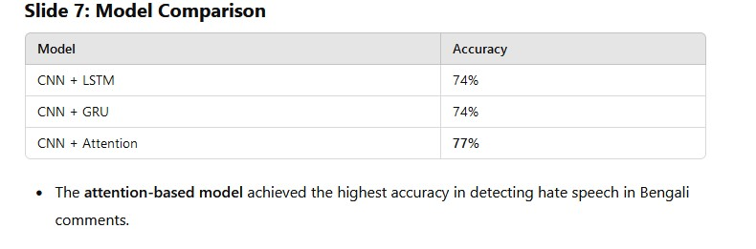

| **Model** | **Accuracy** |
| --- | --- |
| CNN + LSTM | 74% |
| CNN + GRU | 74% |
| CNN + Attention | **77%** |

* The **attention-based model** achieved the highest accuracy in detecting hate speech in Bengali comments.

**Slide 8: Performance Metrics**

* **Precision**:  
  The attention-based model achieved a precision of **0.78**.
* **Recall**:  
  The model’s recall was **0.75**.
* **F1-Score**:  
  The F1-Score was **0.78**.

**Slide 9: Results**

* The **attention-based RNN** model outperformed other methods in detecting hate speech in Bengali comments.
* It provided improved accuracy and better understanding of which words contribute to hate speech.

**Slide 10: Conclusion**

* **Key Takeaways**:
  + First research to apply attention mechanism in Bengali hate speech detection.
  + Attention-based RNN model shows promise with a high accuracy of 77%.
* **Future Work**:
  + Expand the dataset with more mixed-language (Bengali-English) comments.
  + Explore the detection of hate speech from image-based comments or memes.

**Slide 11: Thank You**

* **Questions?**  
  [Your Contact Information]  
  Thank the audience and invite any questions or discussions.

This structure will give your presentation a logical flow and clearly communicate the main points of your thesis. Let me know if you need more help!