|  |  |  |  |  |  |
| --- | --- | --- | --- | --- | --- |
| AIUB | | **American International University- Bangladesh (AIUB)**  **Faculty of Engineering (EEE)** | | | |
|  | | |  |  |  |
| **Course Name:** | | | Microprocessor and Embedded Systems | **Course Code:** | EEE 4103 |
| **Semester:** | | | Fall 2022-2023 | **Section:** | **M** |
| **Faculty Name:** | | | DR. MUHIBUL HAQUE BHUYAN | | |
|  | | |  |  |  |
| **Capstone Project Title:** | | | **Electronic Voting Machine (EVM) Using Arduino** | | |
| **Project Group No.** | | | **04** | | |
|  | | |  |  |  |
|  | **Student ID:** | | | **Student Name:** | |
| **1.** | **17-34775-2** | | | **Md. Fahim Hossain** | |
| **2.** | **20-42096-1** | | | **Sharia Arfin Tanim** | |
| **3.** | **20-42180-1** | | | **Md. Hasibur Rahman** | |
| **4.** | **20-42265-1** | | | **Shahriar Siddique Ayon** | |

**Assessment Materials and Marks Allocation:**

|  |  |  |  |
| --- | --- | --- | --- |
| **Cos** | **Assessment Materials** | **POIs** | **Marks** |
| CO3 | Course Project report ***(Demonstrate a course project using microcontrollers, sensors, actuators, switches, display devices, etc. that can solve a complex engineering problem in the electrical and electronic engineering discipline through appropriate research)*** | **P.d.1.P3** | **5** |

|  |  |  |  |  |  |  |
| --- | --- | --- | --- | --- | --- | --- |
| **CO** | Excellent to proficient  [5- 4] | Good  [3] | Acceptable  [2] | Unacceptable  [1] | No response  [0] | Secured marks |
| **CO3**  **P.d.1.P3** | The outcome of the project demonstrates a course project using microcontrollers, sensors, actuators, switches, display devices, etc. that can solve a complex engineering problem in the electrical and electronic engineering discipline through appropriate research. | The outcome of the project somewhat demonstrates a course project using microcontrollers, sensors, actuators, switches, display devices, etc., and also somewhat solves a complex engineering problem in the electrical and electronic engineering discipline through appropriate research. | The outcome of the project demonstrates a course project using microcontrollers, sensors, actuators, switches, display devices, etc. but cannot solve a complex engineering problem in the electrical and electronic engineering discipline through appropriate research. | The outcome of the project does not demonstrate a course project using microcontrollers, sensors, actuators, switches, display devices, etc. also cannot solve a complex engineering problem in the electrical and electronic engineering discipline through appropriate research. | No Response |  |
| **Comments** |  |  |  |  | Total marks (5) |  |
|  |  |  |  |  |  |  |

Electronic Voting Machine (EVM) Using Arduino

1. Md. Fahim Hossain 2. Sharia Arfin Tanim 3. Md. Hasibur Rahman 4. Shahriar Siddique Ayon

ID: 17-34775-2 ID: 20-42096-1 ID: 20-42180-1 ID: 20-42265-1

BSc in EEE BSc in CSE BSc in CSE BSc in CSE

***Abstract*—** **This project's fundamental goal is to build an electronic voting machine that will contribute to the eradication of vote fraud in manual systems and earlier iterations of electronic voting. The thesis investigates and suggests a technique with numerous tiers of verifications to guarantee the device's dependability. Each voter is placed into the system only after being recognized and compared with the provided database of registered voters thanks to the use of a biometric fingerprint sensor. The voter will be able to proceed with selecting their favorite candidate from the panel of buttons once the corresponding fingerprint is matched with the data given. After that, an LCD displays the results so that voters can see them. The proposed project displays transparency and also carries the feature of being autonomous during the course of operation.**

***Keywords*— *Electronic voting machine, Arduino Uno, Finger sensor, LCD display.***

1. . INTRODUCTION
   1. *BACKGROUND OF STUDY AND MOTIVATION*

Election is the act of a party casting ballots [7,8] to choose a person for a certain post. Depending on the post, elections may involve either a public or private vote. Elections are held for most positions in the municipal, state, and federal governments. Voters just place their ballots in sealed boxes placed across the electoral circuits of a country to vote in elections conducted on paper. All of these boxes are opened when voting is completed, and in the presence of the authorized officials, the votes are hand tallied. Votes may not be correctly counted throughout this process [9] or people may find a means to cast multiple ballots. Sometimes votes are even changed to skew election outcomes in favor of particular candidates. The Indian government developed the direct-recording electronic (DRE) voting method, which is typically an electronic voting machine, to address these issues [10]. (EVM). These gadgets have won accolades for their uncomplicated layout, usability, and dependability. However, it has been discovered that EVMs are easily hackable and not tamper-proof. Furthermore, these attacks—both hardware and software—aren't detected and are rather easy to carry out. This prompted us to develop a system that is safe, open, trustworthy, and simple for the public to use. Electronic voting machines with biometric identification are no longer a novelty; they are now widely utilized in emerging nations like Ghana and Ireland. In this project, we put out a suggestion for a way to prevent fraud in the system that will enable electronic voting in India. Because every human finger print is uniquely different from every other human fingerprint, it enhances security performance and prevents vote falsification.

1.2 Project Objectives

In this project, there are two different types of objectives. First, a general objective. This project's overarching goal is to provide a foundation for an electronic voting system that runs on Arduino.

Second, the system will be evaluated as part of a specified purpose to ensure that it can operate flawlessly in the environment. It is crucial to assess using an efficiency test and a survey's satisfaction level.

*1.*3Outline of the Report

This Report is based on some specific points. Which are given below:

* Introduction
* Literature Review
* Methodology and Modeling
* Working principle of the proposed project
* Components
* Implementation
* Test/Experimental setup
* Cost analysis
* Results and Discussion
* Conclusion and future endeavors
* References

1. . LITERATURE REVIEW

To replace traditional system for voting like ballot paper voting system, Electronic Voting Machine was introduced in 1998 in India [2]. Balloting unit and control unit are the two units consist in voting machine used in India. This makes this voting system difficult to transport. This system is introduced by Bharat Electronic Limited (BHEL). From 1998 till now many inventions has been made in Electronic Voting machine. This system has 15 years life [3]. As per the suggestion of Election Commission manufacturer adopted third-generation design having addition changes. Now a days voting machine are electronics which stores votes electronically instead of ballot paper [1]. “Table I” shows different voting processes used in India.

TABLE I. DIFFERENT TYPES OF VOTING SYSTEM

|  |  |  |  |  |  |
| --- | --- | --- | --- | --- | --- |
| **Sr.n o.** | **Type of voting** | **Hardware** | | **Limitations** | |
| 1 | Ballot paper voting | Paper and ballot box is used for this type of voting. | | Collection of all paper and  declaration of result is delayed | |
| 2 | VVPAT | Ballot unit. | | Complex circuitry | |
| 3. | Electronic Voting  Machine | Control unit  ballot unit. | and | Assembly of all  system is complex | |
| 4 | Remote Internet Voting | Internet  connection, Website, Software. | | Without internet  connection system will not work | |
| 5 | Biometric Voting Machine By using Fingerprint  Module | Arduino Fingerprint Module | and | Suitable small purpose. | only for scale |

• Ballot paper voting: In this type of voting system piece of paper is used to cast vote. A ballot is simple paper on which each voter writes the name of a candidate to cast a vote. For this type of voting the ballot paper and ballot box is used.

• VVPAT: The full form of VVPAT is ‘Voter Verifiable Paper Audit Trail’. VVPAT is intended as an independent verification system for voting machines designed to allow voters to verify that their vote is cast correctly or not. This system is also used in collaboration with electronic voting machine in 2019 elections in India.

• Electronic voting machine: Electronic Voting is the standard means of conducting elections using Electronic Voting Machines. The Electronic Voting Machines is introduced in Indian elections between 1998 and 2001. Before introducing electronic voting machine, the ballot paper system was use for elections in India. The paper ballots method was widely criticized because of fraudulent voting so the Electronic voting machine is introduced.

• Remote Internet voting: In this system using internet user can vote from anywhere were he can by accessing the internet. It helps to increases percentage of voting by maximizing access and convenience of voter by using internet facility. [4]

Numerous techniques have been devised to prevent voting system fraud, but we still cannot totally remove it [5, 6]. The goal of this project is to increase voting machine security performance while also making it simple to cast a ballot using finger print authentication. We scan each person's finger print using the SFG demo v2.0 and Arduino IDE software. The scanned finger print is validated, and if it matches, the person is permitted to vote.

1. . Methodology and Modeling
   1. *Introduction*

Simple methodology has been used while conducting this project.

* 1. *Working principle of the proposed project*

Voting machine follows a process for casting votes. The microcontroller Arduino Uno mainly store memory of the dedicated vote count. A push button is set for giving the permission to the voter so that the person can cast only one vote.

* + 1. *Process of Work*

Voting process is divided into some simple steps. When user wants to vote then he or she needs to get the permission from the dedicated admin/officer by the push button. The LED will blink to make sure the finger sensors are ready to cast vote. After pressing on the push button, the buzzer will make sound and the user can not give another vote. However, the total vote count is displayed in the LCD display by the party name. Moreover, a key switch is applicable whenever it is necessary to reset the vote count.

* 1. *Description of the components*

This system is based on concept of voting machine which required following components:

1. Solderless breadboard- For circuit implementation
2. Arduino Uno- To store data
3. 20×4 LCD Display- For displaying results
4. 100R Resistor- For controlling amount of current
5. 10k Variable Resistor- For display adjustable
6. Connecting Wires- For connection
7. Push Button- To active voting
8. Key Switch- To reset vote count
9. TTP223 Touch Sensor- To cast vote
10. Buzzer- For vote confirmation
11. LED- For vote confirmation

A microcontroller board called Arduino Uno is based on the ATmega328P. (datasheet). It has a 16 MHz ceramic resonator (CSTCE16M0V53-R0), 6 analog inputs, 14 digital input/output pins (of which 6 can be used as PWM outputs), a USB port, a power jack, an ICSP header, and a reset button.

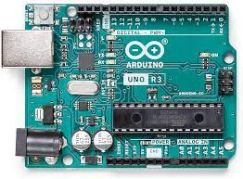

Fig: Arduino Uno Board

It comes with everything required to support the microcontroller; to get started, just use a USB cable to connect it to a computer, or an AC-to-DC adapter or battery to power it.

1. 20×4 LCD Display

This is LCD2004 Parallel LCD Display that provides a simple and cost-effective solution for adding a 20×4 White on RGB Liquid Crystal Display into project. The display is 20 characters by 4-line display that has a very clear and high contrast white text upon a blue background/backlight.

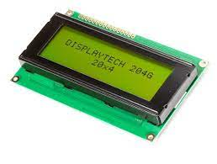

Fig:3.1.1 20×4 LCD Display

1. 100R Resistor

These are run-of-the-mill 1/4 Watt, +/- 5% tolerance PTH resistors. Commonly used in breadboards and other prototyping applications, these 100 ohm resistors make excellent pull-ups, pull-downs and current limiters. These thick-lead versions of the resistors fit snugly into a breadboard with very little movement.

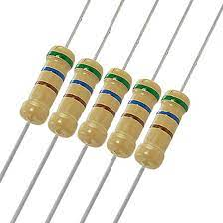

Fig:3.1.2 100R Resistor

1. 10k Variable Resistor

This adjustable or Variable resistor are PCB mountable and has 3 terminals. The voltage between the terminal varies as the preset is rotated. The Variable resistors are used for variation voltage as per the need in a circuit.

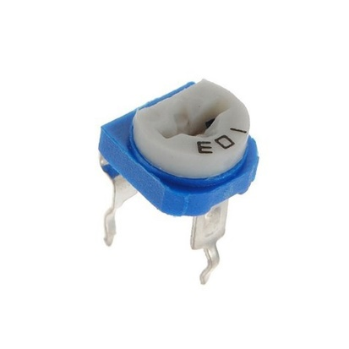

Fig:3.1.3 10k Variable Resistor

1. Key Switch

A key switch (sometimes called a key switch or lock switch) is a key-operated switch. Key switches are used in situations where access needs to be restricted to the switch's functions. Key switches are available as components with solder connections, and are available with a variety of ampere ratings. They may use tubular or other specially-shaped keys for extra security. Key switches have been used for a variety of purposes.

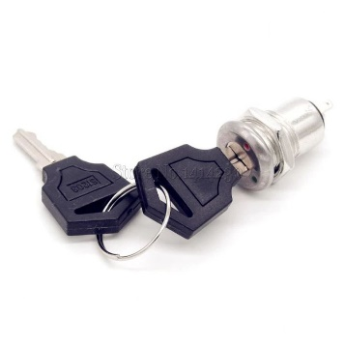

Fig:3.1.4 Key Switch

1. TTP223 Touch Sensor

The TTP223-BA6/TTP223N-BA6 TonTouchTM is a touch pad detector IC which offers 1 touch key. The touching detection IC is designed for replacing traditional direct button key with diverse pad size. Low power consumption and wide operating voltage are the contact key features for DC or AC application.

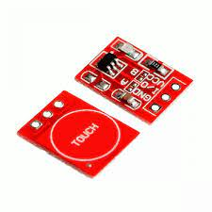

Fig:3.1.5 TTP223 Touch Sensor

* 1. *Implementation*

Voting machine consist of Arduino Uno, Finger sensor, LCD display, key switch. Arduino UNO act as the controller unit. In order to unlock the device and as security a Finger print sensor has been attached to the machine. LCD and button are also used.

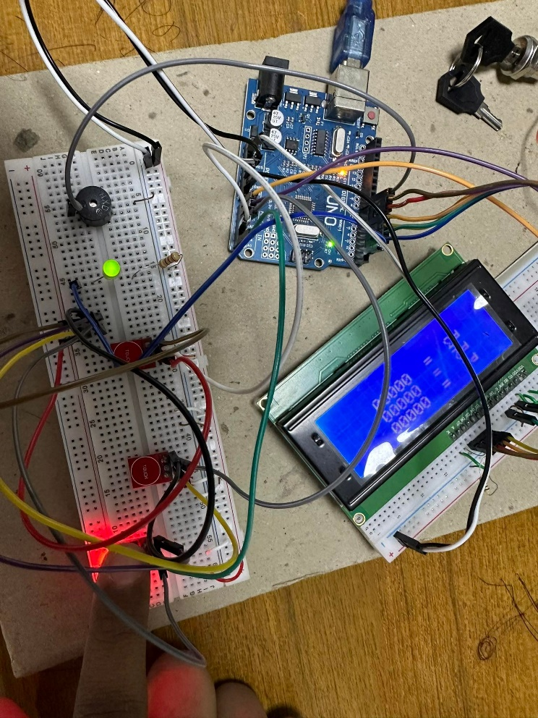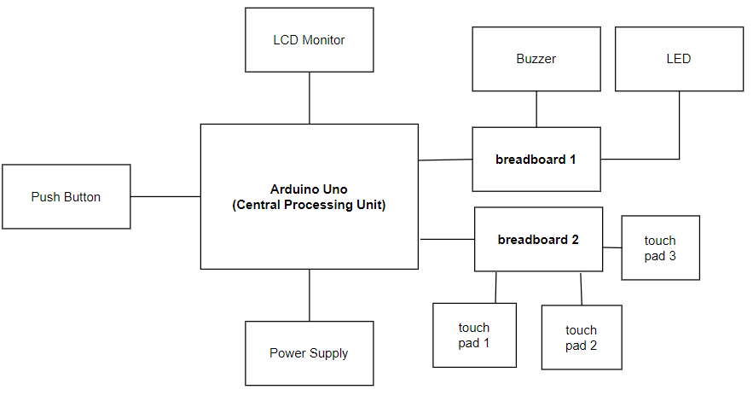Block diagram

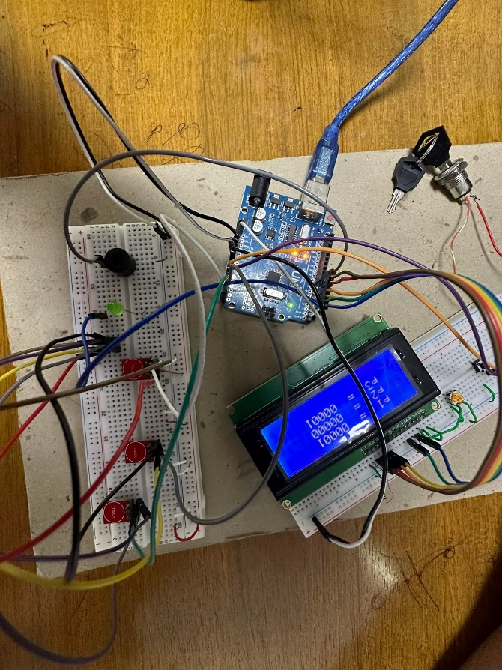*3.5 Test/Experimental setup*

Fig: 3.5.1 Electronic Voting Machine

Fig: 3.5.2 Casting Vote

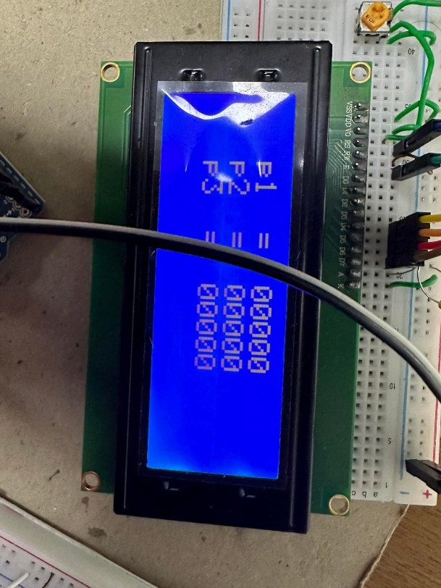 Fig: 3.5.3 Vote count

4. COST ANALYSIS

Solderless Bread Board (2) 310

Arduino Uno R3 (1) 1100

20X4 Character LCD (1) 530

100R resistor (4) 5

10k Variable Resistor (3) 195

Male to Male Jumper Wires 190

Push Button 7

Key Switch 95

TTP223 Touch Sensor (4) 240

Buzzer 15

LED 5

Total 2692

5. RESULT AND DISCUSSION

*5.1 Simulation/Numerical analysis*

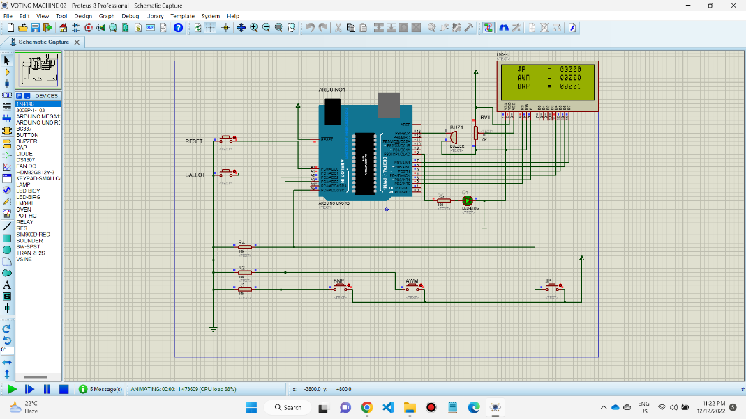

Fig:5.1.1 Proteus Simulation

*5.2 Measured response/Experimental results*

The experiment was successfully done. We have got the expected result from the project. The three sensors worked properly. And the buzzer and the reset pin also worked properly. The LCD monitor showed the votes properly. We have got our desired result from the experiment.

*5.3 Comparison between numerical and experimental results*

The experiment was successfully done. We have got the expected result from the project. The three sensors worked properly. And the buzzer and the reset pin also worked properly. The LCD monitor showed the votes properly. We have got our desired result from the experiment.

*5.4 Limitations in the project*

Project has some limitations in verification process. As there is no verification included in this system, wrong or fake vote can be cast. However, in some cases there also could be some illegal cases.

6. CONCLUSION AND FUTURE ENDEAVORS

The concept of electronic voting systems is not a new one. However, for its use to widely spread it is important to aim for a system that properly is able to fulfill all the requirements expected as well as the standards achievable by the use of technology. The system provided by this paper goes the lengths to cover the necessities that met the requirement for a fair, transparent and reliable election tool. This project assures that, if this system is brought into practice, it will reduce the rate of Corruption in a honest and sincere way. This system is a small contribution for a fair election. But corruption in voting system cannot be erased through this system if there is no sincerity

The experiment was successfully done. We have got the expected result from the project. The sensors worked properly. And the buzzer and the reset pin also worked properly. The LCD monitor showed the votes properly. We have got our desired result from the experiment.

Moreover, there are still some works needed in user/voter verification process. Which might be done in the future.

7. References

1. Rahil Rezwan, Huzaifa Ahmed, M. R. N. Biplo, S. M. Shuvo, Md. Abdur Rahman, “Biometrically secured electronic voting machine”, 2017 IEEE Region 10 Humanitarian Technology Conference (R10- HTC).
2. Annalisa Franco, “Fingerprint: Technologies and Algorithms for Biometrics Applications”, Year: 2011 , Course , Publisher: IEEE.
3. Md. Mahboob Karim, Nabila Shahnaz Khan, Ashratuz Zavin, Shusmoy Kundu, Asibul Islam, Brazab Nayak, “A proposed framework for biometric electronic voting system”, IEEE International conference on 2017
4. A. Piratheepan, S. Sasikaran, P. Thanushkanth, S. Tharsika, M. Nathiya, C. Sivakaran, N. Thiruchchelvan and K. Thiruthanigesan, “Fingerprint Voting System Using Arduino”, College of Technology Jaffna, Sri Lanka University College of Anuradhapura, University of Vocational Technology, Sri Lanka
5. Gomathi. B, Veena priyadarshini. S, “Modernized Voting Machine using Finger Print Recognition”, International Journal of Scientific & Engineering Research, Vol.4, Issue 5, ISSN 2229-5518,2013,pp.156-161
6. Navnath Baban Belote, Sneha Revankar, “Next Generation Electronic Voting Machine”, International Journal of Advanced Research in Computer and Communication Engineering Vol. 5, Issue 6,2016,pp.622-624
7. Aranganadhan. N. S, M. DhineshKumar, Praveenkumar. DSanthosh.A, “Embedded System based Voting Machine System using Wireless Technology”, International journal of innovative research in electrical instrumentation and control engineering, Vol. 4, Issue 2,2016,pp.127-130
8. D. Krishna, “Aadhar Based Electronic Voting System and Providing Authentication” International journal of engineering and advanced technology, ISSN:2250- 3676,Vol.4,Issue 2,2013,pp.237-240
9. Md. Asfaqul Alam, Md. Maminul Islam, Md. Nazmul Hassan, Md. SharifUddin Azad, “ Raspberry Pi and image processing based Electronic Voting Machine (EVM)”, International Journal of Scientific & Engineering Research, Vol.5, Issue 1,2014,pp.1506-1510.
10. Deepak Rasaily‟Jigmee Sherpa, Yashal Dorzee Lepcha, “Design of Electronic Voting Machine using Microcontroller”, International Journal of Engineering Trends and Technology, ISSN: 2231,Vol-32 issue 5,2016,pp.277-278

8. APPENDIX



