SOFTWARE ENGINEERING LAB

BCSE301P L15 + L16

PROJECT REPORT

SUBMITTED BY: Tanish Kumar
23BCE1787

Table of Contents:
- Problem Statement
- Objectives
- Methodology / Approach
- Work Completed So Far (50% Implementation)
- Screenshots / Proof of Implementation
- GitHub Repository Link

- Problem Statement
Teachers and administrative staff in rural government schools across Punjab and other Indian states rely entirely on manual, paper-based attendance systems to record student presence. This process is not only time-consuming but also highly prone to human error, data loss, and deliberate manipulation. The region's limited infrastructure — including unreliable internet connectivity and insufficient digital tools — further compounds this problem.
Currently, there is no unified digital platform that:
  - Authenticates students using secure, verifiable digital identities (QR-based)
  - Records attendance automatically without internet dependency
  - Synchronises offline data to a central cloud system when connectivity is restored
  - Provides real-time visibility to administrators and government officials
  - Detects attendance defaulters and automatically triggers parent notifications
  - Correlates attendance data with academic performance and government scheme eligibility
Impact of the Problem:
Due to the absence of such an integrated system:
  - School authorities waste 10–15 minutes of precious teaching time on manual roll calls every morning
  - Attendance data is unreliable, leading to errors in mid-day meal procurement and scholarship disbursement
  - Parents are not informed when their child is absent, enabling habitual truancy to go unnoticed
  - Government officials cannot access accurate, real-time school-level data for program monitoring
  - Teachers have no mechanism to report classroom emergencies or request urgent leaves digitally
  - There is no correlation between a student's attendance record and their academic outcomes, making early intervention impossible
This highlights the critical need for an integrated, intelligent, and offline-capable system to automate attendance management, enhance administrative efficiency, and strengthen the accuracy of data used for government welfare programs.

- Objectives
Based on the problem statement analysis, the following objectives have been established for the Automated Attendance System for Rural Schools:
Primary Objectives
S.No | Objective | Description
1 | Digital Student Identity System | Assign each student a unique QR Code ID card that can be scanned by teachers for instant, accurate attendance marking.
2 | Offline-First  Attendance  Recording | Implement local device storage so that attendance is recorded even without an internet connection, and automatically synced to the cloud when connectivity is restored.
3 | Centralised  Web  Dashboard | Develop a comprehensive administrative dashboard providing real-time visibility into attendance logs, class-wise statistics, and sync status for all active teachers.
4 | Automated  Defaulter  Detection | Implement a rule-based alert system that automatically flags students whose attendance falls below the governmentmandated 75% threshold.
Secondary Objectives
S.No | Objective | Description
5 | Parent  Communication  Portal | Enable automated SMS and WhatsApp notifications to parents whenever their child is marked absent, and
S.No | Objective | Description
 |  | allow bulk announcement broadcasting for school events.
Automatically calculate daily meal
Mid-Day Meal requirements based on present
6 Programme student count, maintaining accurate Integration records for government funding and reducing food wastage.
7 | Academic  Performance  Correlation | Cross-reference a student's attendance percentage with their examination scores to identify students at academic risk due to irregular attendance, enabling timely counseling.
8 | Emergency and  Leave  Management | Provide a digital portal for teachers to report medical emergencies, request urgent leaves, and allow admins to manage reassignments — all from the dashboard.

- Methodology / Approach
The development of the Automated Attendance System follows a structured, phased approach combining agile methodology with iterative testing and real-world feedback integration.
Development Phases
Phase 1: Requirements Analysis & Planning (Completed)
  - Studied SIH Problem Statement 25012 (Government of Punjab) in detail
  - Analysed existing gaps in rural school attendance management
  - Identified key stakeholders: students, teachers, school administrators, parents, and government officials
  - Defined system architecture and selected the technology stack
  - Mapped out the 8 core dashboard modules and their interdependencies
  - Designed the offline-first data flow and cloud sync logic
Phase 2: Core Frontend Dashboard Development (50% Completed — Current Phase)
  - Established project structure and React component hierarchy
  - Developed a responsive web dashboard with a fixed sidebar navigation system
  - Implemented all 8 modules with inter-page routing (React Router)
  - Created data visualisation for attendance analytics and academic performance
Built searchable, filterable data tables for student directory and attendance logs
Integrated modern Vanilla CSS design system with animations and interactive states
Phase 3: Backend API & Database Integration (Upcoming)
  - Set up Spring Boot REST API with full CRUD endpoints for all entities
  - Configure PostgreSQL database schema with relational integrity
  - Implement CORS and JWT-based authentication for secure API access
  - Develop background sync mechanism for handling offline attendance data uploads
  - Build report generation endpoints for CSV and PDF exports
Phase 4: Mobile Application Development (Upcoming)
  - Build the teacher-facing Android application using React Native
  - Implement QR code scanner with offline attendance logging
  - Create background sync manager to detect connectivity and push data automatically
  - Integrate push notification support for leave approvals and emergency alerts
Technology Stack

Component | Technology Used
Frontend (Web Dashboard) | React.js (Vite), Vanilla CSS, React Router, Lucide React Icons, Google Fonts (Inter)
Backend (REST  API) | Java 17, Spring Boot 3, Spring Data JPA, Spring Web
Database PostgreSQL
Mobile Application | React Native, SQLite (Offline Storage)
Data Sync | RESTful API with background sync on connectivity restore
Version Control | Git, GitHub

- Work Completed So Far (50% Implementation)
- User Interface & Navigation
  - Responsive sidebar navigation with active page highlighting and smooth transitions
  - Eight fully routed pages accessible without full browser reloads (Single Page Application)
  - Animated page transitions and hover micro-animations for professional feel
  - Sticky top navigation bar with admin profile display
  - Mobile-responsive layout structure
- Dashboard Home Module
Summary statistics cards showing: Total Students, Present Today, Absent Today, and Active Emergencies
Color-coded stat cards with contextual icons (blue for totals, green for present, red for absent)
  - Real-time sync log panel showing recent teacher scan activity and pending syncs
  - Quick action buttons: Generate New QR, Broadcast Notice, Approve Leaves, View Meal Requests
- Attendance & Analytics Module
  - Daily and class-level attendance log table with date and class filters
  - Automated attendance percentage calculation per class
  - Defaulter alert panel highlighting students below the 75% attendance threshold with auto-flagging
  - Sync status indicators (Synced / Pending) for each attendance record
  - One-click PDF export button for generating government reports
- Student & QR Management Module
  - Full student directory with real-time search by name or admission number
  - Grade-based filtering for quick class-level views
  - Data table showing Admission Number, Student Name, Grade, Parent Contact, and QR Status
Action buttons per student: View/Print QR Code, Edit Details, Delete Record
Bulk QR Generation button for entire class at once
  - Pagination controls for large student datasets
- Teacher Duties & Staff Management Module
  - Complete duty roster table listing each staff member's current assignment
  - Time slot visibility for each duty (invigilation, mid-day meal, substitution, free period)
  - One-click Reassign button per teacher for emergency duty changes
  - Online status indicators next to each staff member
- Emergencies & Leaves Module
  - Emergency incident cards with type classification (Medical / Leave Request)
  - Color-coded urgency indicators (red for Pending, green for Resolved)
  - One-click "Notify Parents" button triggering automated alerts
  - "Mark Resolved" action button per incident
  - Reported-by and timestamp metadata on each incident card
- Mid-Day Meal Tracker Module
Summary cards showing Total Eligible Students vs. Meals Prepared with buffer count
Class-level breakdown table of eligible headcount and dietary notes
  - Status column to mark recordings as complete for the day
- Parent Communication Portal Module
  - Broadcast message form with target audience selector (All Parents / Grade-specific)
  - Message source field and rich text announcement composer
  - One-click "Send via WhatsApp" broadcast button
  - Recent automated alerts log showing absence notifications and announcement history with timestamps
- Academic Performance Tracker Module
  - Cross-reference table showing each student's attendance percentage alongside their average exam score
  - Visual trend indicators (↑ Up, ↓ Down, — Steady) to show performance direction
  - Automatic color-coding of attendance below 75% in red for quick at-a-glance review
  - "Schedule Counseling" action button for at-risk students

5. Screenshots / Proof of Implementation Screenshot 1:Dashboard
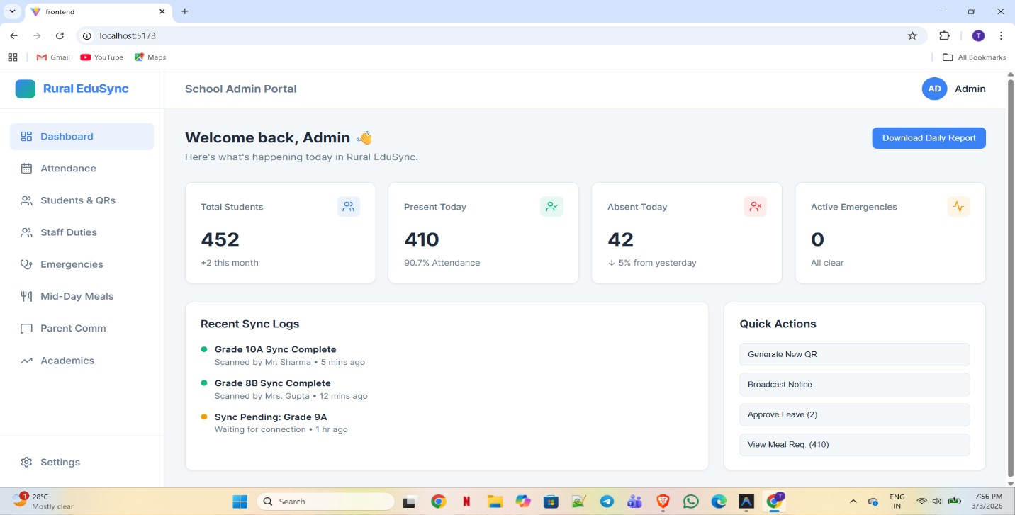

Screenshot 2: Attendence & Analytics
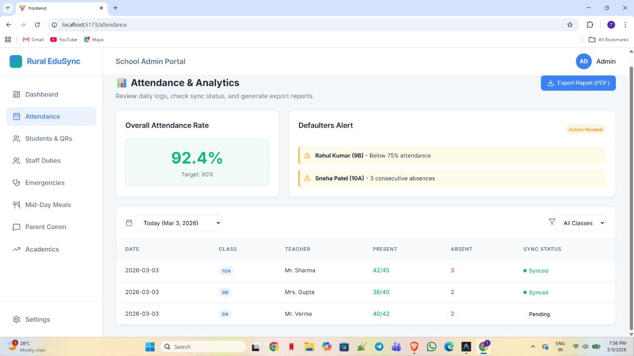

Screenshot 3: Student & QR management
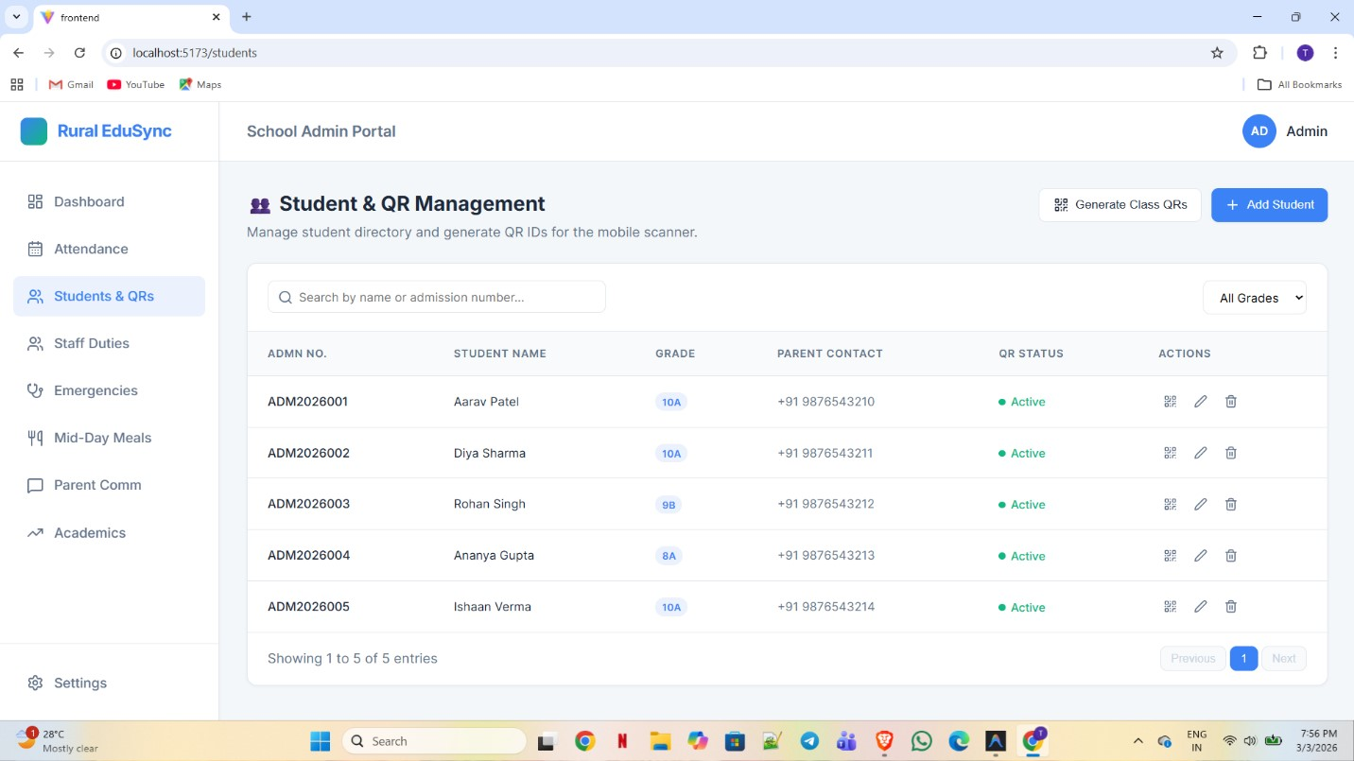

Screenshot 4: Teacher Duties
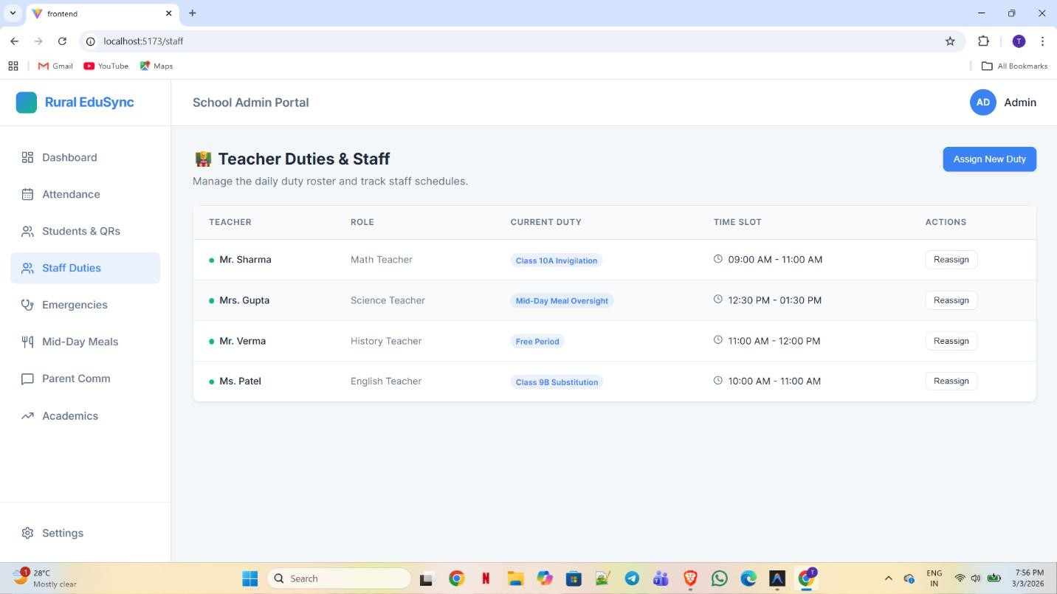

Screenshot 5: Emergencies
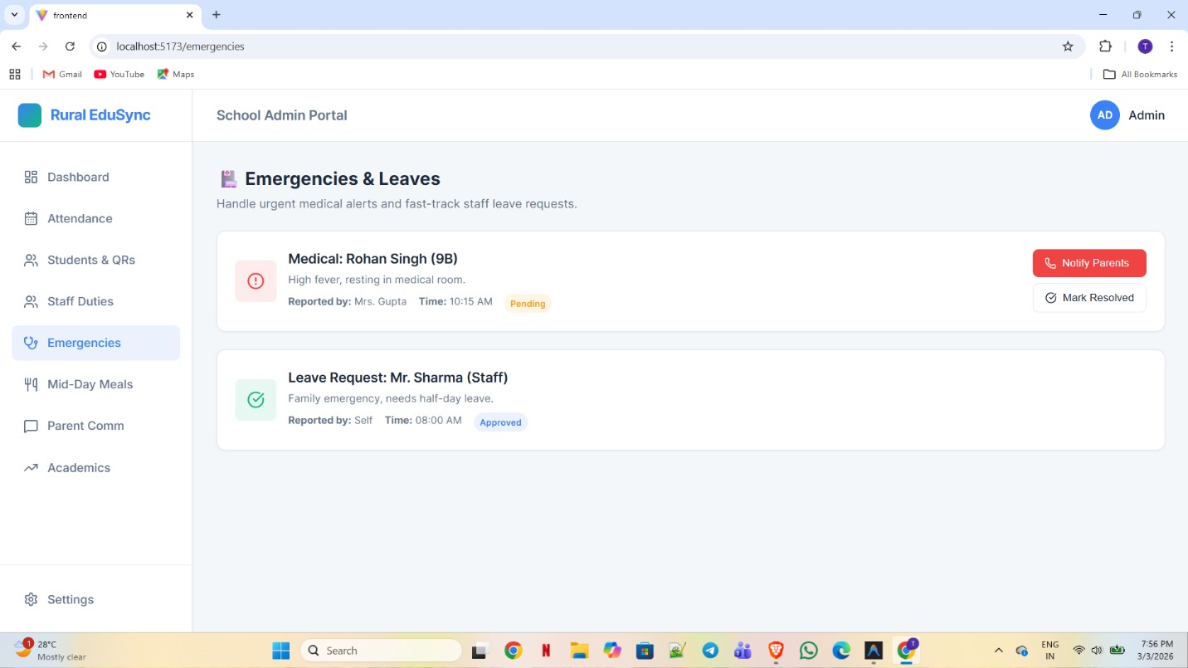

Screenshot 6. Mid day meal tracker
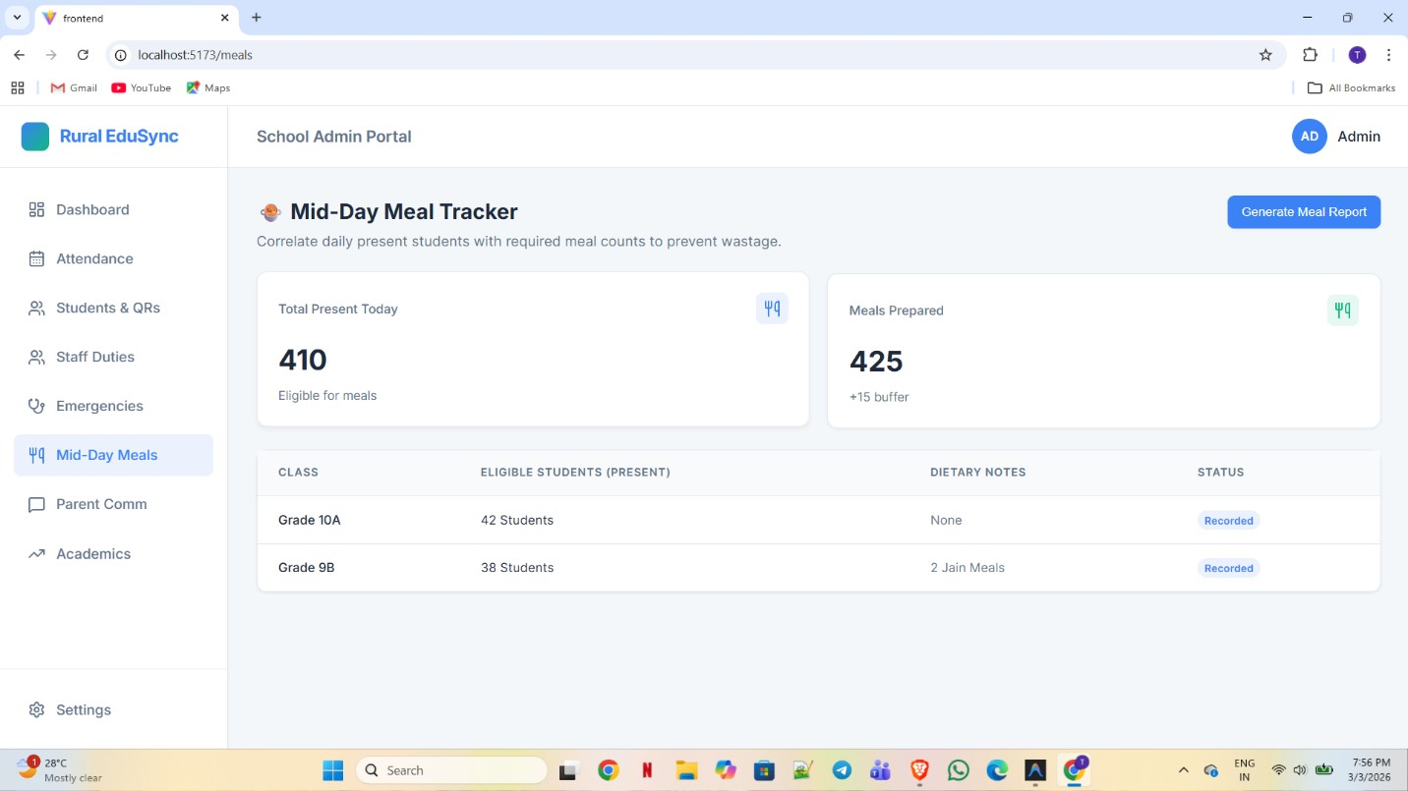

Screenshot 7. Parent Communication portal
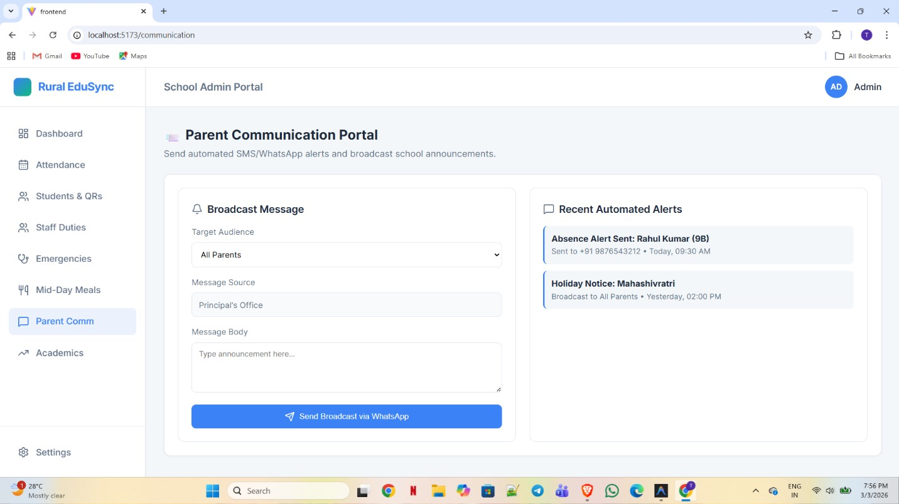

Screenshot 8: Academic Performance Tracker
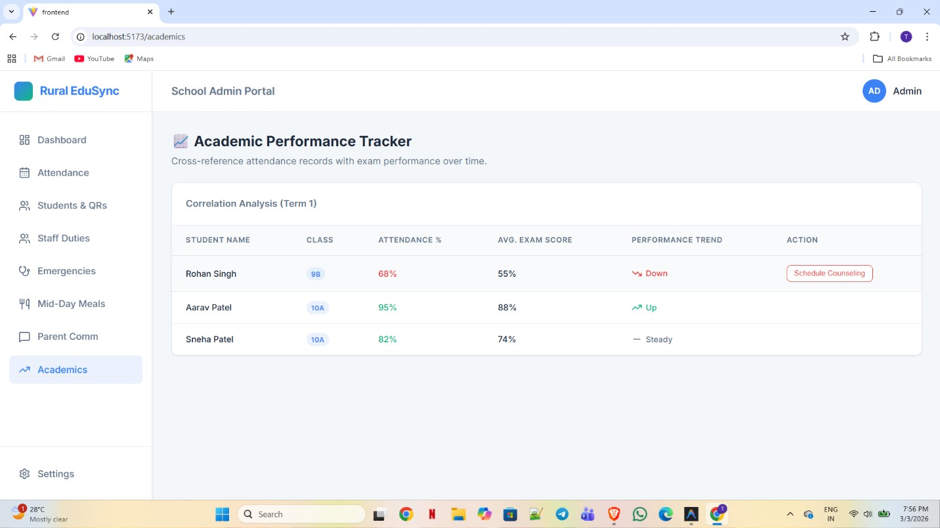

Github Link:

https://github.com/Tanish-132/D2_23BCE1787_TanishKumar

