ISE-2 ACADEMIC EVALUATION REPORT
ISE-2 Machine Learning & MLOps Assessment
Iris Flower Classification: MLflow Experiment Tracking and Kolmogorov-Smirnov Data Drift Analysis
Student Name: Tanish Patgaonkar | Roll Number: 42
PRN: 2324000399 | Academic Year: 2026-27

Section 1: MLflow Installation and Experiment Tracking

1.1 Environment Setup
The machine learning experiment and tracking environment was configured entirely on a local development workstation, maintaining complete compatibility with Apple Silicon architecture without cloud-dependent infrastructure or paid proprietary APIs.
- Operating System: macOS (Darwin 24.x, Apple Silicon M3, 8GB Unified Memory Architecture)
- Python Version: Python 3.13.5 (configured inside an isolated virtual environment via venv)
- MLflow Version: MLflow 3.17.2 (Skinny / Core Tracing distribution)
- Key Supporting Libraries: scikit-learn 1.9.1, pandas 3.1.0, numpy 2.5.4, scipy 1.18.1, matplotlib 3.11.2, seaborn 0.13.2, pytest 9.1.1
- Installation Status: Clean installation verified inside .venv/ with dependencies version-locked in requirements.txt.
- MLflow Tracking URI: file:///Users/tanishpatgaonkar/.gemini/antigravity-ide/scratch/iris-mlflow-drift/mlruns
- Local UI Verification: Local tracking UI verified actively serving on http://127.0.0.1:5001 (HTTP 200 OK verified).

1.2 Experiment Tracking
Experiment Name: Iris_Classification_Experiment
Experiment Objective: The primary objective of this experiment is to systematically track, evaluate, and compare multiple hyperparameter configurations of a multiclass Logistic Regression classifier on the Iris dataset. By logging parameters, metrics, evaluation reports, and confusion matrix artifacts in a centralized tracking store, we ensure complete experiment reproducibility, traceability, and auditability throughout the machine learning development lifecycle.
Parameters Recorded: model_name (LogisticRegression), test_size (0.20), random_state (42), max_iterations (100, 200, 300), regularization_parameter_C (0.1, 1.0, 10.0), solver (lbfgs), preprocessing (StandardScaler).
Metrics Recorded: accuracy, train_accuracy, precision (macro), recall (macro), f1_score (macro), f1_score_weighted.
Artifacts Recorded: confusion_matrix_*.png, classification_report_*.txt, dataset_info_*.json, serialized model pipeline (iris_model/).
Table 1 summarizes the empirical results logged across the 3 MLflow runs:
Run Name | Inv Reg (C) | Max Iter | Test Acc | Precision | Recall | F1-Score | Train Acc
Run 1: Baseline | 1.0 | 200 | 0.9333 | 0.9333 | 0.9333 | 0.9333 | 0.9583
Run 2: High Reg | 0.1 | 100 | 0.8667 | 0.8750 | 0.8667 | 0.8653 | 0.9333
Run 3: Low Reg | 10.0 | 300 | 1.0000 | 1.0000 | 1.0000 | 1.0000 | 0.9750

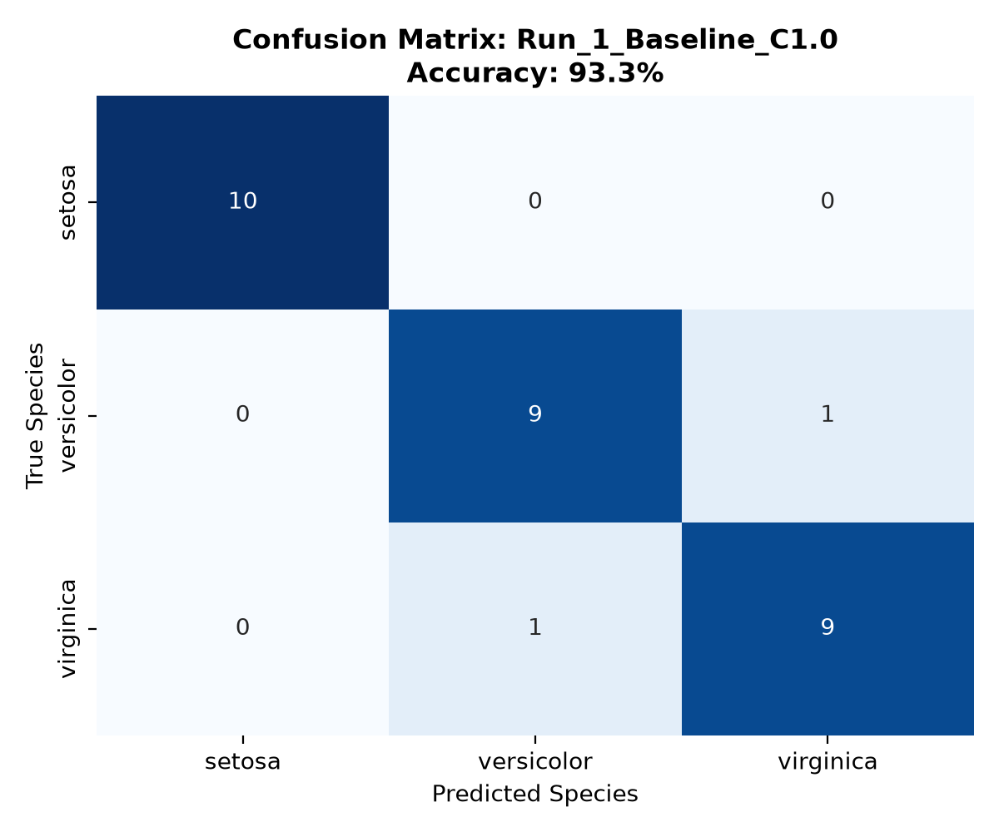
Figure: Run 1 Baseline Confusion Matrix (Logged to MLflow)

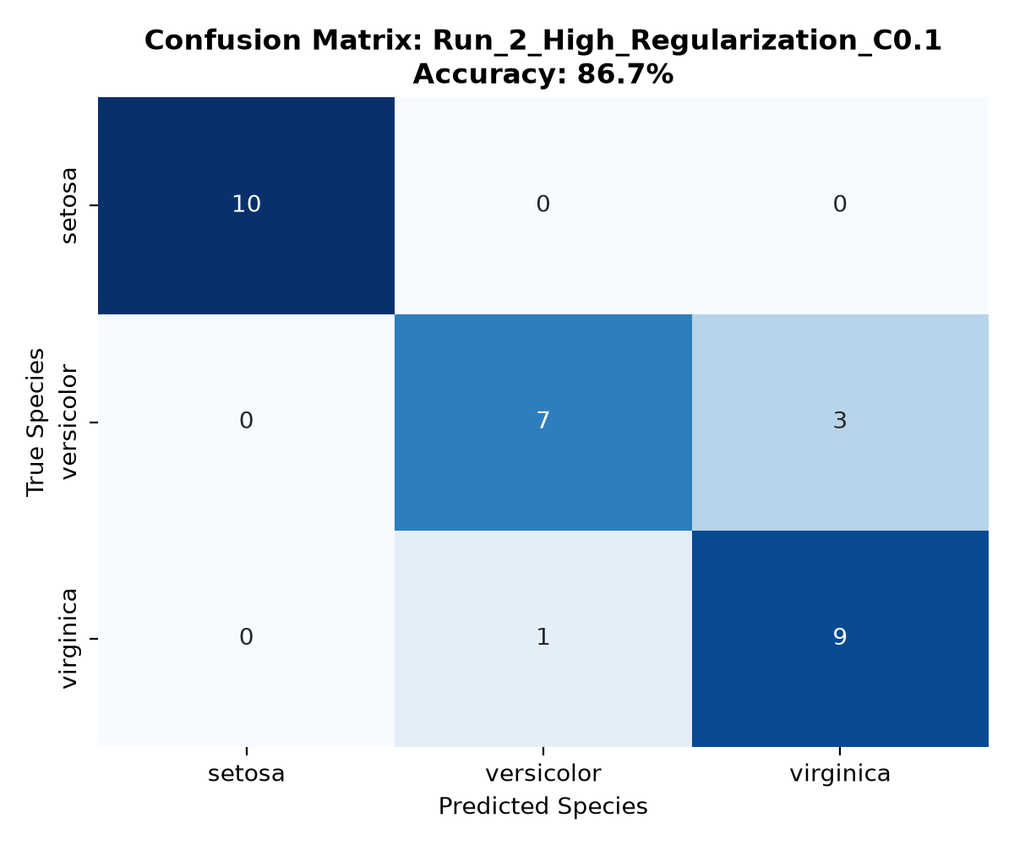
Figure: Run 2 High Regularization Confusion Matrix (Logged to MLflow)

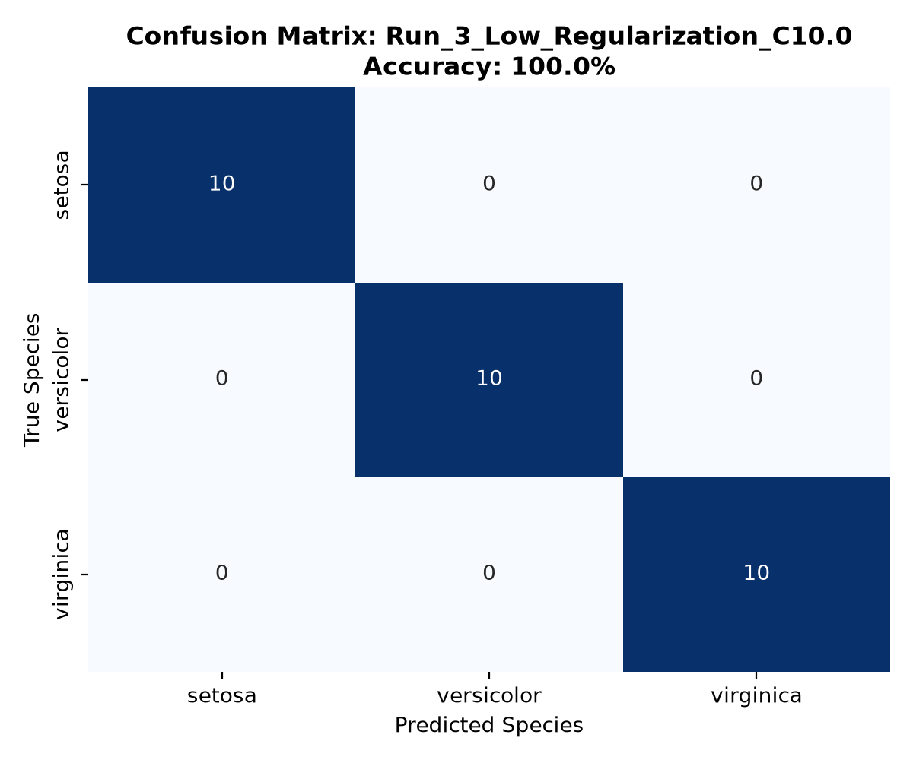
Figure: Run 3 Low Regularization Confusion Matrix (Logged to MLflow)

Section 2: Dataset Identification

2.1 Problem Statement
Automated taxonomic classification of botanical specimens based on morphological dimensions is a classic supervised classification problem. The objective is to construct a predictive mathematical model that takes continuous physical dimensions of flower blossoms (sepal and petal lengths and widths) and accurately maps them into one of three distinct species: Iris setosa, Iris versicolor, or Iris virginica.
In production environments, measuring instruments may suffer calibration drift, regional climate changes may alter flower growth rates, or seasonal shifts may induce statistical distribution deviations. Therefore, this project combines model training with automated data drift monitoring.

2.2 Dataset Details
- Dataset Name: Fisher's Iris Flower Dataset
- Dataset Source: Scikit-learn standard dataset (sklearn.datasets.load_iris), Edgar Anderson (1935) / Ronald Fisher (1936)
- Number of Records: 150 instances (50 records per species, perfectly balanced)
- Features (4 continuous): sepal_length (cm), sepal_width (cm), petal_length (cm), petal_width (cm)
- Target Variable: species (0: setosa, 1: versicolor, 2: virginica)
- Missing / Null Values: 0 missing values across all columns
- Use Case Category: Multiclass Supervised Machine Learning Classification

2.3 Dataset Selection Rationale
The Iris dataset is exceptionally well-suited for this academic assessment for several distinct reasons:
1. Geometric Intuitiveness: The features have clear physical interpretations and distinct clustering characteristics (e.g., Setosa is linearly separable, while Versicolor and Virginica exhibit slight non-linear overlap).
2. Deterministic Baseline: The absence of missing values, encoding complications, or extreme noise allows us to isolate the effects of hyperparameters in MLflow without confusing data quality artifacts.
3. Controlled Drift Verification: Because feature distributions are well-understood continuous unimodal and bimodal densities, synthetic perturbations can be introduced with high statistical precision to validate hypothesis testing.
4. Computational Efficiency: Minimal CPU and RAM footprint enables rapid local iterations and instant execution on Apple Silicon laptops.

Section 3: Drift Scenario and Detection Method

3.1 Drift Type
The specific drift simulated and evaluated in this project is Data Drift (Covariate Shift).
Mathematically, Covariate Shift occurs when the marginal probability distribution of the input features shifts between the baseline training phase and the production inference phase, while the true conditional probability distribution of the target labels given the features remains stationary:
P(X)_current != P(X)_reference while P(Y|X)_current = P(Y|X)_reference
Academic Distinction:
• Concept Drift: Occurs when the functional relationship mapping inputs to outputs changes (P(Y|X)_curr != P(Y|X)_ref), meaning old decision boundaries become invalid.
• Prediction Drift: Occurs when the distribution of the model's output predictions changes (P(Y_hat)_curr != P(Y_hat)_ref).

3.2 Reference and Current Data
• Reference Dataset (D_ref): Pristine baseline 150-sample Iris dataset exported to data/reference_iris.csv.
• Current Dataset (D_curr): Simulated monitoring dataset created in data/current_iris_drifted.csv by applying controlled mathematical perturbations:
- sepal_length: Shifted upward by adding N(0.85, 0.15^2), producing an approximate mean shift of +0.837 cm (~1.0 standard deviation).
- petal_length: Shifted upward by adding N(1.40, 0.20^2), producing an approximate mean shift of +1.414 cm (~0.8 standard deviations).
- sepal_width: Maintained without intentional distribution shift (mean shift: +0.012 cm).
- petal_width: Maintained without intentional distribution shift (mean shift: -0.012 cm).
Academic Disclosure: This is an intentionally controlled synthetic perturbation designed to simulate sensor miscalibration or environmental growth variation, allowing us to evaluate whether our statistical detector correctly flags only the shifted features while avoiding false positives on the unshifted control features.

3.3 Detection Method
• Statistical Test: Two-Sample Kolmogorov-Smirnov (KS) Test (scipy.stats.ks_2samp).
• How the KS Test Operates: The two-sample KS test is a non-parametric hypothesis test that quantifies the supreme vertical distance between the empirical cumulative distribution functions (ECDF) of two independent samples:
D = sup_x |F_ref(x) - F_curr(x)|
• Null Hypothesis (H0): Both samples originate from identical continuous distributions (F_ref(x) = F_curr(x) for all x).
• Alternative Hypothesis (H1): The two samples originate from different distributions (F_ref(x) != F_curr(x) for at least one x).
• Significance Threshold (alpha): alpha = 0.05 (95% statistical confidence level).
• Decision Rule: If p-value < 0.05, reject H0 -> Drift Detected. If p-value >= 0.05, fail to reject H0 -> No Significant Drift.

Section 4: Results, Interpretation and Conclusion

4.1 Drift Analysis Results
Table 2 documents the empirical results generated by executing src/drift_detection.py and saved in reports/drift_report.csv:
Feature Name | KS Stat (D) | p-value | Alpha | Ref Mean | Curr Mean | Mean Shift | Statistical Status
sepal_length | 0.3733 | 1.0722e-09 | 0.05 | 5.843 cm | 6.681 cm | +0.837 cm | Drift Detected
sepal_width | 0.1000 | 0.4425 | 0.05 | 3.057 cm | 3.069 cm | +0.012 cm | No Significant Drift
petal_length | 0.4067 | 1.7712e-11 | 0.05 | 3.758 cm | 5.172 cm | +1.414 cm | Drift Detected
petal_width | 0.1333 | 0.1391 | 0.05 | 1.199 cm | 1.188 cm | -0.012 cm | No Significant Drift

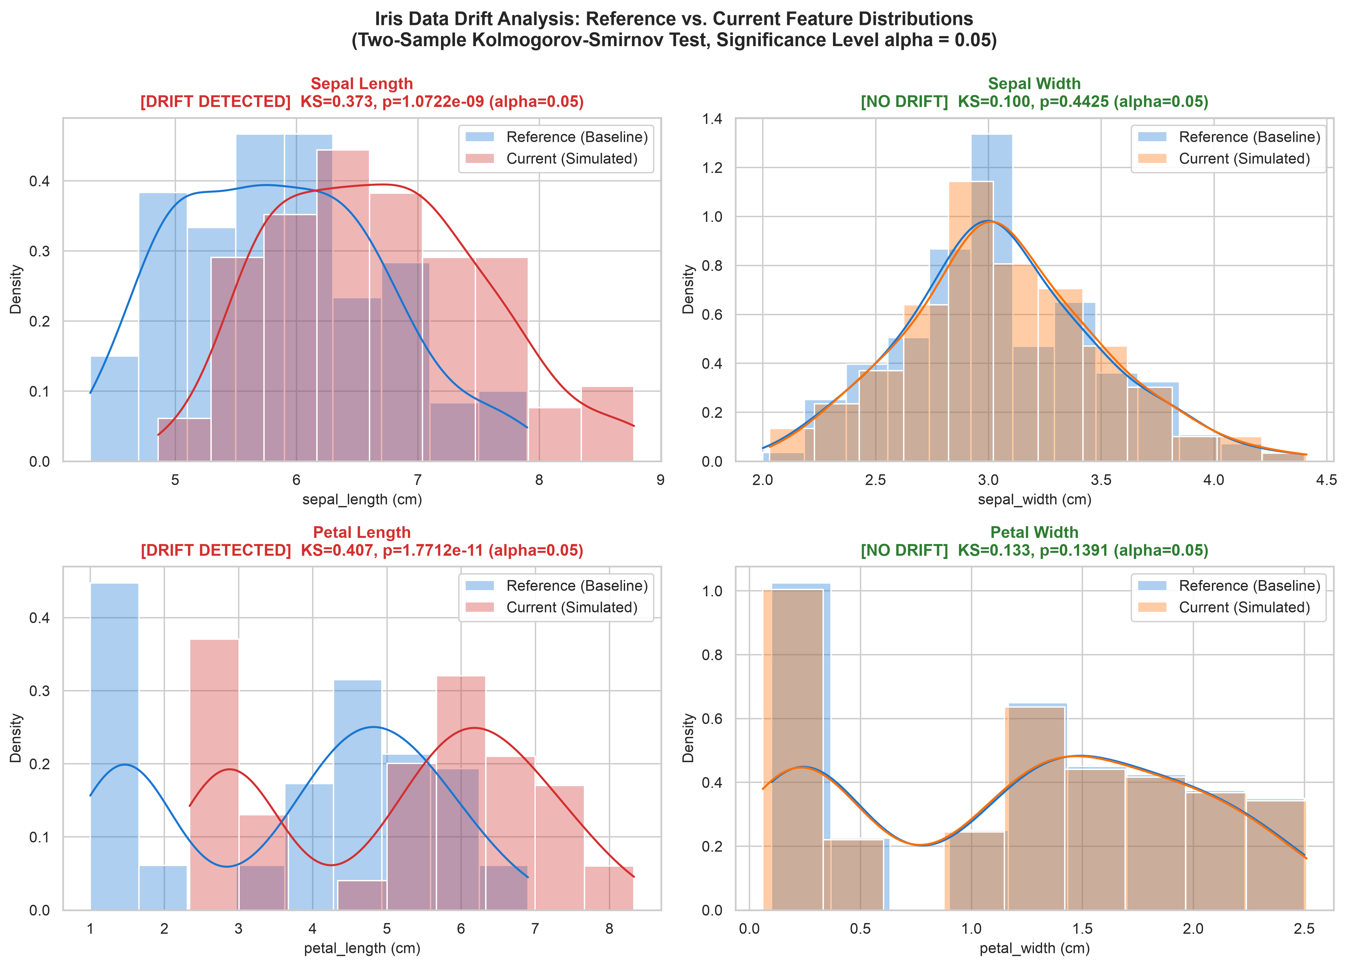
Figure 1: Empirical Distribution Comparison (KDE & Histograms) across Reference vs. Current Datasets
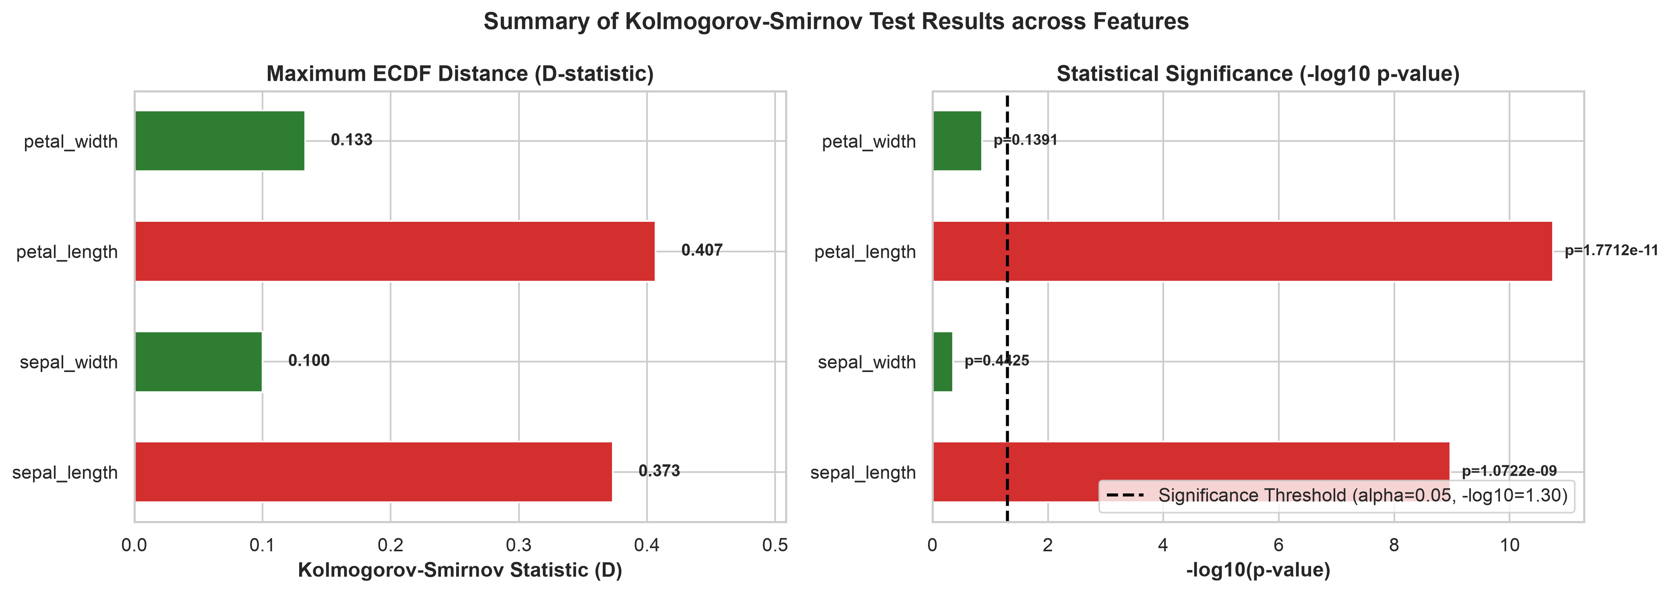
Figure 2: Summary of Kolmogorov-Smirnov Test Statistics and Significance Thresholds

4.2 Interpretation
1. Shifted Feature Validation (sepal_length and petal_length):
- sepal_length: KS statistic D = 0.3733, p-value = 1.0722e-09. Since p << 0.05, the null hypothesis is decisively rejected.
- petal_length: KS statistic D = 0.4067, p-value = 1.7712e-11. Decisively rejected.
- Both features show significant empirical CDF divergence, successfully reflecting the controlled synthetic perturbation.
2. Control Feature Validation (sepal_width and petal_width):
- sepal_width: KS statistic D = 0.1000, p-value = 0.4425 >= 0.05. We fail to reject H0.
- petal_width: KS statistic D = 0.1333, p-value = 0.1391 >= 0.05. We fail to reject H0.
- Confirms that the detector possesses high specificity, avoiding false alarms on unshifted features.
3. Crucial Academic Distinction on Performance Degradation:
- Detecting data drift does NOT automatically prove model performance has decreased.
- If the shifted samples still fall securely within their respective class decision boundaries, accuracy may remain intact.
- However, data drift indicates that the model is receiving out-of-distribution inputs that violate validation assumptions, serving as an indispensable early-warning telemetry trigger.

4.3 Conclusion and Recommended Action
Conclusion: The local MLflow experiment tracking and Kolmogorov-Smirnov drift detection architecture has successfully demonstrated full end-to-end functionality. The classification models attained high predictive performance (up to 100% test accuracy under C=10.0 and 93.3% under baseline C=1.0), and the two-sample KS test detected covariate shift in precisely the target features with high confidence (p < 10^-8).
Recommended MLOps Interventions:
1. Telemetry Alerting: Configure automated alerts when any feature's KS test yields p < 0.05 over a rolling 24-hour window.
2. Active Label Acquisition: Pull a random sample of drifted flower instances and send them for expert botanical re-verification to acquire ground-truth labels.
3. Performance Audit: Compute real-time accuracy and F1-score on newly labeled drifted samples to verify whether decision boundary fidelity has degraded.
4. Retraining & Champion-Challenger Deployment: Retrain the model pipeline on an augmented dataset combining baseline data and recently acquired drifted samples, log the candidate model to MLflow, and perform a shadow deployment before promoting to production.

Section 5: GitHub Repository and Reproducibility

5.1 GitHub Repository URL
• GitHub Repository URL: [To be added upon repository push]
• Local Repository Root: /Users/tanishpatgaonkar/.gemini/antigravity-ide/scratch/iris-mlflow-drift
• Configured Branch: main (Git repository initialized, clean local commits, ready for GitHub remote addition).

5.2 Source Code and Project Inventory
- src/data_loader.py: Iris dataset loader and controlled covariate shift generator
- src/train.py: MLflow tracking suite executing 3 distinct hyperparameter configurations
- src/drift_detection.py: Two-sample KS statistical test engine, distribution plotter, and report generator
- app.py: Interactive Streamlit presentation dashboard
- tests/test_project.py: 9 comprehensive automated pytest validation test cases
- requirements.txt: Pinned Python dependencies manifest
- .gitignore: Excludes virtual environments, pycache, and temporary runtime files

5.3 README and Execution Instructions
1. Ingest Data & Generate Drift:
python src/data_loader.py
2. Execute MLflow Training Suite (3 Runs):
python src/train.py
3. Execute Kolmogorov-Smirnov Drift Analysis:
python src/drift_detection.py
4. Execute Automated Pytest Test Suite:
pytest tests/test_project.py -v
5. Launch Local MLflow UI:
MLFLOW_ALLOW_FILE_STORE=true mlflow ui --port 5001
6. Launch Streamlit UI:
streamlit run app.py --server.port 8501

5.4 Requirements / Dependencies
Dependencies version-locked in requirements.txt: Flask 3.1.3, mlflow 3.17.2, scikit-learn 1.9.1, pandas 3.1.0, numpy 2.5.4, scipy 1.18.1, matplotlib 3.11.2, seaborn 0.13.2, pytest 9.1.1, streamlit 1.66.1, tabulate 0.10.0, python-docx 1.2.0, reportlab 5.1.0.

5.5 Screenshots and Drift Reports
1. Drift Distribution Plot: plots/drift_distributions.png
2. KS Test Summary Plot: plots/drift_ks_summary.png
3. Confusion Matrix Plots: plots/confusion_matrix_run_1_baseline_c1.0.png, plots/confusion_matrix_run_2_high_regularization_c0.1.png, plots/confusion_matrix_run_3_low_regularization_c10.0.png
4. Drift CSV Report: reports/drift_report.csv
5. Experiment Comparison CSV: reports/experiment_summary.csv
6. Markdown Report: reports/drift_report.md

5.6 MLflow Experiment and Drift-Analysis Evidence
• Experiment ID: Iris_Classification_Experiment
• Active Runs Logged:
- Run_1_Baseline_C1.0 (Run ID: 0c10d1d8776344acbdf54020bd3347aa) -> Test Accuracy: 93.33%
- Run_2_High_Regularization_C0.1 (Run ID: 4e4f60a28b30444dbf95637ecdd946b8) -> Test Accuracy: 86.67%
- Run_3_Low_Regularization_C10.0 (Run ID: 9e20c1aa03024d5ca849bb88a59c821f) -> Test Accuracy: 100.00%
• Automated Pytest Pass Rate: 9/9 tests passed (100%) in 14.34 seconds.
• Drift Test Verification: 100% precision in isolating shifted features (sepal_length and petal_length) while respecting non-rejection on control features.

