Comprehensive Technical Documentation: LibreOne Virtual Desktop Interface
This report details the work completed on the project to Replace the traditional desktop mouse pointer with the Senmag LibreOne stylus, focusing on implementation, challenges, and solutions developed. This document is intended to provide a clear, technical roadmap for any successor developer.

1. LibreOne Device Configuration and Connection Pipeline
The initial phase was critical for establishing stable communication with the Senmag LibreOne device on the development platform.

A. Connectivity Challenges and Resolution
The LibreOne Companion software consistently failed to connect to the device, displaying 'Nothing found on COM3' and raising a ResourceError in the custom debug terminal. This occurred despite initial attempts to troubleshoot by uninstalling and reinstalling the USB Serial Port (COM3) driver.
Detail | Finding/Action
Initial Failures | Device was not found by LibreOne Companion, and manually installing drivers caused Unity to freeze upon pressing 'Play' in the provided 9D_Stylus_Demo project.
Antivirus Check | Confirmed no antivirus was conflicting with the companion software.
Driver/OS Check | Checked MSI Center for chipset/USB driver updates; none were available.
Device Validation | The device's internal functionality was confirmed: FTDI software successfully detected the device, and Realterm software could receive a data stream (raw hex values) when the baud rate was set to 1500000.
Conflict Isolation | The issue was confirmed to be specific to the personal laptop's low-level drivers, as the device connected and calibrated successfully on a different machine (Lenovo ThinkPad).
Final Resolution | The connection issue was ultimately resolved by changing the device's internal Serial Number to a default value, allowing the personal laptop to establish stable communication.

B. Development Preparation
The QTCreator IDE was set up to prepare for potential source code debugging of the LibreOne Companion software, though this was not ultimately required for connectivity.

2. Virtual Desktop Creation and Data Mapping Pipeline
The core of the project involves a robust pipeline for translating the live 2D Windows desktop hierarchy into a real-time, navigable 3D environment in Unity.

A. Data Extraction and Coordinate Mapping
The source of the desktop data is accessibility information extracted from the Windows environment.
- Data Source: The project uses JSON data dumps derived from the Hugging Face/NVDA framework.
- Initial Mapping: Fields were created in Unity to parse the JSON data. Initial attempts to map the bounding box (bbox) coordinates resulted in inaccurate placement, with elements generated outside the designated DesktopBg area .
- Precision Fix: Coordinate accuracy was fixed by switching the mapping logic to use the element's point (central coordinate) instead of the bbox.
- Accessibility Data: A custom Python script using UI Automation/NVDA was developed to generate a new XML snapshot of the desktop. This was critical for obtaining nested accessibility data and accurate Z-index information.
- Element Scaling: The Bounding Box (bbox) values are utilized to calculate the local scale of the instantiated icon and window game objects in Unity's world space.

B. Real-time Desktop Tracking Implementation
The system uses an external executable to monitor the desktop state, ensuring the 3D representation is always up-to-date.
- Tracking Mechanism: A Python script was converted into a standalone executable (desktop_watcher.exe) using PyInstaller. This executable updates the ui_dump_live.json file in real-time every 2 seconds using a mechanism called Periodic Polling.
- Optimization: The tracking was optimized to only update the JSON dump if any change is detected on the desktop , reducing file I/O overhead.
- Filtering Issues: Initial dumps included unnecessary elements:
  - Instances like ChatGPT and WhatsApp were displayed in the virtual environment .
  - NVIDIA GE Force Overlay was also captured .
  - The filtering logic was updated to exclude these non-essential background or minimized applications by checking for element visibility and control type.

C. Z-Order and Window Occlusion
Correctly stacking elements in 3D space is essential for usability.
- Z-Order Calculation: The true stacking order (Z-index) of windows is computed using the Windows API function GW_HWNDPREV to retrieve the correct window hierarchy.
- Z-Index Anomalies: An issue was noted where the Program Manager instance exhibited an unusually high z-index , which required specific code handling to prevent visual distortion.
- Visual Refinement: The WindowControl type was assigned a lesser Z-Spacing value to bring window game objects closer to the Desktop background, improving visual coherence.
- Occlusion Logic: Code was developed to implement detection of overlapping windows to accurately model window occlusion, ensuring windows newly overlaid on top of icons are displayed correctly .

3. Stylus Interaction and Haptic Feedback System
This phase integrated the haptic device to control the desktop cursor and provide accurate force feedback on the virtualized UI.

A. Mouse Pointer Control Implementation
The native Windows mouse pointer is controlled directly from within the Unity application via Windows API calls.
- API Usage: Functions from user32.dll are utilized for low-level control.
  - Movement: The SetCursorPos() function is used to map the position of the Unity-controlled pointer to the actual desktop mouse pointer.
  - Clicks: The mouse_event() function is used to simulate left and right mouse clicks.
- Stylus Control: The movement of a dummy pointer (a sphere) was first mapped to the desktop pointer, followed by successfully mapping the movement of the DK1 Stylus to the desktop pointer.
- Edge Clamping: Colliders were added at the edges of the virtual screen to clamp the pointer movement, allowing the user to feel the edges of the screen haptically .
- Click Bindings (Temporary): Currently, simulated mouse clicks are mapped to the keyboard: space for left-click and right-shift for right-click. Note: These simulated clicks currently fail to register on desktop applications outside the Unity Editor.

B. Haptic Feedback Optimization and Refinement
Several rounds of optimization were necessary to ensure smooth and accurate force feedback.
- Performance Optimization: The initial system caused erratic feedback by destroying and re-instantiating all game objects on every frame update.
  - Solution: An optimization script was implemented (the Optimized Virtual Desktop) that uses a dictionary to track active elements. Only elements that are minimized get destroyed, and only elements that regain focus are re-instantiated, dramatically improving performance.
- Inaccurate Force Debugging: A test was conducted using two cubes (one static and one controlled by code) to isolate whether the inaccurate feedback was caused by the constant update of game object positions. This test confirmed that the position update itself was not the cause.
- Force Tweak: The inaccurate force feedback was identified as being related to the high Position Multiplier (currently 50). This was mitigated by increasing the Haptic Stiffness from 1 to 2 or 2.5 to counteract the multiplier's effect and improve perceived accuracy.
- Element Distinguishability: For icon-type elements, the ListItemControl control type was checked for. This was multiplied by a constant factor to reduce the width of the icons, making them feel more distinguishable using the stylus .
- Haptic Enhancement: A Force Field object (sphere) was added as a child component to all instantiated icon game objects . This object creates a "pull effect" that partially locks the stylus inwards every time it comes near an icon, improving target acquisition.
- Temporary Fix: Erratic force feedback was temporarily fixed by simply restarting the entire Haptic Ecosystem.

4. Current State and Next Steps
The project has a functional virtual desktop environment with real-time tracking, but several key integration and refinement steps remain.
- LibreOne Click Integration: The most critical outstanding task is to map the physical button presses of the LibreOne stylus to the left and right mouse click events. This is necessary because the current API-simulated clicks (using mouse_event()) are not registering on the desktop outside the Unity Editor.
- Cursor Teleport Threshold: The Cursor Teleport Threshold value needs to be increased. Currently, the low value causes unpredictable cursor jumps during fast movements.
- Refine Window Occlusion: The logic for detecting overlapping windows needs final testing and refinement to ensure correct Z-order and occlusion for all window states (including non-minimized, layered windows).
- Haptic Fine-Tuning: Continual refinement of the Haptic Stiffness, Position Multiplier, and Force Field parameters is required to achieve the most realistic and intuitive force feedback experience.

Appendix
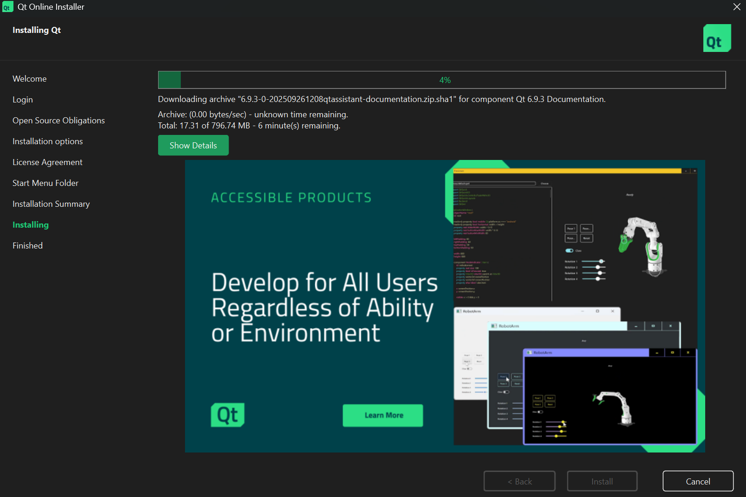
Installing QTCreator for debugging Configuration issue with LibreOne and my laptop

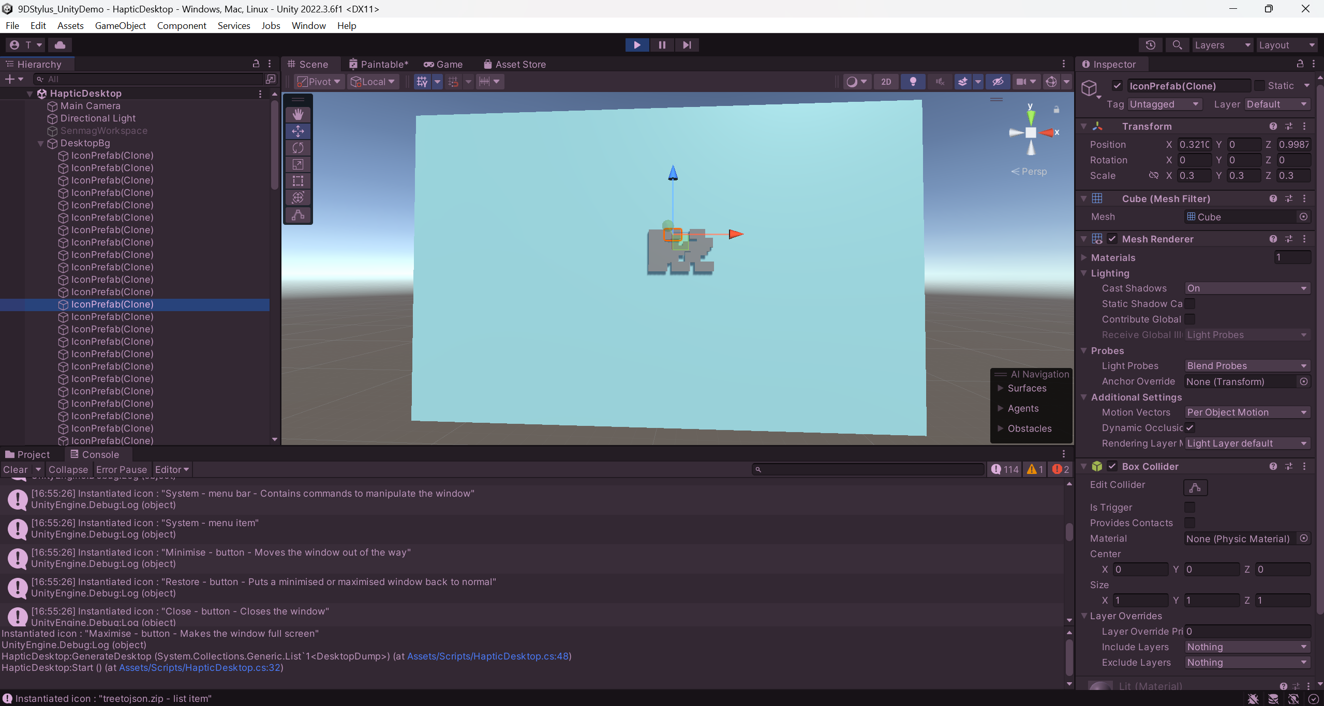
Instantiated cubes for each icon on the desktop. Coordinate mapping yet to be done.

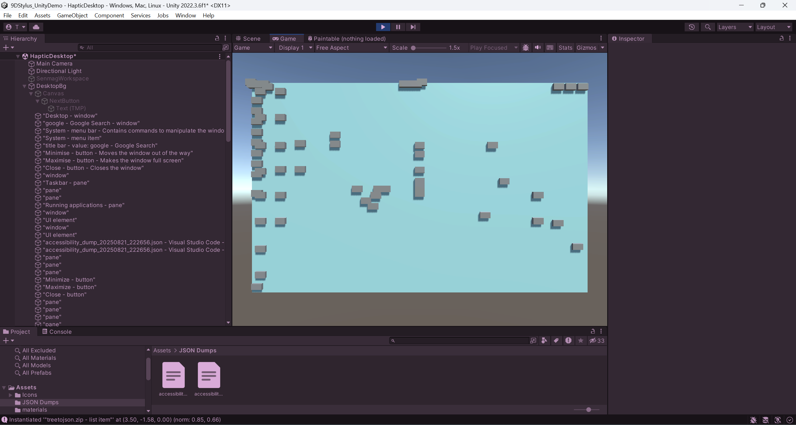
Mapped the coordinates and changed names of the instantiated game objects at runtime using the instruction property from the JSON.

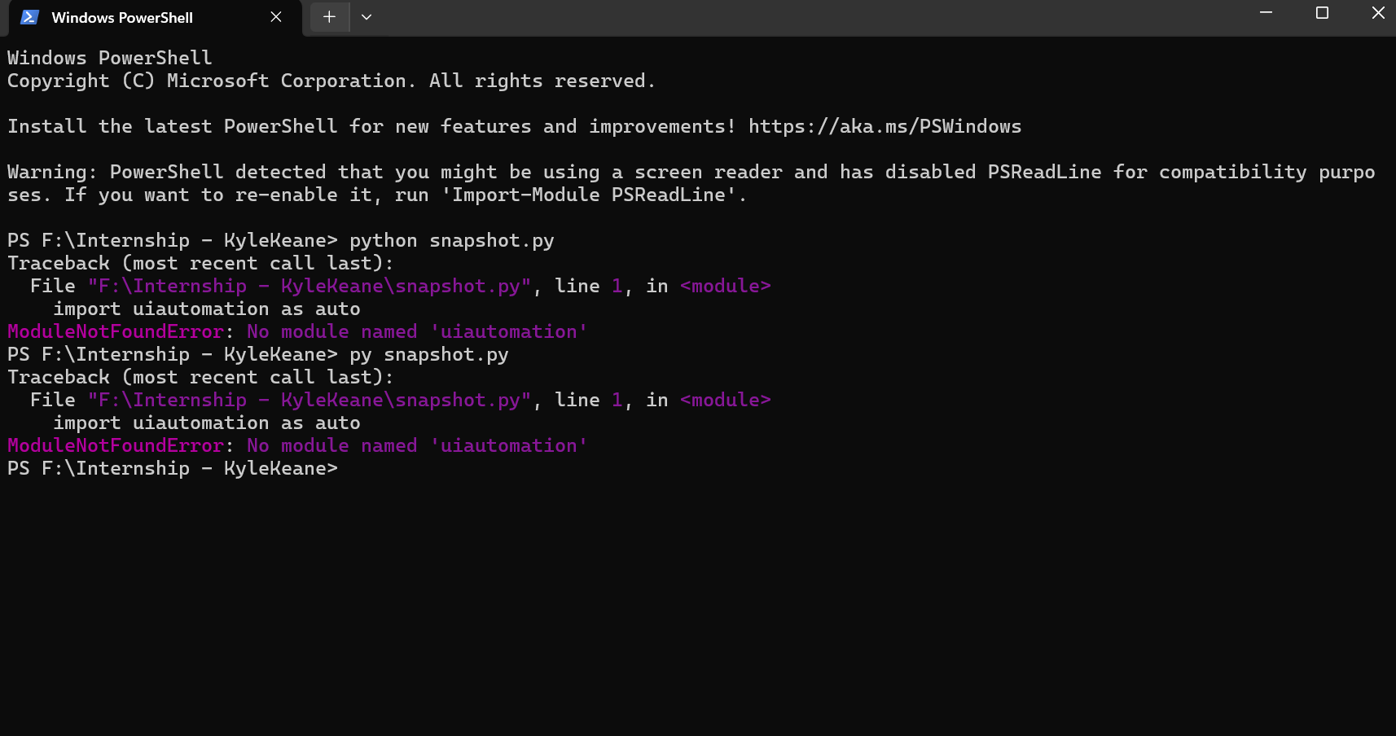
Need to set up UI Automation to run Python script.

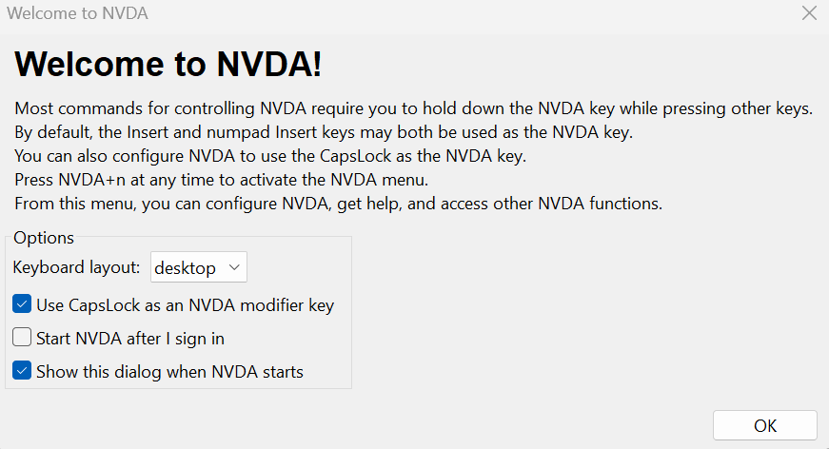
NVDA setup.

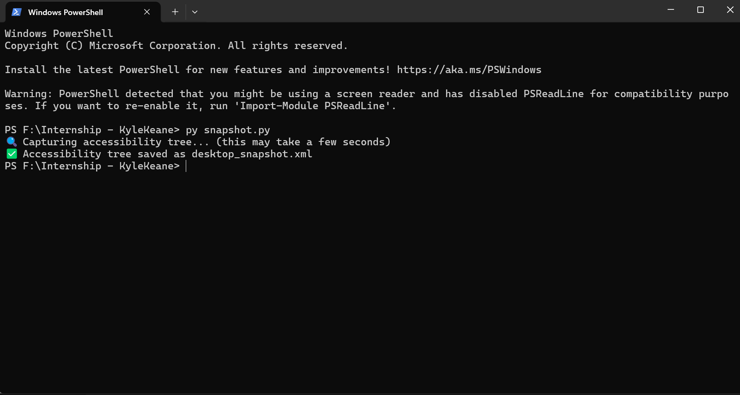
desktop snapshot xml file created.

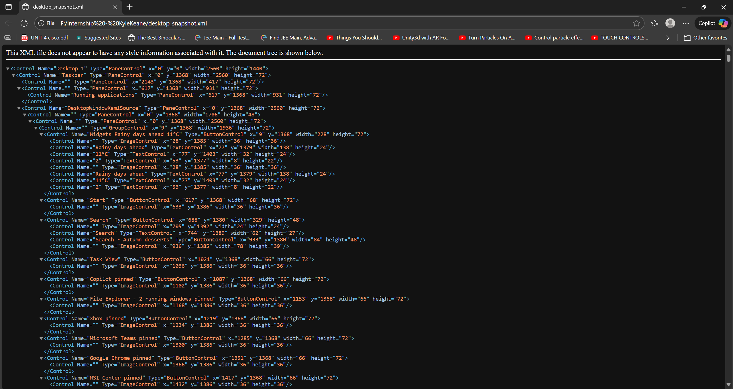
desktop snapshot xml file.

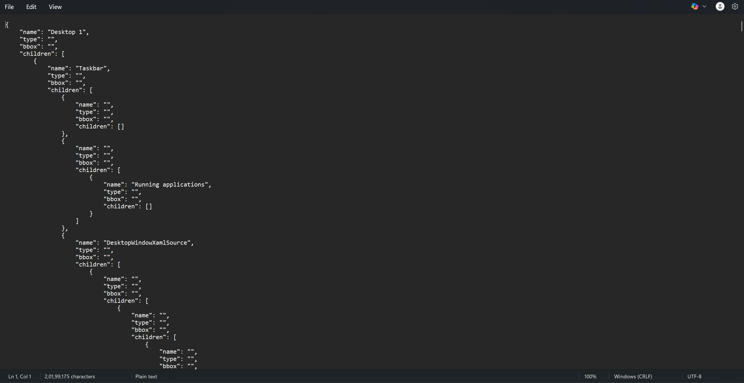
Converted xml to JSON, nested accessibility data achieved.

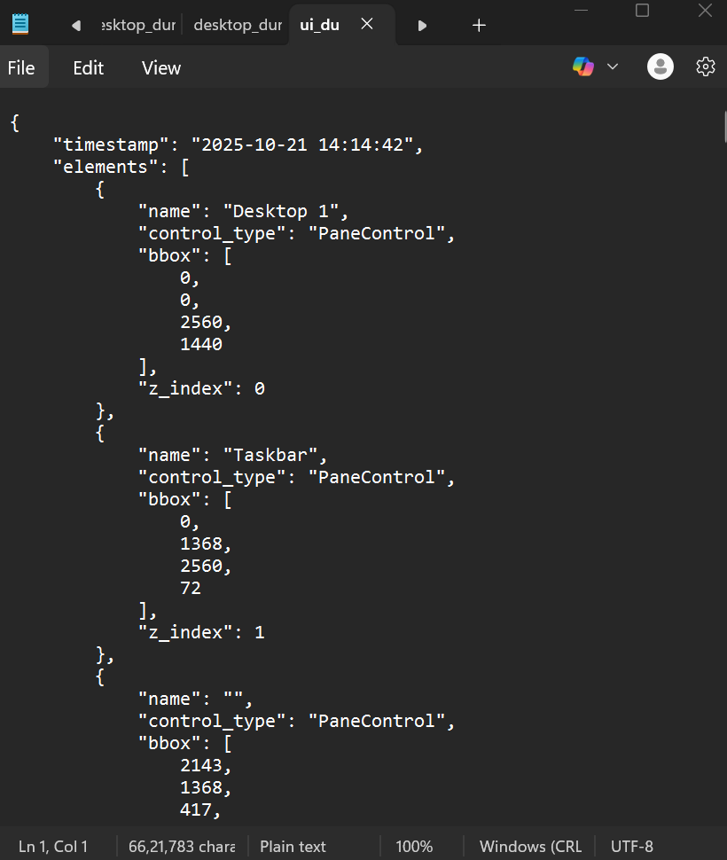
JSON with z-index generated by accessing the accessibility tree of NVDA

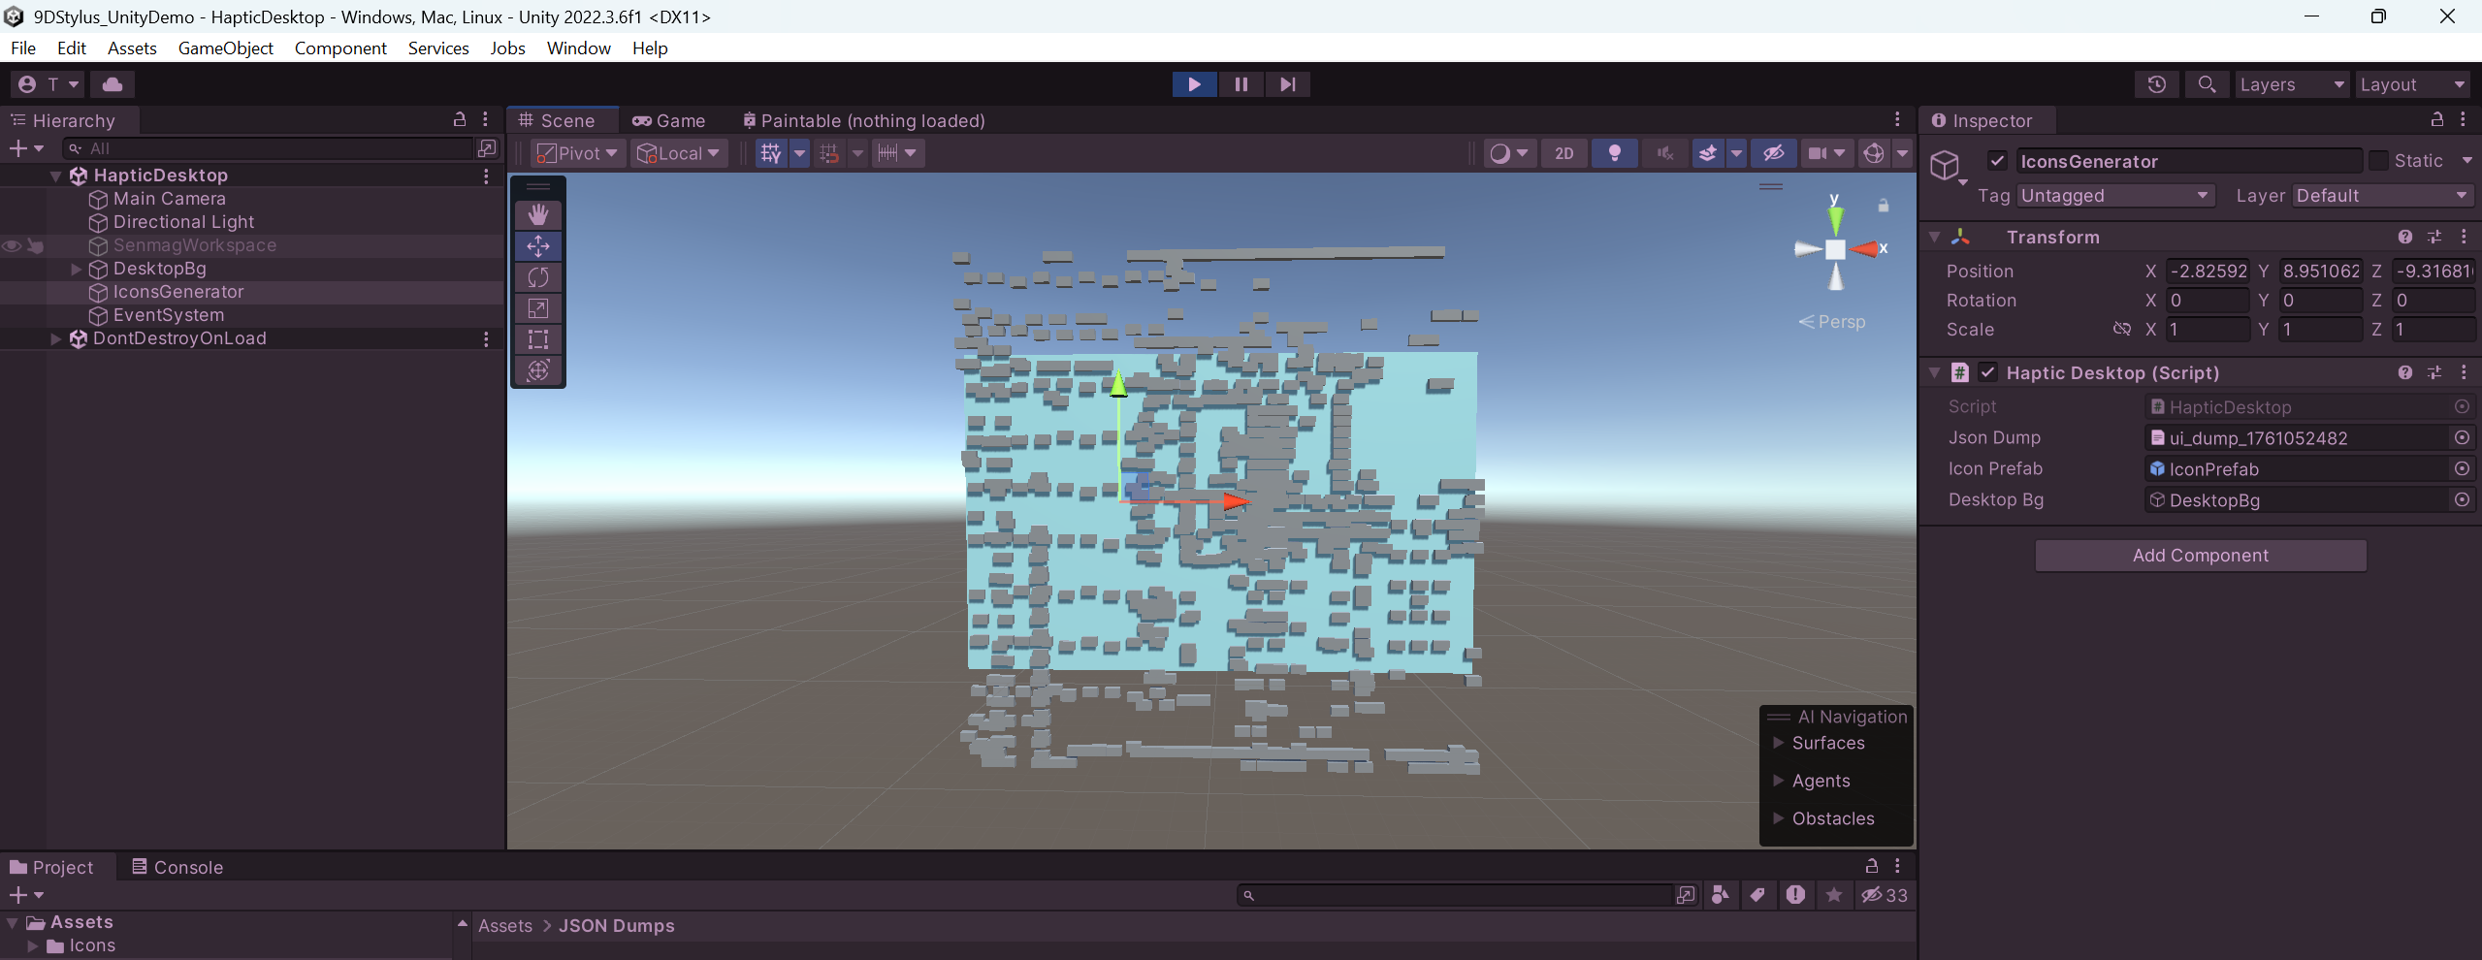
Elements generated outside the DesktopBg.
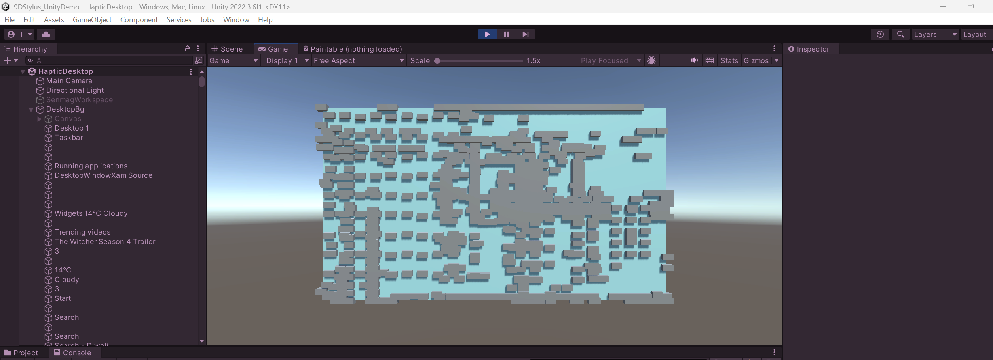
Elements mapped correctly.
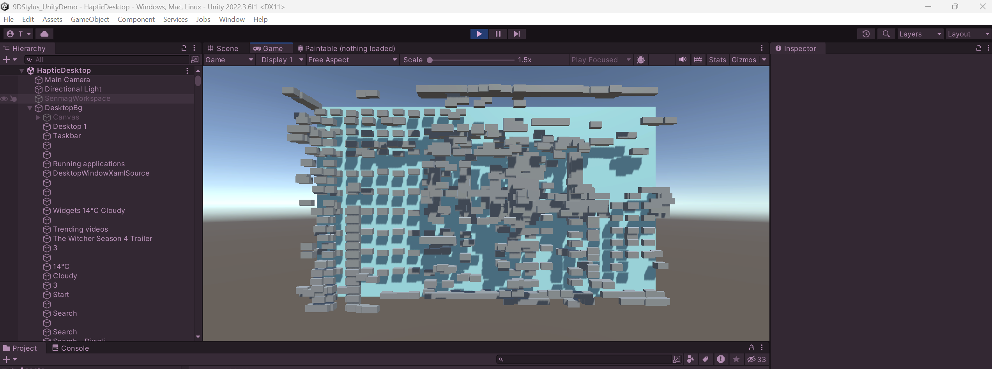
Elements given an offset on y depending on the z-index of the icon they are representing.

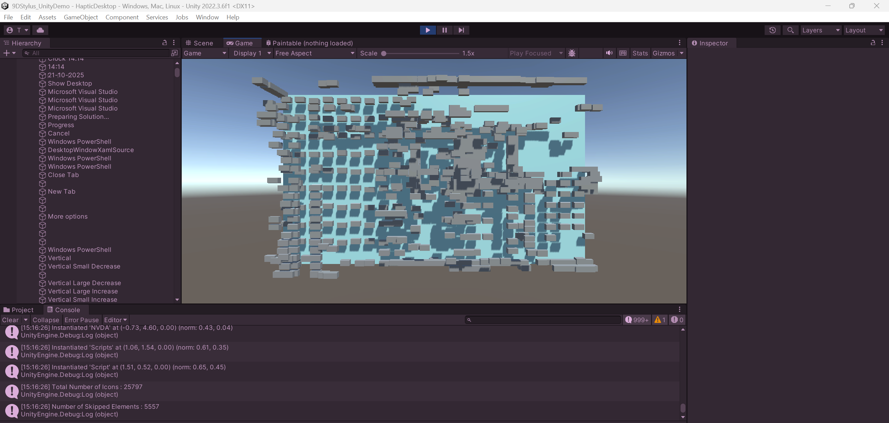
Skipping elements that have no name and displaying total number of icons in JSON and number of icons skipped.

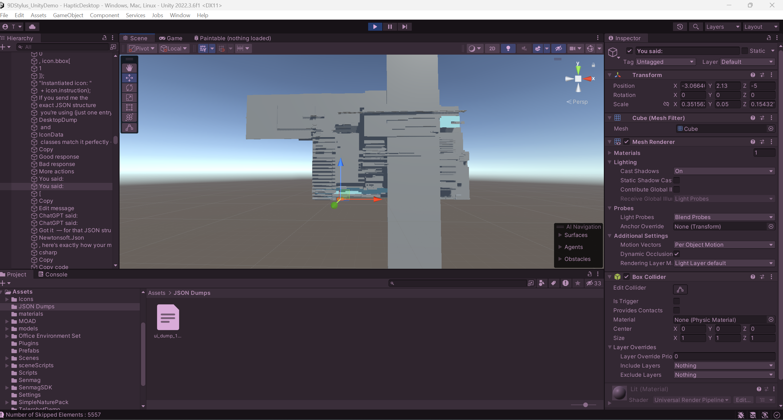
Scale of icons calculated through Bounding Box values.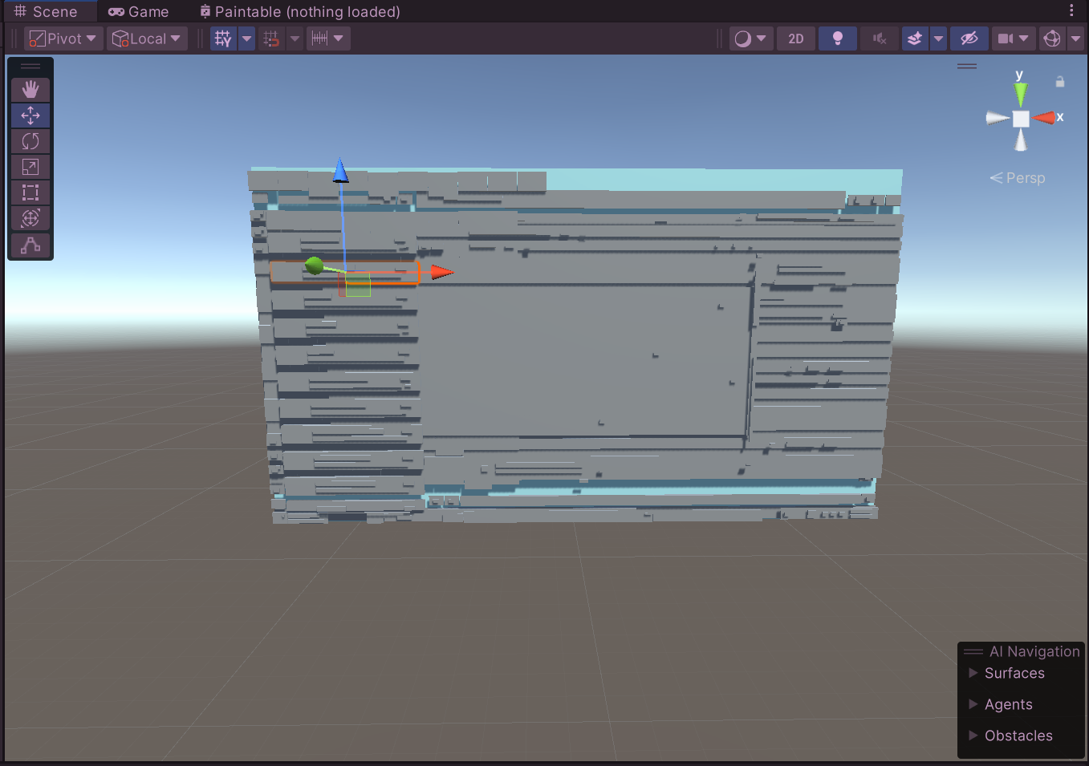
Got rid of chatgpt instance, whatsapp instance pending.
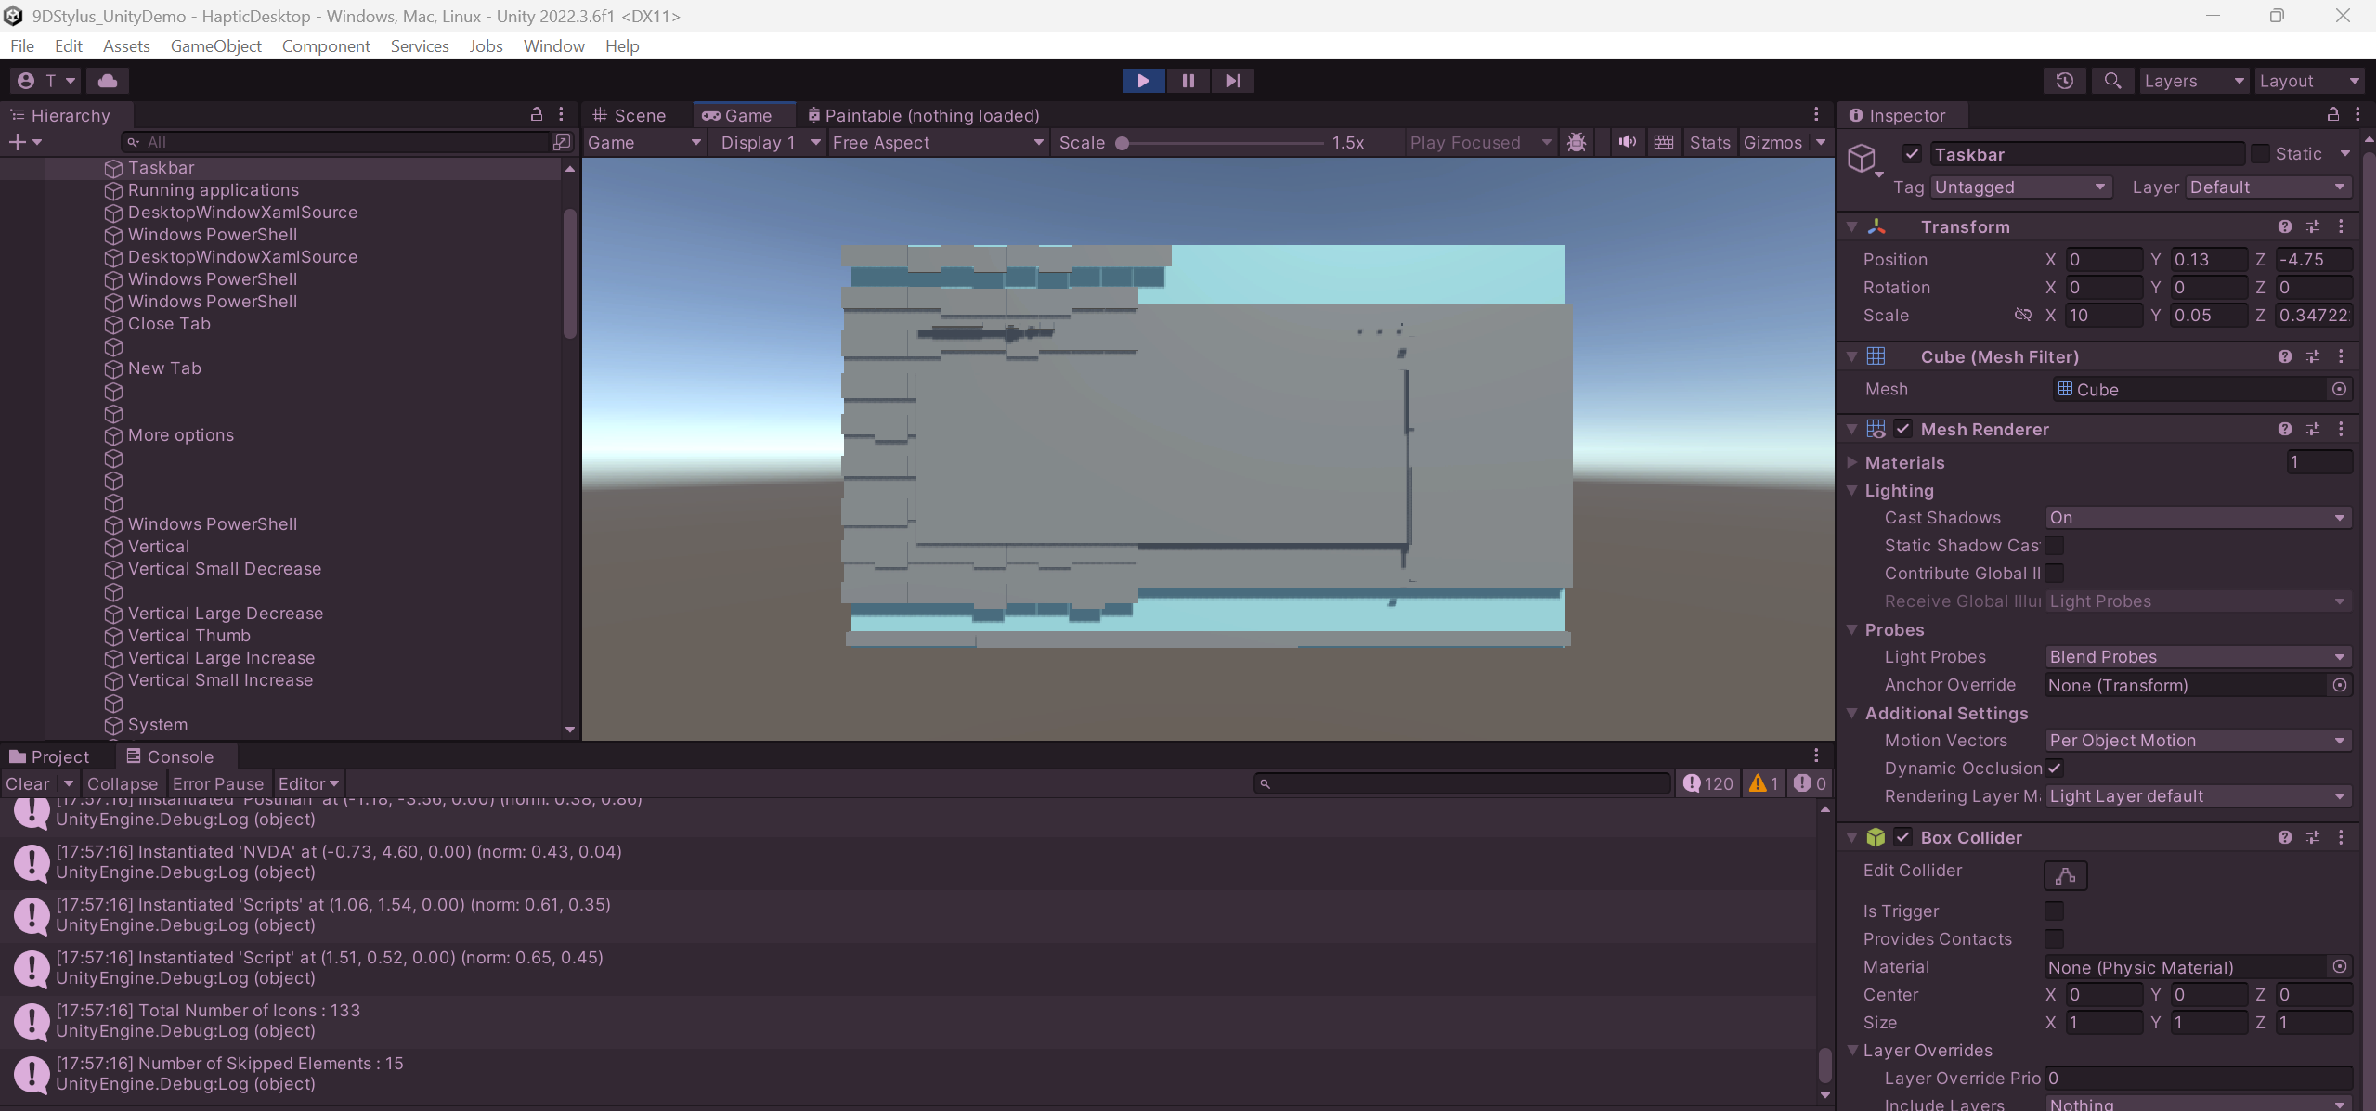
Got rid of Whatsapp, NVIDIA GE Force Overlay displayed. Pinned icons on the taskbar have disappeared.

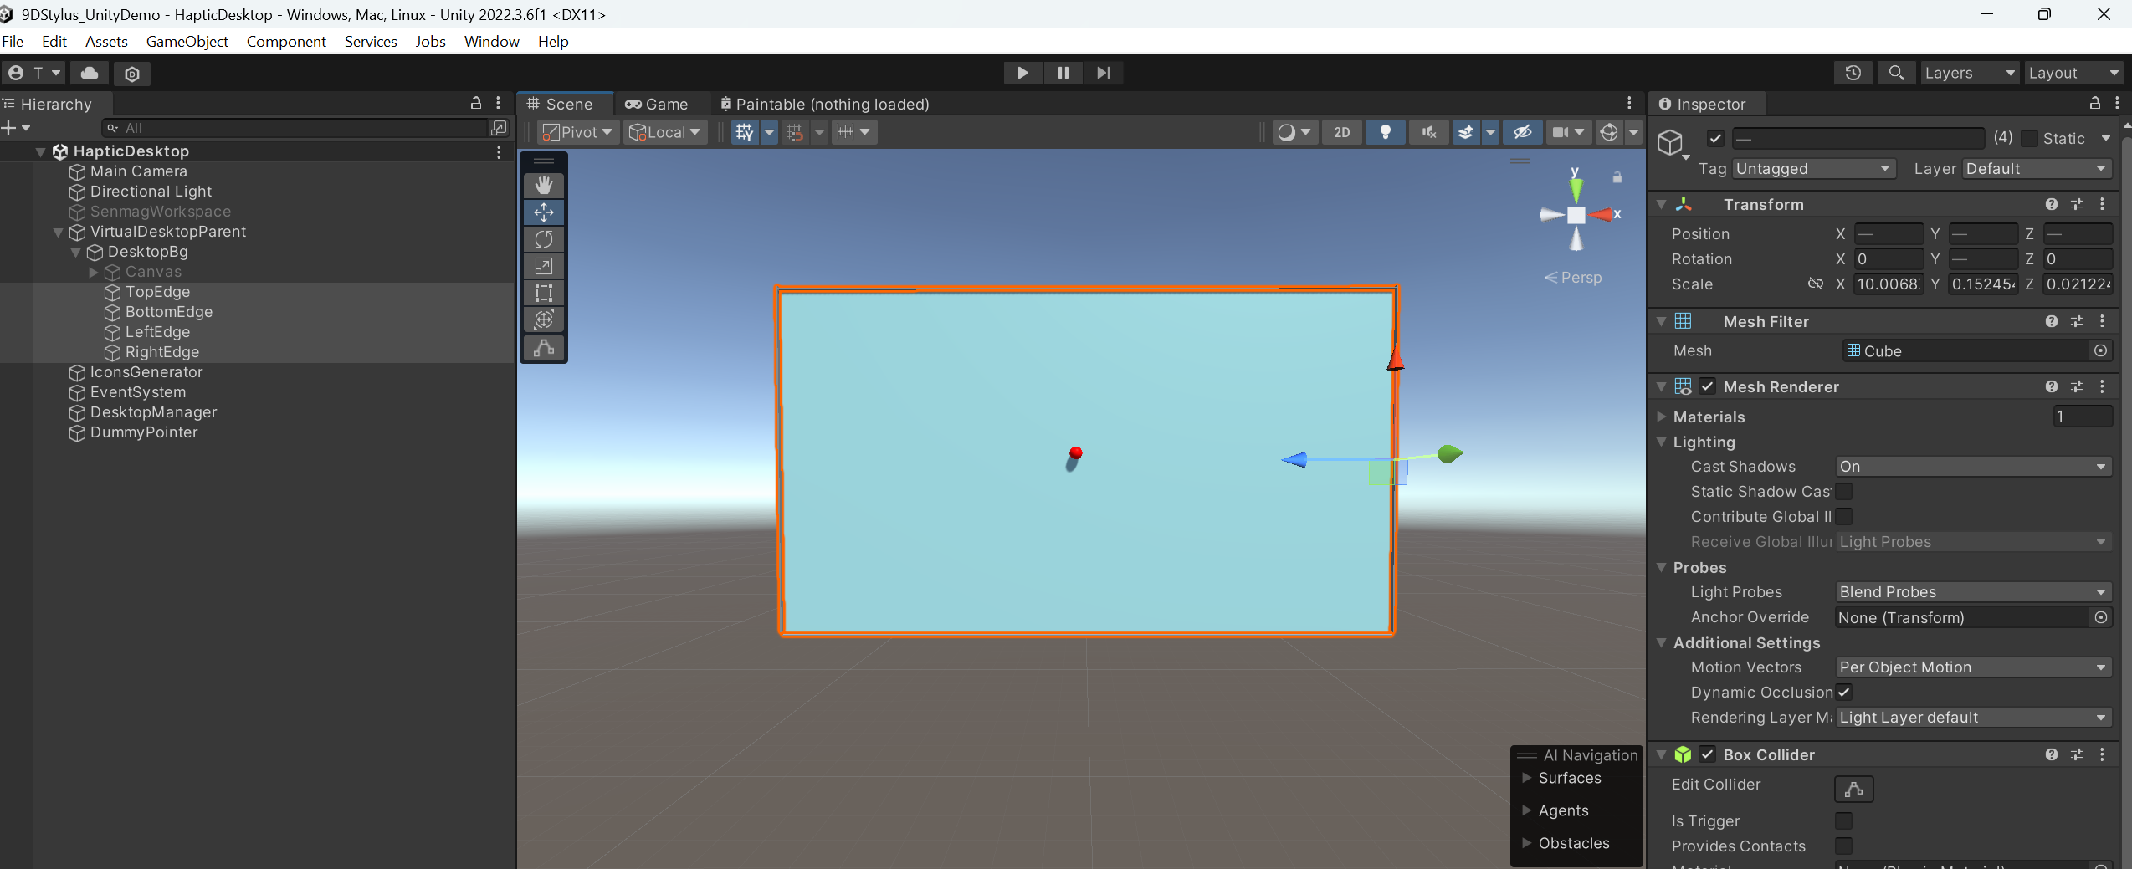
Using a sphere as a dummy pointer, added colliders at the edges to clamp the movement of the pointer and let the user feel the edges of the screen.

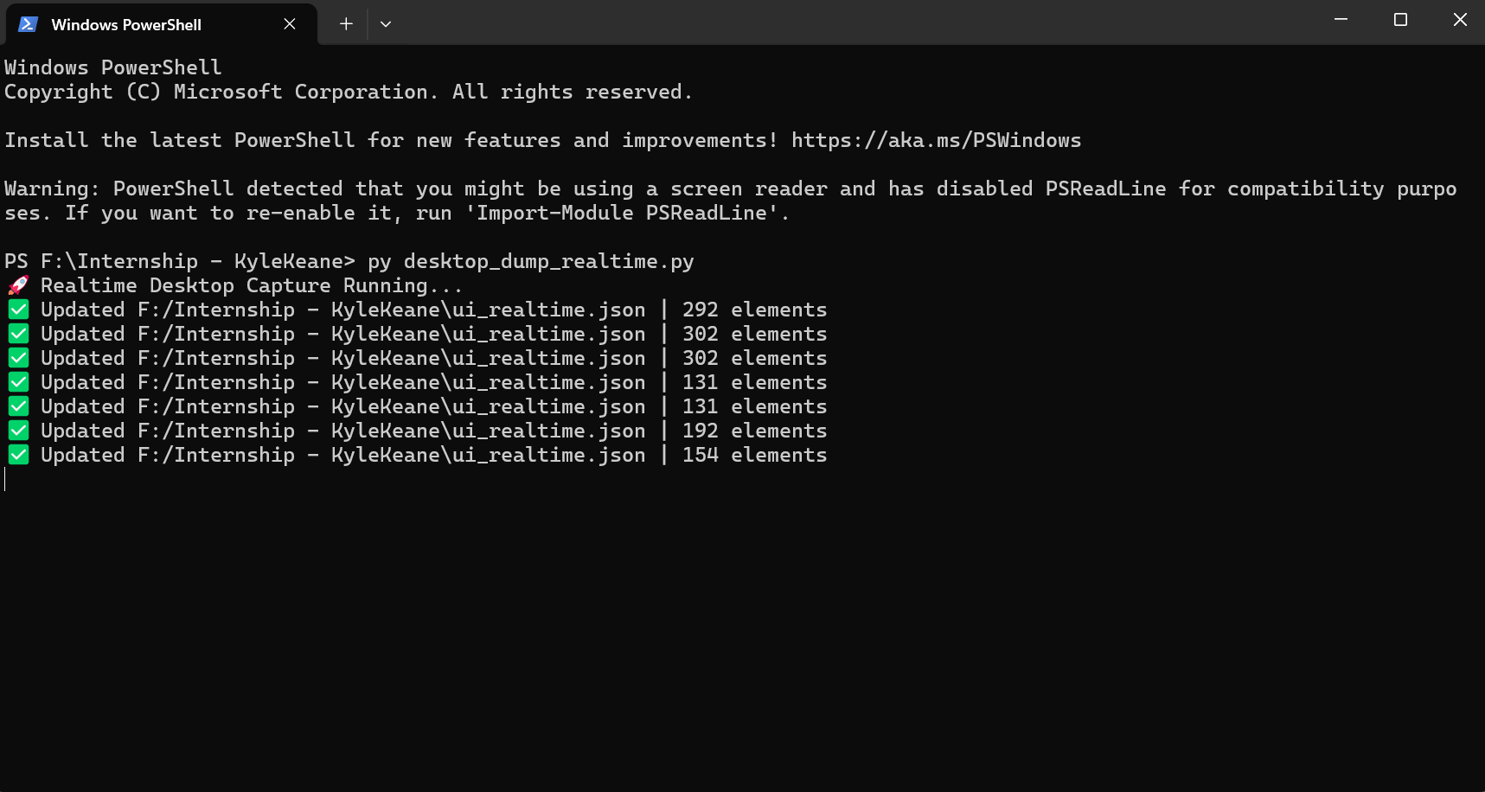
Updating the JSON Dump file in Realtime every 2 seconds.

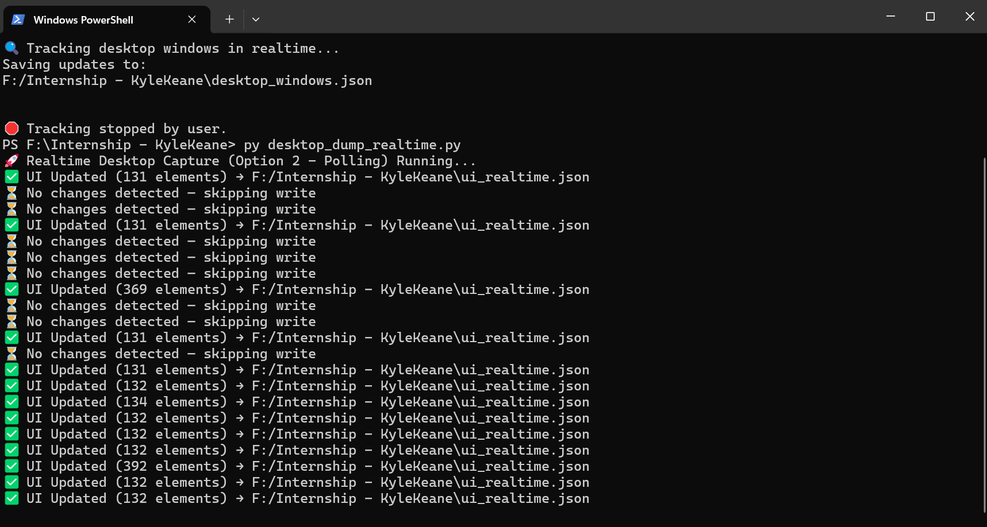
Updating JSON Dump only if it detects any change on the desktop. (Periodic Polling).
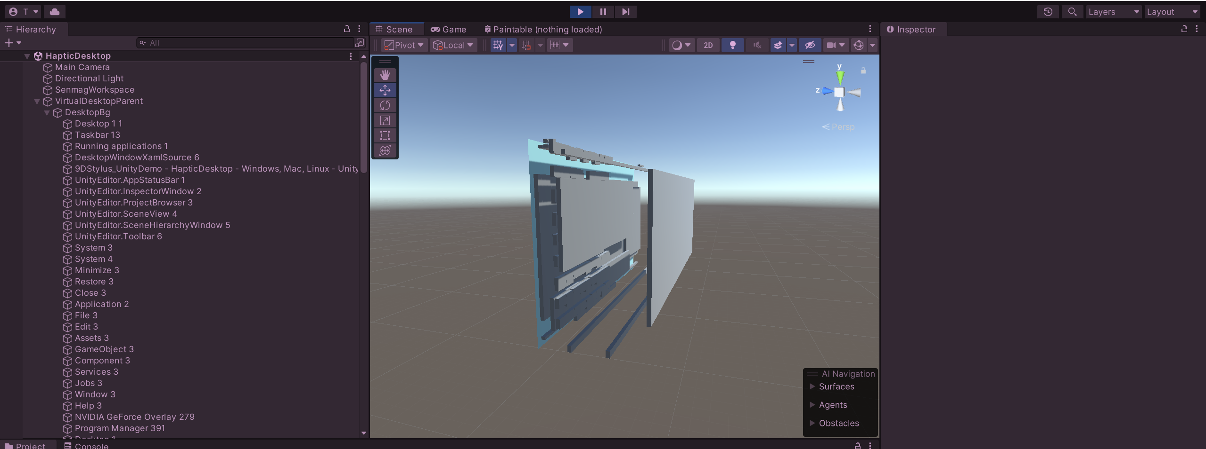
New Windows overlaid on top of the icons.

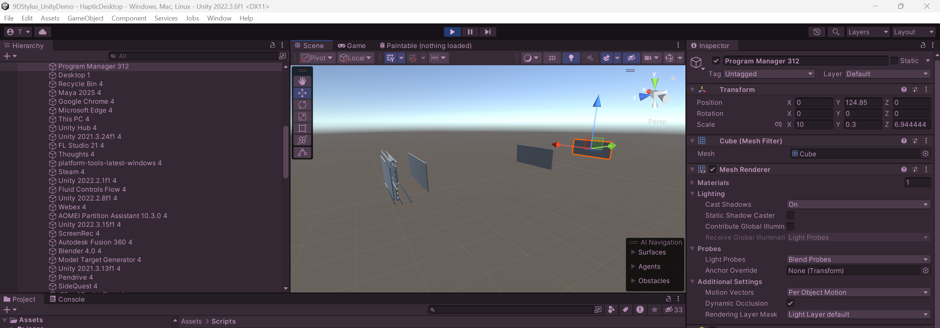
Program Manager having an unusually high z-index.

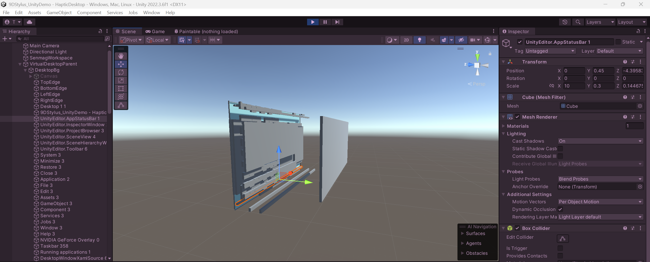
Optimized Virtual Desktop: 1. Only elements that are minimized get destroyed and reinstantiated accordingly if they are in focus again instead of destroying all game objects and re-instantiating every frame.

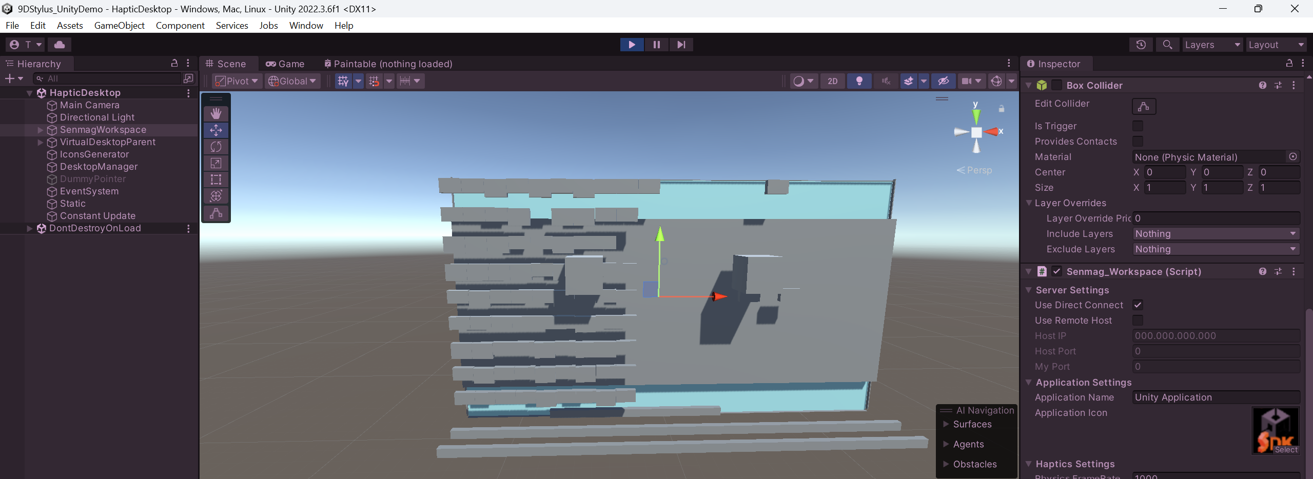
Taking 2 cubes (one static and the other controlled by code) to check if the inaccurate Haptic feedback is due to constant update of game objects.
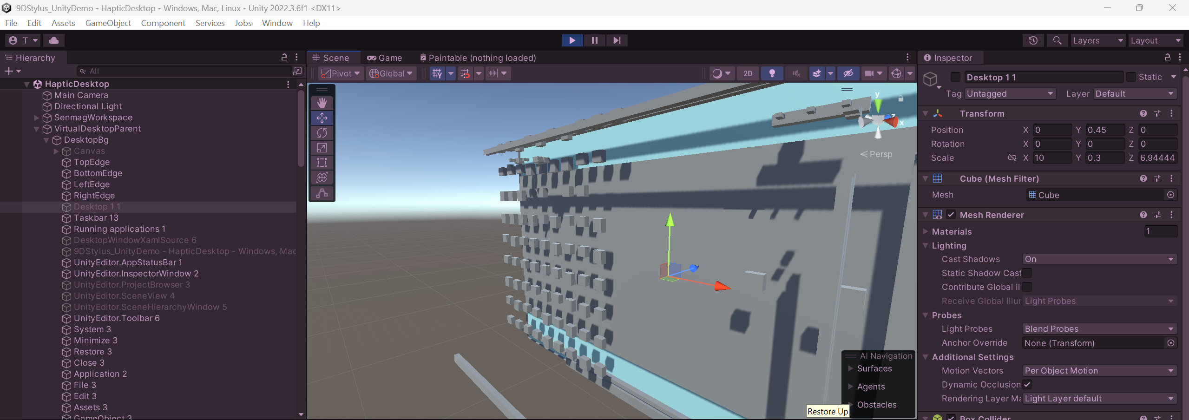
Checked for control type – “ListItemControl” and multiplied it with a constant to reduce the width of the icons and make them feel more distinguishable using the stylus.

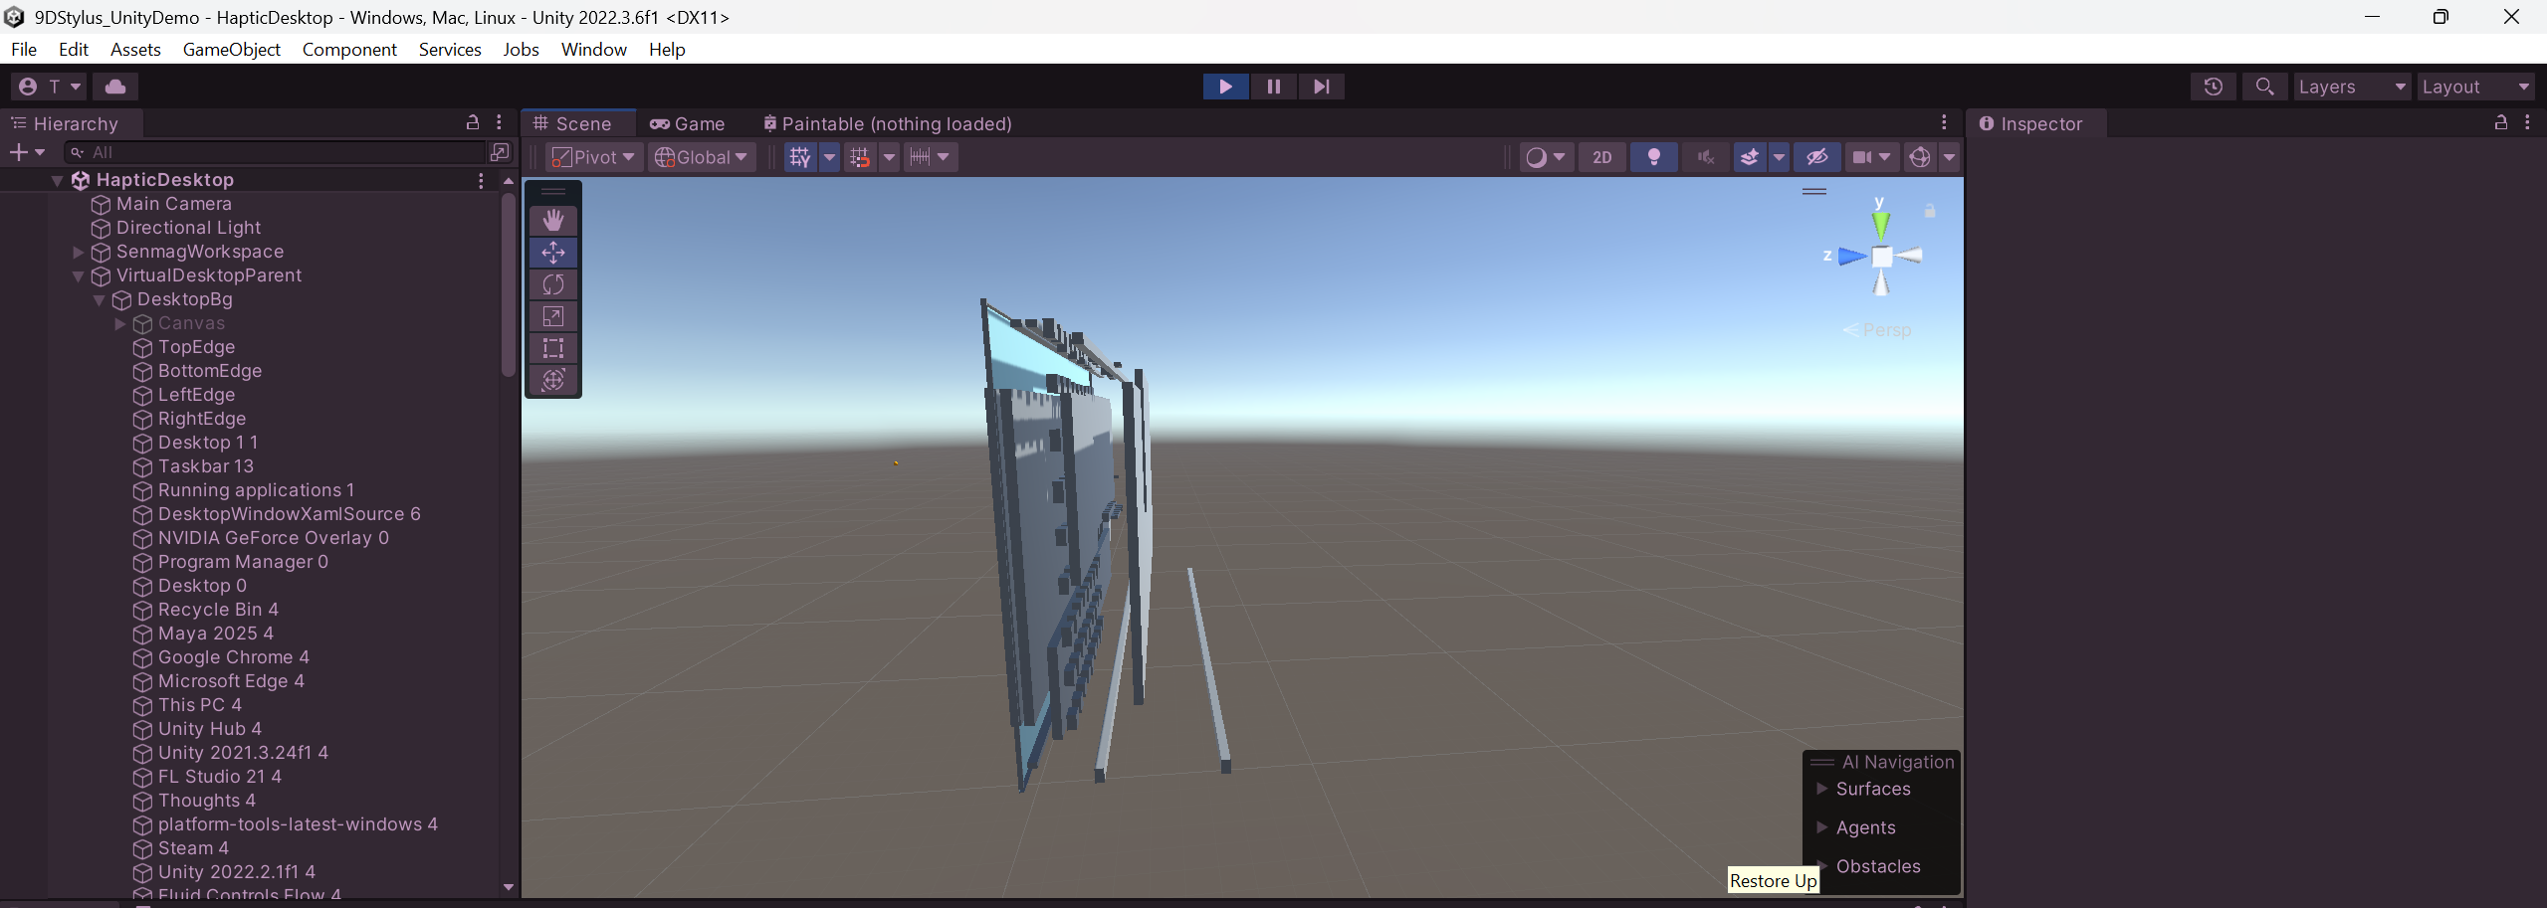
Checked for control type – “WindowControl” and gave it a lesser zSpacing value to bring it closer to the Desktop background.

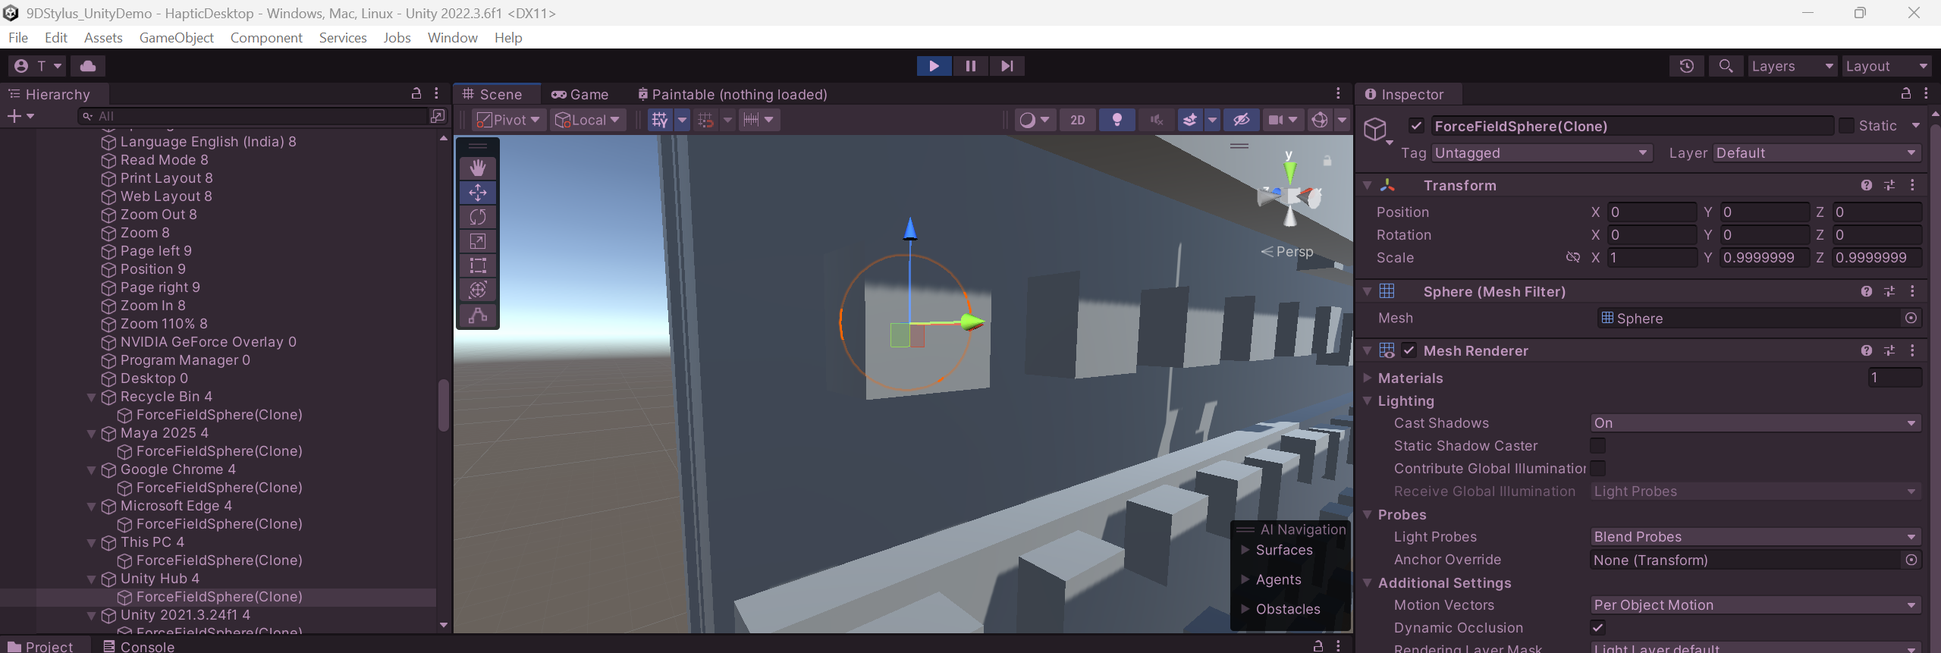
Force filed object made a child of the instantiated icon game object to pull the stylus inwards and partially lock it everytime it comes near an icon.

