Multiplayer VR Livestream Integration – Technical Documentation

1. Introduction
This document presents the design, development, and evaluation of a real-time interactive VR system enabling users inside a Unity-based multiplayer virtual reality environment to view and interact with a live video feed streamed from a Virtual Production (VP) stage. The system integrates multiple technologies including SRS WHIP/WHEP WebRTC streaming, Unity WebRTC, Unity Netcode for Multiplayer, Cloudflare WebSockets, and communication with an Unreal Engine-based VP room.
The aim of the sprint was to create an end-to-end pipeline where a remote VP environment streams live video into an immersive VR space, and VR users can physically throw or shoot interactable objects at the virtual screen. These interactions are transmitted to the VP room, where Unreal Engine reacts by spawning objects (e.g., a football) at exact pixel coordinates on the real VP stage.
This documentation outlines the full technical process, key design challenges, algorithms used for coordinate mapping, and integration approaches for real-time bi-directional communication.

2. System Overview
The system consists of the following major components:

2.1 Unity Multiplayer VR Environment
- Built using Unity’s Multiplayer VR Template.
- XR Interaction Toolkit used for hand tracking, grabbing, and throwing.
- Network replication performed using Unity Netcode for GameObjects (NGO).

2.2 Live Video Stream (WebRTC)
- VP room publishes a live camera feed via SRS (Simple Realtime Server) using WHIP/WHEP.
- Unity receives the stream using Unity WebRTC, decoded as a VideoStreamTrack.
- The decoded texture is applied to a RawImage placed inside the VR scene.

2.3 Interaction & Physics
- Users can throw physical objects (balls, bullets) at the virtual screen.
- Collisions are detected in Unity and mapped into pixel coordinates relative to the video feed.

2.4 WebSockets Communication Pipeline
- Unity communicates with a Cloudflare-hosted WebSocket endpoint.
- Position data is sent using structured JSON.
- VP room in Unreal Engine receives these coordinates and spawns objects accordingly.

3. WebRTC Integration in Unity

3.1 SRS Player Script
The SRS Player script establishes a WHIP/WHEP WebRTC connection to the VP stream:
- Creates RTCPeerConnection.
- Adds RecvOnly video and audio transceivers.
- Negotiates SDP with the server.
- Receives video track → assigns to RawImage texture.
- Receives audio track → binds to an AudioSource.

3.2 Challenges in Mobile VR Builds (Quest Headset)

3.2.1 Missing Video in Quest APK Build
The stream displayed correctly on:
- PCVR
- XR Device Simulator
But NOT when built to the Quest.
Root Causes
- Internet permission disabled
Quest blocked network access → stream could not load.
- Unity Strip Engine Code enabled
Unity removed WebRTC modules during build optimisation.
Fixes
- Set Internet Access = Require.
- Disable Strip Engine Code.
After these fixes, the stream displayed correctly in the standalone Quest build.

4. Improving Stream Quality & Visual Fidelity
When viewed from far away, the stream appeared clipped or low-resolution.

4.1 Cause: Texture Filtering
If the video texture generated by WebRTC defaults to point filtering, it will appear blocky at distances.

4.2 Cause: Mipmap Generation
Unity may attempt to generate mipmaps for a video texture that changes every frame, leading to artifacts at certain camera angles or distances.

4.3 Fixes
- Enforce Bilinear filtering every frame when the texture updates.
- Disable mipmaps by reinitializing RenderTextures if needed.

5. Designing the VR Environment
A realistic VR environment was constructed to simulate a control room:
- Room architecture & furniture layout.
- HDRI skybox used for realistic global illumination.
- Video stream displayed on a large monitor-shaped plane.
- Interactive objects placed throughout the room.
This environment provided an immersive context for testing the real-time pipeline.

6. Interaction System for Throwing Objects at the Stream

6.1 Objective
Allow VR users to throw objects at the screen and detect exact impact pixel coordinates on the streamed video.

6.2 Collision Detection
- Throwable object uses Rigidbody and collider.
- The screen plane uses a MeshCollider (convex NOT required for trigger collisions).

6.3 The Key Technical Challenge
Collision contact points are returned in world space, while the video feed is in pixel space.
A correct mapping from world → local → normalized → pixel is required.

7. Coordinate Mapping Algorithm (Final Working Version)

7.1 The Core Problem
Unity’s Plane mesh has a default size of 10 × 10 units, but scaling, rotation, and parent transforms distort how local points are interpreted.
To eliminate transform distortion, the solution was:
- Set plane scale to 1,1,1.
- Use parent object to visually scale the plane.
- Hardcode base plane width/height = 10.

7.2 Working Algorithm
Step 1: Get point of impact
Vector3 impactPoint = collision.contacts[0].point;
Step 2: Convert world → local position
Vector3 localPoint = plane.transform.InverseTransformPoint(impactPoint);
Step 3: Normalize to 0–1
float normalizedX = (localPoint.x + planeWidth/2) / planeWidth;
float normalizedY = (localPoint.y + planeHeight/2) / planeHeight;
Step 4: Convert to pixel coordinates
int xPosition = Mathf.RoundToInt(normalizedX * rawImage.texture.width);
int yPosition = Mathf.RoundToInt(normalizedY * rawImage.texture.height);
This produced accurate pixel coordinates that matched the VP room’s video feed.

8. WebSocket Integration

8.1 WebSocket Controller Responsibilities
- Establish secure connection to Cloudflare WebSocket endpoint.
- Send player positions at 25 FPS when hosting.
- Respond to server keepalive messages.
- Send impact payloads when objects hit the screen.

8.2 Incoming Keepalive Messages
Server sends:
{"instruction":"keepalive"}
Unity responds by echoing the same message back.

8.3 Impact Payload Format Sent to Unreal
{
"screenDimensionX": 1280,
"screenDimensionY": 720,
"colour": null,
"xposition": 460,
"yposition": 255,
"instruction": "screenClick"
}

8.4 Successful Cross-System Reaction
When Unity sends coordinates →
Unreal Engine spawns a football at corresponding location on the VP wall.
This confirms full pipeline integration.

9. Multiplayer Networking Considerations
- Unity Netcode synchronizes only player avatars.
- Physics-based objects (balls, bullets) must be NetworkObjects with:
  - NetworkRigidbody
  - Client/Server authority handled
- Without proper authority, rigidbody objects may float or freeze when networking starts.

10. Issues Identified and Workarounds

10.1 Stream Missing in APK Build
- Caused by missing Internet permission and engine stripping.
Fix: enable Internet and disable stripping.

10.2 Texture Appears Clipped at Distance
Causes:
- Point filtering
- Mipmaps on video texture
Workarounds:
- Enforce bilinear filter
- Disable mipmapping

10.3 Collision Coordinates Incorrect
Cause: distorted plane transforms.
Workaround:
Reset plane scale to 1,1,1 and scale parent instead.
Hardcode plane size = 10.

11. Outcomes of the Sprint
- Fully functioning VR → VP interactive pipeline.
- Accurate coordinate mapping system integrated.
- Successful WebRTC live stream integration in VR.
- Real-time object instantiation in VP room in response to VR interactions.
- Stable bi-directional WebSocket communication.
- VR environment ready for demonstrations.

12. Future Work

12.1 Audio Track Integration
Although video rendering works, audio is not yet audible inside VR.
Needs:
- Confirm WebRTC audio track creation.
- Bind audio track to AudioSource.
- Test Quest audio permissions and decoding support.

12.2 Robust Reconnection Handling
Improve:
- exponential backoff
- UI feedback for network errors
- retry logic across both WebRTC and WebSockets

12.3 Interaction Layer Improvements
- Ensure ALL objects can trigger coordinate mapping.
- Add laser pointer clicks.
- Add gesture-based interactions.

12.4 Performance Optimization
- Reduce texture resolution dynamically.
- Add LOD for screen mesh.
- Optimize physics for multiplayer.

13. Conclusion
The sprint successfully demonstrated a functional real-time interaction pipeline between a Unity-based multiplayer VR environment and an Unreal-based VP stage. The system allows VR users to physically interact with a live video feed, with precise collision mapping enabling accurate object spawning inside the VP room.
The work performed establishes a strong foundation for future research in remote interactive production environments, virtual control rooms, and synchronized XR–VP workflows.

11. Appendix
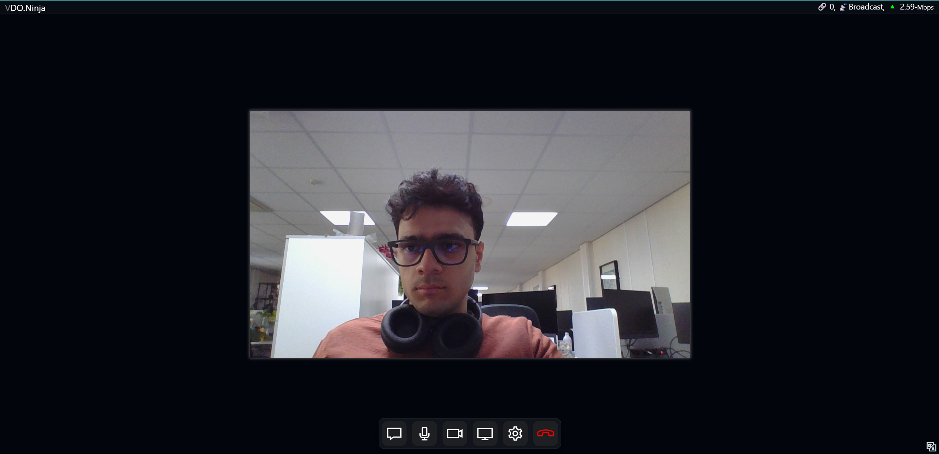
VDO.ninja -> WHIP -> Cloudflare

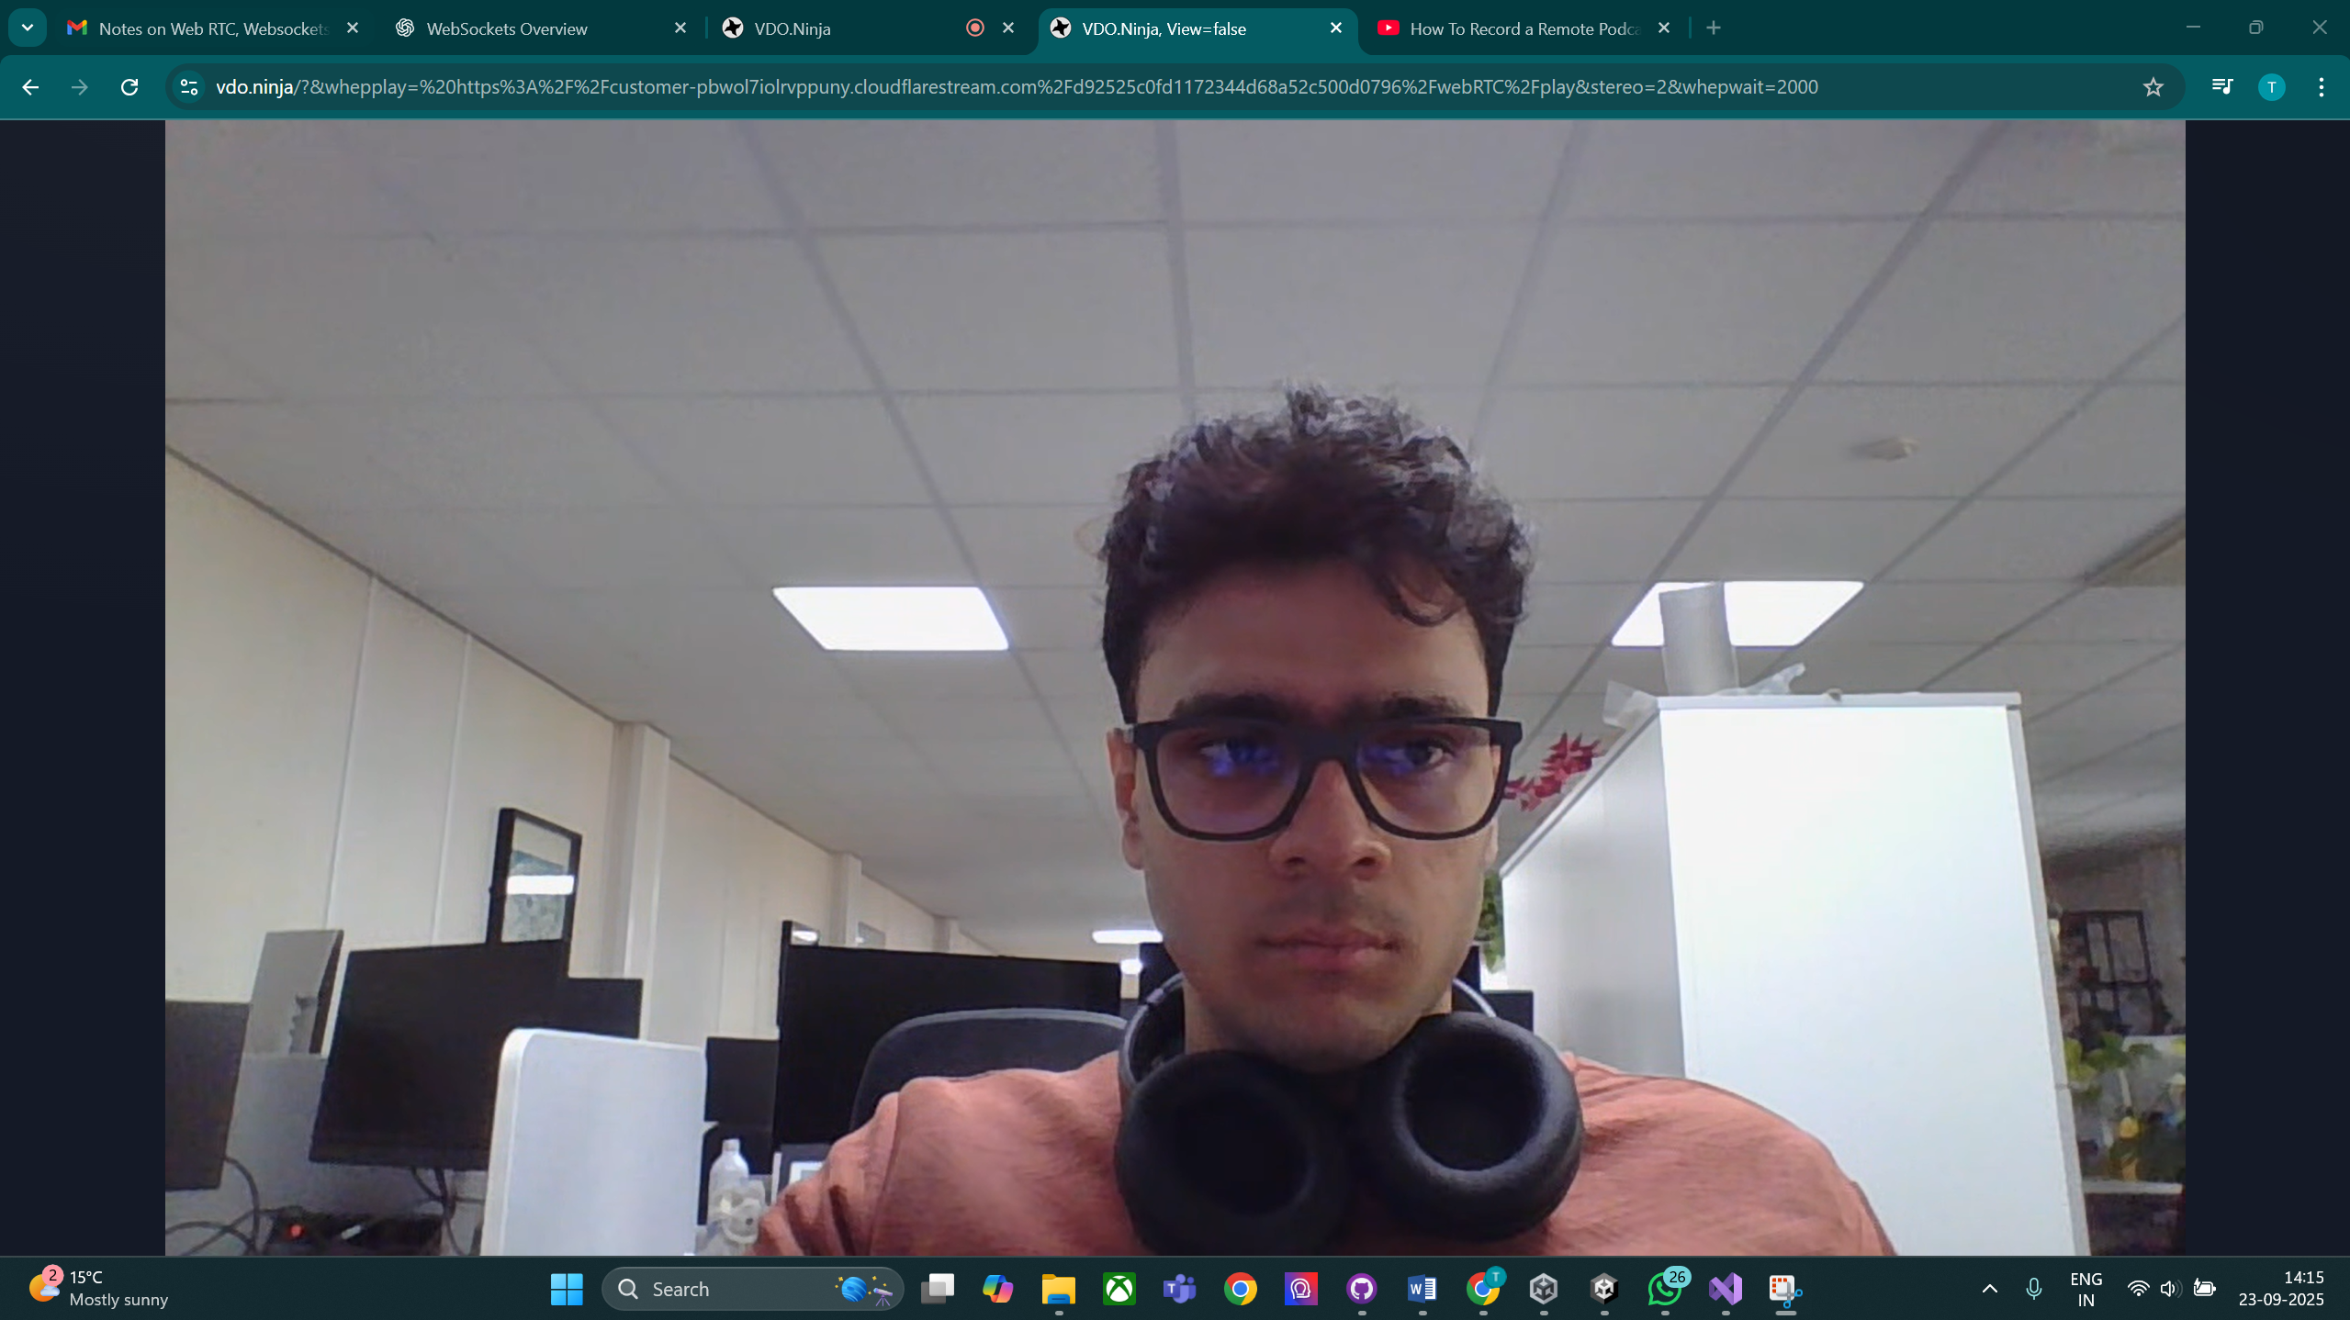
Cloudflare -> WHEP -> VDO.ninja

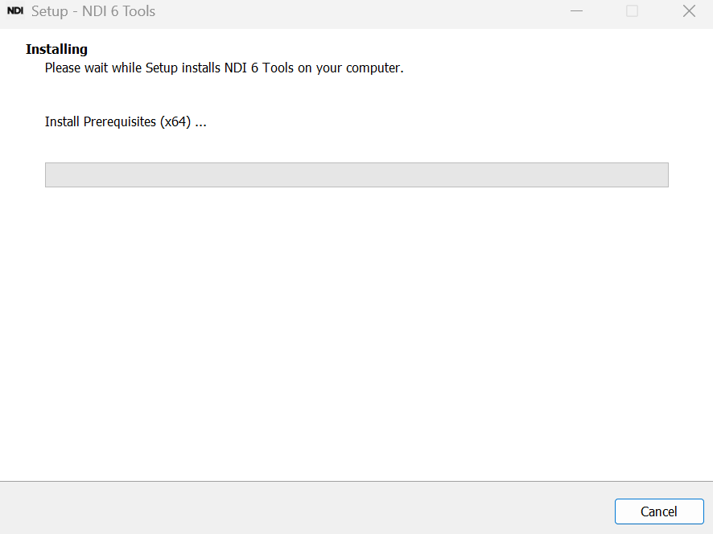
Setting up NDI Tools

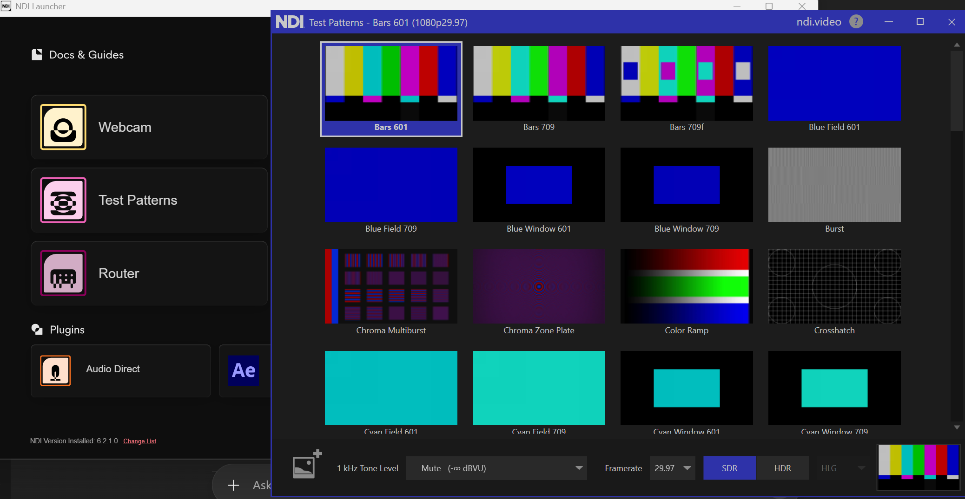
NDI Test Pattern

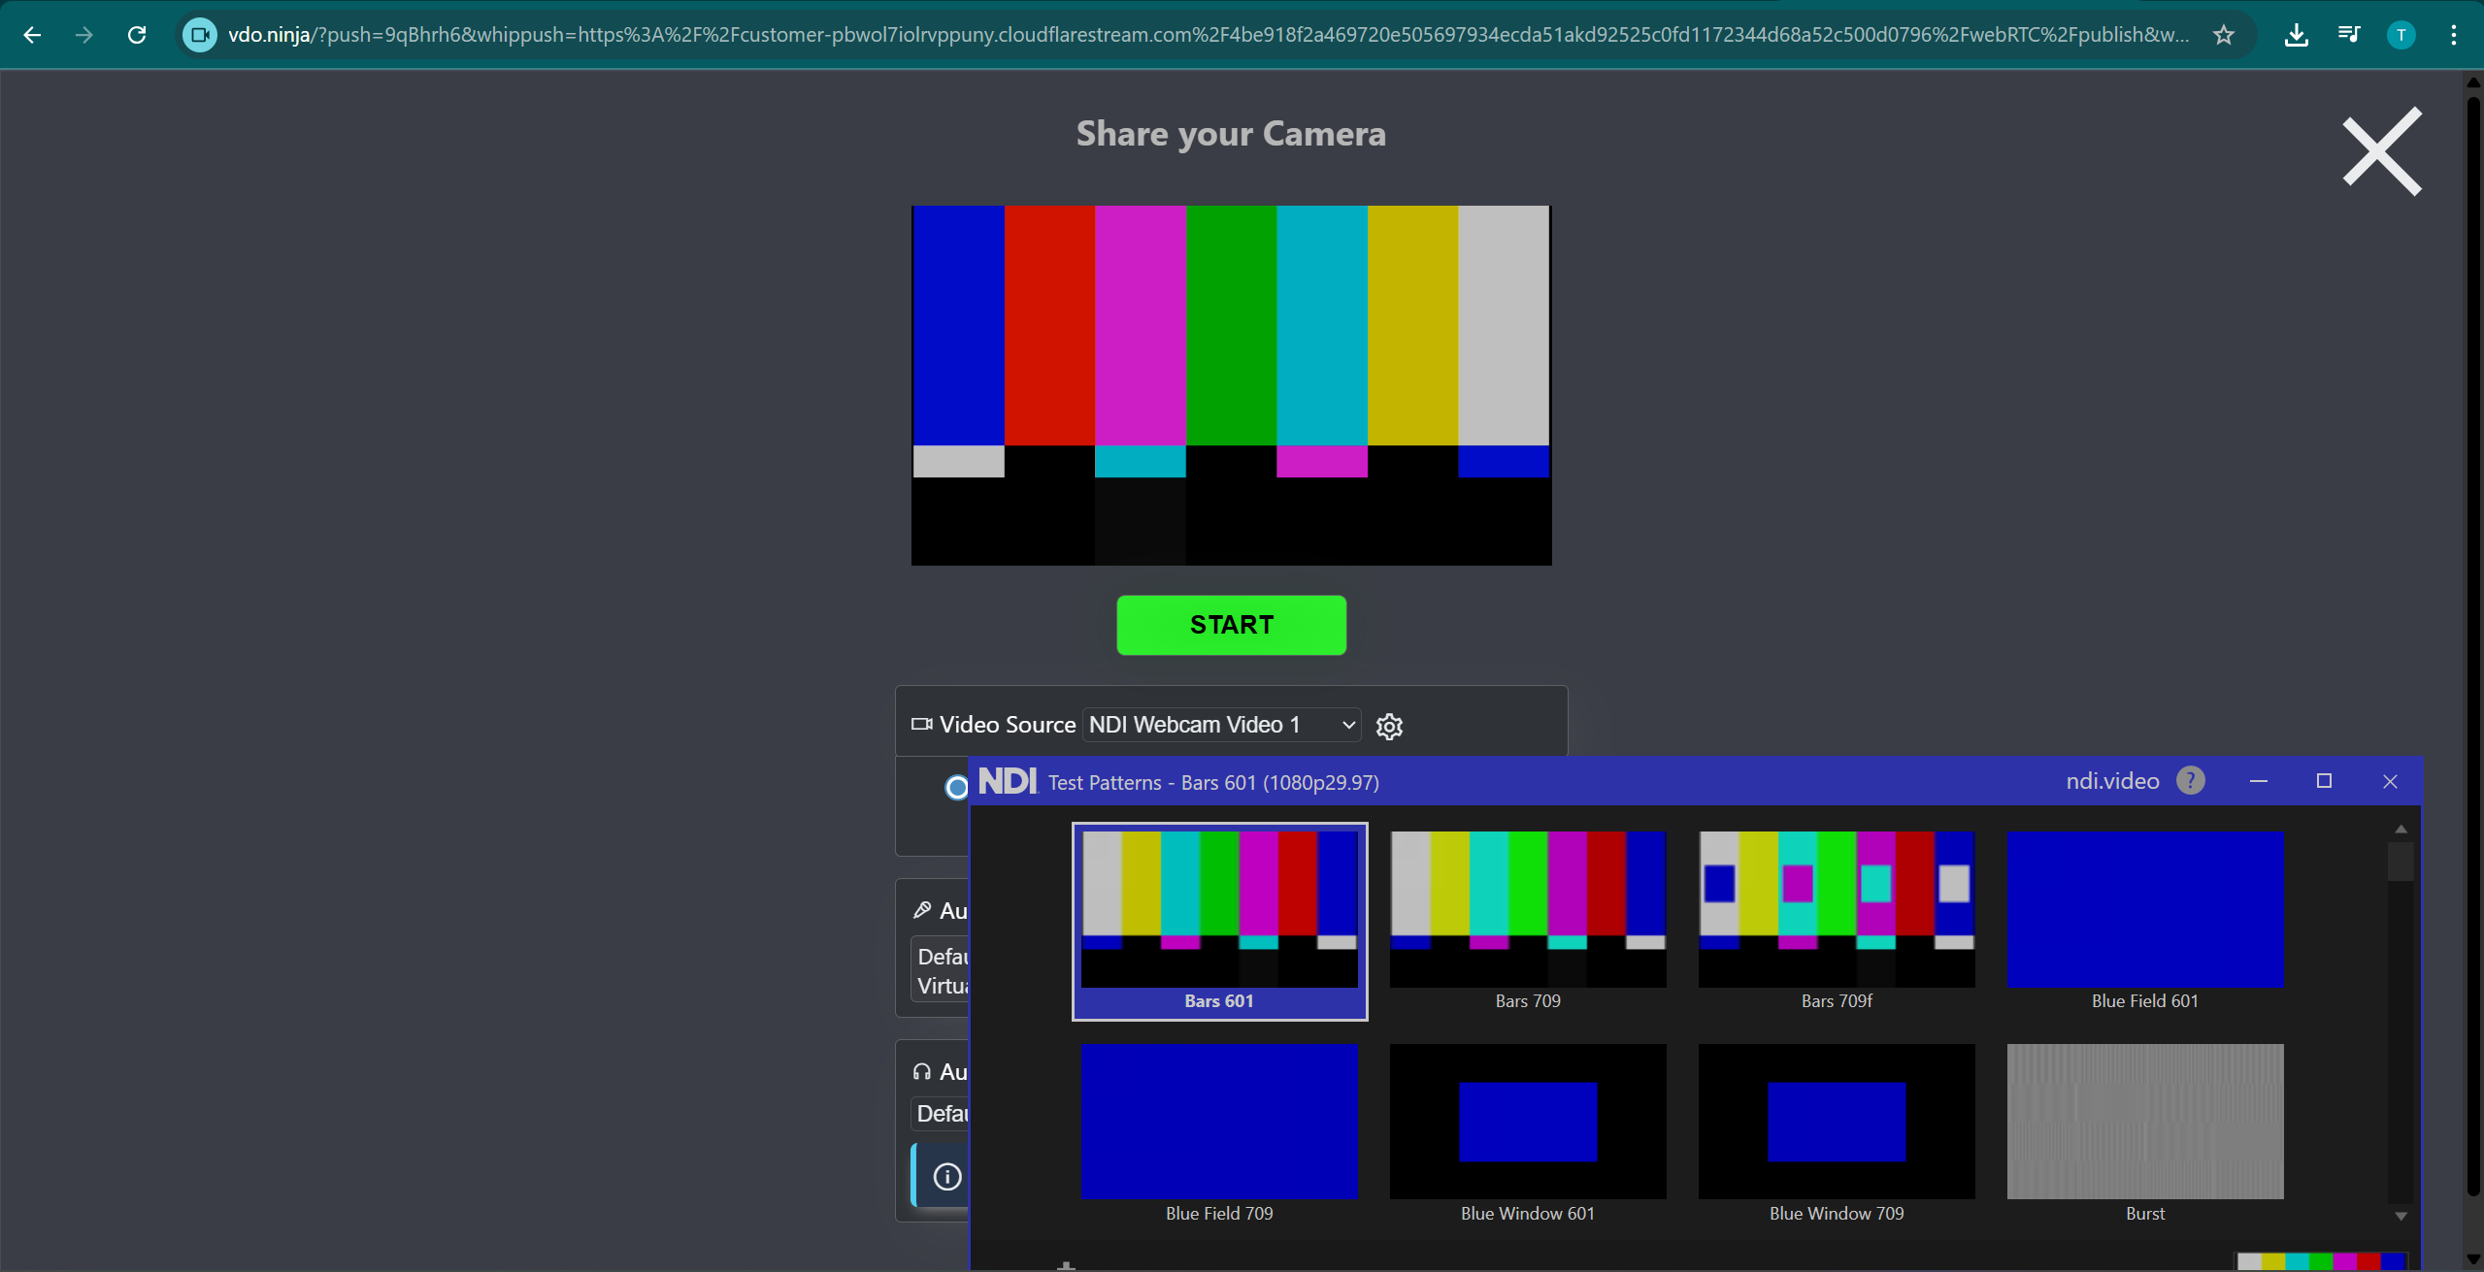
Using NDI Tools (NDI Webcam) to output the test pattern onto a NDI Virtual Camera and then select that Virtual Camera in WHIP publishing side in VDO.ninja

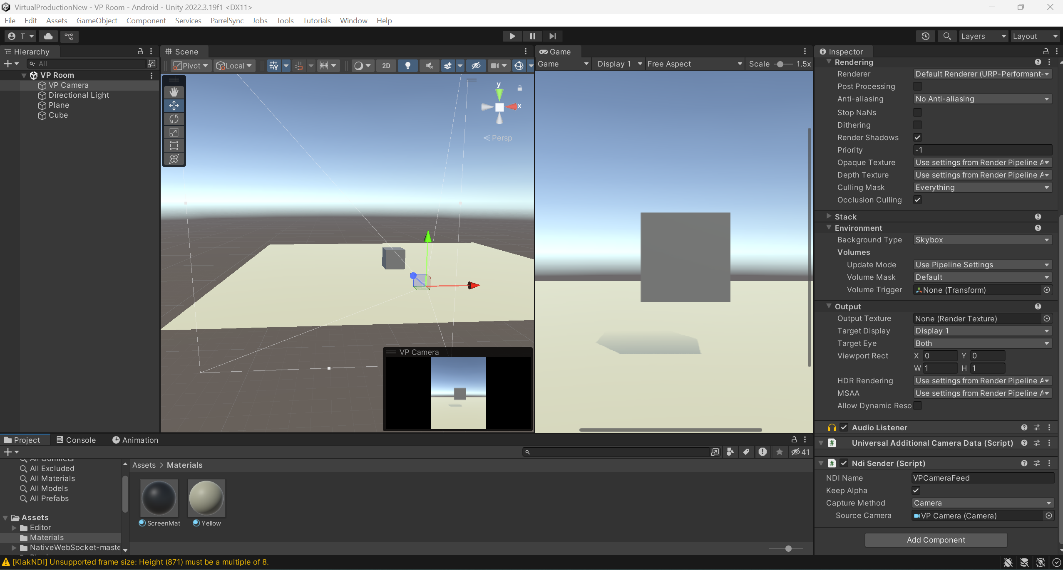
VP Room Scene

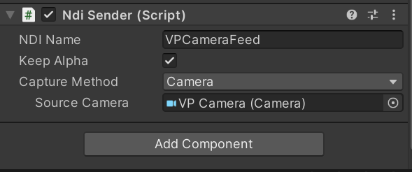
NDI Sender Component attached to the Main Camera to make it an NDI Source

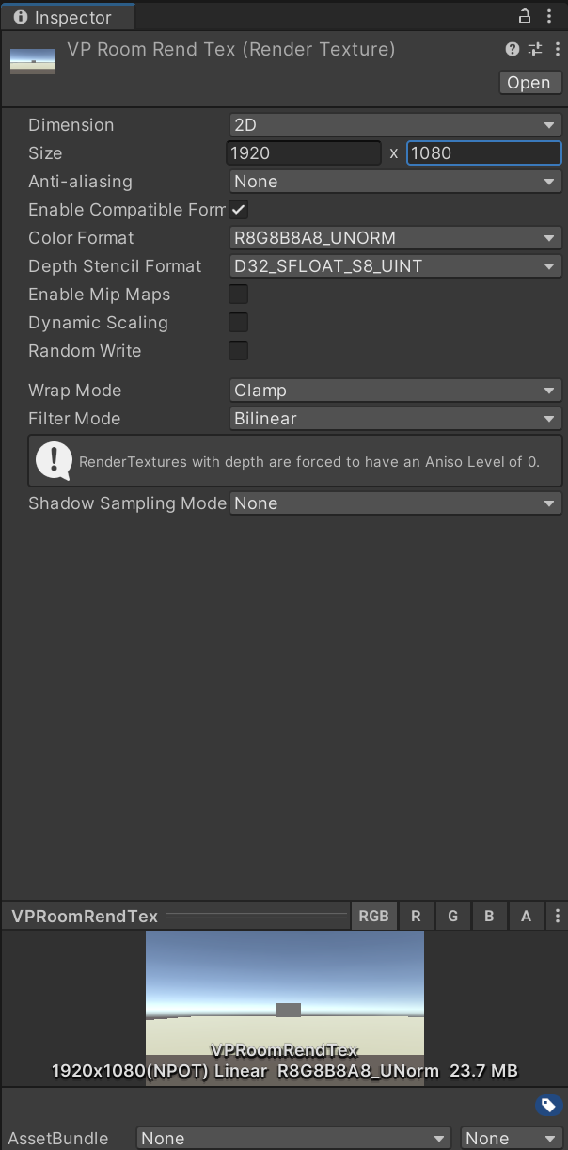
RenderTexture method
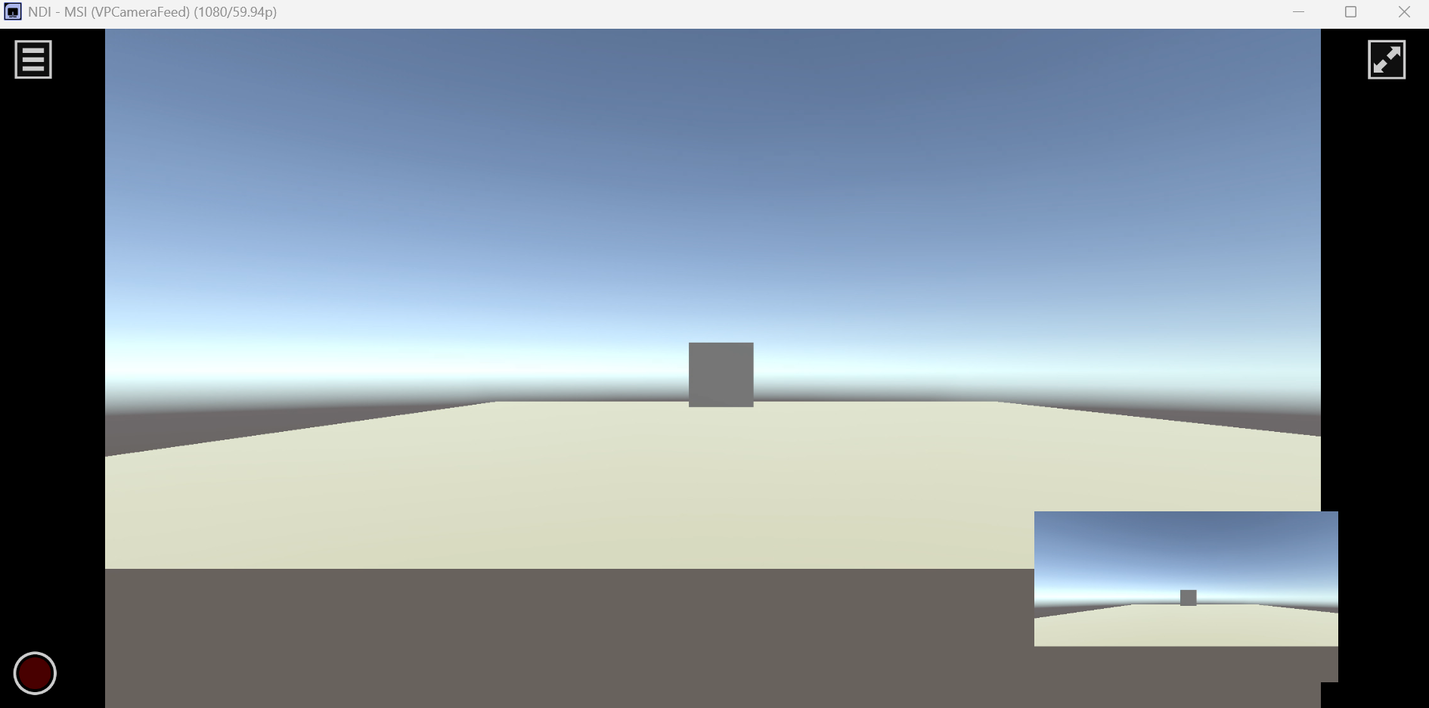
Displaying 2 feeds
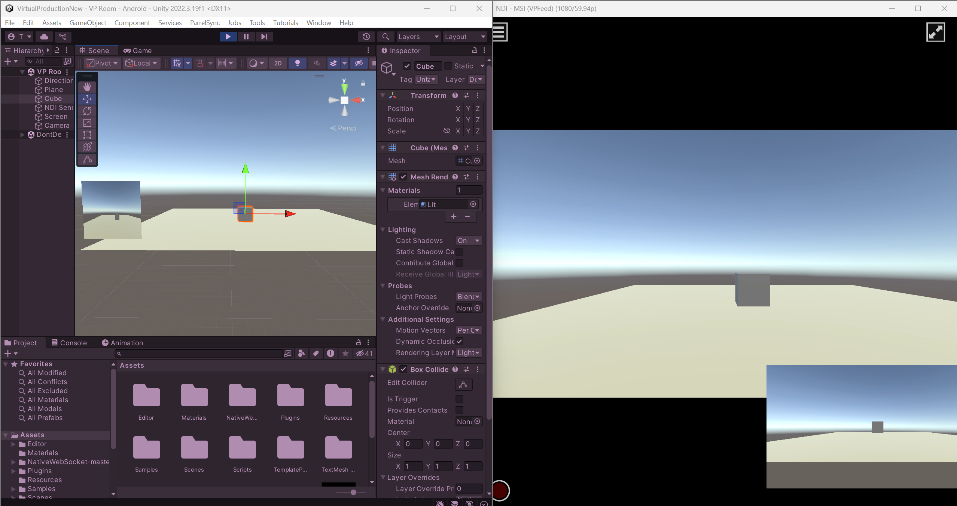
Render Texture updating every frame but same is not showing on the Studio Momitor

Date: 24/09/25
Day: Wednesday
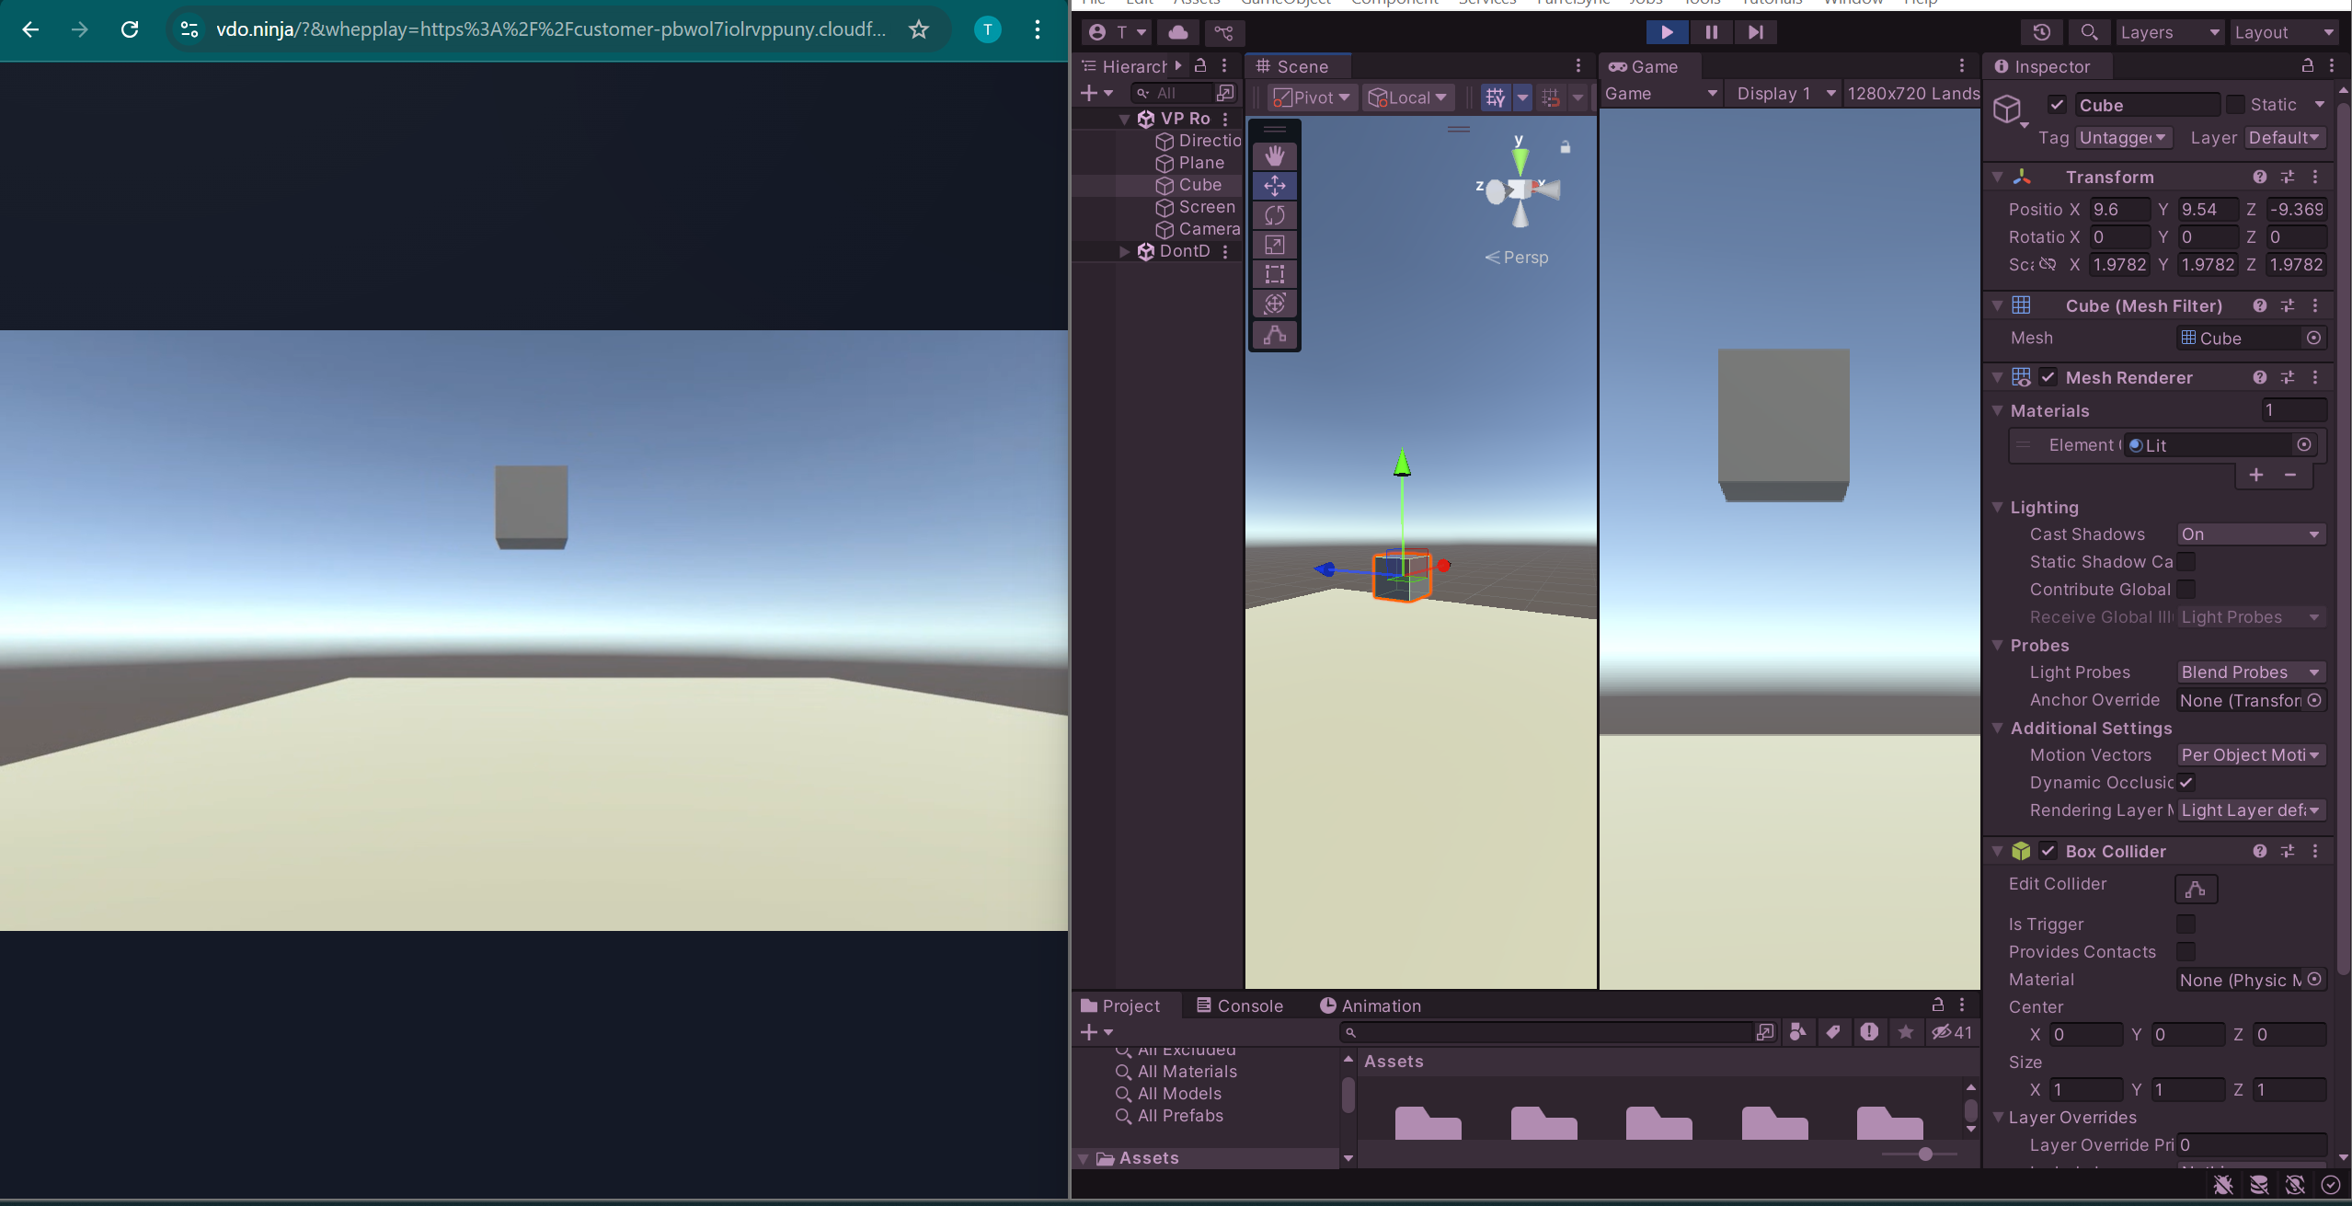
Left: VDO.ninja stream played on WHEP, Right: Unity Editor showing Scene view and Game view of Cube.

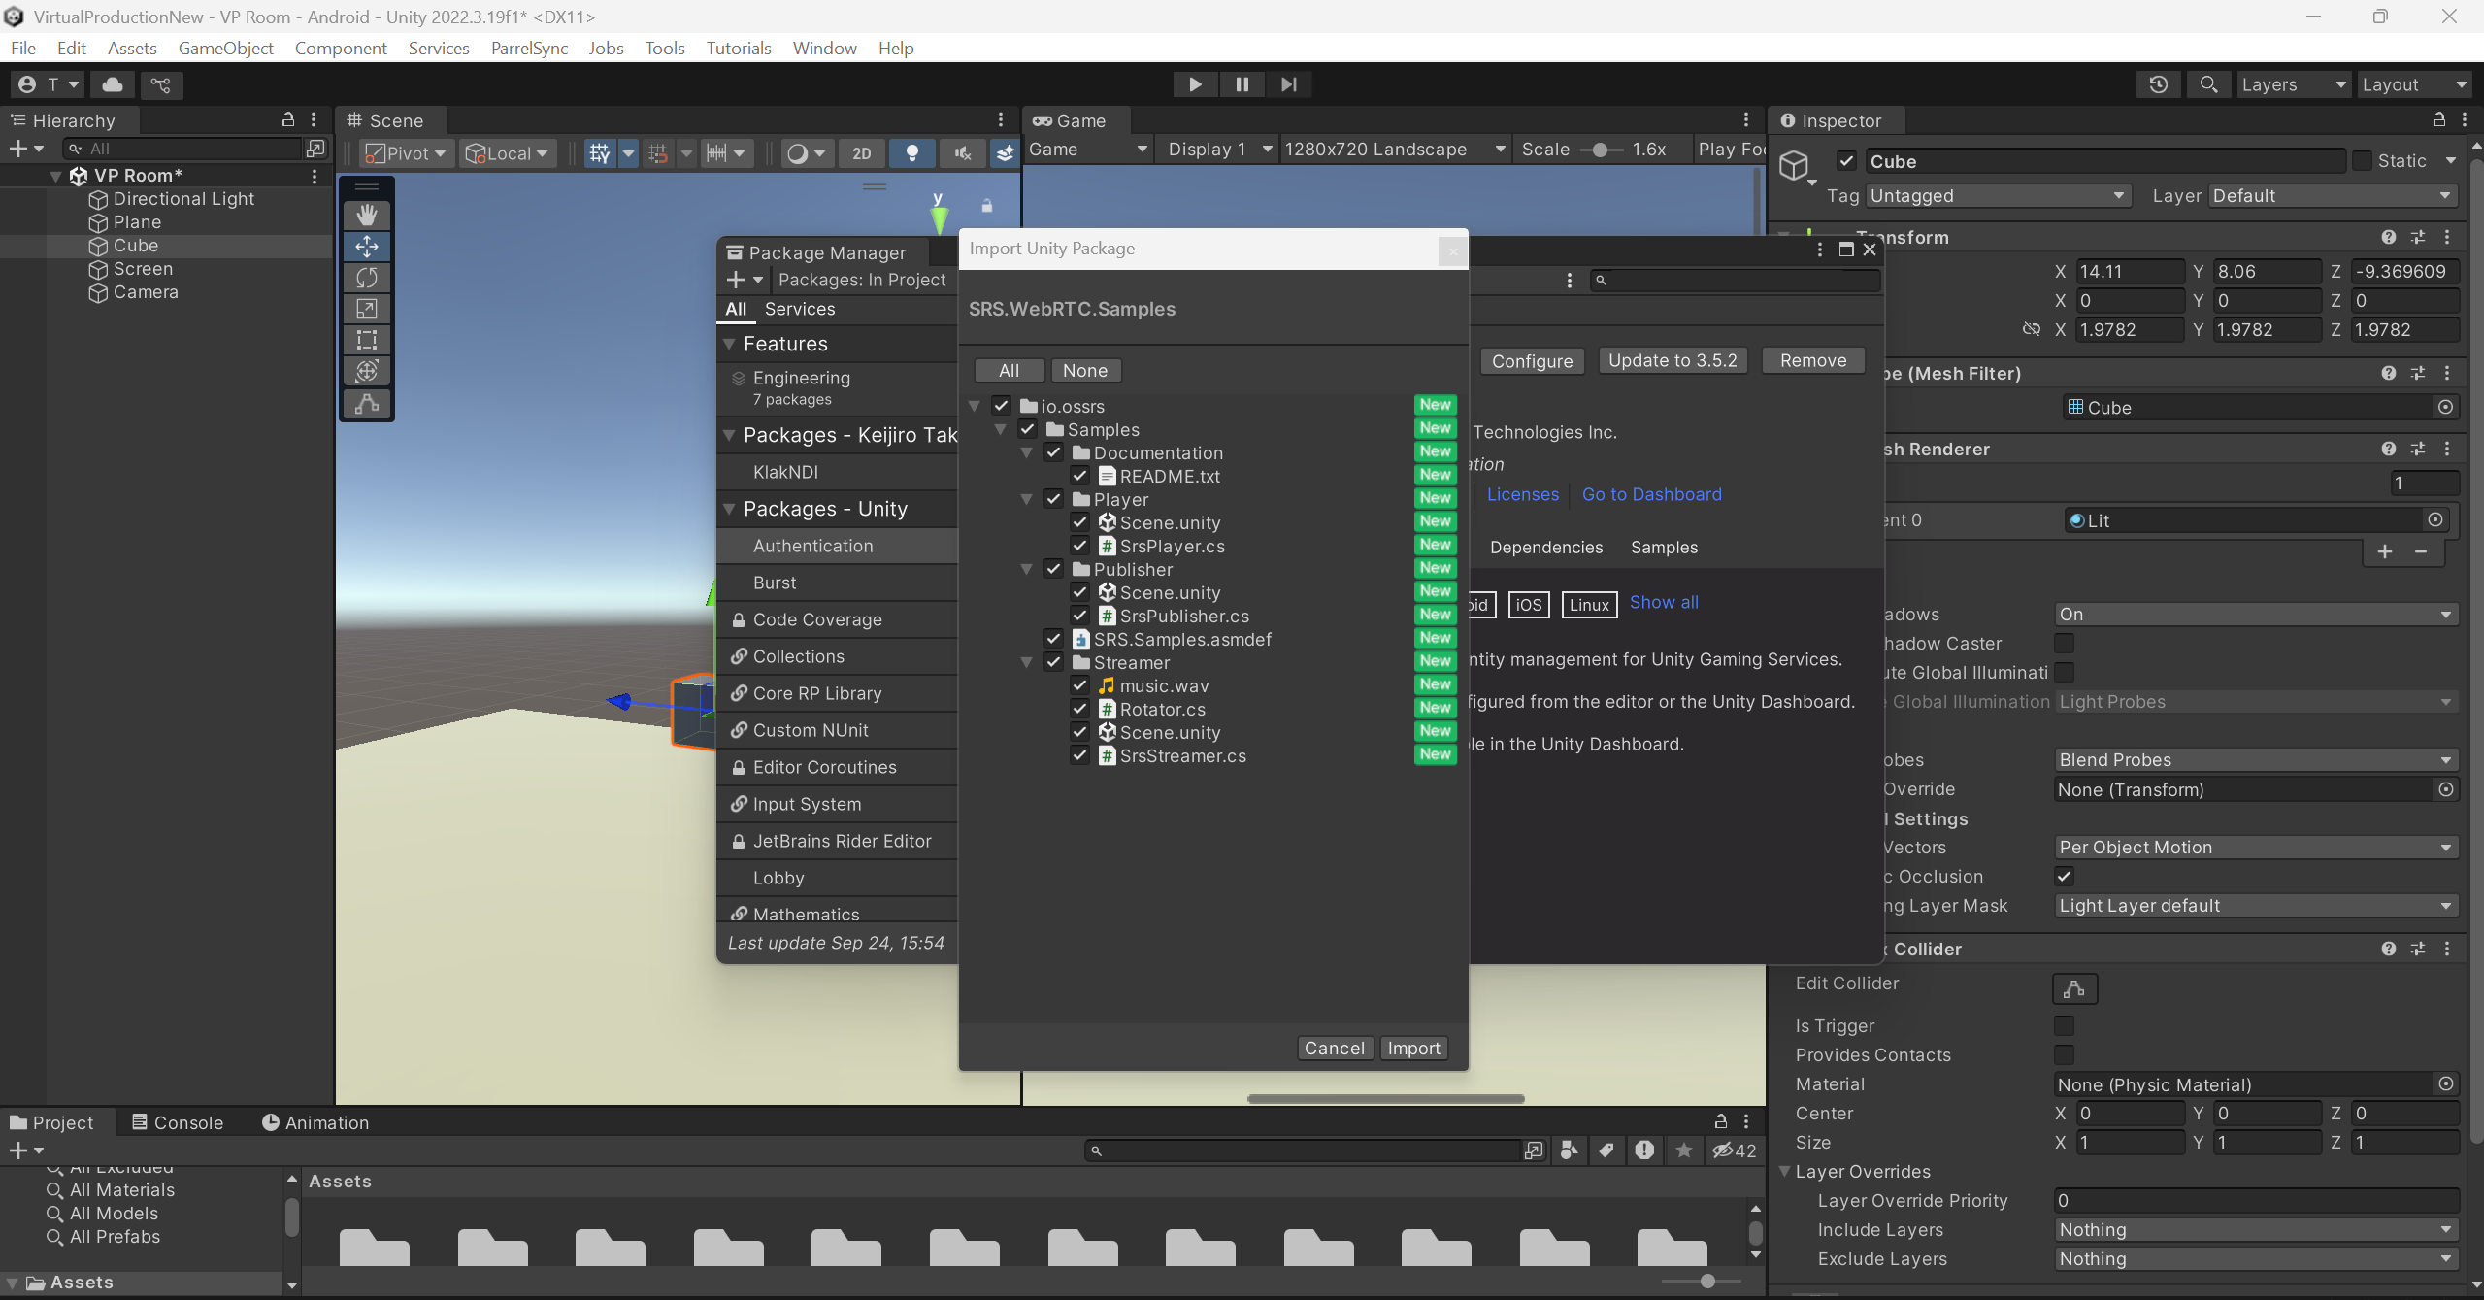
SRS plugin for Unity WebRTC setup.

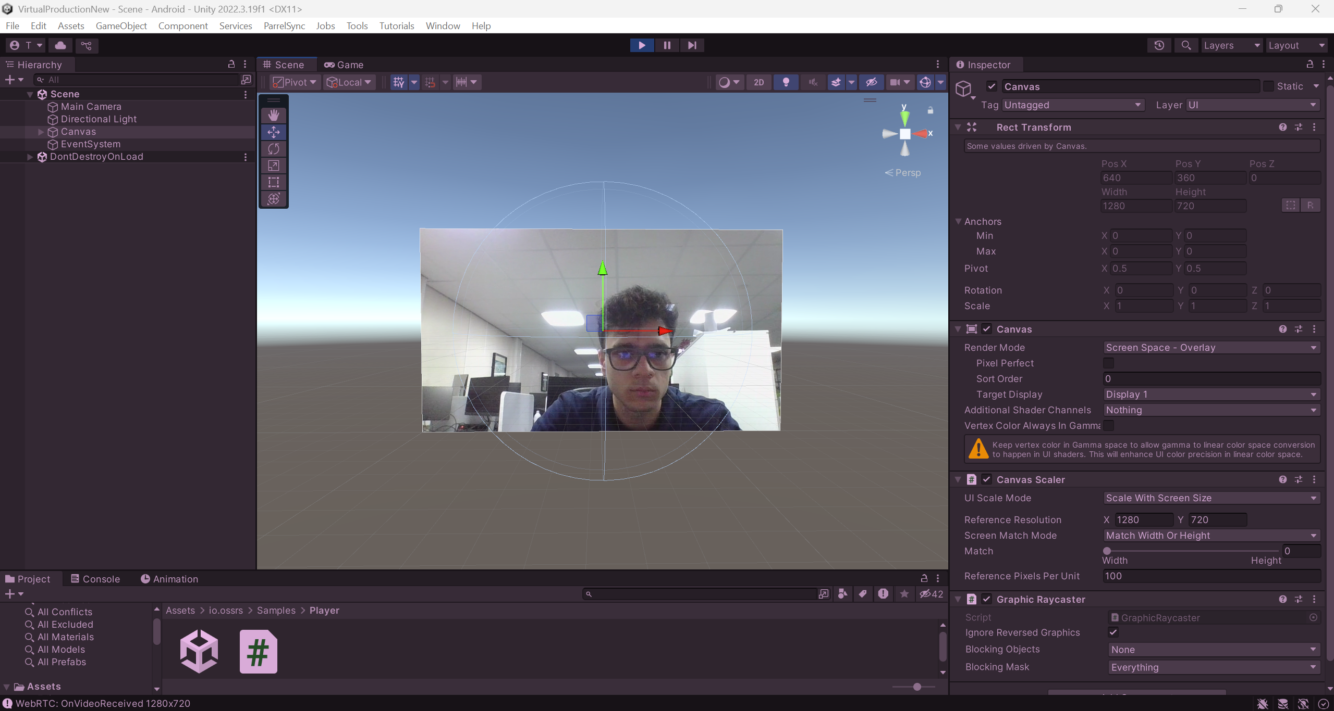 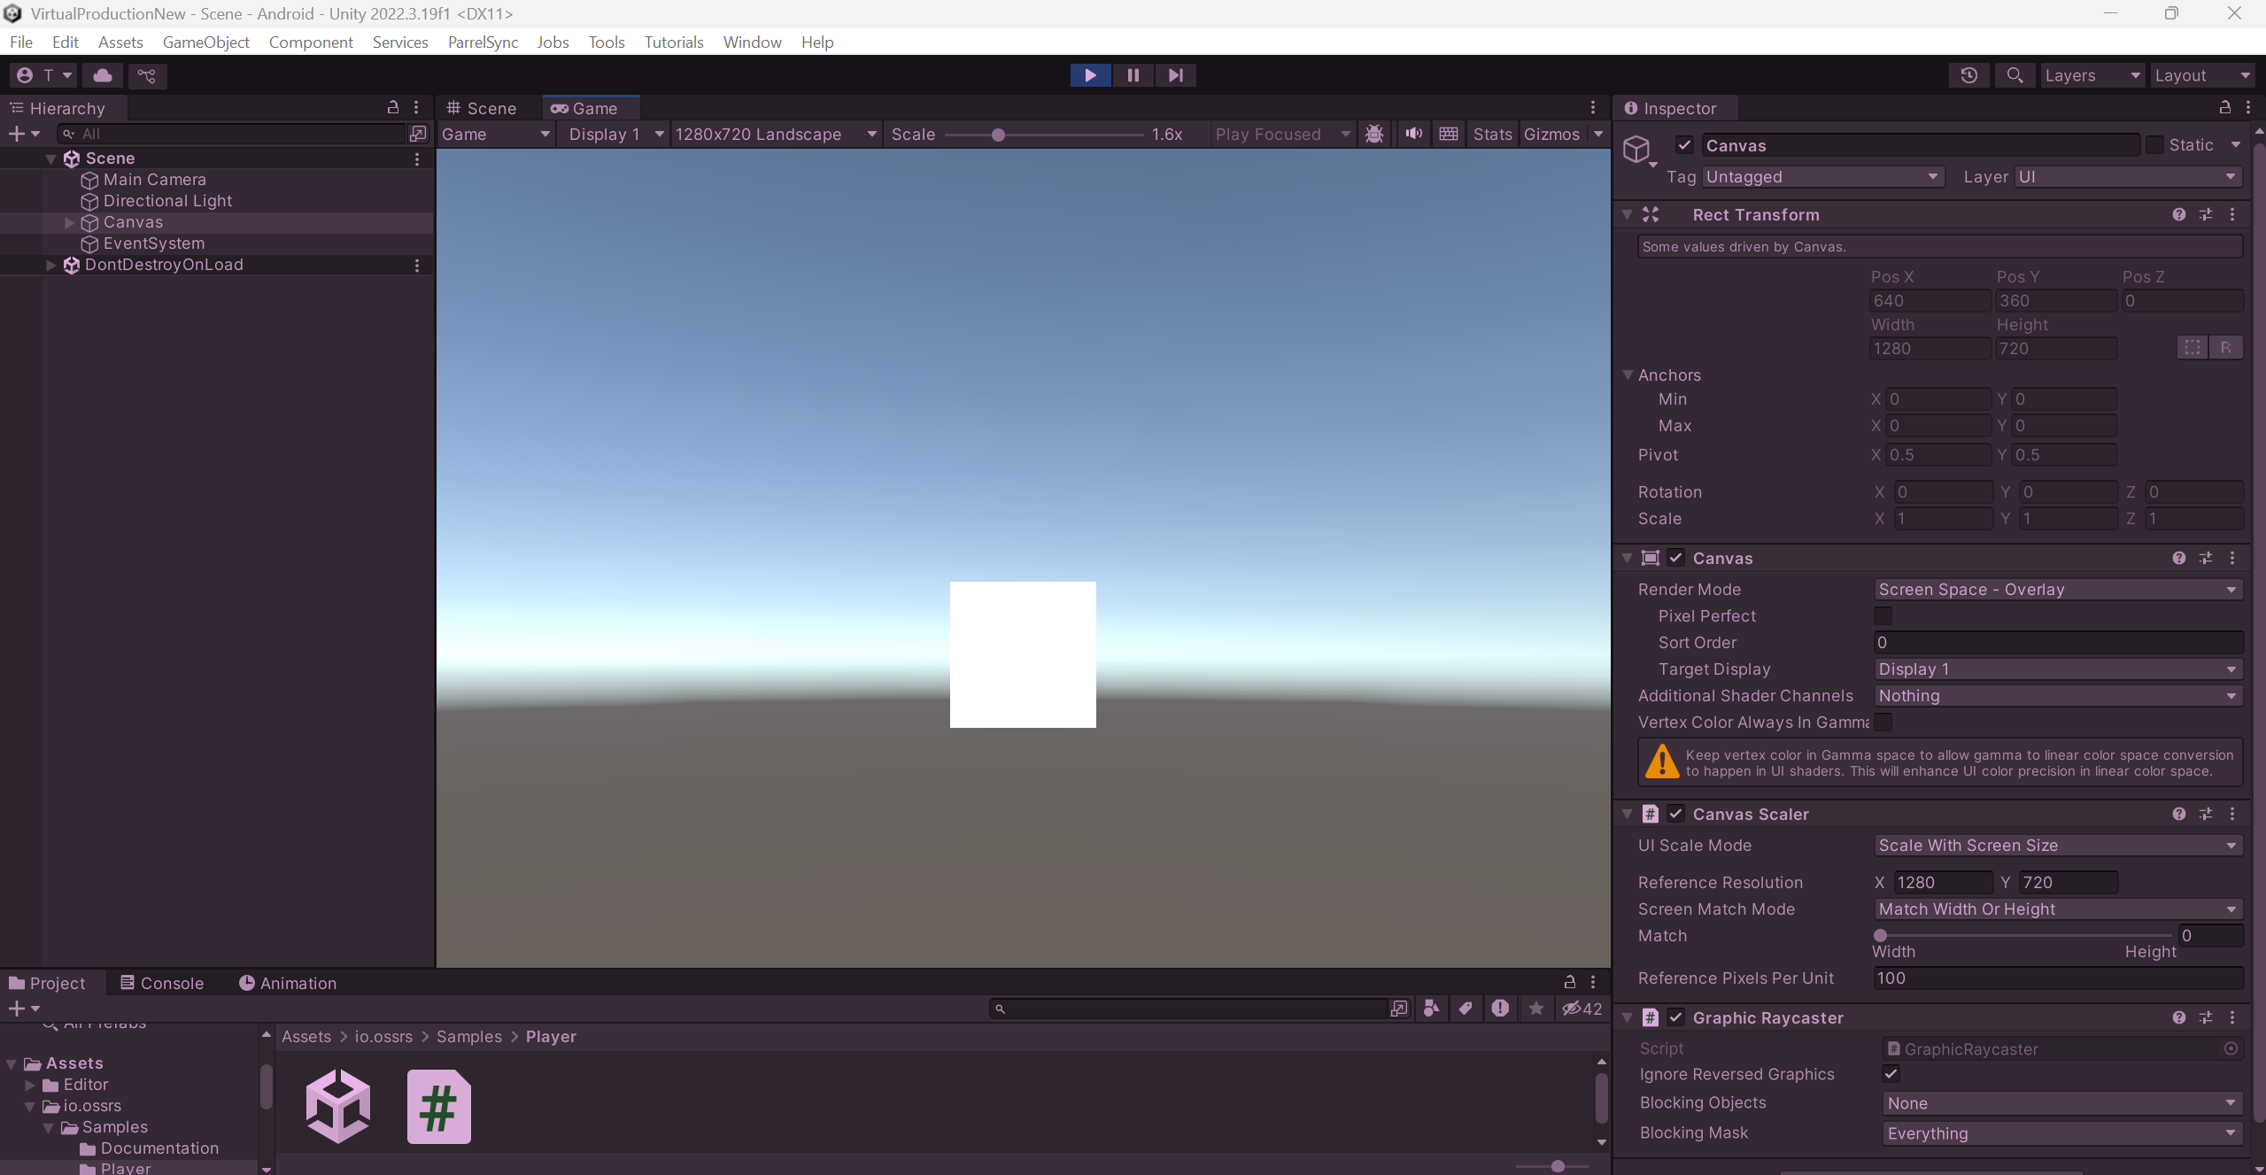
SRS successfully loading laptop Webcam view on Raw Image (Left) but not the NDI Webcam view (Right).

Date: 25/09/25
Day: Thursday
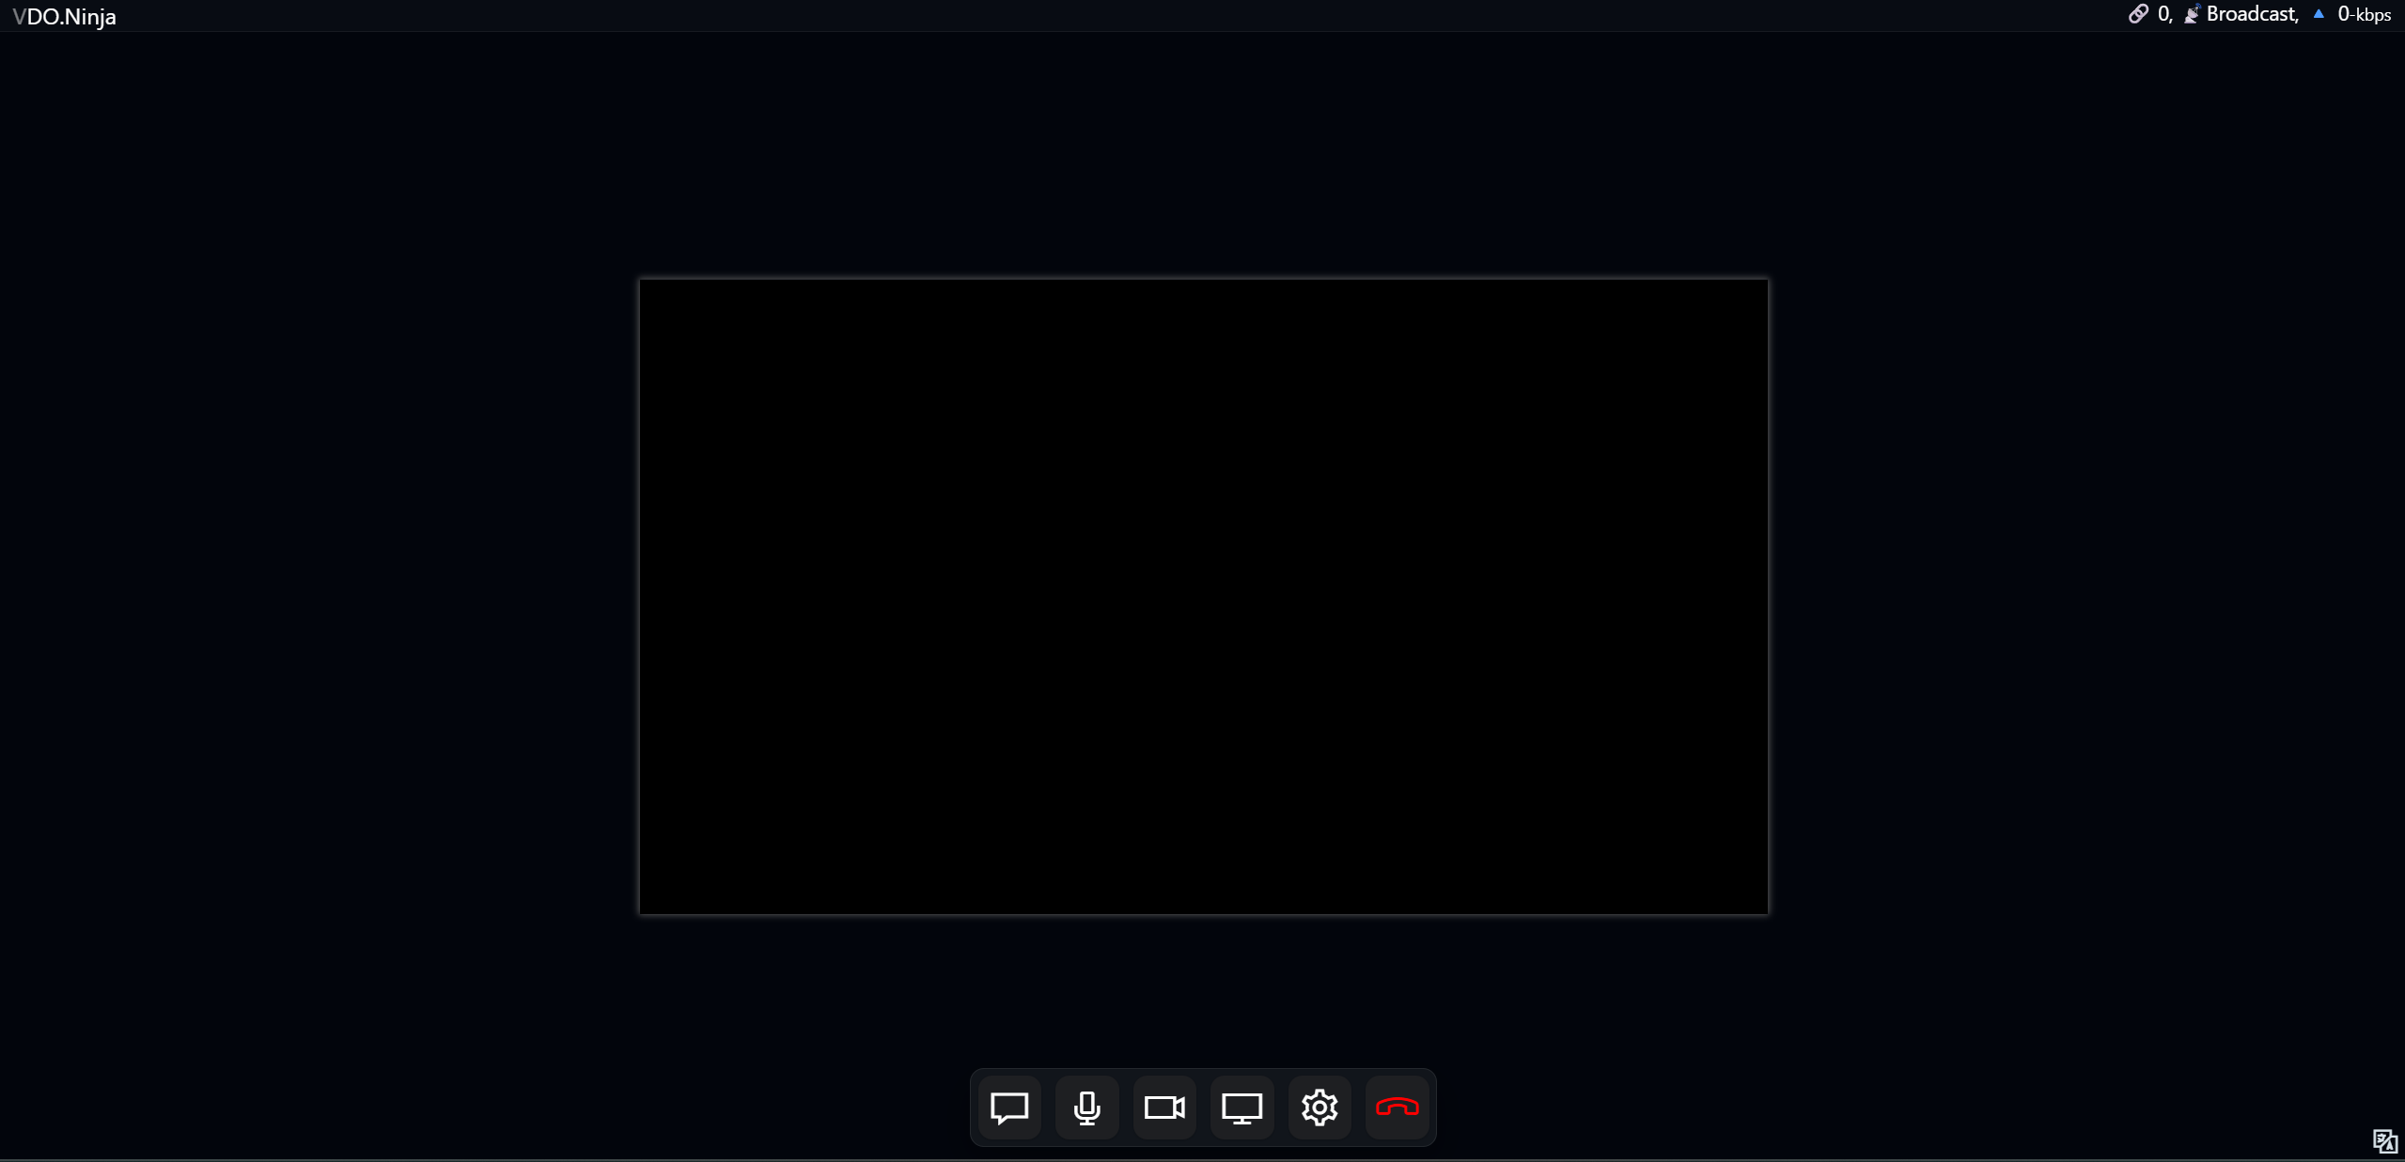
VDO.ninja showing black screen even on the Publishing side
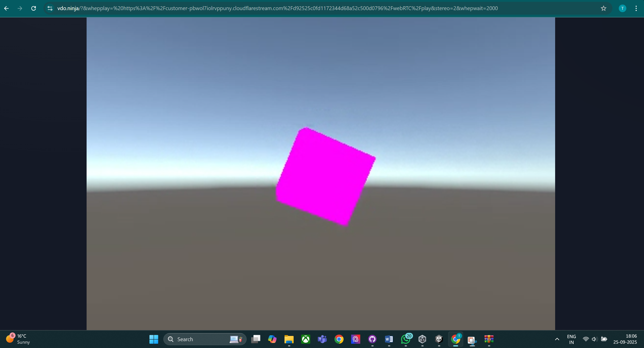
Subscriber (WHEP) end of VDO.ninja showing frozen feed, when SRS Streamer is used to publish video feed.

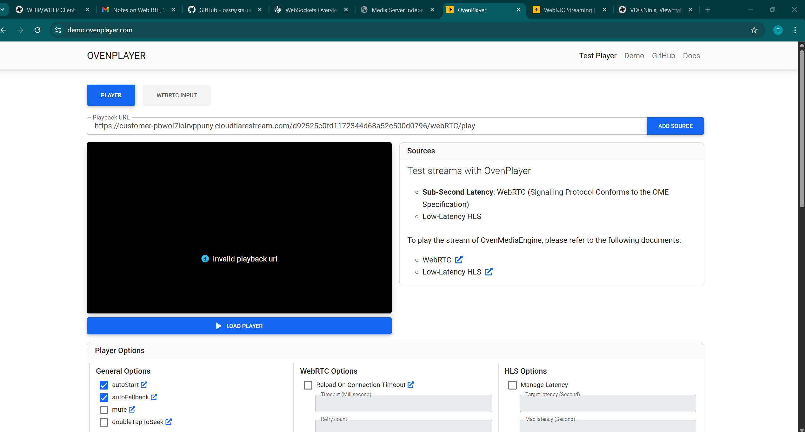
Tried OvenPlayer to play using WHEP URL, but it shows Invalid playback url.
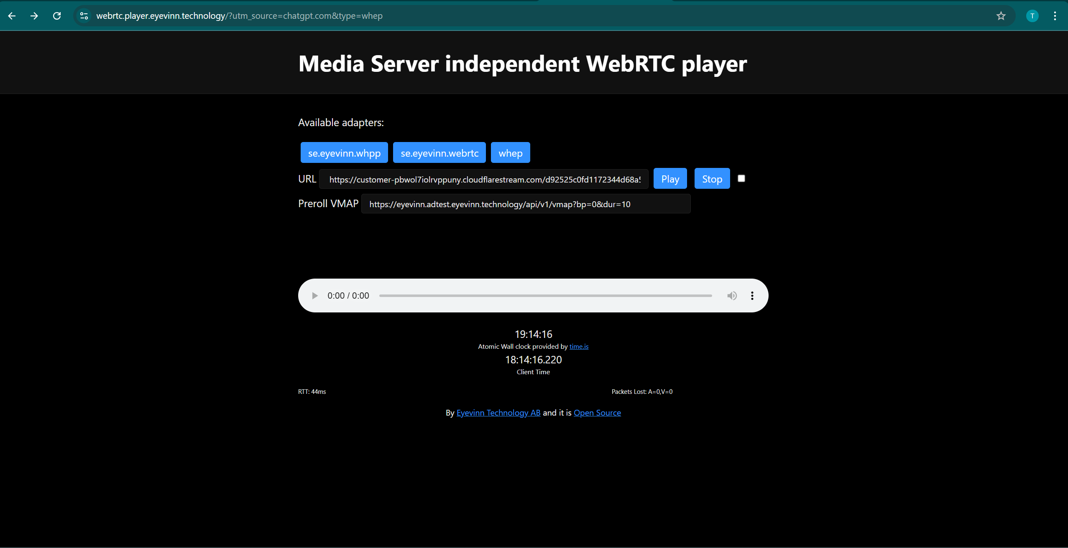
Tried Eyevinn player for playing feed using WHEP URL: Black feed seen.
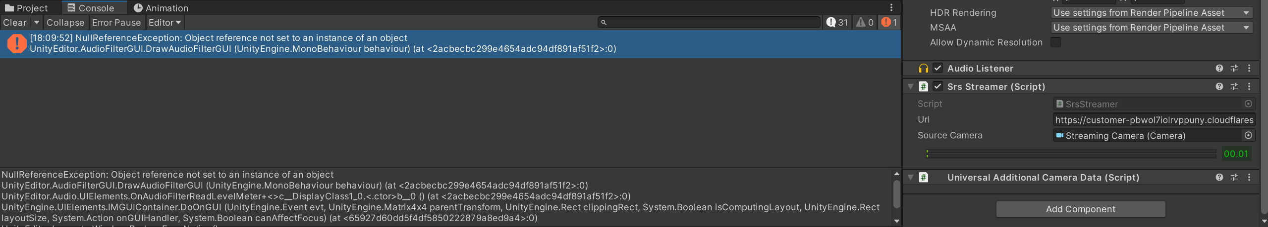
Console Error displayed in SRS Streamer scene upon hitting the play button.

Date: 29/09/25
Day: Monday
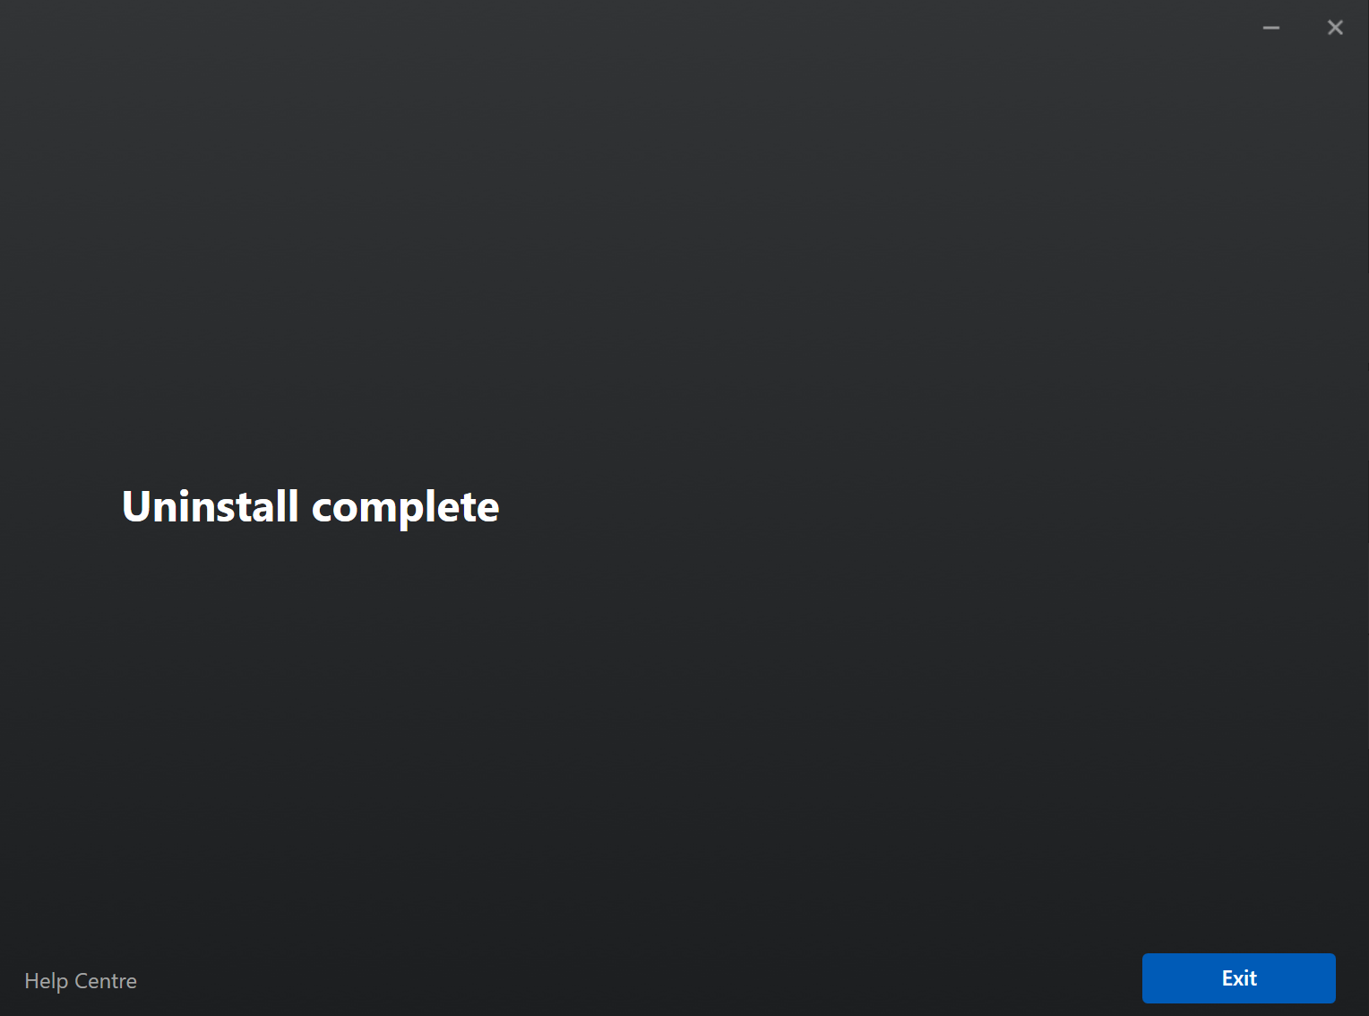
Uninstalled Meta Quest Link software to re-install and fix issue

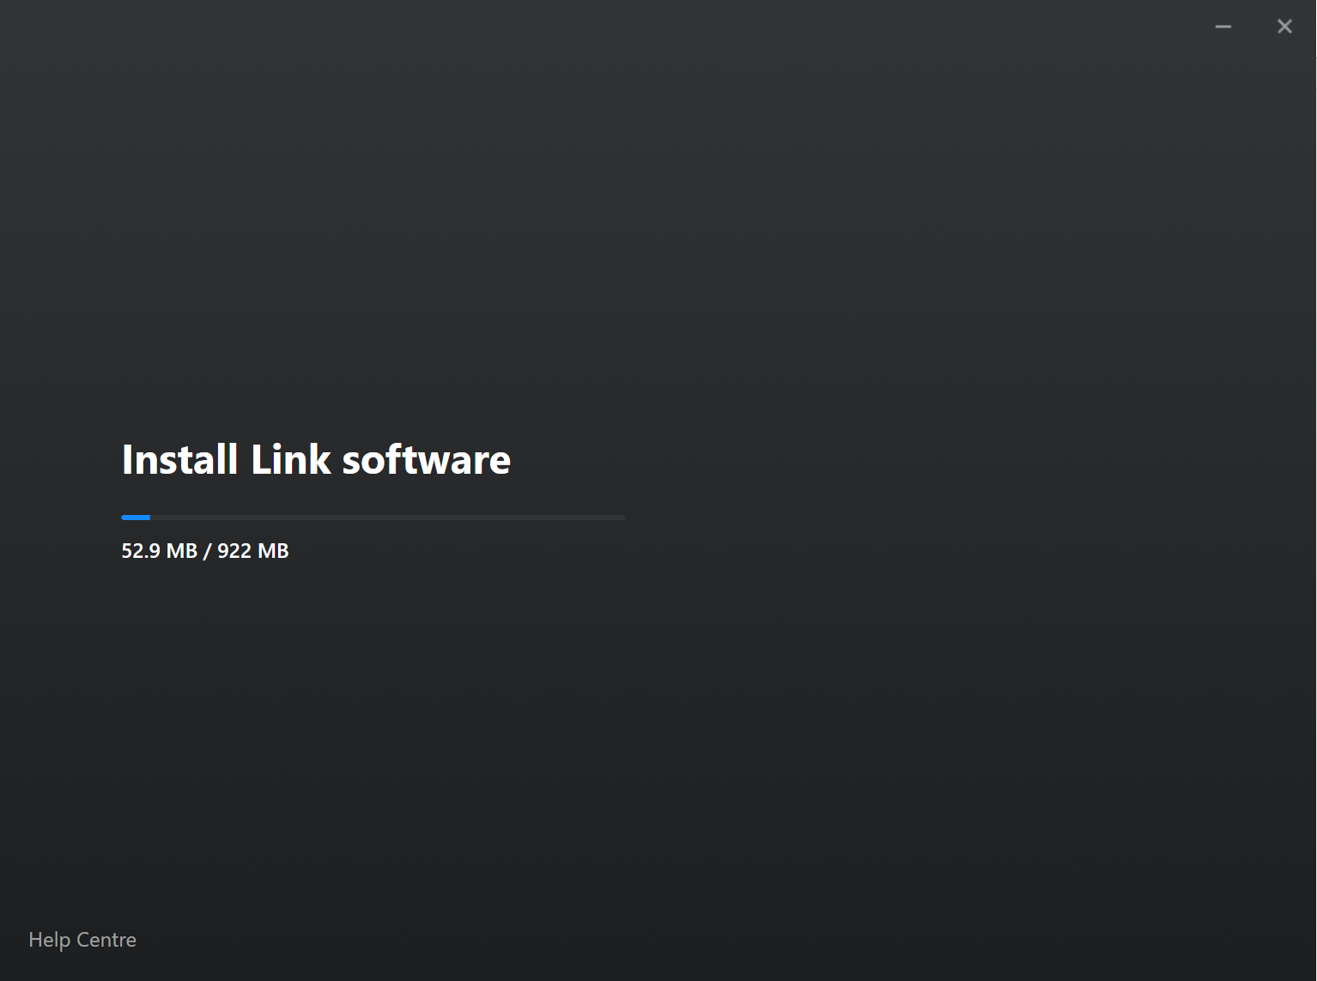
Reinstalling Meta Quest Link software

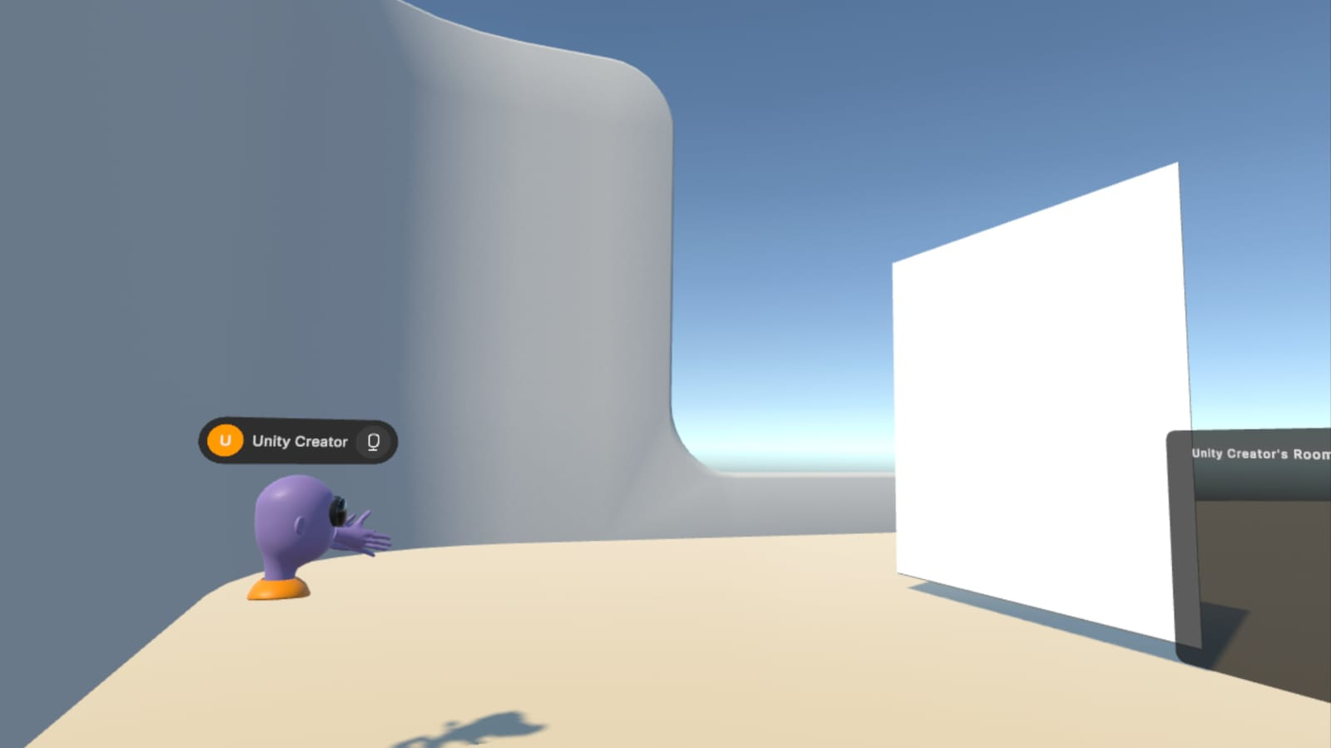
Other player visible but livestream not visible on an apk built to the VR headset

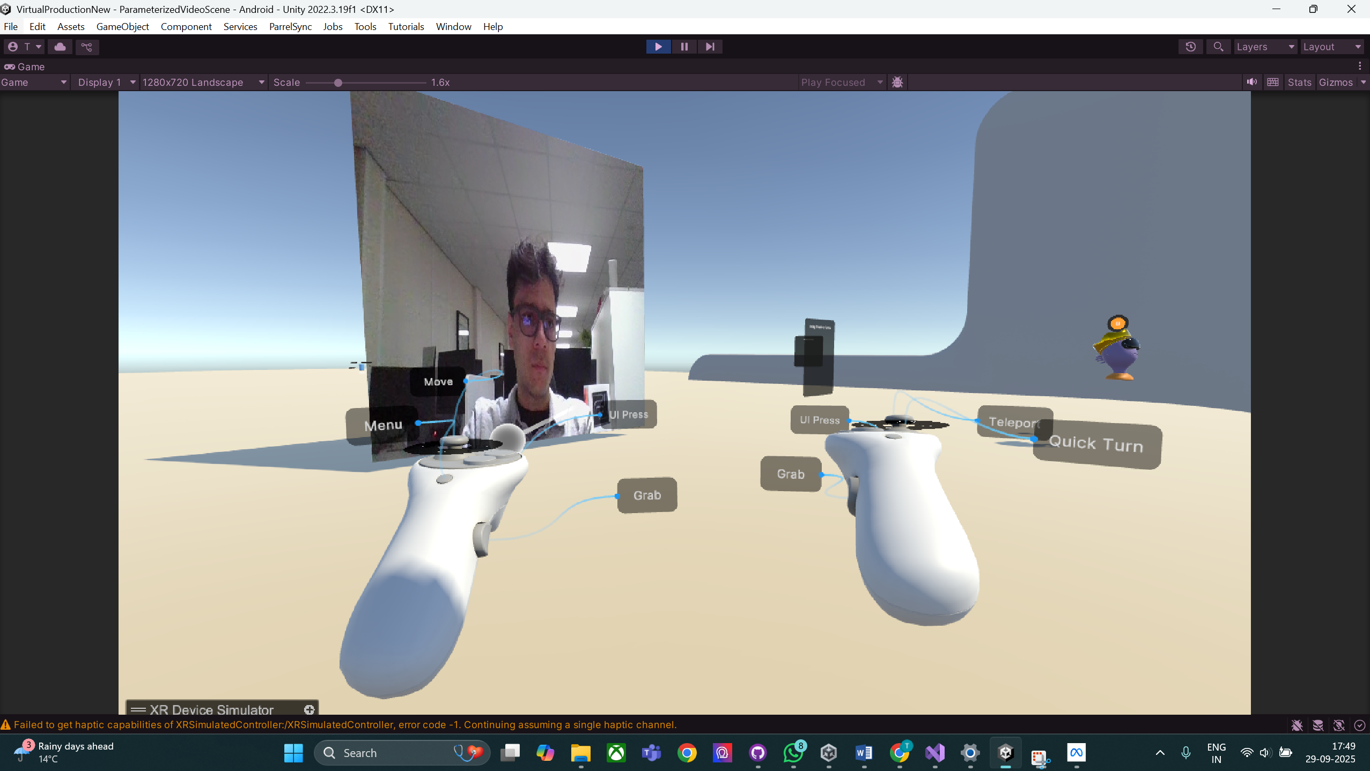
Other player and livestream both visible in PCVR and using the XR Device Simulator

Date: 01/10/25
Day: Wednesday
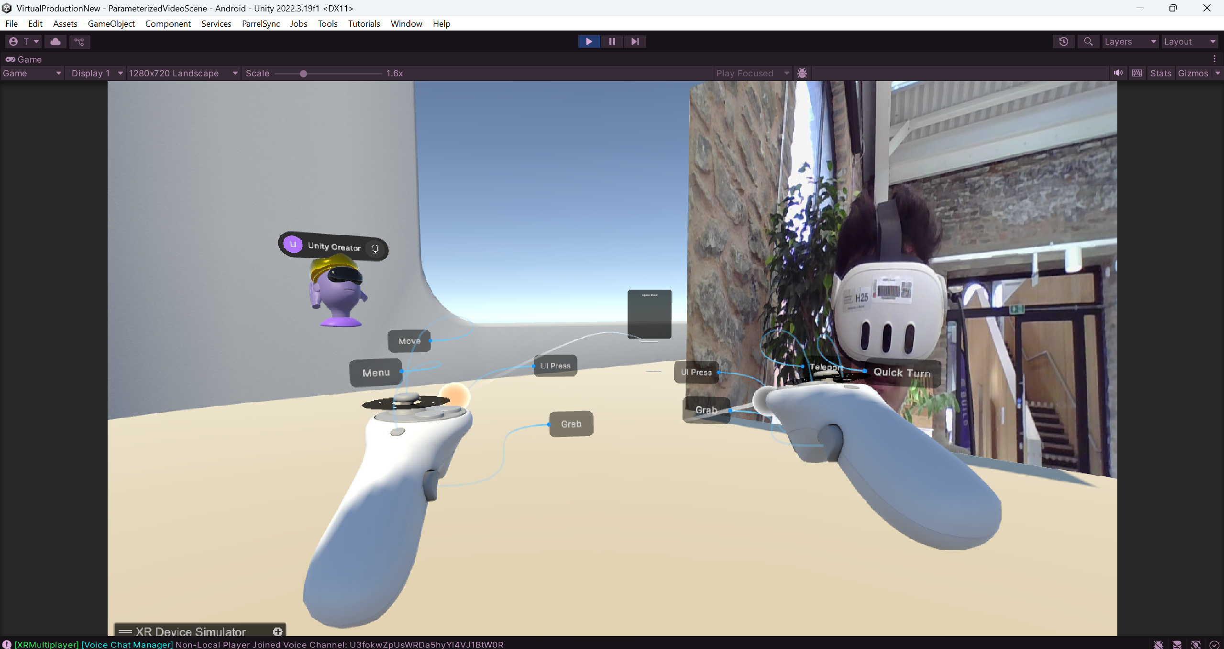
SRS Player feed now displaying in the Quest Build and editor in Multiplayer.
Date: 02/10/25
Day: Thursday
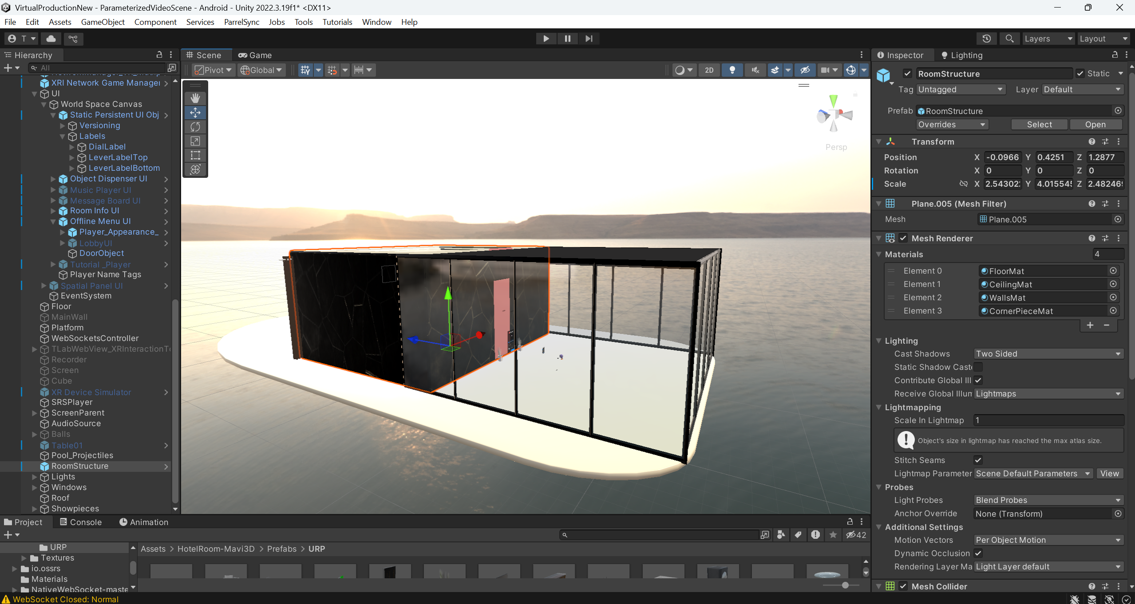
VR Environment Ready

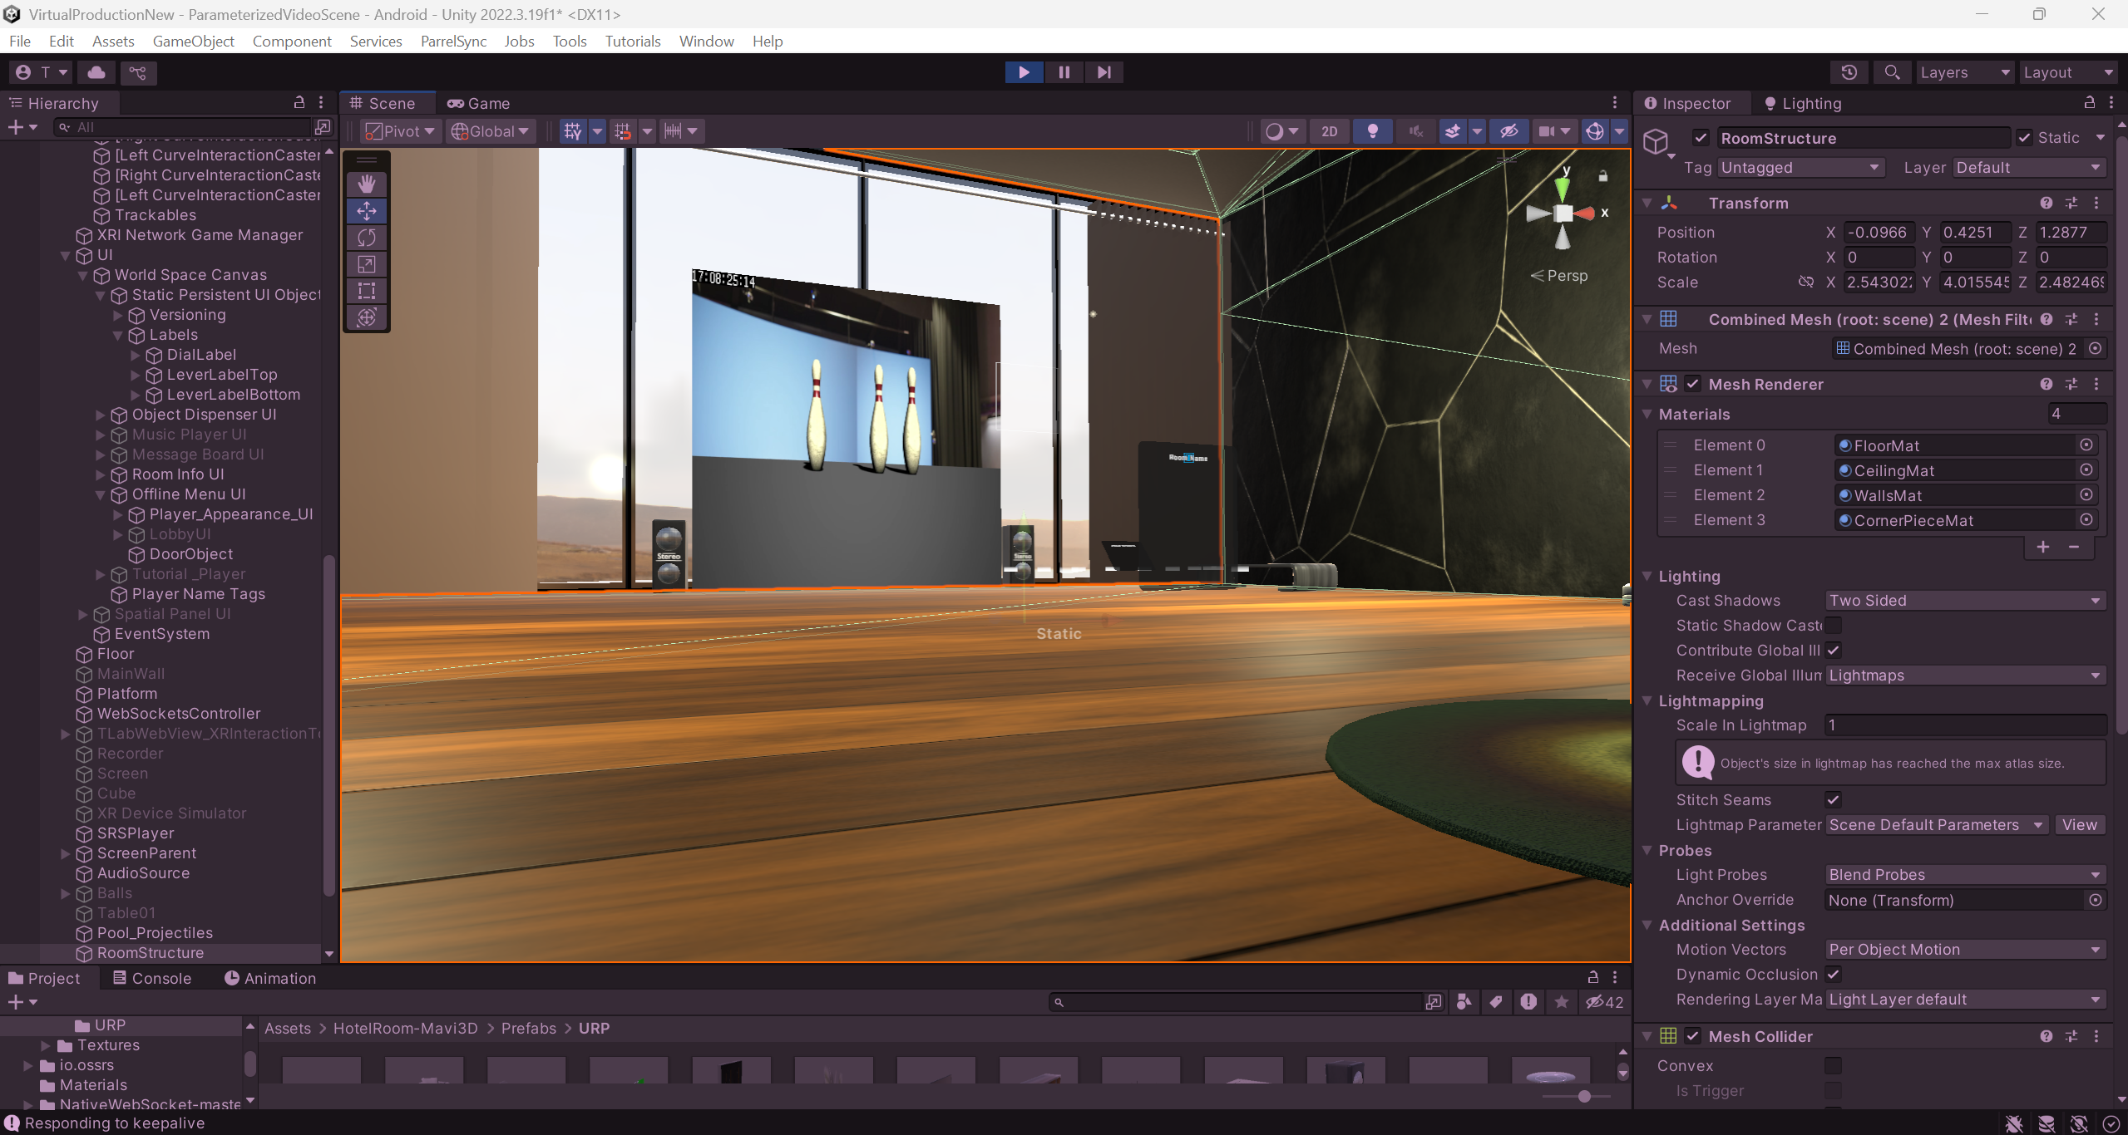
Livestream pulled using WHEP and SRS Player.

Date: 02/10/25
Day: Thursday
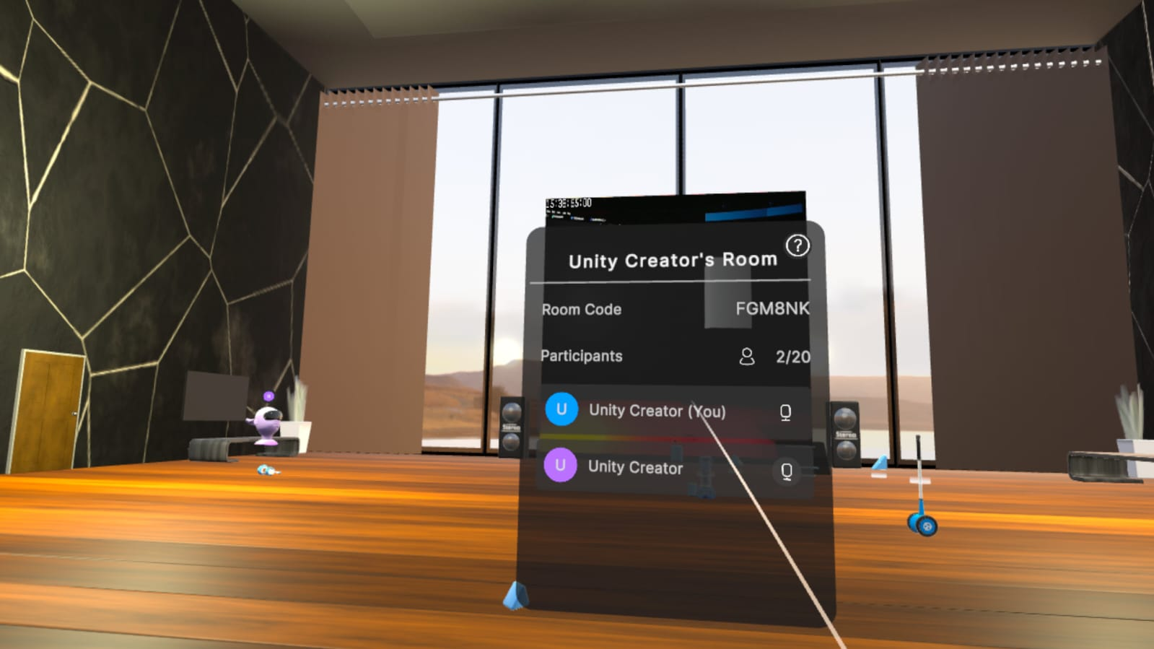

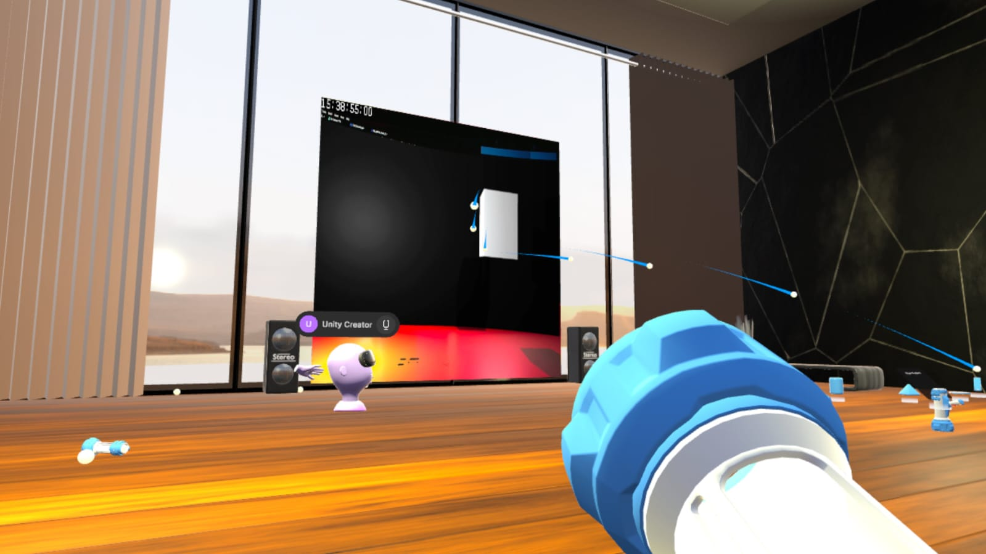
Stream showing on both player’s VR Space in Multiplayer

