Question 1 REPORT

BY Tanish verma
ROLL NO: co24btech11023

Table of Contents
Obtaining the linear equations of the circuit 3
Given circuit diagram 3
Obtaining the solution matrix 4
Solutions from different codes 9
LU decomposition 9
Gauss seidel method 10
Conjugate Gradient 11
Time Taken by each code 12
Effect of SOR on Gauss seidel method 13
CODE REPORTS 15
lu decomposition 15
FUNCTION : LU Decomposition 15
function: Forward Substitution 17
function: Backward Substitution 18
function : Reading Matrix and Vector Input from a File 19
Main Program for Solving Linear Systems via LU Decomposition 20
Gauss Seidel 23
Reading Matrix and Vector Input from File 23
function: Matrix-Vector Multiplication 24
function: Vector Subtraction 25
function: Calculate the square of the Euclidean Norm of a Vector 26
Function: Gauss-Seidel 27
Main Program for Gauss-Seidel with SOR Method 30
Conjugate Gradient method 34
Reading Matrix and Vector Input from File 34
function: Matrix-Vector Multiplication 35
function: Vector Subtraction 36
function: Dot Product of Two Vectors 37
FUNCTION: Conjugate Gradient Method 38
Main Program for Conjugate Gradient Method 41

Obtaining the linear equations of the circuit

Given circuit diagram
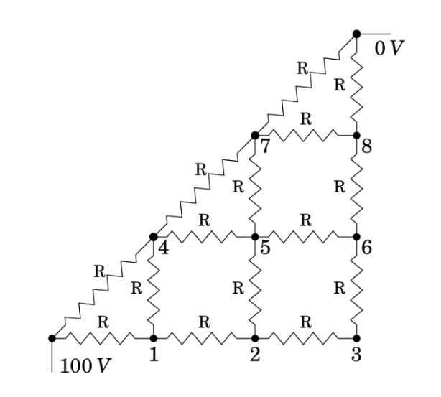

Obtaining the solution matrix

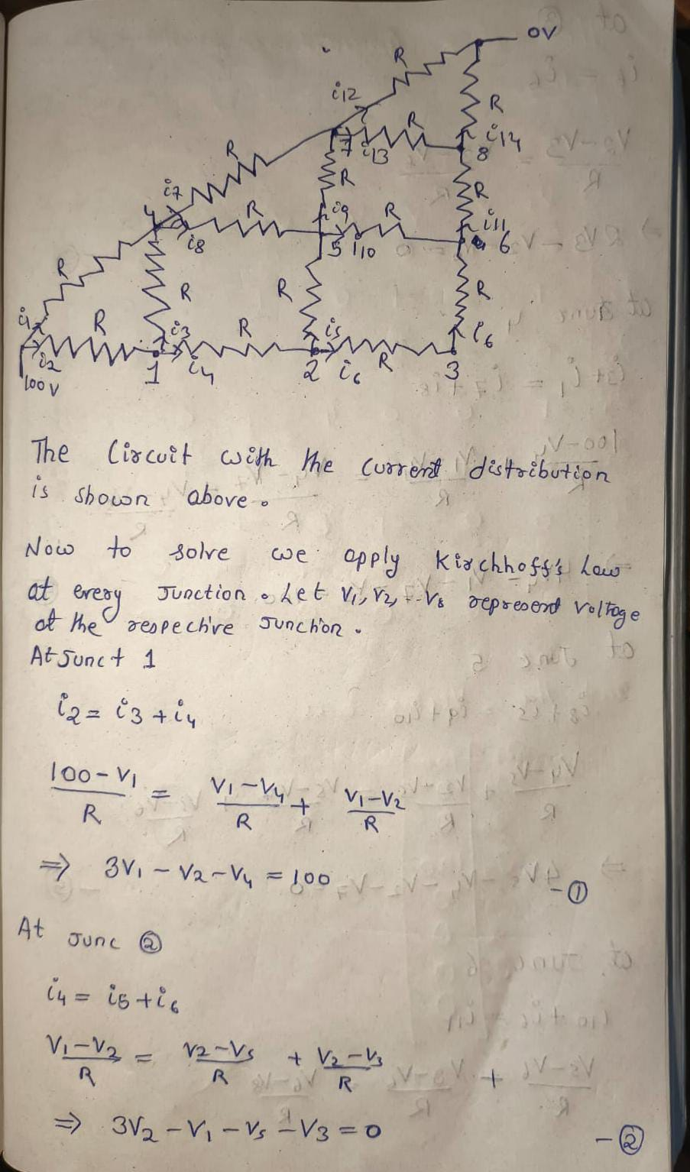
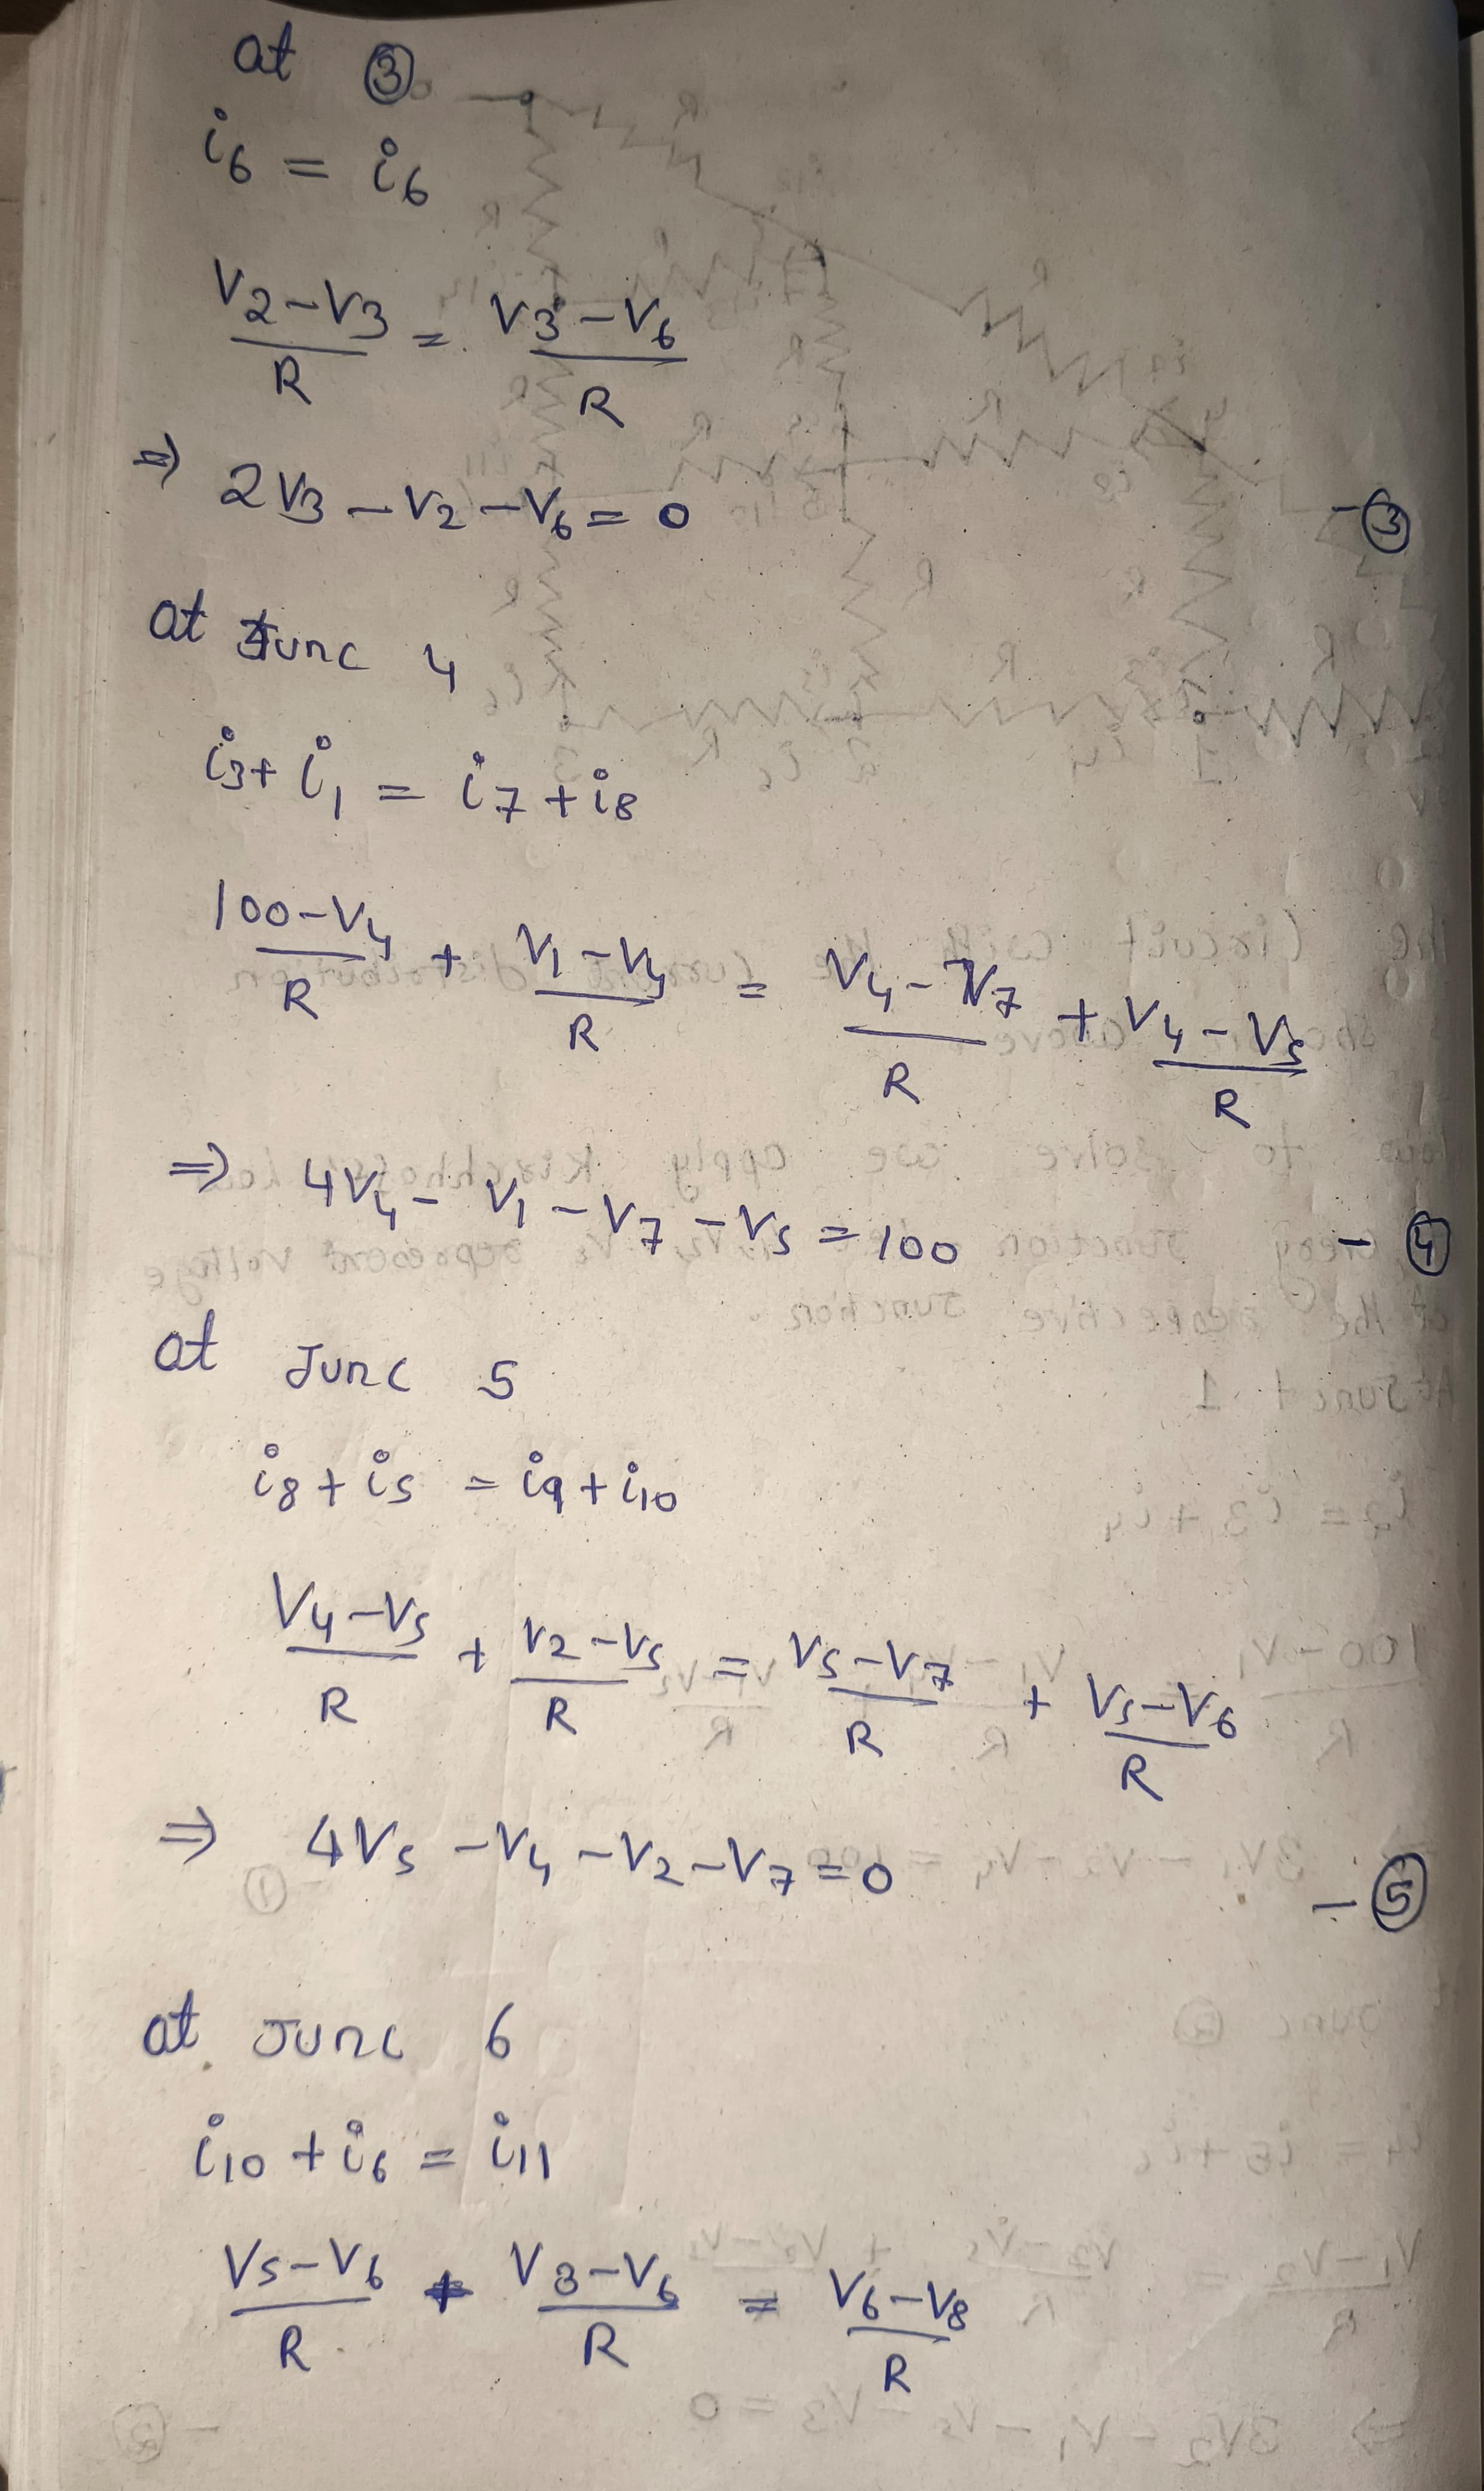
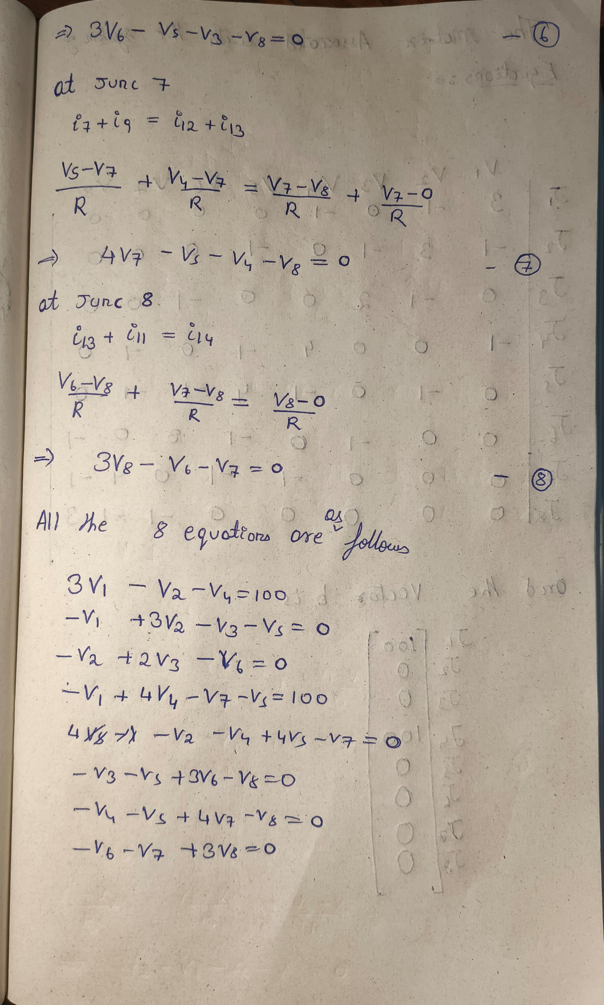
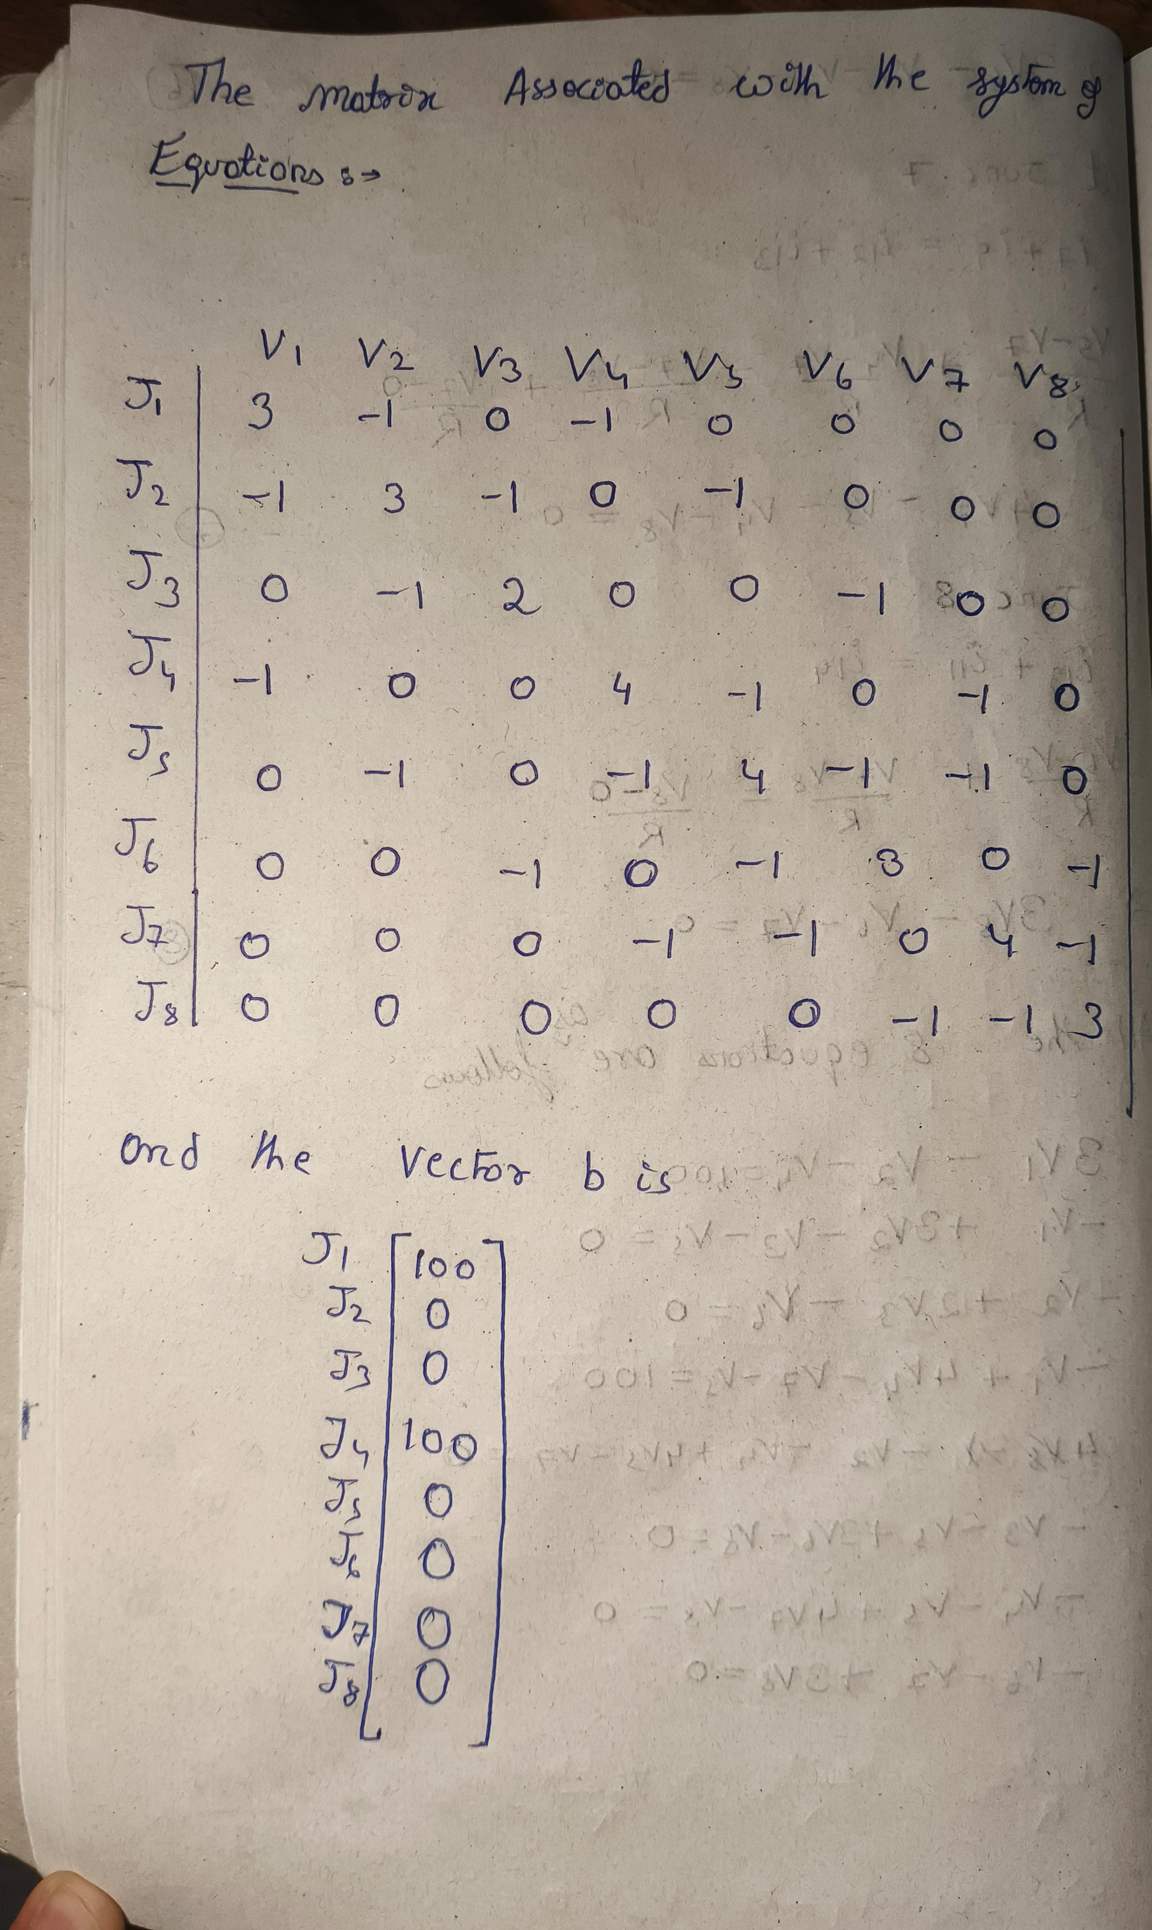
From the above solution we have the following:
Matrix A = $\left[\begin{matrix}3 & -1 & 0 & -1 & 0 & 0 & 0 & 0 \\ -1 & 3 & -1 & 0 & -1 & 0 & 0 & 0 \\ 0 & -1 & 2 & 0 & 0 & -1 & 0 & 0 \\ -1 & 0 & 0 & 4 & -1 & 0 & -1 & 0 \\ 0 & -1 & 0 & -1 & 4 & -1 & -1 & 0 \\ 0 & 0 & -1 & 0 & -1 & 3 & 0 & -1 \\ 0 & 0 & 0 & -1 & -1 & 0 & 4 & -1 \\ 0 & 0 & 0 & 0 & 0 & -1 & -1 & 3\end{matrix}\right]$

And b = $\left[\begin{matrix}100 \\ 0 \\ 0 \\ 100 \\ 0 \\ 0 \\ 0 \\ 0\end{matrix}\right]$

Solutions from different codes

LU decomposition

Algorithm
LU decomposition using Doolittle's method factors a square matrix A into a lower triangular matrix L (with 1s on the diagonal) and an upper triangular matrix U such that A = LU. Here's the algorithm:
Doolittle's Algorithm Steps
- Initialization
  - Let A be an n×n matrix.
  - Initialize L as an identity matrix and U as a copy of A.
- Row Operations for Decomposition
For each column kk from 1 to nn:
  - Compute U's k-th row:
$U_{kj}=A_{kj}-\sum_{m=1}^{k-1}{L_{km}*U_{mj}}$ for j = k,k+1,k+2,….,n
  - Compute L's kk-th column (below the diagonal):
$L_{ik}=\frac{A_{ik}-\sum_{m=1}^{k-1}{L_{im}*U_{mk}}}{U_{kk}}$ for i= k+1,k+2,…n
- Final Output
  - L: Lower triangular matrix with 1s on the diagonal.
  - U: Upper triangular matrix.
- Solving Linear Systems via LU Decomposition:
  - After decomposing AA into L and U, solve Ax=b in two steps:
- Forward Substitution
    - Solve for the intermediate vector y using the lower triangular matrix L: Ly=b
- Backward Substitution
    - Solve for the solution vector x using the upper triangular matrix U: Ux=y

Results
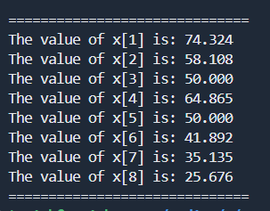

Gauss seidel method

Algorithm
The Gauss-Seidel method with Successive Over-Relaxation (SOR) accelerates convergence by introducing a relaxation factor ω. Here's the algorithm and its key components:
Algorithm Steps
- Initialize
  - Let A be an n×n matrix and b the right-hand vector.
  - Choose an initial guess x(0)) and relaxation factor ω∈(0,2).
- Iterative Update
For each iteration k and component i from 1 to n:
  - Compute the Gauss-Seidel estimate:
  - $x_{GS}^{k+1}\left[i\right]={\frac{1}{A}}_{ii }(b_{i}-\sum_{j=1}^{i-1}{A_{ij}x^{k+1}\left[j\right]}-\sum_{j=i+1}^{n}{A_{ij}x^{k}[j])}$
  - Apply SOR weighting:
  - $x^{k+1}\left[i\right]=\left(1-ω\right)*x^{k}\left[i\right]+ω*x_{gs}^{k+1}\left[i\right]$
- Convergence Check
Stop when $∥x^{k+1} -x^{k}∥<ϵ$ (tolerance).

Result
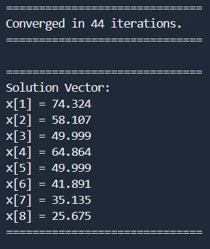
For epsilon = $1*{10}^{-6}$
And weight $ω=1$

Conjugate Gradient

Algorithm
The Conjugate Gradient (CG) algorithm is an iterative method for solving systems of linear equations Ax=b, where A is symmetric positive definite (SPD).
Algorithm Steps
- Initialization
  - Input: SPD matrix A, vector b, initial guess $x_{0}$.
  - Compute initial residual: $r_{0}=b-{A*x}_{0}$
  - Set initial search direction: $P_{0}=r_{0}$
- Iterative Update
For k=0,1,2,… until convergence:
  - Step size: $α_{k}=\frac{r_{k}^{T}*r_{k}}{P_{k}^{T}*A*P_{k}}$
  - Update solution: $x_{k+1}=x_{k}+α_{k}*P_{k}$
  - Update residual: $r_{k+1}=r_{k}-α_{k}*A*P_{k}$
  - Compute conjugate direction: $β_{k}=\frac{r_{k+1}^{T}*r_{k+1}}{r_{k}^{T}*r_{k}} , P_{k+1}=r_{k+1}+β_{k}*P_{k}$
- Stopping Criterion
Terminate when ∥r^{k} ∥<ϵ (tolerance).

Results
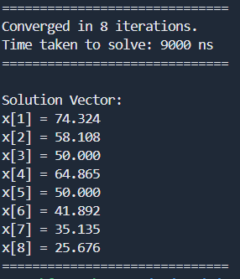
For $ϵ=1*{10}^{-6}$

Time Taken by each code

LU Decomposition | 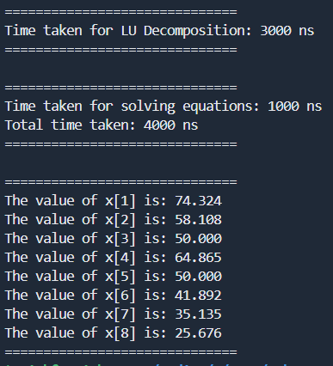
Gauss seidel | 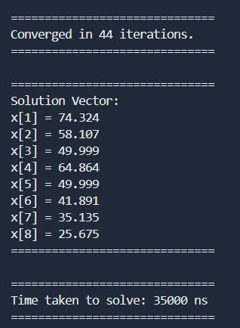
Conjugate Gradient | 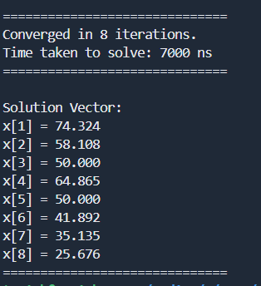

Effect of SOR on Gauss seidel method

$$ω$$ | Time taken
0.5 | 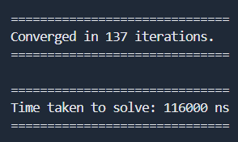
1 | 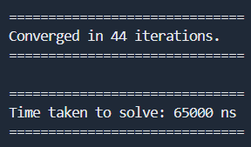
1.5 | 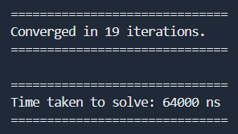
1.75 | 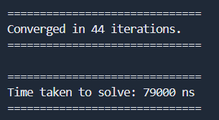

From the presented table, it is clearly evident that the convergence speed of the Successive Over-Relaxation (SOR) method significantly depends on the choice of relaxation parameter ω (omega). The performance pattern demonstrates a distinct trend:
- With under-relaxation (ω = 0.5), the algorithm requires a substantial 137 iterations and takes 116,000 ns to converge.
- At standard Gauss-Seidel (ω = 1.0), performance improves considerably to 44 iterations and 65,000 ns.
- The performance continues to improve as ω increases to 1.5, reaching optimal efficiency with only 19 iterations and 64,000 ns execution time.
- However, when ω is further increased to 1.75, performance deteriorates sharply, reverting to 44 iterations and requiring 79,000 ns.
This confirms the theoretical behaviour of the SOR method, where the convergence rate increases as the relaxation parameter approaches its optimal value, but then rapidly degrades when it exceeds this optimal threshold. For this particular linear system, ω ≈ 1.5 represents the sweet spot that balances acceleration and stability, achieving nearly 3x faster convergence than standard Gauss-Seidel.

CODE REPORTS

lu decomposition

FUNCTION : LU Decomposition

Purpose: This function decomposes a square matrix A into a lower triangular matrix (L) and an upper triangular matrix (U) such that A = LU.

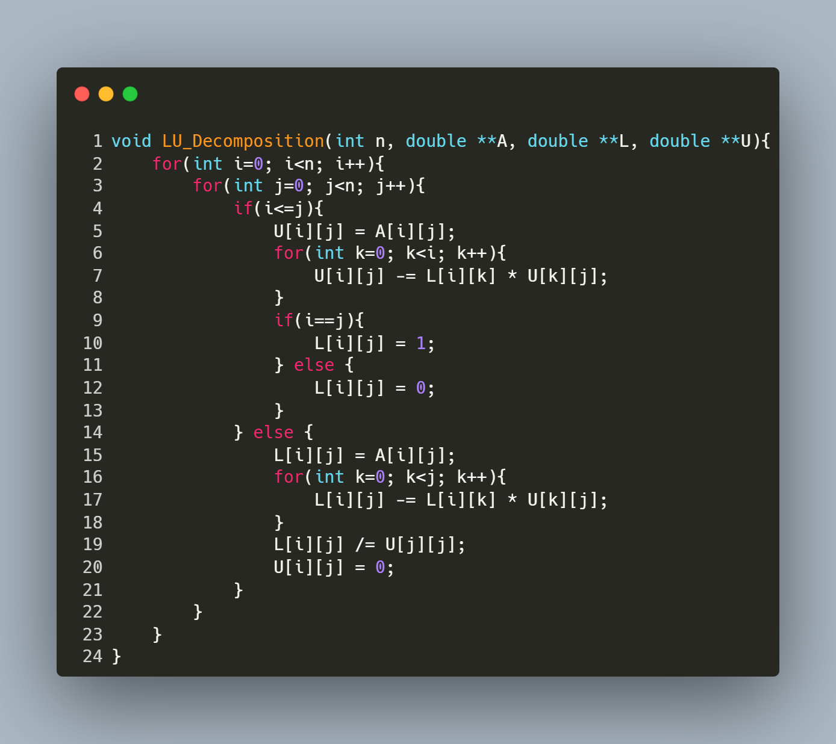
Step-by-Step Explanation
1. Matrix Traversal
- The outer loops iterate over each element of the matrix:
  - i represents the current row.
  - j represents the current column.
2. Upper Triangular Matrix (U)
For elements where i ≤ j (diagonal and upper triangle):
- Initialize U[i][j]:

U[i][j] = A[i][j];
- Subtract Contributions from Previous Rows:
for (int k = 0; k < i; k++) {
U[i][j] -= L[i][k] * U[k][j];
}
This eliminates dependencies on earlier rows using the formula:
- U[i][j]=A[i][j]−$\sum_{k=0}^{i-1}{L\left[i\right]\left[k\right]*U[k][j]}$
- Set L[i][j]:
  - Diagonal (i == j): L[i][j] = 1.0 (unit lower triangular matrix).
  - Upper triangle (i < j): L[i][j] = 0.0.
3. Lower Triangular Matrix (L)
For elements where i > j (lower triangle):
- Initialize L[i][j]:
L[i][j] = A[i][j];
- Subtract Contributions from Previous Columns:
for (int k = 0; k < j; k++) {
L[i][j] -= L[i][k] * U[k][j];
}
This uses the formula:
- L[i][j]=$\frac{A\left[i\right]\left[j\right]- \sum_{k=0}^{i-1}{L\left[i\right]\left[k\right]*U[k][j]}}{U\left[j\right][j]}$
- Normalize by U[j][j]:
L[i][j] /= U[j][j];
- Set U[i][j]:
c
U[i][j] = 0.0; // Ensure upper triangle elements below diagonal are zero

function: Forward Substitution

Purpose: This function solves a system Lx = b where L is a lower triangular matrix
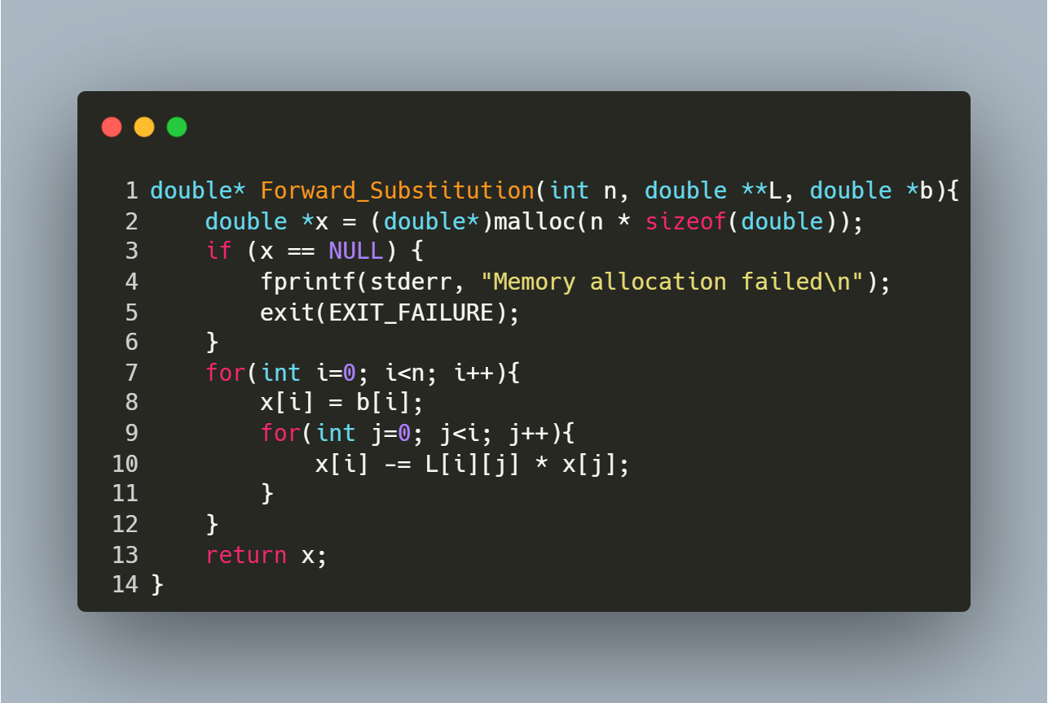
Step-by-Step Explanation
- Memory Allocation:
  - Allocates memory for the solution vector x.
  - Exits with an error if allocation fails.
- Forward Substitution Loop:
  - Iterates over each row i from 0 to n-1:
    - Initialize: x[i] = b[i] (start with the right-hand side value).
    - Subtract Known Terms: For each column j < i, subtract L[i][j] * x[j] to eliminate dependencies on previously computed x[j].
  - No Division Needed: L is a unit lower triangular matrix (1s on the diagonal), so no division by L[i][i] is required.

function: Backward Substitution

Purpose: This function solves a system Ux = b where U is an upper triangular matrix.
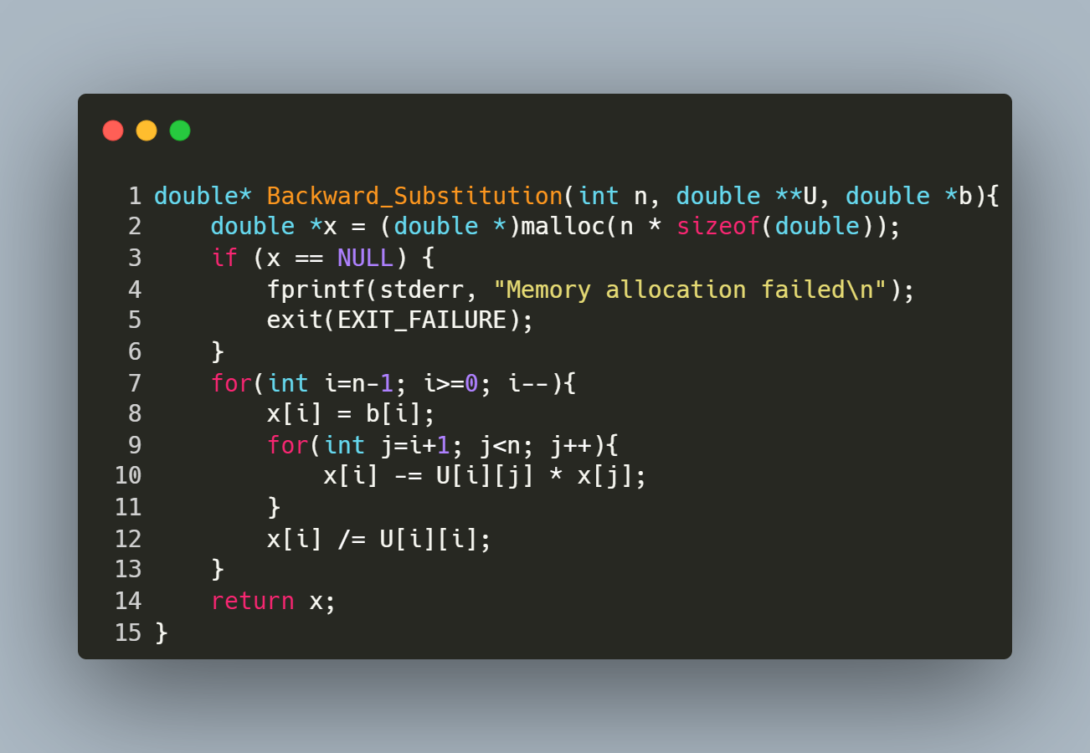
Step-by-Step Explanation
- Memory Allocation:
  - Allocates memory for the solution vector x.
  - Exits with an error if allocation fails.
- Backward Substitution Loop:
  - Iterates over rows i from bottom to top (n-1 to 0):
    - Initialize: x[i] = b[i] (start with the right-hand side value).
    - Subtract Known Terms: For each column j > i, subtract U[i][j] * x[j] to eliminate dependencies on already computed x[j].
    - Normalize: Divide by U[i][i] to isolate x[i].

function : Reading Matrix and Vector Input from a File

Purpose: This function reads a square matrix A of size n x n and a vector b of size n from a file named "inputs.txt". It ensures proper error handling for file operations and input parsing.
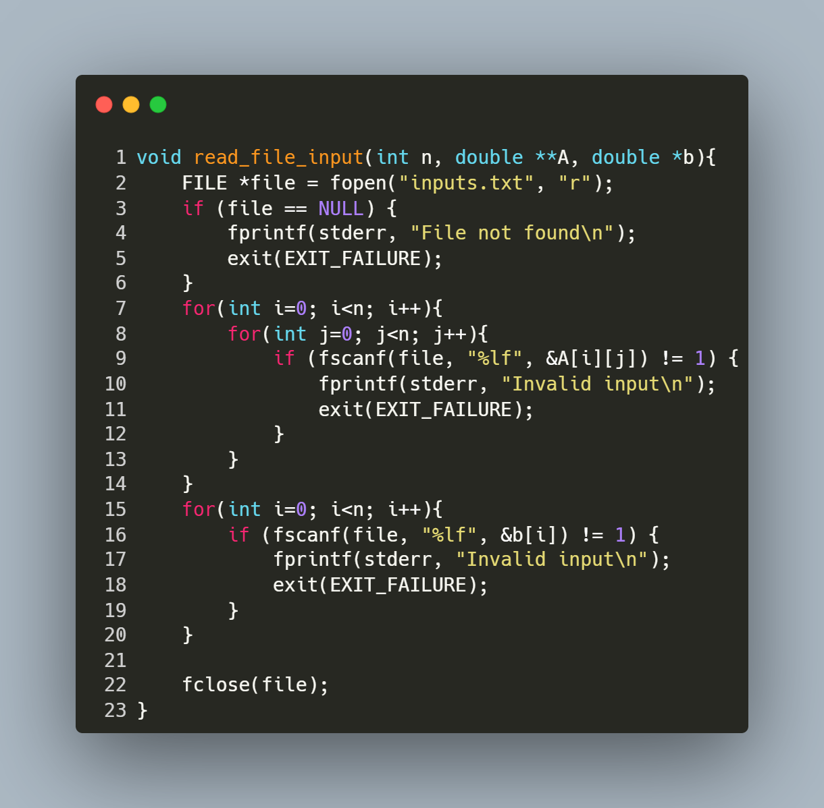
Step-by-Step Explanation
- Open File:
  - FILE *file = fopen("inputs.txt", "r"); opens the file "inputs.txt" in read mode.
  - If the file cannot be opened (e.g., it doesn't exist), the program prints an error message ("File not found") and exits.
- Read Matrix Elements:
  - The nested loop for (int i = 0; i < n; i++) { for (int j = 0; j < n; j++) { ... } } iterates through each row (i) and column (j) of matrix A.
  - fscanf(file, "%lf", &A[i][j]) reads a floating-point number from the file and stores it in the corresponding position in A.
  - If the input is invalid or missing, the program prints "Invalid input" and exits.
- Read Vector Elements:
  - The loop for (int i = 0; i < n; i++) { ... } iterates through each element of vector b.
  - fscanf(file, "%lf", &b[i]) reads a floating-point number from the file and stores it in the corresponding position in b.
  - Similar error handling ensures that invalid or missing input causes the program to terminate with an error message.
- Close File:
fclose(file); closes the file after all data has been read to release system resources.

Main Program for Solving Linear Systems via LU Decomposition

Purpose: This program solves a linear system Ax = b using LU decomposition. It reads matrix A and vector b from a file, factors A into lower triangular matrix L and upper triangular matrix U, solves for x using forward/backward substitution, and reports timings and results.
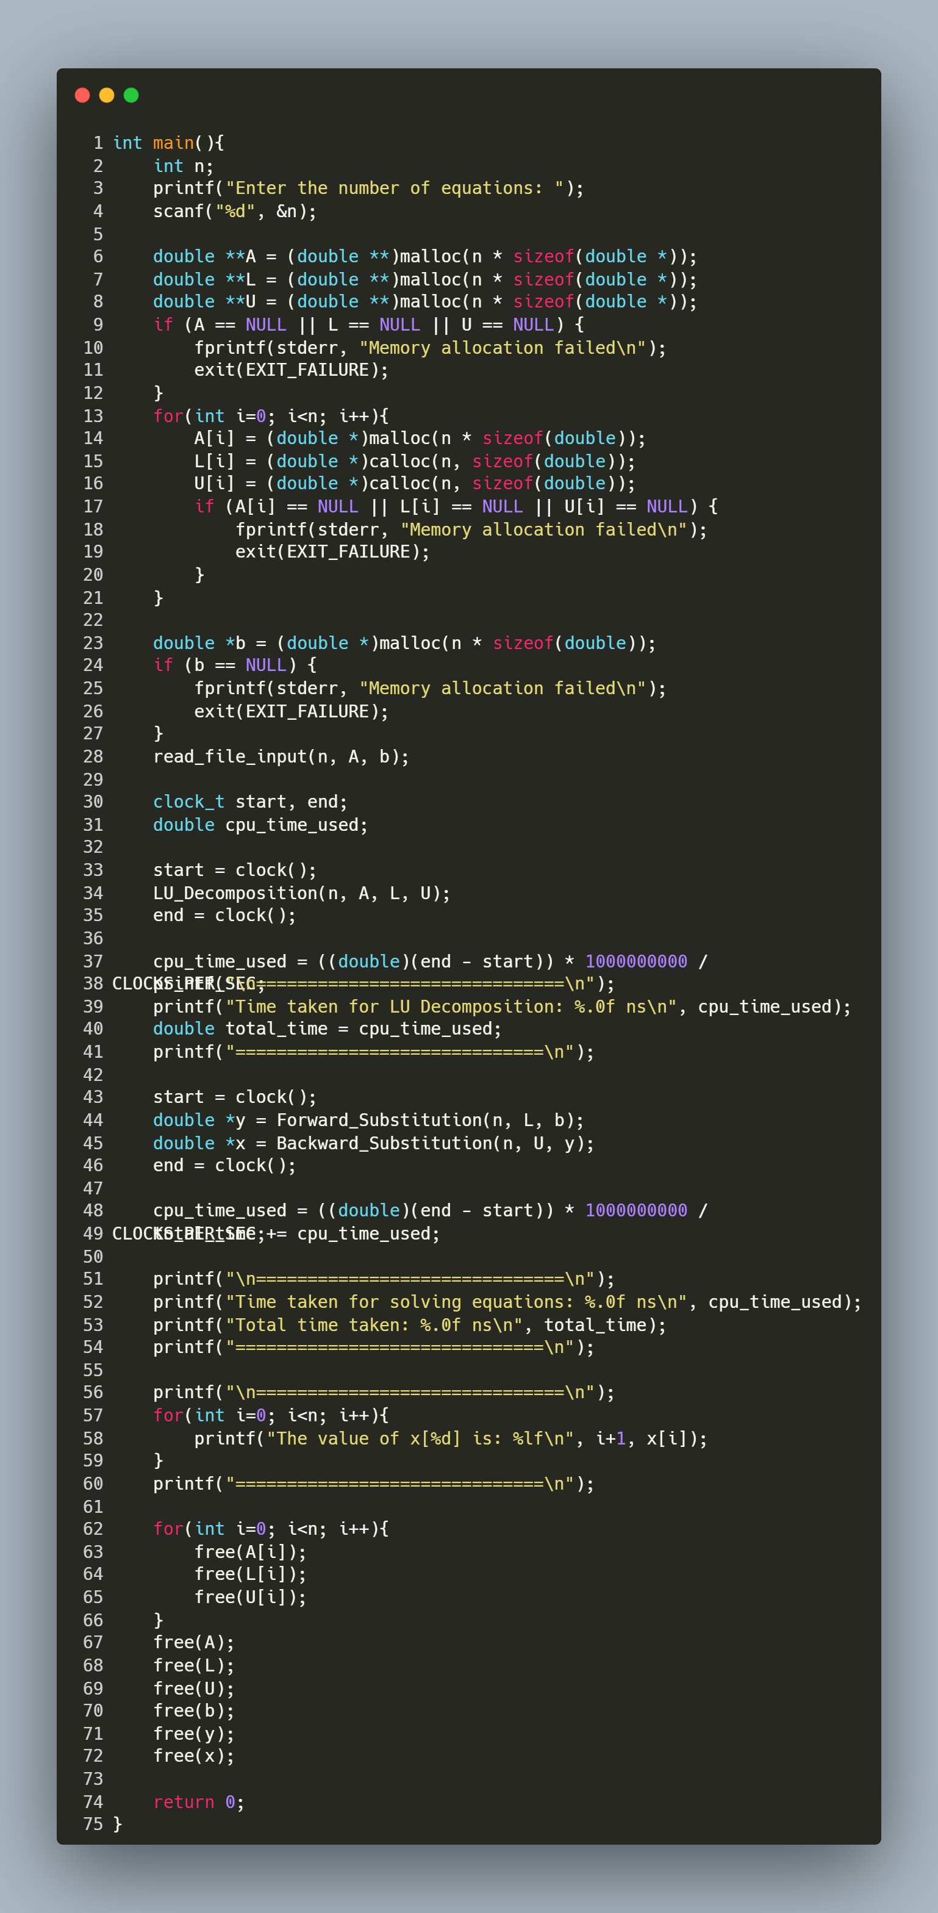
Step-by-Step Explanation
1. User Input & Memory Allocation
- Prompts the user for the number of equations (n).
- Allocates memory for:
  - A (n x n matrix).
  - L (unit lower triangular matrix, initialized with calloc).
  - U (upper triangular matrix, initialized with calloc).
  - b (vector of size n).
- Includes error handling for memory allocation failures.
2. Read Input File
- Calls read_file_input(n, A, b) to load A and b from "inputs.txt".
3. LU Decomposition & Timing
- LU_Decomposition(n, A, L, U) factors A into L and U.
- Measures and prints the time taken for decomposition in nanoseconds.
4. Solve Linear System
- Forward Substitution: Solves Ly = b to get intermediate vector y.
- Backward Substitution: Solves Ux = y to get the solution vector x.
- Measures and prints the time taken for solving the system.
5. Print Results
- Displays the solution vector x with 6 decimal places.
6. Memory Cleanup
- Frees all dynamically allocated memory for A, L, U, b, y, and x.
Key Notes
- Timing:
  - Uses clock() to measure CPU time.
  - Converts time to nanoseconds for readability.
  - WSL vs. Terminal: Timing accuracy may vary between environments.

Gauss Seidel

Reading Matrix and Vector Input from File

Purpose: This function reads a square matrix A of size n x n and a vector b of size n from a specified file. It ensures the file is properly formatted and handles errors during input parsing.
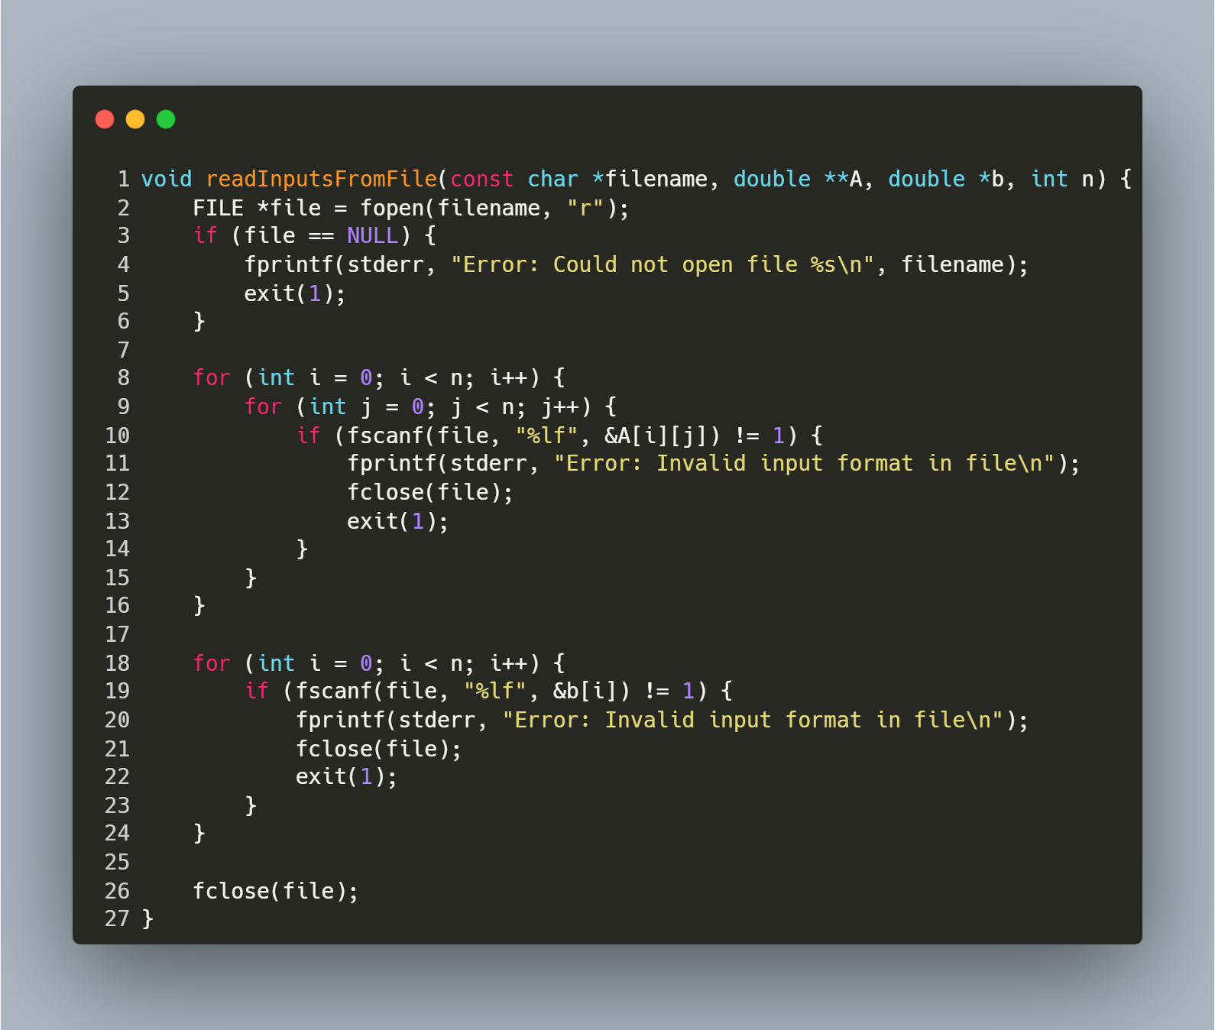
Step-by-Step Explanation
1. Open File
- FILE *file = fopen(filename, "r"); opens the file in read mode.
- If the file cannot be opened (e.g., it does not exist), the function prints an error message and exits with status 1.
2. Read Matrix A
- The nested loops iterate over each row (i) and column (j) of the matrix:
  - fscanf(file, "%lf", &A[i][j]) reads a floating-point number into A[i][j].
  - If the read operation fails (e.g., non-numeric data), the function prints an error, closes the file, and exits.
3. Read Vector b
- The loop iterates over each element of the vector:
  - fscanf(file, "%lf", &b[i]) reads a floating-point number into b[i].
  - If the read operation fails, the function prints an error, closes the file, and exits.
4. Close File
- fclose(file); closes the file after all data is read to release system resources.

function: Matrix-Vector Multiplication

Purpose: This function multiplies a square matrix A of size n x n with a vector b of size n and returns the resulting vector. It computes the dot product of each row of A with b.
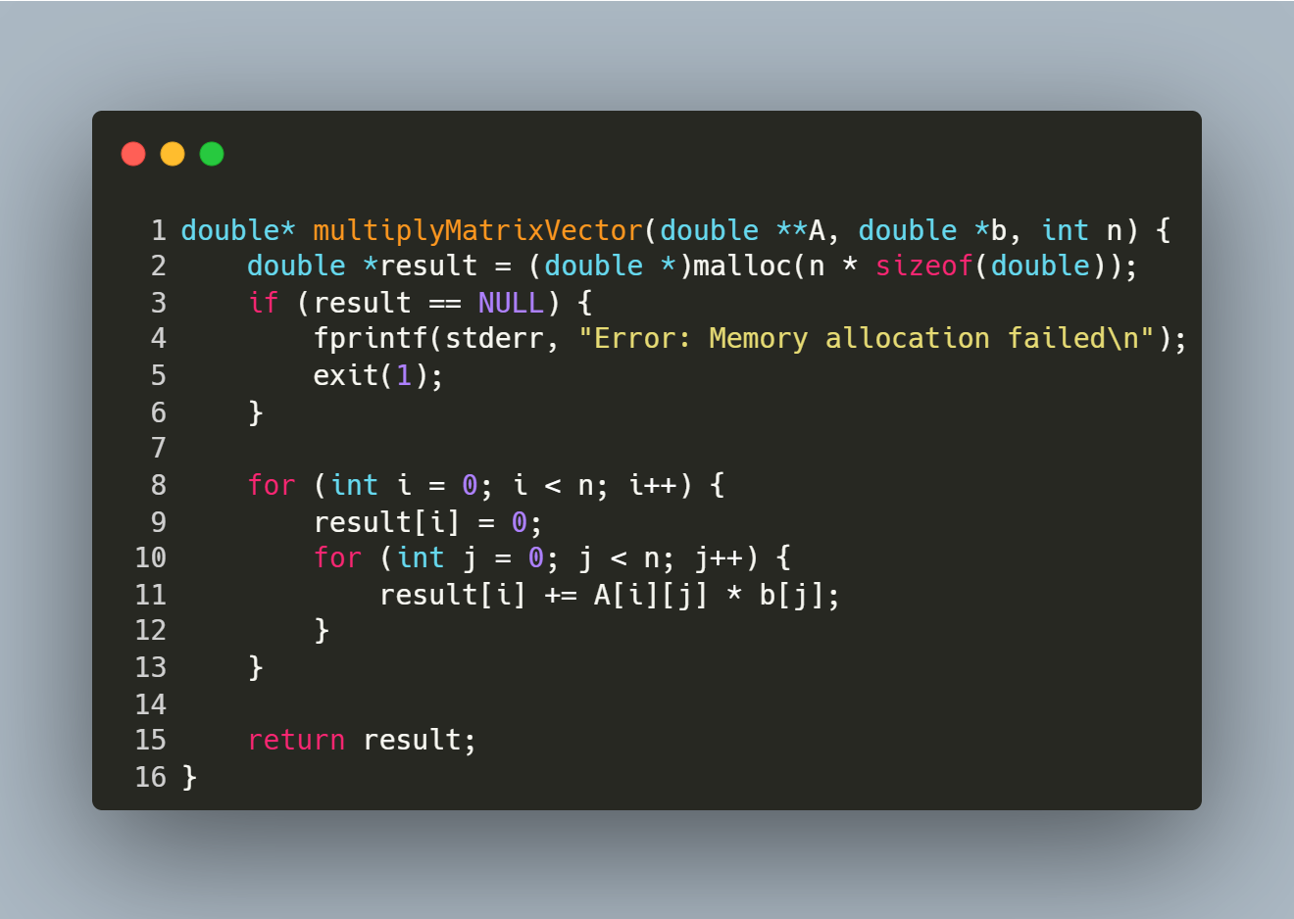
Step-by-Step Explanation
- Memory Allocation:
  - Allocates memory for the result vector result of size n.
  - Exits with an error if memory allocation fails.
- Row Iteration:
  - The outer loop iterates over each row i of the matrix A.
- Dot Product Calculation:
  - Initializes result[i] to 0.
  - The inner loop iterates over each column j of the matrix.
  - Computes the dot product of the i-th row of A and the vector b.
- Return Result:
  - Returns the computed vector result.

function: Vector Subtraction

Purpose: This function computes the element-wise subtraction of two vectors v1 and v2 of size n and returns the result as a new vector
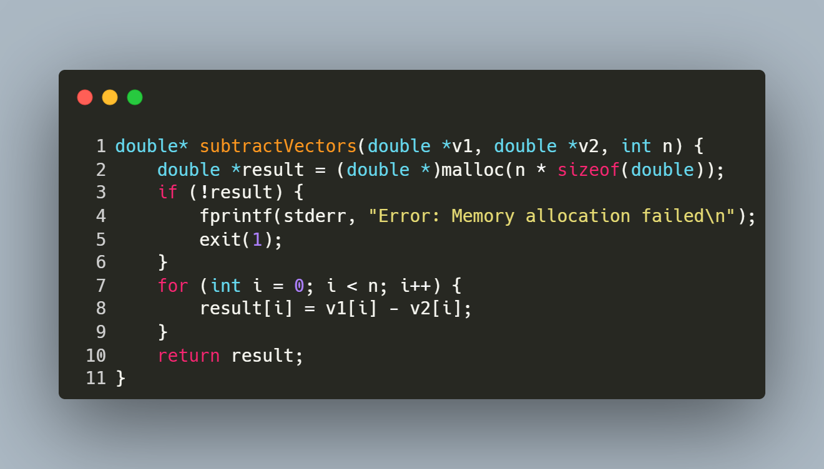
Step-by-Step Explanation
- Memory Allocation:
  - Allocates memory for the result vector result of size n.
  - Exits with an error if memory allocation fails.
- Element-wise Subtraction:
  - Iterates over each index i from 0 to n-1.
  - Computes result[i] = v1[i] - v2[i] for each element.
- Return Result:
  - Returns the vector result containing the difference of v1 and v2.

function: Calculate the square of the Euclidean Norm of a Vector

Purpose: This function computes the square of the Euclidean norm (or magnitude) of a vector.
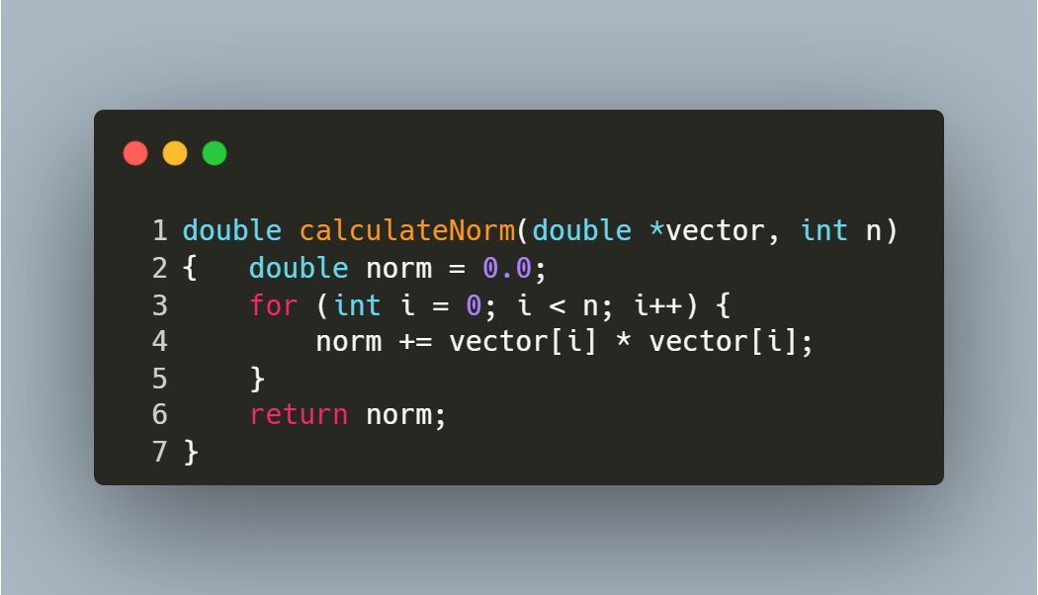
Step-by-Step Explanation
- Initialization:
  - norm is initialized to 0.0 to accumulate the sum of squared elements.
- Element-wise Squaring and Summation:
  - The loop iterates over each index i from 0 to n-1.
  - For each element vector[i], its square (vector[i] * vector[i]) is added to norm.
- Return Result:
The norm is returned:
Norm= $\sum_{i=0}^{n-1}{{V[i]}^{2}}$

Function: Gauss-Seidel

Purpose: This function solves the linear system Ax = b using the Successive Over-Relaxation (SOR) method, an iterative technique that accelerates convergence by introducing a relaxation factor (weight). It is a generalization of the Gauss-Seidel method and is effective for diagonally dominant or symmetric positive-definite matrices.
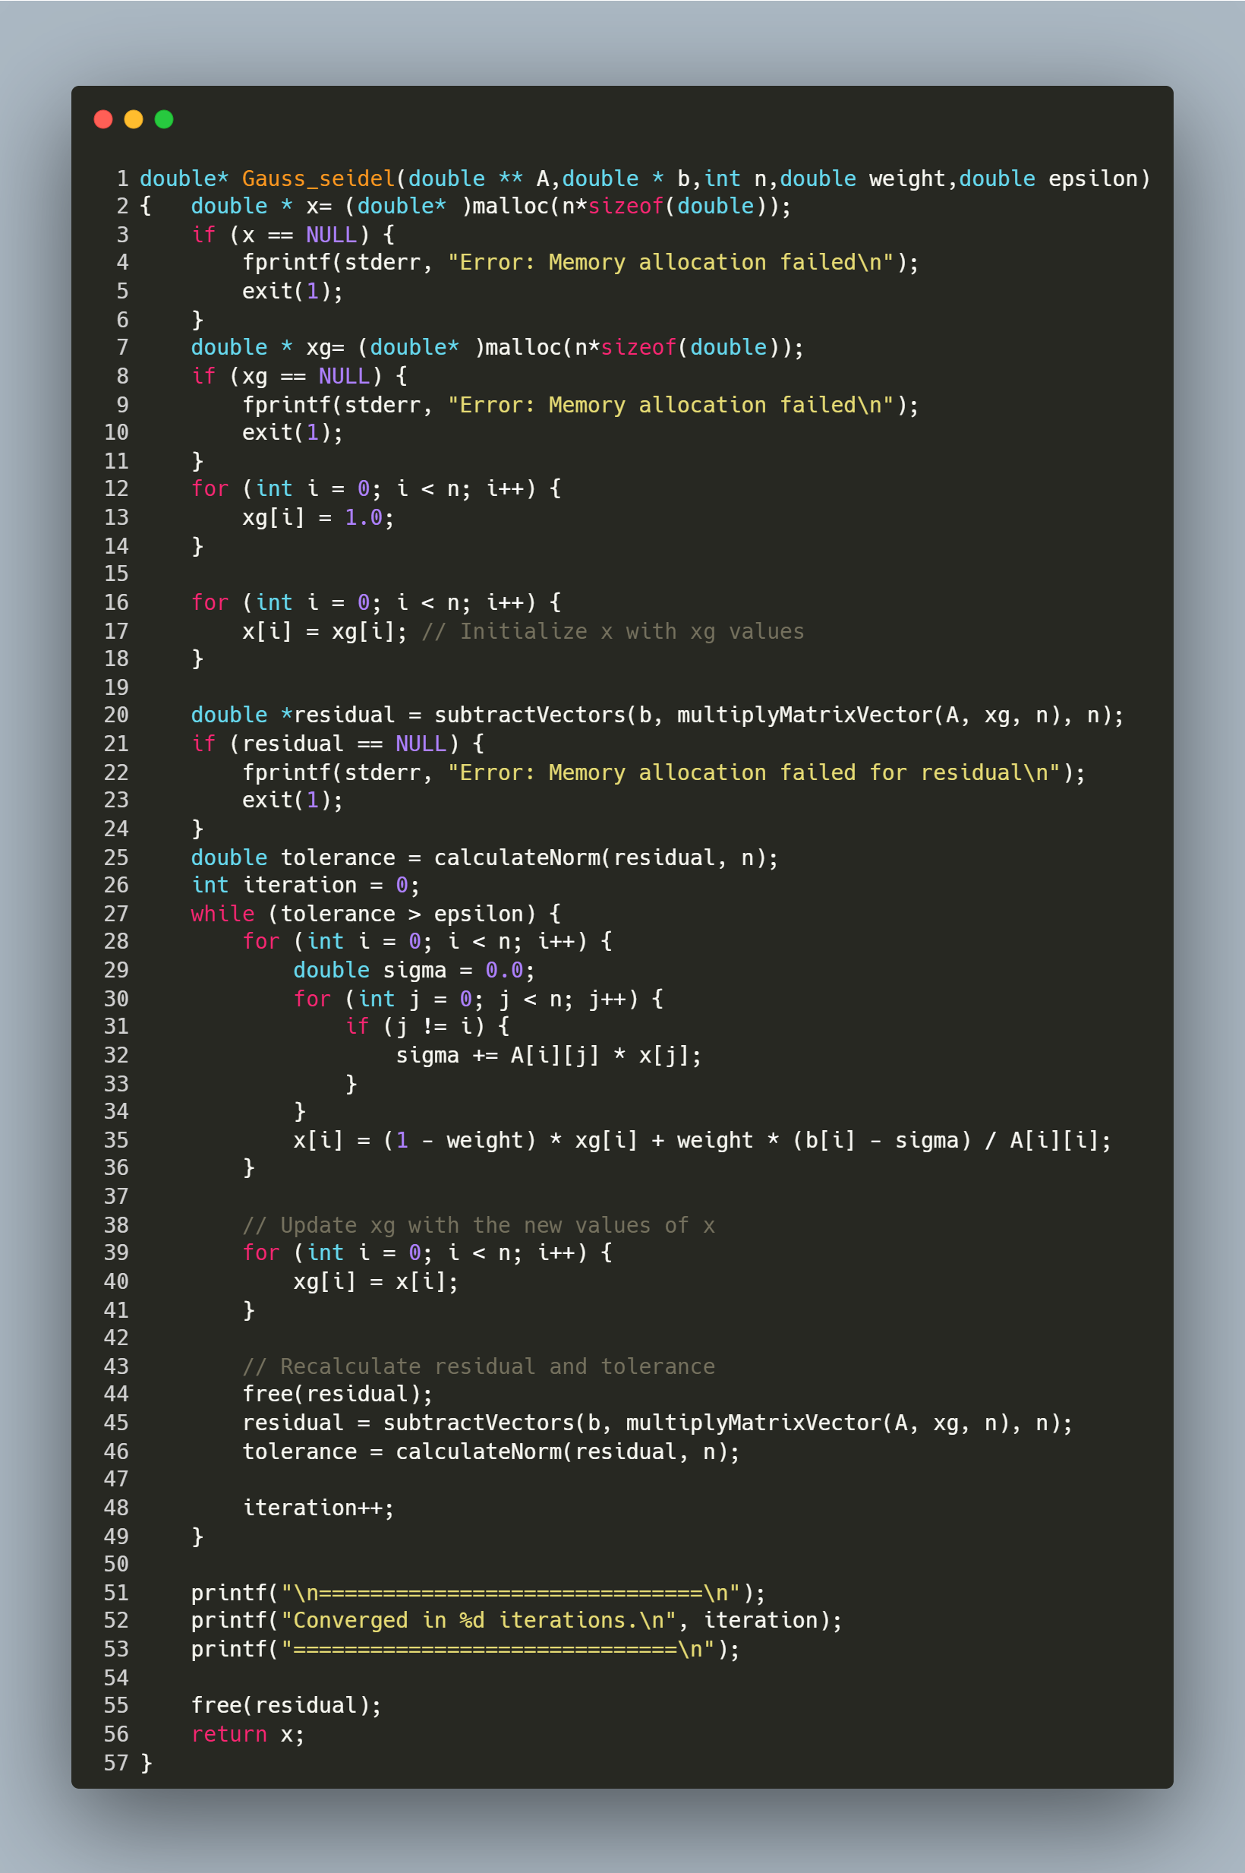

Function Parameters
- A: Coefficient matrix (n x n).
- b: Right-hand side vector (size n).
- n: Size of the system.
- weight: Relaxation factor (1.0 for standard Gauss-Seidel).
- epsilon: Convergence tolerance.
Returns: Solution vector x.
Step-by-Step Explanation
1. Initialization
- Memory Allocation:
  - x: Stores the updated solution in each iteration.
  - xg: Stores the solution from the previous iteration. Initialized to [1.0, 1.0, ..., 1.0].
- Residual Calculation:
c
residual = b - A * xg;
tolerance = ||residual|| (Euclidean norm);
2. Iterative Loop
The loop continues until tolerance ≤ epsilon:
while (tolerance > epsilon) {
// Update each element x[i]
for (int i = 0; i < n; i++) {
sigma = Σ_{j≠i} A[i][j] * x[j];
x[i] = (1 - weight) * xg[i] + weight * (b[i] - sigma) / A[i][i];
}

// Update xg with the new x
xg = x;

// Recompute residual and tolerance
residual = b - A * xg;
tolerance = ||residual||;
iteration++;
}
Key Steps in Each Iteration:
- Element-wise Update:
  - For each element x[i]:
    - Compute sigma, the sum of products of off-diagonal elements of row i and latest x[j] values.
    - Update x[i] using the relaxation formula:
    - $x\left[i\right]=\left(1-ω\right)*x_{old}\left[i\right]+ω*\frac{b\left[i\right]-σ}{A\left[i\right][i]}$
where ω (weight) controls convergence:
      - ω = 1: Standard Gauss-Seidel.
      - ω > 1: Over-relaxation (faster convergence).
      - ω < 1: Under-relaxation (stabilize convergence).
- Update Previous Solution:
  - Copy x into xg to prepare for the next iteration.
- Residual Recalculation:
  - Compute the new residual b - A * xg and its norm to check convergence.
3. Termination and Output
- Convergence: The loop exits when the residual norm tolerance falls below epsilon.
- Result: Prints the number of iterations and returns the solution vector x.

Main Program for Gauss-Seidel with SOR Method

Purpose: This program solves the linear system Ax = b using the Gauss-Seidel method with Successive Over-Relaxation (SOR). It reads the matrix A and vector b from a file, computes the solution x, and prints the results along with performance metrics.
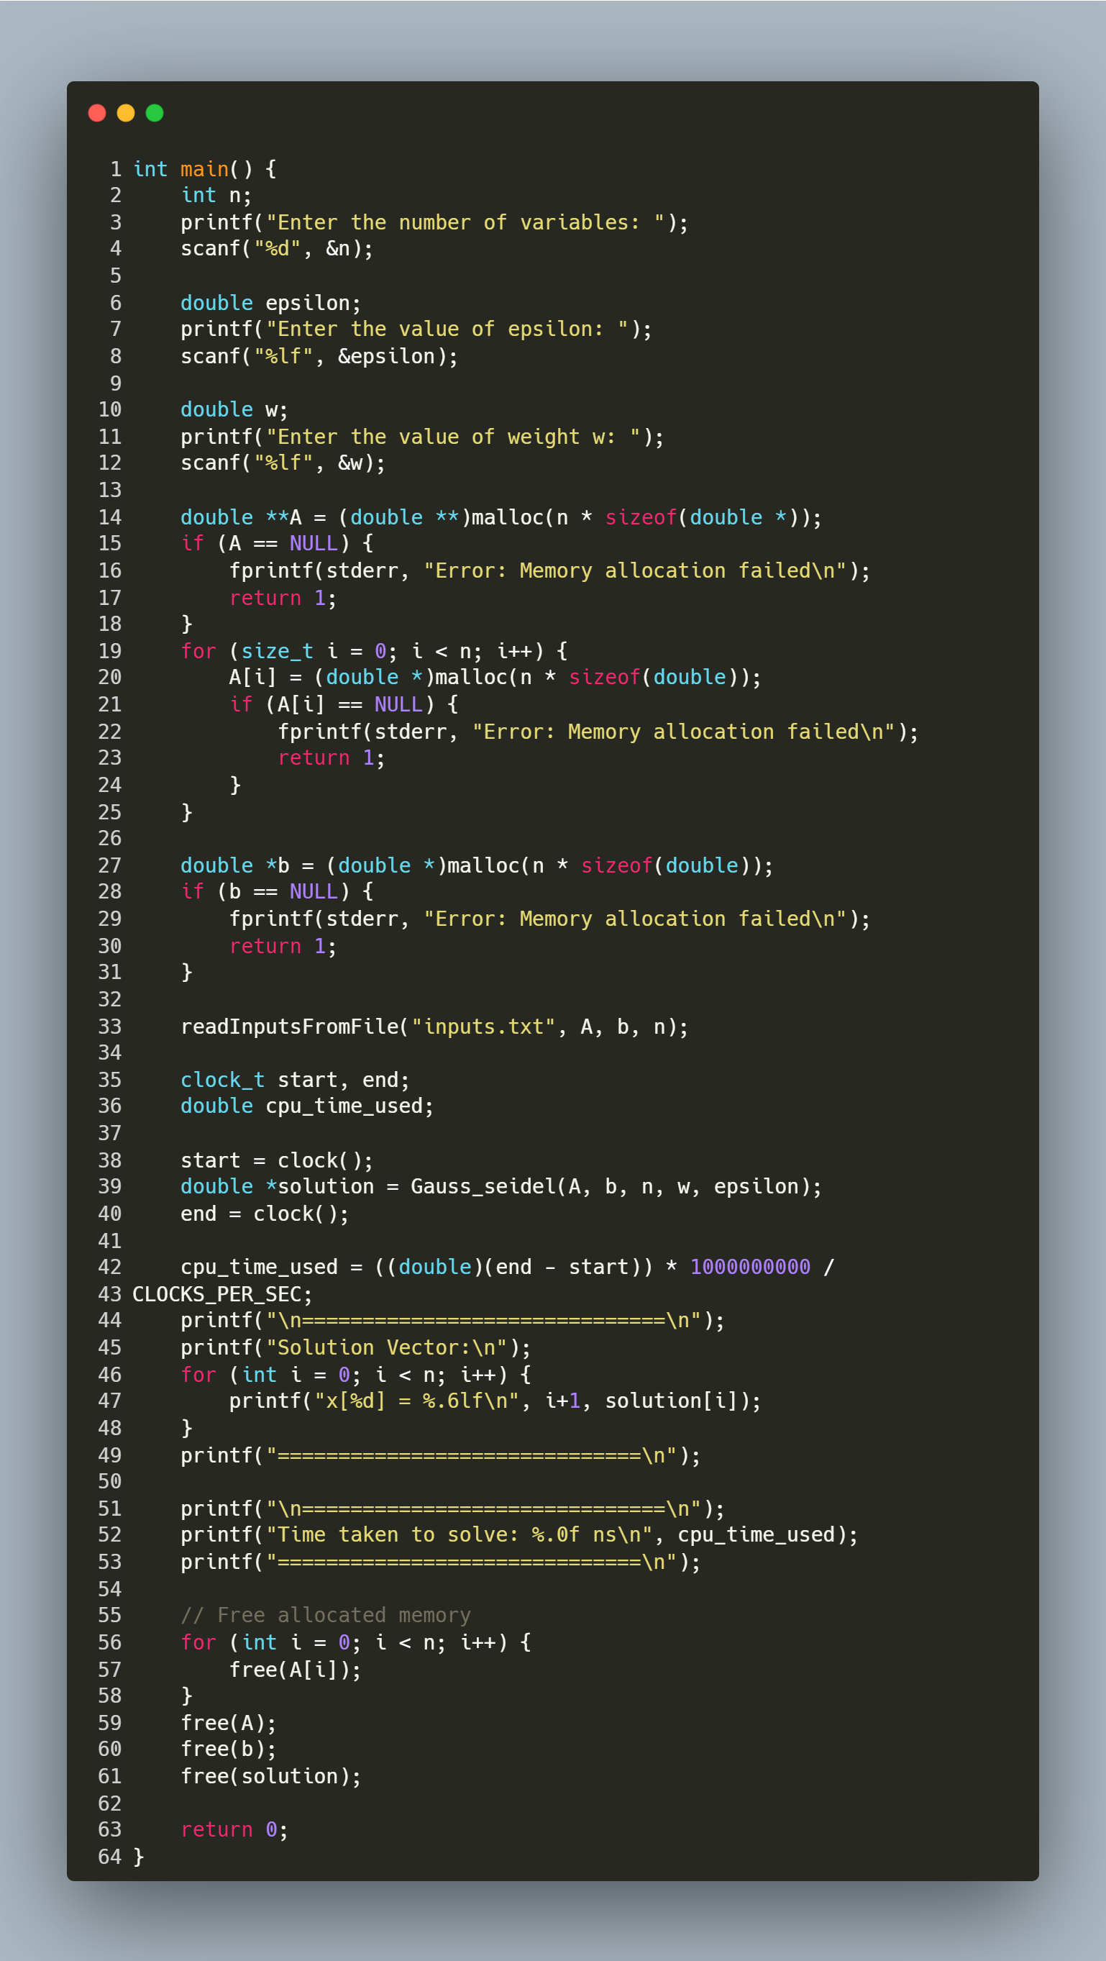
Step-by-Step Explanation
- User Input:
  - Prompts the user for:
    - n: Number of variables (size of the matrix/vector).
    - epsilon: Convergence tolerance (e.g., 1e-6).
    - w: Relaxation factor (1.0 for standard Gauss-Seidel, >1.0 for over-relaxation).
- Memory Allocation:
  - A: Allocates an n x n matrix (dynamic 2D array).
  - b: Allocates a vector of size n.
  - Includes error handling for memory allocation failures.
- Read Input File:
  - Calls readInputsFromFile("inputs.txt", A, b, n) to load A and b from the file.
  - File Format: The file must contain n x n matrix elements followed by n vector elements.
- Solve with Gauss-Seidel SOR:
  - Gauss_seidel(A, b, n, w, epsilon) computes the solution vector x.
    - Input: Matrix A, vector b, size n, relaxation factor w, tolerance epsilon.
    - Output: Solution x and number of iterations to converge (printed internally).
- Performance Timing:
  - Uses clock() to measure CPU time taken by the solver.
  - Converts time to nanoseconds for readability.
- Print Results:
  - Displays the solution vector x with 6 decimal places.
  - Prints the execution time in nanoseconds.
- Memory Cleanup:
  - Frees dynamically allocated memory for A, b, and x to prevent leaks.
- Keynote
  - Timing Function Behavior in Different Environments
    - The program uses the clock() function to measure execution time in CPU cycles and converts it into nanoseconds using CLOCKS_PER_SEC.
- In environments like Windows Subsystem for Linux (WSL) running in VS Code, this function works reliably and provides accurate timing results.
- However, in a terminal-based VS Code setup or native Windows environments, the precision and behavior of clock() may vary due to differences in how CPU time is calculated across platforms.

Conjugate Gradient method

Reading Matrix and Vector Input from File

Purpose: This function reads a square matrix A of size n x n and a vector b of size n from a specified file. It ensures the file is properly formatted and handles errors during input parsing.

Step-by-Step Explanation
1. Open File
- FILE *file = fopen(filename, "r"); opens the file in read mode.
- If the file cannot be opened (e.g., it does not exist), the function prints an error message and exits with status 1.
2. Read Matrix A
- The nested loops iterate over each row (i) and column (j) of the matrix:
  - fscanf(file, "%lf", &A[i][j]) reads a floating-point number into A[i][j].
  - If the read operation fails (e.g., non-numeric data), the function prints an error, closes the file, and exits.
3. Read Vector b
- The loop iterates over each element of the vector:
  - fscanf(file, "%lf", &b[i]) reads a floating-point number into b[i].
  - If the read operation fails, the function prints an error, closes the file, and exits.
4. Close File
- fclose(file); closes the file after all data is read to release system resources.

function: Matrix-Vector Multiplication

Purpose: This function multiplies a square matrix A of size n x n with a vector b of size n and returns the resulting vector. It computes the dot product of each row of A with b.

Step-by-Step Explanation
- Memory Allocation:
  - Allocates memory for the result vector result of size n.
  - Exits with an error if memory allocation fails.
- Row Iteration:
  - The outer loop iterates over each row i of the matrix A.
- Dot Product Calculation:
  - Initializes result[i] to 0.
  - The inner loop iterates over each column j of the matrix.
  - Computes the dot product of the i-th row of A and the vector b.
- Return Result:
  - Returns the computed vector result.

function: Vector Subtraction

Purpose: This function computes the element-wise subtraction of two vectors v1 and v2 of size n and returns the result as a new vector

Step-by-Step Explanation
- Memory Allocation:
  - Allocates memory for the result vector result of size n.
  - Exits with an error if memory allocation fails.
- Element-wise Subtraction:
  - Iterates over each index i from 0 to n-1.
  - Computes result[i] = v1[i] - v2[i] for each element.
- Return Result:
  - Returns the vector result containing the difference of v1 and v2.

function: Dot Product of Two Vectors

Purpose: This function computes the dot product of two vectors v1 and v2 of size n
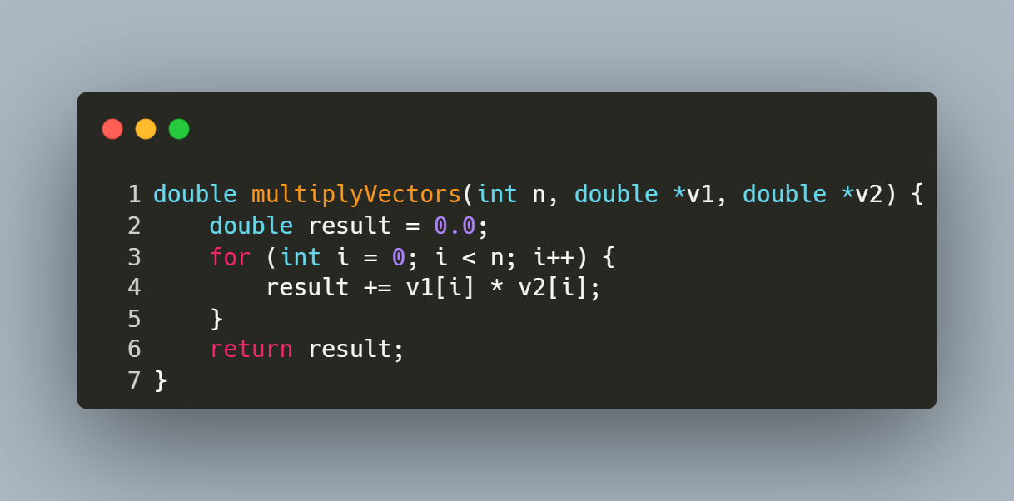
Step-by-Step Explanation
- Initialization:
  - result is initialized to 0.0 to accumulate the sum of products.
- Element-wise Multiplication and Summation:
  - Iterates over each index i from 0 to n-1.
  - Computes the product of corresponding elements v1[i] * v2[i] and adds it to result.
- Return Result:
  - Returns the scalar value result, which is the dot product of the two vectors.

FUNCTION: Conjugate Gradient Method

Purpose: This function solves the linear system Ax = b using the Conjugate Gradient (CG) method, an iterative algorithm optimized for symmetric positive-definite (SPD) matrices. It minimizes the residual error iteratively until convergence.
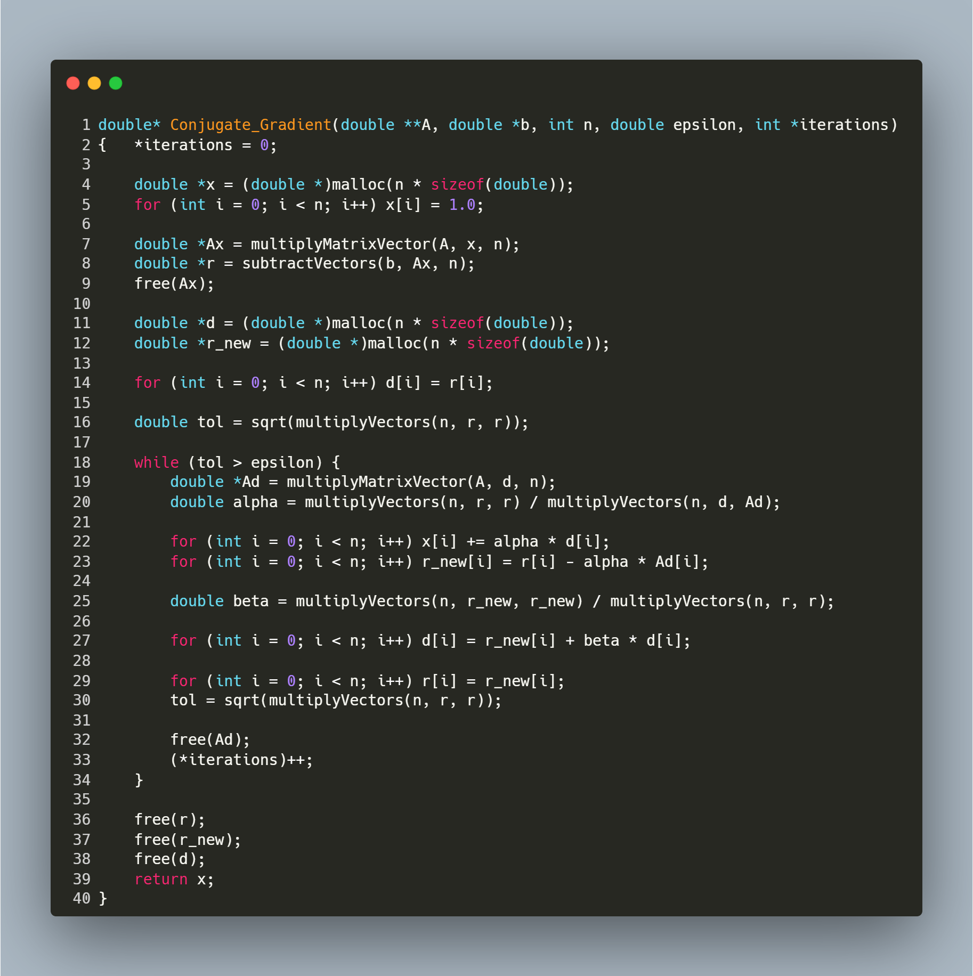
Function Parameters
- A: Symmetric positive-definite matrix (n x n).
- b: Right-hand side vector (size n).
- n: Size of the matrix/vector.
- epsilon: Tolerance threshold for stopping criteria.
- iterations: Output parameter tracking the number of iterations performed.
Returns: Solution vector x.
Step-by-Step Explanation
1. Initialization
- Initial Guess:
double *x = malloc(...);
for (...) x[i] = 1.0; // Initial guess x₀ = [1, 1, ..., 1]
The algorithm starts with an initial guess of x as a vector of ones.
- Residual Calculation:
double *Ax = multiplyMatrixVector(A, x, n);
double *r = subtractVectors(b, Ax, n); // r₀ = b - A x₀
Compute the residual r (error between b and A x).
- Direction Vector:
double *d = malloc(...);
for (...) d[i] = r[i]; // d₀ = r₀
Initialize the search direction d to the residual r.
- Tolerance Check:
double tol = sqrt(multiplyVectors(n, r, r)); // ||r₀||
Calculate the L2 norm of the residual to check convergence.
2. Iterative Loop
The loop continues until the residual norm tol falls below epsilon:
while (tol > epsilon) {
// Step 2.1: Compute α (step size)
double *Ad = multiplyMatrixVector(A, d, n);
double alpha = (rᵀr) / (dᵀ A d);
// Step 2.2: Update x and residual
x += α * d;
r_new = r - α * A d;
// Step 2.3: Compute β (direction adjustment)
double beta = (r_newᵀ r_new) / (rᵀ r);
// Step 2.4: Update direction vector
d = r_new + β * d;
// Step 2.5: Update residual and tolerance
r = r_new;
tol = ||r_new||;
(*iterations)++;
}
Key Steps in Each Iteration:
- Compute Step Size (α):
  - α determines how far to move along the direction d.
  - Formula:
α =$\frac{r^{T}*r}{d^{T}*A*d}$
- Update Solution (x) and Residual (r_new):
  - Adjust x using the step size α and direction d.
  - Update the residual to reflect the new solution: $r_{new}=r-αAd$
- Compute Direction Adjustment (β):
  - β adjusts the search direction to ensure conjugacy with previous directions.
  - Formula:
β=$\frac{r_{new}^{T}*r_{new}}{r^{T}*r}$
- Update Direction Vector (d):
  - Combine the new residual and previous direction:
d=$r_{new}+βd$
3. Termination and Cleanup
- Convergence Check: The loop exits when tol ≤ epsilon.
- Memory Management:
c
free(r); free(r_new); free(d); // Free temporary vectors
- Return Result: The solution vector x is returned.

Main Program for Conjugate Gradient Method
Purpose: This program solves a linear system Ax = b using the Conjugate Gradient (CG) method. It reads the matrix A and vector b from a file, computes the solution x, and prints the results along with performance metrics.
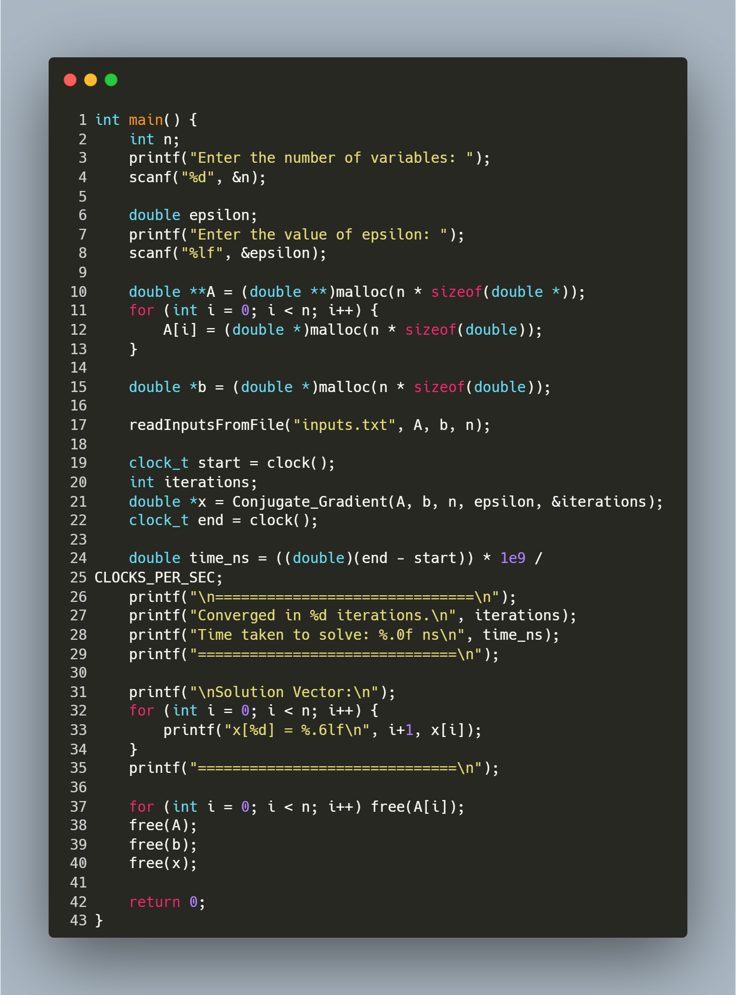
Step-by-Step Explanation
- User Input:
  - Prompts the user for:
    - n: Number of variables (size of the matrix/vector).
    - epsilon: Convergence tolerance (e.g., 1e-6). Smaller values increase precision but may require more iterations.
- Memory Allocation:
  - Allocates memory for:
    - A: n x n matrix (dynamic 2D array).
    - b: Vector of size n.
- Read Input File:
  - Calls readInputsFromFile("inputs.txt", A, b, n) to load A and b from the file.
  - File Format: The file must contain n x n matrix elements followed by n vector elements.
- Solve with Conjugate Gradient:
  - Conjugate_Gradient(A, b, n, epsilon, &iterations) computes the solution vector x.
    - Input: Matrix A, vector b, size n, tolerance epsilon.
    - Output: Solution x and number of iterations to converge.
  - Note: A must be symmetric positive-definite (SPD) for the CG method to work correctly.
- Performance Timing:
  - Uses clock() to measure CPU time taken by the CG method.
  - Converts time to nanoseconds for readability.
- Print Results:
  - Displays the number of iterations and execution time.
  - Prints the solution vector x with 6 decimal places.
- Memory Cleanup:
  - Frees dynamically allocated memory for A, b, and x to prevent leaks.

Thank you

