ASSIGNMENT 2 – TDMA
BY CO24BTECH11023

Question –
Find the temperature along the length of a rod that is 1 m long. Its hot end is at T=100° C and its cold end is at 20° C. Use the following:
$$\frac{d^{2}T}{{dx}^{2}}=\frac{T_{i+1}-{2T}_{i}+T_{i-1}}{{∆x}^{2}}=0 \\ =T_{i+1}-{2T}_{i}+T_{i-1} = 0$$

CODE
Tri Diagonal Matrix Algorithm snippet
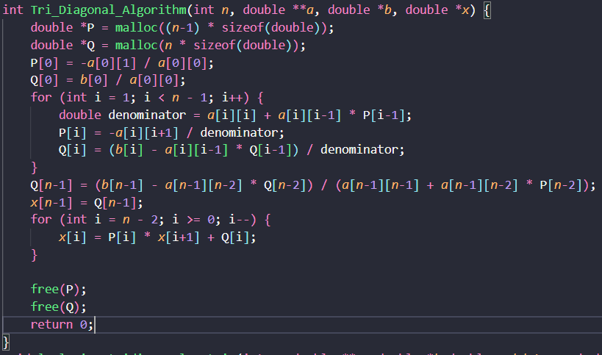
Function Overview
int Tri_Diagonal_Algorithm(int n, double **a, double *b, double *x)
- n: The size of the system (number of equations).
- a: The tridiagonal coefficient matrix (stored as a 2D array).
- b: The right-hand side vector of the system.
- x: The solution vector to be computed. n.
Memory Allocation
double *P = malloc((n - 1) * sizeof(double));
double *Q = malloc(n * sizeof(double));
- P: Stores Values of P after A is converted to Bi-diagonal matrix and divided by diagonal matrix.
- Q:Stores updated values of b after all operations.
The memory is dynamically allocated to handle systems of varying sizes.
Initialization of P and Q
P[0] = -a[0][1] / a[0][0];
Q[0] = b[0] / a[0][0];
- The first elements of P and Q are initialized based on the first row of the tridiagonal matrix a and vector b.
Calculation of P[I] and Q[i]
for (int i = 1; i < n - 1; i++) {
double denominator = a[i][i] + a[i][i - 1] * P[i - 1];
P[i] = -a[i][i + 1] / denominator;
Q[i] = (b[i] - a[i][i - 1] * Q[i - 1]) / denominator;
}
Explanation:
For each row i:
  - Compute a denominator, which is a combination of the current diagonal element and contributions from previous rows.
  - Update P[i] using the algorithm given in notes.
  - Update Q[i] using the algorithm given in notes.
Special Case for Last Row
Q[n - 1] = (b[n - 1] - a[n - 1][n - 2] * Q[n - 2]) /
(a[n - 1][n - 2] * P[n - 2] + a[n - 1][n - 1]);
x[n - 1] = Q[n - 1];
Explanation:
- The last row is handled separately because P[n-1] is not required for further calculations.
- Compute Q[n-1].
- Directly assign x[n-1], as it depends only on Q[n-1].
Backward Substitution
for (int i = n - 2; i >= 0; i--) {
x[i] = P[i] * x[i + 1] + Q[i];
}
Explanation:
- After forward elimination, we perform backward substitution to compute the solution vector x.
- Starting from the second-to-last element (x[n-2]) and moving upwards:
  - Each x[i] is computed using previously calculated values of x and intermediate coefficients stored in P and Q.
Memory Deallocation and Return statement
free(P);
free(Q);
return 0;
The dynamically allocated memory for P and Q is freed to prevent memory leaks and return statement indicates successful execution of the function.

Formation of TDM Matrix
Consider the following Rod AB as shown in the figure below.
A
B

1 m
Now for the given rod we shall divide it into sections of length 0.05 m each.
So, after division we get 20 divisions or 21 points each at a distance of 0.05 m from each other as shown below:
A | $$X_{1}$$ | $$X_{2}$$ | $$X_{3}$$ | $$X_{4}$$ | $$X_{5}$$ | $$X_{6}$$ | $$X_{7}$$ | $$X_{8}$$ | $$X_{9}$$ | $$X_{10}$$ | $$X_{11}$$ | $$X_{12}$$ | $$X_{13}$$ | $$X_{14}$$ | $$X_{15}$$ | $$X_{16}$$ | $$X_{71}$$ | $$X_{18}$$ | $$X_{19}$$ | B
$$T_{Hot}{ T}_{cold}$$
Now the temperature for points A,$X_{1},X_{2},…$,B will be $T_{1},T_{2},T_{3}{,T}_{4}…,T_{21}$ respectively.
According to the question $T_{1}= T_{Hot} and T_{21}= T_{cold}$ .
Therefore $T_{2},T_{3}{,T}_{4}…,T_{20}$ are the unknown values.
Thus, the size of the matrix is 19. In general, for any length of the rod and division the size of the matrix is given by $n = \frac{L}{dx}-1$.
Where L= length of rod
dx = length of division

Now from the equation $T_{i+1}-{2T}_{i}+T_{i-1} = 0$
We can form matrix A and get the vector b values:
We rearrange the equation to get ${{-T}_{i+1}+2T}_{i}-T_{i-1} = 0$.
Now for i=2 we get
${{-T}_{3}+2T}_{2}-T_{1} = 0$
But we know that $T_{1}=T_{Hot}$.
Therefore, we get ${{-T}_{3}+2T}_{2} = T_{Hot}$
So, we get coefficients for first row of matrix A as $\left[\begin{matrix}2 & -1 & 0 \end{matrix}⋯ | 0\right]$
And b [1] as $T_{Hot}$.
Again, for i=3 we get
${{-T}_{4}+2T}_{3}-T_{2} = 0$
Since all values are unknown, we get:
- Coefficients for row 2 as $\left[\begin{matrix}-1 & 2 & -1 & 0\end{matrix}⋯ | 0\right]$.
- b [2] = 0
Similarly for i = 4,5….19 we get b[i]=0 and coefficient as tri diagonal matrix with values -1,2, -1.
For i=20 we get
$${{-T}_{21}+2T}_{20}-T_{19} = 0$$
But we know that $T_{21}=T_{cold}$.
Therefore, we get ${{-T}_{19}+2T}_{20} = T_{cold}$
So, we get coefficients for first row of matrix A as $[\begin{matrix}0 & ⋯ & 0 & -1 & 2\end{matrix}]$
And b [19] as $T_{Cold}$.

Therefore, our b vector looks like as shown below
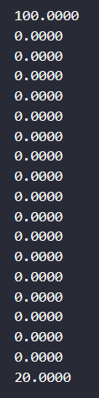
And our matrix A will be:
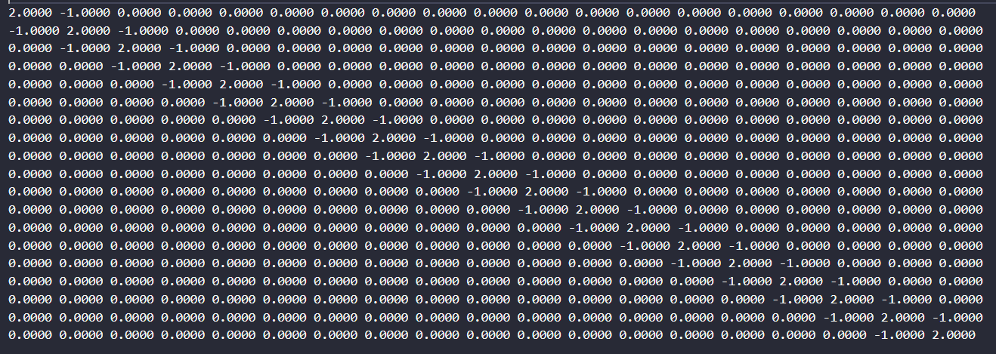
Now here is the snippet on how to make the matrix A and vector b:
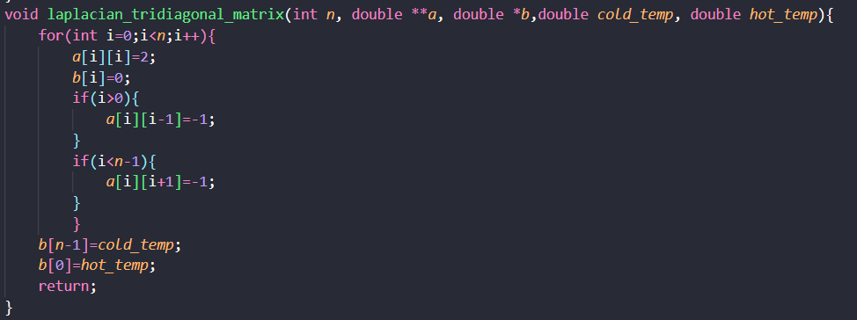
Function Overview
void laplacian_tridiagonal_matrix(int n, double **a, double *b, double cold_temp, double hot_temp)
- n: The size of the system
- a: The tridiagonal coefficient matrix (2D array)
- b: The right-hand side vector
- cold_temp: Temperature at the cold end (boundary condition)
- hot_temp: Temperature at the hot end (boundary condition)
Matrix Construction
for(int i=0; i<n; i++){
a[i][i] = 2;
b[i] = 0;
if(i > 0){
a[i][i-1] = -1;
}
if(i < n-1){
a[i][i+1] = -1;
}
}
This loop constructs the tridiagonal matrix A and initializes the right-hand side vector b:
- Main diagonal elements are set to 2: a[i][i] = 2
- Off-diagonal elements are set to -1: a[i][i-1] = -1 and a[i][i+1] = -1
- The right-hand side vector is initially set to 0: b[i] = 0
The resulting matrix A has the form as explained before :
2 -1 0 0 ...
-1 2 -1 0 ...
0 -1 2 -1 ...
...
Boundary Conditions
b[n-1] = cold_temp;
b[0] = hot_temp;
These lines set the boundary conditions as proved earlier:
- b is set to the hot temperature (left boundary)
- b[n-1] is set to the cold temperature (right boundary)

Printing A and b in a file snippet
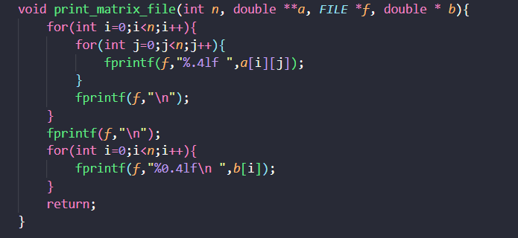
Function Overview
void print_matrix_file(int n, double **a, FILE *f, double *b)
- n: The size of the square matrix and vector
- a: The 2D array representing the matrix
- f: A file pointer where the output will be written
- b: The 1D array representing the vector
Purpose
This function writes the contents of a square matrix a and a vector b to a specified file in a formatted manner.
Matrix Output
for(int i=0; i<n; i++){
for(int j=0; j<n; j++){
fprintf(f, "%.4lf ", a[i][j]);
}
fprintf(f, "\n");
}
fprintf(f, "\n");
This nested loop writes the matrix a to the file:
- Each element is printed with 4 decimal places: %.4lf
- Elements in a row are space-separated
- Each row ends with a newline
- An extra newline is added after the matrix
Vector Output
for(int i=0; i<n; i++){
fprintf(f, "%0.4lf\n", b[i]);
}
This loop writes the vector b to the file:
- Each element is printed on a new line
- Elements are formatted with 4 decimal places

Main Function
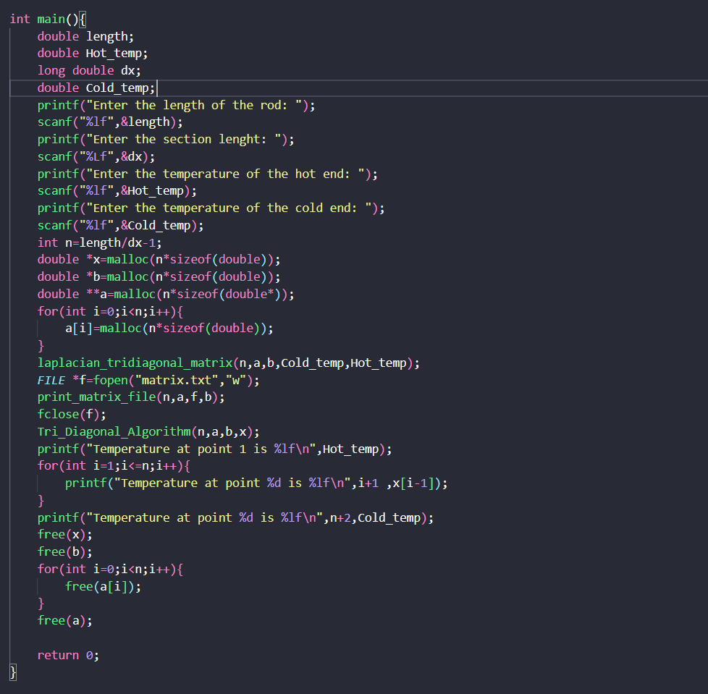
Function Overview
The function performs the following steps:
- Takes user input for the length of the rod, section length, and boundary temperatures.
- Sets up the tridiagonal matrix system for the Laplace equation.
- Solves the system using the Tri-Diagonal Algorithm.
- Outputs results to both a file and the console.
- Frees allocated memory.
User Input
printf("Enter the length of the rod: ");
scanf("%lf", &length);

printf("Enter the section length: ");
scanf("%Lf", &dx);

printf("Enter the temperature of the hot end: ");
scanf("%lf", &Hot_temp);

printf("Enter the temperature of the cold end: ");
scanf("%lf", &Cold_temp);
The user specifies:
  - length: Total length of the rod.
  - dx: Section length (discretization step size).
  - Hot_temp: Temperature at the hot end (left boundary).
  - Cold_temp: Temperature at the cold end (right boundary).
Calculating Number of Interior Points
int n = length / dx - 1;
- The number of interior points (n) is calculated as (length / dx) - 1, excluding boundary points. Derivation is done above.
Memory Allocation
double *x = malloc(n * sizeof(double));
double *b = malloc(n * sizeof(double));
double **a = malloc(n * sizeof(double *));
for (int i = 0; i < n; i++) {
a[i] = malloc(n * sizeof(double));
}
Allocates memory for:
  - x: Solution vector for interior temperatures.
  - b: Right-hand side vector for the system.
  - a: Tridiagonal coefficient matrix.
Setting Up Matrix and Vector
laplacian_tridiagonal_matrix(n, a, b, Cold_temp, Hot_temp);
- Calls laplacian_tridiagonal_matrix to set up:
  - Tridiagonal matrix ‘a’ for finite difference discretization of Laplace's equation.
  - Right-hand side vector b, incorporating boundary conditions.
Writing Matrix to File
FILE *f = fopen("matrix.txt", "w");
print_matrix_file(n, a, f, b);
fclose(f);
- Opens a file named matrix.txt in write mode.
- Writes matrix ‘a’ and vector b to this file using print_matrix_file.
- Closes the file after writing.
Solving System Using Tri-Diagonal Algorithm
Tri_Diagonal_Algorithm(n, a, b, x);
- Solves the linear system Ax = b using the Tri-Diagonal Algorithm.
- The solution vector x contains temperatures at interior points.
Printing Results
Hot End Temperature
printf("Temperature at point 1 is %lf\n", Hot_temp);
- Prints the hot-end temperature (boundary condition).
Interior Temperatures
for (int i = 1; i <= n; i++) {
printf("Temperature at point %d is %lf\n", i + 1, x[i - 1]);
}
- Prints temperatures at interior points (x[i-1]) with corresponding indices.
Cold End Temperature
printf("Temperature at point %d is %lf\n", n + 2, Cold_temp);
- Prints the cold-end temperature (boundary condition).
Memory Deallocation
free(x);
free(b);
for (int i = 0; i < n; i++) {
free(a[i]);
}
free(a);
Frees all dynamically allocated memory to prevent memory leaks:
  - Frees vectors x and b.
  - Frees each row of matrix a.
  - Frees the array of pointers for matrix a.

SOLUTION
