Question 2 report
by tanish verma
roll NO: co24btech11023

Table of Contents
Question 2 4
Matrix and Vector 4
Subquestions 4
Condition Number of a matrix 5
Defination 5
Well-Conditioned vs. Ill-Conditioned Matrices 5
Algorithm 5
Result 5
Estimation of Q matrix using Grahm Schmidt 6
Algorithm 6
For Q matrix 6
For Solutions 6
Result 6
Householder Transformation and Solutions 7
Algorithm 7
For Q and R matrix 7
For Solutions 9
Results 9
Code Reports 10
Condition Number 10
Function: Reading a Matrix from a File in C 10
Function: Calculating the Matrix Norm 11
Recursive Determinant Calculation 13
Adjoint Matrix Calculation 16
Matrix Inversion Using the Classical Adjoint Method 18
Function: MAIN PROGRAM FOR MATRIX CONDITION NUMBER CALCULATION 21
Gram schmidt orthogonalisation 23
Function: GRAM-SCHMIDT ORTHOGONALIZATION 23
Function: Backward Substitution for Solving Upper Triangular Systems 25
Function: Matrix Transposition 26
Function: Matrix Multiplication for Square Matrices 27
Function: Matrix-Vector Multiplication 28
Function: QR Factorization for Solving Linear Systems 29
Function: Reading Matrix and Vector Input from a File 30
Function: Main Program for Solving Linear Systems via QR Factorization 32
HouseHolder Transformation 35
Function: Euclidean Norm Calculation for Vectors 35
Function: Matrix Multiplication for Square Matrices 35
Function: Matrix Transposition 36
Function: QR Factorization Using Householder Reflections 37
Function: Solving Linear Systems Using QR Decomposition 42
Function: Reading Matrix and Vector Input from a File 43
Main Program for Solving Linear Systems via QR Factorization 44

Question 2

Matrix and Vector
Given Matrix A = $\left[\begin{matrix}1 & 2 & 4 & 1 \\ 2 & -5 & 3 & -5 \\ 1 & -4 & 4 & 7 \\ 2 & -3 & 2 & -5\end{matrix}\right]$ and vector b = $\left[\begin{matrix}2 \\ 4 \\ 4 \\ 9\end{matrix}\right]$

Subquestions

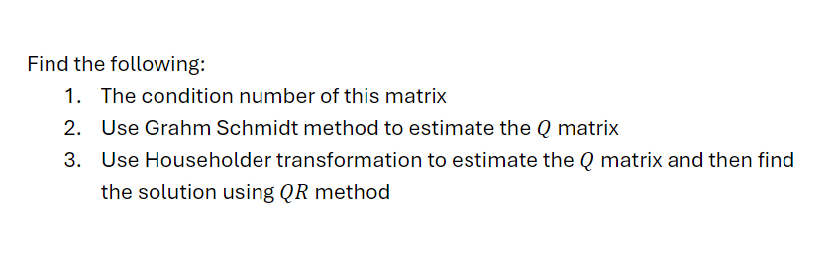

Condition Number of a matrix

Defination
The condition number of a matrix is a fundamental concept in numerical linear algebra that quantifies how sensitive a matrix-based computation is to small changes or errors in the input data.

Well-Conditioned vs. Ill-Conditioned Matrices
- Well-conditioned matrix: Has a low condition number, meaning small changes in input produce correspondingly small changes in output.
- Ill-conditioned matrix: Has a high condition number, indicating that small perturbations in input data can result in significantly large changes in the solution

Algorithm
- Choose a matrix norm
- Calculate the matrix inverse A⁻¹ using ${ A}^{-1}=\frac{1}{|A|}*Adj(A)$
- Compute both norms: ‖A‖ and ‖A⁻¹‖
- Multiply the norms: κ(A) = ‖A‖ · ‖A⁻¹‖

Result
Since the Condition number of the matrix is much greater than 1, hence the Matrix is ill – conditioned.

Estimation of Q matrix using Grahm Schmidt

Algorithm

For Q matrix
Let the columns of matrix A be:
A=$[a_{1},a_{2},…,a_{n}]$
We want to create orthonormal vectors:
Q=$[q_{1},q_{2},…,q_{n}] ​$
Steps:
- Initialize:
Set: $u_{1}=a_{1}$
- Iterate for j = 2 to n:
  - $u_{j}=a_{j}- \sum_{k=1}^{n}{C_{k}*u_{k}} where C_{k}=\frac{u_{k}^{T}*a_{k}}{u_{k}^{T}*u_{k}}$
  - $q_{j}=\frac{u_{j}}{u_{j}^{T}*u_{j}}$
- Now use the $q_{j}$to form the Q matrix

For Solutions
Steps:
- Calculate R (upper triangular) matrix using the relation: $R=Q^{T}*A$
- Calculate b’ using the relation $b^{'} =Q^{T}*b$
- Solve Rx = b’ using backward substitution.

Result
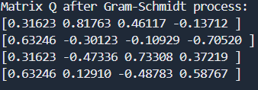

Householder Transformation and Solutions

Algorithm

For Q and R matrix
Householder method of QR factorization uses a sequence of orthogonal matrices known as Householder matrices to transform the given matrix A to QR form. The idea of the method is to reduce the coefficient matrix to upper triangular form by multiplying the matrix by a series of Householder matrices.
$$H_{n}H_{n-1} ...H_{1}*A = U$$
As Householder matrices are orthogonal, the matrix HnHn−1 ...H1 is also orthogonal. The upper triangular matrix U thus obtained is R and thus
$${\left({H_{n}H}_{n-1} ...H_{1}\right)}^{-1} = Q = H_{1}^{T} H_{2}^{T} ...H_{n}^{T}$$
Consider a Householder matrix H1 defined as $H_{1} = I-2{uu}^{T}$
H₁H^{T}₁ = (I−2uu^{T} )(I−2uu^{T} )^{T} = (I^{T} −2(uu^{T} )^{T} )(I−2uu^{T} ) = (I−2uu^{T} )(I−2uu^{T} ) = I−4uu^{T} +4uu^{T}uu^{T} = I−4uu^{T} +4u(u^{T}u)u^{T} = I−4uu^{T} +4uu^{T} = I
Let vector x represent the first column of the coefficient matrix. x T = $[a_{1,1} a_{2,1} ··· a_{i,1} ···a_{n,1} ]$
We desire that this vector be transformed, on pre-multiplication by H1, to xˆ1e1 where e1 is the unit vector defined as e^{T}₁ = [1 0 0··· 0 ]
and x₁ is a non-zero number i.e. all the elements below the pivot element are zero. Thus, we should have H₁x = x₁e₁
On pre-multiplication by (H1x)^{T} Equation becomes (H₁x)^{T}H₁x = x^{T}H^{T}₁H₁x = x^{T}x = (x₁e₁)^{T} x₁e₁ = x²₁
x₁ = sqrt(x^{T}x)
Therefore using the above relation for H₁x = x₁e₁ we get
H^{T}₁H₁x = x = H^{T}₁ x₁e₁ = x₁H^{T}₁ e₁ = x₁(I−2uu^{T} )^{T} e₁ = x₁(e₁ −2uu^{T} e₁)
x₁ = x₁(1−2u²₁ ); x_{i} = x₁(0−2u₁u_{i}) for i $≠$ 1
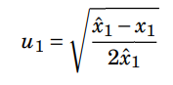
hence we get for i=1

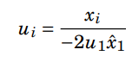
and for i $≠$ 1 we have

Then we can calculate $H_{1} = I-2{uu}^{T}$

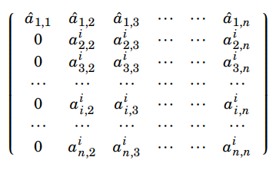
Multiplying A with H₁ we get

A second Householder transformation is used to put zeros in all the elements in the second column below the pivot. For this consider the n −1× n −1 matrix obtained by removing the first row and column of the matrix shown on the right in Equation 2.86. We use the n−1×1 vector given by
x^{T} = [a^{i}_{2,2} a^{i}_{3,2} ··· a^{i}_{i,2} ···a^{i}_{n,2} ]
We construct a Householder matrix given by H’₂ = I − 2uu^{T} where the elements of u are obtained such that the vector x is transformed to a unit vector x₂e₂ where e₂ is n −1 ×1 unit vector. Note that I in the above is the n−1× n−1 identity matrix. It is clear that the analysis presented earlier can be used directly now to get the vector u. By adding the row and column that were removed earlier, we construct a matrix H₂ = I − 2u’u’^{T} where I is the n× n identity matrix and u’ is n×1 vector given by u’^{T} = [0 u₁ u₂ ··· u_{n−1}]
Premultiplication of H1A by H2 should lead to
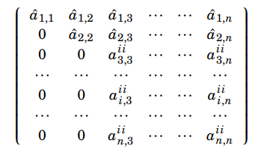
The process above may be repeated with matrices obtained by removing two rows and two columns, three rows and three columns and so on till we are able to transform the coefficient matrix to upper triangle form R.
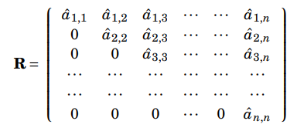
It is also clear that H_{n−1}H_{n−2} ...H₂H₁A = R and hence Q should be given by Q = (H_{n−1}H_{n−2} ...H₂H₁)⁻¹ = H^{T}₁H^{T}₂ ...H^{T}_{n−1}

For Solutions
Steps:
- Calculate b’ using the relation $b^{'} =Q^{T}*b$
- Solve Rx = b’ using backward substitution.

Results

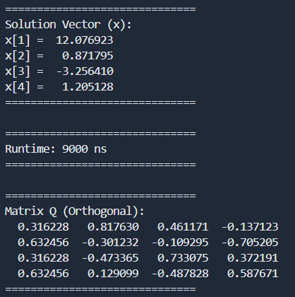

Code Reports

Condition Number

Function: Reading a Matrix from a File in C

Purpose: This function reads a square matrix of size n x n from a file and stores it in a 2D array (matrix). It is used to load matrix data from external files for computational tasks.

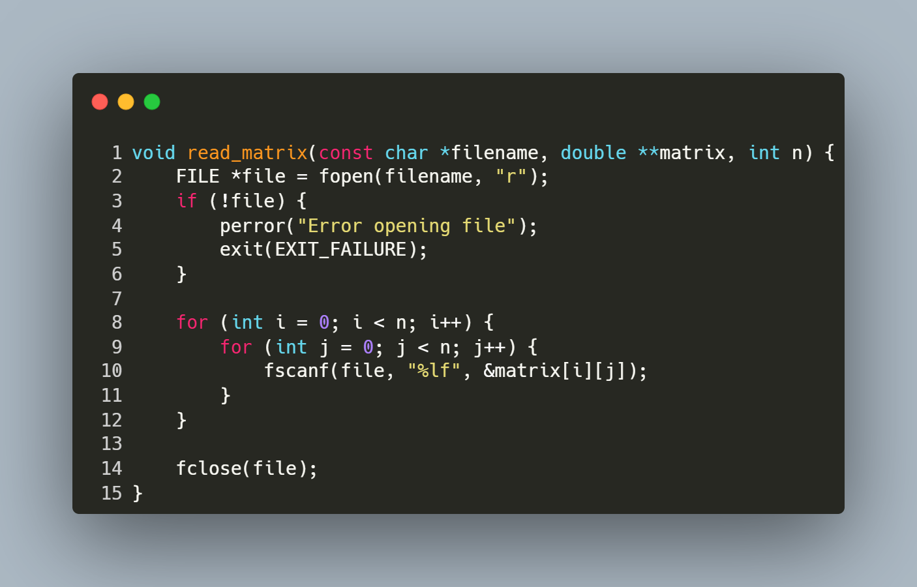
Step-by-Step Explanation
- Opening the File:
  - FILE *file = fopen(filename, "r");
  - Opens the file specified by filename in read mode.
- Error Handling:
  - if (!file) { perror("Error opening file"); exit(EXIT_FAILURE); }
  - Checks if the file was successfully opened. If not, prints an error message and exits the program.
- Reading Matrix Elements:
  - The nested for loops iterate over each row (i) and column (j) of the matrix:
    - fscanf(file, "%lf", &matrix[i][j]);
    - Reads a floating-point number (%lf) from the file and stores it in the corresponding position in the matrix.
- Closing the File:
  - fclose(file);
  - Closes the file after all elements are read to release system resources.

Function: Calculating the Matrix Norm

Purpose: This function calculates the maximum row sum norm (also known as the infinity norm) of a square matrix of size n x n.

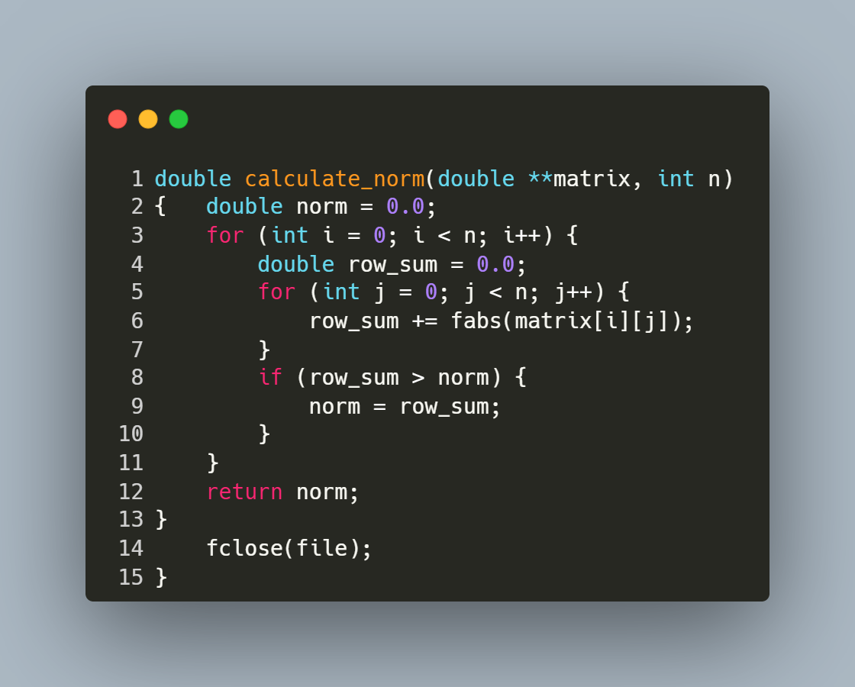
Step-by-Step Explanation
- Initialization:
  - double norm = 0.0;
    - Initializes norm to store the maximum row sum.
- Outer Loop:
  - for (int i = 0; i < n; i++) {
    - Iterates over each row (i) of the matrix.
- Row Sum Calculation:
  - double row_sum = 0.0;
    - Initializes row_sum to accumulate the absolute values of elements in the current row.
- Inner Loop:
  - for (int j = 0; j < n; j++) {
    - Iterates over each column (j) in the current row.
- Absolute Value Addition:
  - row_sum += fabs(matrix[i][j]);
    - Adds the absolute value of each matrix element to row_sum.
- Updating Norm:
  - if (row_sum > norm) { norm = row_sum; }
    - Compares row_sum with norm and updates norm if row_sum is larger.
- Return Statement:
  - return norm;
    - Returns the maximum row sum as the calculated matrix norm.

Recursive Determinant Calculation

Purpose: This function calculates the determinant of a square matrix of size n×n using the cofactor expansion method.
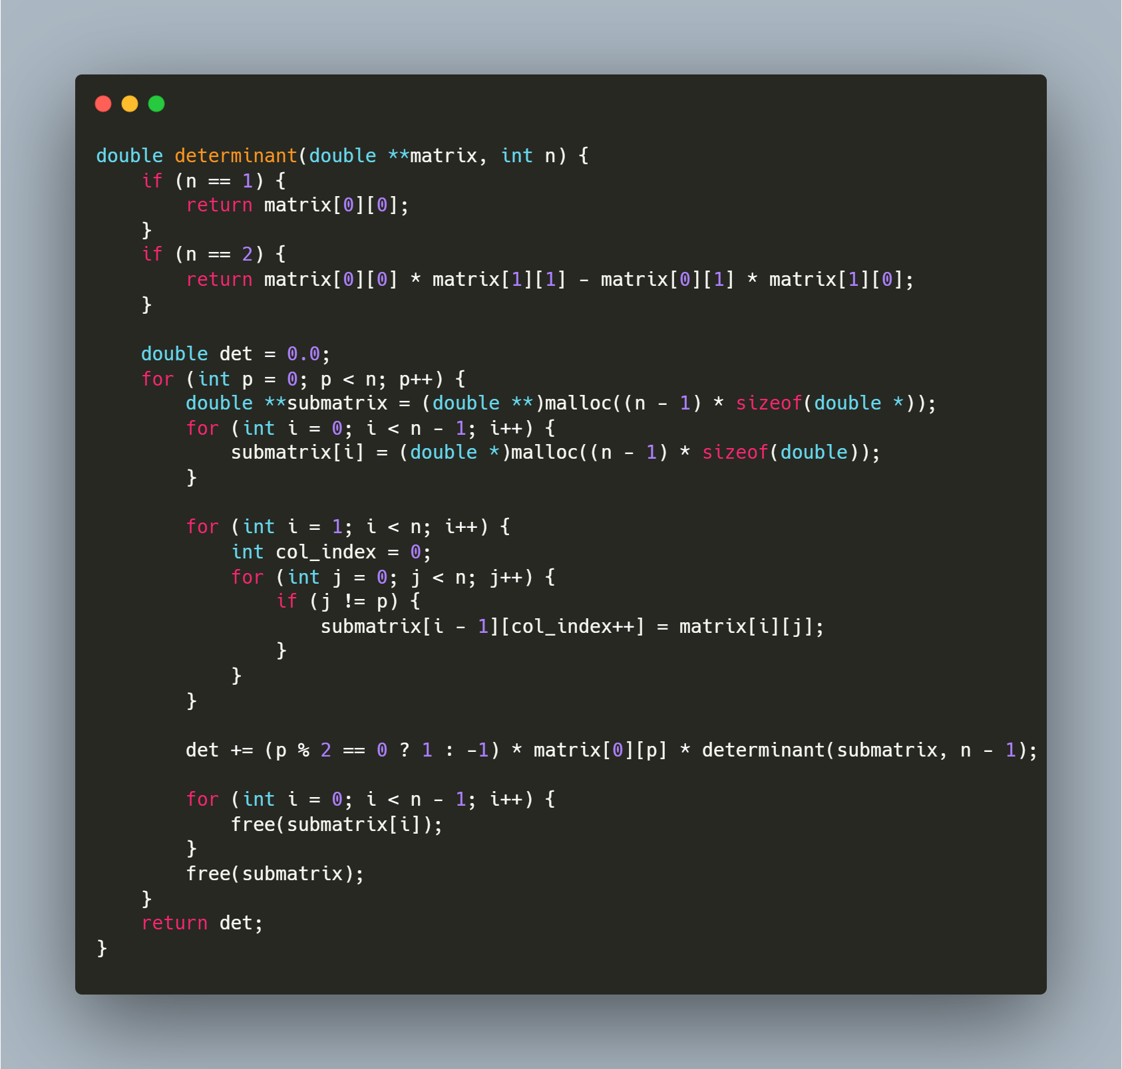
Step-by-Step Explanation
1. Base Cases
- The function handles two base cases for efficiency:
  - 1×1 Matrix: The determinant is simply the single element (matrix).
  - 2×2 Matrix: Uses the direct formula: det([[a,b],[c,d]]) = ad - bc.
2. Cofactor Expansion
For matrices larger than 2×2, the function uses the Laplace expansion along the first row:
double det = 0.0;
for (int p = 0; p < n; p++) {
}
- The variable p iterates through each column of the first row.
- The function will sum up the contributions of each element to the determinant.
3. Submatrix Construction
For each element in the first row, we need a submatrix that excludes the first row and the column containing that element:]
double **submatrix = (double **)malloc((n - 1) * sizeof(double *));
for (int i = 0; i < n - 1; i++) {
submatrix[i] = (double *)malloc((n - 1) * sizeof(double));
}

for (int i = 1; i < n; i++) {
int col_index = 0;
for (int j = 0; j < n; j++) {
if (j != p) {
submatrix[i - 1][col_index++] = matrix[i][j];
}
}
}
- Allocates memory for a submatrix of size (n-1)×(n-1).
- The outer loop starts from row 1 (skipping row 0, which is the first row we're expanding along).
- For each row, we copy elements from the original matrix, skipping the p-th column.
- col_index tracks the position in the submatrix where we're copying elements.
4. Recursive Determinant Calculation
det += (p % 2 == 0 ? 1 : -1) * matrix[0][p] * determinant(submatrix, n - 1);
- This implements the cofactor formula: det(A) =$Σ ((-1)^(i+j) * A[i,j] * det(M[i,j]))$.
- Since we're expanding along the first row (i=0), the sign factor is (-1)^(0+j) or simply (-1)^j.
- (p % 2 == 0 ? 1 : -1) computes (-1)^p, which alternates between 1 and -1.
- The function recursively calls itself to calculate the determinant of the submatrix.
5. Memory Management
for (int i = 0; i < n - 1; i++) {
free(submatrix[i]);
}
free(submatrix);
- Properly frees all dynamically allocated memory to prevent memory leaks.
- Each row of the submatrix is freed individually, then the array of pointers is freed.

Adjoint Matrix Calculation

Purpose: This function calculates the adjoint of a square matrix of size n×n.
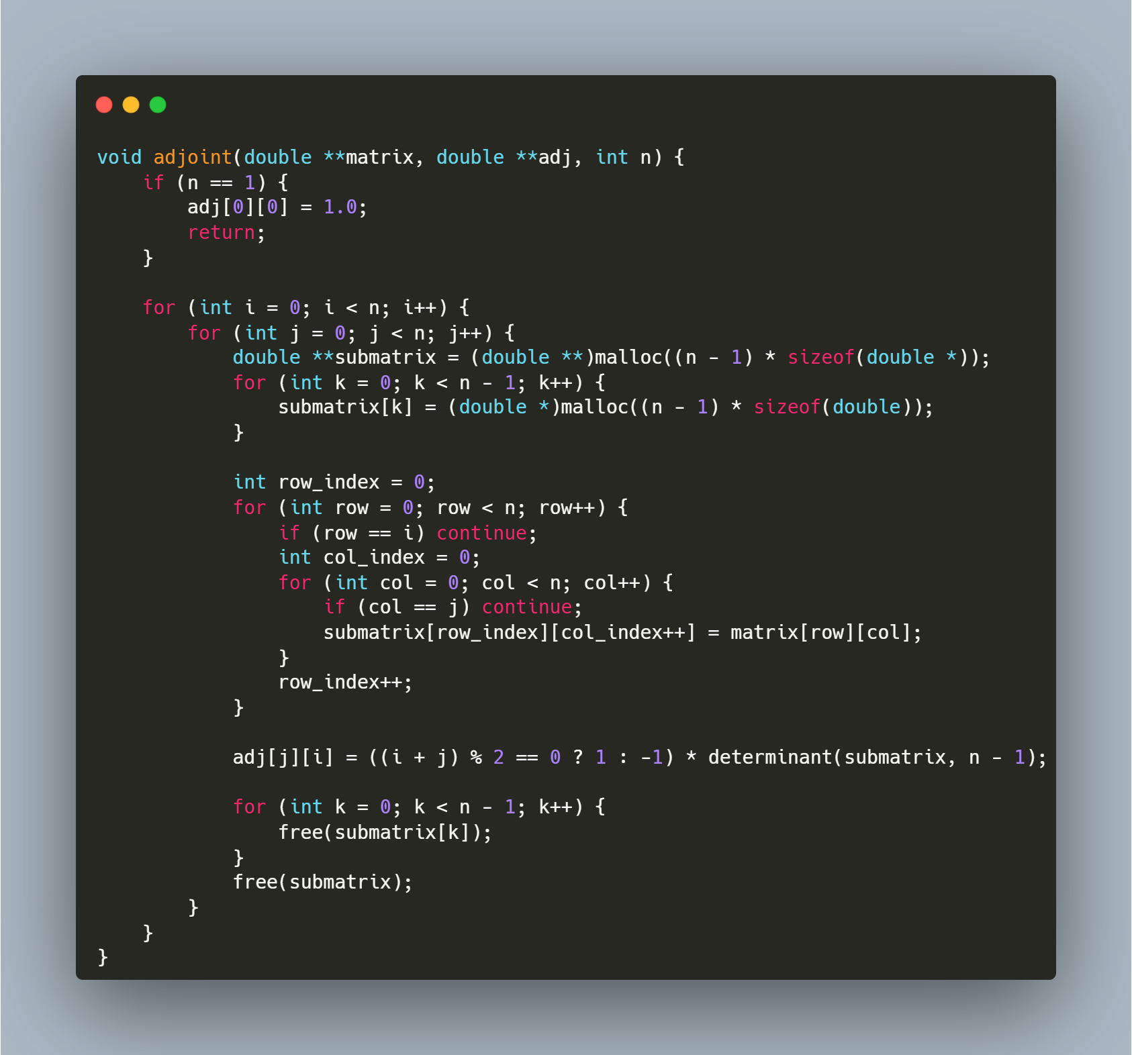

Step-by-Step Explanation
1. Base Case Handling
if (n == 1) {
adj[0][0] = 1.0;
return;
}
- For a 1×1 matrix, the adjoint is simply 1.0
- This is a special case that aligns with the mathematical definition where the adjoint of a 1×1 matrix [a] is1
2. Iterating Through Matrix Elements
for (int i = 0; i < n; i++) {
for (int j = 0; j < n; j++) {
}
}
- The nested loops iterate through each position (i,j) in the original matrix
- For each position, we'll calculate the corresponding cofactor
3. Submatrix Construction
double **submatrix = (double **)malloc((n - 1) * sizeof(double *));
for (int k = 0; k < n - 1; k++) {
submatrix[k] = (double *)malloc((n - 1) * sizeof(double));
}

int row_index = 0;
for (int row = 0; row < n; row++) {
if (row == i) continue;
int col_index = 0;
for (int col = 0; col < n; col++) {
if (col == j) continue;
submatrix[row_index][col_index++] = matrix[row][col];
}
row_index++;
}
- Allocates memory for a submatrix of size (n-1)×(n-1)
- Creates the minor matrix M(i,j) by excluding the i-th row and j-th column from the original matrix
- The row_index and col_index variables track positions in the submatrix
- continue statements skip the i-th row and j-th column of the original matrix
4. Cofactor Calculation and Assignment
adj[j][i] = ((i + j) % 2 == 0 ? 1 : -1) * determinant(submatrix, n - 1);
- Calculates the determinant of the submatrix using the previously defined determinant () function
- Applies the cofactor sign pattern: +1 if (i+j) is even, -1 if (i+j) is odd
- Critical detail: Assigns to adj[j][i] not adj[i][j] - this performs the transpose operation, as the adjoint is the transpose of the cofactor matrix
5. Memory Cleanup
for (int k = 0; k < n - 1; k++) {
free(submatrix[k]);
}
free(submatrix);
- Properly frees the dynamically allocated memory for each submatrix
- Prevents memory leaks by first freeing each row, then the array of pointers

Matrix Inversion Using the Classical Adjoint Method

Purpose: This function computes the inverse of a square matrix using the classical formula: A⁻¹ = adj(A)/det(A).
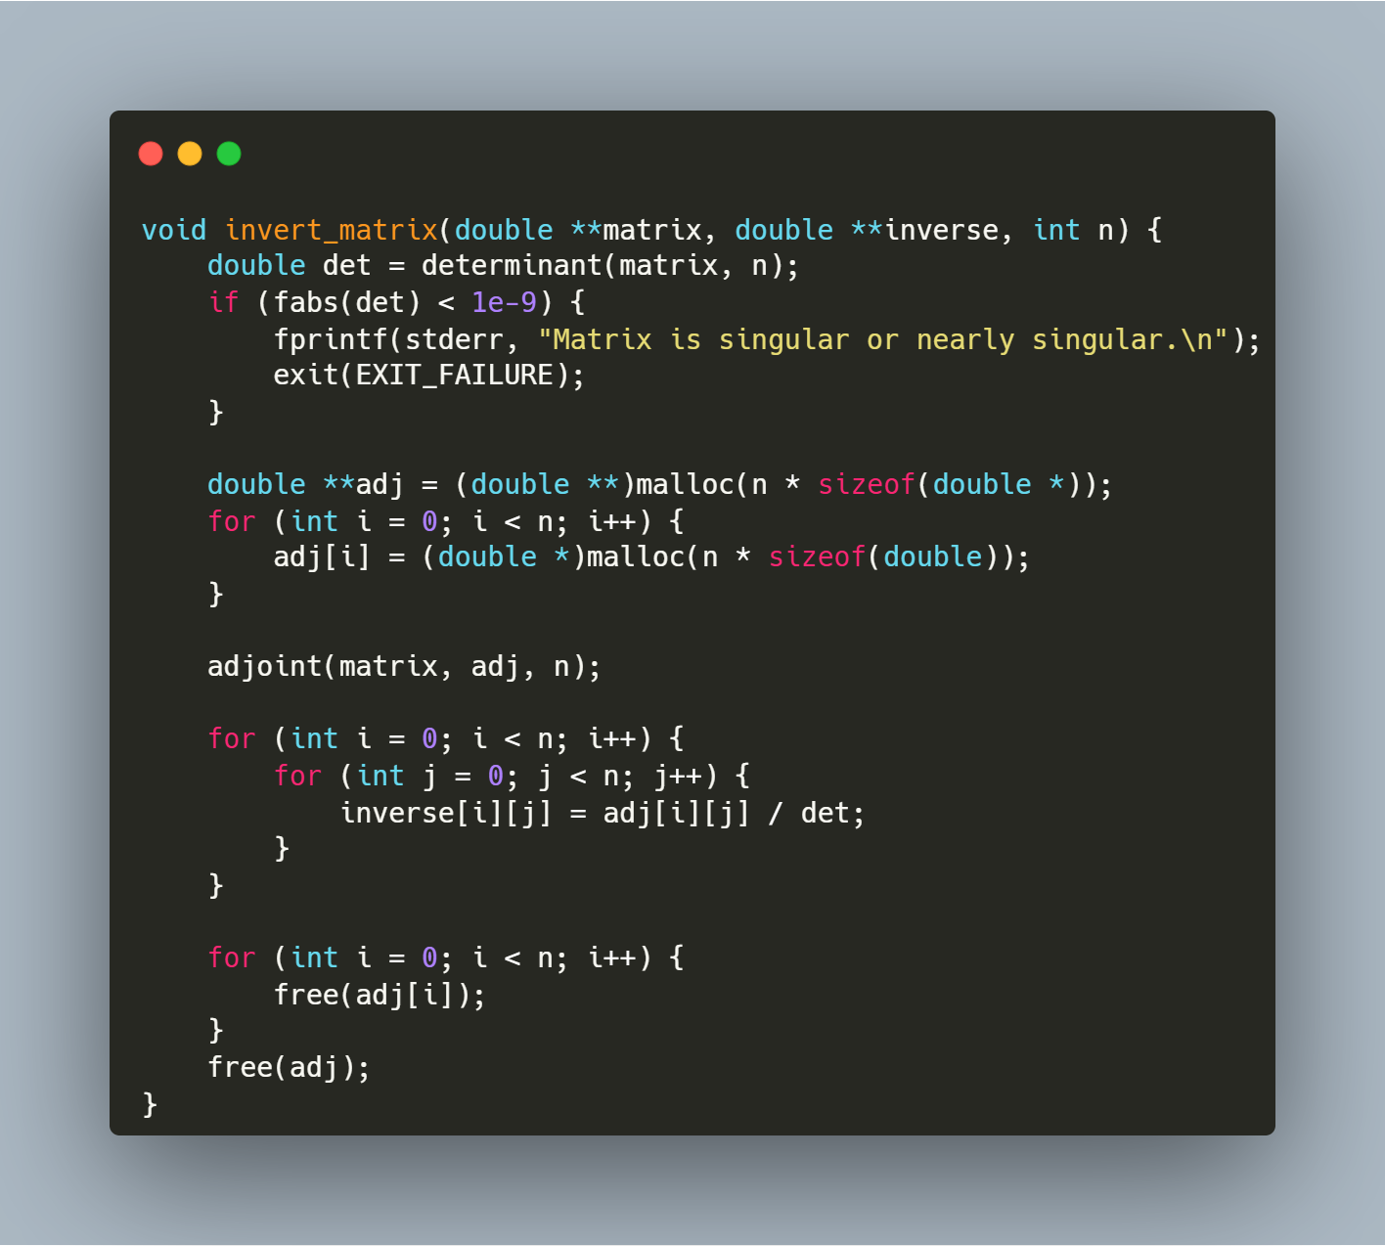
Step-by-Step Explanation
1. Determinant Calculation and Singularity Check
double det = determinant(matrix, n);
if (fabs(det) < 1e-9) {
fprintf(stderr, "Matrix is singular or nearly singular.\n");
exit(EXIT_FAILURE);
}
- Calls the determinant() function to compute the determinant of the input matrix
- Checks if the absolute value of the determinant is less than 10⁻⁹ (effectively zero)
- If the determinant is near zero, the matrix is singular (non-invertible), so the function prints an error message and terminates the program
- This check is critical as divisions by zero (or very small numbers) would lead to numerical instability
2. Memory Allocation for Adjoint Matrix
double **adj = (double **)malloc(n * sizeof(double *));
for (int i = 0; i < n; i++) {
adj[i] = (double *)malloc(n * sizeof(double));
}
- Allocates memory for an n×n matrix to store the adjoint
- Uses a two-dimensional dynamic array structure with row pointers
3. Adjoint Calculation
adjoint(matrix, adj, n);
- Calls the adjoint() function to calculate the adjoint matrix
- The adjoint is the transpose of the cofactor matrix of the original matrix
4. Inverse Calculation
for (int i = 0; i < n; i++) {
for (int j = 0; j < n; j++) {
inverse[i][j] = adj[i][j] / det;
}
}
- Calculates each element of the inverse matrix using the formula: inverse[i][j] = adj[i][j] / det
- Implements the mathematical relationship: A⁻¹ = adj(A)/det(A)
- This nested loop performs n² operations (one division per matrix element)
5. Memory Cleanup
for (int i = 0; i < n; i++) {
free(adj[i]);
}
free(adj);
- Frees all memory allocated for the adjoint matrix
- Prevents memory leaks by first freeing each row, then the array of row pointers

Function: MAIN PROGRAM FOR MATRIX CONDITION NUMBER CALCULATION

Purpose: This function serves as the main entry point for a program that reads a matrix from a file, calculates its condition, and displays the result. It handles memory allocation, function calls, and memory cleanup.
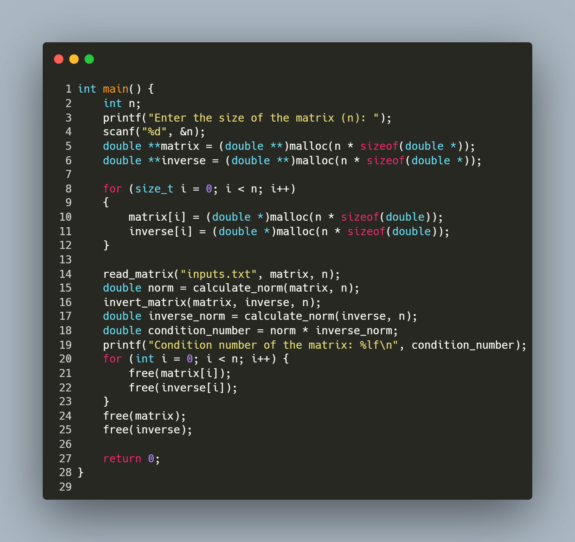
Step-by-Step Explanation:
- User Input:
  - The program prompts the user to enter the size of the square matrix (n).
  - scanf("%d", &n); reads the value entered by the user.
- Memory Allocation:
  - The program allocates memory for two n×n matrices: the original matrix and its inverse.
  - double **matrix = (double **)malloc(n * sizeof(double *)); allocates an array of n pointers.
  - The nested loop allocates memory for each row of both matrices.
- Matrix Reading:
  - read_matrix("inputs.txt", matrix, n); calls the previously defined function to read matrix data from a file.
- Matrix Norm Calculation:
  - double norm = calculate_norm(matrix, n); calculates the norm of the original matrix.
- Matrix Inversion:
  - invert_matrix(matrix, inverse, n); inverts the matrix and stores the result in the inverse array.
- Condition Number Calculation:
  - double inverse_norm = calculate_norm(inverse, n); calculates the norm of the inverse matrix.
  - double condition_number = norm * inverse_norm; computes the condition number as the product of the two norms.
  - The condition number is a measure of how sensitive a matrix is to errors in input data or computational operations.
- Result Output:
  - The program prints the calculated condition number using printf.
- Memory Cleanup:
  - The nested loop frees memory for each row of both matrices.
  - The final two free() calls release the memory for the arrays of pointers.
- Program Termination:
  - return 0; indicates successful program execution.

Gram schmidt orthogonalisation

Function: GRAM-SCHMIDT ORTHOGONALIZATION

Purpose: This function implements the Gram-Schmidt orthogonalization process, which transforms a set of linearly independent vectors (columns of matrix A) into an orthonormal basis (stored in matrix Q).
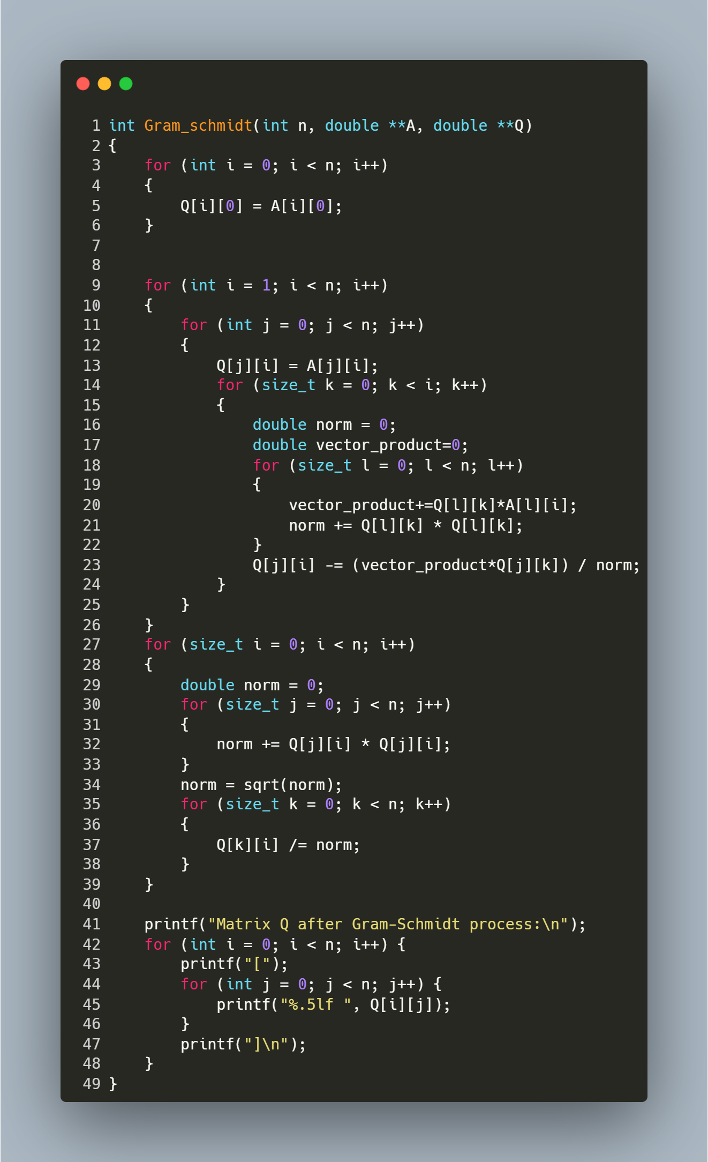

Step-by-Step Explanation:
- First Vector Initialization:
  - The function copies the first column of matrix A directly to matrix Q.
  - Q[i] = A[i]; for all rows i from 0 to n-1.
- Orthogonalization Process:
  - The outer loop for (int i = 1; i < n; i++) iterates through each column of A starting from the second column.
  - For each column i:
    - Initially copies column i from A to Q: Q[j][i] = A[j][i];
    - For each previously processed column k (0 to i-1):
      - Calculates the dot product between column k of Q and column i of A: vector_product+=Q[l][k]*A[l][i];
      - Calculates the squared norm of column k of Q: norm += Q[l][k] * Q[l][k];
      - Subtracts the projection of column i onto column k: Q[j][i] -= (vector_product*Q[j][k]) / norm;
    - This makes column i orthogonal to all previous columns.
- Normalization:
  - After all columns are orthogonalized, each column is normalized to have unit length.
  - For each column i:
    - Calculates the Euclidean norm: norm = sqrt(norm);
    - Divides each element by the norm: Q[k][i] /= norm;
    - This transforms orthogonal vectors into orthonormal vectors.
- Result Output:
  - The function prints the resulting orthonormal matrix Q.
  - Each row is displayed in bracket notation with values formatted to 5 decimal places.

Function: Backward Substitution for Solving Upper Triangular Systems

Purpose: This function solves a system of linear equations Ux = b, where U is an upper triangular matrix.
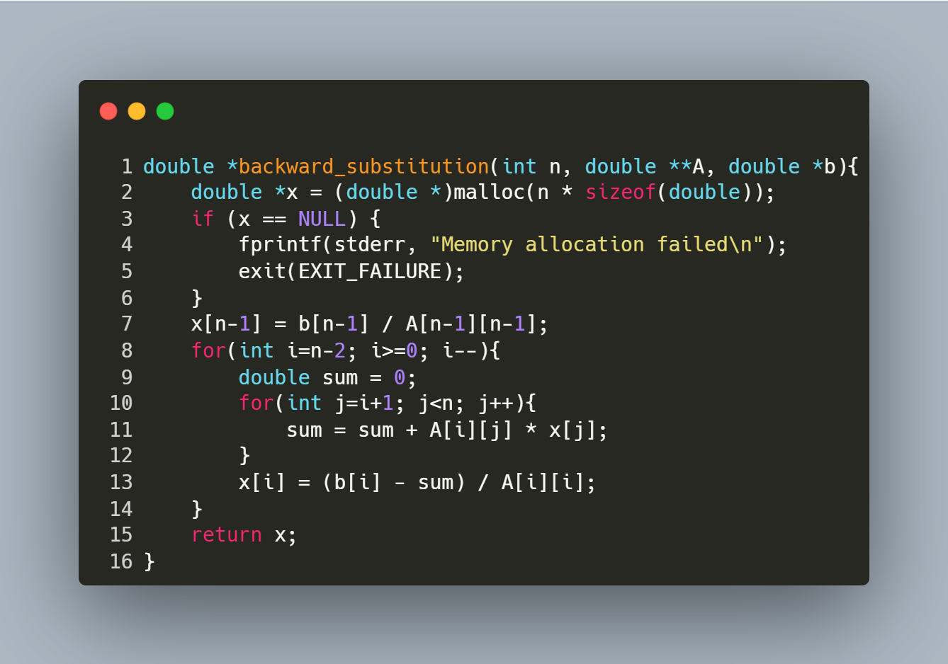
Step-by-Step Explanation
- Memory Allocation:
  - double *x = (double *)malloc(n * sizeof(double));
Allocates memory for the solution vector x.
  - Checks for allocation failure and exits if memory is unavailable.
- Initialize Last Element:
  - x[n-1] = b[n-1] / A[n-1][n-1];
Solves for the last variable directly using the bottom row of the upper triangular matrix U.
- Backward Substitution Loop:
  - for(int i=n-2; i>=0; i--)
Iterates from the second-last row to the first row.
  - double sum = 0;
Initializes a sum to accumulate contributions from already solved variables.
  - for(int j=i+1; j<n; j++)
Sums the products of coefficients (A[i][j]) and known solutions (x[j]).
  - x[i] = (b[i] - sum) / A[i][i];
Computes the current variable x[i] by subtracting the accumulated sum from b[i] and dividing by the diagonal element A[i][i].
- Return Result:
  - Returns the solution vector x, which satisfies Ux = b.

Function: Matrix Transposition

Purpose: This function transposes a square matrix of size n x n
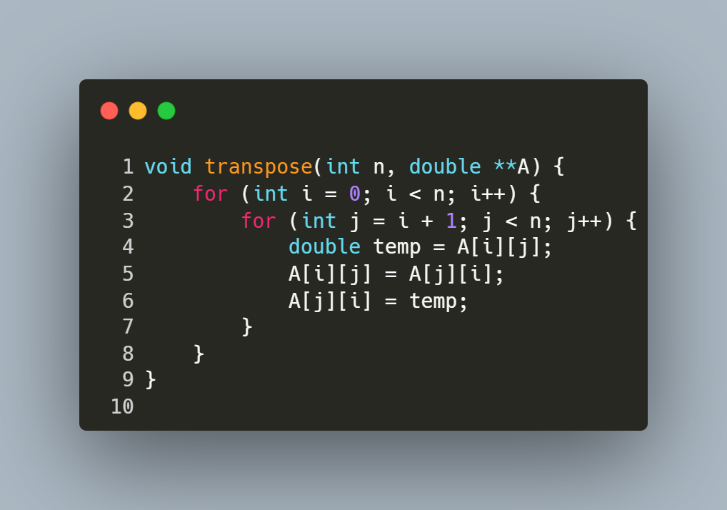
Step-by-Step Explanation
- Outer Loop (i from 0 to n-1):
  - Iterates over each row of the matrix.
- Inner Loop (j from i+1 to n-1):
  - For each row i, iterates over columns starting from i+1 (avoids redundant swaps on the diagonal and below).
- Swap Elements:
  - Swaps A[i][j] (element above the diagonal) with A[j][i] (element below the diagonal).
  - Example: For i=0 and j=1, A and A are swapped.
- Result:
  - After all iterations, the original matrix A becomes its transpose.

Function: Matrix Multiplication for Square Matrices

Purpose: This function multiplies two square matrices A and B of size n x n and stores the result in matrix C.
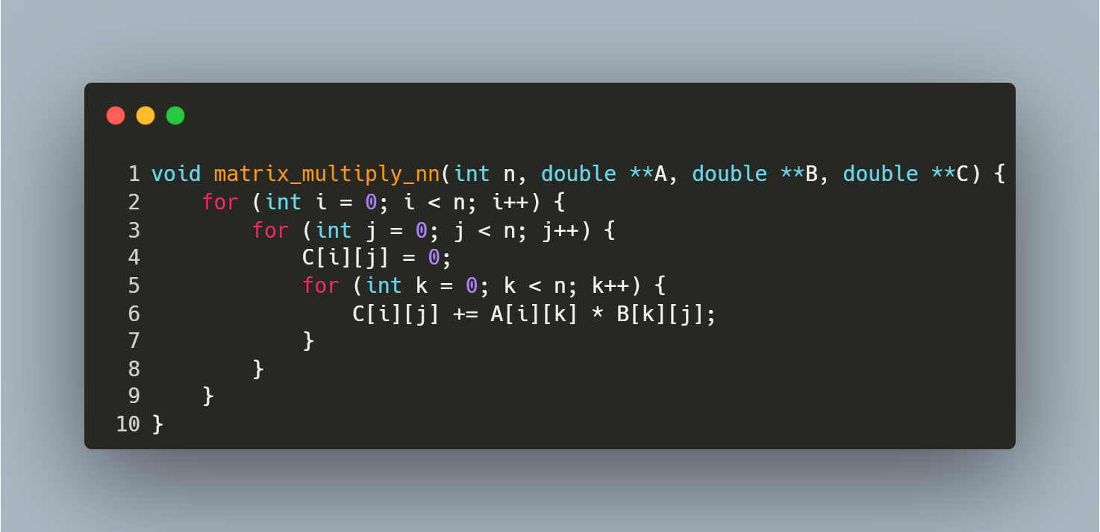
Step-by-Step Explanation
- Initialization:
  - The outer loop for (int i = 0; i < n; i++) iterates over each row of matrix A.
- Column Iteration:
  - The middle loop for (int j = 0; j < n; j++) iterates over each column of matrix B.
- Dot Product Calculation:
  - C[i][j] = 0; initializes the element at row i, column j of matrix C to zero.
  - The inner loop for (int k = 0; k < n; k++) computes the dot product of the i-th row of A and the j-th column of B:
    - C[i][j] += A[i][k] * B[k][j]; accumulates the product of corresponding elements.
- Result Storage:
  - After completing all iterations, matrix C contains the product of A and B.

Function: Matrix-Vector Multiplication

Purpose: This function multiplies a square matrix A of size n x n with a vector B of size n and stores the result in vector C. It computes the dot product of each row of A with B to produce C.
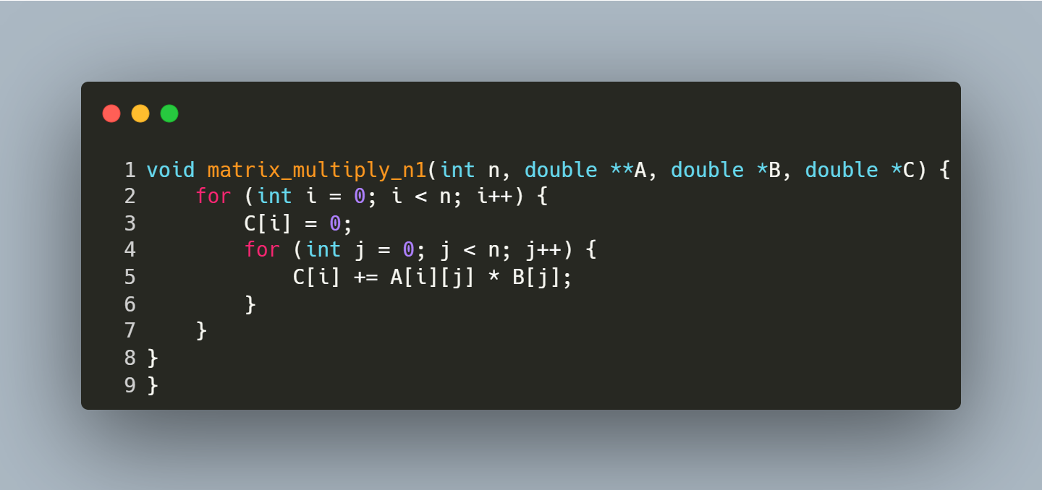
Step-by-Step Explanation
- Initialization:
  - The outer loop for (int i = 0; i < n; i++) iterates over each row of matrix A.
- Reset Result Vector:
  - C[i] = 0; initializes the i-th element of the result vector C to zero.
- Dot Product Calculation:
  - The inner loop for (int j = 0; j < n; j++) computes the dot product of the i-th row of A and the vector B:
    - C[i] += A[i][j] * B[j]; accumulates the product of the matrix element A[i][j] and vector element B[j].
- Result Storage:
  - After the inner loop completes, C[i] holds the dot product result for the i-th row.

Function: QR Factorization for Solving Linear Systems

Purpose: This function solves a linear system Ax = b using QR factorization. It decomposes matrix A into Q (orthonormal) and R (upper triangular), then solves Rx = Qᵀb via backward substitution.
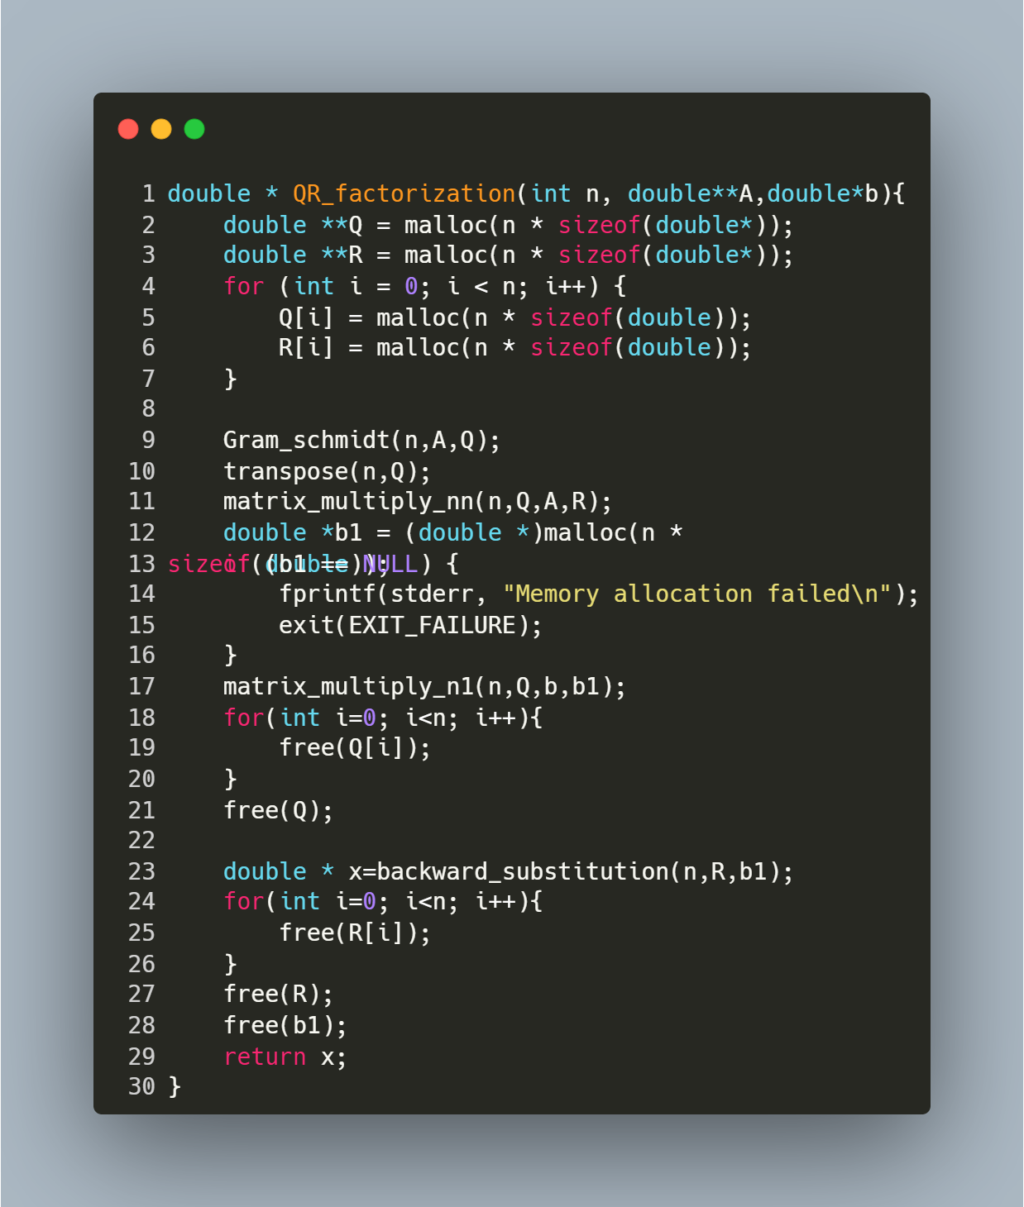
Step-by-Step Explanation
- Memory Allocation:
  - Allocates memory for matrices Q (orthonormal) and R (upper triangular).
- Gram-Schmidt Process:
  - Gram_schmidt(n, A, Q) transforms A into Q with orthonormal columns.
- Transpose Q:
  - transpose(n, Q) converts Q from column-orthonormal to row-orthonormal (effectively computing Qᵀ).
- Compute R:
  - matrix_multiply_nn(n, Q, A, R) calculates R = Qᵀ * A.
- Transform b:
  - matrix_multiply_n1(n, Q, b, b1) computes b1 = Qᵀ * b.
- Solve for x:
  - backward_substitution(n, R, b1) solves Rx = b1 to find the solution vector x.
- Memory Cleanup:
  - Frees Q, R, and b1 to prevent leaks.

Function: Reading Matrix and Vector Input from a File

Purpose: This function reads a square matrix A of size n x n and a vector b of size n from a file named "inputs.txt". It ensures proper error handling for file operations and input parsing.
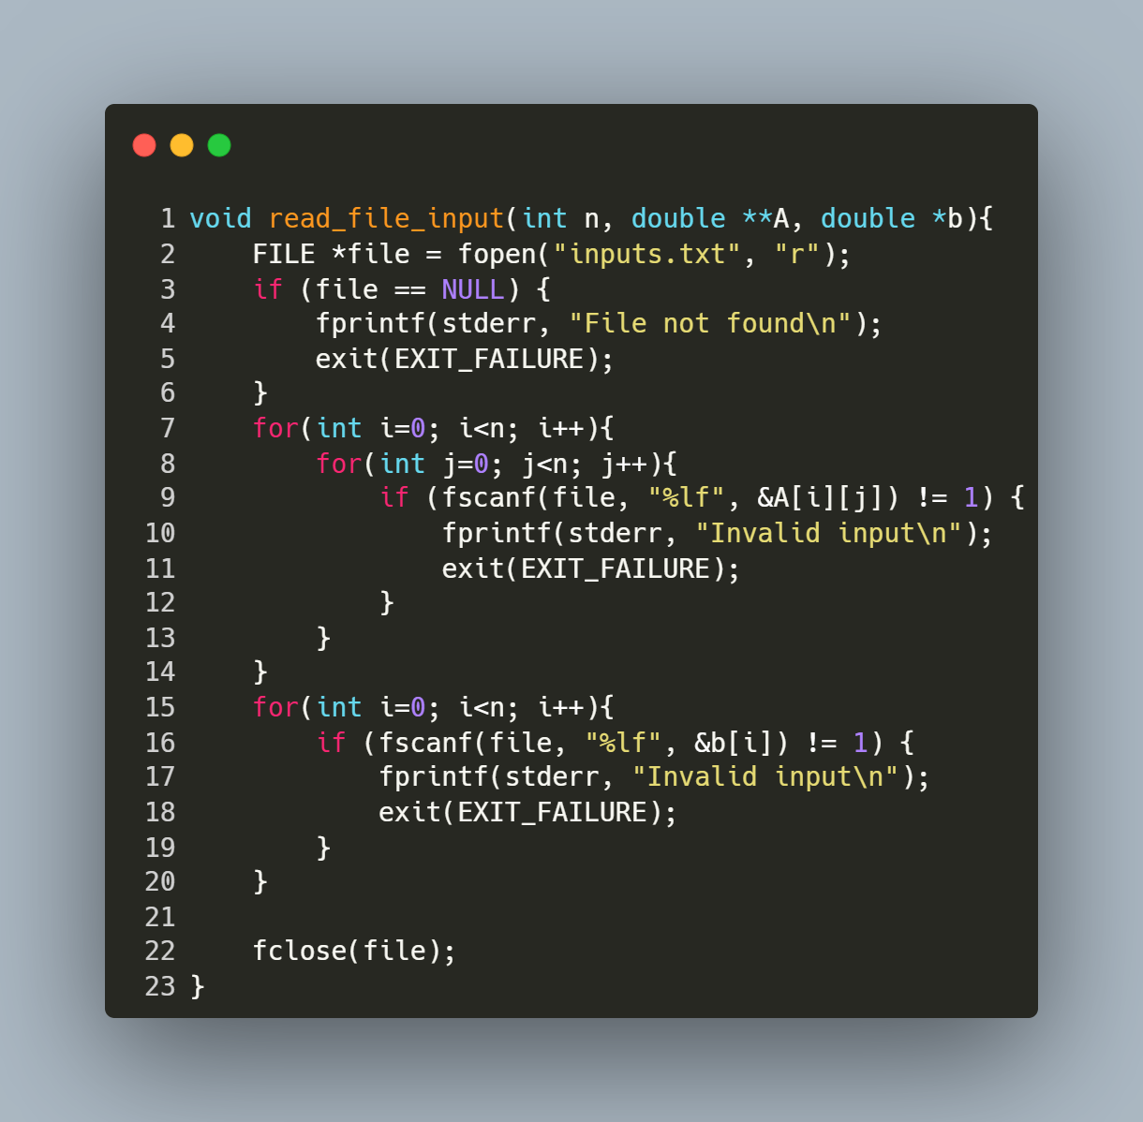
Step-by-Step Explanation
- Open File:
  - FILE *file = fopen("inputs.txt", "r"); opens the file "inputs.txt" in read mode.
  - If the file cannot be opened (e.g., it doesn't exist), the program prints an error message ("File not found") and exits.
- Read Matrix Elements:
  - The nested loop for (int i = 0; i < n; i++) { for (int j = 0; j < n; j++) { ... } } iterates through each row (i) and column (j) of matrix A.
  - fscanf(file, "%lf", &A[i][j]) reads a floating-point number from the file and stores it in the corresponding position in A.
  - If the input is invalid or missing, the program prints "Invalid input" and exits.
- Read Vector Elements:
  - The loop for (int i = 0; i < n; i++) { ... } iterates through each element of vector b.
  - fscanf(file, "%lf", &b[i]) reads a floating-point number from the file and stores it in the corresponding position in b.
  - Similar error handling ensures that invalid or missing input causes the program to terminate with an error message.
- Close File:
  - fclose(file); closes the file after all data has been read to release system resources.

Function: Main Program for Solving Linear Systems via QR Factorization

Purpose: This program solves a linear system Ax = b using QR factorization. It reads matrix A and vector b from a file, computes the solution x, prints the result, and measures the execution time of the QR factorization process.
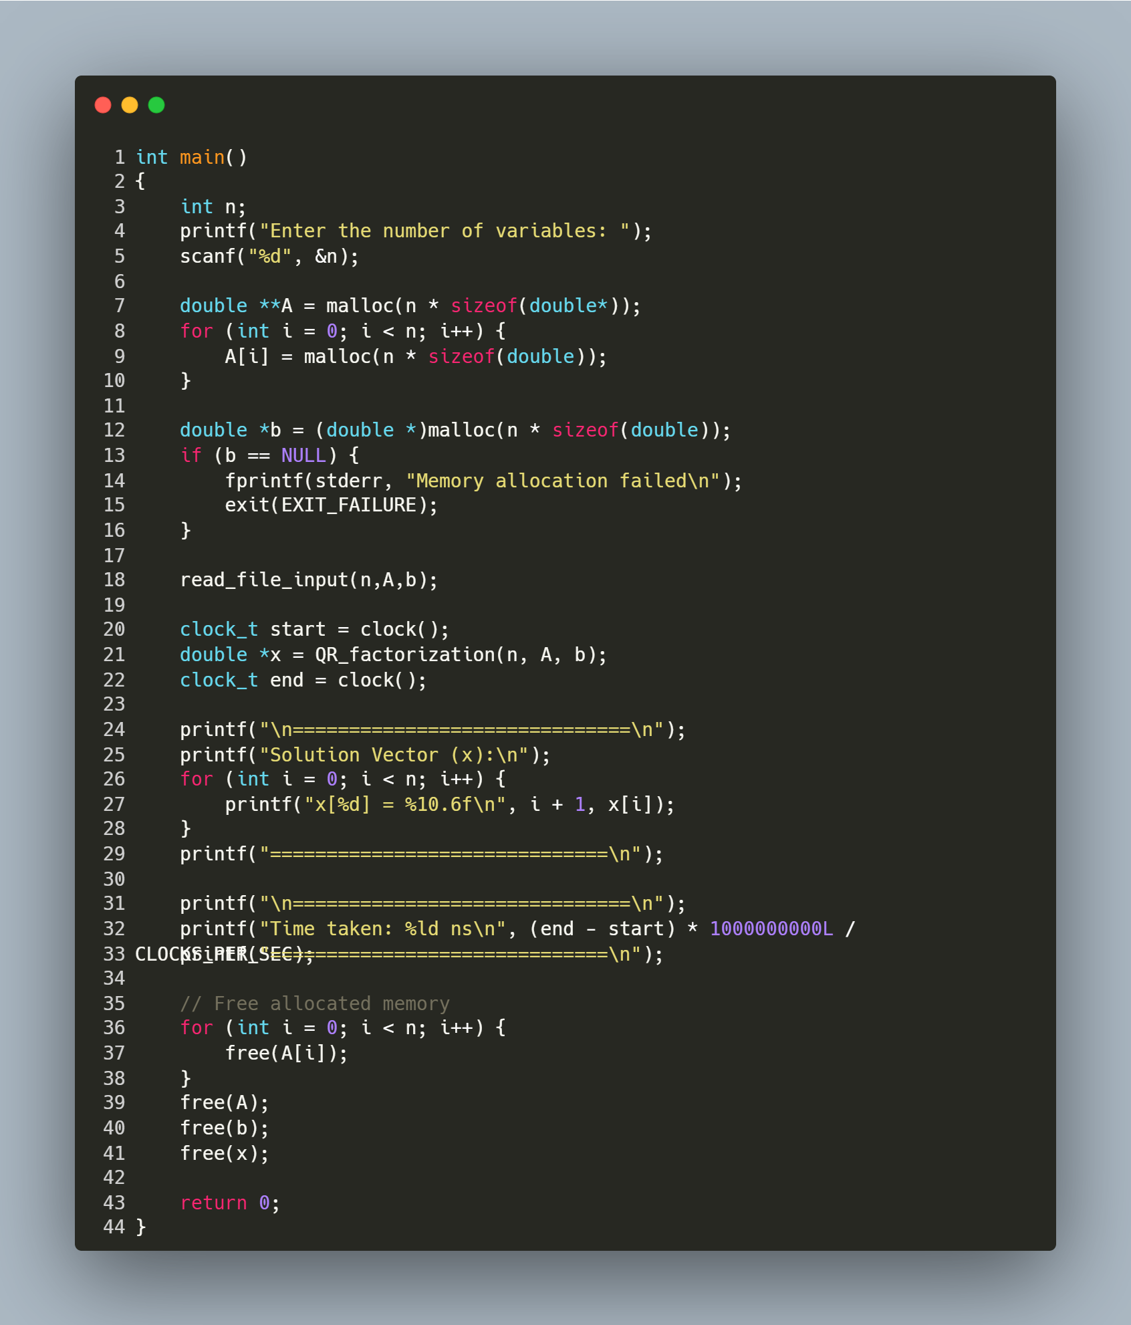
Step-by-Step Explanation
- User Input:
  - Prompts the user to enter the number of variables (n).
- Memory Allocation:
  - Allocates memory for:
    - A (n x n matrix) using nested malloc calls.
    - b (vector of size n).
  - Checks for allocation failure in b and exits if memory is unavailable.
- Read Input File:
  - Calls read_file_input(n, A, b) to populate A and b from "inputs.txt".
- QR Factorization & Timing:
  - clock() records the start time.
  - QR_factorization(n, A, b) computes the solution vector x.
  - clock() records the end time.
- Print Results:
  - Displays the solution vector x with 6 decimal places.
  - Calculates and prints the execution time in nanoseconds.
- Memory Cleanup:
  - Frees all dynamically allocated memory for A, b, and x to prevent leaks.

HouseHolder Transformation

Function: Euclidean Norm Calculation for Vectors

Purpose: This function calculates the Euclidean norm (magnitude) of a vector v of length len.
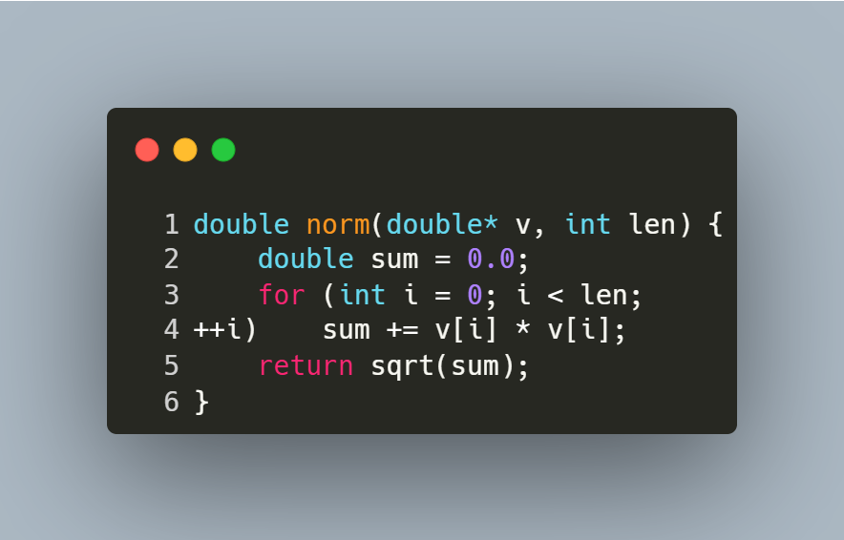
Step-by-Step Explanation
- Initialization:
  - double sum = 0.0; initializes a variable to accumulate the sum of squared elements.
- Loop Through Elements:
  - for (int i = 0; i < len; ++i) iterates over each element of the vector.
- Sum of Squares:
  - sum += v[i] * v[i]; squares each element and adds it to sum.
- Final Calculation:
  - return sqrt(sum); returns the square root of the accumulated sum, giving the Euclidean norm.

Function: Matrix Multiplication for Square Matrices

Purpose: This function multiplies two square matrices A and B of size n x n and stores the result in matrix C.
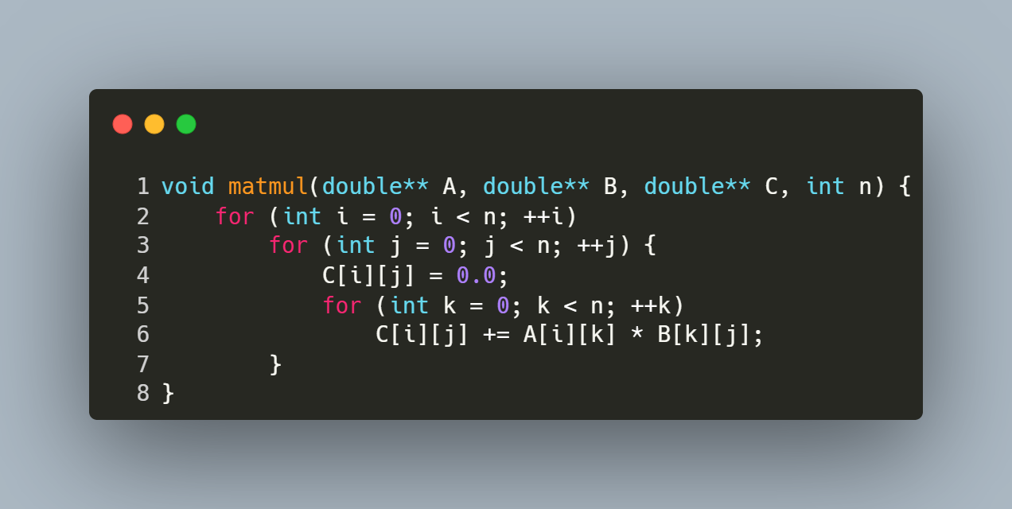
Step-by-Step Explanation
- Row Iteration (i loop):
  - Iterates over each row of matrix A (from 0 to n-1).
- Column Iteration (j loop):
  - For each row i, iterates over each column of matrix B (from 0 to n-1).
- Element Initialization:
  - C[i][j] = 0.0; resets the target element in C to zero to avoid garbage values.
- Dot Product Calculation (k loop):
  - Computes the dot product of the i-th row of A and the j-th column of B.
  - Accumulates the sum of products: C[i][j] += A[i][k] * B[k][j];.
- Result Storage:
  - After the k loop completes, C[i][j] holds the final value for the element at row i, column j of the product matrix.

Function: Matrix Transposition

Purpose: This function computes the transpose of a square matrix src of size n x n and stores the result in another matrix dst.
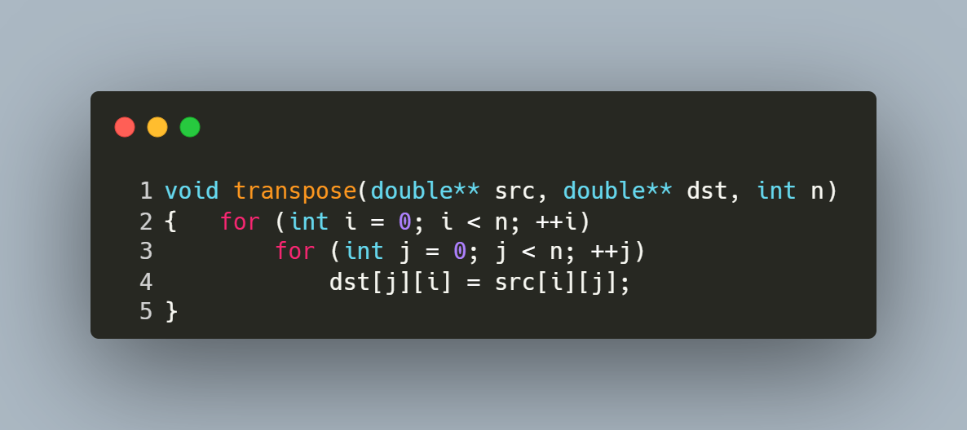
Step-by-Step Explanation
- Outer Loop (i loop):
  - Iterates over each row of the source matrix src (from 0 to n-1).
- Inner Loop (j loop):
  - For each row i, iterates over each column of the source matrix src (from 0 to n-1).
- Transpose Operation:
  - The element at position (i, j) in the source matrix is assigned to position (j, i) in the destination matrix:
    - dst[j][i] = src[i][j];.
- Result Storage:
  - After all iterations, the destination matrix dst contains the transpose of the source matrix src.

Function: QR Factorization Using Householder Reflections

Purpose: This function performs QR decomposition of a square matrix A into an orthogonal matrix Q and an upper triangular matrix R using Householder reflections.

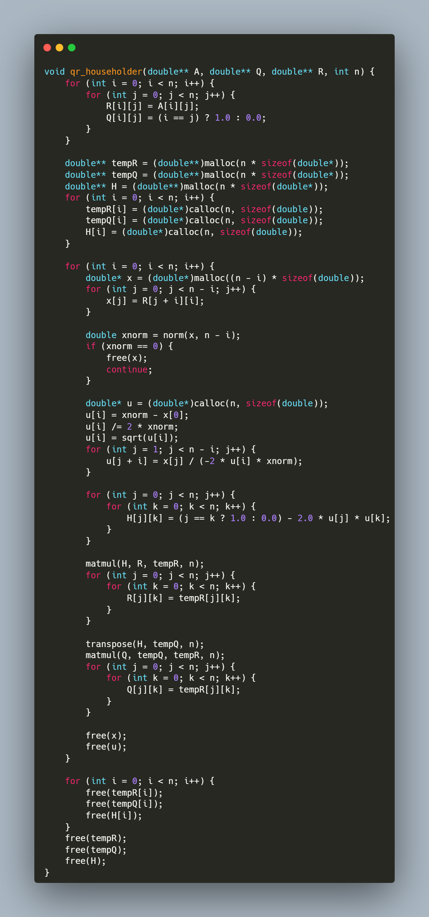
Step-by-Step Explanation
1. Initialization
for (int i = 0; i < n; i++) {
for (int j = 0; j < n; j++) {
R[i][j] = A[i][j];
Q[i][j] = (i == j) ? 1.0 : 0.0;
}
}
- R is initialized as a copy of A.
- Q starts as an identity matrix, which will accumulate orthogonal transformations.
2. Temporary Matrix Allocation
double** tempR = (double**)malloc(n * sizeof(double*));
double** tempQ = (double**)malloc(n * sizeof(double*));
double** H = (double**)malloc(n * sizeof(double*));
for (int i = 0; i < n; i++) {
tempR[i] = (double*)calloc(n, sizeof(double));
tempQ[i] = (double*)calloc(n, sizeof(double));
H[i] = (double*)calloc(n, sizeof(double));
}
- tempR/tempQ: Store intermediate results during matrix multiplications.
- H: Stores the Householder reflection matrix for each iteration.
- calloc initializes elements to zero.
3. Main Loop Over Columns
The function processes each column to zero out sub-diagonal elements:
for (int i = 0; i < n; i++) {
}
3.1 Column Extraction
double* x = (double*)malloc((n - i) * sizeof(double));
for (int j = 0; j < n - i; j++) {
x[j] = R[j + i][i];
}
- Extracts the sub-column starting at R[i][i] (elements below the diagonal).
3.2 Norm Calculation
double xnorm = norm(x, n - i);
if (xnorm == 0) {
free(x);
continue;
}
- Computes the Euclidean norm of the sub-column.
- Skips processing if the column is already zero (avoid division by zero).
3.3 Householder Vector (u) Construction
double* u = (double*)calloc(n, sizeof(double));
u[i] = xnorm - x[0];
u[i] /= 2 * xnorm;
u[i] = sqrt(u[i]);
for (int j = 1; j < n - i; j++) {
u[j + i] = x[j] / (-2 * u[i] * xnorm);
}
- u is computed according the Algorithm given.
3.4 Householder Matrix (H) Construction
for (int j = 0; j < n; j++) {
for (int k = 0; k < n; k++) {
H[j][k] = (j == k ? 1.0 : 0.0) - 2.0 * u[j] * u[k];
}
}
- H is computed as I - 2uuᵀ, where u is the Householder vector.
3.5 Update R Matrix
matmul(H, R, tempR, n);
for (int j = 0; j < n; j++) {
for (int k = 0; k < n; k++) {
R[j][k] = tempR[j][k];
}
}
- Applies the reflection to R, zeroing out sub-diagonal elements in column i.
3.6 Update Q Matrix
transpose(H, tempQ, n);
matmul(Q, tempQ, tempR, n);
for (int j = 0; j < n; j++) {
for (int k = 0; k < n; k++) {
Q[j][k] = tempR[j][k];
}
}
- Updates Q by accumulating the reflection: Q = Q * Hᵀ.
- Since H is orthogonal, its transpose is its inverse.
3.7 Memory Cleanup (Per Iteration)
free(x);
free(u);
- Releases memory for temporary vectors to prevent leaks.
4. Final Memory Cleanup
for (int i = 0; i < n; i++) {
free(tempR[i]);
free(tempQ[i]);
free(H[i]);
}
free(tempR);
free(tempQ);
free(H);
- Frees all dynamically allocated matrices.

Function: Solving Linear Systems Using QR Decomposition

Purpose: This function solves the linear system Ax = b using the QR factorization of matrix A. It computes the solution x by first transforming b into Qᵀb and then performing backward substitution on the upper triangular matrix R.
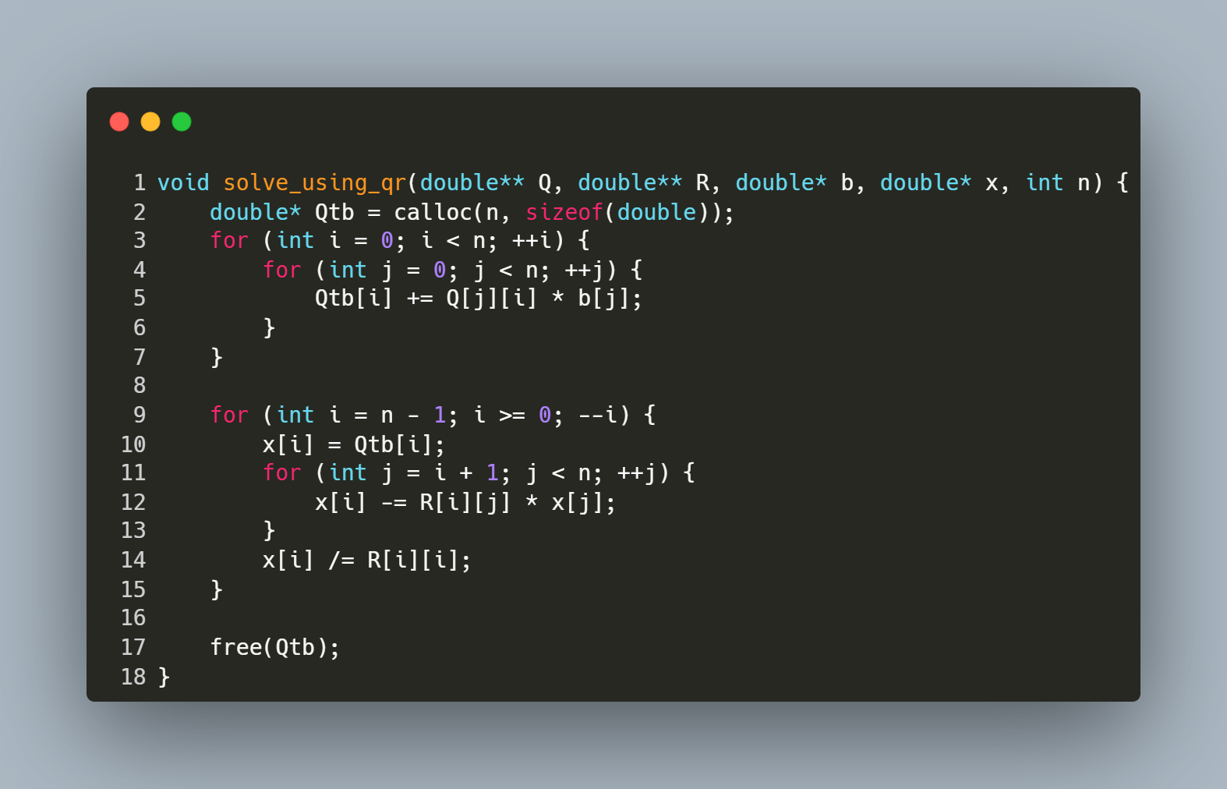
Step-by-Step Explanation
1. Compute Qᵀb
- Allocates a vector Qtb to store the product of Qᵀ (orthogonal matrix) and b.
- The nested loop calculates each element of Qtb as the dot product of the i-th column of Q (equivalent to the i-th row of Qᵀ) and b.
2. Backward Substitution
- Iterates backward from the last row (i = n-1) to the first (i = 0):
  - Initialize: x[i] = Qtb[i] (starting value for the solution element).
  - Subtract Known Terms: For each column j > i, subtract R[i][j] * x[j] to eliminate dependencies on already solved variables.
  - Normalize: Divide by the diagonal element R[i][i] to isolate x[i].

Function: Reading Matrix and Vector Input from a File

Purpose: This function reads a square matrix A of size n x n and a vector b of size n from a file named "inputs.txt". It ensures proper error handling for file operations and input parsing.

Step-by-Step Explanation
- Open File:
  - FILE *file = fopen("inputs.txt", "r"); opens the file "inputs.txt" in read mode.
  - If the file cannot be opened (e.g., it doesn't exist), the program prints an error message ("File not found") and exits.
- Read Matrix Elements:
  - The nested loop for (int i = 0; i < n; i++) { for (int j = 0; j < n; j++) { ... } } iterates through each row (i) and column (j) of matrix A.
  - fscanf(file, "%lf", &A[i][j]) reads a floating-point number from the file and stores it in the corresponding position in A.
  - If the input is invalid or missing, the program prints "Invalid input" and exits.
- Read Vector Elements:
  - The loop for (int i = 0; i < n; i++) { ... } iterates through each element of vector b.
  - fscanf(file, "%lf", &b[i]) reads a floating-point number from the file and stores it in the corresponding position in b.
  - Similar error handling ensures that invalid or missing input causes the program to terminate with an error message.
- Close File:
fclose(file); closes the file after all data has been read to release system resources.

Main Program for Solving Linear Systems via QR Factorization

Purpose: This program solves a linear system Ax = b using QR decomposition. It reads matrix A and vector b from a file, computes the orthogonal matrix Q and upper triangular matrix R, solves for x, and prints the solution, runtime, and matrix Q.
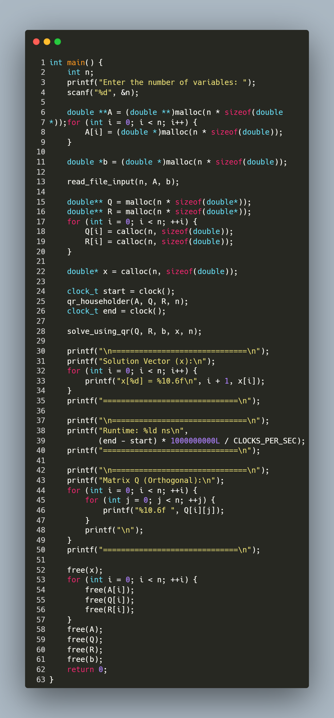
Step-by-Step Explanation
1. User Input
- Prompts the user to enter the number of variables (n).
2. Memory Allocation
- Allocates memory for:
  - A (n x n matrix) using nested malloc.
  - b (vector of size n).
  - Q and R (n x n matrices initialized with calloc).
  - x (solution vector initialized with calloc).
3. Read Input File
- Calls read_file_input(n, A, b) to populate A and b from "inputs.txt".
4. QR Factorization & Timing
- clock() records the start time.
- qr_householder(A, Q, R, n) decomposes A into Q (orthogonal) and R (upper triangular).
- clock() records the end time.
5. Solve for x
- solve_using_qr(Q, R, b, x, n) computes the solution vector x via backward substitution.
6. Print Results
- Displays the solution vector x with 6 decimal places.
- Prints the runtime in nanoseconds.
- Outputs the orthogonal matrix Q for verification.
7. Memory Cleanup
- Frees all dynamically allocated memory for A, b, Q, R, and x.

Thank You

