**BOKEH**

**Bokeh**is a data visualization library in Python that provides high-performance interactive charts and plots. Bokeh output can be obtained in various mediums like notebook, html and server. It is possible to embed bokeh plots in Django and flask apps.  
  
Bokeh provides two visualization interfaces to users:

***bokeh.models****: A low level interface that provides high flexibility to application developers.****bokeh.plotting****: A high level interface for creating visual glyphs.*

**Scatter Marker-**

|  |
| --- |
| # import modules  from bokeh.plotting import figure, output_notebook, show    # output to notebook  output_notebook()    # create figure  p = figure(plot_width = 400, plot_height = 400)    # add a circle renderer with  # size, color and alpha  p.circle([1, 2, 3, 4, 5], [4, 7, 1, 6, 3],           size = 10, color = "navy", alpha = 0.5)    # show the results  show(p) |

**Output :**  
  
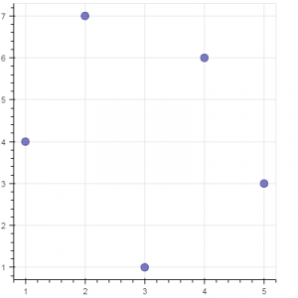

**Single line**

|  |
| --- |
| # import modules  from bokeh.plotting import figure, output_notebook, show    # output to notebook  output_notebook()    # create figure  p = figure(plot_width = 400, plot_height = 400)    # add a line renderer  p.line([1, 2, 3, 4, 5], [3, 1, 2, 6, 5],          line_width = 2, color = "green")    # show the results  show(p) |

**Output :**  
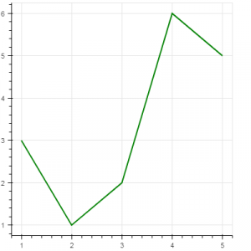

**Bar Chart**

|  |
| --- |
| # import necessary modules  import pandas as pd  from bokeh.charts import Bar, output_notebook, show    # output to notebook  output_notebook()    # read data in dataframe  df = pd.read_csv(r"D:/kaggle/mcdonald/menu.csv")    # create bar  p = Bar(df, "Category", values = "Calories",          title = "Total Calories by Category",                          legend = "top_right")    # show the results  show(p) |

**Output :**  
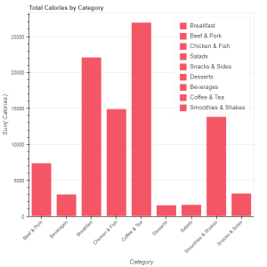

**Box Plot**

Box plot is used to represent statistical data on a plot. It helps to summarize statistical properties of various data groups present in the data.

|  |
| --- |
| # import necessary modules  from bokeh.charts import BoxPlot, output_notebook, show  import pandas as pd    # output to notebook  output_notebook()    # read data in dataframe  df = pd.read_csv(r"D:/kaggle / mcdonald / menu.csv")    # create bar  p = BoxPlot(df, values = "Protein", label = "Category",              color = "yellow", title = "Protein Summary (grouped by category)",               legend = "top_right")    # show the results  show(p) |

**Output :**  
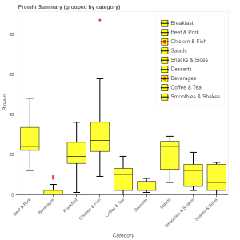

**Histogram**

Histogram is used to represent distribution of numerical data. The height of a rectangle in a histogram is proportional to the frequency of values in a class interval.

|  |
| --- |
| # import necessary modules  from bokeh.charts import Histogram, output_notebook, show  import pandas as pd    # output to notebook  output_notebook()    # read data in dataframe  df = pd.read_csv(r"D:/kaggle / mcdonald / menu.csv")    # create histogram  p = Histogram(df, values = "Total Fat",                 title = "Total Fat Distribution",                 color = "navy")    # show the results  show(p) |

**Output :**

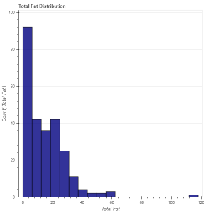

**Scatter plot**  
Scatter plot is used to plot values of two variables in a dataset. It helps to find correlation among the two variables that are selected.

|  |
| --- |
| # import necessary modules  from bokeh.charts import Scatter, output_notebook, show  import pandas as pd    # output to notebook  output_notebook()    # read data in dataframe  df = pd.read_csv(r"D:/kaggle / mcdonald / menu.csv")    # create scatter plot  p = Scatter(df, x = "Carbohydrates", y = "Saturated Fat",              title = "Saturated Fat vs Carbohydrates",              xlabel = "Carbohydrates", ylabel = "Saturated Fat",              color = "orange")    # show the results  show(p) |

**Output :**

