SQLAlchemy

[SQLAlchemy](http://www.sqlalchemy.org/) ([source code](https://github.com/zzzeek/sqlalchemy)) is a well-regarded database toolkit and [object-relational mapper (ORM)](https://www.fullstackpython.com/object-relational-mappers-orms.html) implementation written in Python. SQLAlchemy provides a generalized interface for creating and executing database-agnostic code without needing to write SQL statements.

SQLAlchemy isn't just an ORM- it also provides SQLAlchemy Core for performing database work that is abstracted from the implementation differences between PostgreSQL, SQLite, etc. In some ways, the ORM is a bonus to Core that automates commonly-required create, read, update and delete operations.

SQLAlchemy can be used with or without the ORM features. Any given project can choose to just use SQLAlchemy Core or both Core and the ORM. The following diagram shows a few example configurations with various application software stacks and backend databases. Any of these configurations can be a valid option depending on what type of application you are coding.

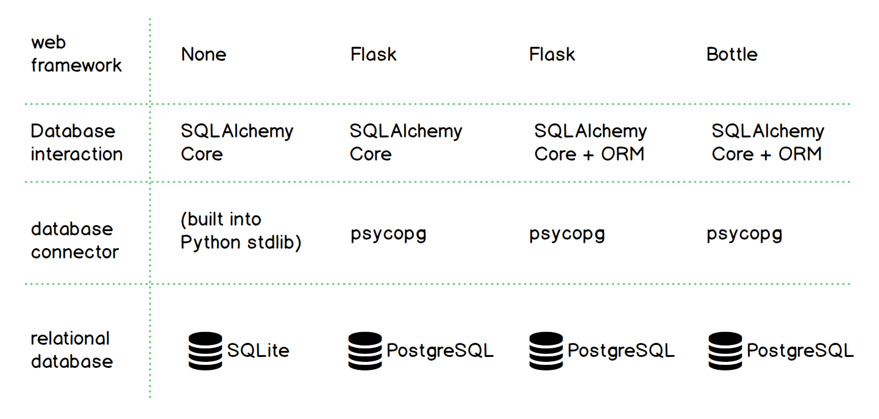

A benefit many developers enjoy with SQLAlchemy is that it allows them to write Python code in their project to map from the database schema to the applications' Python objects. No SQL is required to create, maintain and query the database. The mapping allows SQLAlchemy to handle the underlying database so developers can work with their Python objects instead of writing bridge code to get data in and out of relational tables.