**Devices and Circuits Laboratory**

**Experiment-10**

**Audio Amplifier and Microphone Circuits**

Aditya Kalyani 200020003

Tanish H Talapaneni 200020050

**Objectives:**

To Construct and Experiment with an audio amplifier and a microphone amplifier.

**Part A (Audio Amplifier)**

|  | **Input Amplitude** | **Output Amplitude** | **Distortion** |
| --- | --- | --- | --- |
|  | 1.1V | 1 | No |
|  | 1.1V | 1.3 | No |
|  | 1.1V | 1.4 | No |
|  | 1.1V | 1.8 | No |
|  | 1.1V | 3.1 | No |
|  | 1.1V | 4.6 | No |
|  | 1.1V | 6.8 | Yes |
|  | 1.1V | 7.2 | Yes |
|  | 1.1V | 8 | Yes |

Value of Rp pot when distortion is first observed: 6.8V

Average current drawn by the audio amplifier circuit at full-volume

conditions (potentiometer position at maximum) with a +0.025 V 1 kHz sine-wave

input: 32mA.

Average current drawn by audio amplifier when playing music audio under normal

listening conditions: 17mA.

Battery life for this circuit assuming a 500 mAh battery rating:

(500/avg current) : 40 hrs.

| **Rp Position** | **Current Drawn** | **Output Amplitude** |
| --- | --- | --- |
| Minimum | 10mA | 1.3V |
| Beginning of Distortion | 17mA | 6.8V |
| Maximum | 32mA | 8.2V |

Maximum Audio is heard at minimum Rp value.

Minimum Audio is heard at maximum Rp value.

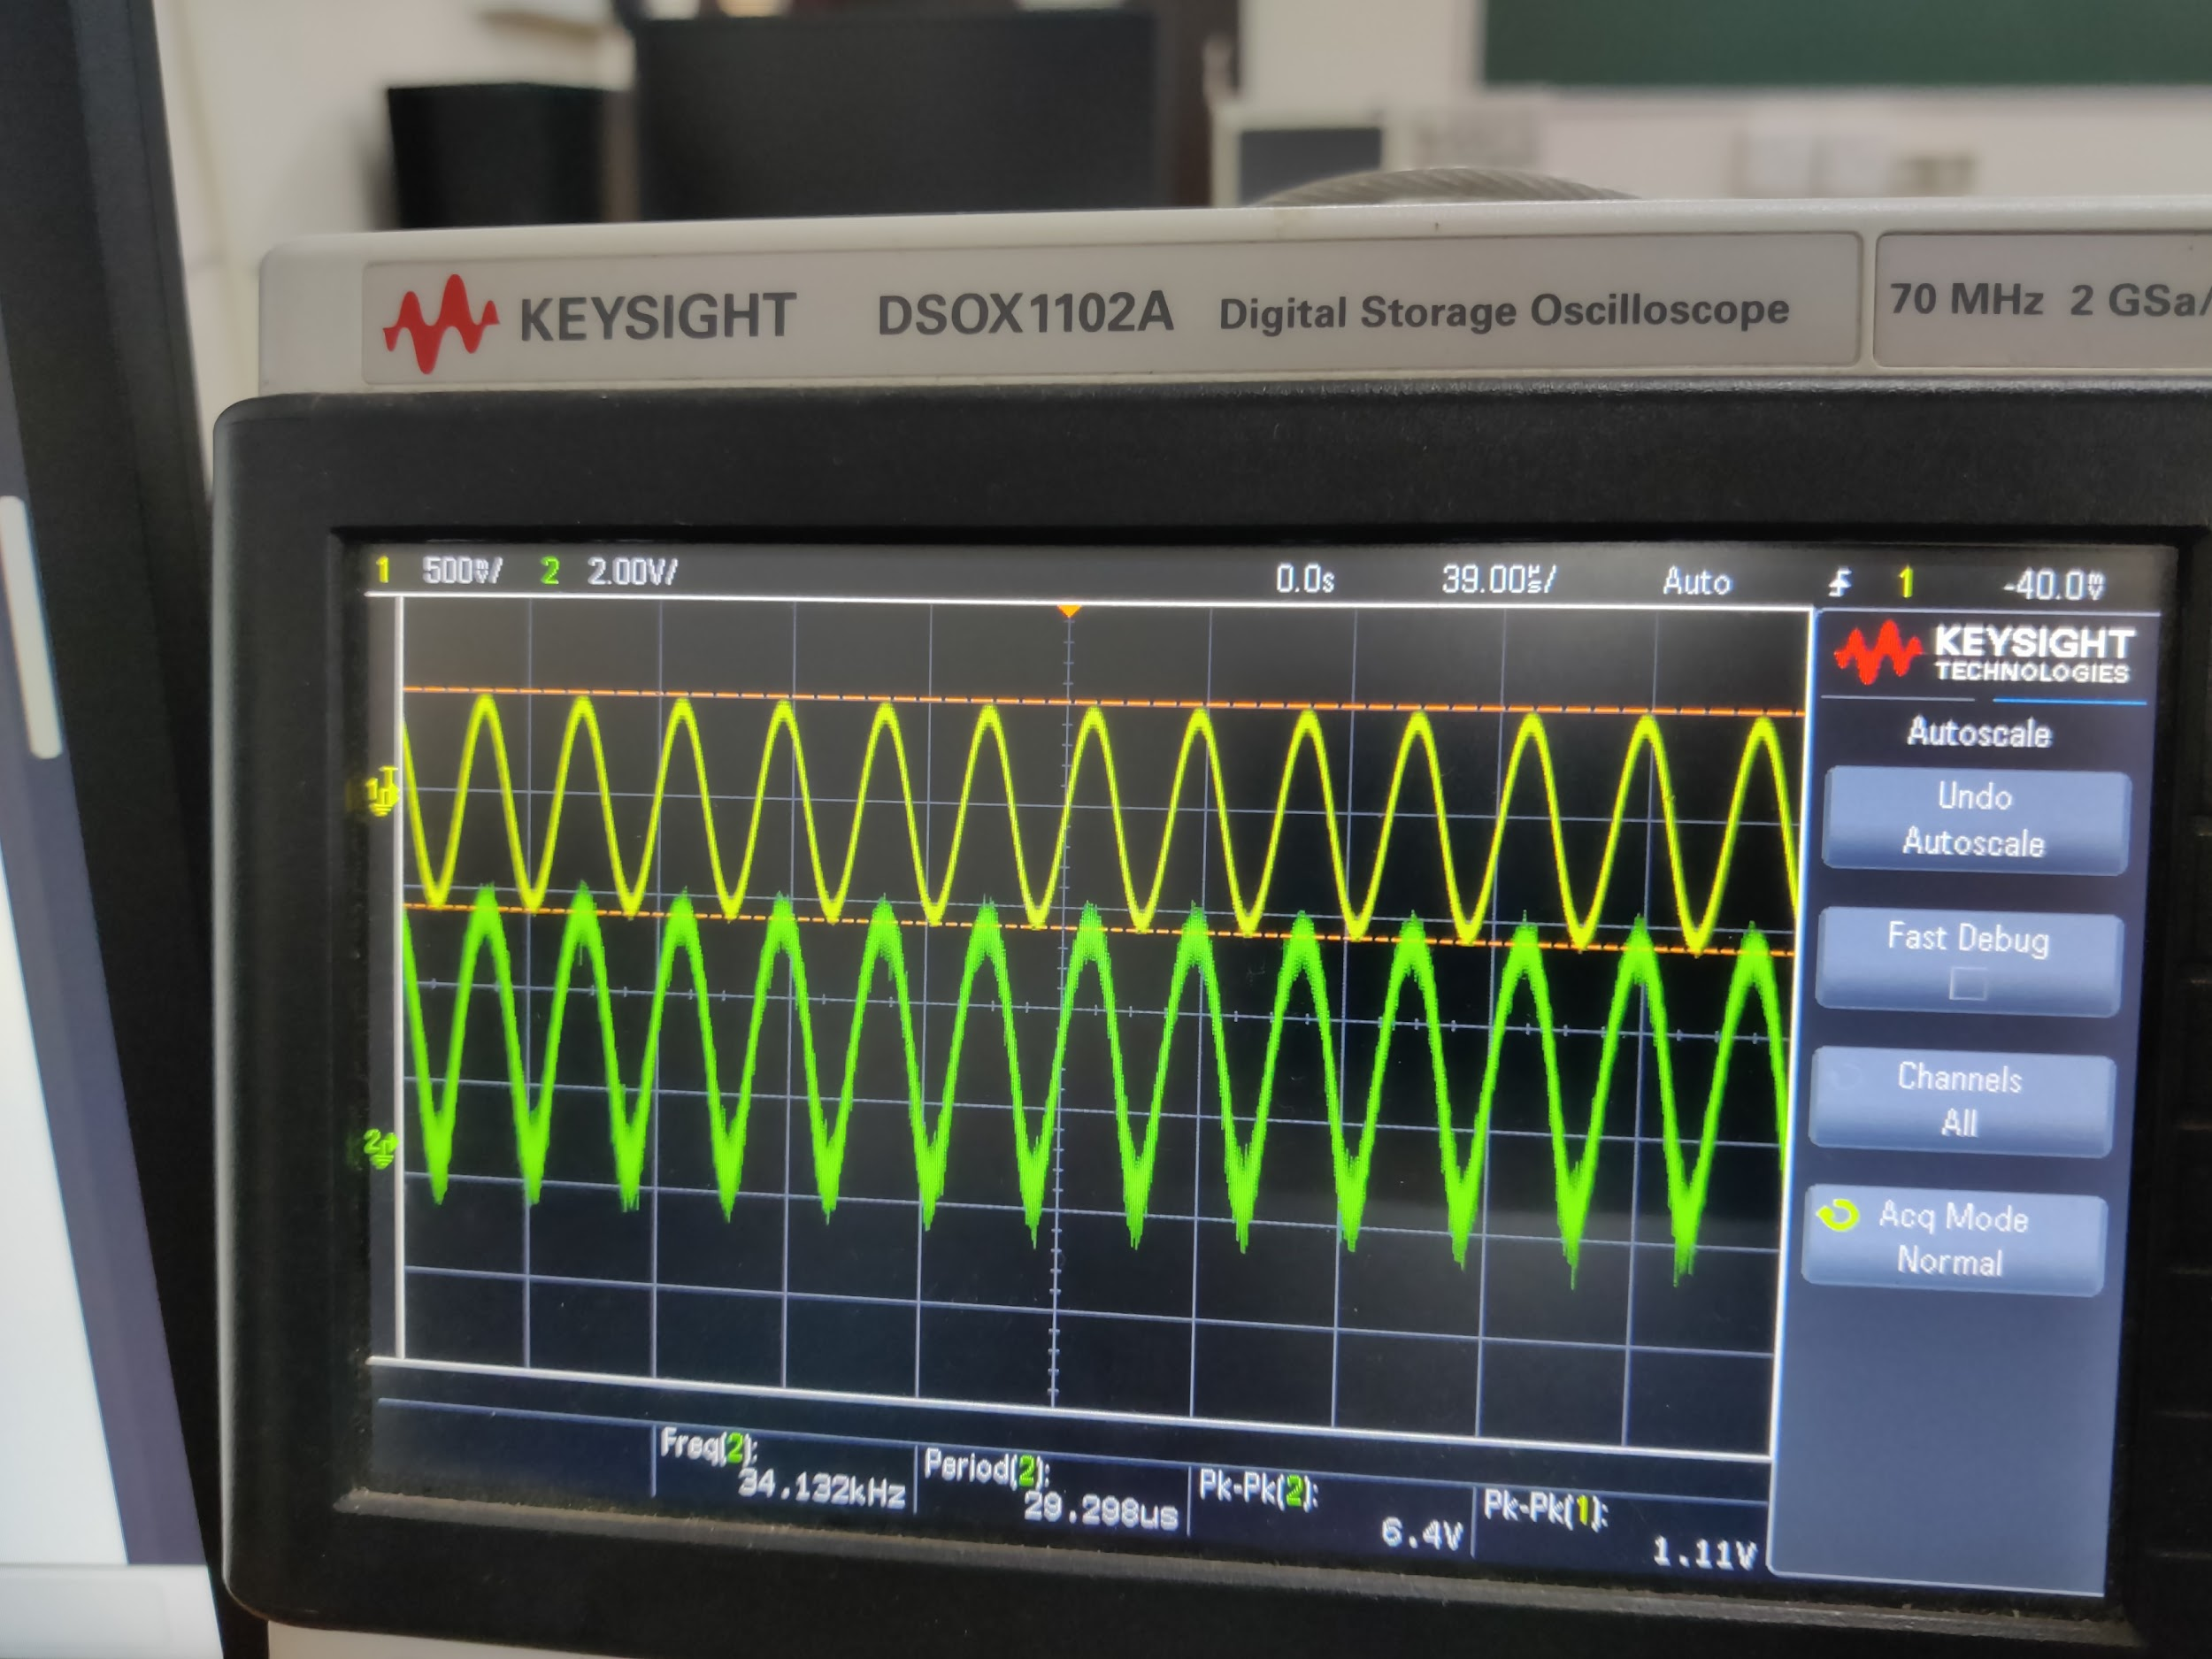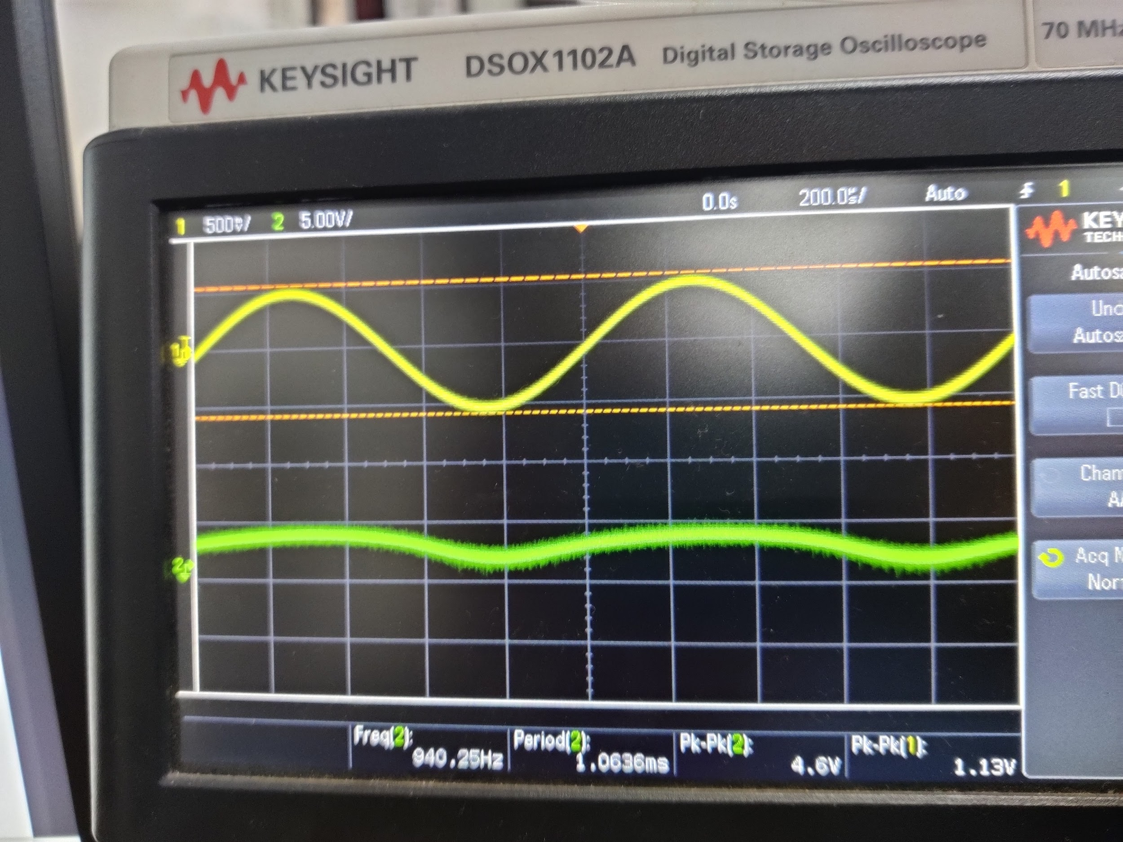

**Part B (Microphone Amplifier)**

|  | Without C2 | |
| --- | --- | --- |
| Frequency | Vo | Gain |
| 10 | 1.10 |  |
| 50 | 5.10 |  |
| 100 | 6.80 |  |
| 500 | 9.00 |  |
| 2000 | 9.00 |  |
| 5000 | 9.20 |  |
| 10000 | 9.20 |  |
| 50000 | 9.00 |  |
| 100000 | 8.20 |  |
| 500000 | 3.60 |  |

Cutoff Frequencies:

For C1: = 72.34Hz

For C2: = 4822.88Hz

On connecting the microphone at the input and speaker at the output, the output audio is undistorted. The audio obtained is clear.

On connecting the output of the microphone circuit to the input of the audio amplifier

circuit, the voice output seems distorted.

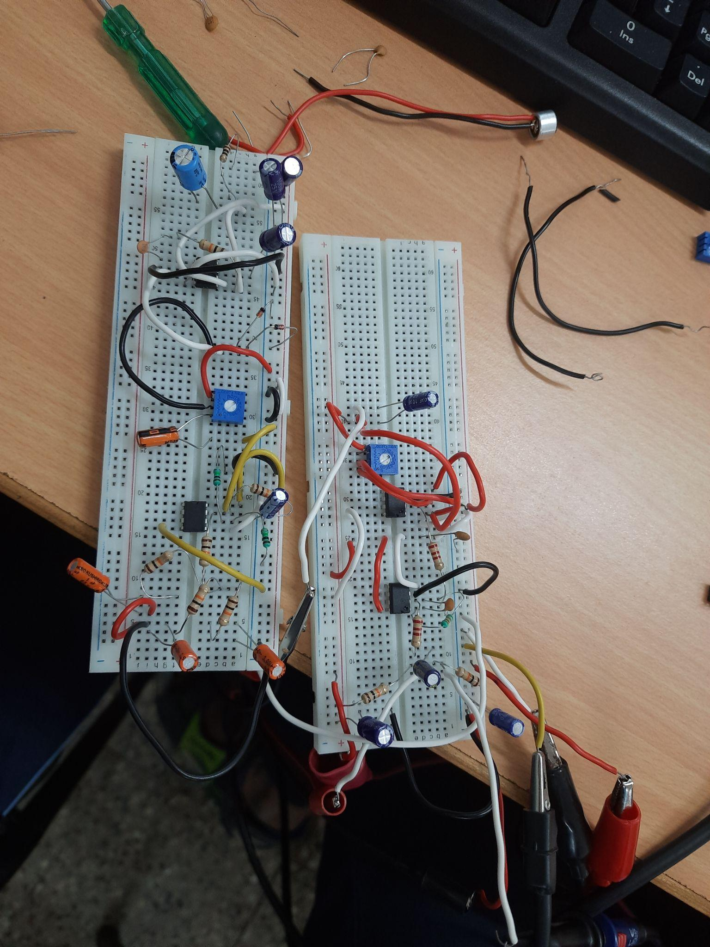

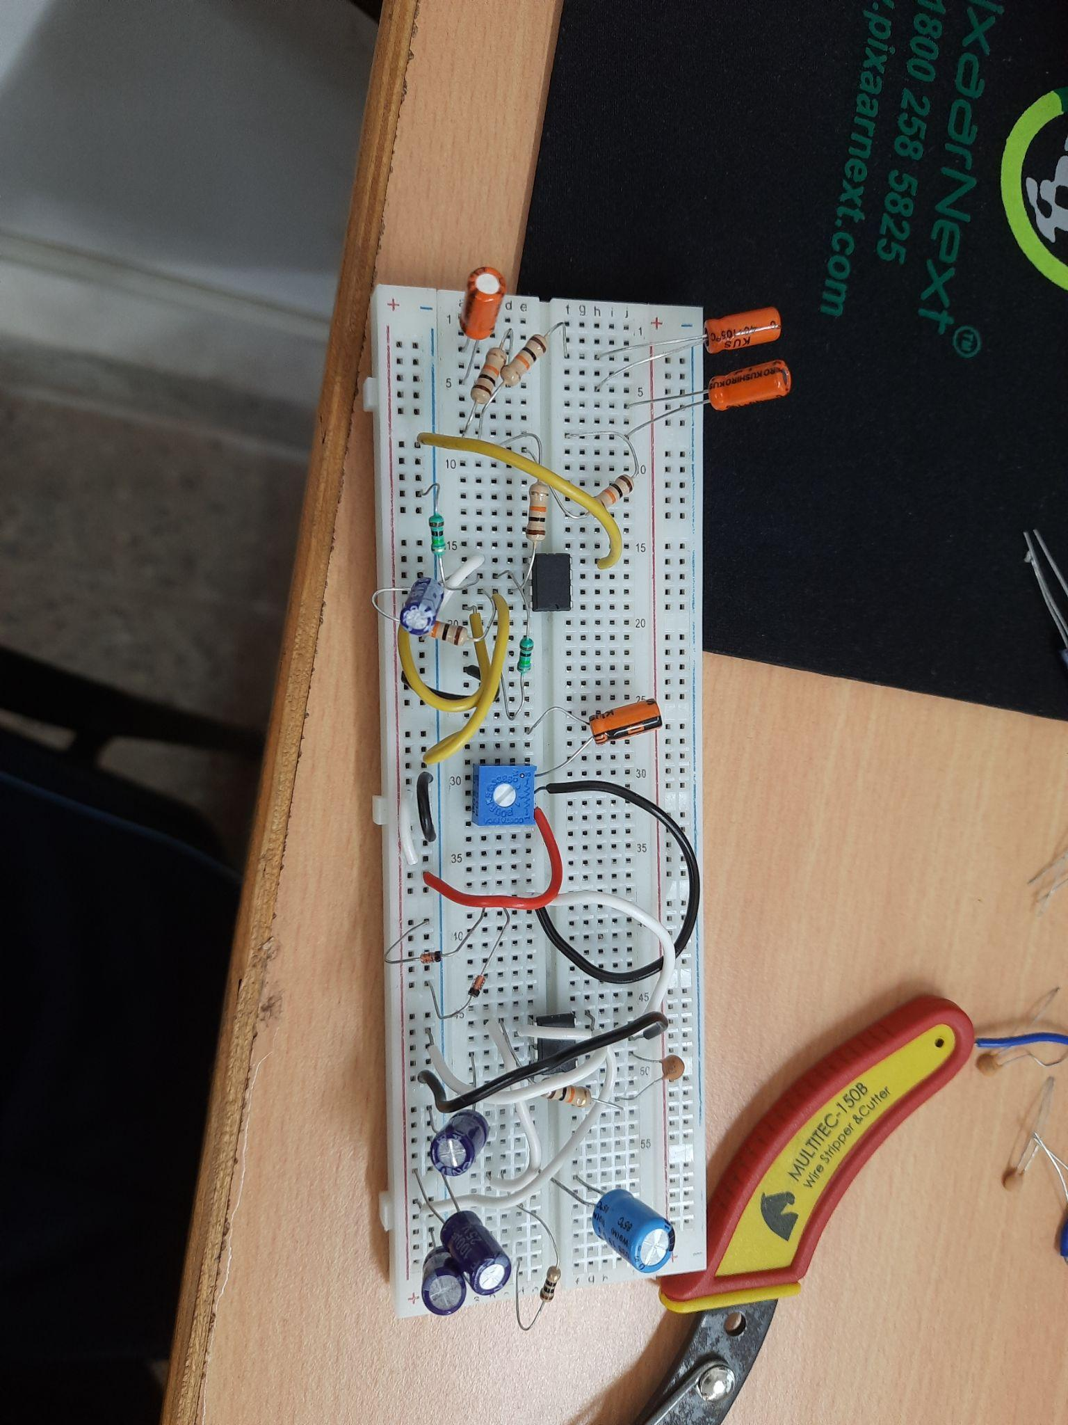

**Results and Discussions:**

**Tanish H Talapaneni:**

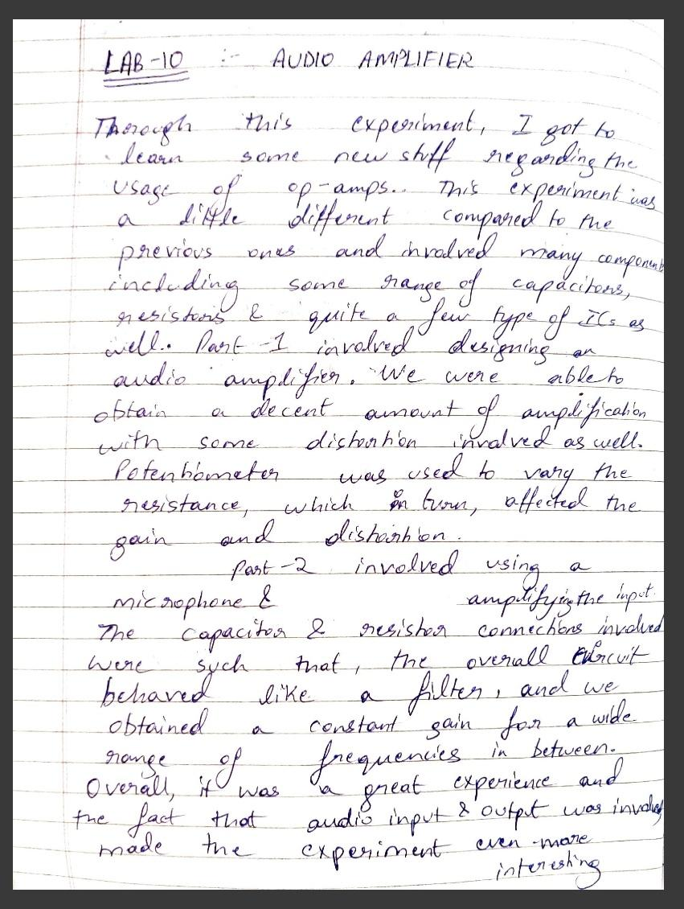

**Aditya Kalyani:**

