**Devices and Circuits Laboratory**

**Experiment-7**

**Non-Idealities in an Operational Amplifier**

Aditya Kalyani 200020003

Tanish H Talapaneni 200020050

**Objectives:**

Measurement of Offset Voltage, Bias Currents, Slew rate and Open-loop Gain of Operational Amplifiers

**Part A**

**Input offset voltage**

2.Values of the resistors using a multimeter.

R1=9.86k ohm

R2=10.12k ohm.

3.Output Voltage VO.

VO= 4.1 mV

4.The Offset voltage, VOS is calculated as:

=VO/𝐴v= $(4.1mV)/2×10^5$ = 0.02 $μV$

**Part B**

**Offset current measurement**

2.Output Voltage, VO.

VO= 0.365 V

4.

| Vo | Ib- | Ib+ | Ib | IOS |
| --- | --- | --- | --- | --- |
| -0.338V | 0.0365 $μA$ | 0.0338 $μA$ | 0.0703 $μA$ | 0.0027 $μA$ |

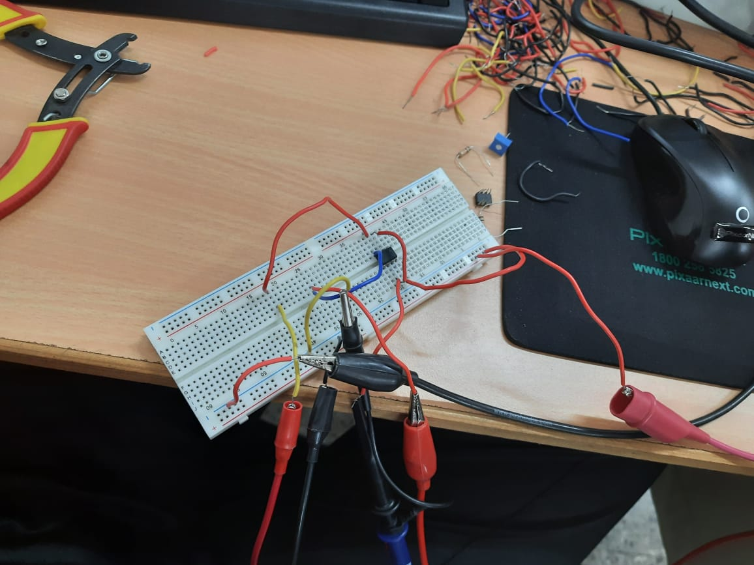

**Part C**

**Slew rate and Bandwidth measurement**

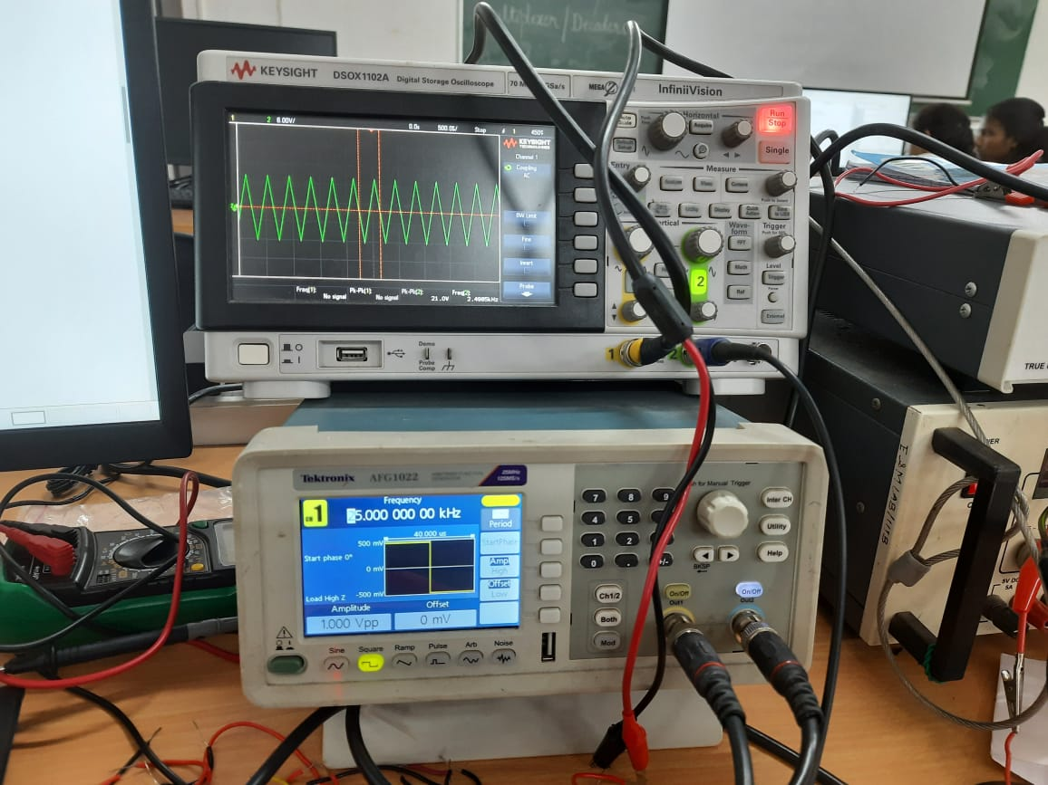

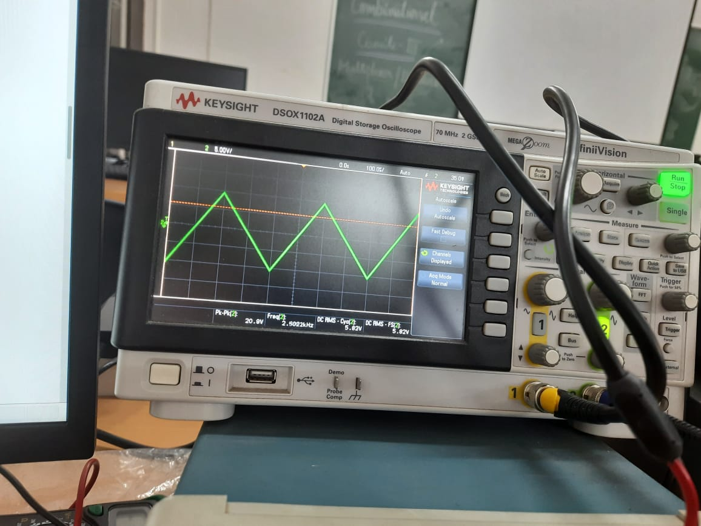

| Frequency | ΔV | ΔT | SR=ΔV/ΔT |
| --- | --- | --- | --- |
| 10kHz | 1.77 | 1.95 $μs$ | 0.533 V/ $μs$ |
| 25kHz | 1.05 | 2 $μs$. | 0.525 V/ $μs$ |
| 30kHz | 1.03 | 2.2 $μs$. | 0.526 V/ $μs$ |

The Slew rate of the OpAmp: **0.53V/ $μs$**

**Part D**

**Bandwidth measurement**

| Frequency | i/p | o/p | gain | Gain(in db) |
| --- | --- | --- | --- | --- |
| 1k | 1 | 1.22 | 1.22 | 1.7271 |
| 10k | 1 | 1.13 | 1.13 | 1.06 |
| 100k | 1. | 1.09 | 1.09 | 0.748 |
| 200k | 1 | 0.94 | 0.94 | -0.54 |
| 250k | 1 | 0.87 | 0.87 | -1.2 |
| 350k | 1 | 0.7 | 0.79 | -3.09 |
| 500k | 1 | 0.45 | 0.45 | -6.9 |

Bandwidth when gain falls below 3dB: **300k**

**Part E**

**Measurement of DC open-loop gain**

| VOA | VOB | -V’ | AOL |
| --- | --- | --- | --- |
| 0.9V | 0.98 | 1 | 125012.5 |

R2 = 1M ohm

R3  = 100 ohm

AOL =

= 125012.5

**Results and Discussions:**

Tanish H Talapaneni:

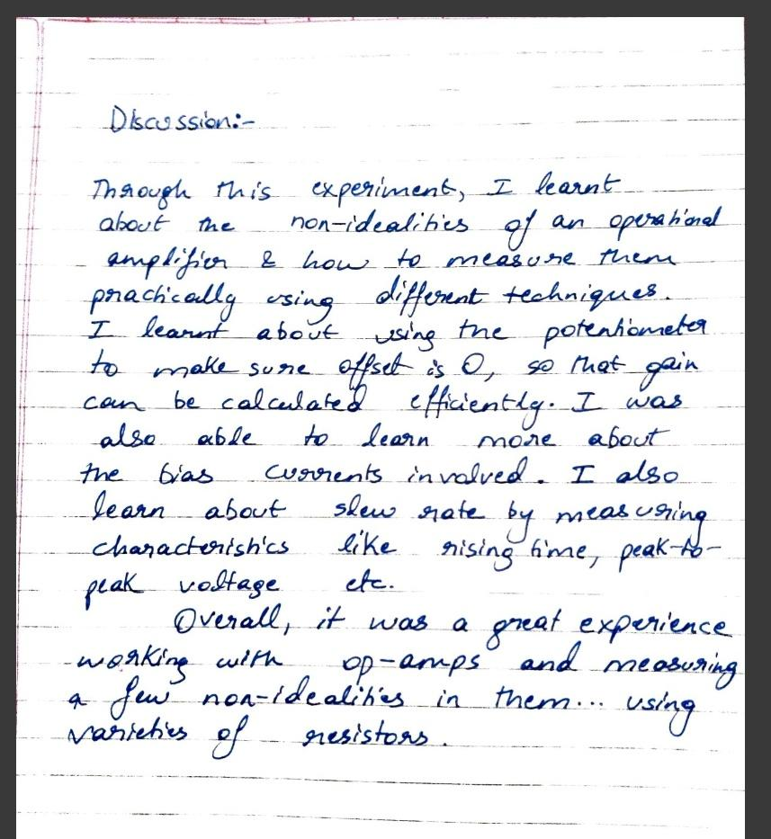

**Aditya Kalyani:**

