**+Devices and Circuits Laboratory**

**Experiment-8**

**Active Filters**

Aditya Kalyani 200020003

Tanish H Talapaneni 200020050

**Objectives:**

Measurement of Characteristics of low-pass, high-pass, band-pass and band-reject active filters

**Part A**

**Low Pass Filter**

Cut-off Frequency: = 1989.4 Hz

| Freq(in Hz) | Vi | Vo | Phase Diff |
| --- | --- | --- | --- |
| 500 | 100 | 140 | -18 |
| 700 | 100 | 137 | -22 |
| 1000 | 100 | 137 | -20 |
| 1500 | 100 | 135 | -30 |
| 3000 | 100 | 130 | -52 |
| 5000 | 100 | 78 | -130 |
| 10000 | 100 | 35 | 0 |
| 25000 | 100 | 10 | 0 |
| 50000 | 100 | 2 | 0 |
| 100000 | 100 | 1 | 0 |

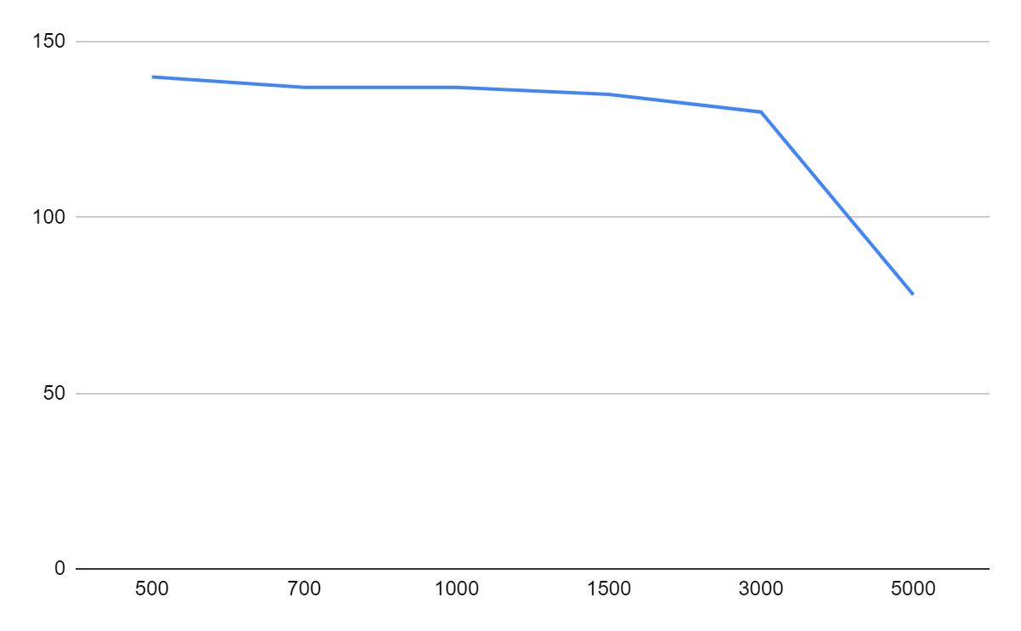

V0vs Frequency Graph

**High Pass Filter**

Cut-off Frequency: = 7234.3 Hz

| Freq(in Hz) | Vi | Vo | Phase Diff |
| --- | --- | --- | --- |
| 500 | 100 | 54 | -500 |
| 700 | 100 | 70 | -230 |
| 1000 | 100 | 72 | -250 |
| 1500 | 100 | 80 | -300 |
| 3000 | 100 | 107 | 62.91 |
| 5000 | 100 | 109 | 30 |
| 10000 | 100 | 110 | 33.1 |
| 25000 | 100 | 125 | 31 |
| 50000 | 100 | 130 | 27 |
| 100000 | 100 | 132 | 26 |

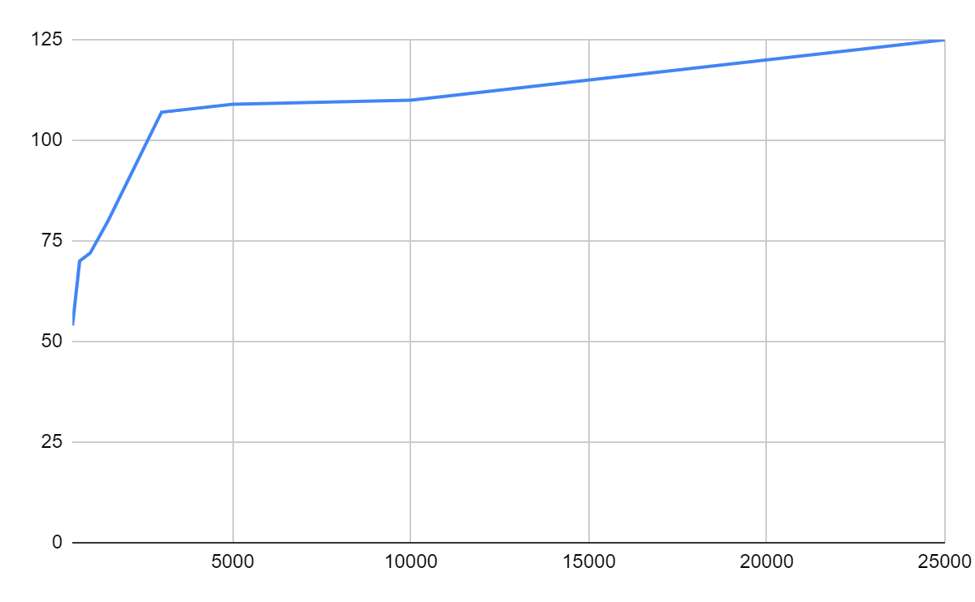

V0vs Frequency Graph

**Band-Reject Filter**

Lower Cut-off Frequency: = 1989.4 Hz

Higher Cut-off Frequency: = 7234.3 Hz

| Freq(in Hz) | Vi | Vo | Phase Diff |
| --- | --- | --- | --- |
| 100 | 0.6 | -170 | 1.6 |
| 500 | 0.6 | -170 | 1.6 |
| 1000 | 0.58 | -160 | 1.3 |
| 1500 | 0.5 | -160 | 0 |
| 2000 | 0.49 | -150 | -0.2 |
| 2500 | 0.47 | -160 | -0.5 |
| 5000 | 0.39 | -170 | -2.2 |
| 8000 | 0.41 | 171 | -1.7 |
| 9000 | 0.43 | 140 | -1.3 |
| 14000 | 0.49 | 173 | -0.2 |
| 15000 | 0.51 | 177 | 0.2 |
| 18000 | 0.52 | 175 | 0.3 |
| 25000 | 0.53 | 175 | 0.5 |
| 30000 | 0.51 | -160 | 0.4 |

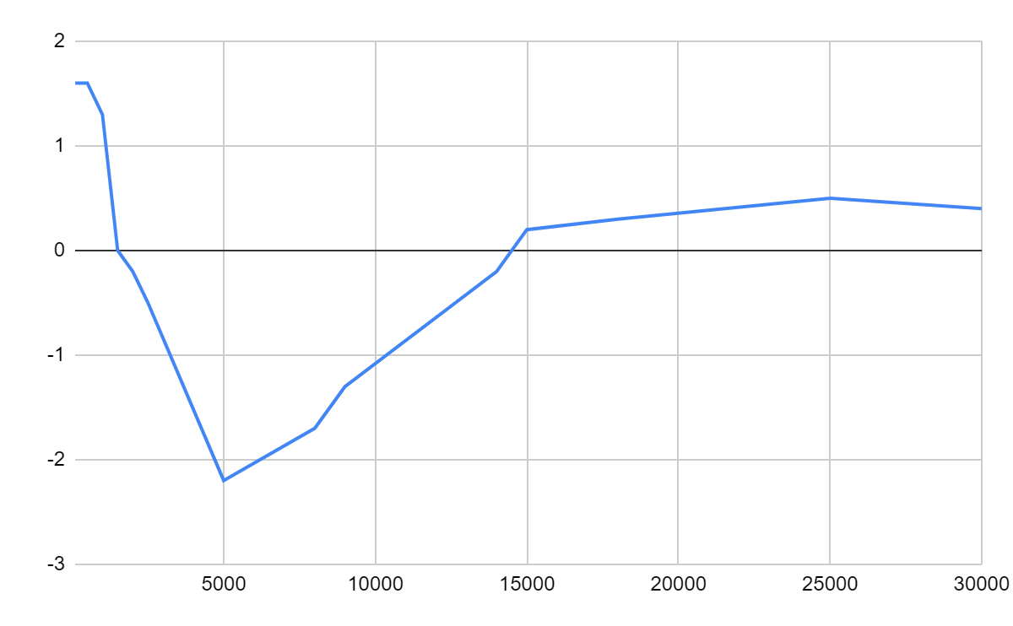

Gainvs Frequency Graph

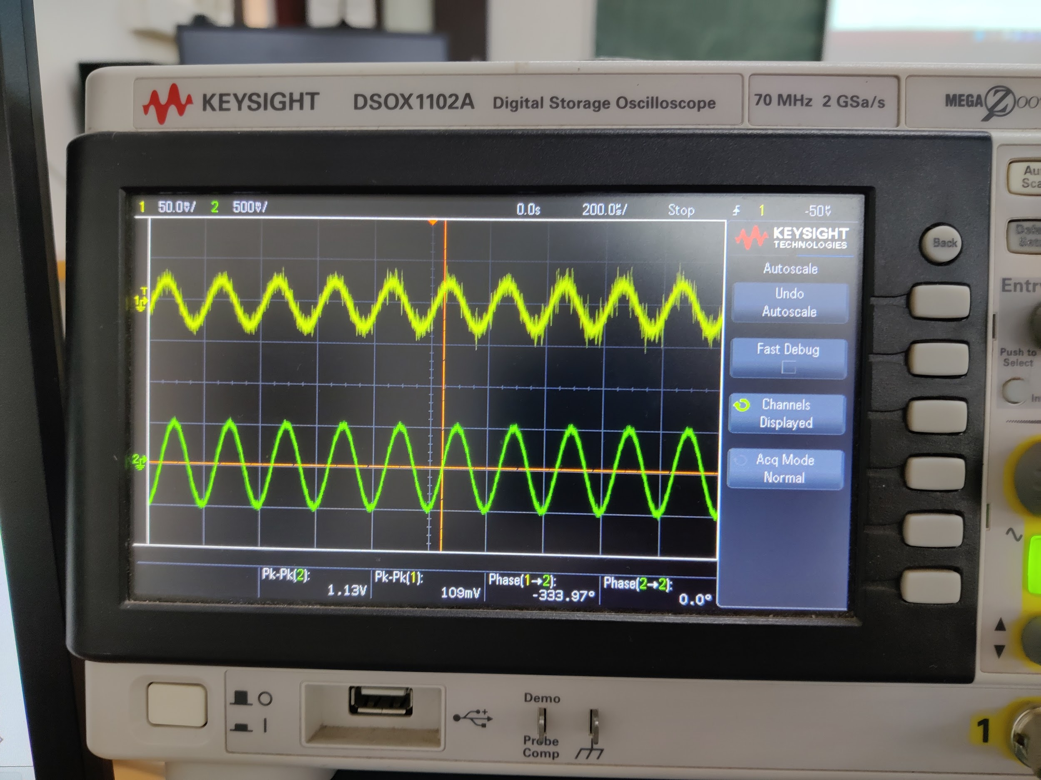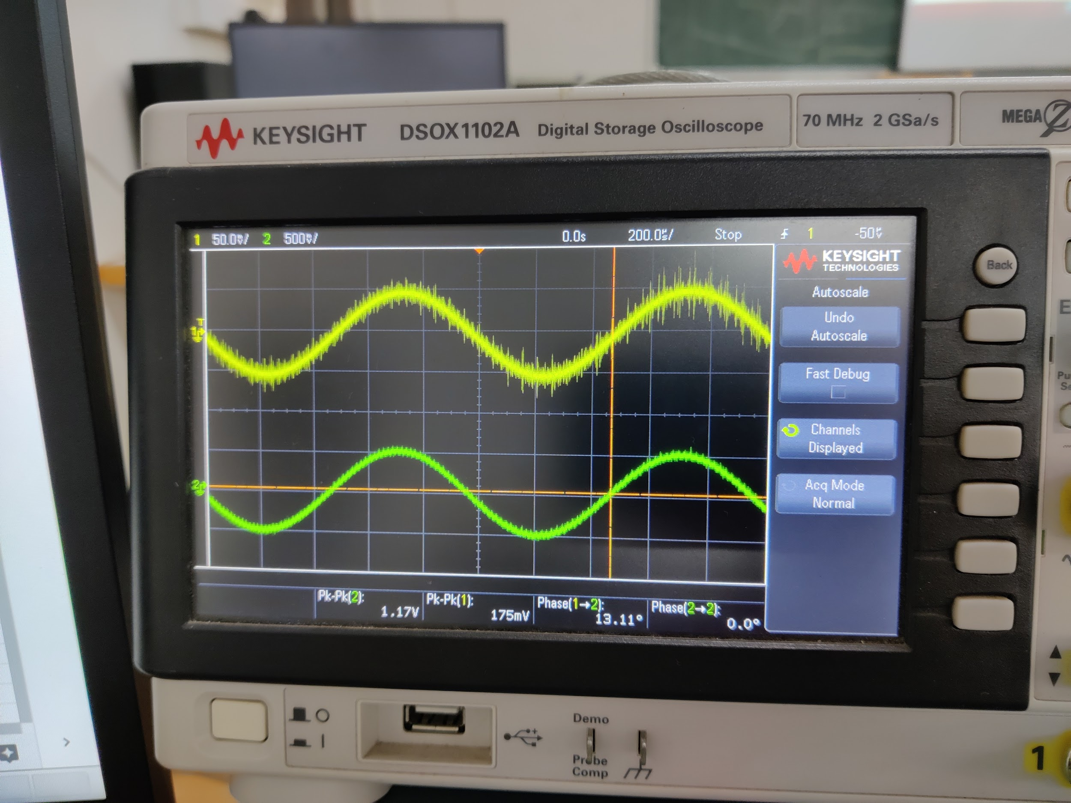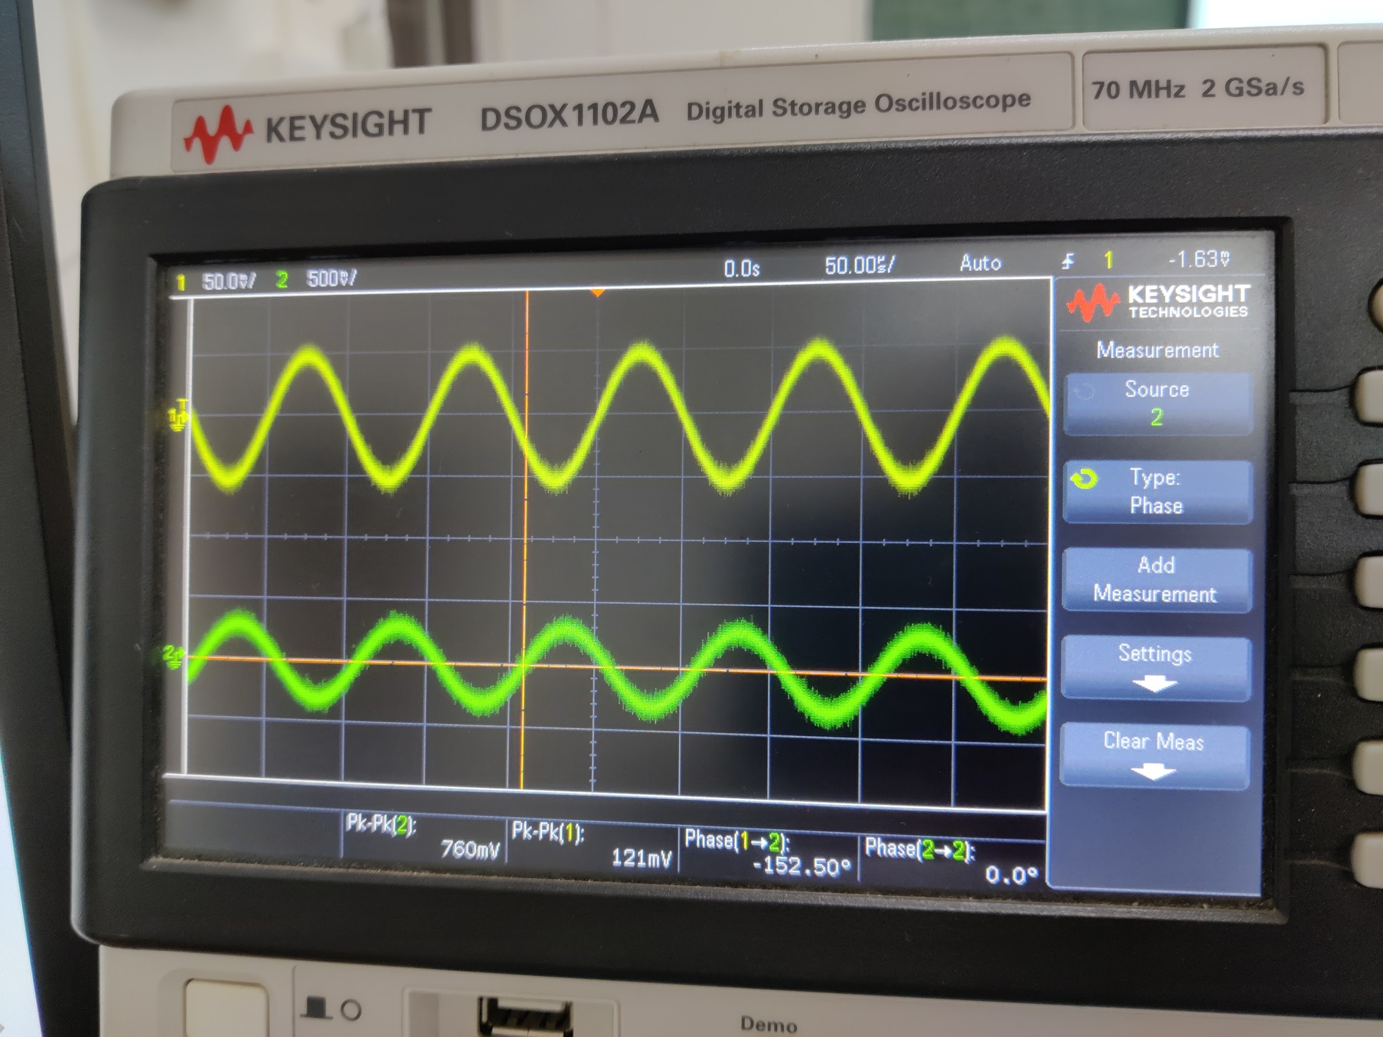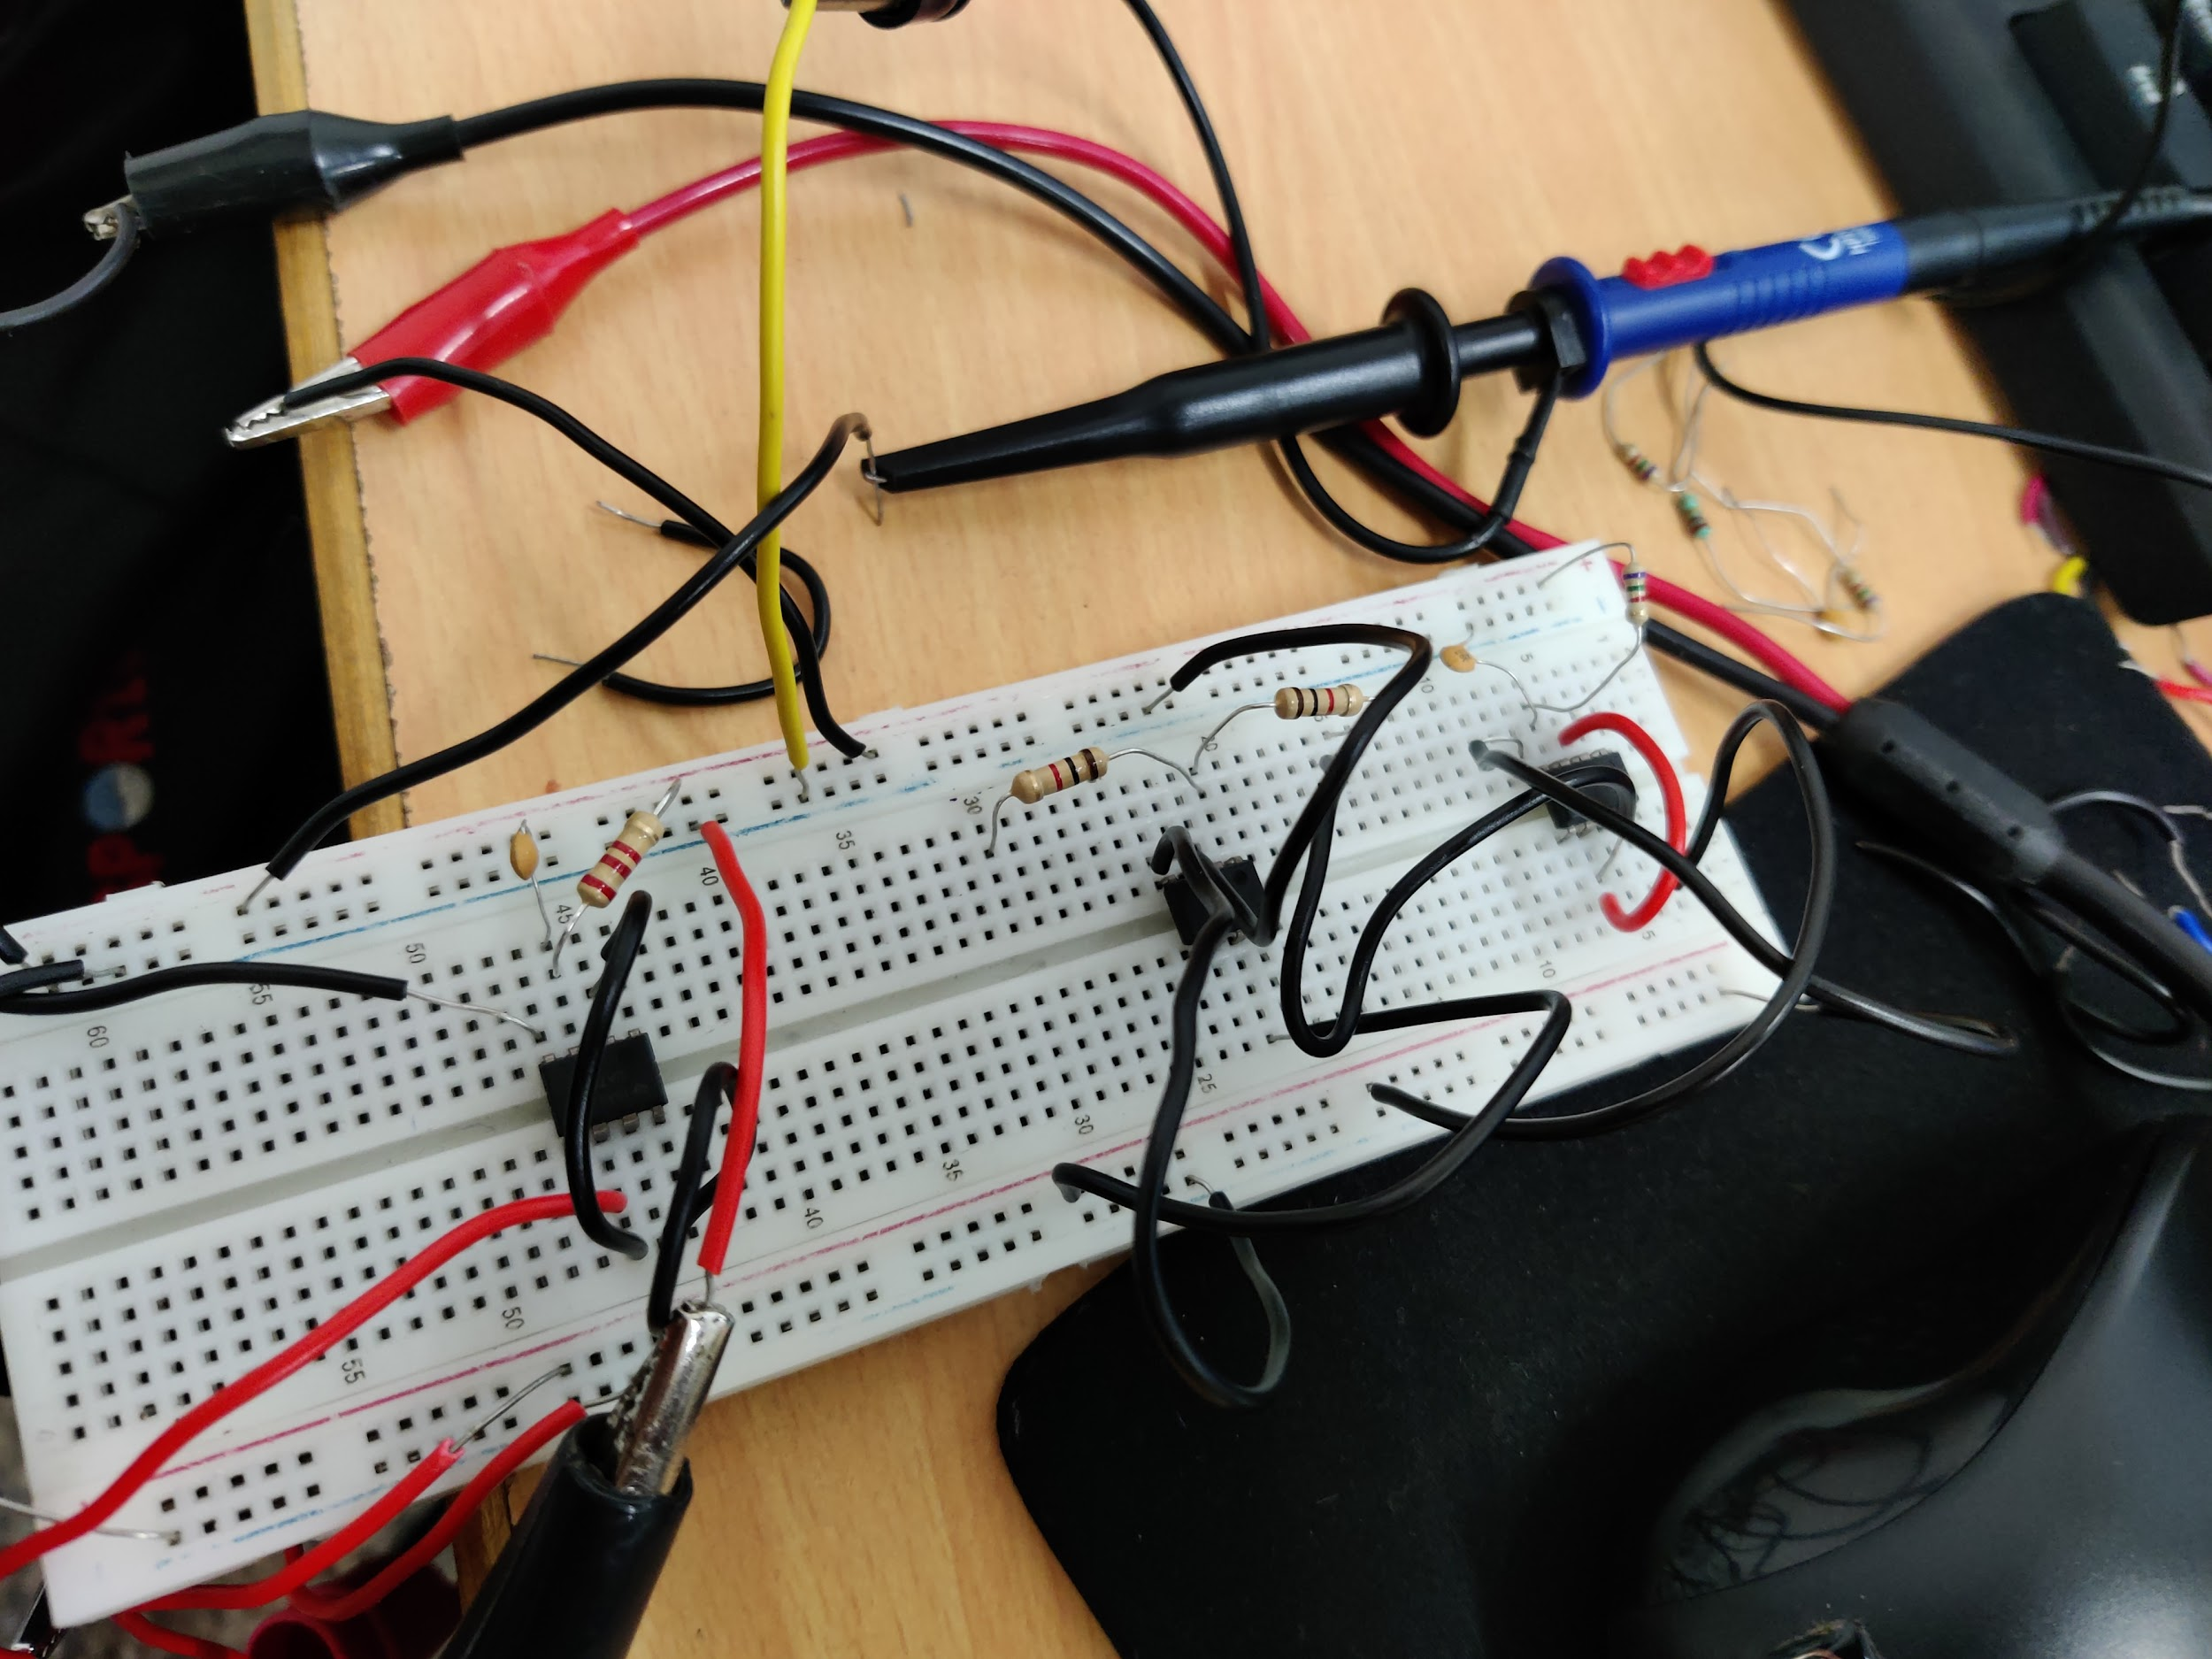

**Part B**

**Band Pass Filter**

Lower Cut-off Frequency: = 723.4 Hz

Higher Cut-off Frequency: = 7234.3 Hz

| Freq(in Hz) | Vi | Vo | Phase Diff |
| --- | --- | --- | --- |
| 100 | 100 | 200 | 0 |
| 500 | 100 | 300 | 0 |
| 1000 | 100 | 600 | 0 |
| 2000 | 100 | 860 | 10 |
| 5000 | 100 | 980 | 160 |
| 7500 | 100 | 900 | 162 |
| 10000 | 100 | 900 | 150 |
| 12500 | 100 | 800 | 140 |
| 15000 | 100 | 400 | 130 |
| 25000 | 100 | 200 | 110 |
| 50000 | 100 | 50 | 20 |
| 100000 | 100 | 10 | 5k |

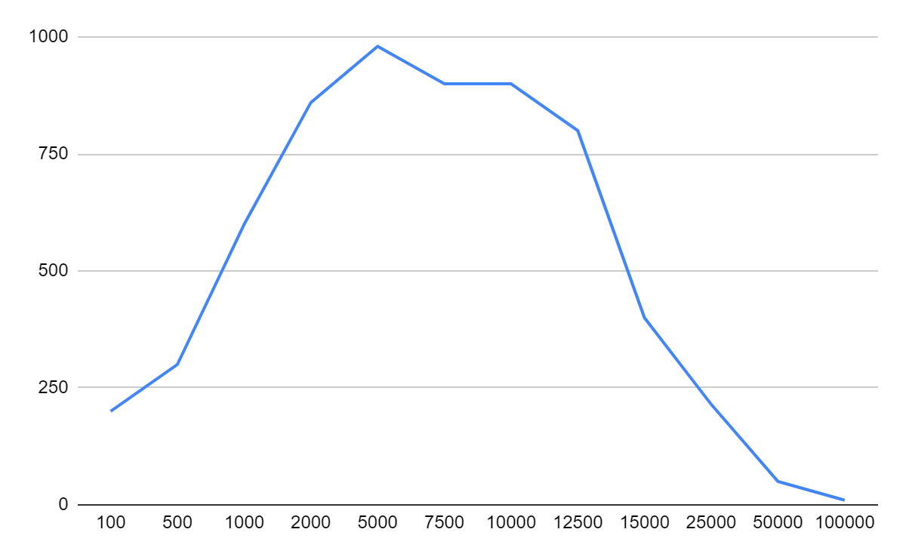

V0vs Frequency Graph

**Results and Discussions:**

Tanish H Talapaneni:

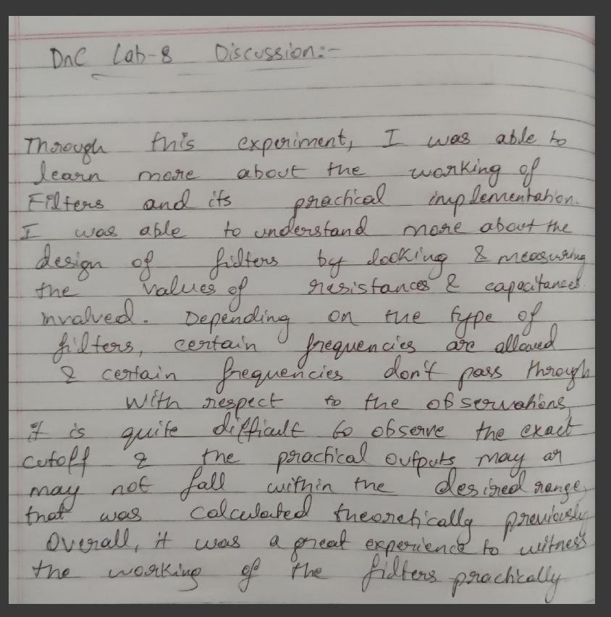

**Aditya Kalyani:**

