**Devices and Circuits Laboratory**

**Experiment-9**

**Multivibrators**

Aditya Kalyani 200020003

Tanish H Talapaneni 200020050

**Objectives:**

To construct and characterize a Scmitt Trigger, Mono-stable multivibrator and an Astable multivibrator.

**Part A**

| Va,R1,R2 | Practical | | | Theoretical | | |
| --- | --- | --- | --- | --- | --- | --- |
|  | Vt+ | Vt- (-) | Vt+-Vt- | Vt+ | Vt- (-) | Vt+-Vt- |
| 0,10,10 | 2.2 | 2.2 | 4.4 | 2 | 2 | 4 |
| 0,25,10 | 1.35 | 1.35 | 2.7 | 1.1 | 1.1 | 2.2 |
| 3,10,10 | 3.4 | 1.4 | 4.8 | 4.7 | 1.7 | 6.4 |
| 3,25,10 | 3.2 | 0.9 | 4.1 | 4 | 0.3 | 3.4 |

Theoretical Value:

| Input Frequency(in Hz) | Vi | Vo |
| --- | --- | --- |
| 100 | 5.0 | 3.7 |
| 500 | 5.0 | 3.72 |
| 1000 | 5.0 | 3.6 |
| 2500 | 5.0 | 3.72 |
| 5000 | 5.0 | 3.5 |
| 10000 | 5.0 | 3.76 |
| 15000 | 5.0 | 3.8 |
| 25000 | 5.0 | 3.7 |
| 50000 | 5.0 | 2.17 |
| 75000 | 5.0 | 0.57 |
| 100000 | 5.0 | 0.2 |

With change in frequency, the effect on the working of the circuit is almost none initially. On observing the hysteresis graph( in XY mode of the DSO), the changes observed are less. But, there is an operating frequency range for the trigger and once it is crossed. The trigger stops functioning and noise immunity can’t be achieved.

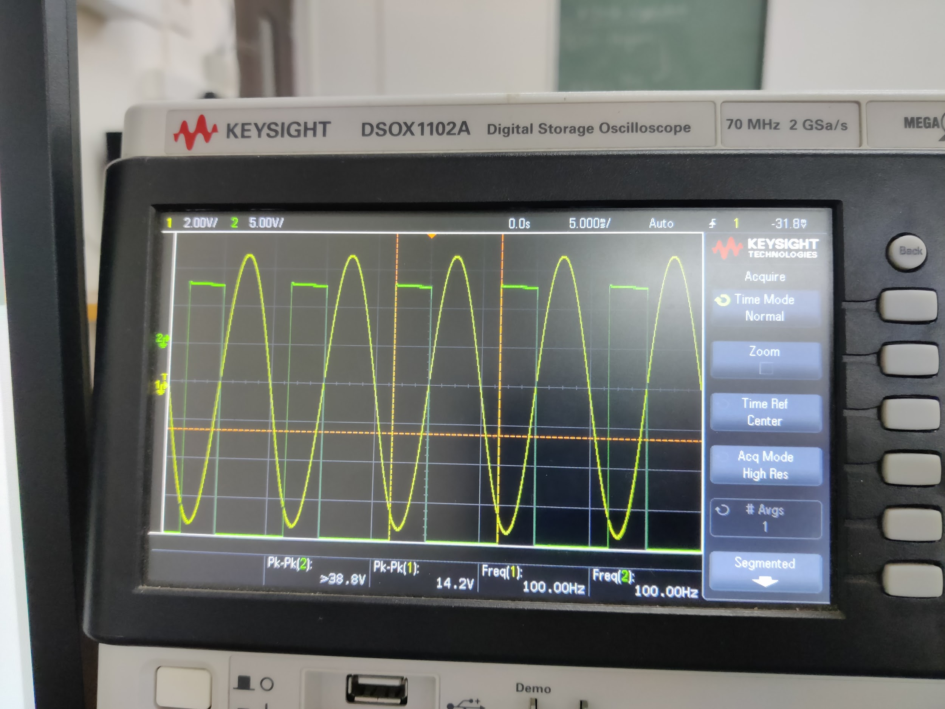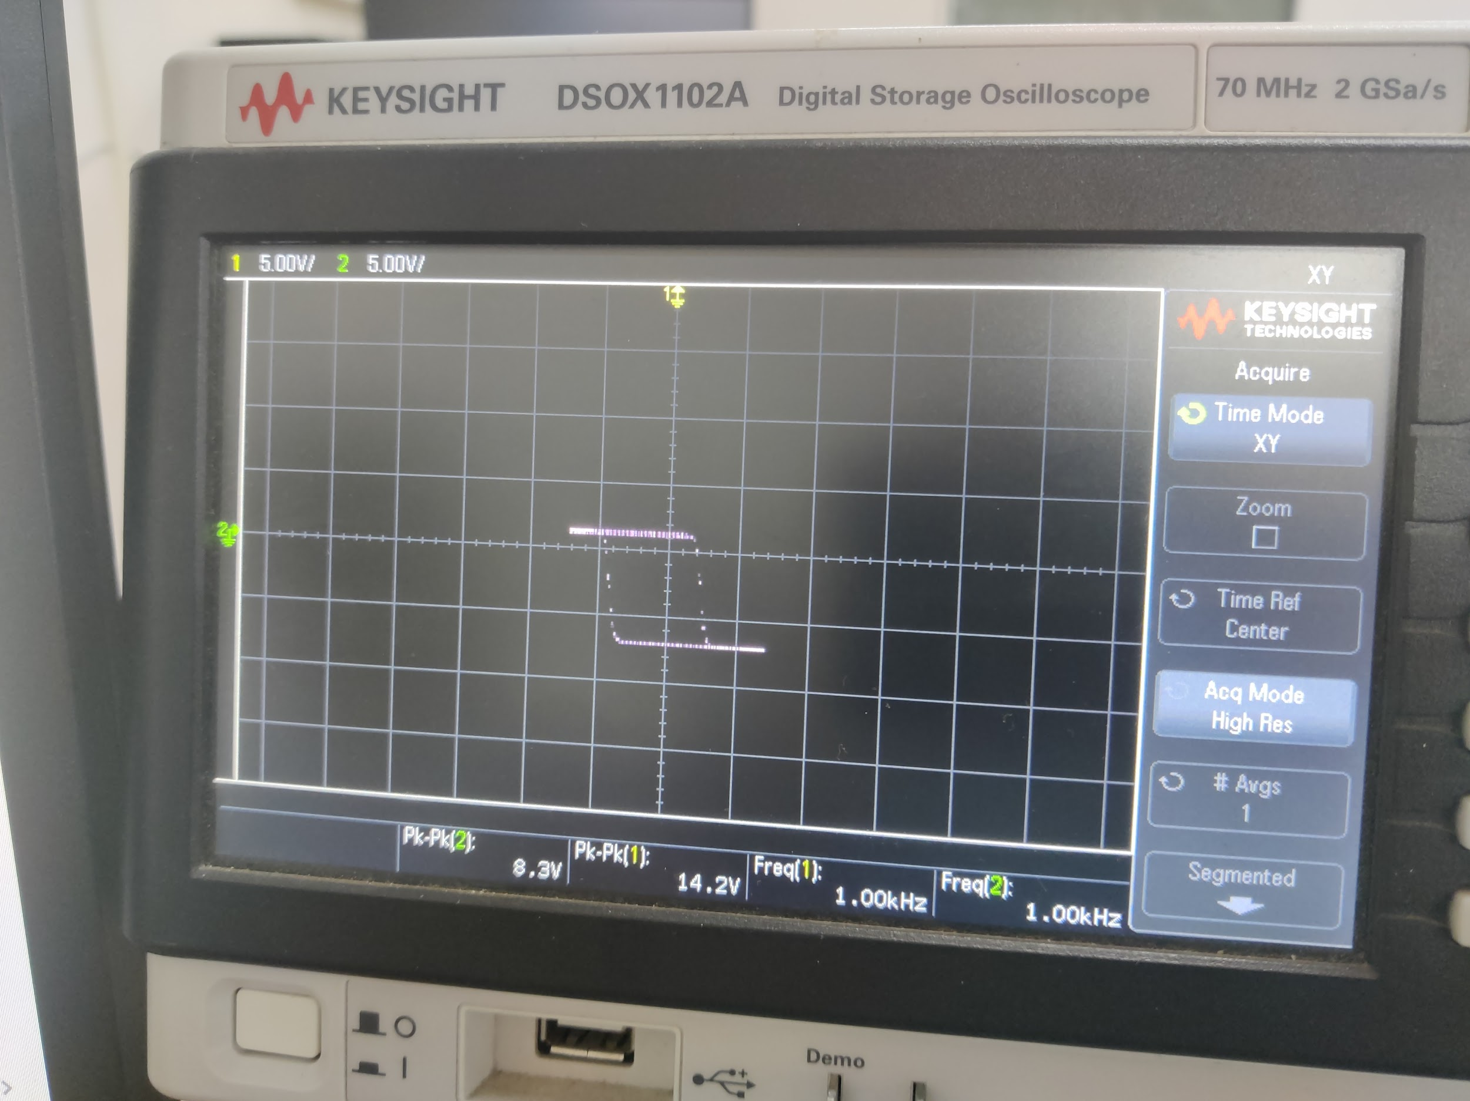

**Part B**

|  | Practical | | | Theoretical | | |
| --- | --- | --- | --- | --- | --- | --- |
| Resistance | Vc | Vo | Time period(s) | Vc | Vo | Time period(s) |
| 12 | 5.2 | 8.1 | 243 | 5.2 | 8.1 | 282 |
| 13 | 5.1 | 7.9 | 244 | 5.2 | 8.1 | 291 |
| 17 | 4.9 | 7.8 | 345 | 5.2 | 8.1 | 350 |
| 25 | 4.8 | 7.8 | 445.8 | 5.2 | 8.1 | 565 |
| 29 | 5.2 | 8.1 | 517 | 5.2 | 8.1 | 601 |
| 38 | 4.7 | 7.7 | 748.6 | 5.2 | 8.1 | 855 |
| 60 | 4.6 | 8.5 | 1450.5 | 5.2 | 8.1 | 1410 |
| 84 | 5.2 | 8.3 | 1881.2 | 5.2 | 8.1 | 1965 |
| 95 | 5.3 | 8.1 | 1925.7 | 5.2 | 8.1 | 2244 |
| 100 | 5.2 | 8.2 | 2055 | 5.2 | 8.1 | 2405 |
| 120 | 5.1 | 8.5 | 2209.3 | 5.2 | 8.1 | 2820 |
| 125.5 | 4.5 | 7.5 | 2400.4 | 5.2 | 8.1 | 2960 |

Theoretical Value:

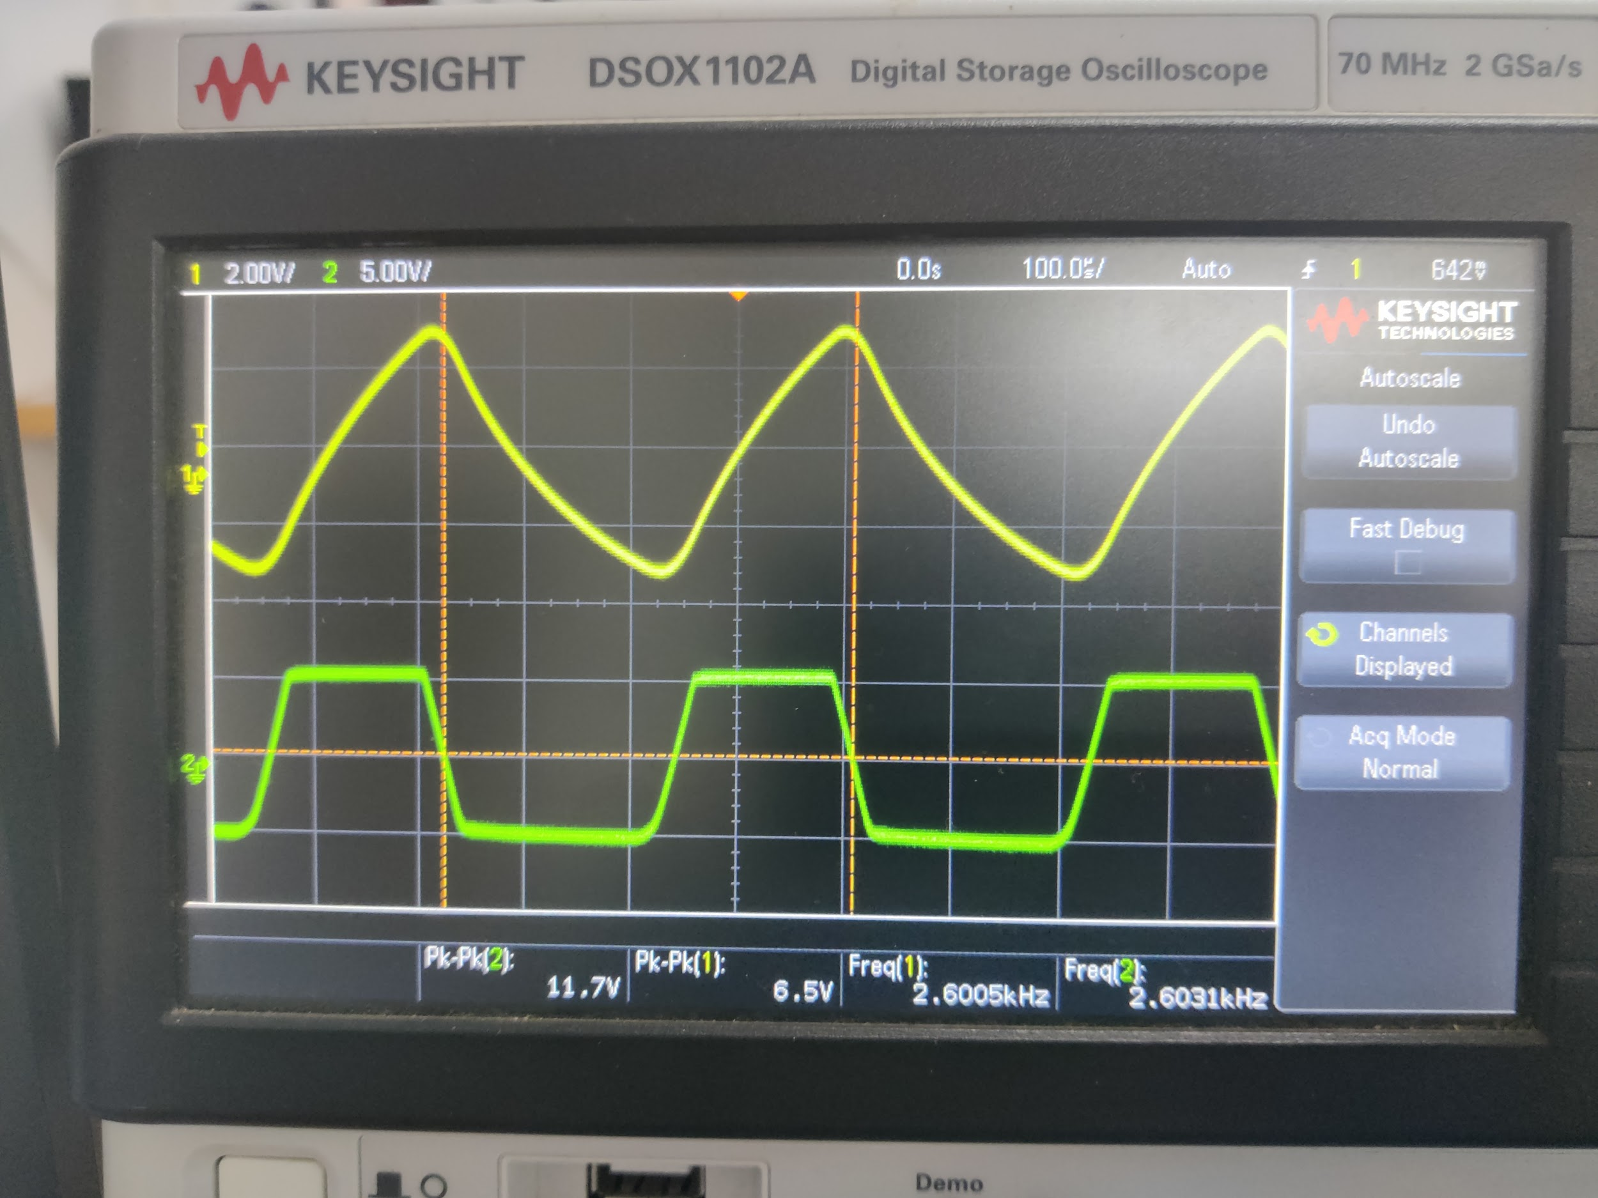

**Part C**

**Monostable Vibrator**:

When the 74LS121 standard op-amps are used, the output pulse width is equal to

Practical observation of pulse width: **9.5s**

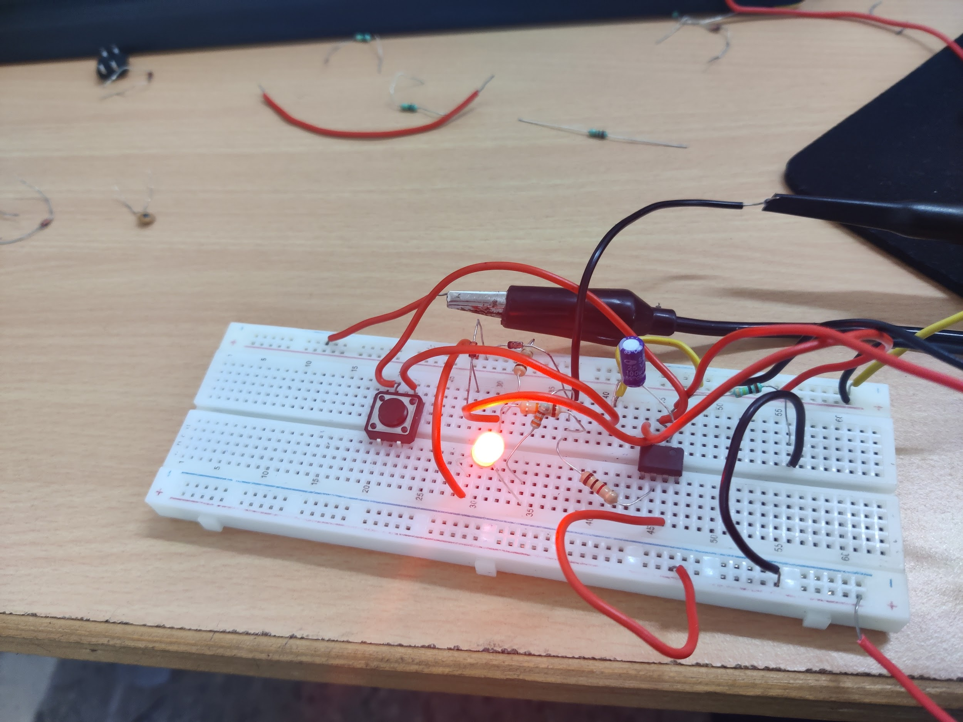

**Results and Discussions:**

**Tanish H Talapaneni:**

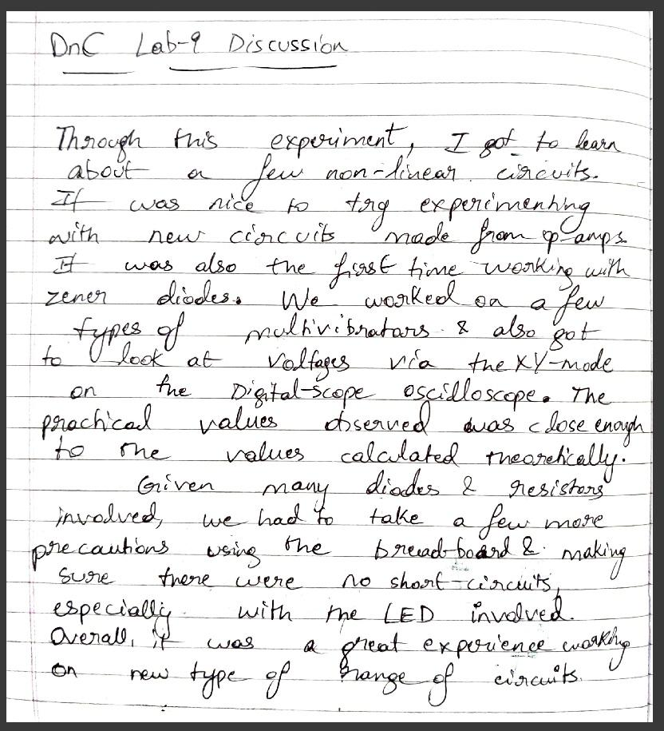

**Aditya Kalyani:**

