**Devices and Circuits Laboratory**

**Experiment-3**

**BJT Common Emitter Amplifier Characteristics**

Group : 1

Aditya Kalyani - 200020003

Tanish H Talapaneni - 200020050

**Software Simulation**

**Q1**:

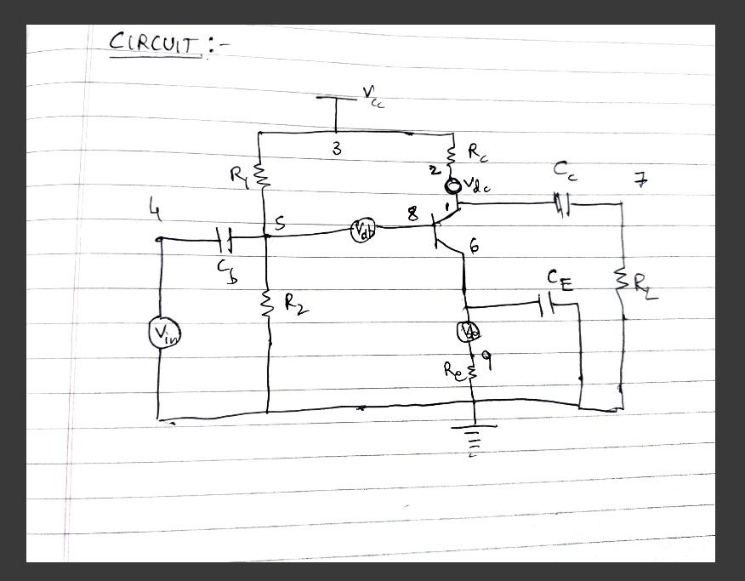

**Q2:**

**i) Netlist**

Common Emitter Amplifier

Vcc 3 0 12

Vin 4 0 1

Vdc 1 2 0

Vdb 5 8 0

Vde 6 9 0

.MODEL Q2N2222A NPN(IS=8.11E-14 BF=205 VAF=113 IKF=0.5 ISE=1.06E-11+ NE=2 BR=4 VAR=24 IKR=0.225 RB=1.37 RE=0.343 RC=0.137 CJE=2.95E-11+ TF=3.97E-10 CJC=1.52E-11 TR=8.5E-8 XTB=1.5)

Q1 2 8 6 Q2N2222A

Rc 3 1 5k

R1 3 5 33k

R2 5 0 10k

Re 9 0 2k

*Control Statements

.control

op

dc vin 0.01 1 0.02

run

*Plotting the output

plot i(Vdb)

plot i(Vdc)

plot i(Vde)

plot v(6)

plot v(1)

.endc

.end

**iI) Transient Analysis**

Common Emitter Amplifier

Vcc 3 0 12

Vin 4 0 ac 10mV SIN (10n 100m 2Khz 0 0 )

Vdc 1 2 0

Vdb 5 8 0

Vde 6 9 0

Cb 4 5 60u

Ce 9 0 100u

Cc 1 7 120u

Q1 2 8 6 Q2N2222A

.MODEL Q2N2222A NPN(IS=8.11E-14 BF=205 VAF=113 IKF=0.5 ISE=1.06E-11+ NE=2 BR=4 VAR=24 IKR=0.225 RB=1.37 RE=0.343 RC=0.137 CJE=2.95E-11+ TF=3.97E-10 CJC=1.52E-11 TR=8.5E-8 XTB=1.5)

R1 3 5 33k

Rc 3 1 5k

R2 5 0 10k

Re 9 0 2k

Rl 7 0 1k

.tran 0.001ms 1ms

.control

op

run

plot v(4),v(7)

*plot v(7)/v(4) xlabel 'time' ylabel 'gain'

.endc

.end

**iii) AC Analysis**

Common Emitter Amplifier

Vcc 3 0 12

Vin 4 0 ac 10mV SIN (10n 10m 3Khz 0 0 )

Vdc 1 2 0

Vdb 5 8 0

Vde 6 9 0

Cb 4 5 60u

Ce 9 0 100u

Cc 1 7 120u

Q1 2 8 6 Q2N2222A

.MODEL Q2N2222A NPN(IS=8.11E-14 BF=205 VAF=113 IKF=0.5 ISE=1.06E-11+ NE=2 BR=4 VAR=24 IKR=0.225 RB=1.37 RE=0.343 RC=0.137 CJE=2.95E-11+ TF=3.97E-10 CJC=1.52E-11 TR=8.5E-8 XTB=1.5)

R1 3 5 33k

Rc 3 1 5k

R2 5 0 10k

Re 9 0 2k

Rl 7 0 1k

.ac dec 10 20 100000k

.control

op

run

plot -v(7)/v(5)

.endc

.end

**Q3**:

Values:

From Simulation:

**VC** 6.89V

**VE** 2.04V

**VCE** 4.85V

**IC** 1.04 mA

**IE** 1.05 mA

**IB** 6.35 A

From Calculation:

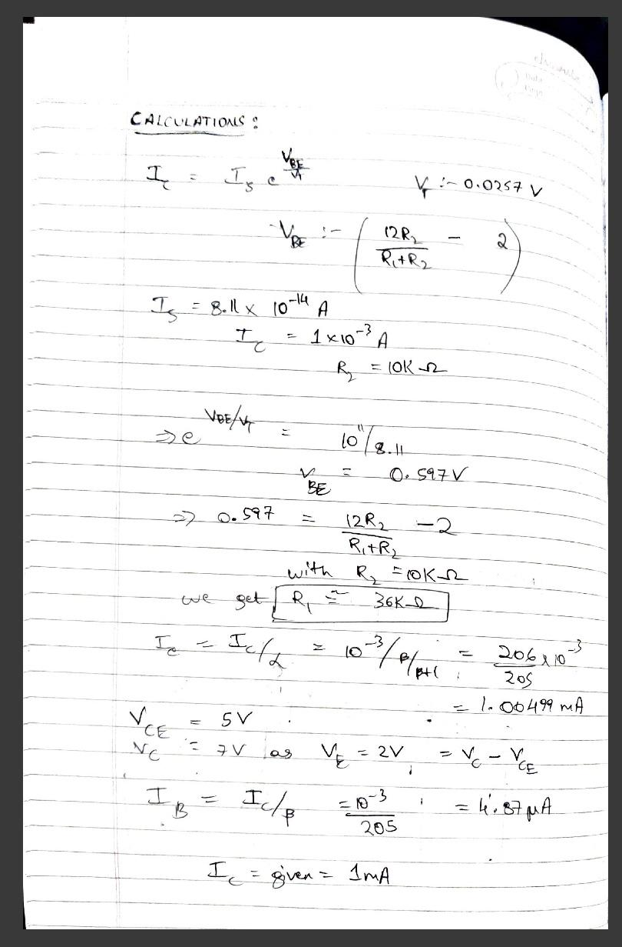

**Q4**: Capacitance Values

FCUTOFF = 1Hz

FCUTOFF

Cc = 120μF

CB = 60μF

CE = 100μF

**Q5**: Output and Input Waveform:

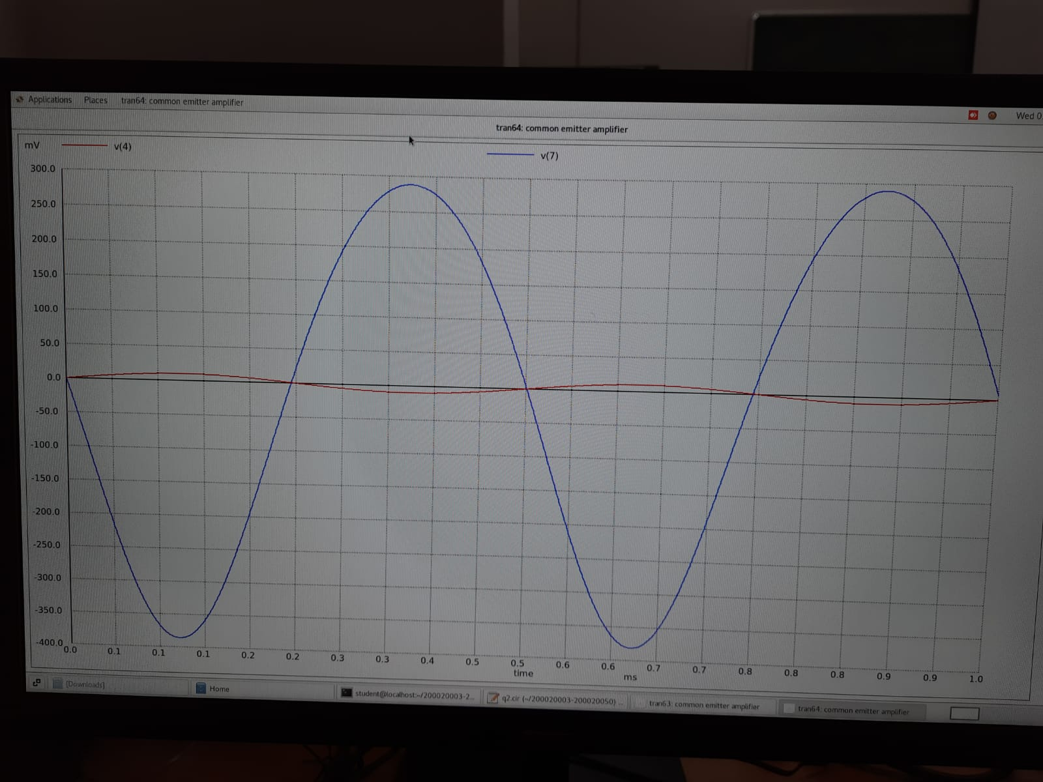

**Q6**: Frequency Response of Amplifier:

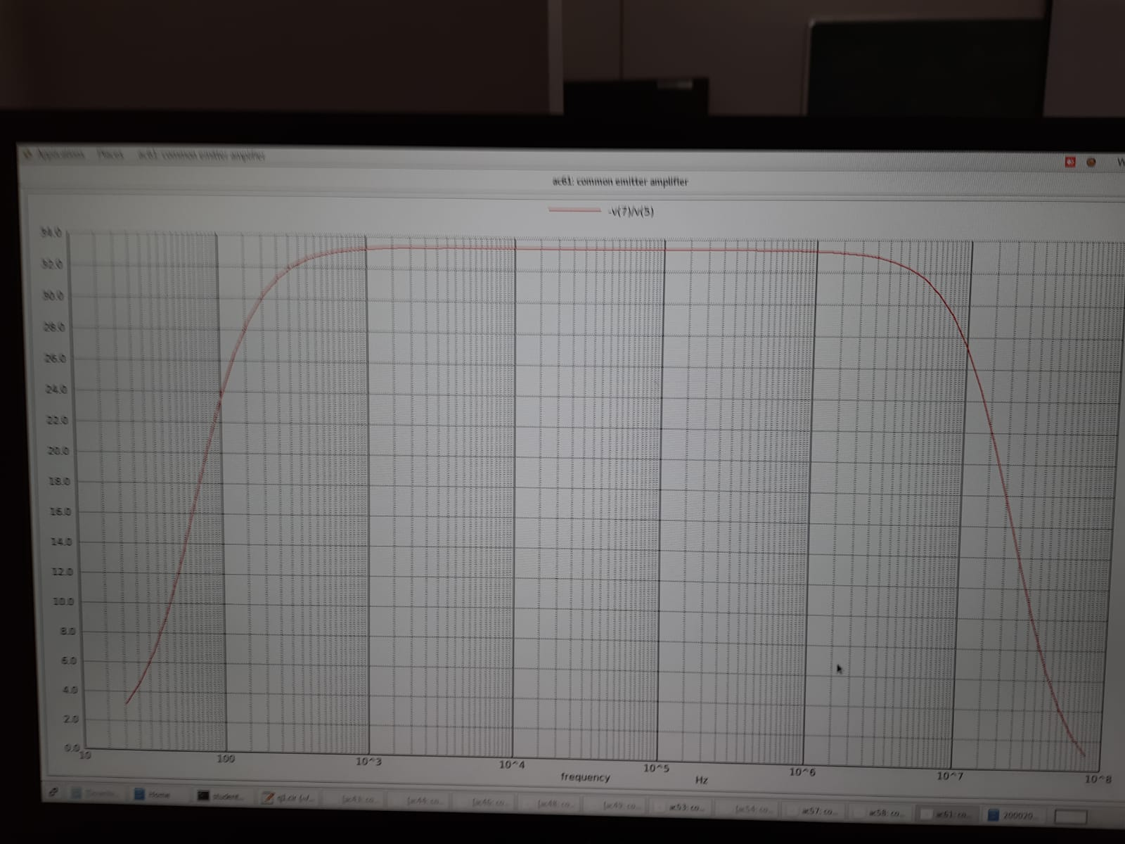

**Hardware Simulation**

**Breadboard Connections:**

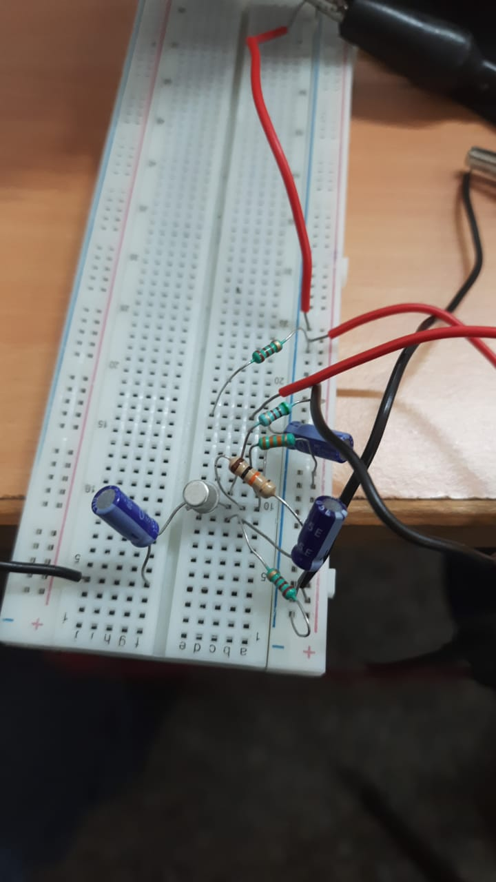

**Observations**:

| Frequency(Hz) | Vin(mV) | Vout(mV) | Gain |
| --- | --- | --- | --- |
|  |  |  |  |
| 10 | 100 | 0.15 | 1.5 |
| 100 | 100 | 0.23 | 2.3 |
| 500 | 100 | 0.95 | 9.5 |
| 1k | 100 | 1.78 | 17.8 |
| 2k | 100 | 2.69 | 26.9 |
| 1.5k | 100 | 2.29 | 22.9 |
| 2.5k | 100 | 3.02 | 30.2 |
| 3k | 100 | 3.3 | 33 |
| 3.5k | 100 | 3.5 | 35 |
| 5k | 100 | 3.9 | 39 |
| 7.5k | 100 | 4.2 | 42 |
| 10k | 100 | 4.3 | 43 |
| 12.5k | 100 | 4.4 | 44 |
| 15k | 100 | 4.4 | 44 |
| 17.5k | 100 | 4.4 | 44 |
| 20k | 100 | 4.4 | 44 |
| 25k | 100 | 4.4 | 44 |
| 30k | 100 | 4.4 | 44 |
| 50k | 100 | 4.4 | 44 |
| 75k | 100 | 4.4 | 44 |
| 80k | 100 | 4.3 | 43 |
| 90k | 100 | 4.2 | 42 |
| 100k | 100 | 4.2 | 42 |
| 200k | 100 | 4.1 | 41 |
| 500k | 100 | 3.9 | 39 |
| 600k | 100 | 3.6 | 36 |
| 750k | 100 | 3.2 | 32 |
| 900k | 100 | 3 | 30 |
| 1M | 100 | 2.8 | 28 |
| 1.2M | 100 | 2.5 | 25 |
| 1.4M | 100 | 2 | 20 |
| 1.6M | 100 | 1.7 | 17 |
| 2M | 100 | 1.2 | 12 |
| 3M | 100 | 0.15 | 1.5 |

**Q3 and Q4:**

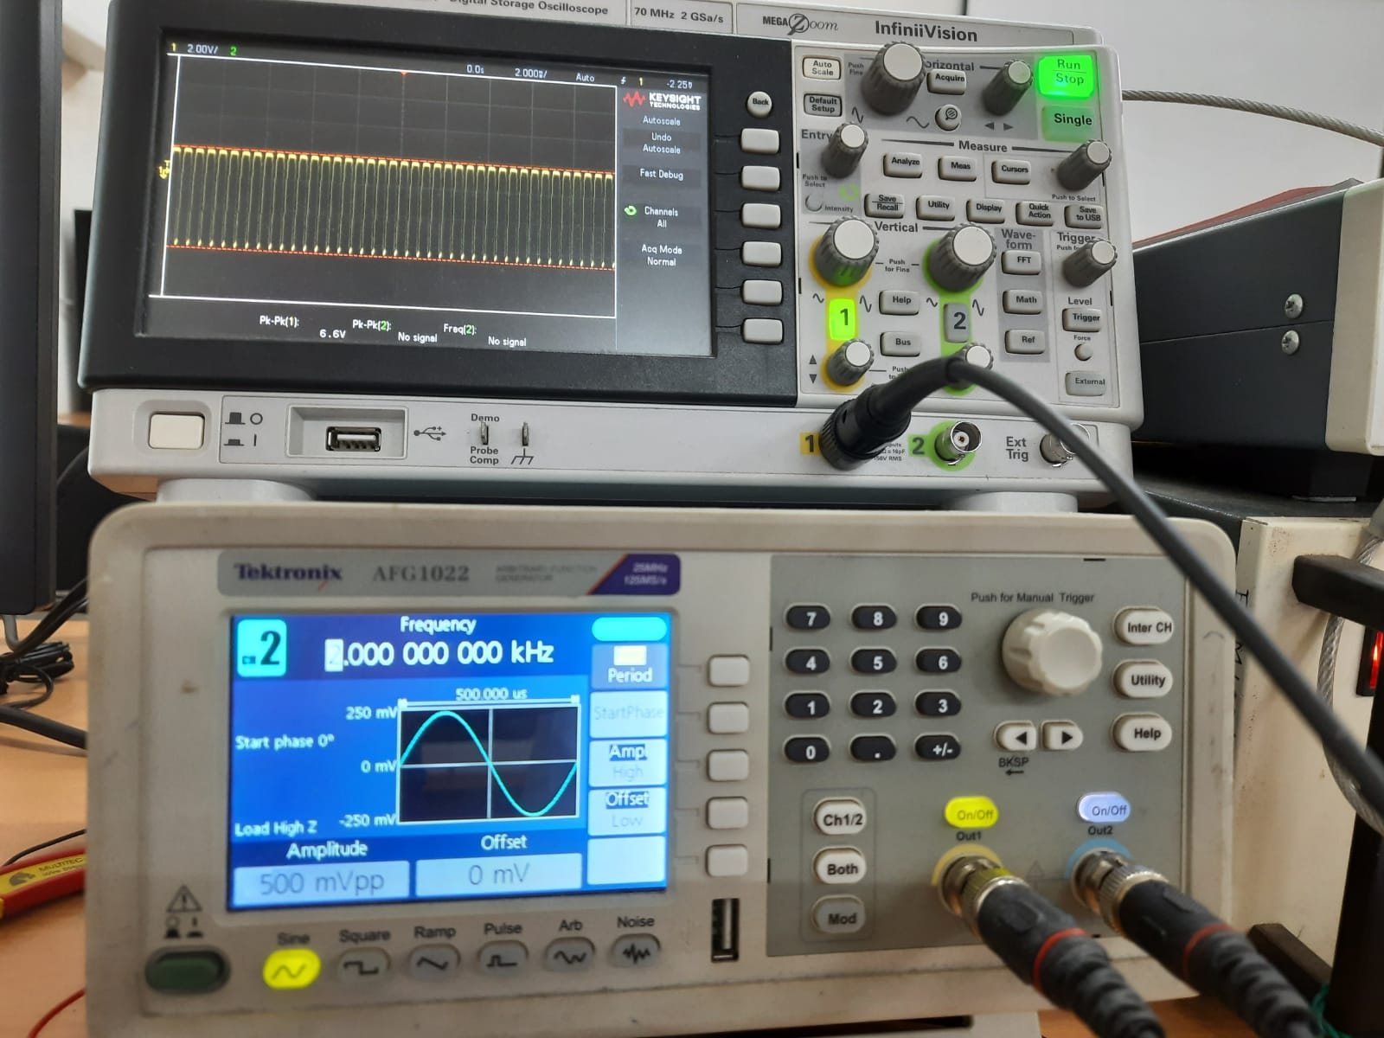

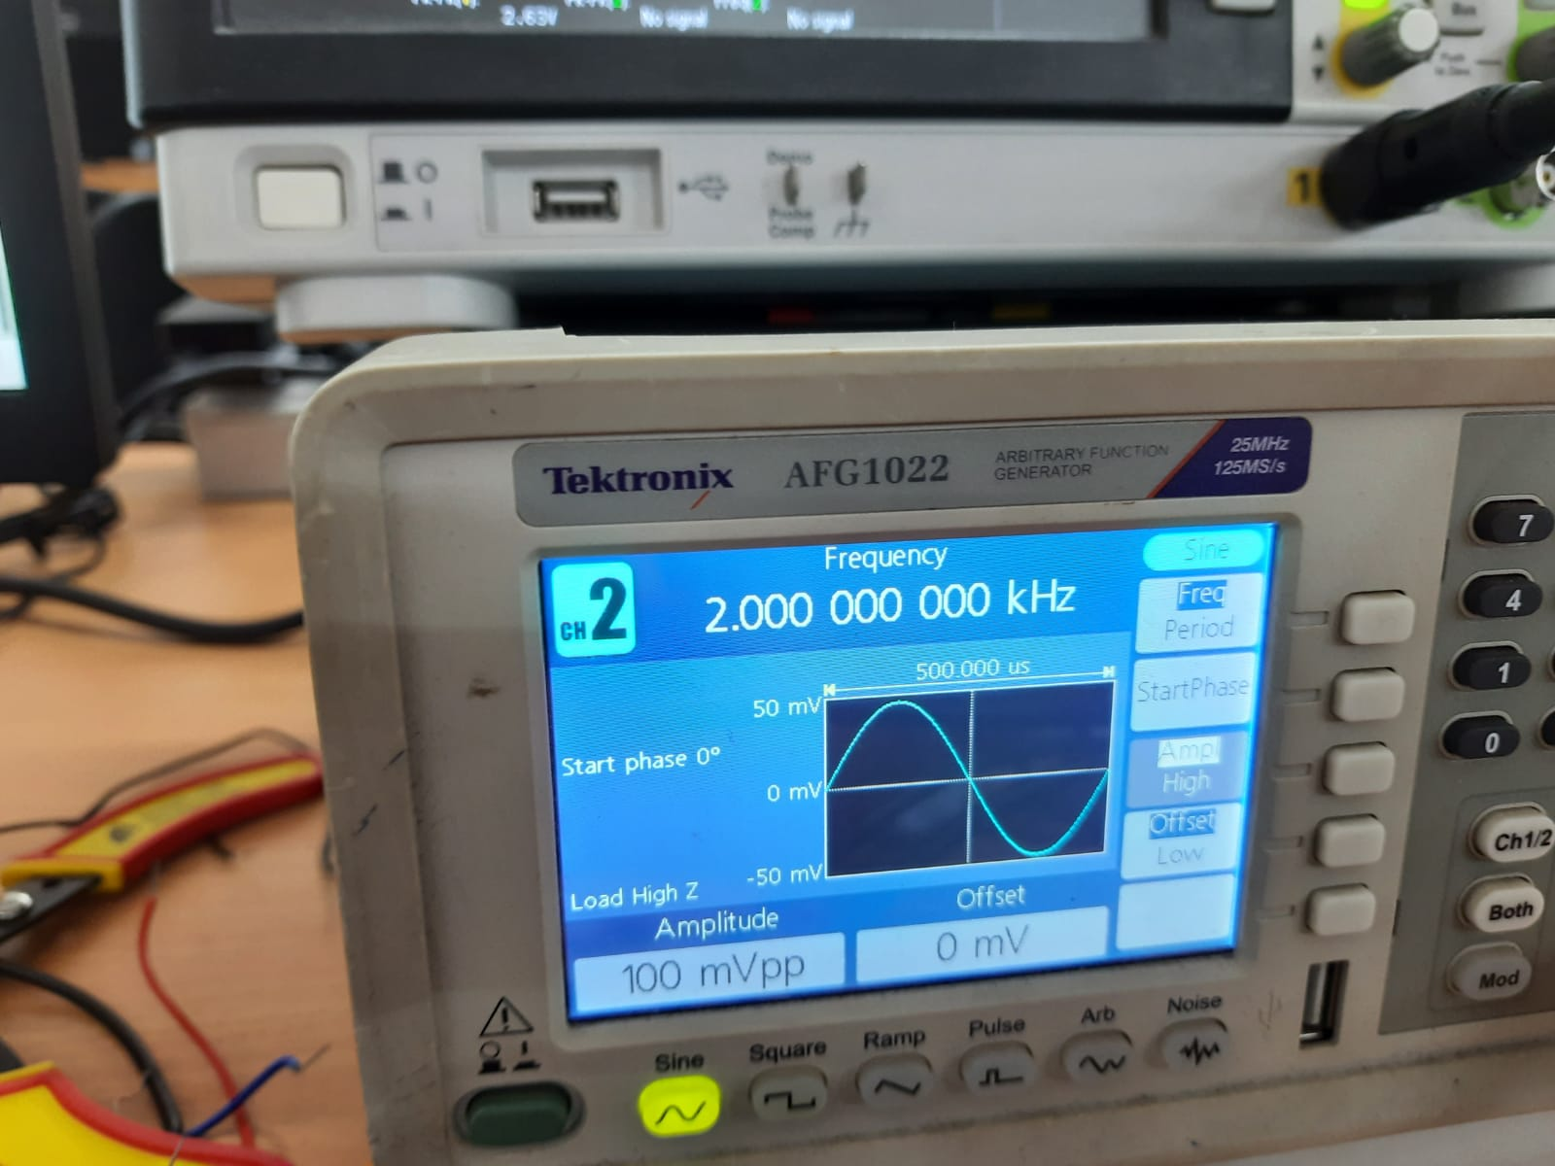

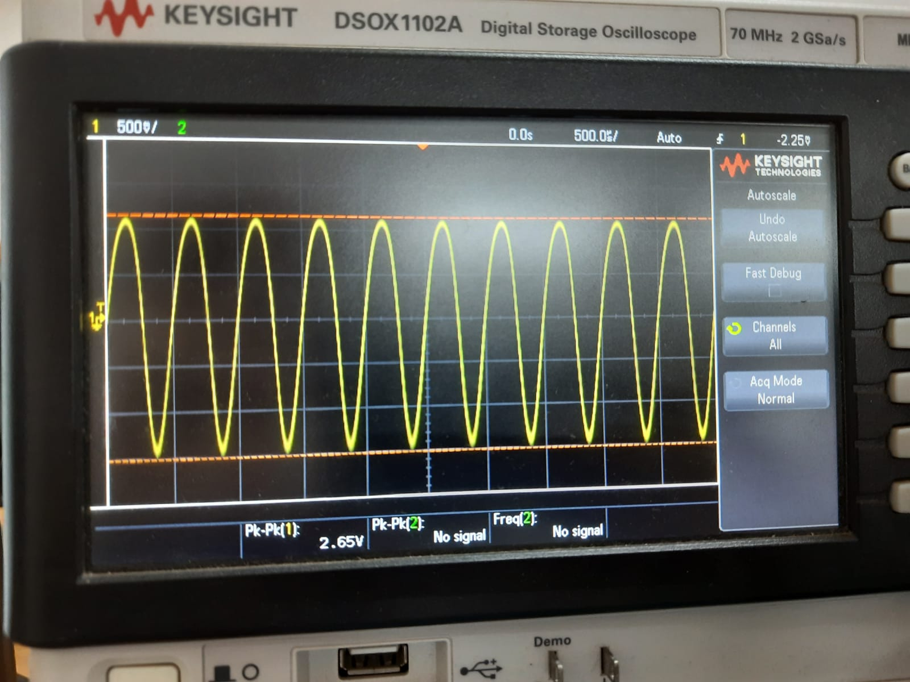

**Q5**: Simulation at 500mVP-P

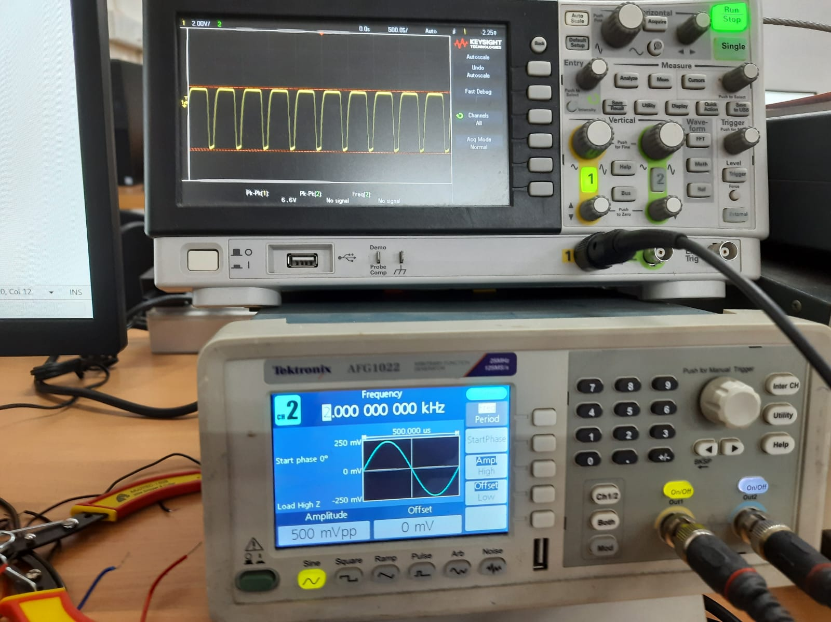

Yes, the output signal gets distorted because we exceed the limits of the diode parameters

Simulation at1000mVP-P

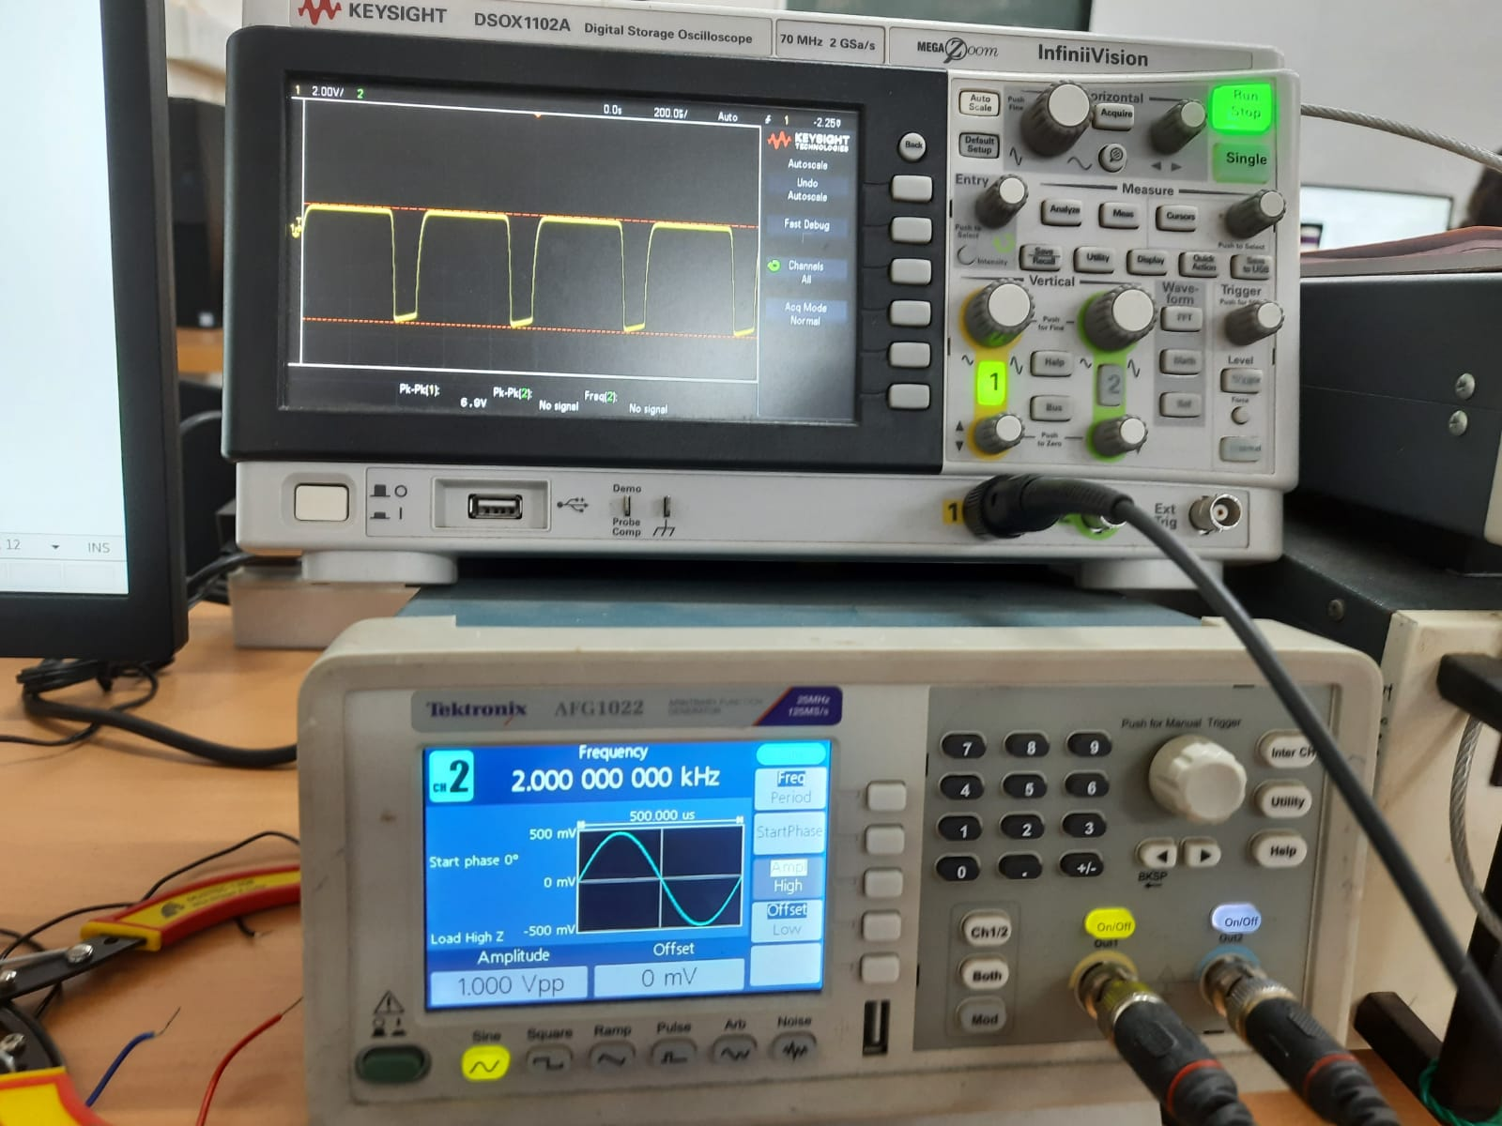

**Q6**: Graph of Gain vs Frequency

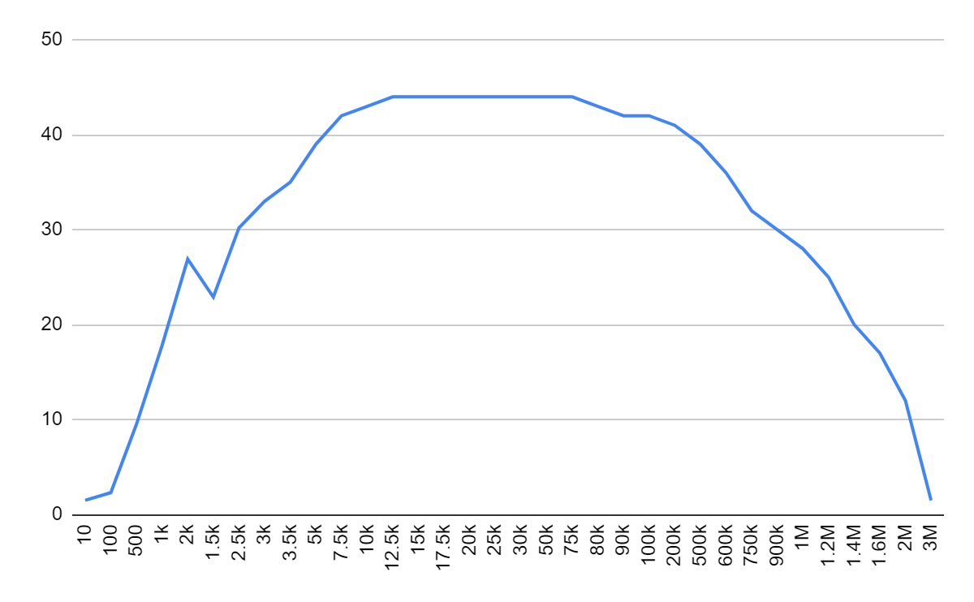

The graph is such that the gain remains constant for a range of frequencies (known as mid-band region) and the overall graph is in a plateau shape.

Log-Log Plot:

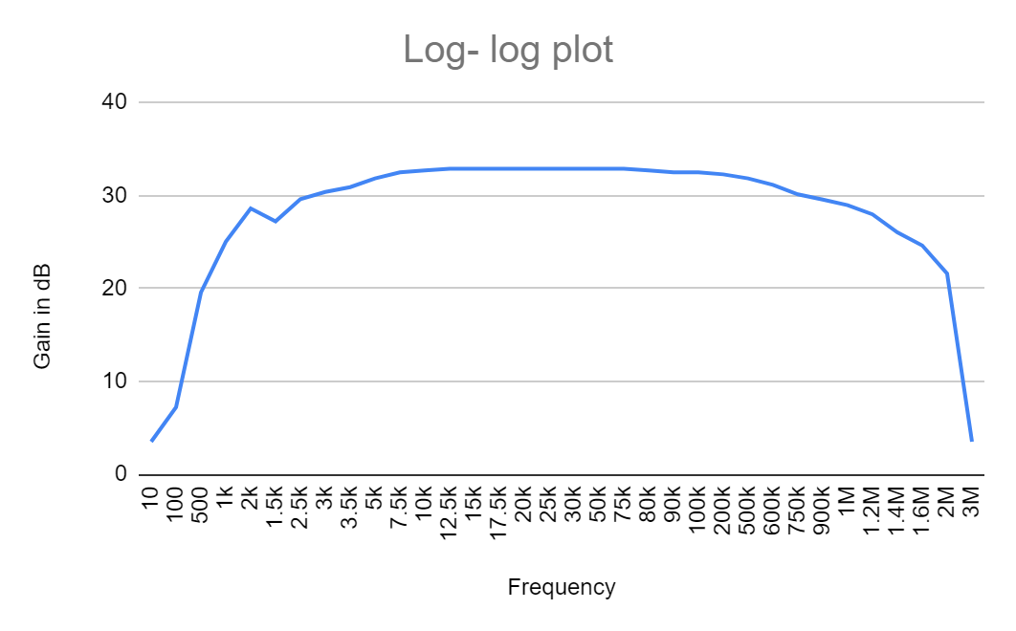

**Discussion**:

Tanish H Talapaneni:

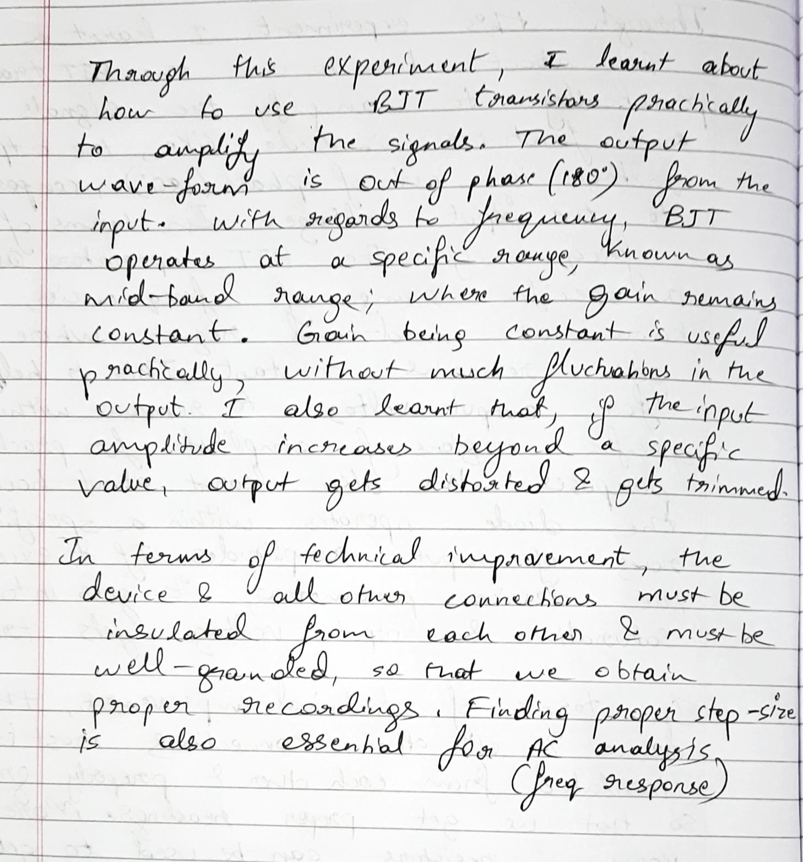

:

Aditya Kalyani

