**Devices and Circuits Laboratory**

**Experiment-2**

**Experiments on Solar Cell**

Tanish H Talapaneni

200020050

Objectives:

1. I-V Characterization of solar cell under dark and illuminated conditions
2. Using the solar cell as power source

**Dark and Illuminated conditions:**

Table Of Observations:

| Dark | | Illuminated I1 | | Illuminated I2 | |
| --- | --- | --- | --- | --- | --- |
| Icell | Vcell | Icell | Vcell | Icell | Vcell |
| -0.02 | -0.37 | -14.6 | -0.45 | -11.1 | -1.29 |
| 0 | -0.13 | -13.2 | 0.05 | -10.2 | 0 |
| 0.12 | 0.27 | -11.83 | 0.32 | -2.7 | 0.33 |
| 0.48 | 0.31 | -6.6 | 0.39 | -0.92 | 0.38 |
| 1.05 | 0.32 | -0.7 | 0.45 | 3.32 | 0.49 |
| 2.44 | 0.41 | 5.5 | 0.61 | 7.27 | 0.58 |
| 3.45 | 0.47 | 9.5 | 0.69 | 9.34 | 0.62 |
| 7.85 | 0.56 | 15.4 | 0.74 | 16.78 | 0.66 |
| 10.91 | 0.62 | 19.7 | 0.78 | 22.5 | 0.71 |

**Graphs of Results:**

I-V characteristics of the solar cell in different modes where current is in mA and voltage is in volts.

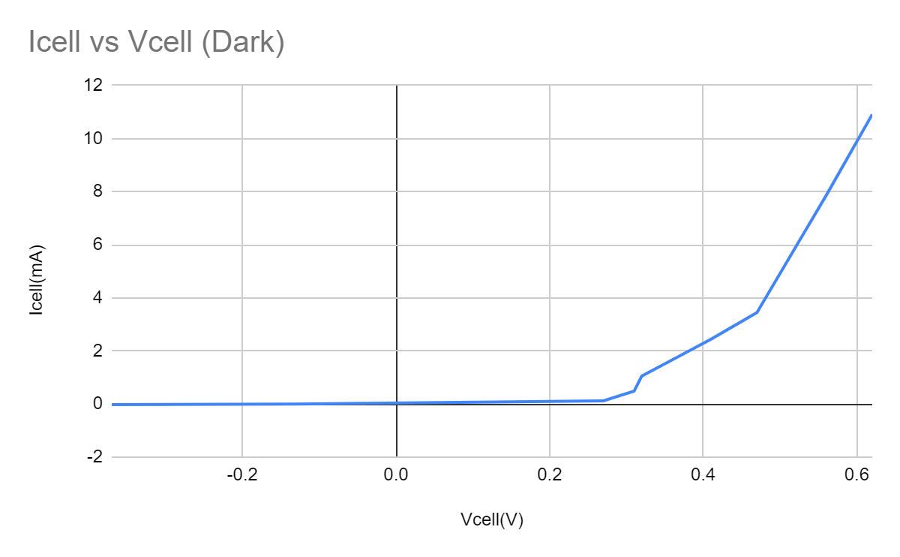

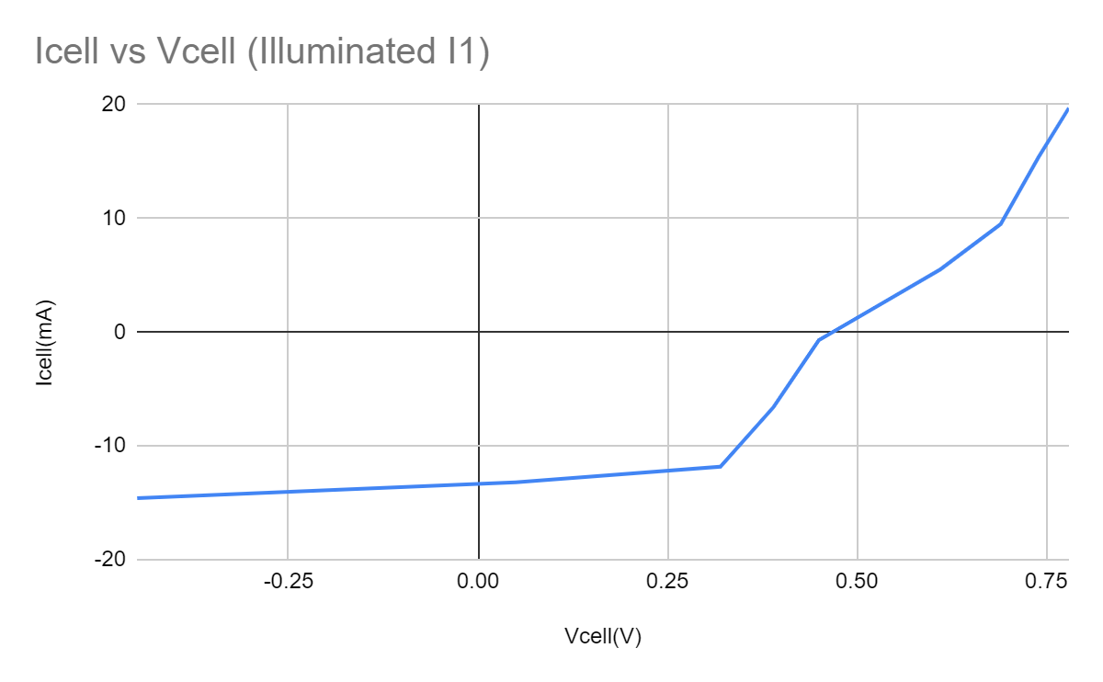

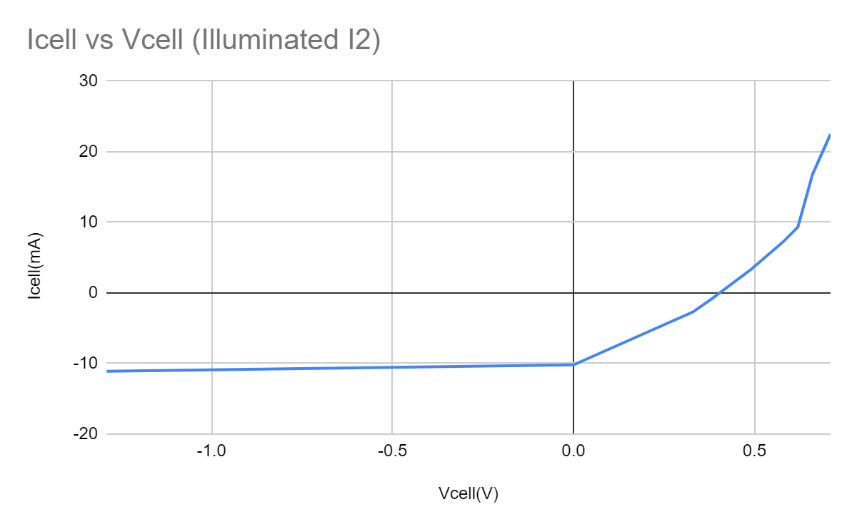

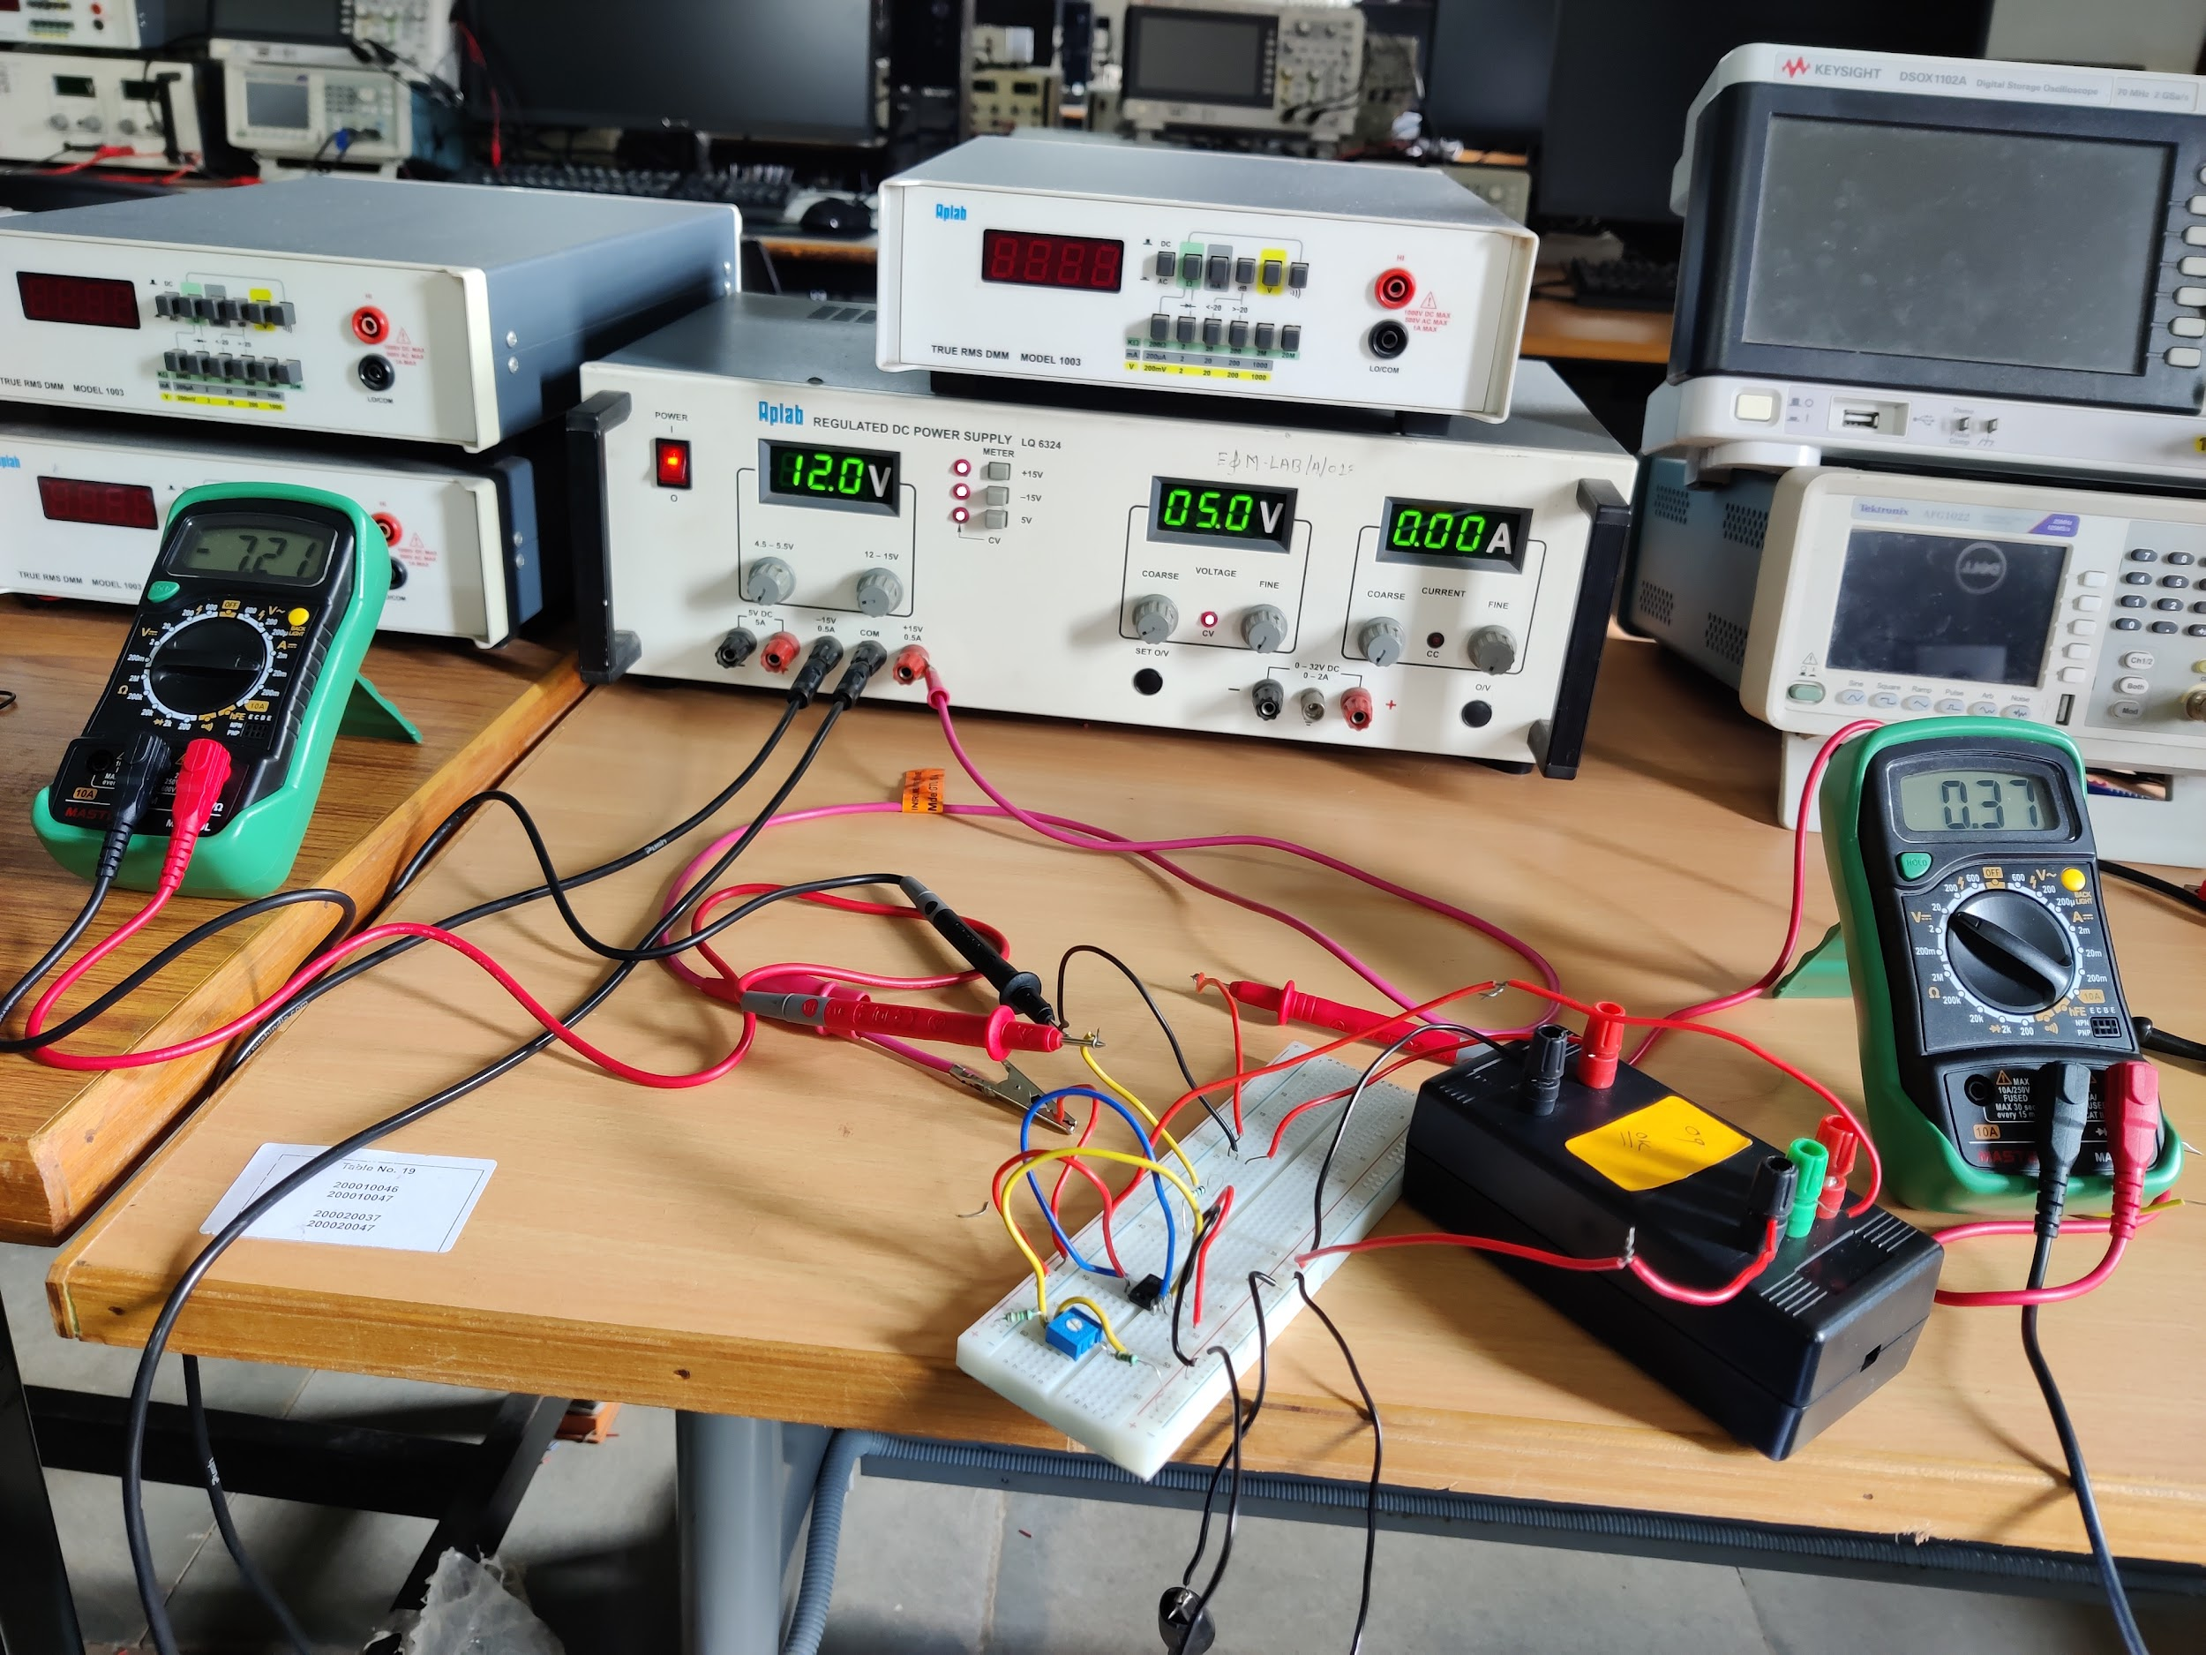

**Solar cell as power source:**

| Illuminated I1 | | | Illuminated I2 | | |
| --- | --- | --- | --- | --- | --- |
| Icell (mA) | Vcel (V) | Power (mW) | Icell (mA) | Vcell (V) | Power (mW) |
| 0.8 | 0.48 | 0.384 | 0.4 | 0.51 | 0.204 |
| 1.4 | 0.48 | 0.672 | 0.8 | 0.49 | 0.392 |
| 1.92 | 0.44 | 0.8448 | 2.2 | 0.49 | 1.078 |
| 2.2 | 0.47 | 1.034 | 3.3 | 0.48 | 1.584 |
| 3.8 | 0.43 | 1.634 | 4.1 | 0.48 | 1.968 |
| 5.8 | 0.45 | 2.61 | 5.45 | 0.47 | 2.5615 |
| 7.27 | 0.37 | 2.6899 | 6.1 | 0.47 | 2.867 |
| 9.6 | 0.35 | 3.36 | 9.33 | 0.45 | 4.1985 |
| 10.7 | 0.32 | 3.424 | 13.6 | 0.42 | 5.712 |
| 11.5 | 0.27 | 3.105 | 15.2 | 0.32 | 4.864 |
| 12.0 | 0.13 | 1.56 | 16.4 | 0.13 | 2.132 |

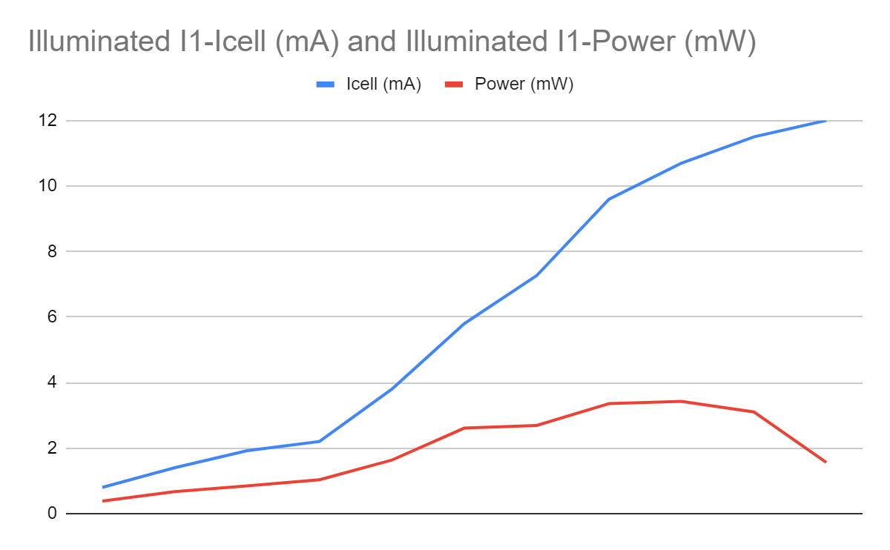

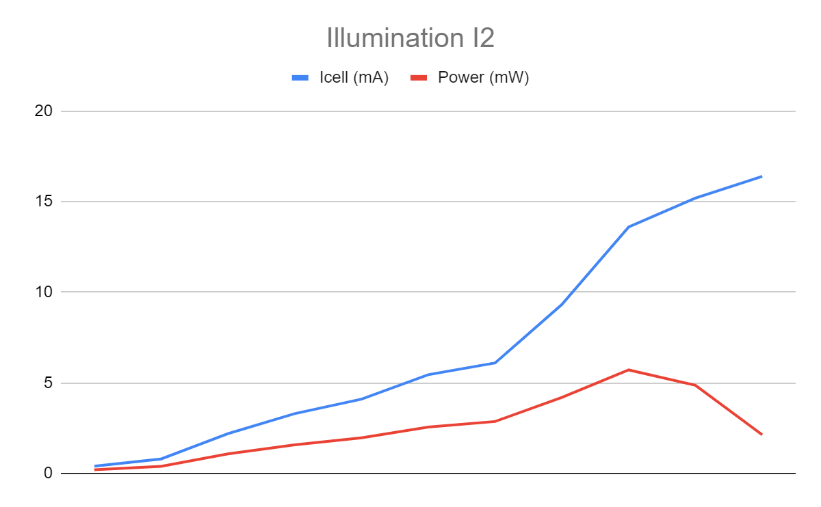

Results from graph:

Illumination I1:

=10.7mA V

V

Illumination 2:

=13.6mA V

V

Form Factor (FF) = ( * /( *)

Illumination 1:

Form factor for I(LED) = 20mA is FF = 0.599

Illumination 2:

Form factor for I(LED) = 20mA is FF = 0.736

**Measurement of VOC and ISC at different illumination levels:**

| Iled (mA) | Voc | Isc |
| --- | --- | --- |
| 10 | 0.36 | 1.73 |
| 15 | 0.39 | 2.88 |
| 20 | 0.40 | 3.76 |
| 25 | 0.42 | 5.3 |
| 30 | 0.44 | 6.1 |
| 35 | 0.47 | 9.41 |
| 40 | 0.48 | 10.55 |
| 45 | 0.48 | 12.21 |
| 50 | 0.49 | 12.99 |

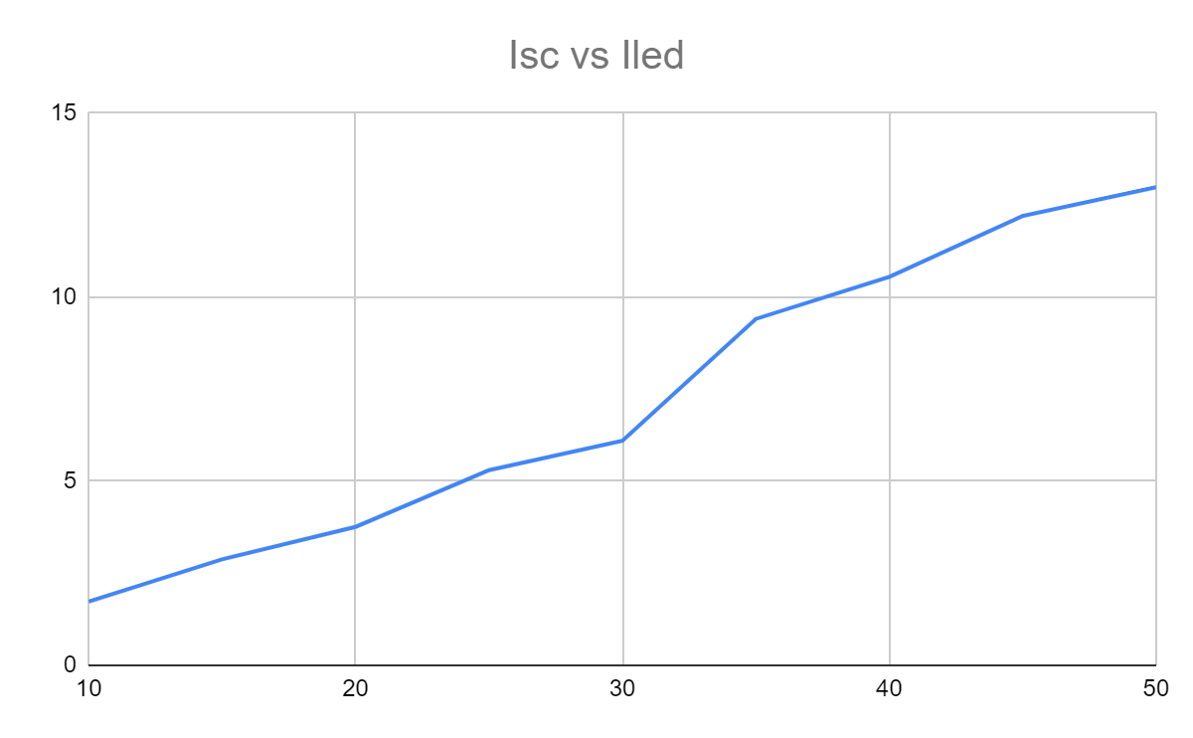

The graph of Isc vs Iled is almost linear

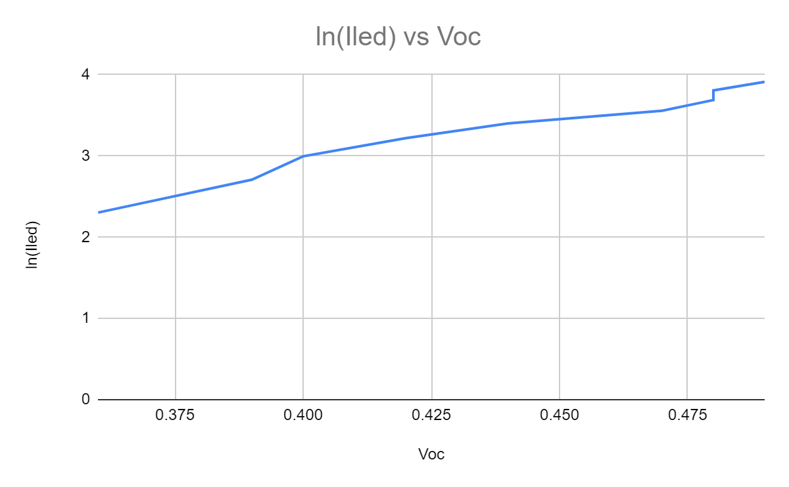

The graph of ln(ied) vs voc is almost a straight line.

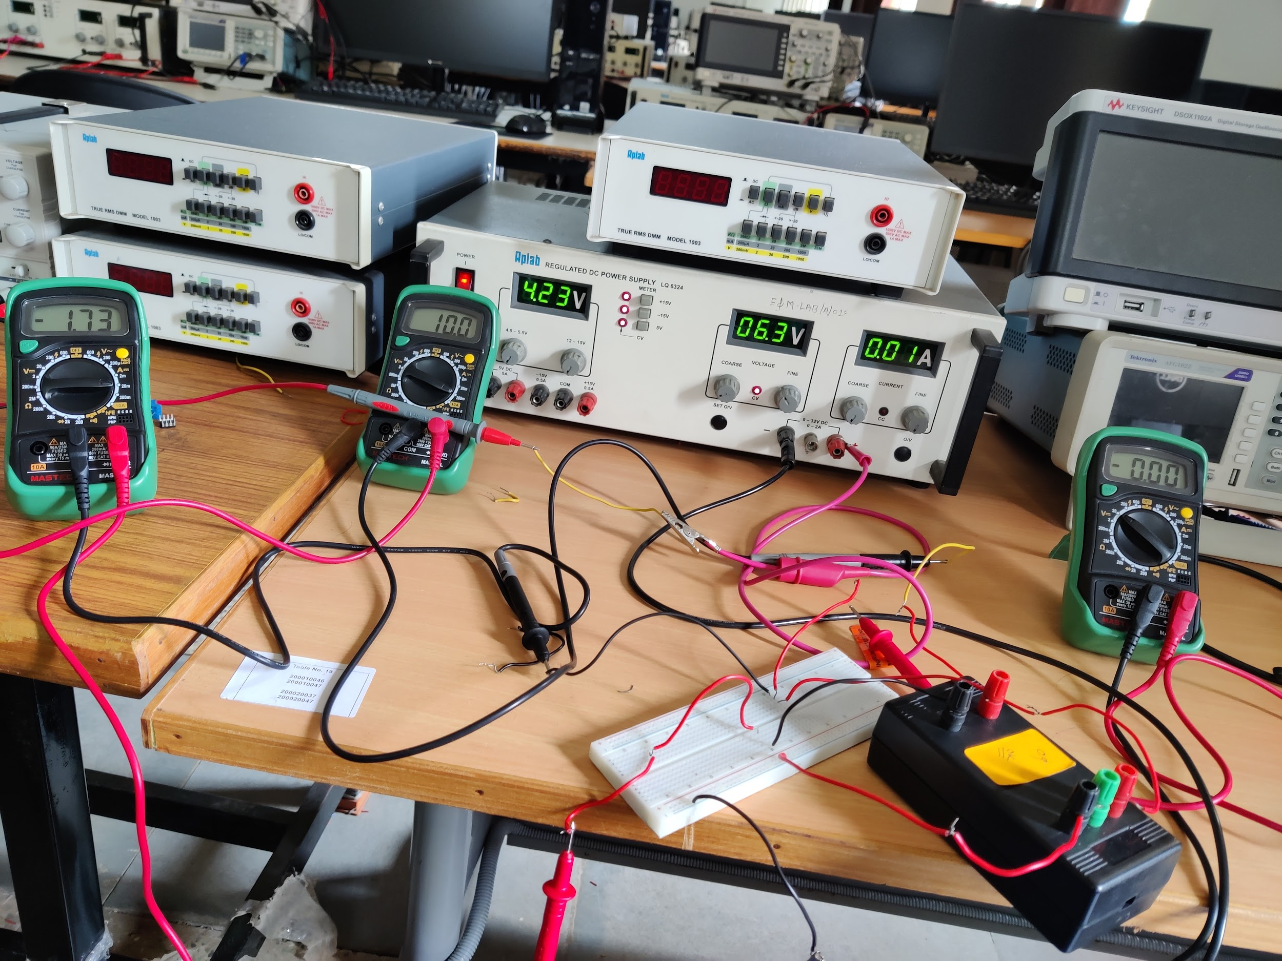

Discussion:

It was great working with a solar cell. I operated on the solar cell in both light and dark conditions, by giving both positive and negative voltage supply. Rigging up the circuit on the breadboard was nice. I got to know more about the practical usage of an op-amp and potentiometer. There was usage of various multimeters involved and many readings were taken, including creating many graphs and inferring the characteristics. Took some time to finish everything, but in the end, it was great to work on it.