**EXPERIMENT- 2,3**

**COMBINATIONAL LOGIC CIRCUITS BASED ON CMOS LOGIC FAMILIES**

Tanish H Talapaneni

200020050

**Aim:** To use CMOS Logics to built the fundamental Gates- OR, NAND, AND, NOR, XOR, XNOR

**Summary:** Using CMOS to build up digital ICs by creating circuits with

HC4007 IC

**Components used:** IC HCF4007, DIP Switches, LED Display, Breadboard, Power supply, 1k ohm resistor

**Procedure:**

* Connect the circuit as shown in diagrams with some additional circuit.
* Select inputs from the truth table. Make the changes in the switch accordingly.
* Glowing LED implies that output was 1, otherwise 0.
* Verify if the simulation matches with the expected values.

**Truth Tables:**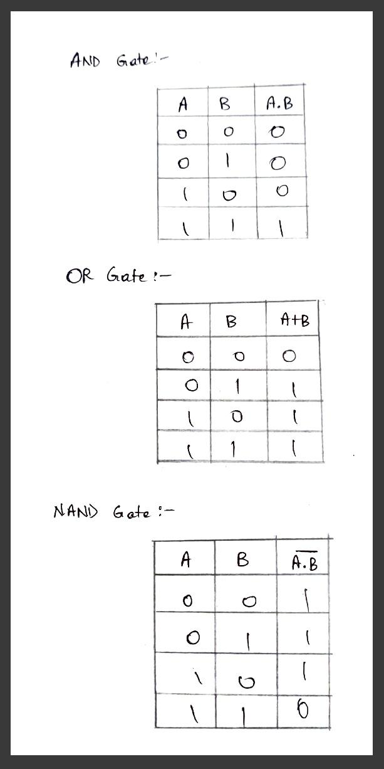

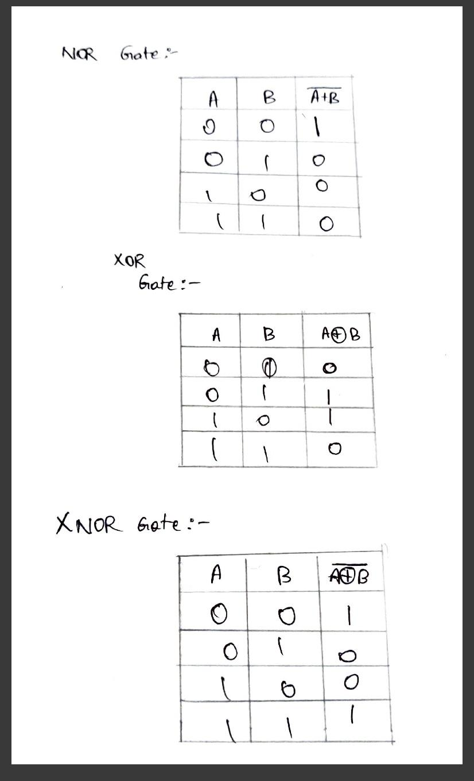

**Gate Design:**

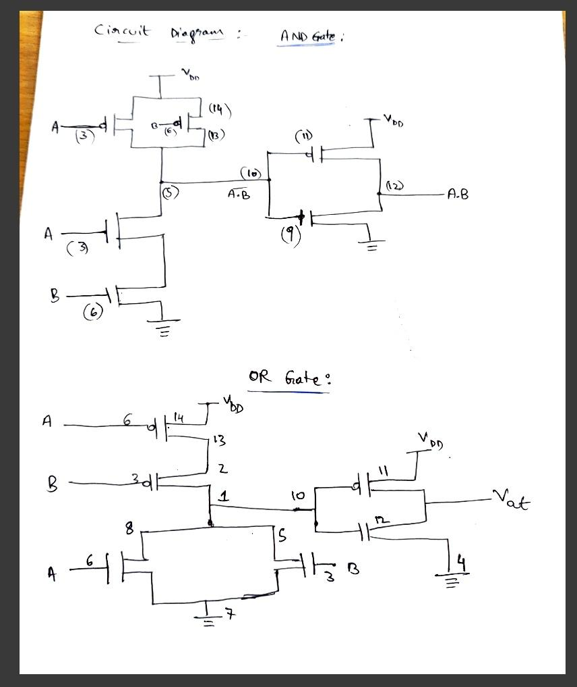

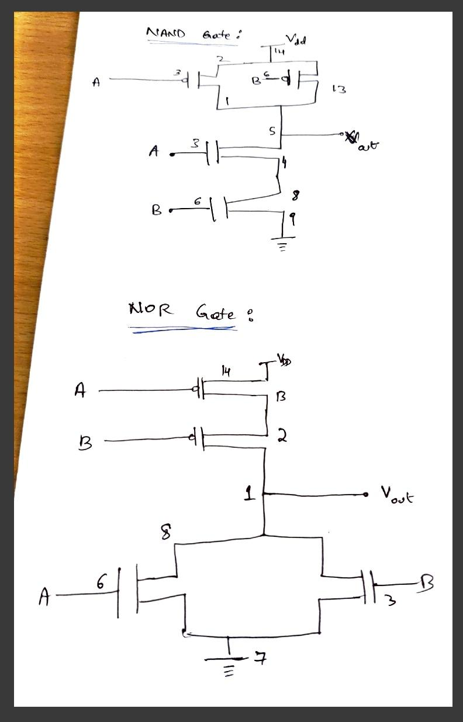

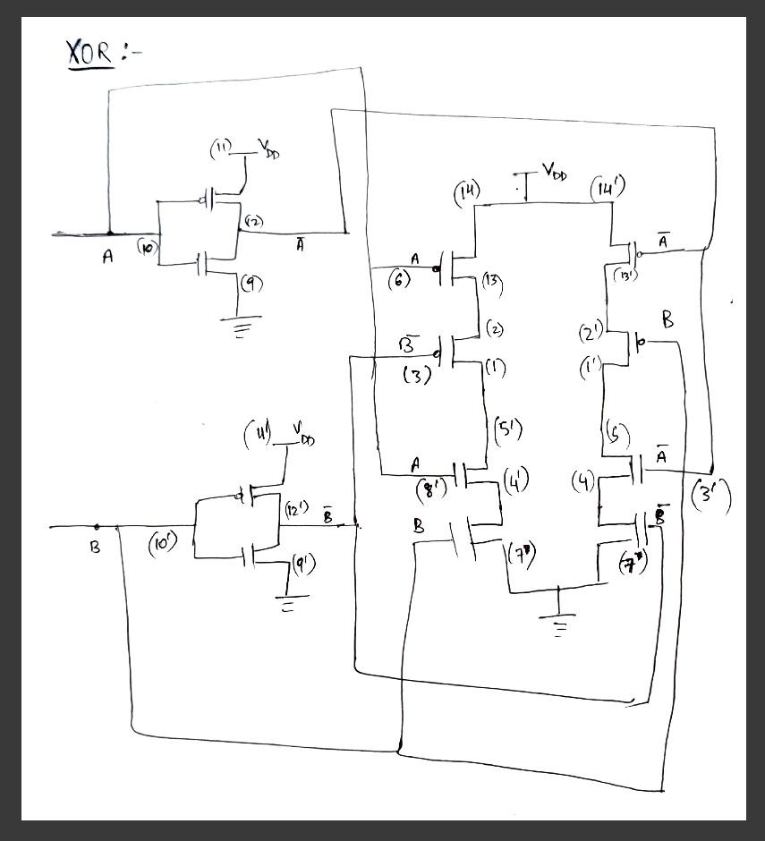

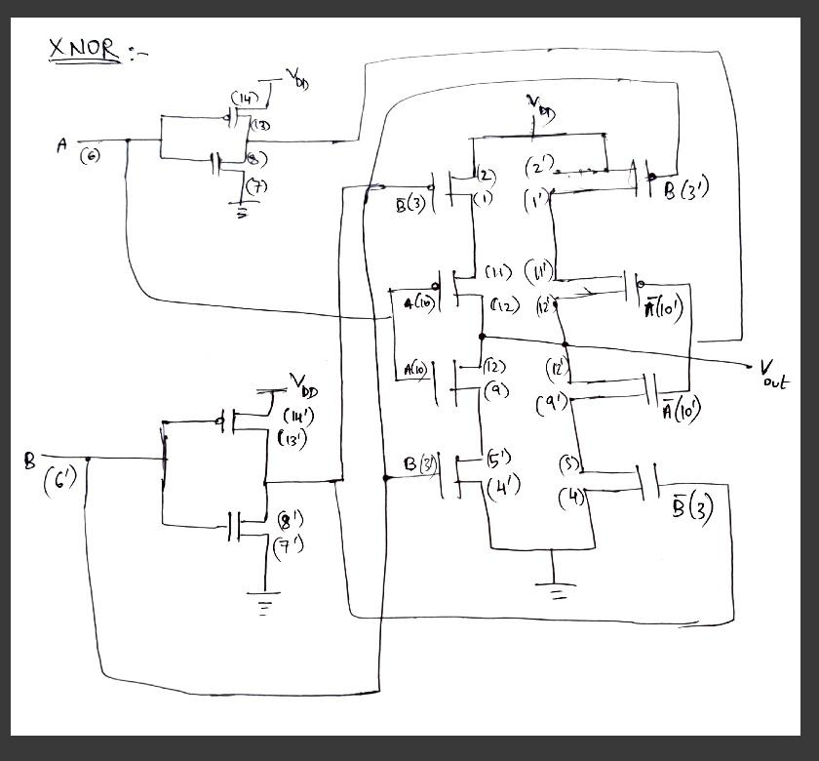

**Hardware:**

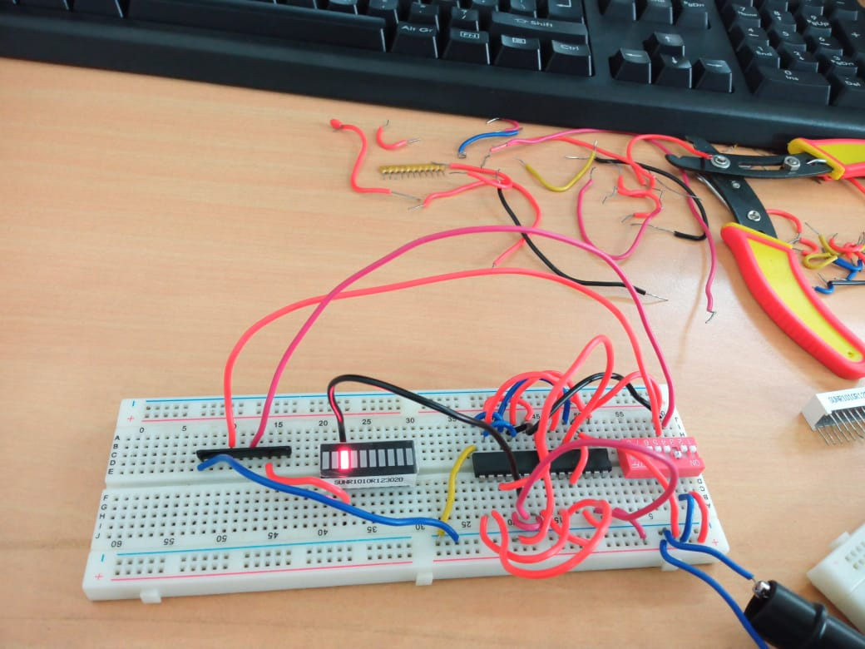

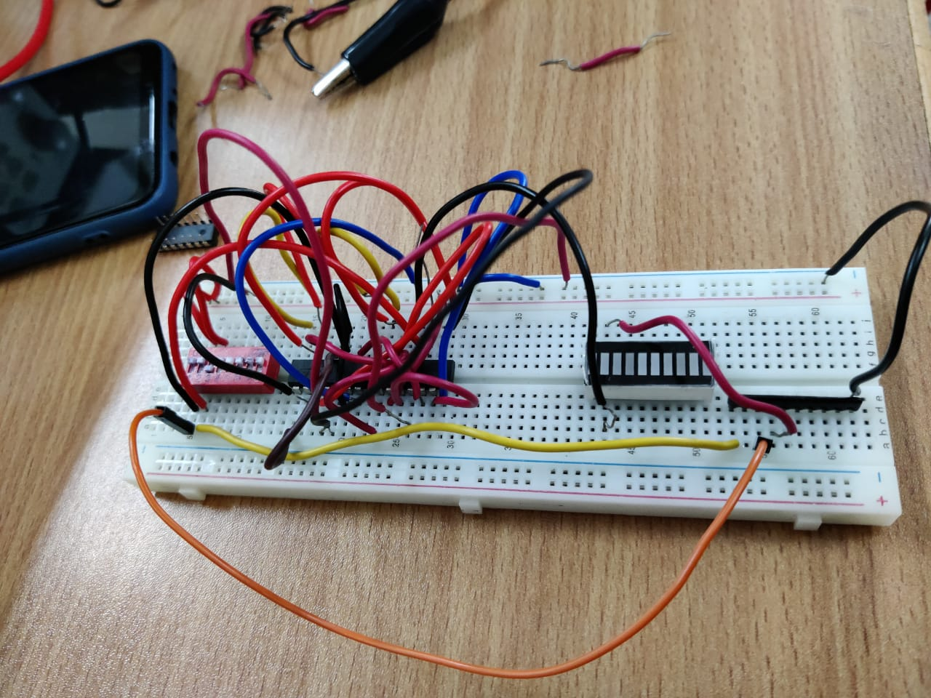

**Results and Discussions:** We made many connections and understood how to decide the pin numbers for the various connections required. We learnt how to connect the LED Display and the switches with a 1k ohm resistor to ensure smooth working. We learnt about the inner arrangements of the IC consisting of PMOS and NMOS gates. Working on all the six gates practically ensured my understanding of the working of the gates, along with the knowledge of truth tables.

**Conclusion:** I was able to understand the **pin-level** implementation of Logic Gates using the IC- HCF4007. We verified the functionality of the CMOS Family Logic gates with its theoretical results.