**EXPERIMENT- 1**

**BASIC LOGIC GATES**

Tanish H Talapaneni

200020050

**Aim:** To study functioning of basic gates using Digital ICs.

**Summary:** Studying the functioning of basic digital ICs and usage of function generator and Digital Scope Oscillator, along with rigging up the circuits.

**Components used:** IC 7400, 7408, 7432, 7486, DIP Switches, LED Display, Breadboard, Power supply, Resistor

**Procedure:**

* Connect the circuit as shown in diagrams with some additional circuit.
* Select inputs from the truth table. Make the changes in the switch accordingly.
* Glowing LED implies that output was 1, otherwise 0.
* Verify if the simulation matches with the expected values.

**Design of Gates:**

Truth Tables:

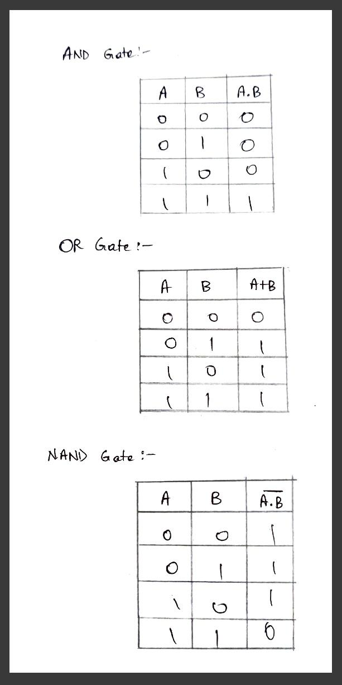

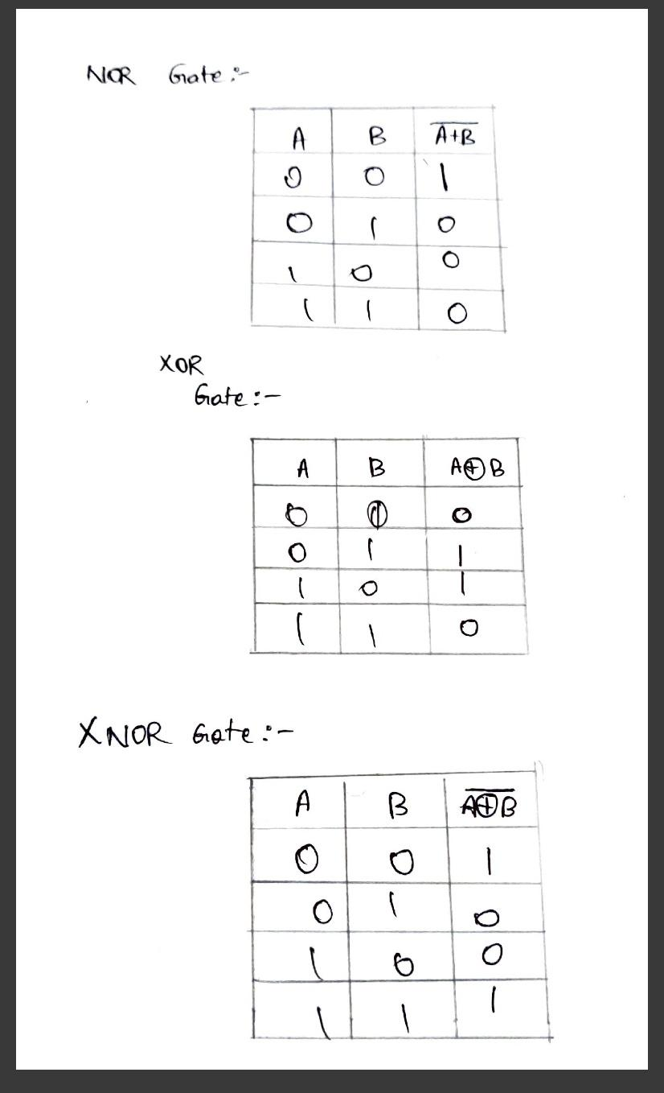

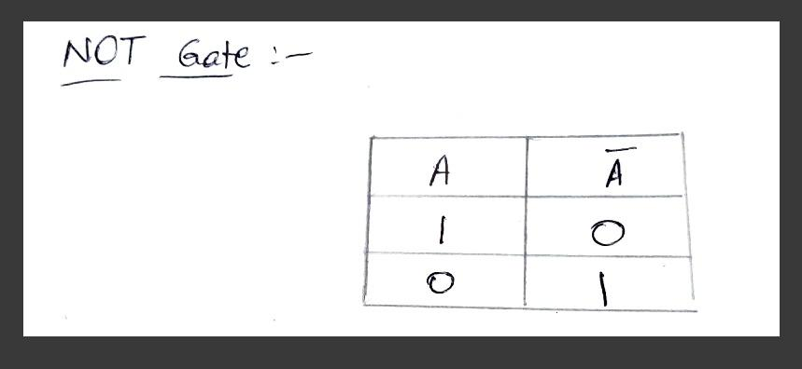

Gate Design:

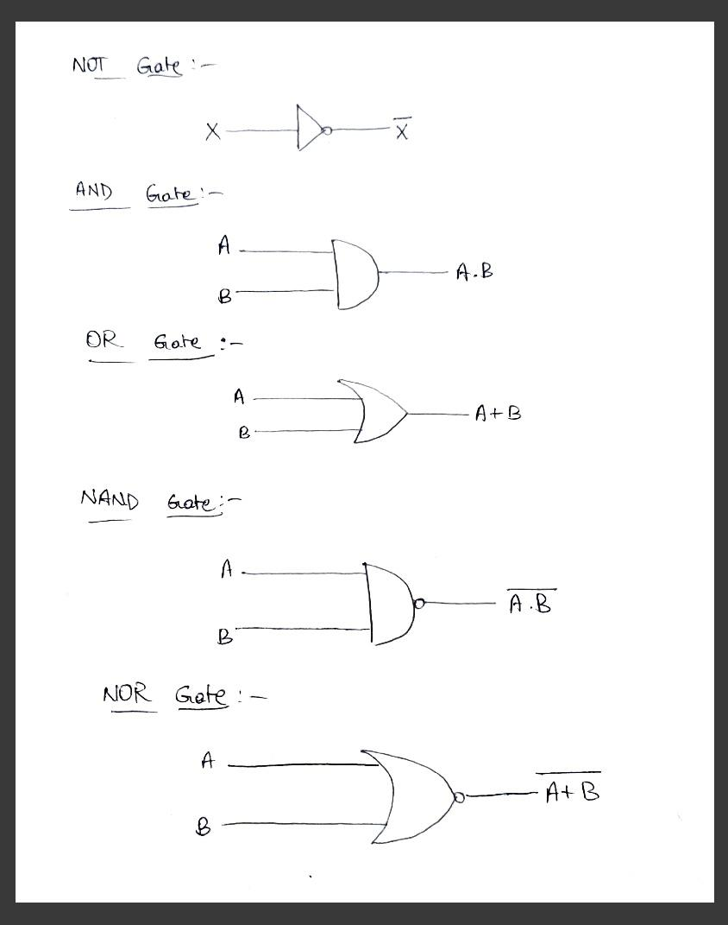

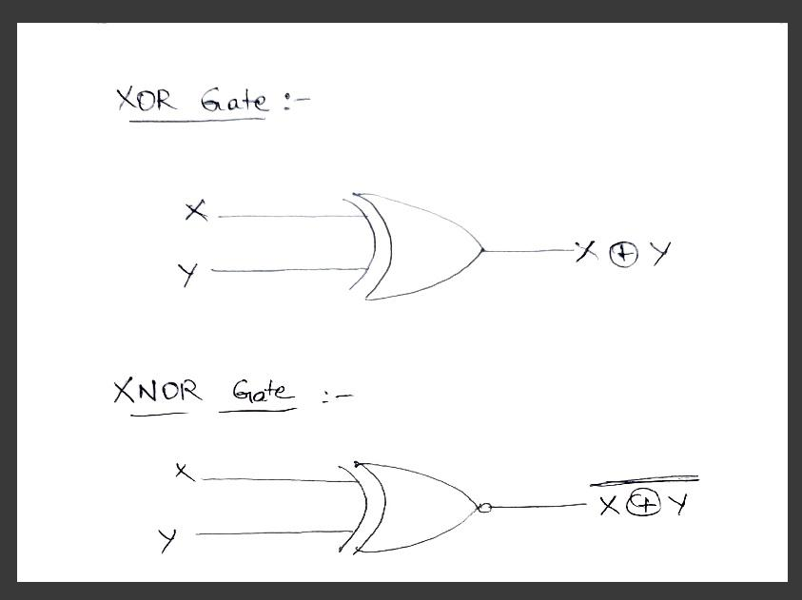

Hardware: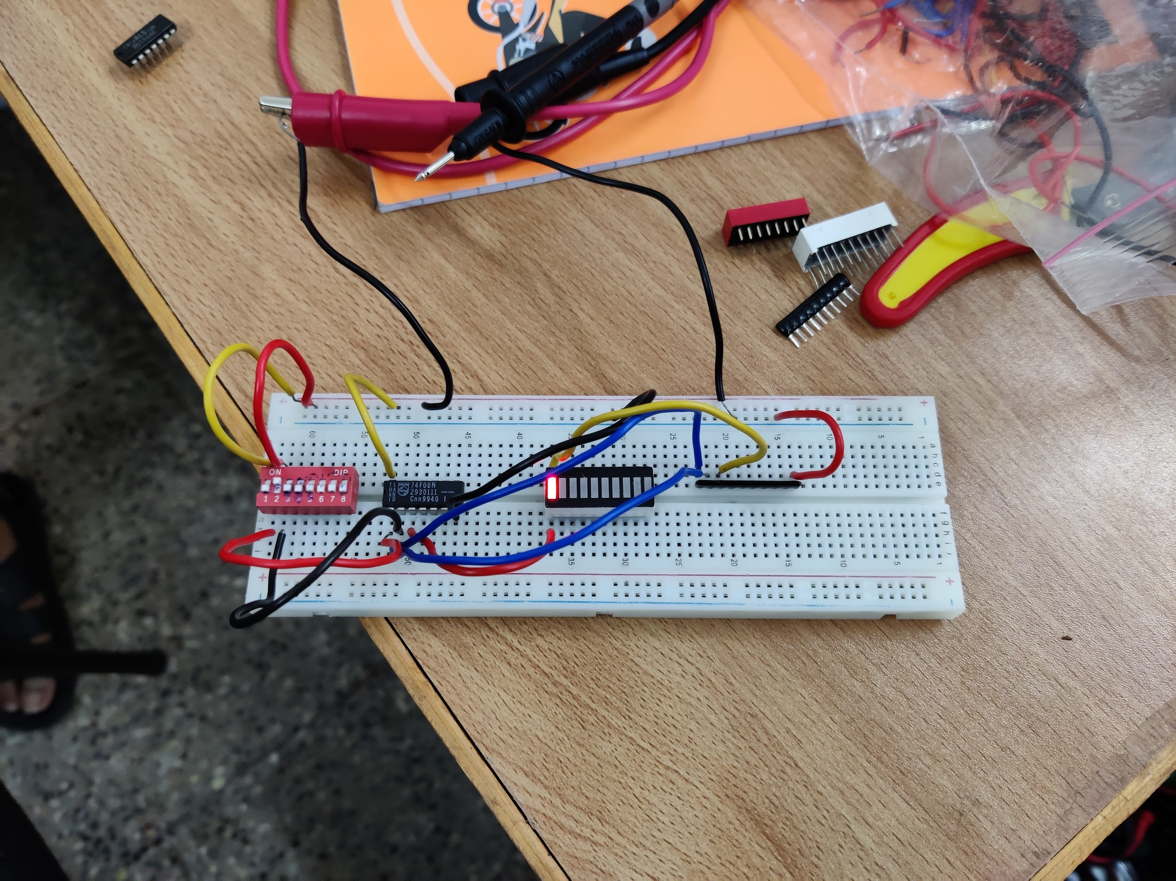

**Results and Discussions:**

I understood the working of different types of ICs and the gates they represent. I understood how to use the switches and LED Display and connect it to the resistor, including grounding it. I learnt about the working of breadboard as well. I was able to verify all the truth table logics using ICs.

**Conclusion:**

Verification of logic gates included in ICs with its truth table values.