**DIGITAL CIRCUITS LABORATORY**

**Experiment-4**

**NAND Gates and K-Map Implementation**

Tanish H Talapaneni

200020050

**Aim:**To use K-Map logic to build a logic-gate system that can act as an Industrial Alarm

**Summary:** K-Map implementation to get the final boolean expression and implementing it using only NAND gates

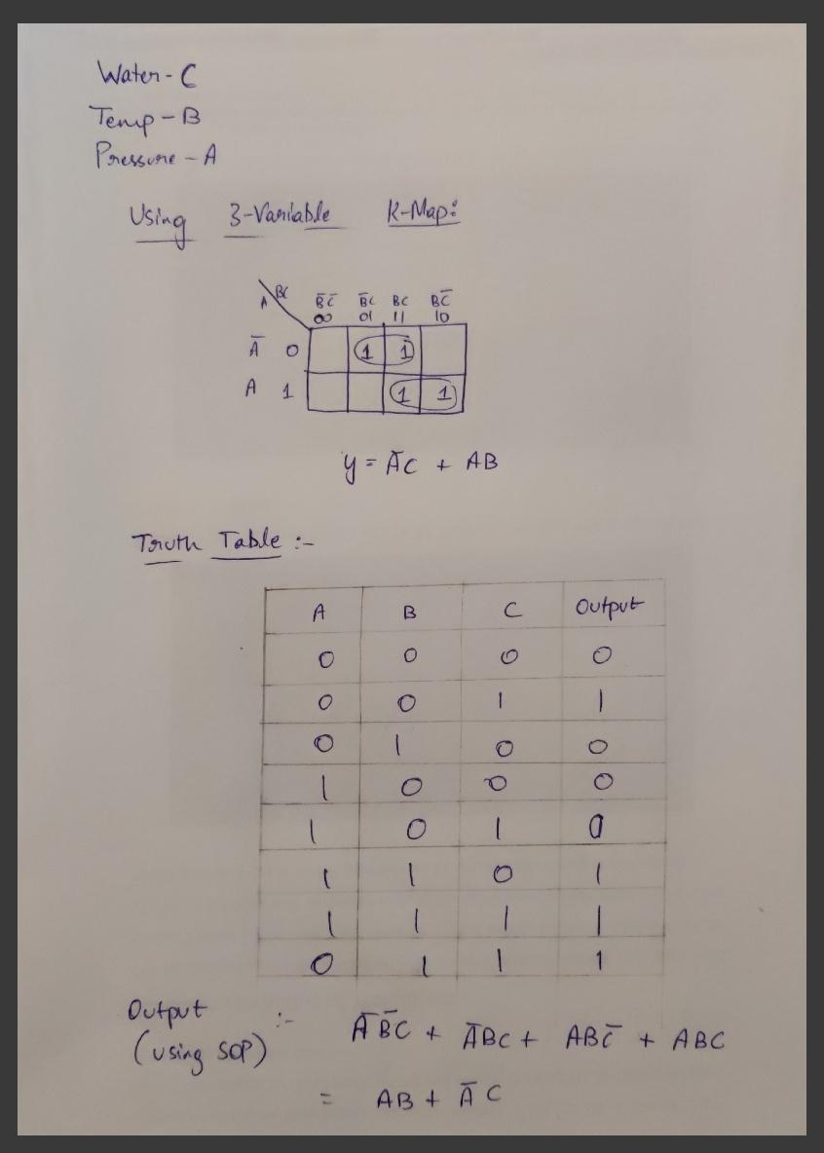

**Components used:** DM7400(NAND), DM7404(NOT), DM7408(AND), DM74LS32(OR), DIP Switches, LED Display, Breadboard, Power supply, 1k ohm resistor.

**Procedure:**

* Connect the circuit as shown in diagrams and give it power input.
* Select inputs from the truth table. Make the changes in the switch accordingly.
* Glowing LED implies that output was 1, otherwise 0.
* Verify if the simulation matches with the expected values.

**Truth Table:**



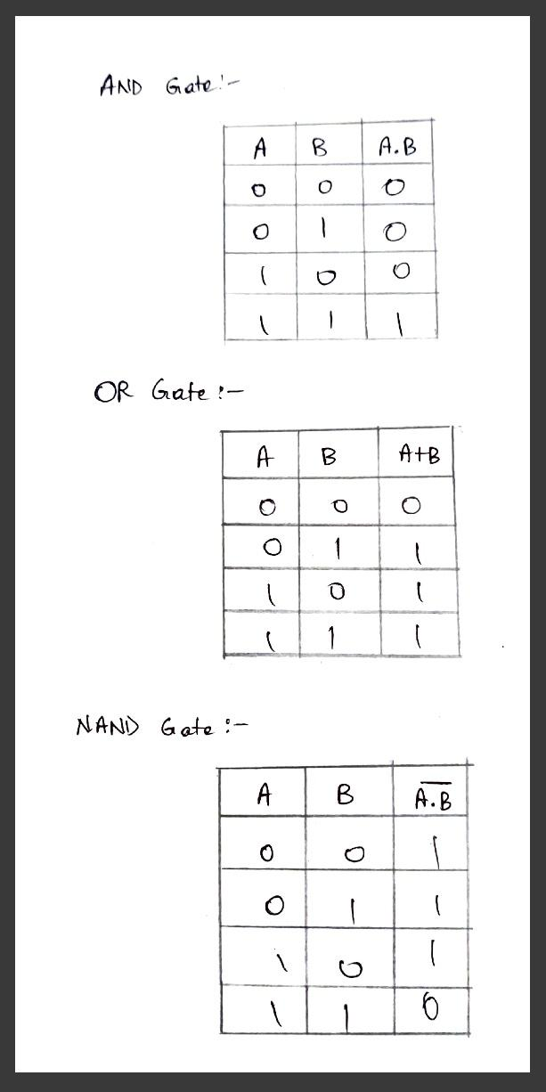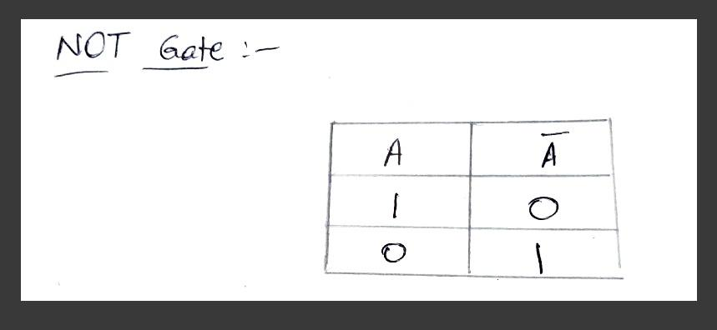



**Gate Design:**

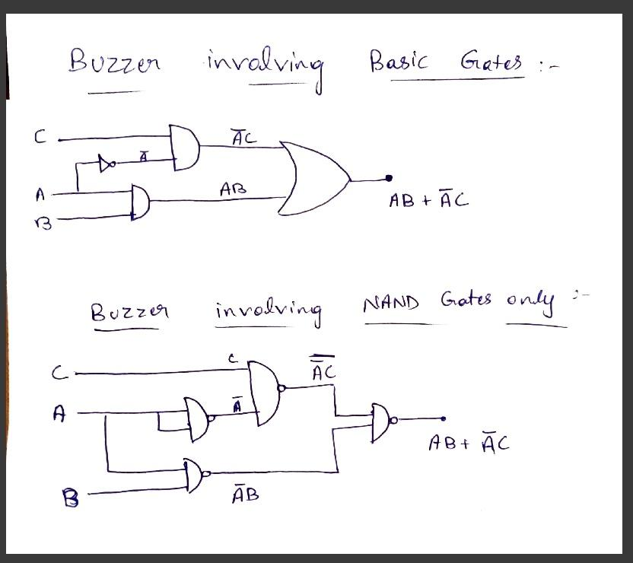

**Hardware:**

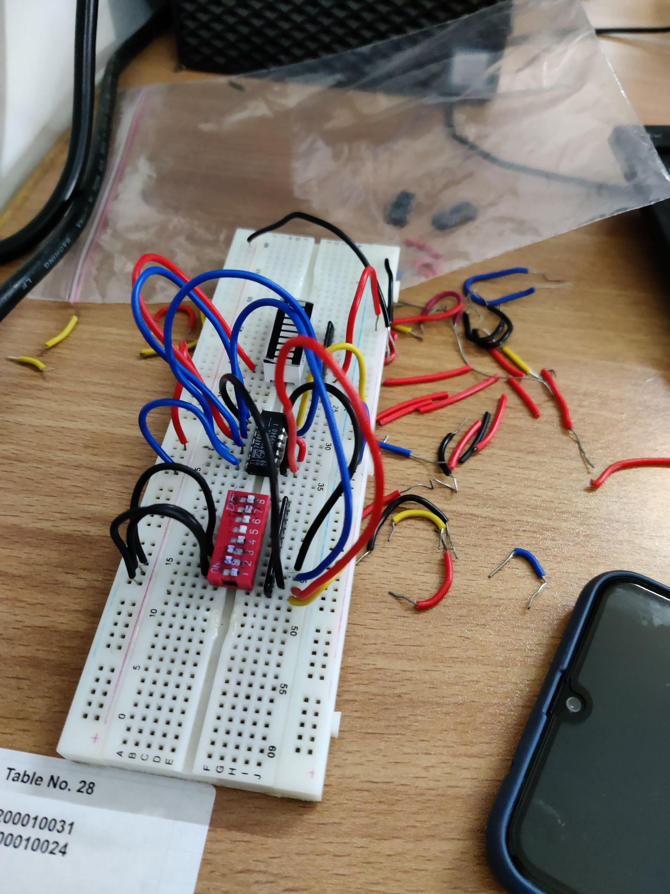

**Results and Discussions:** We finally understood how we can use K-,Map to directly get the simplest boolean expression. We were able to verify it with the SSOP method and were also able to implement it practically using different combinations. One combination was the simple type, with AND, OR and NOT gates. The other combination involved only NAND gates. Designing the circuits strengthened our understanding of gate-logic and implementing it on the breadboard was fun.

**Conclusion:** I was able to verify the boolean logic theoretically with its practical implementation, once using simple logic gates, and once using only NAND gates.