Exp.1 ***Christmas dual led chaser lights***

Circuit Diagram:

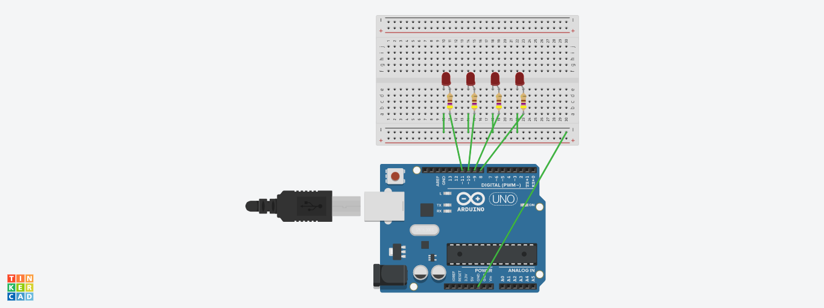

Theory:

Concept Used:

1)In this experiment I have used the concept of p-n junction diode.

2)How a resistance is used in a circuit.

3) To make a circuit on Bread Board.

4)Concept to code for Arduino UNO by using Loop statement.

Learning & Observations:

**Learning:**

**1)I have learnt to use Arduino Board and how code works to glow light.**

**2)How a circuit on breadboard is placed so that it can work properly.**

**3)**

**4)Arduino board has Digital pins and Analog pins.**

**Digital pin provides Input as well as Output, but Analog pin provides only input.**

**5)The Arduino board has ~ sign in Digital pin side which is also known as Pulse Width Modulation(PWM).**

**These pins help’s in getting analog results with digital means.**

**Observations:**

1)The Arduino board can provide a supply of 5V to the chaser circuit.

2)I connected the ‘p’ terminal of the p-n junction diodes to the Digital pins 8,9,10,11 in combination with the resistance, and ‘n’ terminals with the ground(GND).

3)After uploading the code on the Arduino software, the LED’s started switching on or off in pairs and blinking and moving forward inconsecutive manner with the time interval of 600miliseconds and they are moving in pair and giving the sense of LED chaser.

Problems and Troubleshooting:

1)The LED was not glowing due to its loose connection. By reinserting it again I was able to fix this issue.

2)I got confuse in can we use the void loop 2 times. The solution to that we can use ‘for’ loop in the function of void loop to overcome this problem.

3)I was not knowing how the delay function works for that I have the practical by removing the delay function and observing the result and again observe the result by using the delay function.

Precaution:

1)We need to handle the elements of the device with good care.

2)The connections on the Arduino board must coincide with the codes written on the software.

3)During the writing of the codes, the insertion of delay should not be forgotten and that too of the required time interval and not any random value.

4)In the IDE of Arduino the instructions should be given only in void loop section.

Learning and Outcomes:

1)We have learnt to make circuits using breadboard, Arduino board and other equipments.

2)We have learnt the various patterns that a LED chaser can do.

3)we have learnt how we can make any other type of gadgets related to this concept.