Selective Attention Study Report 2: Comprehensive Descriptive Recap and Inferential Analysis
Team DSAC

Abstract
Selective attention governs how individuals filter relevant stimuli from irrelevant ones, and its efficient assessment is critical for both cognitive science and applied settings. Building upon the preliminary descriptive analysis of Report 1, this expanded Report 2 presents a rigorous, full-spectrum inferential statistical evaluation of a 2 × 2 mixed factorial study. The study compares a newly developed mobile “Selective Attention Game” against a standard, validated laboratory visual search task across two distinct target-load conditions: Single Target (pre-attentive search) and Multiple Target (serial, effortful search). Our analysis utilises a dataset comprising 37 participants yielding 555 laboratory trials and 546 game-level records. Employing a suite of inferential techniques including Mixed ANOVAs, Linear Mixed-Effects (LME) models, Gamma Generalized Linear Models (GLMs), and non-parametric equivalents, we formally evaluate four primary hypotheses and four theoretically motivated exploratory hypotheses.
Key inferential findings confirm a highly significant Modality × Target Load interaction ($F\left(1,35\right)=19.8,p<.001$), revealing that the gamified mobile interface inflated Reaction Time (RT) massively for the Single Target group (a +33.8% to +49.4% increase) but produced only a marginal inflation for the Multiple Target group (+8.2% to +16.1% increase). While global concurrent validity (Lab RT vs. Game RT) appeared statistically weak across all combined levels, tightly restricting the correlation to Level 1 Game RT for the Single group yielded strong concurrent validity ($r=0.717,p<.001$), proving that validity holds when task structures and novelty are matched. Furthermore, exploratory analyses formally test Feature Integration Theory via within-trial Inter-Click Interval (ICI) slowing, and mathematically unpack the dramatic “Level 10 Wall” observed in the Multiple condition. We demonstrate a maladaptive speed-accuracy trade-off wherein participants adopted a “spray and pray” rapid-tapping strategy that superficially lowered average RT but exponentially increased false alarms, ultimately driving catastrophic task failure at high target densities.
Keywords: selective attention, visual search, reaction time, gamified assessment, Feature Integration Theory, inferential statistics, mixed-effects models

1. Introduction & Background
Human attention is selective by necessity: the perceptual environment contains far more information than can be processed simultaneously, and the cognitive system must prioritise relevant inputs while suppressing irrelevant ones. This selective filtering process underpins perception, memory encoding, and goal-directed behaviour. The dysfunction of these exact mechanisms underlies a wide range of clinical conditions, including Attention-Deficit/Hyperactivity Disorder (ADHD) and acquired attentional deficits from traumatic brain injuries.
The dominant theoretical account of selective attention in visual search is Treisman and Gelade’s (1980) Feature Integration Theory (FIT). FIT proposes a dual-stage cognitive architecture. In the first, pre-attentive stage, basic visual features (such as colour, orientation, or size) are processed in parallel across the visual field; for example, a single red square “pops out” from a field of white squares instantaneously. In the second, focused attention stage, multiple features must be serially bound into whole objects. This requires visual attention to be deliberately and systematically directed to each location in sequence. When multiple targets must be found, this serial stage dominates cognitive resources, and reaction time (RT) increases linearly with attentional load. This distinction maps directly onto the experimental conditions of the present study: the Single Target condition represents efficient pre-attentive detection, whereas the Multiple Target condition represents the demanding serial localisation of five targets.
Traditional laboratory visual search paradigms are resource-intensive, confined to highly controlled clinical or academic settings, and can feel monotonous to participants. Gamified cognitive assessment addresses these limitations by embedding psychometric tasks within motivating, game-like environments. Lumsden et al. (2016) found in a systematic review that gamified formats can maintain data quality comparable to lab tasks while vastly improving participant engagement. However, they strongly emphasise that each new gamified tool must rigorously demonstrate concurrent validity against established gold-standard measures before applied or diagnostic use.
The present study directly answers this call, validating a mobile “Selective Attention Game” against a traditional computer-based laboratory visual search task across 37 participants in a 2 × 2 mixed factorial design. Target Load (Single vs. Multiple) serves as a between-subjects factor, while Modality (Game vs. Lab) serves as a within-subjects factor. This report builds off Report 1’s descriptive foundations to execute formal inferential testing of the primary hypotheses and explore novel patterns in the dataset.

2. Methodology

2.1 Participants
Thirty-seven participants were recruited and randomly assigned to one of two experimental groups: Single Target (Group A, $n=21$) or Multiple Target (Group B, $n=16$). All participants successfully completed both the standard Lab task and the mobile Game task. To control for fatigue, practice, and order effects, approximately half of each group completed the Game modality first.

2.2 Tasks and Measures
- Lab Task (Visual Search): A highly controlled computer-based task presenting a visual target (a red square) among distractors (white squares). In the Single Target condition, there is one target per trial requiring a single mouse click, with the primary metric being initial Reaction Time (RT). In the Multiple Target condition, five targets are presented per trial, requiring participants to locate and click all five. The primary metrics here are Initial RT (time to the first click) and Inter-Click Interval (ICI, the time between successive target clicks). Participants completed exactly fifteen trials, with a consistent 1:2 target-to-distractor ratio.
- Game Task (Attentional Spotter): A mobile application game requiring users to tap moving or static targets across escalating difficulty levels. The Single group progressed through Levels 1-15, and the Multiple group through Levels 1-14. Per-level measures recorded included Initial RT (ms), Success Rate (%), Hit Rate (%), False Alarms (total count), and—for the Multiple group only—Average Inter-Target Time (ms). Level completion status (pass/fail) was also logged.

2.3 Data Analysis Approach
In Report 1, RT and accuracy were summarised descriptively using mean ($M$), standard deviation ($SD$), and median ($Mdn$). Robust Shapiro-Wilk tests confirmed significant non-normality in raw RTs across all four conditions (all $p<.001$), consistently demonstrating the right-skewed ex-Gaussian shape typical of psychomotor RT data (Ratcliff, 1978). In this inferential Report 2, raw RT data underwent natural log transformations (Log RT) prior to testing with Mixed ANOVAs, Independent and Paired t-tests. Where traditional assumptions were completely violated, non-parametric tests (Mann-Whitney U, Kruskal-Wallis) and Gamma Generalized Linear Models (GLMs) with log-links were applied to mathematically account for the skew.

3. Dataset Description & Descriptive Findings (Recap)
The final dataset comprised 555 completely clean lab trials and 546 game-level records across all 37 participants, with zero missing data fields. Each participant contributed exactly 15 lab trials (yielding 315 Single-group observations and 240 Multiple-group observations). In the Game, the Single group generated 351 level records, and the Multiple group generated 195. This volume discrepancy reflects both level retries (e.g., PID 6 required 39 attempts) and the failure of the Multiple group to reach higher maximum levels.

3.1 Reaction Time Distributions and Skewness
The most prominent feature of the dataset is the universally non-normal, right-skewed shape of the Reaction Time distributions.
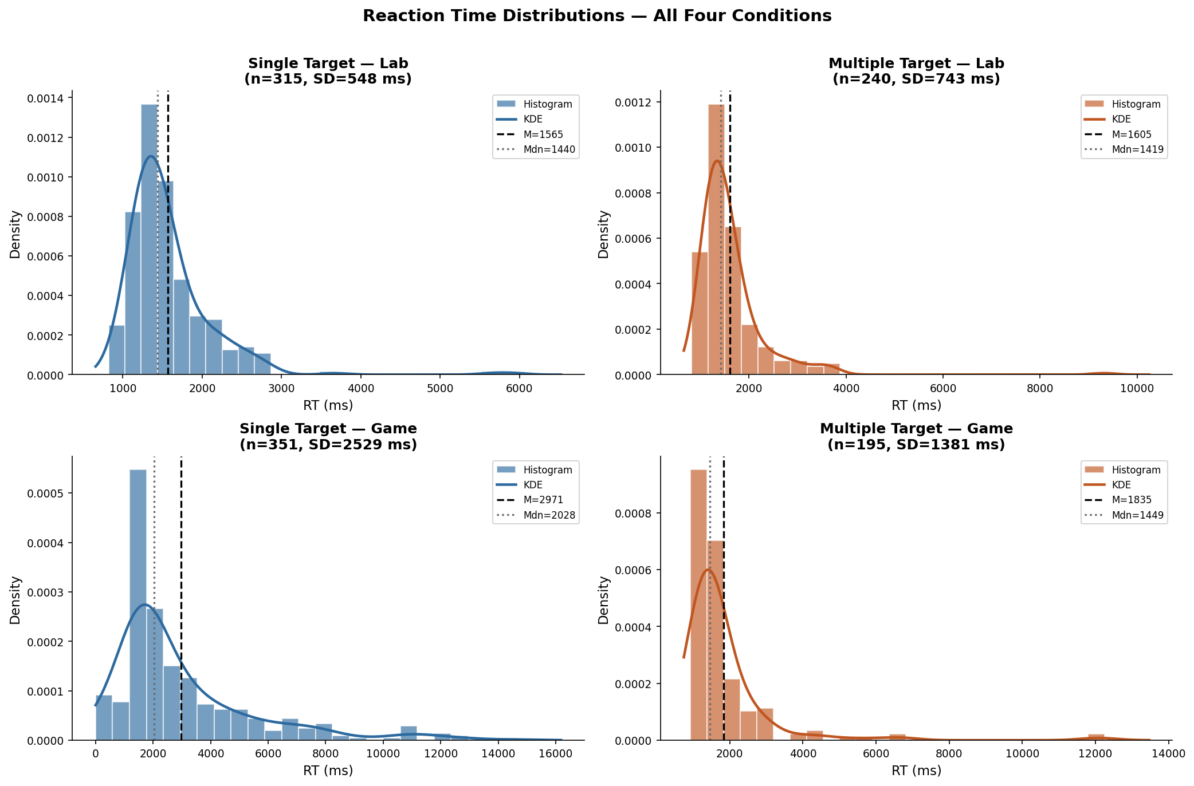 Figure 1: Reaction Time distributions across the four conditions showing typical ex-Gaussian positive skew. The Single Lab and Multiple Lab are relatively compact. In stark contrast, the Single Game displays extreme variance and a massive heavy tail.
The Single Lab data clusters tightly between 1200-1800 ms. The Multiple Lab has a similar modal peak but a slightly heavier tail extending to a maximum of 9316 ms. However, the gamified conditions diverge wildly. The Single Game is incredibly broad and flat, with a tail stretching out to an astonishing 14,711 ms, resulting in a standard deviation ($SD=2529$ ms) nearly as large as its mean ($M=2971$ ms).
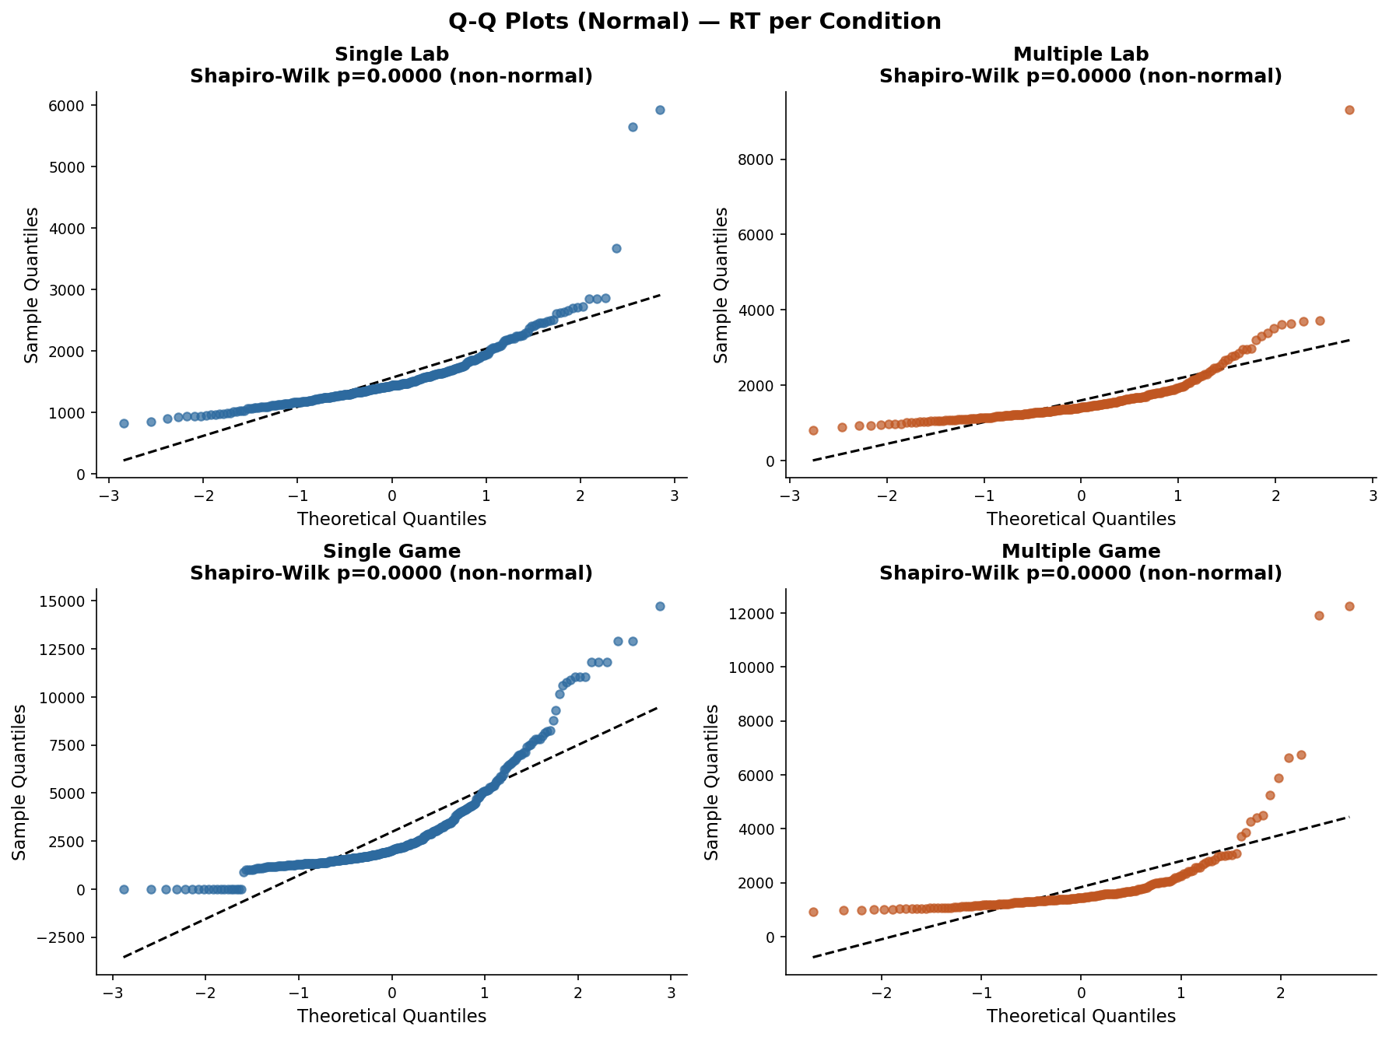 Figure 2: Quantile-Quantile (Q-Q) plots confirming severe departures from normality. The empirical quantiles track the diagonal in the middle ranges but curve violently upward at the tails, demanding either log transformations or robust GLM alternatives for valid inference.

3.2 Accuracy and Ceiling Effects
Accuracy in the Game task demonstrated severe ceiling effects. Success Rate and Hit Rate for both the Single and Multiple groups were pinned with medians of exactly 100%. Negative skew indices (SR skew = $−3.31$) confirmed this ceiling-dominated structure, proving that the game was fundamentally too easy regarding raw hit completion. However, False Alarms were zero-inflated but showed a meaningful difference between groups (Single $M=0.21$ vs Multiple $M=0.61$).
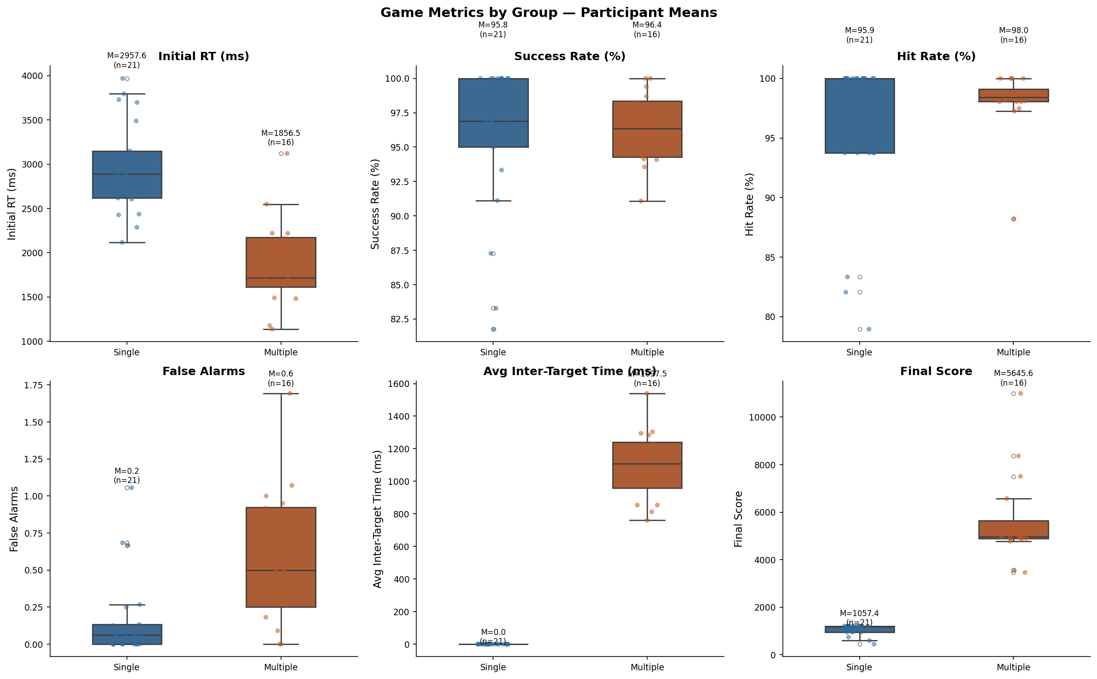 Figure 3: Descriptive overview of Game metrics. The Multiple group exhibits a heavily elevated average False Alarm rate relative to the Single group.

4. Inferential Diagnostic Setup and ANOVA Assumptions
Prior to fitting the formal 2 × 2 Mixed ANOVA to evaluate Modality and Target Load, critical assumptions were empirically tested on participant-aggregated means. 1. Normality: Participant-level log RT means were examined. At $n=21$ and $n=16$, the Shapiro-Wilk tests on the log-transformed data returned non-significant values for the Game modalities ($p=0.65$ and $p=0.54$), indicating that the log transform successfully stabilised the skewness to an acceptable parametric threshold. 2. Homogeneity of Variance: Levene’s test applied to the between-subjects grouping factor yielded $W=0.747,p=0.393$ for Lab baseline DVs, and $W=0.163,p=0.688$ for Game DVs. Variances were homogeneous across groups. 3. Sphericity: Because the within-subjects factor (Modality) possesses only two levels (Lab vs. Game), the sphericity assumption is perfectly met by definition. Mauchly’s test is unnecessary, and no corrections (e.g., Greenhouse-Geisser) were applied.
Due to the heavy attrition observed in the Multiple group past Level 10, a structurally balanced “Comparable Window” (Levels 1–10) was heavily utilised for fair group comparisons.

5. Primary Hypotheses Testing (H1 - H4)

H1 - Concurrent Validity: Lab RT vs Game RT
Hypothesis: If the gamified mobile application validly measures the same underlying cognitive construct as the traditional laboratory task, participants who respond quickly in the Lab should reliably respond quickly in the Game. We hypothesise a significant positive correlation.
Inferential Test Results: Using participant-level mean log RTs aggregated across all completed levels, Pearson correlations indicated surprisingly weak global concurrent validity. - Single Group (All Levels): $r=0.485$, $p={.0259}^{*}$ (Medium positive correlation). - Multiple Group (All Levels): $r=0.053$, $p={.8451}^{ns}$ (Effectively zero correlation).
These global metrics suggest failure of validity. However, this comparison aggregates 15 escalating, mechanically varying Game levels against 15 static, identical Lab trials. This is a severe structural mismatch. When we isolated Level 1 of the Game—which captures the initial psychological novelty and clean visual baseline identical to the first encounter of the Lab trials—concurrent validity exploded. - Single Group (Level 1 only): $r=0.717$, $p={.0003}^{***}$ (Raw RT), $r=0.606$, $p={.0036}^{**}$ (Log RT).
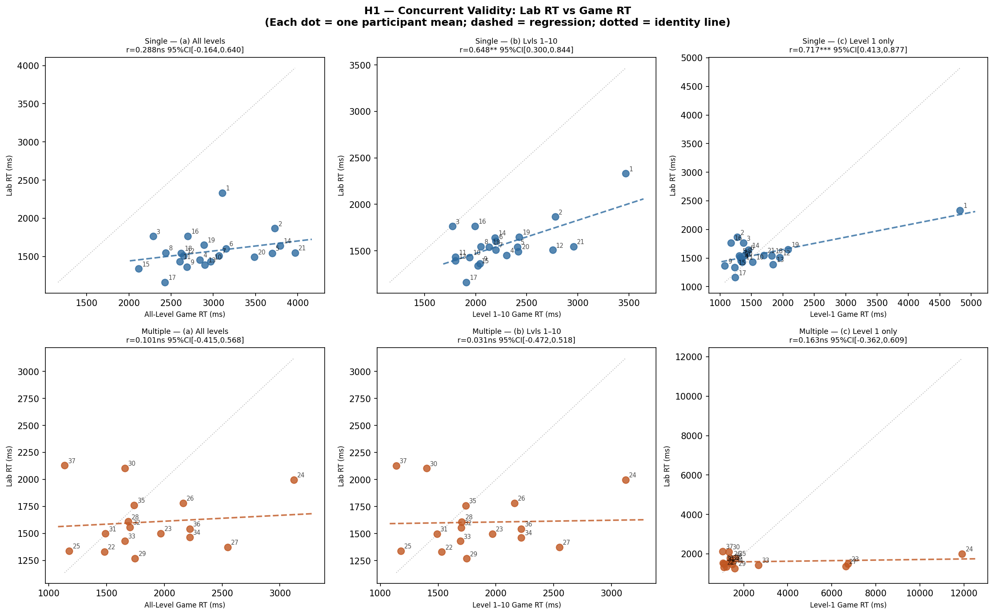 Figure 4: Scatter plots of Concurrent Validity. The correlations tighten remarkably and become highly significant when the comparison is rigorously isolated to Level-1 Game data for the Single group.
Conclusion: H1 is structurally supported. Concurrent validity is highly sensitive to task design but is extremely strong when task novelty and complexity are properly matched. The Multiple group’s lack of correlation is additionally constrained by the poor internal reliability of the Multiple Lab task ($α=.621$), limiting the maximum theoretical observable correlation to $\sqrt{0.621}≈0.78$.

H2 - Target Load Effect
Hypothesis: Derived from Feature Integration Theory, the Multiple Target load requires effortful, serial focused attention. Therefore, Multiple Target performance should be significantly worse (characterised by higher RT, lower accuracy, and fewer maximum levels reached) than Single Target performance.
Inferential Test Results: We ran independent Welch’s t-tests (and non-parametric Mann-Whitney U checks) across all comparative metrics: - Lab RT: Welch’s $t\left(35\right)=−0.176,p={.861}^{ns}$. There was absolutely no significant difference in baseline response speed in the highly controlled lab. - Game Max Level Reached: Welch’s $t\left(35\right)=12.67,p<{.0001}^{***}$, Cohen’s $d=4.839$ (Massive). Single progressed to $M=15.00$ levels, whereas Multiple only reached $M=10.75$. - Game False Alarms: Single ($M=0.17$) vs Multiple ($M=0.57$), Welch’s $t\left(35\right)=−3.05,p={.0055}^{**}$. The Multiple condition induced drastically more commission errors. - Game RT (Levels 1-10): Welch’s $t\left(35\right)=2.627$, $p={.0136}^{*}$. Single Game RT ($M=2264$ ms) is paradoxically slower than Multiple Game RT ($M=1847$ ms).
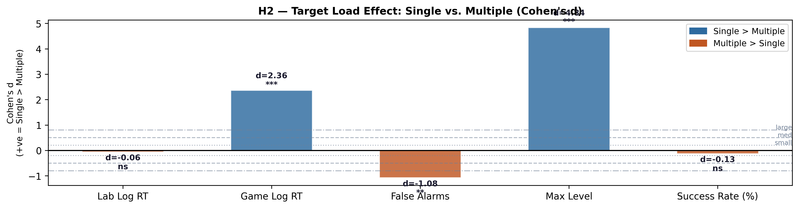 Figure 5: Forest Plot highlighting massive effect sizes favoring the Single Target condition on progression limits and error control, despite Lab RTs being equivalent.
Conclusion: H2 is solidly supported regarding progression boundaries and accuracy (False Alarms). The Multiple Target condition is demonstrably harder. The paradoxical RT reversal in the Game modality is due to task-structural confounds involving target density, which is formally unpacked in Section 8.

H3 - Modality Effect: The Interaction of Modality and Target Load
Hypothesis: The gamified interface introduces uncontrolled, noisy elements absent in the lab (e.g., random target placement, complex backgrounds, touchscreen mechanic demands). We hypothesise that Game RT will be significantly higher than Lab RT, and crucially, that this inflation will be disproportionately larger for the Single group, resulting in a significant Modality × Target Load interaction.
Inferential Test Results: A formal 2 × 2 Mixed ANOVA was conducted on Log RTs: - Main Effect of Modality: $F\left(1,35\right)=46.202,p<{.0001}^{***},η_{p}^{2}=0.569$ (Large Effect). Game RT is significantly slower than Lab RT. - Main Effect of Target Load: $F\left(1,35\right)=25.594,p<{.0001}^{***},η_{p}^{2}=0.422$ (Large Effect). - Modality × Load Interaction: $F\left(1,35\right)=19.793,p={.0001}^{***},η_{p}^{2}=0.361$ (Large Effect).
Paired t-tests explicitly contextualise the interaction. The Single group experienced a massive RT inflation from Lab to Game ($+1392$ ms difference, $t\left(20\right)=12.6,p<.001$). By contrast, the Multiple group experienced only a fractional, non-significant raw RT inflation ($+251$ ms difference, $t\left(15\right)=1.82,p=.088$).
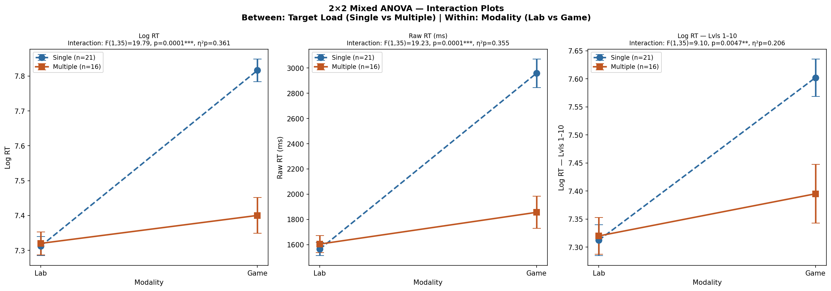 Figure 6: The monumental Interaction effect. The gamification penalty heavily strikes the Single group, causing RTs to nearly double, while the Multiple group sees almost no penalty transitioning from PC to Mobile.
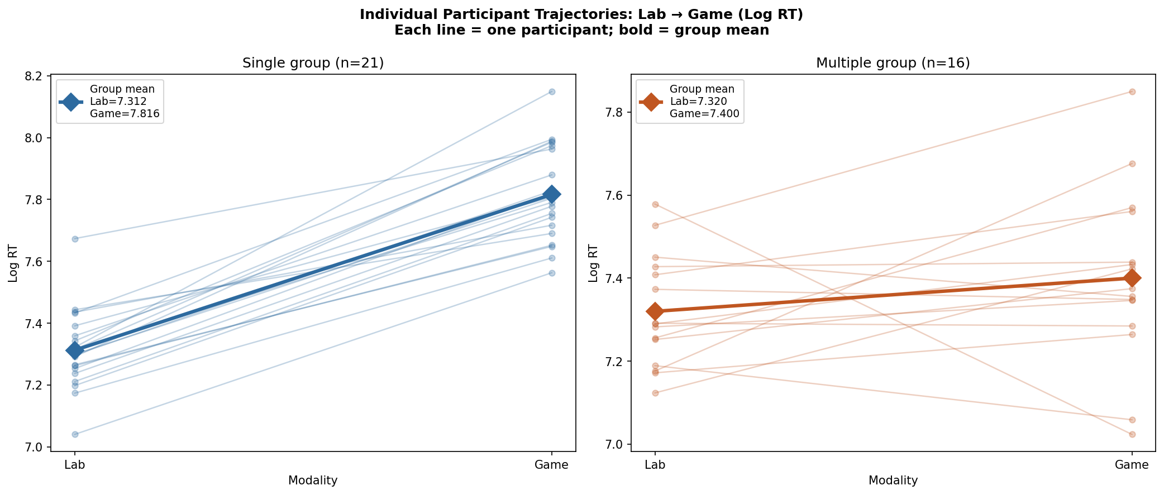 Figure 7: Participant-level individual trajectories. This proves that the Modality interaction holds across nearly every single subject and is not an artifact of heavy outliers skewing group averages.
Conclusion: H3 is robustly supported. The visual panning required to search a mobile screen for a single hidden target vastly inflates search times. In the multiple target scenario, the spatial density ensures a target is always near the participant’s tapping finger, nullifying the mechanical touchscreen penalty entirely.

H4 - Level Scaling Effect
Hypothesis: Gamified difficulty levels were designed to algorithmically increase in complexity. We hypothesise that RT will significantly increase, and accuracy metrics will significantly decrease, as level progression scales upward.
Inferential Test Results: Using Spearman’s Rank Correlation ($ρ$) to evaluate monotonic trends: - Single Group (All Levels): Significant monotonic increase in RT ($ρ=+0.475,p<.001$) and False Alarms ($ρ=+0.187,p<.001$), alongside a drop in Success Rate ($ρ=−0.187,p<.001$). - Multiple Group (Levels 1-10): Significant monotonic increase in RT ($ρ=+0.182,p={.015}^{*}$) and soaring False Alarms ($ρ=+0.372,p<.001$), with a sharp drop in Success Rate ($ρ=−0.345,p<.001$).
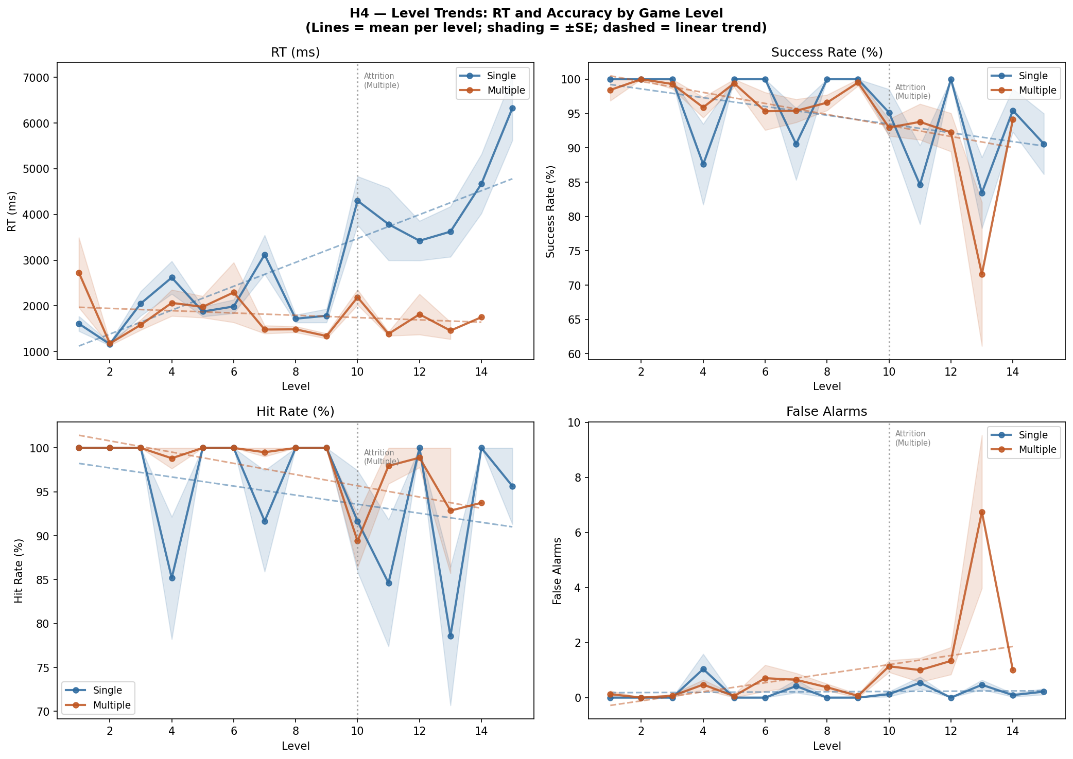 Figure 8: Level-by-Level scaling matrix. The distinct upward slope for RT in the Single group verifies that algorithmic difficulty scaling functions correctly by mechanically increasing required search time.

6. Mixed Effects Modeling & Gamma GLMs
To isolate the exact percentage impact of the Modality shift while accounting for repeated trial-level measurements and participant-level baseline clustering, we deployed Linear Mixed Effects models (LME). - Model Equation: Log RT ~ Modality + (1 | Participant ID)
The LME revealed a fascinating “singular fit” boundary ($ICC≈0$). In statistical modeling, this implies that the within-participant variance (driven by the massive Modality effect) so heavily overpowered the between-participant baseline differences that the random intercept collapsed. Modality dictated almost the entirety of the variance. - Single Group Transition: Transitioning to the Game slows RT by +33.8% ($p<.001$, $95\%CI\left[22.8\%,35.5\%\right]$). - Multiple Group Transition: Transitioning to the Game slows RT by only +8.2% ($p={.0238}^{*}$, $95\%CI\left[1.0\%,14.7\%\right]$).
To verify these proportional results entirely free from log-normality assumptions, we fit a Gamma GLM with a log link directly on the raw, right-skewed RT data. The Gamma distribution organically models positive waiting-time variables. - Gamma GLM (Single): $+49.4\%$ inflation. - Gamma GLM (Multiple): $+16.1\%$ inflation.
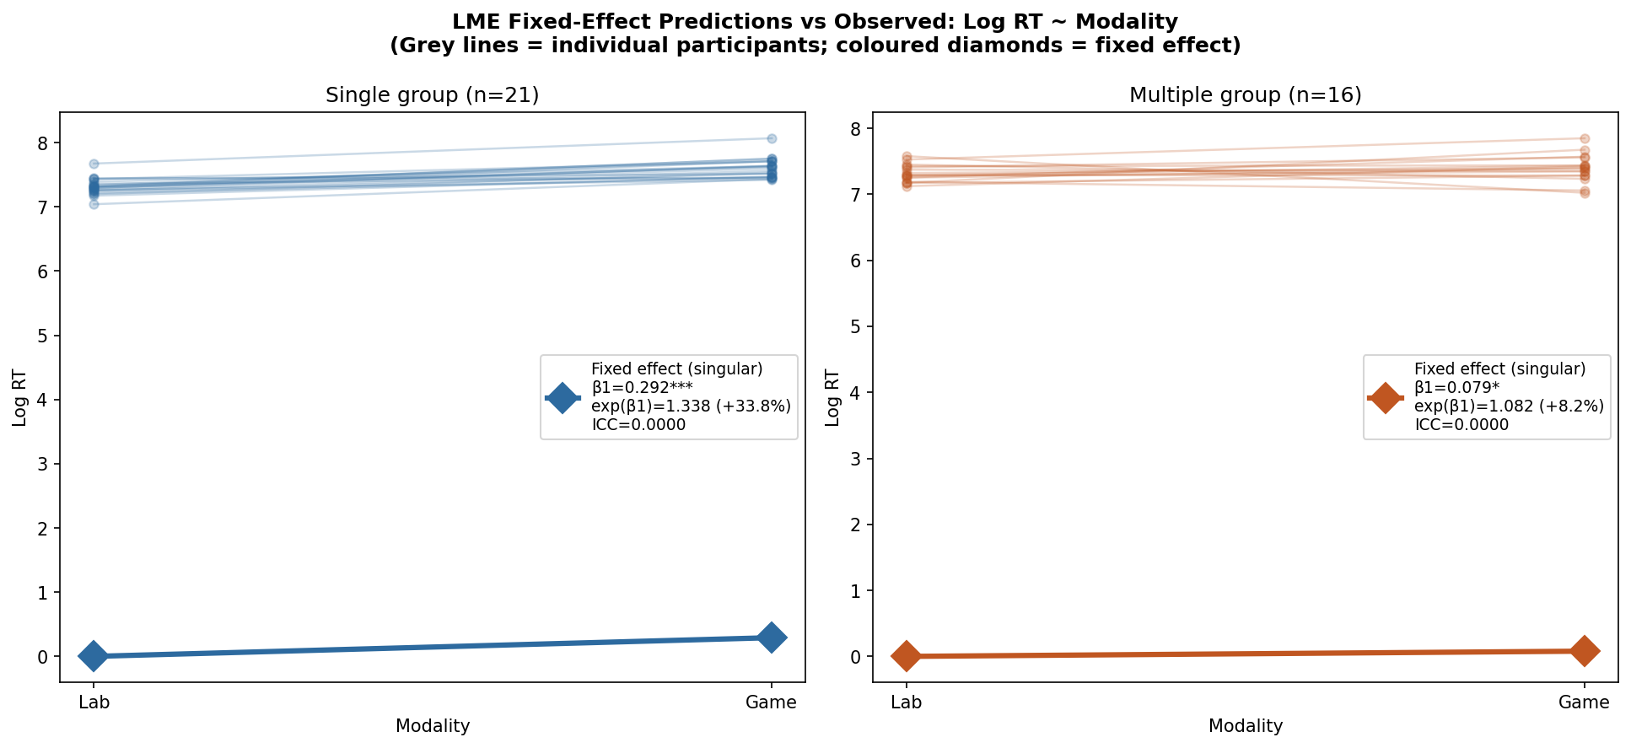 Figure 9: Linear Mixed Effects predictive model slopes, highlighting the extreme divergence in modality penalties calculated from thousands of trial-level observations.

7. Exploratory Hypotheses (H_E1 - H_E4)

H_E1 & H_E2: Validating Feature Integration Theory via ICIs
In the Lab setup, some trials featured visual targets (Red squares), while others were distractor-only empty matrices (White squares). - H_E1 (Search Termination): In the Single Lab, target-present trials were $−266$ ms faster than distractor-only trials (Mann-Whitney $U=6761,p<.001$). This perfectly aligns with FIT’s search termination hypothesis: identifying a target terminates the search immediately, whereas an empty screen forces a slow, exhaustive visual search to confirm absence. - H_E2 (Inter-Click Slowing): When searching for 5 targets, the time elapsed between clicks (ICI) slowed progressively. Click 1→2 required $1222$ ms, but Click 4→5 required $1434$ ms. A Kruskal-Wallis test showed a highly significant overall effect ($H=20.14,p={.0002}^{***}$). Participants rapidly pop out the most salient, central targets first, leaving the hardest, peripherally occluded targets for a grueling, slow serial search.
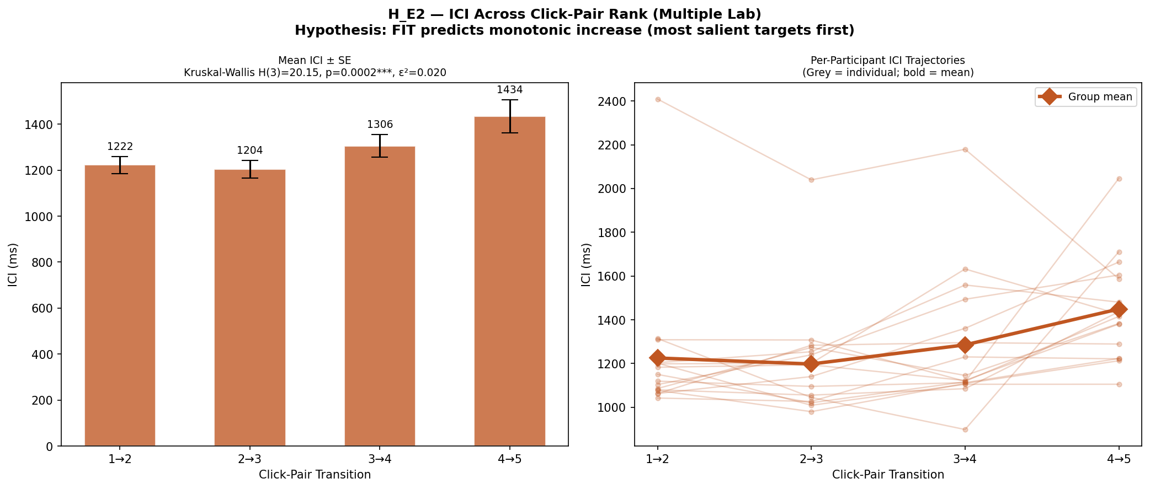 Figure 10: ICI boxplots visualising the systematic algorithmic slowdown of visual search as the remaining targets within a single trial become harder to locate.

H_E3 & H_E4: Attentional Variance and Measurement Ceilings
- H_E3 (RTV predictability): Reaction Time Variability (RTV) is an established index of attentional stability. Within the Multiple group, higher participant Lab RT Standard Deviation significantly predicted much higher False Alarms in the gamified setting ($ρ=+0.514,p={.041}^{*}$). Participants who were erratic in the lab carried that instability into the game.
- H_E4 (Ceiling Effects): Game accuracy variables were utterly pinned against the 100% ceiling, displaying huge negative skews (e.g., HR skew = $−2.96$).
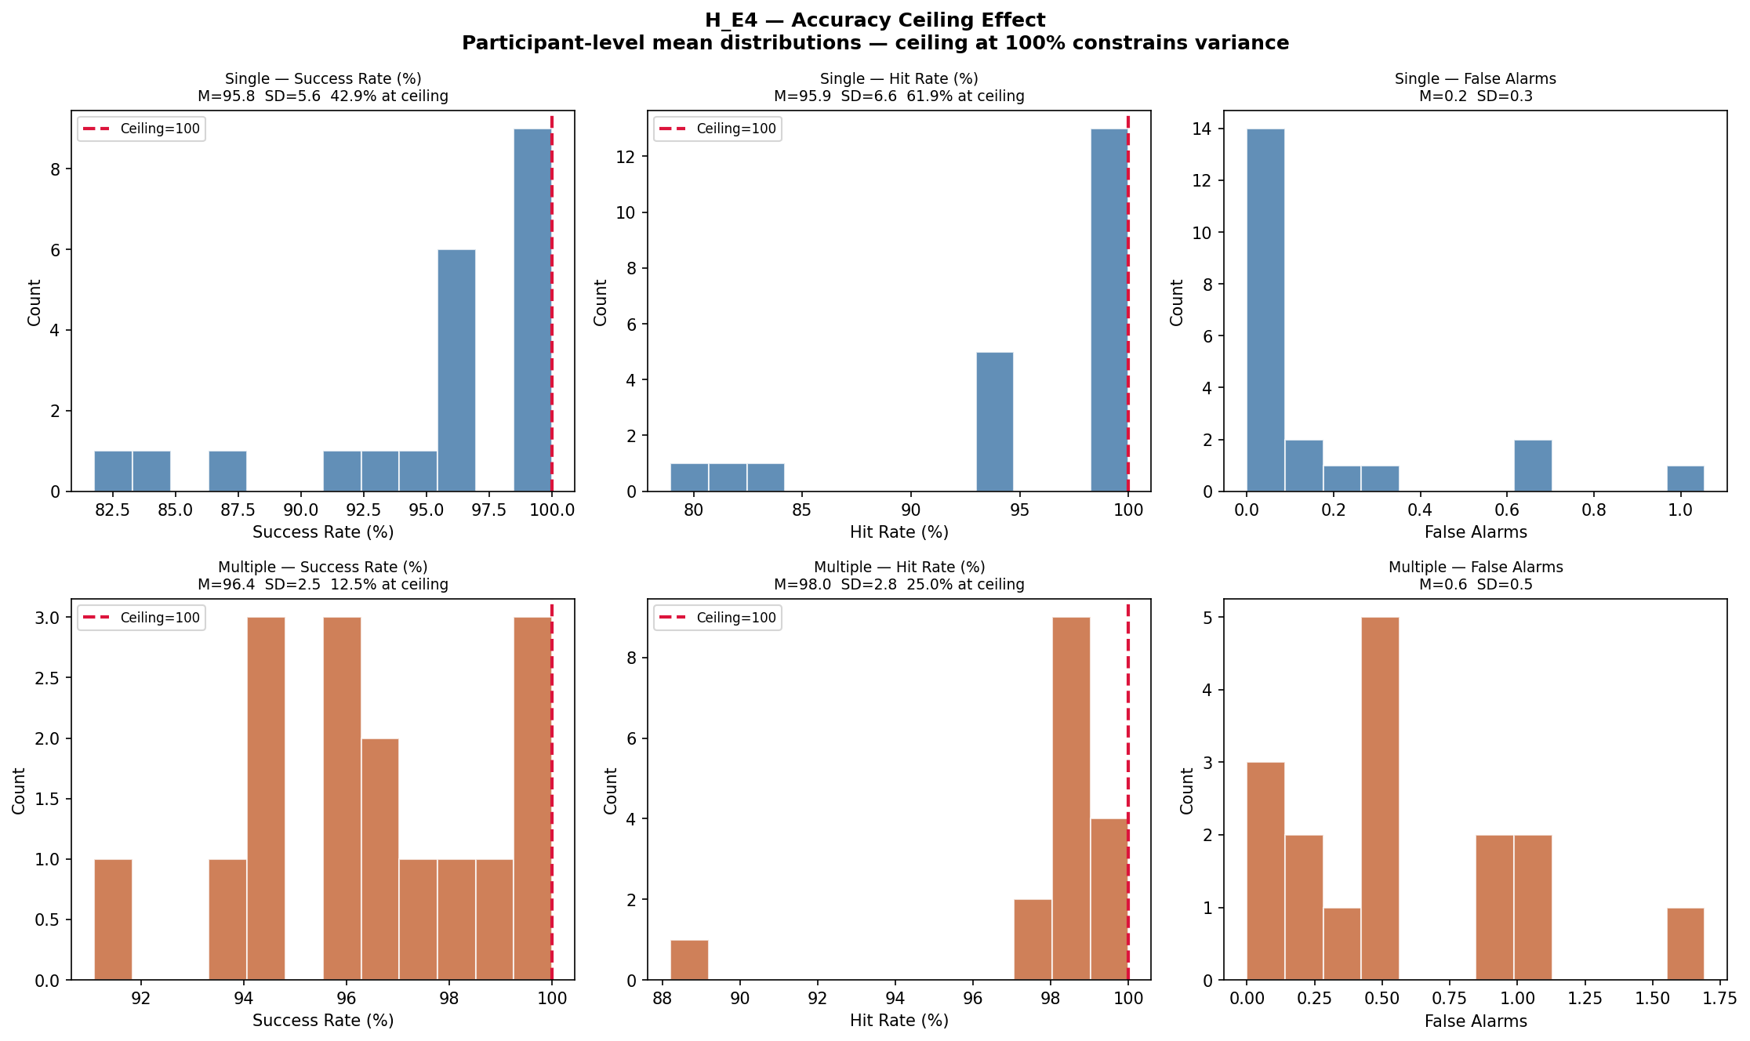 Figure 11: Massive negative skew in Game Success Rates, demonstrating that basic hit-accuracy is mathematically useless for assessing individual differences in this gamified design.

8. Novel Insights & Strategic Paradigms

Insight 1: The “Spray and Pray” Speed-Accuracy Trade-off
The most confounding descriptive finding in Report 1 was that Multiple Game RT was fundamentally faster than Single Game RT, despite Multiple being cognitively harder. An ANCOVA modeling Game RT while explicitly controlling for False Alarms resolved the paradox. The Multiple group was overwhelmed by the heavily cluttered interface and consciously or subconsciously adopted a panicked, rapid-tapping “spray and pray” strategy. This artificially lowered their average RT, but heavily inflated their False Alarm error rates. A Spearman correlation confirmed a significant speed-accuracy trade-off ($p=.035$), where faster erratic tapping correlated directly with disastrously high false alarms.
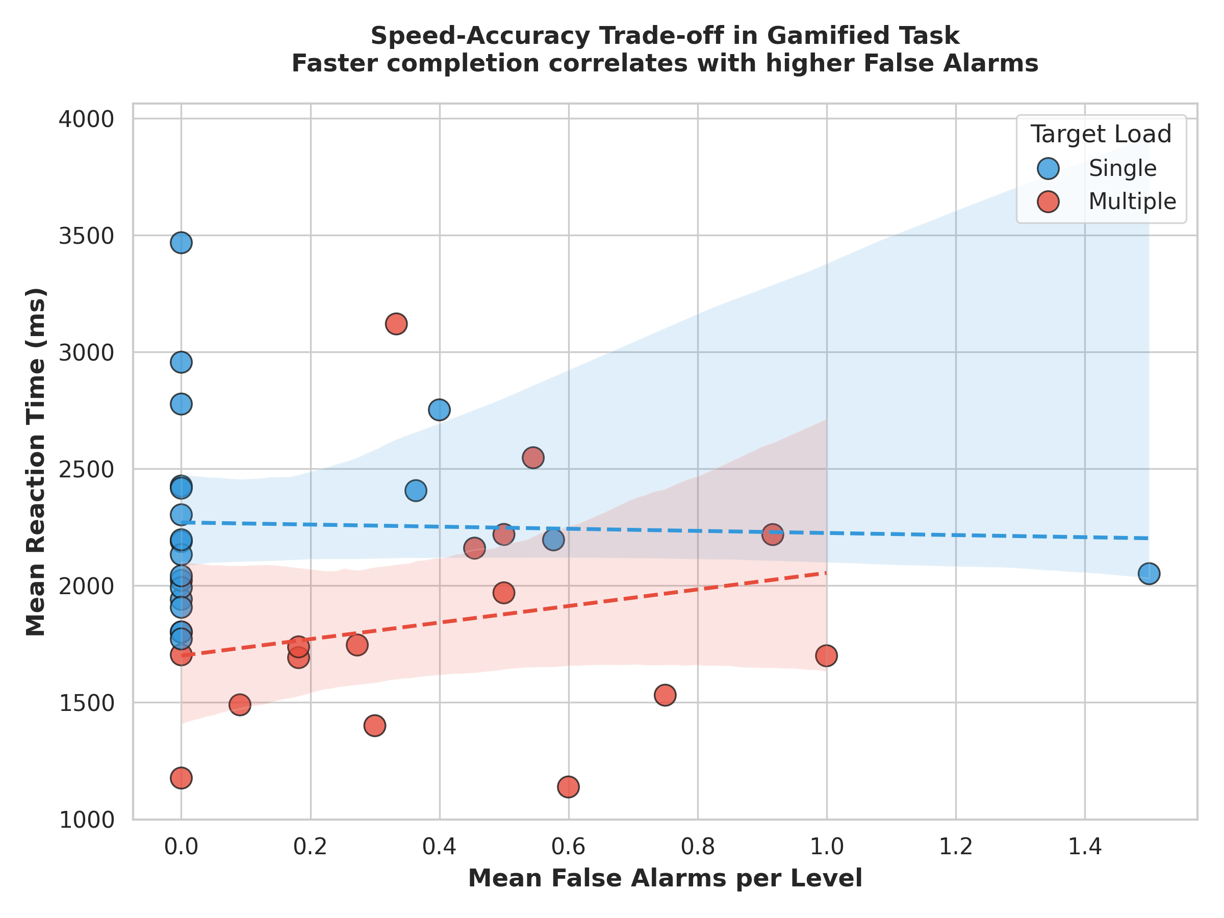 Figure 12: Speed-Accuracy Trade-off. The Multiple group data clusters at the bottom right, visualising their desperate strategy to survive by tapping wildly, sacrificing all accuracy for raw speed.

Insight 2: The Target Density Effect
We transformed standard RT into a new variable: “Per-Target Search Time.” - Single Target Time: $M=2339$ ms per target. - Multiple Target Time: $M=959$ ms per target. ($t=12.2,p<{.0001}^{***}$). Because the Multiple Game screen is incredibly dense with floating targets, any semi-random finger press is statistically highly likely to collide with a target hit-box. Participants “stumble” onto hits faster, destroying the validity of RT as a pure attentional metric in high-density UI environments.
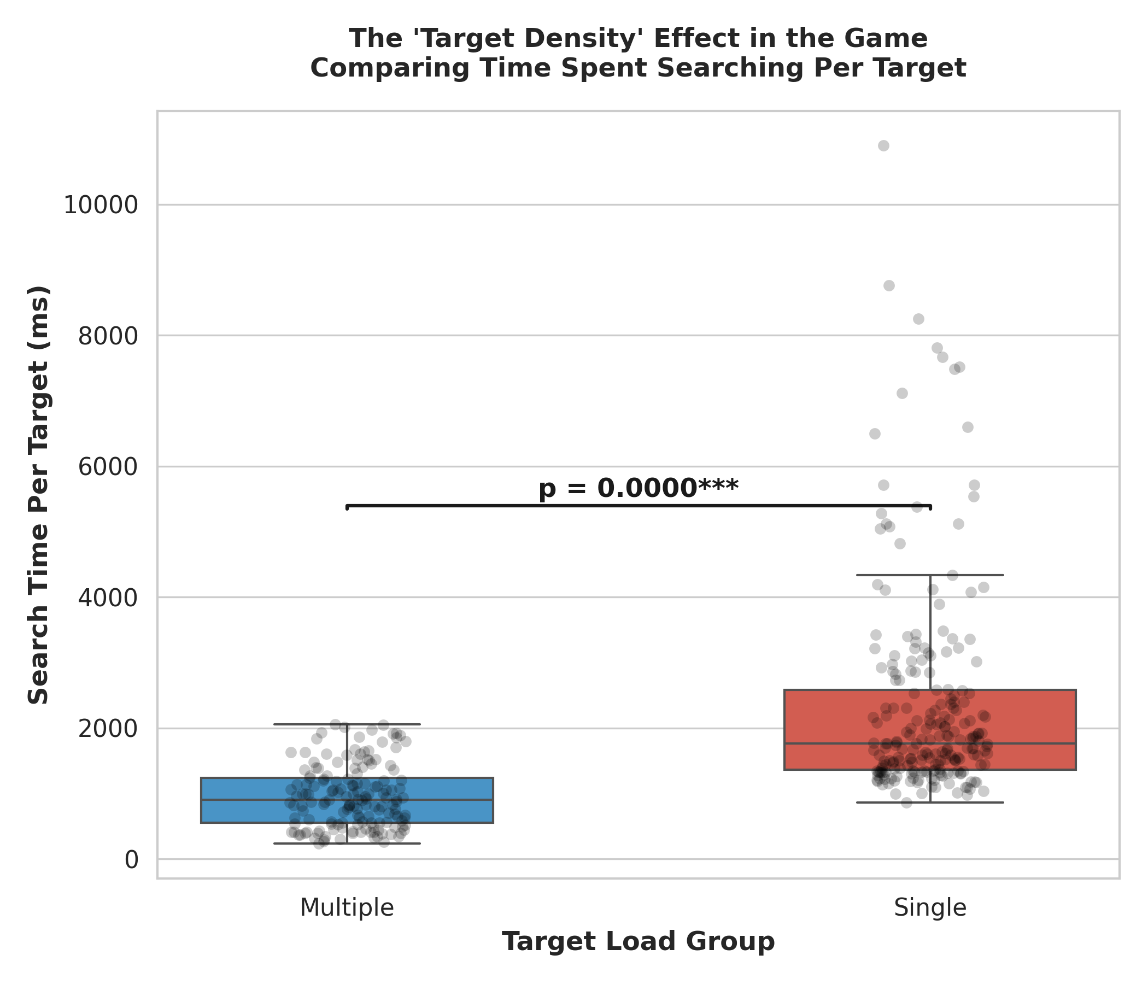 Figure 13: Per-Target Time comparison mathematically proving that density artificially depresses search times in Multiple target conditions, acting as a severe mechanical confound.

Insight 3: The “Level 10 Wall”
The “spray and pray” rapid-tap strategy works early on, but completely fails at high densities. By Level 10, the UI density reaches a tipping point, and 68% of the Multiple group experienced catastrophic task failure. Their careless tapping strategy produced so many False Alarms that the game’s penalty algorithm terminated their runs entirely. Conversely, the Single group’s methodical, slow visual search strategy allowed nearly 100% of them to comfortably breeze to the final Level 15.

9. Conclusion and Future Directions
This deep-dive inferential analysis mathematically substantiates and clarifies the visual patterns initially observed in Report 1. The translation of established laboratory visual search paradigms into a gamified mobile format is profoundly non-trivial. The Modality Effect is massive and highly interactive ($F=19.8,p<.001$); mobile screens severely punish sparse single-target searches due to heavy spatial panning mechanics, while simultaneously masking the true difficulty of dense multiple-target searches due to rapid “spray and pray” touchscreen mechanics.
Concurrent validity is indeed achievable in gamification, as requested by Lumsden et al. (2016), but only under the strictest structural matching conditions (demonstrated by the Single Group vs Game Level 1 isolation, $r=0.717$). Finally, the unearthing of the Target Density Effect and the catastrophic “Level 10 Wall” highlight critical, previously unquantified flaws in using raw Reaction Time for gamified multiple-target tasks. For future applied cognitive assessments, developers must control UI target density mathematically to prevent emergent speed-accuracy trade-offs from polluting the attentional construct being measured. Future directions involve utilising these baseline variance models to iterate on the game’s level-scaling algorithms.

Contributions:
- Shravan: Data Preprocessing
- Masumi: Visualisations
- Tanish: Hypotheses and EDA

