Walmart (NYSE: WMT)
April 2, 2026
Recommendation:
- Stock Rating: BUY
- Price Target: $134.43
- Risk: Medium
Market Data:
- Price (4/2/2026): $123.50
- Market Cap: $984.592 billion
- 52 Week Range: 79.81 - 134.69
- Dividend Yield: 0.78%
Financial Highlights:
- Revenue (TTM): $713.2 billion
- Beta: 0.66
- Net Income: $21.9 billion
- Operating CF: $41.6 billion
Members:
- Diya Patel
- Tanish Raha
- Benny Ho
- Soham Patel
- Kyle Dallon
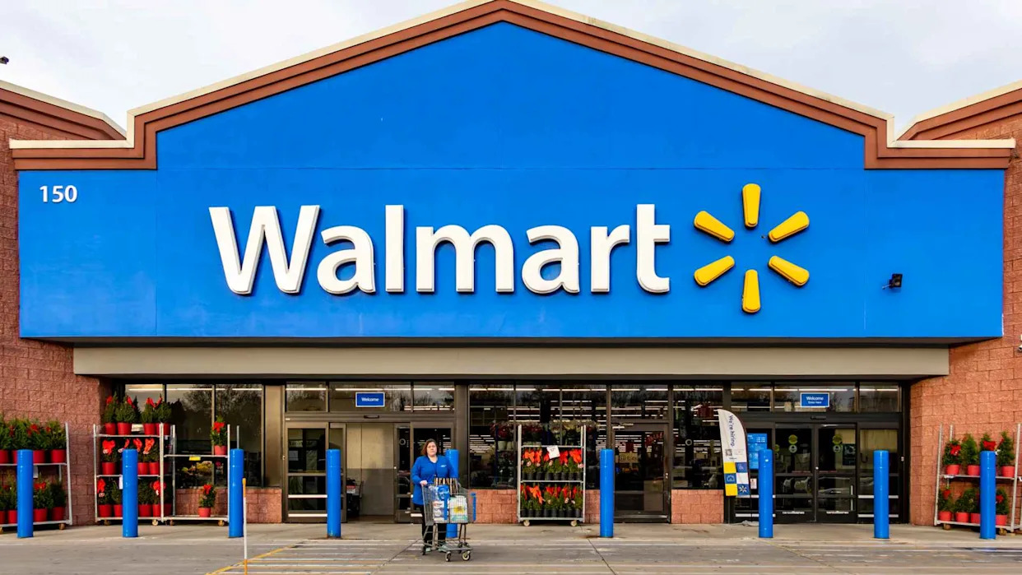

- Walmart is currently one of the leading global retailers, operating a hybrid business model that combines physical store operations with a growing e-commerce platform. This report evaluates a BUY position on Walmart’s stock by analyzing key trends, competitive dynamics, and the company’s overall strategic positioning.
- The retail industry remains highly competitive and is transitioning into the digital commerce era. Consumers increasingly expect convenience, competitive pricing, and fast fulfillment, driving companies to invest in logistics, digital capabilities, and AI to improve efficiency and profitability.
- Walmart maintains a strong competitive position through its cost leadership strategy and economies of scale, which allow it to offer low prices across a wide range of products. Its omnichannel approach integrates in-store and online shopping, strengthening its ability to compete with both traditional retailers and digital-first competitors.
- Walmart’s ability to operate in a low-margin environment helps it withstand competitive pressure, particularly in e-commerce. Based on our valuation analysis and Walmart’s expansion we believe stock is currently undervalued compared to its long-term growth potential. However, some external factors such as economic volatility and competition require ongoing adaptation.
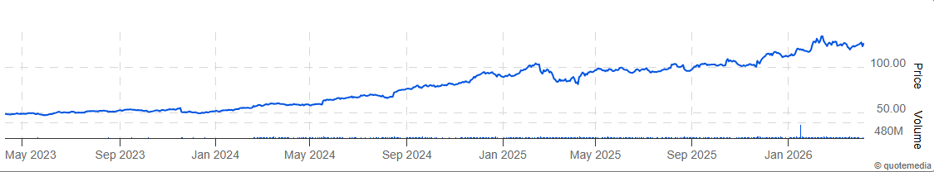
- Overall, Walmart is a strong investment due to its scale, pricing strategy, and ability to adapt to changing consumer behavior. Its integrated model supports continued investment in AI and digital capabilities, strengthening supply chain efficiency and positining them optimally for long term growth.

Company Overview
Walmart is a leader in the consumer staples industry and the world’s largest company by revenue, generating approximately $681 billion in fiscal year 2025. It is a leading omnichannel retailer operating in over 19 countries worldwide and employing over 2.1 million associates.
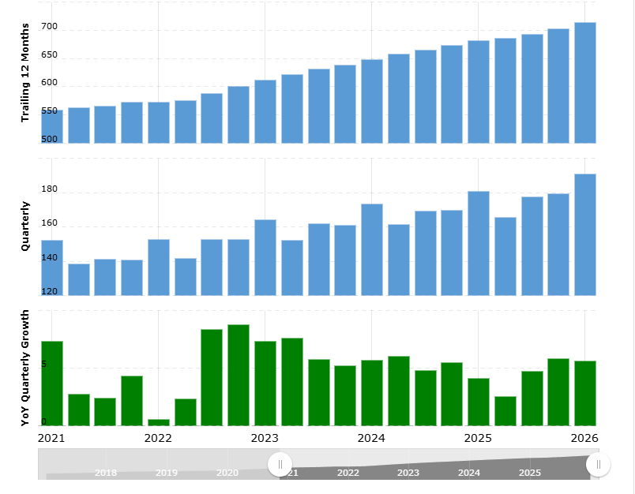
Walmart was founded in 1962 by Sam Walton in Rogers, Arkansas, who wanted to offer customers the lowest prices possible while operating at maximum efficiency. This “Everyday Low Price” (EDLP) strategy became a foundation to the company’s business model and continues to be a driving force in operations today.
Walmart went public in 1970 during its initial public offering (IPO) and established its first distribution center in Bentonville, Arkansas, where it is headquartered today. Over the following decades, Walmart grew exponentially, mainly driven by its efficient supply chain, strong supplier relationships, and ability to offer lower prices than its competitors. Walmart has rapidly expanded across all 50 states and into international markets. Today, Walmart has established itself as the first traditional retailer valued at over $1 trillion and is evolving into a technology-driven company that combines physical location and online shopping to serve expanding consumer markets.

Business Segments
Walmart operates through three primary business segments: Walmart U.S., Walmart International, and Sam’s Club. These segments come together to generate stable revenue across both domestic and international markets while allowing the company to serve customers through different shopping experiences.
Walmart U.S is the company’s largest segment and accounts for most of the total revenue. It includes supercenters, discount stores, and neighborhood stores and offers a wide range of products, including groceries, electronics, apparel, and general merchandise. Grocery sales make up a big portion of this segment and consistently provide recurring demand. Walmart U.S. has also integrated e-commerce into its physical stores through services like curbside pick-up and same-day delivery.
Walmart International represents the company’s operations outside the United States and is an important part of expanding Walmart’s core mission to global markets. The segment was officially established in 1991 and since then has expanded across five continents, currently operating in regions like Mexico, Canada, China, Chile, as well as parts of Africa and India. Walmart adapts its operations to meet the needs of local markets while maintaining its focus on affordability. Overall, the segment reduces Walmart’s reliance on U.S. operations and positions the company for global success.

Sam’s Club is Walmart's membership-based segment that operates similarly to its main competitor, Costco. Customers pay an annual fee in exchange for access to bulk-priced goods and numerous savings. It generates revenue mainly through product sales and membership fees, which creates a more predictable and stable income than traditional retail stores. This segment is popular amongst small business owners and families seeking lower prices on bulk quantities of everyday goods. The business operates on a limited-item model where high-demand products are selected rather than carrying an extensive variety of everything. Overall, Sam’s Club has been able to retain a strong customer base not only through product savings but also member benefits, including free shipping, early shopping hours, pharmacy discounts, and gas savings.

PRODUCTS AND SERVICES

Walmart offers a broad and diversified mix of products and services, making it a great “one-stop” shopping destination for everyday customers. Walmart can attract a wide range of customers because of its focus on providing both essential and nonessential items.

Core Product Categories
Walmart’s core product offerings cover everyday essentials and can split into the following major categories:
- Grocery & Consumables is one of the largest contributors to total profits, accounting for almost 60% of Walmart’s revenue in the U.S. It includes items like fresh produce, packaged goods, meat and seafood, dairy, packaged pantry goods, beverages, and household essentials like cleaning products. Walmart’s focus on affordable and good-quality staples makes this segment popular amongst recurring customers.
- General Merchandise includes a wide range of non-grocery goods like electronics, home and outdoor, toys, automotive and hardware, apparel, as well as entertainment and office.
- Health & Wellness includes things like over-the-counter medications, beauty products, and wellness and personal care items.
Walmart’s products are accessible both in-store and online through its e-commerce platform, which offers consumers options like same-day delivery, curbside pickup, and shipping. This approach gives consumers numerous different options that are convenient for them.

Services
Walmart also has a variety of services that enhance consumer experience while also strengthening its business model by diversifying revenue beyond just retail sales.
- Pharmacy & Health Services → Prescriptions, vision care, immunizations and vaccines, and other clinical services
- Auto Care & Tech Services → Oil changes, tire services, protection plans, device setup
- Financial Services → Walmart MoneyCenter provides in-store financial services, including money transfers, check cashing, money orders, bill pay, and tax preparation

Walmart Private Label Brands
A key component of Walmart’s products is its collection of private-label brands that enables it to offer lower-priced alternatives to more popular brands while maintaining high profits. These brands strengthen consumer loyalty by providing high-quality goods at low prices. Some brands include Great Value, Equate, Mainstays, and No Boundaries. By offering reliable alternatives, Walmart can enforce its Everyday Low-Price strategy and strengthen its competitive advantage in the consumer staples and retail industry.


MANAGEMENT
The company saw major changes in its executive leadership during early 2026. John Furner became President and CEO of Walmart Inc. in February 2026, following Doug McMillon, who had been at the company since 2014. Furner has previous experience as CEO of both Walmart U.S. and Sam’s Club and has held multiple positions during his 30 years at Walmart, including store manager, district manager, VP of global sourcing, head of marketing and merchandising for Walmart China, and chief merchant for Sam’s Club.
John David Rainey serves as the chief financial officer (CFO) and executive vice president. He was appointed in 2022 and is responsible for overlooking the company’s financial performance, corporate strategy, and investor relations.
After the 2026 restructuring, each major business segment is led by David Guggina, Chris Nicolas, and Latriece Watkins for Walmart U.S., Walmart International, and Sam’s Club, respectively.

BUSINESS MODEL + TECHNOLOGY INFLUENCE
Walmart operates around its Everyday Low Price (EDLP) strategy, focusing on providing low prices across its product and service offerings. This cost leadership business model allows the company to focus on being affordable rather than providing discounts and promotions to gain sales. This approach has helped Walmart build strong trust and keep its consumers coming back, especially for essential products like groceries, regardless of the time of year or economic conditions.
Walmart also sits as the largest retailer globally and has over $680 billion in annual revenue, allowing it to leverage its economies of scale. It can negotiate lower costs with its suppliers and reduce its cost of goods sold (COGS), passing those savings onto its consumers in the form of lower prices. It also has an advanced supply chain distribution network which minimizes inventory management and storage costs. This high-volume, low-margin approach allows it to generate revenue through high sales volumes rather than high markups on individual items. Overall, Walmart has maintained a pricing advantage amongst its main competitors like Target and Costco.
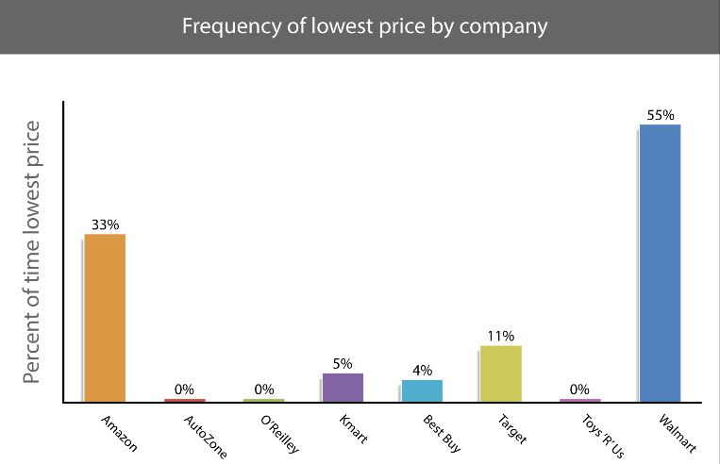
In recent years, it has adopted a more hybrid approach, combining both physical, in-person stores with a strong online presence. Walmart is increasingly integrating technology into its business model to enhance both efficiency and customer experience while competing with top e-commerce companies like Amazon. It has invested billions of dollars into its website and mobile app, offering products to people on over five continents. To meet consumer demand and preferences, it has also integrated services like curb-side pickup and same-day delivery into its physical stores. With more companies using AI, Walmart has stepped up and continues to invest in automated and data-driven technologies, such as automated warehouses and AI-run inventory management. Together these approaches have helped in reducing costs, improving efficiency, and increasing customer satisfaction through faster delivery.
Industry Analysis

Walmart sits within the global retail industry, which has companies that specialize in groceries, general merchandise, and ecommerce, and it is one of the largest sectors in the world, generating over $30 trillion dollars in annual revenue. Walmart operates as a dominant player in the industry, accounting for a heavy share of global retail sales through its low-cost business model. In the U.S, Walmart holds approximately 21.2–25% share of the grocery market, making it the largest grocery retailer. The global retail industry strongly emphasizes high volume, low margins, and increasing revenue within these firms. Long-term industry growth is expected to remain in the low-to-mid single-digit range, supported by steady consumer demand and the continued expansion of digital commerce within the industry. As the sector evolves toward omnichannel integration and value-based consumption, companies with advanced logistics networks and strong pricing power are best positioned to succeed. In this environment, Walmart is particularly well positioned to capitalize on these trends given its scale, supply chain efficiency, and cost leadership.

Key Industry Trends
- E-Commerce and Omnichannel Integration: Retailers are quickly integrating digital and physical channels to help entice their customers and enhance their overall experience. Capabilities such as same-day delivery, curbside pickup, and mobile commerce are becoming essential to remain competitive within the industry.
- Value Based Consumption: With macroeconomic pressure rising, including inflation, this has increased consumer price sensitivity, driving demand toward discount retailers and private-label products. This trend is benefiting firms that can maintain low prices at a proper scale.
- Supply Chain and Logistics Innovation: Due to the age of AI, advanced logistics, automation, and data analytics are becoming key differentiators among these firms. Companies are investing heavily in their distribution networks to improve efficiency, reduce costs, and meet rising delivery expectations.

Macroeconomic Factors

Consumer spending & employment: Consumer spending, employment levels, and interest rates are big influences on the purchasing power and overall retail demand scale, making the industry highly cyclical

Inflation & Cost Pressures: Inflation is currently increasing and thus leading to higher input and operating costs, but this helps benefit discount retailers as consumers shift toward lower-priced alternatives and private label products.

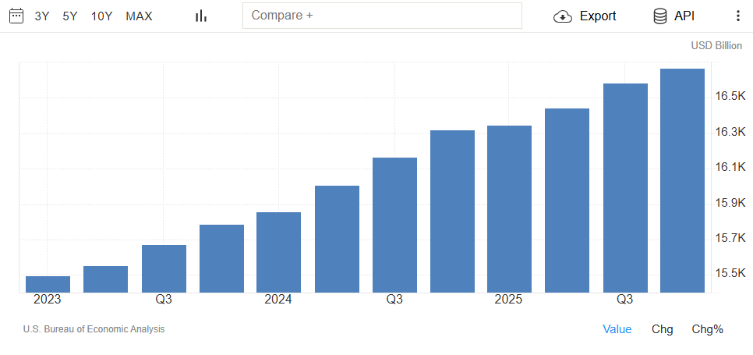
Regulation and Supply Chain Risk: Current government policies, including labor laws, tariffs, and regulation among the war crises, are making major supply chain disruptions, which directly can impact costs, inventory, and operation efficiency.

Porters 5 Forces
- Competitive Rivalry – High
The retail industry that encompasses Walmart sits with some strong heavy hitters and intense competition with players such as Amazon, Costco, Target, etc. These firms compete aggressively with each other on prices, convenience, and particularly e-commerce, as the era of AI and digitalization continues to thrive. The industry's low margins further induce this rivalry, as companies must keep finding new ways to optimize costs while maintaining aggressive pricing to match competitors. Due to this sustained investment in logistics, technology, and customer satisfaction is crucial to maintaining and growing market share.
- Threat of New Entrants – Low
The threat of new entrants in the retail industry is low due to the significant barriers that are there for entry, including high capital, complex supply chains, and the need for large-scale distribution networks. The established firms benefit from strong brand recognition, economies of scale, and longstanding supplier relationships, which helps them create a strong competitive advantage, and makes it difficult for new firms and new competitors to enter the industry. While e-commerce platforms have lowered the entry barriers for smaller players, competing at a scale with Walmart and other heavy-hitter companies is challenging still. This dynamic allows Walmart to capitalize and make the most of their market position.
- Threat of Substitutes – Moderate to High
The threat of substitutes in retail is seen as high because consumers have access to a wide range of alternative purchasing options, specifically different retailers that they can go to and different online areas to help get their needs. The growth of digital platforms has also made it more convenient for customers to compare their prices and pick whichever works the best among all these providers. Additionally, as consumer preferences begin to evolve, and the loyalty of a brand is slowly diminishing, this further increases that substitution risk. And to remain competitive, retailers must be able to differentiate themselves through pricing, convenience, and different product offerings.
- Bargaining Power of Buyers – High
Customers in the retail industry have strong bargaining power due to the low cost for switching and a wide variety of purchasing options available. The overall price sensitivity remains high, particularly during the current inflation increase mixed with economic uncertainty, forcing retailers to be highly competitive in their pricing. The availability of the online sector and e-commerce has empowered consumers by increasing their options and access to other alternatives. These dynamics place a lot of pressure on retailers and their margins and emphasize the importance of cost leadership.
- Bargaining Power of Suppliers – Moderate to Low
Large retailers such as Walmart and its competitors possess significant negotiating power over suppliers due to their scale and the volume that they purchase at. This allows them to secure the favorable pricing and contract terms, reducing the cost that it takes for input. However, the suppliers that have stronger brands or many differentiated products may retain some of that pricing power back to themselves, particularly in high-demand categories. Overall, the balance of power tends to favor large retailers, especially those that have a strong and extensive distribution network like Walmart’s.


Key Players/Competitive Landscape
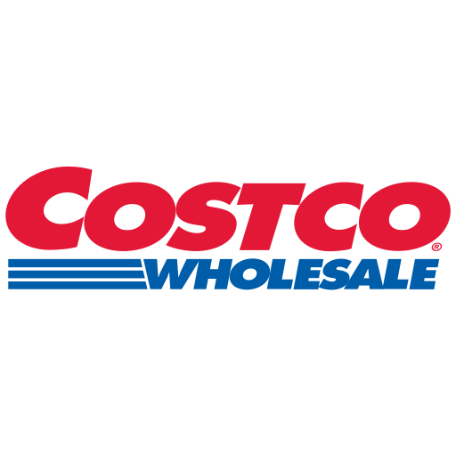
- Amazon – Amazon is the leading global e-commerce platform which offers a vast selection of products supported by advanced logistics as well as their capabilities in fulfillment. It was founded in 1994 and is mainly headquarters in Seattle, Washington. The company has expanded beyond the retail into cloud computing, which is their AWS program, digital streaming, and artificial intelligence. It also offers special membership called Prime membership, which strengthens customer loyalty through fast shipping, exclusive deals, and bundled services. Amazon can generate hundreds of billions of dollars in revenue with North America being its largest market, and its ability to combine technology, scale, and convenience makes it one of the most significant competitive threats in both online as well as physical retail.
- Costco – Costco is a membership-based warehouse retailer known for its bulk product offerings as well as the strong customer loyalty that it can build. Founded in 1983 and headquartered in Issaquah, Washington, the company operates a limited SKU model that allows it to maintain its low prices with its high inventory turnover. Costco also has its very strong private label brand called Kirkland Signature, which is a key driver in both their margins as well as their customer trust. The company generates over $200 billion in annual revenue and can maintain a high loyal customer base due to its variant pricing, as well as its consistent product quality and the fact that you need membership to enter most stores. It focuses on efficiency and a membership standpoint to create revenue through a differentiated model within the retail industry.

- Target – Target is a major U.S. retailer that differentiates itself through a combination of affordability, design, and customer experience. It was founded in 1902 and is headquartered currently in Minneapolis, Minnesota. Target offers a wide range of products, which include apparel, home goods, as well as groceries and other items. The company heavily invests in already owned brands and as well as the store remodeling and omnichannel cap abilities such as curbside pickup and same-day delivery. Target can generate over $100 billion in annual revenue and appeals to a slightly style conscious as well as the higher income demographic compared to the traditional discount retailers. It also emphasizes a strong brand partnership and in-store experience, which is unique to the other competitors within the competitive landscape.

Field Research
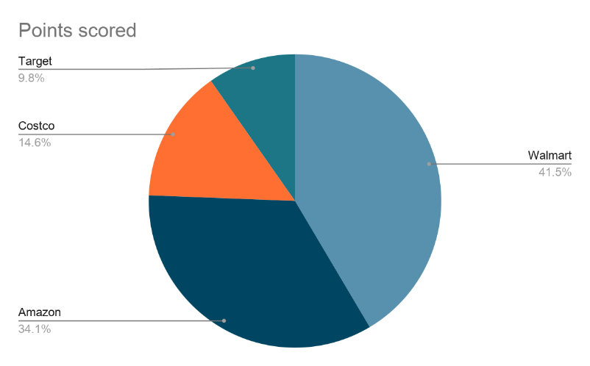
To help us better understand the customer base and consumer trends within the industry, we decided to conduct field research at two Walmart stores, Walmart East Windsor and Walmart Edison. Our fieldwork mainly consisted of finding 41 customers to fill out our short surveys to ascertain the retail industry viewpoint of the average Walmart customer. Our surveys consisted of three key metrics: Retailer Preference, Most Important Factor When Choosing a Retailer, and Walmart Value for Money.
Retailer Preference: Our survey showed that Walmart was the preferred retailer of customers. Walmart was the preferred retailer with 41.5% responses, followed by Amazon at 34.1%, Costco at 14.6%, and Target at 9.8% of respondents. Walmart’s leading position helps support the idea of continued strength in its value-driven model, with low prices and broad product choices that strongly align with consumers’ different wants and needs and appeal to them through e-commerce, pricing, and overall shopping experience.
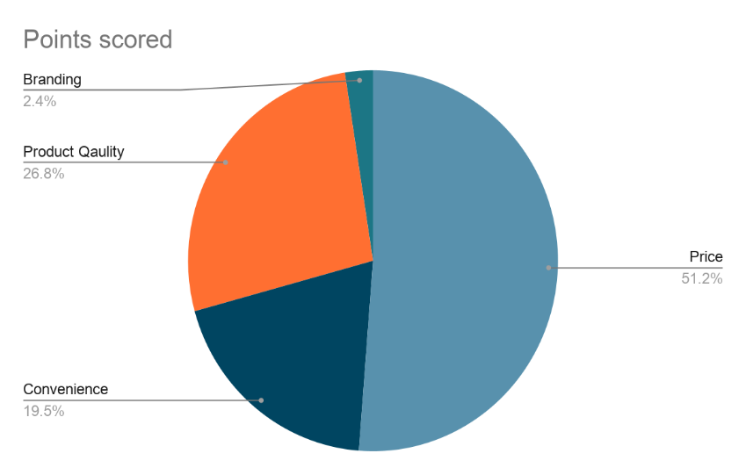
Most Important Factor When Choosing a Retailer: Our survey showed that the majority (51.8%) of the respondents identified price as the most important factor when choosing a retailer. Price was followed by product quality at 26.8%, and convenience at 19.5% of the time. This lines up with Walmart’s core business model of squeezing suppliers for the lowest prices and passing those savings onto customers. This also means that Walmart is well positioned to maintain their strong standing in the retail industry with competitive pricing compared to retail competitors.

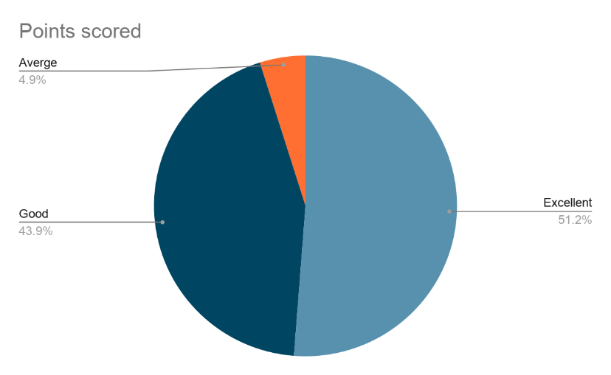
Walmart Money Perception: Surveys showed that the general customer perception of Walmart’s value was good to excellent, the two shared had over 90% of responses. This reflects high customer perception, which again is in line with Walmart's marketing goals. Being able to offer high customer value at such low prices, it suggests Walmart has strong marketing influence and bargaining power with suppliers, which gives Walmart a strong position to maintain and even grow their customer base in the future.

Financial Statement Analysis

Revenue:
Walmart has achieved consistent growth in its overall revenue over the past several years due to its U.S. Retail Segment, International Segment, and eCom. Walmart’s Total Revenue increased from $648.1 billion in 2024 to $680.9 billion in 2025 and $713.2 billion in 2026 with consistent increases of a range between 4.75%-5.00% respectively. Walmart will continue to grow at a moderate and stable pace by leveraging the growing demand for essential products, the substantial share of the grocery market that it owns, and its increasing number of methods of interacting with and selling to its customers (including pickup and delivery options and the Walmart+ subscription service).
Through 2027, the company is expected to generate $746.6 billion of total revenue, which would mean an approximately 4.75%-5.00% annual growth rate over the five years ending in 2031 ($905.6 billion in Total Revenue). The lower growth expectation is because of Walmart nearing its long-term growth potential in the U.S. retail market, but continued growth is expected from the increasing level of e-commerce activity, the expansion of private label goods (such as Great Value and Sam's Choice), and the generation of ad revenue through the Walmart Connect advertising service.
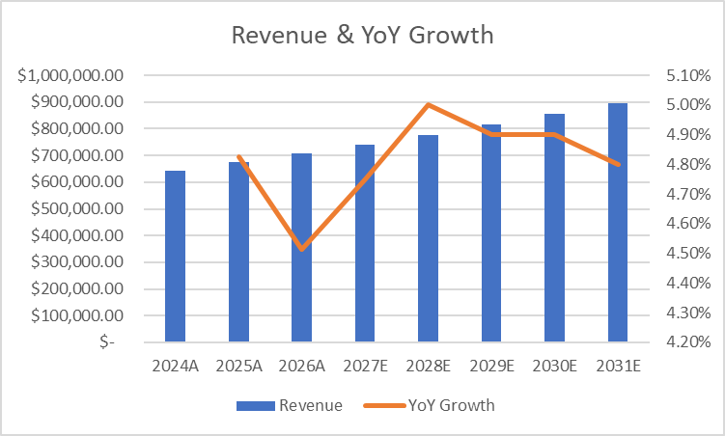

Cost of Goods Sold (COGS) & Gross Profit: COGS is Walmart’s largest expense as it has a low margin/high volume business model. From 2024 through 2026, COGS rose from $490.1 billion to $535.4 billion while the percentage remained almost constant at around 75% of revenue (decreasing slightly from 75.62% to 75.07%). The minor increase shows Walmart's scale related advantages with regards to procurement, negotiating favorable supplier pricing and their use of automation and data analytics to make their supply chain more efficient.
From 2024 to 2026, gross profit increased from $158.0 billion to $177.8 billion and is projected to be $230 billion by FY2031. There is potential for growth in gross margins due to higher-margin revenues from advertising, third-party marketplace sales, and membership.
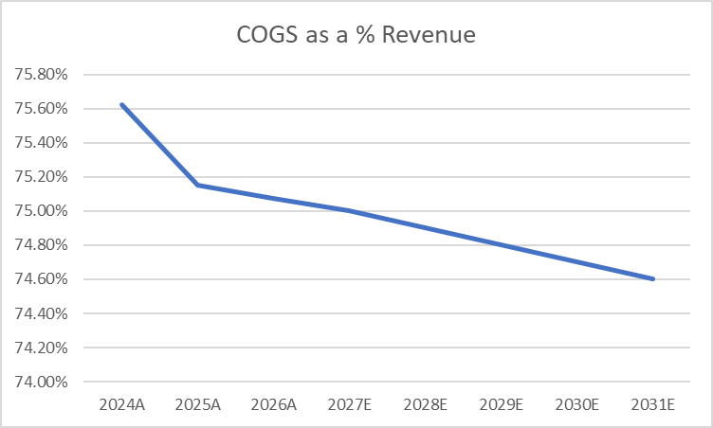

Operating Expenses & EBIT: Selling, general & administrative (SG&A) expenses have shown stability in the range of 20.2% - 20.74% of revenue, as SG&A is increasing from $131.0 billion in 2024 to $147.9 billion in 2026. Walmart invests heavily in employee wages, store operations, and technology infrastructure, specifically in automation and digital fulfillment. As a result, operating profit (EBIT) is projected to grow from approximately $27.0 billion in 2024 to approximately $29.8 billion in 2026, with projections of about $48.0 billion by 2031. The operating margin remains low but stable due to Walmart’s volume/low profit margin retail model.
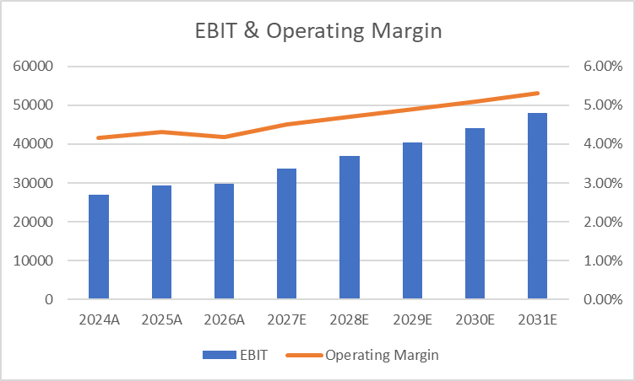

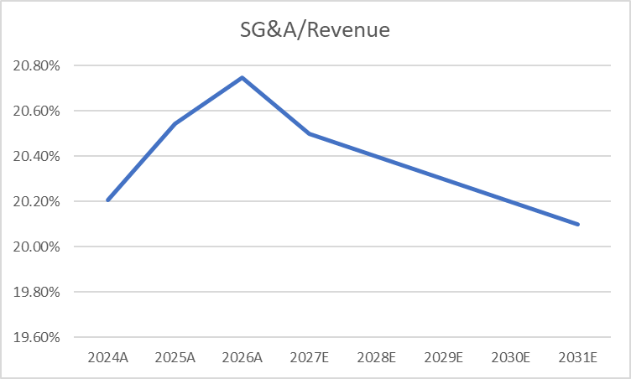

Net income: Walmart increased net income from $15.5 billion in 2024 to about $21.9 billion by 2026, resulting from improved operating performance and cost controls. Earnings per share increased from approximately $1.92 in 2024 to about $2.74 by 2026, showing that Walmart continues to create value for its shareholders. Walmart’s profitability is supported by stable demand for essential goods and its ability to maintain pricing power in a competitive retail environment.

Balance Sheet
Assets: Total assets increased from $252.4 billion in 2024 to $284.7 billion in 2026, mostly due to investments in PP&E, which increased from $110.8 billion in 2024 to $136.1 billion in 2026. These investments show Walmart's ongoing expansion of distribution centers, automation facilities, and store remodels in support of omnichannel operations.
Inventories also increased, going from $54.9 billion in 2024 to $58.9 billion in 2026 because of increased sales volumes and Walmart's focus on keeping strong in stock levels, especially groceries and consumables.
Liquidity & Working Capital: Even though Walmart is operating with negative net working capital, Walmart continues to show strong liquidity. Current Assets grew from $76.9 billion in 2024 to $84.9 billion in 2026, however current liabilities grew at a higher rate, increasing from $92.4 billion in 2024 to $107.5 billion in 2026.
Net working capital decreased, from $18.6 billion in 2024 to $20.1 billion in 2026, and is expected to continue declining, to about $36.4 billion by 2031, which speaks to Walmart's ability to quickly collect cash from their customers, while taking longer to pay their suppliers and use that money to run their operations, providing them with a strong competitive advantage over smaller retailers.

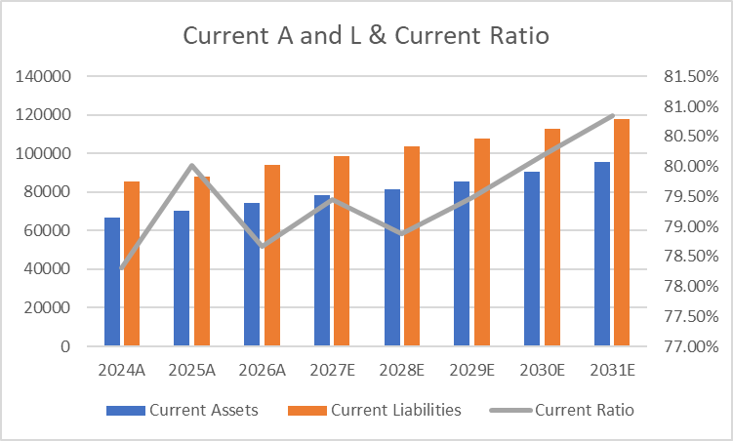

Liabilities & Debt: Walmart has a very conservative and stable capital structure. The long-term debt will remain flat between around $36.1 billion in 2024 and $34.6 billion in 2026. However, total liabilities continue to grow with the scale of operations. Walmart has strong, predictable cash flows, which give it the ability to comfortably meet its debt obligations. Walmart's cost of debt is low around 4.1%, and it has a good credit rating, allowing for financial flexibility.

Cash Flow
Operating Cash Flow: Walmart has a solid amount of operating cash flow, with this value increasing from $35.7 billion in 2024 to $36.4 billion in 2025 to $41.6 billion in 2026. This increase results from increases in both net income and efficiently managing Walmart's working capital. A major strength of Walmart's business model is its ability to consistently generate cash flow from operations.

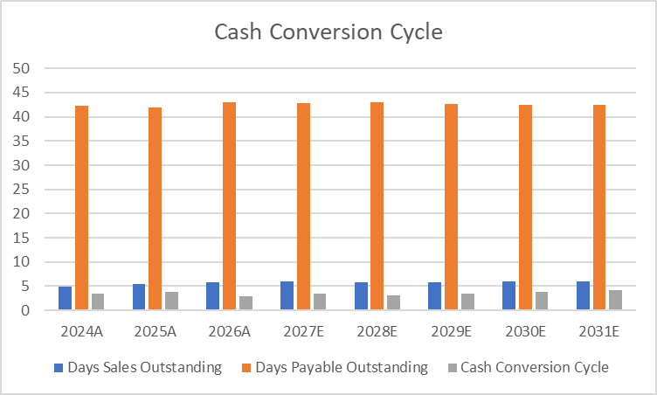

Capital Expenditures: Capital expenditures have grown from $20.6 billion in 2024 to $27.6 billion in 2026, mainly because of the investments made to upgrade stores, automate supply chains, and build ecommerce infrastructure. These types of investments will allow Walmart to continue to compete successfully with online competitors like Amazon and become more efficient over the long term.
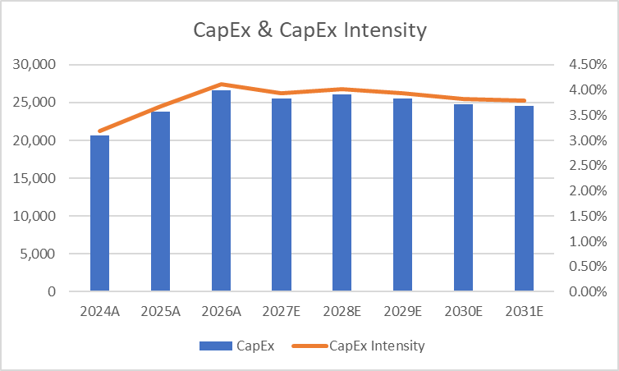

Free Cash Flow (Unlevered): Unlevered Free Cash Flow increased from $12.7 billion in 2026 and is expected to grow to $15.7 billion in 2027, before sitting between $20.4 billion and $32.1 billion through 2031. The large jump in 2027 is mainly due to a major change in net working capital, $20.2 billion, showing how changes in working capital can have a significant impact on cash flow for Walmart in any given year.

Overall Financial Outlook
As an established and very efficient retailer, Walmart has a solid financial presence and a very stable long-term growth pattern, and a great cash flow generation capability. It is anticipated that Walmart's revenue will grow approximately 4% each year in the future because of its efforts around omnichannel expansion, its increasing entry into the private label market segment, and its new sources of revenue that will be derived from high-margin services such as advertising and membership.
Walmart's margins are relatively low compared with other retailers; however, its massive scale, efficiency of operations, and competitive advantages associated with its supply chain have allowed Walmart to maintain high levels of profitability and generate strong cash flow. The use of negative working capital increases Walmart's liquidity and reduces its financing needs. Walmart is in a great position to provide consistent, long-term growth with continued financial stability. Walmart also has the ability to compete highly effectively in the global retail marketplace.

Valuation

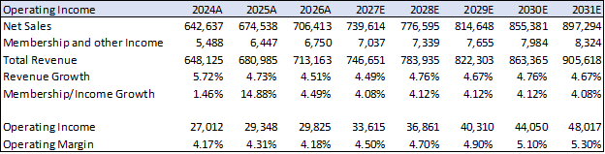
Project revenue growth of 4-5% is supported by historical performance, which has consistently remained in the low-to-mid single digits. Over the five-year period, revenue growth has averaged 4.7% and leading to our forward assumptions. As a mature retailer, Walmart is expected to maintain stable growth driven by existing operations and continued slow expansion into ecommerce.

We project operating margin expansion driven by continued investment in automation, supply chain optimization, and workforce efficiency initiatives including the integration of AI across operations. These efforts are expected to reduce labor intensity, improve productivity, and create flexibility amongst current strategies. While eCommerce investments may pressure margins currently, we expect efficiency gains to significantly drive operating income.
Walmart operates in a competitive retail landscape, and we selected comparable companies across discount, wholesale, and eCommerce segments, including Costco, BJ’s Wholesale Club, Target, Amazon, and Dollar General. While Amazon is not a direct comparable, it is included to reflect Walmart’s growing presence in eCommerce.
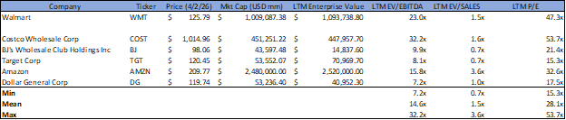
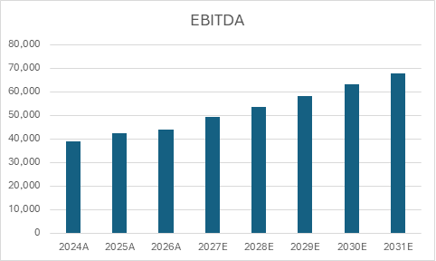

Walmart’s equity cost of 7.1% reflects its low-risk, defensive profile, with inputs based on current Treasury yields, market risk premium, and an adjusted beta. The cost of debt is calculated using the company’s outstanding borrowings. These components result in a WACC of 6.81%.
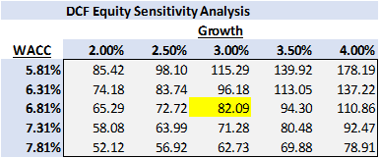
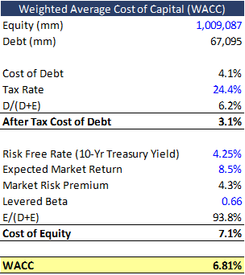
Terminal Growth Rate: A range of 2.0%–4.0% is applied, reflecting long-term economic growth and inflation expectations. The base case of 3.0% aligns with Walmart’s mature profile and stable demand characteristics.
WACC: A weighted average cost of capital of 6.81% is used in the base case, derived from a cost of equity of 7.1% and an after-tax cost of debt of 3.1%. The cost of equity is based on current Treasury yields, an estimated market risk premium, and a beta of 0.66, reflecting Walmart’s defensive nature.
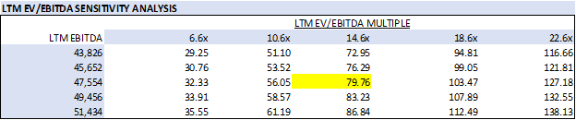

LTM EV/EBITDA: Walmart’s LTM Enterprise Value is calculated as market capitalization plus total debt minus cash, resulting in approximately $1,093,739 million. Dividing by LTM EBITDA of $47,554 million implies an EV/EBITDA multiple of approximately 23.0x. Based on comparable company analysis, we apply a normalized multiple range of approximately 18.0x–23.0x to reflect Walmart’s premium valuation and strong market position. Applying this range to LTM EBITDA and adjusting for net debt and shares outstanding yields an implied equity value range of approximately $90 to $140 per share.

Enterprise Value/EBITDA: Walmart’s LTM Enterprise Value is calculated as market capitalization plus total debt minus cash, resulting in approximately $1,093,739 million. Dividing by LTM EBITDA of $47,554 million implies an EV/EBITDA multiple of approximately 23.0x. Based on comparable company analysis, we apply a normalized multiple range of approximately 18.0x–23.0x to reflect Walmart’s premium valuation and strong market position. Applying this range to LTM EBITDA and adjusting for net debt and shares outstanding yields an implied equity value range of approximately $90 to $140 per share.
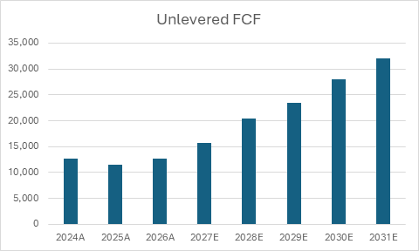

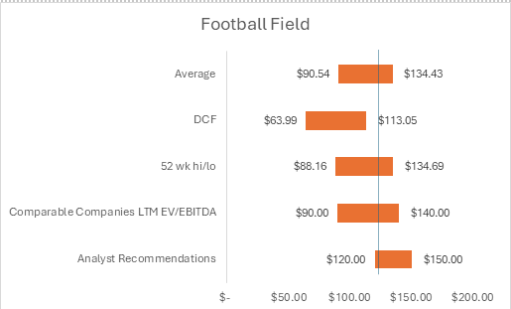

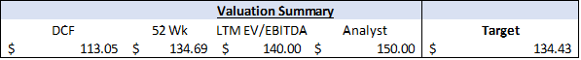

Target Price Rationale: We assign a target price of $134 per share, reflecting a balance between our conservative DCF valuation and higher market-based approaches. The elevated valuation is supported by current economic conditions, where investors favor defensive, stable companies. Walmart benefits from increased demand as consumers shift toward value-oriented retailers amid inflationary pressures, while its scale and omnichannel capabilities reinforce consistent performance. As a result, the market assigns a premium multiple, justifying a target price toward the higher end of our valuation range.

Risks
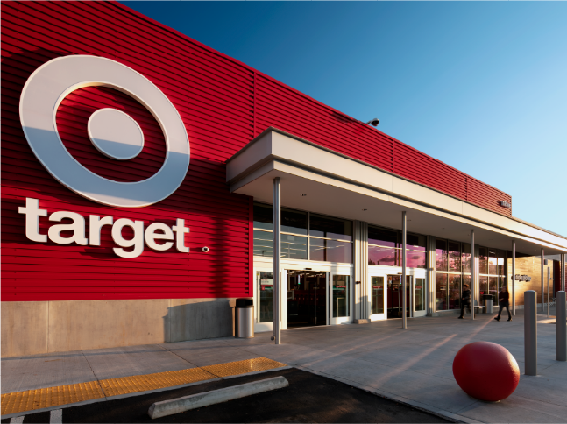
- Walmart faces immense competition from other mega retailers. Other retailers like Costco, Kroger, Target, and Amazon provide a similar breadth of products. On top of this, all but Amazon share near-identical business models and provide similar value for consumers.

  - Mitigants: Walmart, being the largest retailer in America, leverages its massive business scale to negotiate better deals with their suppliers, they pass these deals onto consumers which allows them to maintain consistently lower pricing than competitors like Target, who cannot leverage their scale to the same degree as Walmart. Furthermore, Walmart has more than double the physical location of any of its competitor retailers, making it widely accessible when compared to its peers.
- The rise of online retailers like Amazon poses a significant threat to physical retailers like Walmart. Because of its online nature, Amazon can offer a wider product array with more flexibility for access and delivery. This makes it a fierce competitor to Walmart for consumers who seek niche products or don’t mind waiting for possession of the good.

  - Mitigants: In the past decade, Walmart has aggressively expanded its online retail business to keep up with competitors like Amazon. On top of this, Walmart has integrated their business channels together to create a seamless omnichannel retail system that offers flexibility, reliability, and quality on par with online competitors. Walmart has also expanded its product array by creating the Walmart Marketplace, a platform where third party individuals can sell goods through Walmart's product channels, allowing Walmart to better compete with online retailers like Amazon.
- Walmart has very low operating margins, due to high operating costs and intense competition that force lower prices. Their low margins leave them vulnerable to loss when either costs increase, or sales decrease.
  - Mitigants: Digital ecosystem and retail expansion gives Walmart more flexibility in how they sell goods and who they can sell it to, this helps alleviate strain on Walmart’s business when demand faces sudden decline, safeguarding their low margin business model by increasing turnover. Moreover, Walmart has a diverse supply chain. This allows them to protect against sudden spikes in price of goods and decrease in demand of goods, allowing them to maintain operations even when demand or supply waivers.
Appendix 1: Income Statement
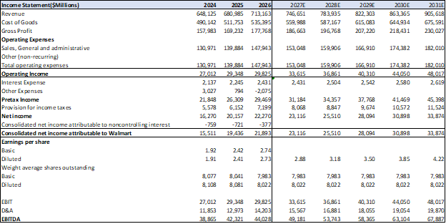

Appendix 2: Balance Sheet
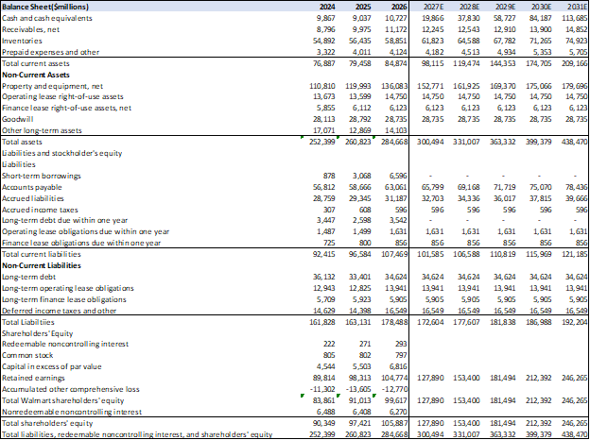

Appendix 3: Cash Flow Statement
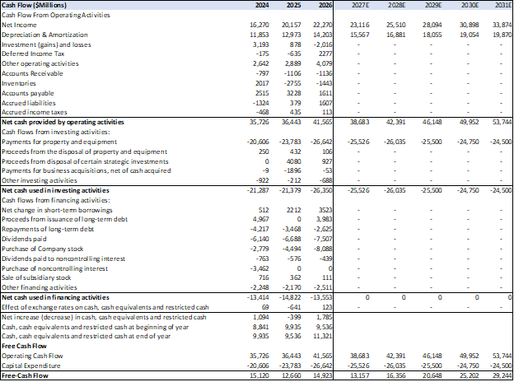

Appendix 4: Unlevered FCF Calculation
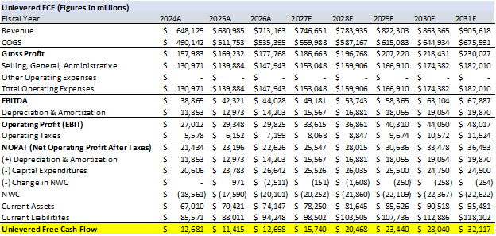

Appendix 5: Sources
- https://stockanalysis.com/stocks/wmt/
- https://finance.yahoo.com/quote/WMT/
- https://app.koyfin.com/snapshot/s/eq-vk18jc
- https://stock.walmart.com/sec-filings/all-sec-filings/content/0000104169-23-000020/wmt-20230131.htm#ic0762e37664541589e0e296d7f31d4ab_115
- https://stock.walmart.com/sec-filings/all-sec-filings/content/0000104169-26-000055/wmt-20260131.htm#i6e16e33efce1499a82f13fd9f63b74c6_112
- https://www.cnbc.com/quotes/WMT
- https://www.tipranks.com/stocks/wmt/forecast
- https://www.cnbc.com/quotes/US10Y
- https://corporate.walmart.com/about/samsclub/sams-club-history
- https://vizologi.combusiness-strategy-canvas/walmart-business-model-canvas/
- ​​https://corporate.walmart.com/about/leadership
- https://d3.harvard.edu/platform-rctom/submission/wal-mart-every-day-low-prices-business-model/
- https://www.macrotrends.net/stocks/charts/WMT/walmart/revenue
- https://www.mckinsey.com/industries/retail/our-insights
- https://www.census.gov/retail/index.html
- https://www.statista.com/statistics/1450393/leading-grocery-store-by-market-share-us
- https://nrf.com/research-insights/top-retailers/top-100-retailers/top-100-retailers-2025-list
- https://www.macrotrends.net/stocks/charts/WMT/walmart/profit-margins
- https://www.webfx.com/marketplaces/glossary/what-is-walmart-marketplace/
- https://us.trendlyne.com/us/fundamentals/peer-group/1405128/WMT/walmart-inc/#peer-group

