PRACTICAL FILE
ON
PYTHON

(REGULAR DEGREE)

Submitted By:
Name: Tanish
Reg. No.: 2416241073
Semester: 5 ^{th}
Submitted To:

SAT PRIYA GROUP OF INSTITUTIONS
INDEX

S No. | Topic Name | Page No. | Remarks
1 | Salary based on hours worked | 4
2 | Gross salary of an employee | 4
3 | Numerical grade to letter grade | 5
4 | Smallest of three numbers | 5
5 | Vowel or consonant | 7
6 | Electricity bill | 7
7 | Sum of numbers from 1 to n | 7
8 | Multiplication table | 8
9 | Count digits of a number | 8
10 | Reverse a list using a loop | 9
11 | Menu driven NumPy program | 9
12 | Letter frequency using dictionary | 11
13 | Copy alternate lines between files | 11
14 | Handle ZeroDivisionError | 12
15 | Sine, cosine, polynomial and exponential curves | 13
16 | Line plot of monthly profit | 14
17 | Square spiral using turtle | 16
18 | Clock using Python | 17
19 | Colorful spiral of user's name | 18
20 | Calendar GUI | 20
21 | Tic Tac Toe game | 21
22 | Registration form using Tkinter | 23
23 | Database, table and record insert | 26
24 | Customized meme generator | 26
25 | Colorful star using turtle | 28
26 | Music player | 30
27 | Banking management system | 32
28 | Age calculator using Tkinter | 34
29 | Year the user turns 100 | 37
30 | Image crop and resize using OpenCV | 37
31 | Sudoku game design in pygame | 38
32 | Screen recorder | 42

Q.1 Salary based on hours worked
Question: The calculation of salary based on hours worked is: Hours worked = 8, payment = 1500. Hours worked < 8, pay less, 75 per hour. Hours worked > 8, pay more, 75 per hour.
Program:
# Q1: Salary based on hours worked
# 8 hours = Rs 1500; less than 8 -> deduct Rs 75/hour; more than 8 -> add Rs 75/hour
hours = float(input("Enter hours worked: "))
base = 1500
if hours == 8:
pay = base
elif hours < 8:
pay = base - (8 - hours) * 75
else:
pay = base + (hours - 8) * 75
print("Hours worked:", hours)
print("Total payment: Rs", pay)
Output:
Enter hours worked: 8
Hours worked: 8.0
Total payment: Rs 1500

Enter hours worked: 6
Hours worked: 6.0
Total payment: Rs 1350.0

Enter hours worked: 10.5
Hours worked: 10.5
Total payment: Rs 1687.5

Q.2 Gross salary of an employee
Question: Calculate the Gross Salary of an employee for the following allowances & deductions. Get Basic Salary of the employee; DA = 25% of Basic, HRA = 15% of Basic, PF = 12% of Basic, TA = 7.50% of Basic. Net Pay = Basic + DA + HRA + TA. Gross Pay = Net Pay - PF.
Program:
# Q2: Gross salary calculation
basic = float(input("Enter Basic Salary: "))
da = 0.25 * basic
hra = 0.15 * basic
pf = 0.12 * basic
ta = 0.075 * basic
net_pay = basic + da + hra + ta
gross_pay = net_pay - pf
print("DA (25%) =", da)
print("HRA (15%) =", hra)
print("PF (12%) =", pf)
print("TA (7.5%) =", ta)
print("Net Pay =", net_pay)
print("Gross Pay =", gross_pay)
Output:
Enter Basic Salary: 20000
DA (25%) = 5000.0
HRA (15%) = 3000.0
PF (12%) = 2400.0
TA (7.5%) = 1500.0
Net Pay = 29500.0
Gross Pay = 27100.0

Q.3 Numerical grade to letter grade
Question: I want to make a piece of code that converts from a numerical grade (35 - 100) to a letter grade (A, B, C, D, F).
Program:
# Q3: Numerical grade (35-100) to letter grade
marks = int(input("Enter numerical grade (35-100): "))
if marks < 35 or marks > 100:
print("Invalid input! Enter a value between 35 and 100.")
elif marks >= 90:
print("Grade: A")
elif marks >= 80:
print("Grade: B")
elif marks >= 70:
print("Grade: C")
elif marks >= 50:
print("Grade: D")
else:
print("Grade: F")
Output:
Enter numerical grade (35-100): 95
Grade: A

Enter numerical grade (35-100): 85
Grade: B

Enter numerical grade (35-100): 72
Grade: C

Enter numerical grade (35-100): 55
Grade: D

Enter numerical grade (35-100): 40
Grade: F

Q.4 Smallest of three numbers
Question: WAP to find which one is smallest given the three variables.
Program:
# Q4: Smallest of three variables
a = int(input("Enter first number: "))
b = int(input("Enter second number: "))
c = int(input("Enter third number: "))
if a <= b and a <= c:
smallest = a
elif b <= a and b <= c:
smallest = b
else:
smallest = c
print("Smallest number is:", smallest)
Output:
Enter first number: 45
Enter second number: 12
Enter third number: 78
Smallest number is: 12

Q.5 Vowel or consonant
Question: Python program to check whether the entered character is vowel or consonant.
Program:
# Q5: Vowel or consonant
ch = input("Enter a character: ")
if len(ch) != 1 or not ch.isalpha():
print("Please enter a single alphabet character.")
elif ch.lower() in "aeiou":
print(ch, "is a Vowel")
else:
print(ch, "is a Consonant")
Output:
Enter a character: e
e is a Vowel

Enter a character: k
k is a Consonant

Q.6 Electricity bill
Question: Write a program to calculate the electricity bill (accept number of units from user) according to the following criteria: First 100 units - no charge; Next 100 units - Rs 5 per unit; After 100 units - Rs 10 per unit. If input unit is 350 then total bill amount is Rs 2000.
Program:
# Q6: Electricity bill
# First 100 units free, next 100 units Rs 5/unit, beyond 200 units Rs 10/unit
units = int(input("Enter number of units consumed: "))
if units <= 100:
bill = 0
elif units <= 200:
bill = (units - 100) * 5
else:
bill = 100 * 5 + (units - 200) * 10
print("Total electricity bill: Rs", bill)
Output:
Enter number of units consumed: 80
Total electricity bill: Rs 0

Enter number of units consumed: 150
Total electricity bill: Rs 250

Enter number of units consumed: 350
Total electricity bill: Rs 2000

Q.7 Sum of numbers from 1 to n
Question: Calculate the sum of all numbers from 1 to a given number.
Program:
# Q7: Sum of numbers from 1 to n
n = int(input("Enter a number: "))
total = 0
for i in range(1, n + 1):
total += i
print("Sum of numbers from 1 to", n, "is", total)
Output:
Enter a number: 10
Sum of numbers from 1 to 10 is 55

Q.8 Multiplication table
Question: Write a program to print multiplication table of a given number.
Program:
# Q8: Multiplication table
n = int(input("Enter a number: "))
print("Multiplication table of", n)
for i in range(1, 11):
print(n, "x", i, "=", n * i)
Output:
Enter a number: 7
Multiplication table of 7
7 x 1 = 7
7 x 2 = 14
7 x 3 = 21
7 x 4 = 28
7 x 5 = 35
7 x 6 = 42
7 x 7 = 49
7 x 8 = 56
7 x 9 = 63
7 x 10 = 70

Q.9 Count digits of a number
Question: Count the total number of digits in a number.
Program:
# Q9: Count digits in a number
n = int(input("Enter a number: "))
num = abs(n)
count = 0
if num == 0:
count = 1
while num > 0:
num //= 10
count += 1
print("Total number of digits:", count)
Output:
Enter a number: 98765
Total number of digits: 5

Q.10 Reverse a list using a loop
Question: Print list in reverse order using a loop.
Program:
# Q10: Print list in reverse order using a loop
my_list = [10, 20, 30, 40, 50]
print("Original list:", my_list)
print("List in reverse order:")
for i in range(len(my_list) - 1, -1, -1):
print(my_list[i])
Output:
Original list: [10, 20, 30, 40, 50]
List in reverse order:
50
40
30
20
10

Q.11 Menu driven NumPy program
Question: Using numpy module write a menu driven program to do the following: (a) create an array filled with 1's, (b) find maximum and minimum values of an array, (c) dot product of 2 arrays, (d) reshape a 1-D array to 2-D array.
Program:
# Q11: Menu driven program using NumPy
import numpy as np

while True:
print("\n----- NumPy Menu -----")
print("a. Create an array filled with 1's")
print("b. Find maximum and minimum of an array")
print("c. Dot product of 2 arrays")
print("d. Reshape 1-D array to 2-D array")
print("e. Exit")
ch = input("Enter your choice: ").lower()
if ch == 'a':
r = int(input("Enter number of rows: "))
c = int(input("Enter number of columns: "))
print(np.ones((r, c)))
elif ch == 'b':
arr = np.array(list(map(int, input("Enter array elements separated by space: ").split())))
print("Array:", arr)
print("Maximum:", arr.max())
print("Minimum:", arr.min())
elif ch == 'c':
a = np.array(list(map(int, input("Enter elements of first array: ").split())))
b = np.array(list(map(int, input("Enter elements of second array: ").split())))
if a.size != b.size:
print("Arrays must be of the same size.")
else:
print("Dot product:", np.dot(a, b))
elif ch == 'd':
arr = np.arange(1, 13)
print("1-D array:", arr)
print("Reshaped to 3x4:")
print(arr.reshape(3, 4))
elif ch == 'e':
print("Exiting...")
break
else:
print("Invalid choice!")
Output:

----- NumPy Menu -----
a. Create an array filled with 1's
b. Find maximum and minimum of an array
c. Dot product of 2 arrays
d. Reshape 1-D array to 2-D array
e. Exit
Enter your choice: a
Enter number of rows: 2
Enter number of columns: 3
[[1. 1. 1.]
[1. 1. 1.]]

----- NumPy Menu -----
a. Create an array filled with 1's
b. Find maximum and minimum of an array
c. Dot product of 2 arrays
d. Reshape 1-D array to 2-D array
e. Exit
Enter your choice: b
Enter array elements separated by space: 4 9 1 7 3
Array: [4 9 1 7 3]
Maximum: 9
Minimum: 1

----- NumPy Menu -----
a. Create an array filled with 1's
b. Find maximum and minimum of an array
c. Dot product of 2 arrays
d. Reshape 1-D array to 2-D array
e. Exit
Enter your choice: c
Enter elements of first array: 1 2 3
Enter elements of second array: 4 5 6
Dot product: 32

----- NumPy Menu -----
a. Create an array filled with 1's
b. Find maximum and minimum of an array
c. Dot product of 2 arrays
d. Reshape 1-D array to 2-D array
e. Exit
Enter your choice: d
1-D array: [ 1 2 3 4 5 6 7 8 9 10 11 12]
Reshaped to 3x4:
[[ 1 2 3 4]
[ 5 6 7 8]
[ 9 10 11 12]]

----- NumPy Menu -----
a. Create an array filled with 1's
b. Find maximum and minimum of an array
c. Dot product of 2 arrays
d. Reshape 1-D array to 2-D array
e. Exit
Enter your choice: e
Exiting...

Q.12 Letter frequency using dictionary
Question: Write a function that takes a sentence as input from the user and calculates the frequency of each letter. Use a variable of dictionary type to maintain the count.
Program:
# Q12: Frequency of each letter using a dictionary
def letter_frequency(sentence):
freq = {}
for ch in sentence.lower():
if ch.isalpha():
freq[ch] = freq.get(ch, 0) + 1
return freq

text = input("Enter a sentence: ")
result = letter_frequency(text)
print("Frequency of each letter:")
for letter in sorted(result):
print(letter, ":", result[letter])
Output:
Enter a sentence: Python is fun
Frequency of each letter:
f : 1
h : 1
i : 1
n : 2
o : 1
p : 1
s : 1
t : 1
u : 1
y : 1

Q.13 Copy alternate lines between files
Question: Write a function that reads a file file1 and copies only alternative lines to another file file2. Alternative lines copied should be the odd numbered lines.
Program:
# Q13: Copy odd numbered lines of file1 to file2
def copy_alternate_lines(src, dest):
with open(src, "r") as f1, open(dest, "w") as f2:
for i, line in enumerate(f1, start=1):
if i % 2 != 0:
f2.write(line)

# create a sample file1
with open("file1.txt", "w") as f:
f.write("Line 1: Python\nLine 2: Java\nLine 3: C++\nLine 4: HTML\nLine 5: SQL\nLine 6: CSS\n")

copy_alternate_lines("file1.txt", "file2.txt")

print("Contents of file1.txt:")
print(open("file1.txt").read())
print("Contents of file2.txt (odd numbered lines):")
print(open("file2.txt").read())
Output:
Contents of file1.txt:
Line 1: Python
Line 2: Java
Line 3: C++
Line 4: HTML
Line 5: SQL
Line 6: CSS

Contents of file2.txt (odd numbered lines):
Line 1: Python
Line 3: C++
Line 5: SQL

Q.14 Handle ZeroDivisionError
Question: Write a python program to handle a ZeroDivisionError exception when dividing a number by zero.
Program:
# Q14: Handle ZeroDivisionError
try:
a = int(input("Enter numerator: "))
b = int(input("Enter denominator: "))
result = a / b
print("Result:", result)
except ZeroDivisionError:
print("Error: Division by zero is not allowed!")
finally:
print("Program execution completed.")
Output:
Enter numerator: 10
Enter denominator: 0
Error: Division by zero is not allowed!
Program execution completed.

Enter numerator: 10
Enter denominator: 4
Result: 2.5
Program execution completed.

Q.15 Sine, cosine, polynomial and exponential curves
Question: Write a program that makes use of a function to display sine, cosine, polynomial and exponential curves.
Program:
# Q15: Function to display sine, cosine, polynomial and exponential curves
import numpy as np
import matplotlib.pyplot as plt

def plot_curves():
x = np.linspace(-3, 3, 200)
fig, axs = plt.subplots(2, 2, figsize=(10, 7))

axs[0, 0].plot(x, np.sin(x), color='blue')
axs[0, 0].set_title("Sine Curve y = sin(x)")

axs[0, 1].plot(x, np.cos(x), color='green')
axs[0, 1].set_title("Cosine Curve y = cos(x)")

axs[1, 0].plot(x, x**3 - 2*x**2 + x, color='red')
axs[1, 0].set_title("Polynomial Curve y = x^3 - 2x^2 + x")

axs[1, 1].plot(x, np.exp(x), color='purple')
axs[1, 1].set_title("Exponential Curve y = e^x")

for ax in axs.flat:
ax.grid(True)
ax.set_xlabel("x")
ax.set_ylabel("y")
plt.tight_layout()
plt.show()

plot_curves()
print("Curves plotted successfully.")
Output:
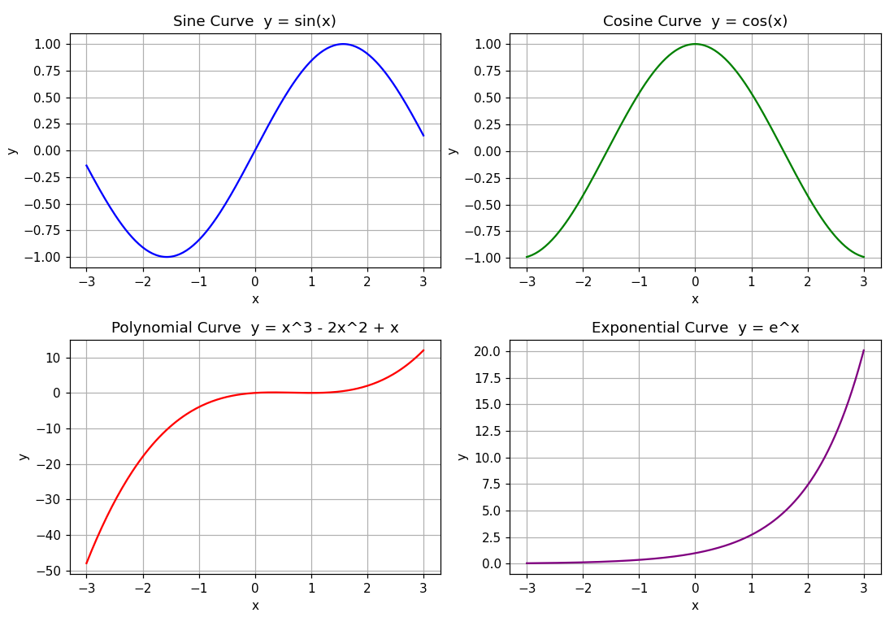
Output: plot window showing the four curves

Q.16 Line plot of monthly profit
Question: Take an input of the months and profit made by a company ABC over a year. Represent this data using a line plot. The generated line plot must include X axis label name = Month numbers and Y axis label name = Total profit.
Program:
# Q16: Line plot of month number vs total profit of company ABC
import matplotlib.pyplot as plt

months = []
profit = []
n = int(input("Enter number of months: "))
for i in range(n):
m = int(input("Enter month number: "))
p = float(input(f"Enter profit for month {m}: "))
months.append(m)
profit.append(p)

plt.plot(months, profit, marker='o', color='blue', linewidth=2)
plt.xlabel("Month numbers")
plt.ylabel("Total profit")
plt.title("Company ABC - Profit over the year")
plt.xticks(months)
plt.grid(True)
plt.show()
Output:
Enter number of months: 12
Enter month number: 1
Enter profit for month 1: 21000
Enter month number: 2
Enter profit for month 2: 23500
Enter month number: 3
Enter profit for month 3: 19800
Enter month number: 4
Enter profit for month 4: 26000
Enter month number: 5
Enter profit for month 5: 31000
Enter month number: 6
Enter profit for month 6: 29500
Enter month number: 7
Enter profit for month 7: 33000
Enter month number: 8
Enter profit for month 8: 35500
Enter month number: 9
Enter profit for month 9: 32000
Enter month number: 10
Enter profit for month 10: 37000
Enter month number: 11
Enter profit for month 11: 40500
Enter month number: 12
Enter profit for month 12: 43000
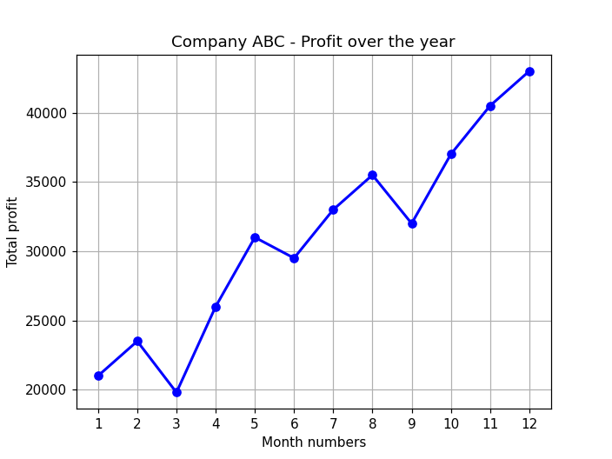
Output: line plot of Month numbers vs Total profit

Q.17 Square spiral using turtle
Question: Draw a square spiral using turtle.
Program:
# Q17: Draw a square spiral using turtle
import turtle

screen = turtle.Screen()
screen.title("Square Spiral")
screen.bgcolor("black")

t = turtle.Turtle()
t.speed(0)
t.color("cyan")
t.pensize(2)
t.hideturtle()

side = 5
for i in range(80):
t.forward(side)
t.left(90)
side += 5

turtle.done()
Output:
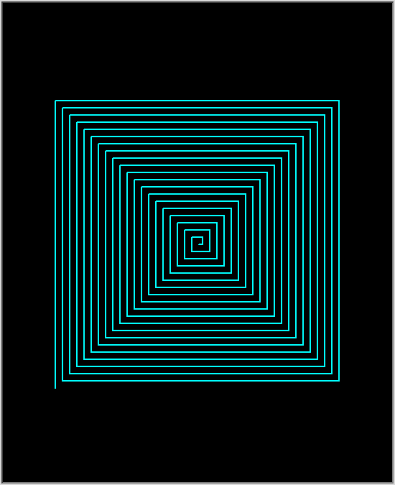
Output: turtle window

Q.18 Clock using Python
Question: Make a clock using Python.
Program:
# Q18: Analog clock using turtle
import turtle
import time
import math

screen = turtle.Screen()
screen.setup(width=600, height=600)
screen.bgcolor("black")
screen.title("Analog Clock")
screen.tracer(0)

pen = turtle.Turtle()
pen.hideturtle()
pen.speed(0)
pen.pensize(3)

def draw_hand(length, angle, width, color):
pen.penup()
pen.goto(0, 0)
pen.setheading(90 - angle) # 0 degree = 12 o'clock, clockwise
pen.pencolor(color)
pen.pensize(width)
pen.pendown()
pen.forward(length)

def draw_face():
pen.penup()
pen.goto(0, -210)
pen.setheading(0)
pen.pencolor("white")
pen.pensize(5)
pen.pendown()
pen.circle(210, steps=100)
# hour numbers
for h in range(1, 13):
ang = math.radians(h * 30)
pen.penup()
pen.goto(170 * math.sin(ang), 170 * math.cos(ang) - 12)
pen.write(str(h), align="center", font=("Arial", 18, "bold"))
# minute ticks
for m in range(60):
ang = math.radians(m * 6)
pen.penup()
pen.goto(195 * math.sin(ang), 195 * math.cos(ang))
pen.setheading(90 - m * 6)
pen.pendown()
pen.forward(15 if m % 5 == 0 else 6)

def update_clock():
pen.clear()
draw_face()
now = time.localtime()
h, m, s = now.tm_hour % 12, now.tm_min, now.tm_sec
draw_hand(100, (h + m / 60) * 30, 8, "white") # hour hand
draw_hand(150, (m + s / 60) * 6, 5, "cyan") # minute hand
draw_hand(175, s * 6, 2, "red") # second hand
pen.penup()
pen.goto(0, -260)
pen.pencolor("yellow")
pen.write(time.strftime("%H:%M:%S"), align="center", font=("Arial", 16, "normal"))
screen.update()
screen.ontimer(update_clock, 1000)

update_clock()
turtle.done()
Output:
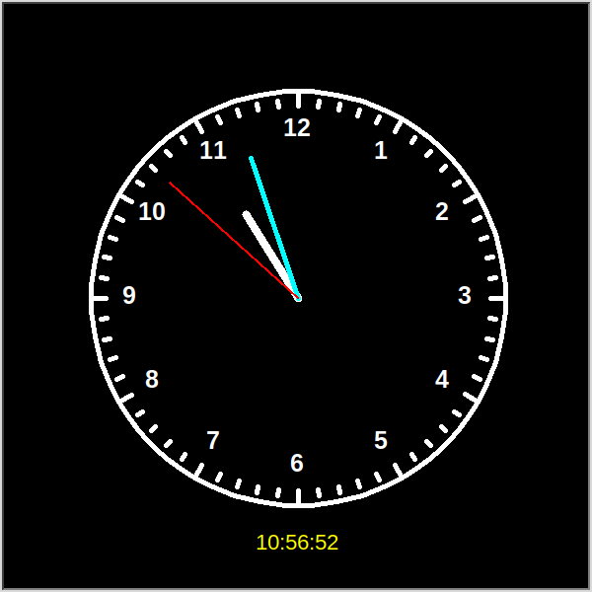
Output: analog clock window

Q.19 Colorful spiral of user's name
Question: Print a colorful spiral of the user's name.
Program:
# Q19: Colorful spiral of the user's name using turtle
import turtle

name = input("Enter your name: ")

screen = turtle.Screen()
screen.title("Colorful Spiral of " + name)
screen.bgcolor("black")

t = turtle.Turtle()
t.speed(0)
t.hideturtle()
t.penup()

colors = ["red", "yellow", "orange", "cyan", "magenta", "lime", "white", "pink"]
for i in range(100):
t.color(colors[i % len(colors)])
t.write(name, font=("Arial", 6 + i // 8, "bold"))
t.forward(3 + i * 0.9)
t.left(25)

turtle.done()
Output:
Enter your name: Tanish
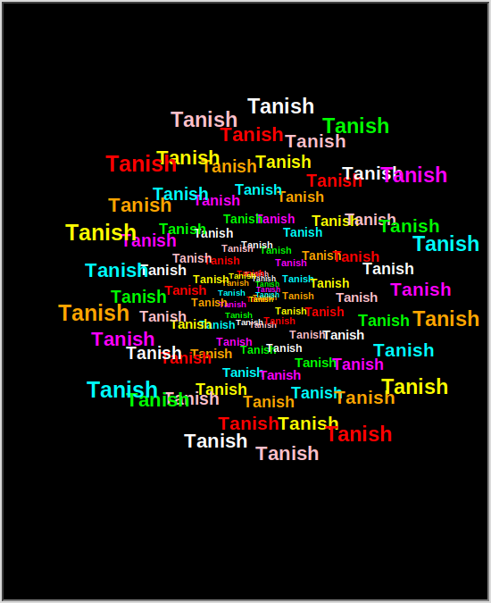
Output: turtle window

Q.20 Calendar GUI
Question: Create a Calendar in GUI.
Program:
# Q20: Calendar GUI using Tkinter
import tkinter as tk
import calendar
from datetime import datetime

class CalendarApp:
def __init__(self, root):
self.root = root
root.title("Calendar")
root.configure(bg="white")
now = datetime.now()
self.year, self.month = now.year, now.month
self.today = now.day

top = tk.Frame(root, bg="#2c3e50")
top.pack(fill="x")
tk.Button(top, text="<", width=3, command=self.prev_month).pack(side="left", padx=5, pady=5)
self.title_lbl = tk.Label(top, font=("Arial", 14, "bold"), fg="white", bg="#2c3e50", width=18)
self.title_lbl.pack(side="left", expand=True)
tk.Button(top, text=">", width=3, command=self.next_month).pack(side="right", padx=5, pady=5)

self.grid_frame = tk.Frame(root, bg="white")
self.grid_frame.pack(padx=10, pady=10)
self.draw()

def draw(self):
for w in self.grid_frame.winfo_children():
w.destroy()
self.title_lbl.config(text=f"{calendar.month_name[self.month]} {self.year}")
for c, d in enumerate(["Mon", "Tue", "Wed", "Thu", "Fri", "Sat", "Sun"]):
tk.Label(self.grid_frame, text=d, width=5, font=("Arial", 10, "bold"),
fg="#c0392b" if d == "Sun" else "black", bg="white").grid(row=0, column=c)
now = datetime.now()
for r, week in enumerate(calendar.monthcalendar(self.year, self.month), start=1):
for c, day in enumerate(week):
if day == 0:
continue
is_today = (day == now.day and self.month == now.month and self.year == now.year)
tk.Label(self.grid_frame, text=str(day), width=5, height=2,
bg="#3498db" if is_today else "white",
fg="white" if is_today else ("#c0392b" if c == 6 else "black")
).grid(row=r, column=c)

def prev_month(self):
self.month -= 1
if self.month == 0:
self.month, self.year = 12, self.year - 1
self.draw()

def next_month(self):
self.month += 1
if self.month == 13:
self.month, self.year = 1, self.year + 1
self.draw()

if __name__ == "__main__":
root = tk.Tk()
CalendarApp(root)
root.mainloop()
Output:
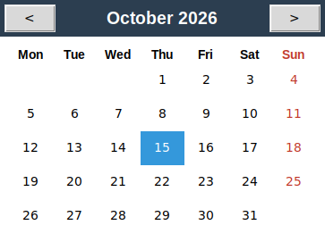
Output: calendar window

Q.21 Tic Tac Toe game
Question: Tic Tac Toe game design in Python.
Program:
# Q21: Tic Tac Toe game using Tkinter
import tkinter as tk
from tkinter import messagebox

class TicTacToe:
def __init__(self, root):
self.root = root
root.title("Tic Tac Toe")
self.player = "X"
self.board = [""] * 9
self.buttons = []
self.status = tk.Label(root, text="Player X's turn", font=("Arial", 14))
self.status.grid(row=0, column=0, columnspan=3, pady=5)
for i in range(9):
b = tk.Button(root, text="", font=("Arial", 32, "bold"), width=4, height=1,
command=lambda i=i: self.click(i))
b.grid(row=1 + i // 3, column=i % 3)
self.buttons.append(b)
tk.Button(root, text="Restart", command=self.reset).grid(row=4, column=0, columnspan=3, pady=5)

def click(self, i):
if self.board[i] != "":
return
self.board[i] = self.player
self.buttons[i].config(text=self.player, fg="blue" if self.player == "X" else "red")
winner = self.check_winner()
if winner:
self.status.config(text=f"Player {winner} wins!")
self.show("Game Over", f"Player {winner} wins!")
self.disable()
elif "" not in self.board:
self.status.config(text="It's a draw!")
self.show("Game Over", "It's a draw!")
else:
self.player = "O" if self.player == "X" else "X"
self.status.config(text=f"Player {self.player}'s turn")

def check_winner(self):
lines = [(0,1,2),(3,4,5),(6,7,8),(0,3,6),(1,4,7),(2,5,8),(0,4,8),(2,4,6)]
for a, b, c in lines:
if self.board[a] != "" and self.board[a] == self.board[b] == self.board[c]:
return self.board[a]
return None

def show(self, title, msg):
if getattr(self, "silent", False):
return
messagebox.showinfo(title, msg)

def disable(self):
for b in self.buttons:
b.config(state="disabled")

def reset(self):
self.player = "X"
self.board = [""] * 9
self.status.config(text="Player X's turn")
for b in self.buttons:
b.config(text="", state="normal")

if __name__ == "__main__":
root = tk.Tk()
TicTacToe(root)
root.mainloop()
Output:
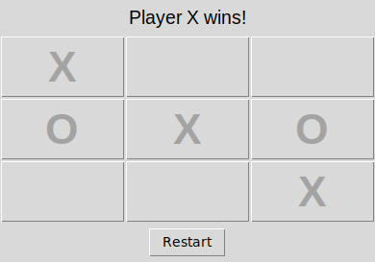
Output: game window (Player X wins)

Q.22 Registration form using Tkinter
Question: Simple Registration form using Tkinter in Python.
Program:
# Q22: Simple Registration Form using Tkinter
import tkinter as tk
from tkinter import ttk

class RegistrationForm:
def __init__(self, root):
self.root = root
root.title("Registration Form")
root.geometry("380x420")
tk.Label(root, text="Registration Form", font=("Arial", 18, "bold"), fg="#2c3e50").pack(pady=10)

form = tk.Frame(root)
form.pack(pady=5)

self.name = tk.StringVar()
self.email = tk.StringVar()
self.phone = tk.StringVar()
self.gender = tk.StringVar(value="Male")
self.course = tk.StringVar()

tk.Label(form, text="Full Name:").grid(row=0, column=0, sticky="w", pady=6)
tk.Entry(form, textvariable=self.name, width=28).grid(row=0, column=1)
tk.Label(form, text="Email:").grid(row=1, column=0, sticky="w", pady=6)
tk.Entry(form, textvariable=self.email, width=28).grid(row=1, column=1)
tk.Label(form, text="Phone:").grid(row=2, column=0, sticky="w", pady=6)
tk.Entry(form, textvariable=self.phone, width=28).grid(row=2, column=1)

tk.Label(form, text="Gender:").grid(row=3, column=0, sticky="w", pady=6)
g = tk.Frame(form)
g.grid(row=3, column=1, sticky="w")
for t in ("Male", "Female", "Other"):
tk.Radiobutton(g, text=t, variable=self.gender, value=t).pack(side="left")

tk.Label(form, text="Course:").grid(row=4, column=0, sticky="w", pady=6)
ttk.Combobox(form, textvariable=self.course, values=["BCA", "BBA", "B.Com", "B.Sc"],
width=25, state="readonly").grid(row=4, column=1)

tk.Button(root, text="Submit", bg="#27ae60", fg="white", width=12, command=self.submit).pack(pady=10)
self.result = tk.Label(root, text="", justify="left", font=("Arial", 10), fg="#2c3e50")
self.result.pack()

def submit(self):
if not self.name.get() or not self.email.get() or not self.course.get():
self.result.config(text="Please fill all the required fields!", fg="red")
return
with open("registrations.txt", "a") as f:
f.write(f"{self.name.get()},{self.email.get()},{self.phone.get()},{self.gender.get()},{self.course.get()}\n")
self.result.config(fg="#27ae60", text=(
"Registration Successful!\n"
f"Name : {self.name.get()}\nEmail : {self.email.get()}\n"
f"Phone : {self.phone.get()}\nGender : {self.gender.get()}\nCourse : {self.course.get()}"))

if __name__ == "__main__":
root = tk.Tk()
RegistrationForm(root)
root.mainloop()
Output:
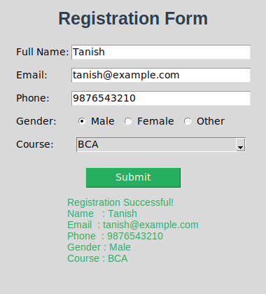
Output: form after clicking Submit

Q.23 Database, table and record insert
Question: Create database, table and record insert using Python.
Program:
# Q23: Create database, table and insert records using Python (sqlite3)
import sqlite3

conn = sqlite3.connect("college.db")
cur = conn.cursor()

cur.execute("DROP TABLE IF EXISTS students")
cur.execute("""CREATE TABLE students (
roll_no INTEGER PRIMARY KEY,
name TEXT NOT NULL,
course TEXT,
marks INTEGER)""")
print("Database and table created successfully.")

records = [(1, "Tanish", "BCA", 85),
(2, "Aman", "BCA", 78),
(3, "Riya", "BCA", 91)]
cur.executemany("INSERT INTO students VALUES (?, ?, ?, ?)", records)
conn.commit()
print("Records inserted successfully.\n")

print("Records in table 'students':")
print("Roll No | Name | Course | Marks")
for row in cur.execute("SELECT * FROM students"):
print(f"{row[0]:<7} | {row[1]:<6} | {row[2]:<6} | {row[3]}")
conn.close()
Output:
Database and table created successfully.
Records inserted successfully.

Records in table 'students':
Roll No | Name | Course | Marks
1 | Tanish | BCA | 85
2 | Aman | BCA | 78
3 | Riya | BCA | 91

Q.24 Customized meme generator
Question: Customize meme generator using Tkinter or GUI module.
Program:
# Q24: Customizable Meme Generator using Tkinter (needs Pillow: pip install pillow)
import tkinter as tk
from tkinter import filedialog, colorchooser
from PIL import Image, ImageDraw, ImageFont, ImageTk

class MemeGenerator:
def __init__(self, root):
self.root = root
root.title("Meme Generator")
self.img = None
self.meme = None
self.color = "white"

panel = tk.Frame(root, padx=10, pady=10)
panel.pack(side="left", fill="y")
tk.Button(panel, text="Open Image", width=18, command=self.open_image).pack(pady=4)
tk.Label(panel, text="Top Text").pack()
self.top = tk.Entry(panel, width=24)
self.top.pack()
tk.Label(panel, text="Bottom Text").pack()
self.bottom = tk.Entry(panel, width=24)
self.bottom.pack()
tk.Label(panel, text="Font Size").pack(pady=(8, 0))
self.size = tk.Scale(panel, from_=20, to=90, orient="horizontal", length=170)
self.size.set(48)
self.size.pack()
tk.Button(panel, text="Text Colour", width=18, command=self.pick_color).pack(pady=4)
tk.Button(panel, text="Generate Meme", width=18, bg="#27ae60", fg="white", command=self.generate).pack(pady=4)
tk.Button(panel, text="Save Meme", width=18, command=self.save).pack(pady=4)

self.canvas = tk.Label(root, text="Open an image to start", width=60, height=20, bg="#dfe6e9")
self.canvas.pack(side="right", padx=10, pady=10)

def open_image(self, path=None):
path = path or filedialog.askopenfilename(filetypes=[("Images", "*.png *.jpg *.jpeg")])
if path:
self.img = Image.open(path).convert("RGB")
self.img.thumbnail((500, 400))
self.generate()

def pick_color(self):
c = colorchooser.askcolor()[1]
if c:
self.color = c

def draw_text(self, draw, text, y):
size = self.size.get()
font = self._font(size)
# shrink the font until the text fits inside the image width
while draw.textlength(text, font=font) > self.meme.width - 20 and size > 10:
size -= 2
font = self._font(size)
w = draw.textlength(text, font=font)
x = (self.meme.width - w) / 2
for dx in (-2, 0, 2):
for dy in (-2, 0, 2):
draw.text((x + dx, y + dy), text, font=font, fill="black")
draw.text((x, y), text, font=font, fill=self.color)

def _font(self, size):
try:
return ImageFont.truetype("DejaVuSans-Bold.ttf", size)
except OSError:
return ImageFont.load_default()

def generate(self):
if self.img is None:
return
self.meme = self.img.copy()
d = ImageDraw.Draw(self.meme)
self.draw_text(d, self.top.get().upper(), 10)
self.draw_text(d, self.bottom.get().upper(), self.meme.height - self.size.get() - 25)
self.tk_img = ImageTk.PhotoImage(self.meme)
self.canvas.config(image=self.tk_img, text="", width=self.meme.width, height=self.meme.height)

def save(self):
if self.meme:
path = filedialog.asksaveasfilename(defaultextension=".png")
if path:
self.meme.save(path)

if __name__ == "__main__":
root = tk.Tk()
MemeGenerator(root)
root.mainloop()
Output:
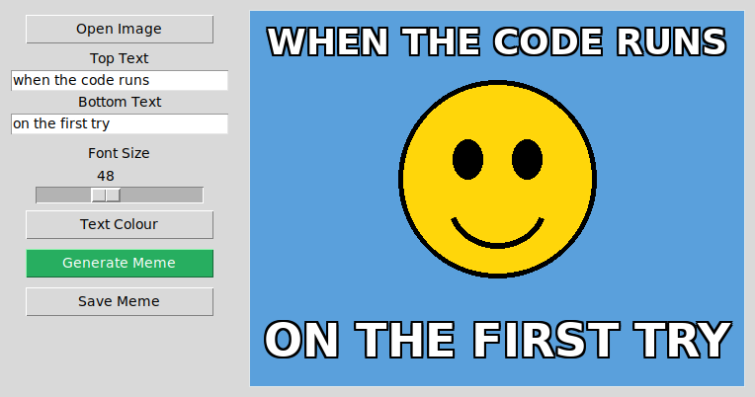
Output: meme generator window

Q.25 Colorful star using turtle
Question: Colorful star making using turtle.
Program:
# Q25: Colorful star using turtle
import turtle
import colorsys

screen = turtle.Screen()
screen.title("Colorful Star")
screen.bgcolor("black")
screen.tracer(0)

t = turtle.Turtle()
t.speed(0)
t.hideturtle()
t.pensize(2)

def star(size):
for _ in range(5):
t.forward(size)
t.right(144) # 144 degrees makes a 5-pointed star

for i in range(36):
r, g, b = colorsys.hsv_to_rgb(i / 36, 1, 1)
t.color(r, g, b)
star(180)
t.right(10) # rotate each star by 10 degrees

screen.update()
turtle.done()
Output:
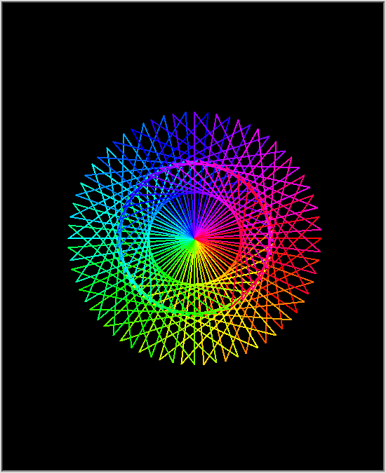
Output: turtle window

Q.26 Music player
Question: Music player using Python.
Program:
# Q26: Music player using Tkinter + pygame (pip install pygame)
import os
import tkinter as tk
from tkinter import filedialog
import pygame

class MusicPlayer:
def __init__(self, root):
self.root = root
root.title("Music Player")
root.geometry("480x440")
root.configure(bg="#1e272e")
pygame.mixer.init()
self.songs = []
self.index = 0
self.paused = False

tk.Label(root, text="MUSIC PLAYER", font=("Arial", 18, "bold"), bg="#1e272e", fg="#0be881").pack(pady=10)
self.now = tk.Label(root, text="No song selected", bg="#1e272e", fg="white", font=("Arial", 11))
self.now.pack(pady=4)

self.listbox = tk.Listbox(root, width=48, height=10, bg="#2f3640", fg="white", selectbackground="#0be881",
selectforeground="black")
self.listbox.pack(pady=8)
self.listbox.bind("<Double-Button-1>", lambda e: self.play())

btns = tk.Frame(root, bg="#1e272e")
btns.pack(pady=6)
for text, cmd in (("Prev", self.prev), ("Play", self.play), ("Pause", self.pause),
("Resume", self.resume), ("Stop", self.stop), ("Next", self.next)):
tk.Button(btns, text=text, width=5, command=cmd).pack(side="left", padx=2)

tk.Label(root, text="Volume", bg="#1e272e", fg="white").pack()
self.vol = tk.Scale(root, from_=0, to=100, orient="horizontal", length=250, bg="#1e272e", fg="white",
command=lambda v: pygame.mixer.music.set_volume(int(v) / 100))
self.vol.set(70)
self.vol.pack()
tk.Button(root, text="Add Folder", command=self.add_folder).pack(pady=6)

def add_folder(self, folder=None):
folder = folder or filedialog.askdirectory()
if not folder:
return
self.songs = [os.path.join(folder, f) for f in sorted(os.listdir(folder)) if f.lower().endswith((".mp3", ".wav", ".ogg"))]
self.listbox.delete(0, "end")
for s in self.songs:
self.listbox.insert("end", os.path.basename(s))

def play(self):
sel = self.listbox.curselection()
if sel:
self.index = sel[0]
if not self.songs:
return
pygame.mixer.music.load(self.songs[self.index])
pygame.mixer.music.play()
self.paused = False
self.listbox.selection_clear(0, "end")
self.listbox.selection_set(self.index)
self.now.config(text="Playing: " + os.path.basename(self.songs[self.index]))

def pause(self):
pygame.mixer.music.pause()
self.paused = True
self.now.config(text="Paused: " + os.path.basename(self.songs[self.index]))

def resume(self):
if self.paused:
pygame.mixer.music.unpause()
self.paused = False
self.now.config(text="Playing: " + os.path.basename(self.songs[self.index]))

def stop(self):
pygame.mixer.music.stop()
self.now.config(text="Stopped")

def next(self):
if self.songs:
self.index = (self.index + 1) % len(self.songs)
self.listbox.selection_clear(0, "end")
self.listbox.selection_set(self.index)
self.play()

def prev(self):
if self.songs:
self.index = (self.index - 1) % len(self.songs)
self.listbox.selection_clear(0, "end")
self.listbox.selection_set(self.index)
self.play()

if __name__ == "__main__":
root = tk.Tk()
MusicPlayer(root)
root.mainloop()
Output:
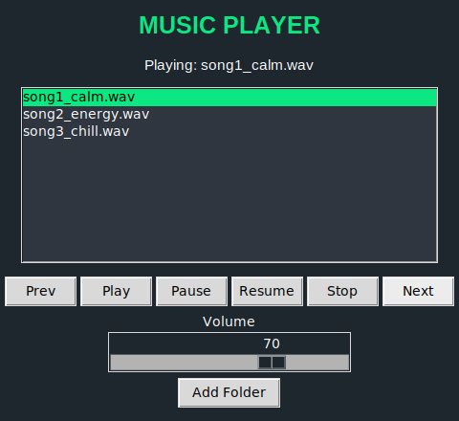
Output: music player playing a song

Q.27 Banking management system
Question: Banking management using Python.
Program:
# Q27: Banking management system
class Account:
def __init__(self, acc_no, name, balance=0):
self.acc_no = acc_no
self.name = name
self.balance = balance

def deposit(self, amount):
if amount <= 0:
print("Invalid amount!")
else:
self.balance += amount
print(f"Rs {amount} deposited. New balance: Rs {self.balance}")

def withdraw(self, amount):
if amount <= 0:
print("Invalid amount!")
elif amount > self.balance:
print("Insufficient balance!")
else:
self.balance -= amount
print(f"Rs {amount} withdrawn. New balance: Rs {self.balance}")

def show(self):
print(f"Account No: {self.acc_no} | Name: {self.name} | Balance: Rs {self.balance}")

accounts = {}
while True:
print("\n===== BANK MANAGEMENT SYSTEM =====")
print("1. Create Account")
print("2. Deposit")
print("3. Withdraw")
print("4. Check Balance")
print("5. Exit")
ch = input("Enter your choice: ")
if ch == '1':
no = int(input("Enter account number: "))
name = input("Enter account holder name: ")
bal = float(input("Enter opening balance: "))
accounts[no] = Account(no, name, bal)
print("Account created successfully!")
elif ch in ('2', '3', '4'):
no = int(input("Enter account number: "))
if no not in accounts:
print("Account not found!")
continue
if ch == '2':
accounts[no].deposit(float(input("Enter amount to deposit: ")))
elif ch == '3':
accounts[no].withdraw(float(input("Enter amount to withdraw: ")))
else:
accounts[no].show()
elif ch == '5':
print("Thank you for banking with us!")
break
else:
print("Invalid choice!")
Output:

===== BANK MANAGEMENT SYSTEM =====
1. Create Account
2. Deposit
3. Withdraw
4. Check Balance
5. Exit
Enter your choice: 1
Enter account number: 1001
Enter account holder name: Tanish
Enter opening balance: 5000
Account created successfully!

===== BANK MANAGEMENT SYSTEM =====
1. Create Account
2. Deposit
3. Withdraw
4. Check Balance
5. Exit
Enter your choice: 2
Enter account number: 1001
Enter amount to deposit: 2500
Rs 2500.0 deposited. New balance: Rs 7500.0

===== BANK MANAGEMENT SYSTEM =====
1. Create Account
2. Deposit
3. Withdraw
4. Check Balance
5. Exit
Enter your choice: 3
Enter account number: 1001
Enter amount to withdraw: 1000
Rs 1000.0 withdrawn. New balance: Rs 6500.0

===== BANK MANAGEMENT SYSTEM =====
1. Create Account
2. Deposit
3. Withdraw
4. Check Balance
5. Exit
Enter your choice: 3
Enter account number: 1001
Enter amount to withdraw: 9000
Insufficient balance!

===== BANK MANAGEMENT SYSTEM =====
1. Create Account
2. Deposit
3. Withdraw
4. Check Balance
5. Exit
Enter your choice: 4
Enter account number: 1001
Account No: 1001 | Name: Tanish | Balance: Rs 6500.0

===== BANK MANAGEMENT SYSTEM =====
1. Create Account
2. Deposit
3. Withdraw
4. Check Balance
5. Exit
Enter your choice: 5
Thank you for banking with us!

Q.28 Age calculator using Tkinter
Question: AGE CALCULATOR using Tkinter.
Program:
# Q28: Age Calculator using Tkinter
import tkinter as tk
import calendar
from datetime import date

class AgeCalculator:
def __init__(self, root):
self.root = root
root.title("Age Calculator")
root.geometry("360x330")
root.configure(bg="#ecf0f1")
tk.Label(root, text="AGE CALCULATOR", font=("Arial", 18, "bold"), bg="#ecf0f1", fg="#2c3e50").pack(pady=12)

f = tk.Frame(root, bg="#ecf0f1")
f.pack()
self.day, self.month, self.year = tk.StringVar(), tk.StringVar(), tk.StringVar()
for i, (lbl, var) in enumerate((("Day", self.day), ("Month", self.month), ("Year", self.year))):
tk.Label(f, text=lbl, bg="#ecf0f1").grid(row=0, column=i, padx=8)
tk.Entry(f, textvariable=var, width=8, justify="center").grid(row=1, column=i, padx=8, pady=4)

tk.Button(root, text="Calculate Age", bg="#2980b9", fg="white", command=self.calculate).pack(pady=12)
self.out = tk.Label(root, text="Enter your date of birth", font=("Arial", 12), bg="#ecf0f1", justify="center")
self.out.pack(pady=5)

def calculate(self):
try:
dob = date(int(self.year.get()), int(self.month.get()), int(self.day.get()))
except ValueError:
self.out.config(text="Invalid date! Please try again.", fg="red")
return
today = date.today()
if dob > today:
self.out.config(text="Date of birth cannot be in the future!", fg="red")
return
years = today.year - dob.year
months = today.month - dob.month
days = today.day - dob.day
if days < 0:
months -= 1
prev_month = today.month - 1 or 12
prev_year = today.year if today.month > 1 else today.year - 1
days += calendar.monthrange(prev_year, prev_month)[1]
if months < 0:
years -= 1
months += 12
total_days = (today - dob).days
self.out.config(fg="#27ae60", text=f"Your age is:\n{years} years, {months} months, {days} days\n\n(Total days lived: {total_days})")

if __name__ == "__main__":
root = tk.Tk()
AgeCalculator(root)
root.mainloop()
Output:
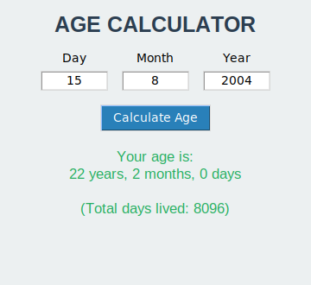
Output: age calculator window

Q.29 Year the user turns 100
Question: Create a program that asks the user to enter their name and their age. Print out a message addressed to them that tells them the year that they will turn 100 years old. Use the built-in Python datetime library so the code works every year, not just the current one.
Program:
# Q29: Year in which the user will turn 100
from datetime import datetime

name = input("Enter your name: ")
age = int(input("Enter your age: "))
years_left = 100 - age
year_100 = datetime.now().year + years_left
print(f"Hello {name}! You will turn 100 years old in the year {year_100}.")
Output:
Enter your name: Tanish
Enter your age: 21
Hello Tanish! You will turn 100 years old in the year 2105.

Q.30 Image crop and resize using OpenCV
Question: Image crop and resize using OpenCV.
Program:
# Q30: Image crop and resize using OpenCV
import cv2
import numpy as np

# Create a sample image (use cv2.imread("photo.jpg") for your own image)
img = np.zeros((400, 600, 3), dtype=np.uint8)
img[:] = (240, 220, 200)
cv2.rectangle(img, (50, 50), (250, 200), (255, 0, 0), -1)
cv2.circle(img, (430, 150), 80, (0, 0, 255), -1)
cv2.putText(img, "OpenCV", (180, 330), cv2.FONT_HERSHEY_SIMPLEX, 2, (0, 120, 0), 4)
cv2.imwrite("original.png", img)

print("Original image size (height, width, channels):", img.shape)

# Crop: img[y1:y2, x1:x2]
cropped = img[30:230, 30:280]
print("Cropped image size:", cropped.shape)
cv2.imwrite("cropped.png", cropped)

# Resize to 300 x 200 (width, height)
resized = cv2.resize(img, (300, 200))
print("Resized image size:", resized.shape)
cv2.imwrite("resized.png", resized)

# To show on screen:
# cv2.imshow("Original", img); cv2.imshow("Cropped", cropped); cv2.imshow("Resized", resized)
# cv2.waitKey(0); cv2.destroyAllWindows()
Output:
Original image size (height, width, channels): (400, 600, 3)
Cropped image size: (200, 250, 3)
Resized image size: (200, 300, 3)
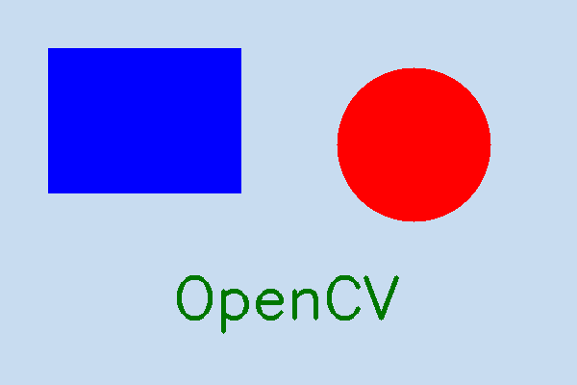
Output 1: original image
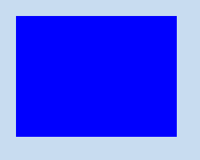
Output 2: cropped image
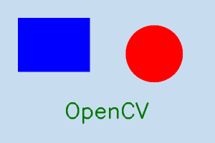
Output 3: resized image (300 x 200)

Q.31 Sudoku game design in pygame
Question: Create Sudoku game design in pygame.
Program:
# Q31: Sudoku game using pygame (pip install pygame)
import random
import pygame

CELL, SIZE = 60, 540
WIDTH, HEIGHT = SIZE, SIZE + 60

def valid(board, r, c, n):
for i in range(9):
if board[r][i] == n or board[i][c] == n:
return False
br, bc = 3 * (r // 3), 3 * (c // 3)
for i in range(br, br + 3):
for j in range(bc, bc + 3):
if board[i][j] == n:
return False
return True

def solve(board):
for r in range(9):
for c in range(9):
if board[r][c] == 0:
nums = list(range(1, 10))
random.shuffle(nums)
for n in nums:
if valid(board, r, c, n):
board[r][c] = n
if solve(board):
return True
board[r][c] = 0
return False
return True

def make_puzzle(holes=40):
full = [[0] * 9 for _ in range(9)]
solve(full)
puzzle = [row[:] for row in full]
for pos in random.sample(range(81), holes):
puzzle[pos // 9][pos % 9] = 0
return puzzle, full

class Sudoku:
def __init__(self):
self.puzzle, self.solution = make_puzzle()
self.board = [row[:] for row in self.puzzle]
self.sel = None
self.message = "Click a cell and type 1-9 (Backspace to clear)"
self.font = pygame.font.SysFont("arial", 34)
self.small = pygame.font.SysFont("arial", 20)

def draw(self, screen):
screen.fill((255, 255, 255))
if self.sel:
r, c = self.sel
pygame.draw.rect(screen, (187, 222, 251), (c * CELL, r * CELL, CELL, CELL))
for r in range(9):
for c in range(9):
n = self.board[r][c]
if n:
given = self.puzzle[r][c] != 0
ok = n == self.solution[r][c]
color = (0, 0, 0) if given else ((25, 118, 210) if ok else (211, 47, 47))
t = self.font.render(str(n), True, color)
screen.blit(t, (c * CELL + (CELL - t.get_width()) // 2, r * CELL + (CELL - t.get_height()) // 2))
for i in range(10):
w = 4 if i % 3 == 0 else 1
pygame.draw.line(screen, (0, 0, 0), (0, i * CELL), (SIZE, i * CELL), w)
pygame.draw.line(screen, (0, 0, 0), (i * CELL, 0), (i * CELL, SIZE), w)
msg = self.small.render(self.message, True, (50, 50, 50))
screen.blit(msg, (10, SIZE + 18))

def click(self, pos):
x, y = pos
if y < SIZE:
self.sel = (y // CELL, x // CELL)

def key(self, k):
if not self.sel:
return
r, c = self.sel
if self.puzzle[r][c] != 0:
return
if pygame.K_1 <= k <= pygame.K_9:
self.board[r][c] = k - pygame.K_0
elif k in (pygame.K_BACKSPACE, pygame.K_DELETE):
self.board[r][c] = 0
if self.board == self.solution:
self.message = "Congratulations! You solved the Sudoku!"

def main():
pygame.init()
screen = pygame.display.set_mode((WIDTH, HEIGHT))
pygame.display.set_caption("Sudoku")
game = Sudoku()
clock = pygame.time.Clock()
running = True
while running:
for e in pygame.event.get():
if e.type == pygame.QUIT:
running = False
elif e.type == pygame.MOUSEBUTTONDOWN:
game.click(e.pos)
elif e.type == pygame.KEYDOWN:
game.key(e.key)
game.draw(screen)
pygame.display.flip()
clock.tick(30)
pygame.quit()

if __name__ == "__main__":
main()
Output:
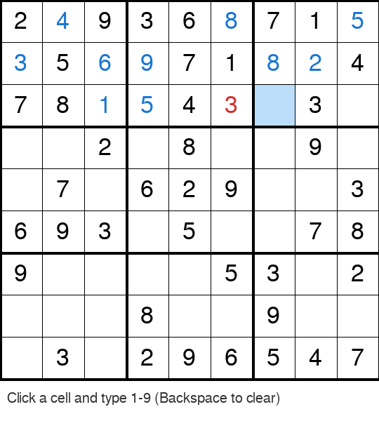
Output: Sudoku board (blue = correct entry, red = wrong entry, highlighted = selected cell)

Q.32 Screen recorder
Question: Screen Recorder using Python.
Program:
# Q32: Screen recorder using Python (pip install mss opencv-python numpy)
import time
import cv2
import numpy as np
import mss

duration = int(input("Enter recording duration in seconds: "))
fps = 10
filename = "screen_record.avi"

with mss.MSS() as sct:
monitor = sct.monitors[1] # primary monitor
width, height = monitor["width"], monitor["height"]
fourcc = cv2.VideoWriter_fourcc(*"XVID")
out = cv2.VideoWriter(filename, fourcc, fps, (width, height))

print("Recording started...")
start = time.time()
frames = 0
while time.time() - start < duration:
frame = np.array(sct.grab(monitor)) # BGRA screenshot
frame = cv2.cvtColor(frame, cv2.COLOR_BGRA2BGR)
out.write(frame)
frames += 1
time.sleep(1 / fps)
out.release()

print("Recording stopped.")
print("Frames captured:", frames)
print("Video saved as:", filename)
Output:
Enter recording duration in seconds: 3
Recording started...
Recording stopped.
Frames captured: 28
Video saved as: screen_record.avi
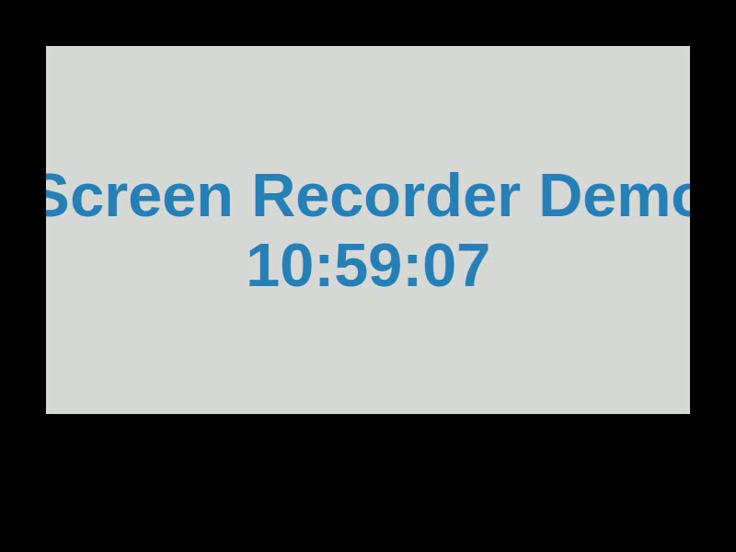
Output: one frame taken from the recorded video

