PRACTICE SHEET 3 OF 4 — DAY 1
Inside RAG: Embeddings, Chunking & Vector Search
Bridges Module 1 → Modules 4–5 | Hour 3 of the Day | Duration: ~50 minutes
Where this fits
Sheet 2 told you RAG exists and why enterprises prefer it. This sheet opens the box: what actually happens, step by step, between a raw document and a cited answer. The hands-on build of this pipeline happens in Modules 4–5 — today is about building the mental model first.

A. Why SQL Struggles Here — and What Vector Databases Fix
Sheet 2 introduced SQL vs vector databases side by side. Here's specifically where a SQL-only approach breaks down for document search, and how a vector database closes each gap.

Challenge with SQL alone | How a vector database overcomes it
SQL matches exact keywords. If an engineer searches “max power” but the manual says “maximum EIRP,” a keyword search can miss it entirely. | Vector search matches by meaning, not exact words — “max power” and “maximum EIRP” can sit close together if they mean similar things in context.
Free-form text (PDFs, manuals, contracts) doesn't fit neatly into rows and columns — forcing it into a rigid schema loses nuance. | Vector databases store the meaning of a whole chunk of text as a single numeric representation, with no fixed schema required.
SQL has no concept of “how similar” two pieces of text are — only exact match or no match. | Vector databases rank results by similarity score, so the most relevant passages surface even when wording differs.
Scaling keyword search across millions of unstructured documents (manuals, tickets, SLAs) gets slow and imprecise. | Vector indexes (e.g., HNSW) are purpose-built for fast nearest-neighbour search across millions of entries, keeping retrieval fast at scale.

B. What Is a Vector?

Explain it like I'm 10
Imagine every word or idea gets a set of GPS coordinates — not on a map of the earth, but on a map of meaning. Words that mean similar things get coordinates that are close together. Words with very different meanings end up far apart. A vector is just that list of coordinates — except instead of 2 numbers (latitude, longitude), it might be 768 or 1,536 numbers, capturing meaning in far more dimensions than a map ever could.

In engineering terms
A vector (or embedding) is a fixed-length list of numbers that represents the meaning of a piece of text, generated by an embedding model. Text with similar meaning produces vectors that are numerically close together, measured using distance metrics like cosine similarity.
The classic example
“City” and “town” will end up close together in vector space, because they're used in similar contexts and mean similar things — even though they don't share a single letter in common. “City” and “banana” will end up far apart. This is exactly what makes semantic search possible.

C. From Words to Vectors — The Full Journey
Before a document can be searched semantically, it passes through several transformations. Each step matters:

Step | What happens
1. Raw text | The original document — a PDF manual, an SOP, a contract, a ticket.
2. Tokens | The text is broken into tokens — the small text units models actually process (Sheet 2, Section D).
3. Chunks | Tokens are grouped into chunks — manageable, meaningful sections of text (explained in Section D below).
4. Embedding model | Each chunk is passed through an embedding model, which converts it into a vector — a list of numbers capturing its meaning.
5. Vector | The resulting numeric representation is what actually gets stored and searched — not the raw text itself.

D. What Is Chunking?
Explain it like I'm 10: If you had to find one specific sentence in a 500-page book, you wouldn't hand a friend the entire book and hope they find it — you'd first break the book into chapters, then pages, then paragraphs, so the right piece is easy to locate and hand over. Chunking is that same idea, done to documents before they're indexed.
In engineering terms: Chunking splits a document into smaller, coherent text units before embedding, because embedding an entire 200-page manual as a single vector would blur its meaning into mush — and it wouldn't fit in any model's context window anyway.

Why chunking matters
- Retrieval precision: smaller, focused chunks let the search return exactly the relevant passage, not an entire irrelevant document
- Context window limits: the model can only accept a limited number of tokens per request — chunks must fit within that budget alongside the user's question
- Cost control: retrieving 3 small relevant chunks costs far fewer tokens than retrieving 3 entire documents

Common chunking strategies
- Fixed-size chunking: split every N tokens, regardless of sentence or paragraph boundaries — simple but can cut sentences awkwardly
- Sentence-level chunking: split at sentence boundaries — keeps grammar intact
- Heading-aware chunking: split at document headings/sections — keeps a topic together as one unit
- Semantic chunking: split where the meaning shifts, rather than at a fixed length
- Overlapping chunks: each chunk shares a little text with its neighbour, so an idea that spans a chunk boundary isn't lost entirely

E. The End-to-End Architecture
Putting it all together — from raw structured and unstructured data, through chunking and embedding, to a cited answer generated by the LLM:

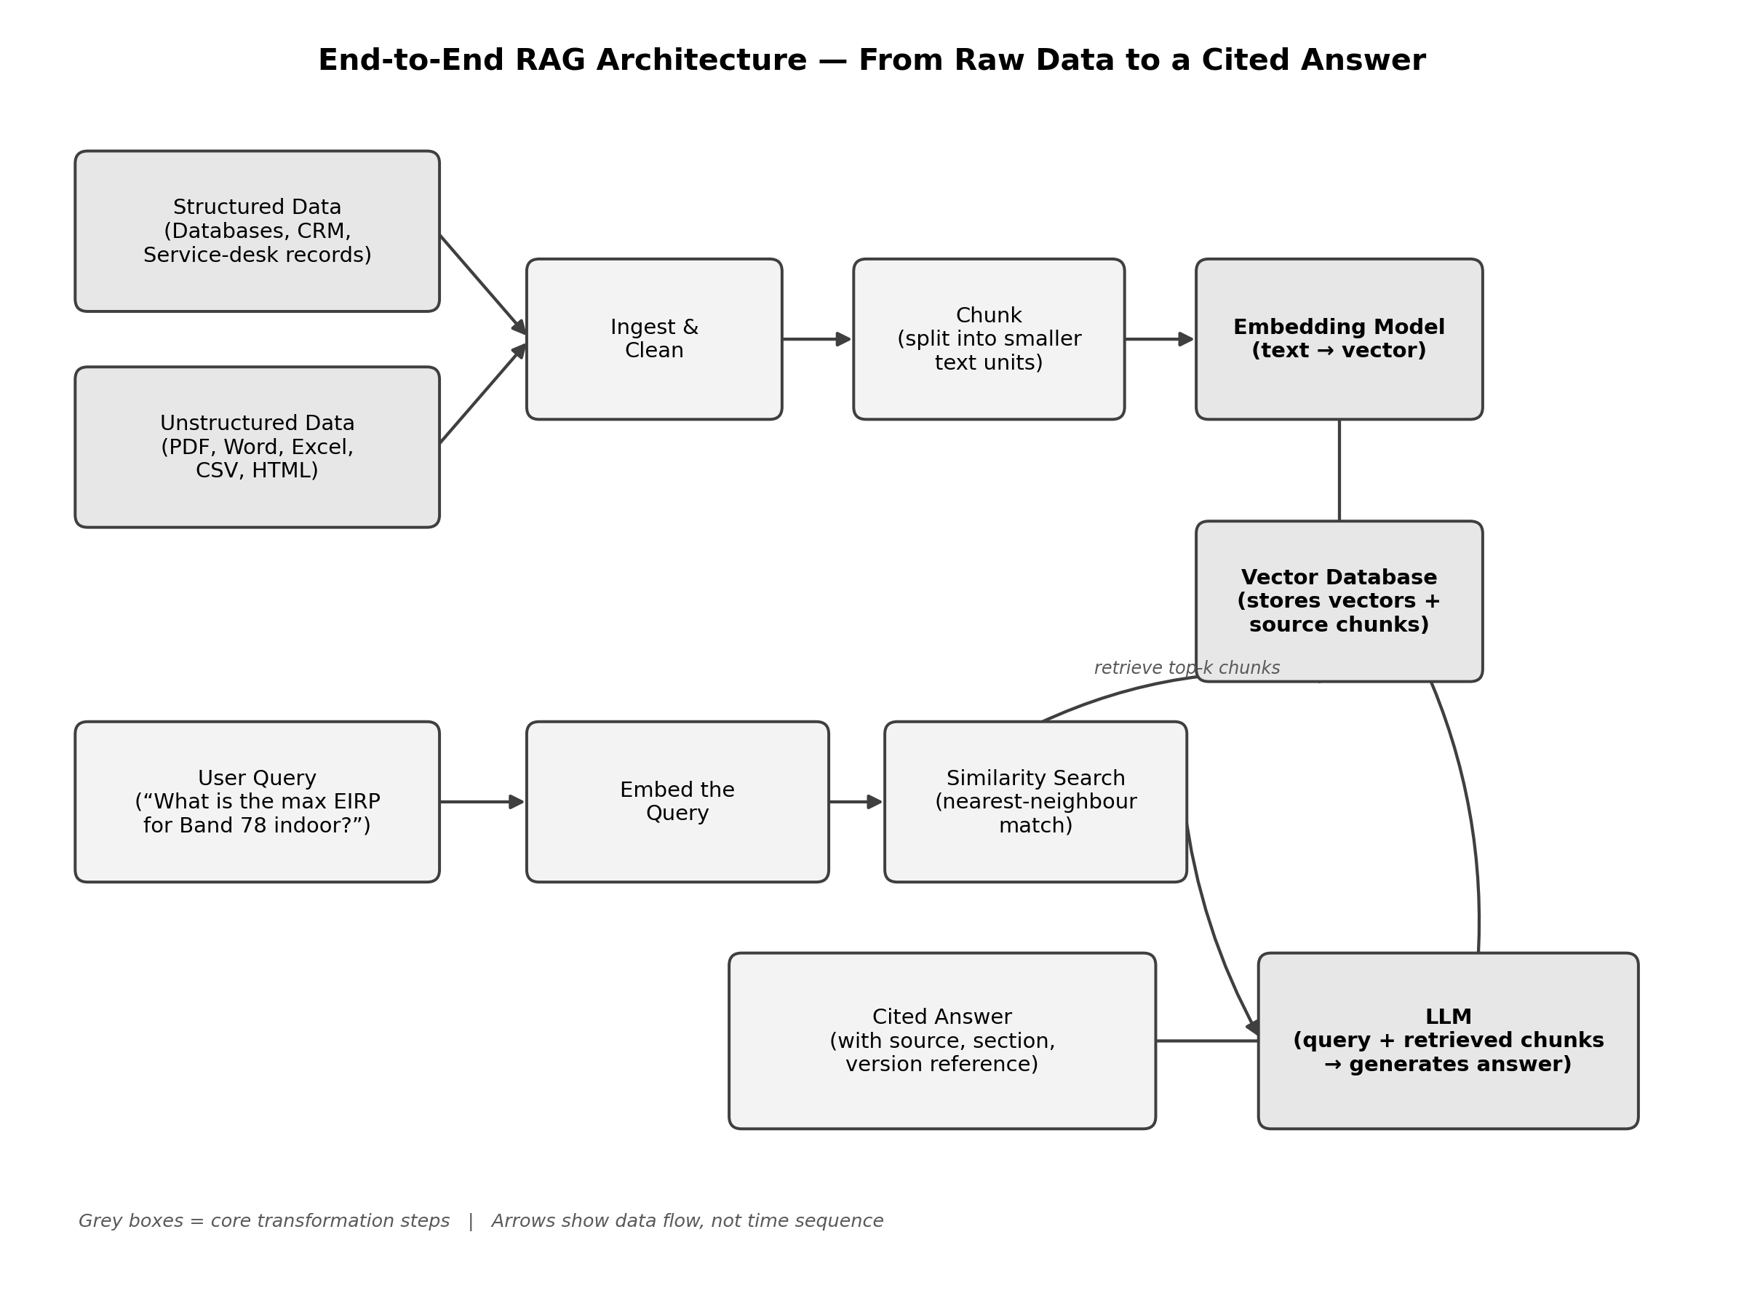

F. Semantic & Similarity Search — How It Actually Finds the Right Answer
Once a user asks a question, that question is embedded into a vector using the exact same embedding model used on the documents. The vector database then performs a similarity search: it looks for the stored chunk-vectors that sit closest to the query's vector in meaning-space, using a distance measure such as cosine similarity.
This is why an engineer can ask “What is the max power for Band 78 indoor?” and still retrieve a passage that says “maximum EIRP” — the two phrases sit close together in vector space, even though the exact words differ.
Those top-matching chunks (often called “top-k” results) are then handed to the LLM alongside the original question. The LLM does not search anything itself — it simply reads the retrieved chunks and generates a grounded, cited answer in response, typically within a second or two.

G. LLM vs. Text-Embedding Model — Not the Same Thing
These two model types are often confused because they're used together in every RAG pipeline — but they do fundamentally different jobs.

 | Large Language Model (LLM) | Text-embedding model
What it takes in | Text (a prompt, possibly with retrieved chunks) | Text (a chunk, a query, a document)
What it produces | New generated text — an answer, a summary, code | A vector — a fixed-length list of numbers representing meaning
Its job in RAG | Reads retrieved chunks and generates the final grounded answer | Converts chunks and queries into vectors so similarity search is possible
Examples | GPT-4o, Claude, Gemini | OpenAI Ada / text-embedding-3, Google's embedding models
Can it be swapped independently? | Yes — you can change the LLM without re-embedding your documents | Yes, but if you change embedding models, you generally must re-embed your entire document store to keep vectors comparable

H. Meet the Vector Databases
Several purpose-built vector databases are used across the industry — including in this programme's labs (Module 4 onward). Here are three you'll encounter most often:

Vector database | What it is | Typical use
ChromaDB | An open-source, lightweight vector database that's easy to run locally — the one used throughout this programme's labs. | Fast prototyping and small-to-medium enterprise document stores
FAISS (Facebook AI Similarity Search) | An open-source library (not a full database) for extremely fast similarity search over very large vector sets. | High-scale, performance-critical search where you build the surrounding infrastructure yourself
Weaviate | An open-source vector database with built-in hybrid search (keyword + vector) and a managed cloud option. | Production deployments needing hybrid search and managed hosting out of the box

A note on names
If your notes mentioned “RomaDB, PAS, VBA” — these aren't recognised vector database names. Based on what's actually used in this space (and in this programme), we've used ChromaDB, FAISS, and Weaviate above. Flag with your facilitator if you had specific different tools in mind.

Why vector databases beat SQL on latency for this job
A SQL database answering “find rows where column = X” is fast because it's an exact index lookup. But asking SQL to find “text similar in meaning to this question” has no native mechanism — it would require scanning and comparing text manually, which doesn't scale. Vector databases use specialised indexing structures (like HNSW — Hierarchical Navigable Small World graphs) built specifically for fast nearest-neighbour search, returning highly relevant results across millions of chunks in milliseconds — without ever running a full manual scan.

I. Hands-On Activity (15 minutes)
Individually or in pairs: take one paragraph from any telco document you have access to (an SOP, a manual excerpt, anything non-confidential). Manually do what an ingestion pipeline would do, and record your steps below.

Step | What I did / would do

J. Reflection Questions (5 minutes)
- 1. Explain in your own words why “city” and “town” end up close together in vector space, but “city” and “banana” do not.
- 2. Why might chunking a 200-page manual into overlapping chunks retrieve better answers than chunking it into non-overlapping fixed-size blocks?
- 3. If your organisation switches from one embedding model to another, why can't you just keep using the old vectors?
- 4. In one sentence, explain the difference between what an LLM does and what an embedding model does in a RAG pipeline.

K. Quick Recap
- SQL matches exact values; vector databases match by meaning — which is what unstructured document search actually needs.
- A vector is a numeric representation of meaning; similar meanings sit close together in vector space.
- Chunking breaks documents into retrievable, context-window-friendly units before embedding.
- The full pipeline runs: ingest → chunk → embed → store in a vector database → embed the query → similarity search → retrieve top-k chunks → LLM generates a cited answer.
- An embedding model and an LLM are different tools doing different jobs — one turns text into searchable meaning, the other generates the final answer.
- ChromaDB, FAISS, and Weaviate are three widely used vector databases, each with different strengths for scale and hybrid search.

