PROMPT PRACTICE SHEET 1 OF 4 — DAY 1 WRAP-UP
Seeing Models, Tokens & Prompt Quality in Action
25 Hands-On Prompts | Use Cases 1, 2 & 3 | No coding — GUI tools only
How to use this sheet
Run each prompt in ChatGPT, Copilot, Gemini, or Claude — whichever you have access to. Where a prompt says “run in two tools,” actually do it; the comparison is the whole point. No prompt-engineering jargon is used below — every prompt simply follows the same formula from Sheet 4: instruction + context + input + output format. This is GUI-only practice before we open VS Code in the next session.

The Prompt Formula (recap)
Part | What goes here
Instruction | What you want done
Context | Who you are / what this is for
Input | The actual content to work on
Output format | How the answer should be shaped

25 Prompts — Try Each One, Fill In What You Notice
# | Use Case | Prompt to run | What to notice
1 | UC1 | “You are a NOC RCA assistant. A critical alert says: eNodeB-4471-Pune Cell Down, 02:14, 0 throughput. In 3 bullet points, list the most likely root causes, and suggest one first check for a field engineer.” | Run in 2 tools. Compare technical depth and structure.
2 | UC1 | Same as #1, but add: “Reason through the possible causes methodically before giving your final answer, but only show me the final 3 bullets.” | Compare answer quality to #1 — does hidden reasoning change the result?
3 | UC1 | Run prompt #1 once in your tool's fast/standard mode and once in its deep-thinking/extended-reasoning mode, if available. | Notice speed vs. depth trade-off from Sheet 4.
4 | UC2 | “You are a telecom customer care assistant. A customer asks: My data pack ran out early, can you tell me why? Only answer using general billing knowledge; if you'd need their specific account, say so instead of guessing.” | Does the model refuse to guess, or does it speculate anyway?
5 | UC2 | “Rewrite your last answer in under 50 words, in a calm, apologetic, non-defensive tone suitable for a live customer chat.” | Output-format and tone control in one instruction.
6 | UC2 | “Roughly how many tokens was your last response, and how did you estimate it?” | Compare the model's self-estimate to the tokenizer tool from Sheet 2.
7 | UC3 | “Explain, as if to a new field engineer with no telecom background, what EIRP means and why an indoor 5G small cell has a lower EIRP limit than an outdoor macro cell.” | ELI10-quality check — compare explanation clarity across tools.
8 | UC3 | Run prompt #7 in two different tools and compare their answers for technical accuracy. | Do they agree? Note any factual disagreement — keep this for Sheet 7.
9 | — | Paste your prompt from #7 into platform.openai.com/tokenizer. | Note the exact token count of your own prompt, not just the answer.
10 | UC1 | “List 3 telecom-specific terms that could confuse a general-purpose model with no telecom training, and explain each in one sentence.” | Domain-gap awareness — sets up why RAG matters (Sheet 7).
11 | UC2 | First try the vague prompt: “customer angry about bill.” Then try a well-formed version using all four parts of the prompt formula above. | Feel the anatomy difference directly — same task, very different usefulness.
12 | UC1 | “In under 100 words, explain the difference between a Critical, High, and Medium severity network incident, for someone brand-new to NOC operations.” | Check strict word-limit compliance.
13 | UC3 | “What is the maximum indoor EIRP for 5G Band 78, based on general industry knowledge (not any specific company document)?” | Remember this answer — compare it to the real SOP value in Sheet 7.
14 | UC3 | Run prompt #13 in your cheapest/fastest model tier, then in the flagship/reasoning tier. | Compare confidence and hedging language between tiers.
15 | UC2 | “You are the assistant for Use Case 2 (Intelligent Customer Care). Introduce yourself to a customer in one sentence.” | See how a role instruction shapes tone, even before any real task.
16 | UC1 | Ask the exact prompt from #1 twice, in two fresh chats. | Compare wording between the two answers — notice the model isn't perfectly repeatable.
17 | UC3 | “Summarise 5G indoor deployment safety in exactly 2 sentences — no more, no fewer.” | Strict output-format compliance check.
18 | UC2 | “Return as JSON: {dispute_likely: yes/no, reason: string, tone_recommended: string} for this message: I was charged twice for the same recharge!” | Structured-output prompting — the same pattern Use Case 4 relies on.
19 | UC1 | “Return your answer as a markdown table with columns: Severity | Meaning | Example.” | Table-formatting compliance — useful for NOC handover reports (Use Case 8).
20 | UC3 | “Roughly how many tokens should I expect if I want to retrieve and read a 3-page SOP excerpt inside one prompt?” | Ties directly back to token economics (Sheet 2).
21 | UC1 | “If your root-cause answer above turned out to be wrong, what real-world consequence could that have for a telecom NOC team?” | Risk-awareness prompting — primes Sheet 8's guardrail discussion.
22 | UC2 | Ask the same billing question once for a “confident” answer and once for a “cautious, uncertainty-flagging” answer. | Compare hedging language — relevant to confidence scores (Sheet 2).
23 | UC3 | Ask two different tools the exact same domain-specific question (e.g., #13) and compare their factual claims. | Any disagreement here is exactly why RAG grounding exists — Sheet 7.
24 | UC1 | “Estimate, in tokens, how long a typical NOC shift-handover report (roughly 300 words) would be.” | Practice real word-to-token estimation.
25 | — | “In your own words, summarise what you noticed today about the difference between a vague prompt and a well-formed one, across at least two tools.” | Wrap-up reflection — write your answer in the space below.

Today vs. Next Session
Everything above was done by hand, in a chat window, one prompt at a time. Here's what changes when this becomes code:

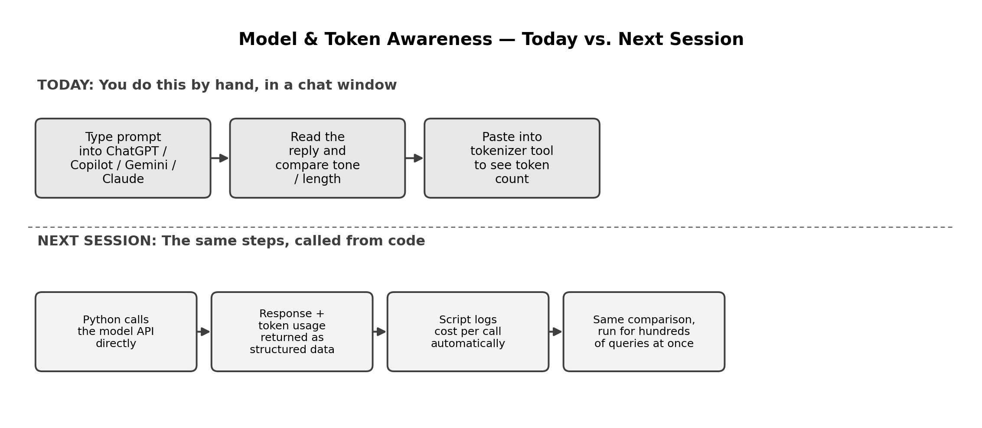

Reflection Space
Your notes

