PROMPT PRACTICE SHEET 2 OF 4 — DAY 1 WRAP-UP
Seeing RAG, Chunking & Grounded Citations in Action
25 Hands-On Prompts | Use Cases 3, 4, 5 & 6 | No coding — GUI tools only
Starter files for this sheet
Three sample files are provided with this session: Sample_5G_Deployment_SOP.pdf, Sample_Enterprise_SLA_Excerpt.pdf, and Billing_Dispute_Tickets_Sample.csv. All contain fictional data created for training only. Upload them into ChatGPT, Copilot, Gemini, or Claude as instructed below.

25 Prompts — Try Each One, Fill In What You Notice
# | Use Case | Prompt to run | What to notice
1 | UC3 | Upload Sample_5G_Deployment_SOP.pdf. Ask: “What is the maximum indoor EIRP for Band 78 according to this document? Cite the exact section.” | Compare this grounded answer to your guess from Sheet 6, prompt #13.
2 | UC3 | “Quote the exact sentence in this document that states the EIRP limit.” | A grounded citation, not a paraphrase — the core promise of RAG.
3 | UC3 | “What is the outdoor macro-cell EIRP limit per this document?” (This isn't fully specified in the excerpt.) | Does the tool correctly say ‘not covered here, see SOP-009’, or does it guess a number anyway?
4 | UC3 | “Summarise this document section by section.” | Chunking behaviour, revisited with real telecom content.
5 | UC3 | “Based only on this document, what should a field engineer check before marking a site as commissioned?” | Grounded list generation, not general knowledge.
6 | UC5 | Upload Sample_Enterprise_SLA_Excerpt.pdf. Ask: “What is the guaranteed uptime percentage, and what happens if it's breached? Cite the clause.” | Grounded contract reading with citation.
7 | UC5 | “If actual uptime was 99.1% for a month with a monthly fee of ₹10,00,000, calculate the service credit owed per this contract.” | Grounding combined with a calculation — check the maths yourself.
8 | UC5 | “What exclusions does the service provider have per this contract? List all of them.” | Completeness check — did it miss any exclusion?
9 | UC5 | “What is the penalty if uptime falls below 95%?” (Not specified in the excerpt.) | Watch for hallucinated extrapolation vs. an honest ‘not specified.’
10 | UC5 | “Rewrite Clause 5 in plain English for a non-legal account manager.” | Grounded simplification — no new facts should be introduced.
11 | UC4 | Upload Billing_Dispute_Tickets_Sample.csv. Ask: “How many tickets are type ‘Roaming Error’, and what's the total amount disputed?” | Structured-data question — like a SQL query, asked in plain English.
12 | UC4 | “Which single ticket has the highest disputed amount, and what is it?” | Precision retrieval on structured data.
13 | UC4 | “Classify each open ticket by likely root cause in one word, and return as a table.” | Structured output over grounded data — Use Case 4's actual pattern.
14 | UC4 | “Draft a customer-facing resolution message for ticket BD-5002, using only its description.” | Grounded drafting — check nothing outside the ticket sneaks in.
15 | UC3 | Ask the EIRP question (#1) again in a brand-new chat, without uploading the document. | Compare to #1 — this is hallucination risk, side by side, with grounding vs. without it.
16 | UC5 | Ask the uptime question (#6) again in a brand-new chat, without uploading the SLA document. | Same comparison for a contract fact — notice any confident-sounding but wrong number.
17 | UC3 | “If I only gave you page 2 of this document instead of the whole thing, would you still answer the EIRP question correctly?” | This is a live discussion of chunking and retrieval precision.
18 | UC6 | No file needed: “Given a customer with declining usage, 3 recent complaints, and a renewal due in 20 days, write a one-paragraph churn-risk summary with a risk level and one recommended action.” | Reasoning over a scenario, without any document to ground it.
19 | UC6 | Repeat #18, but require strict JSON: {risk_level, evidence, recommended_action}. | Structured output — the exact shape Use Case 6's dashboard needs.
20 | UC4 | “For the CSV data, tell me which columns you actually used to answer question #11, and which you ignored.” | Transparency check — what data actually grounded the answer?
21 | UC3 | “Does this document mention outdoor macro-cell deployment? Quote if yes, or say clearly if it's not covered.” | Refusal discipline — rewarding ‘I don't know’ over a confident guess.
22 | UC5 | “Summarise this entire contract in exactly 5 bullet points, one per major clause.” | Output-format discipline applied to grounded content.
23 | UC4 | “If a customer disputes an amount not represented anywhere in this CSV, what should the assistant do?” | This answer should come from good practice, not the data — notice the shift.
24 | UC3 | “Which part of the document did you draw your EIRP answer from — can you tell me which section or paragraph?” | Some tools approximate this; a real RAG pipeline cites the exact chunk every time (Module 5).
25 | — | “Across today's exercises, describe one moment where NOT having the document uploaded would have produced a wrong or hallucinated answer.” | Wrap-up reflection — write your answer below.

Today vs. Next Session
Today, you played the role of the retrieval system yourself — uploading the right file, by hand, before asking. Here's what a coded RAG pipeline automates:

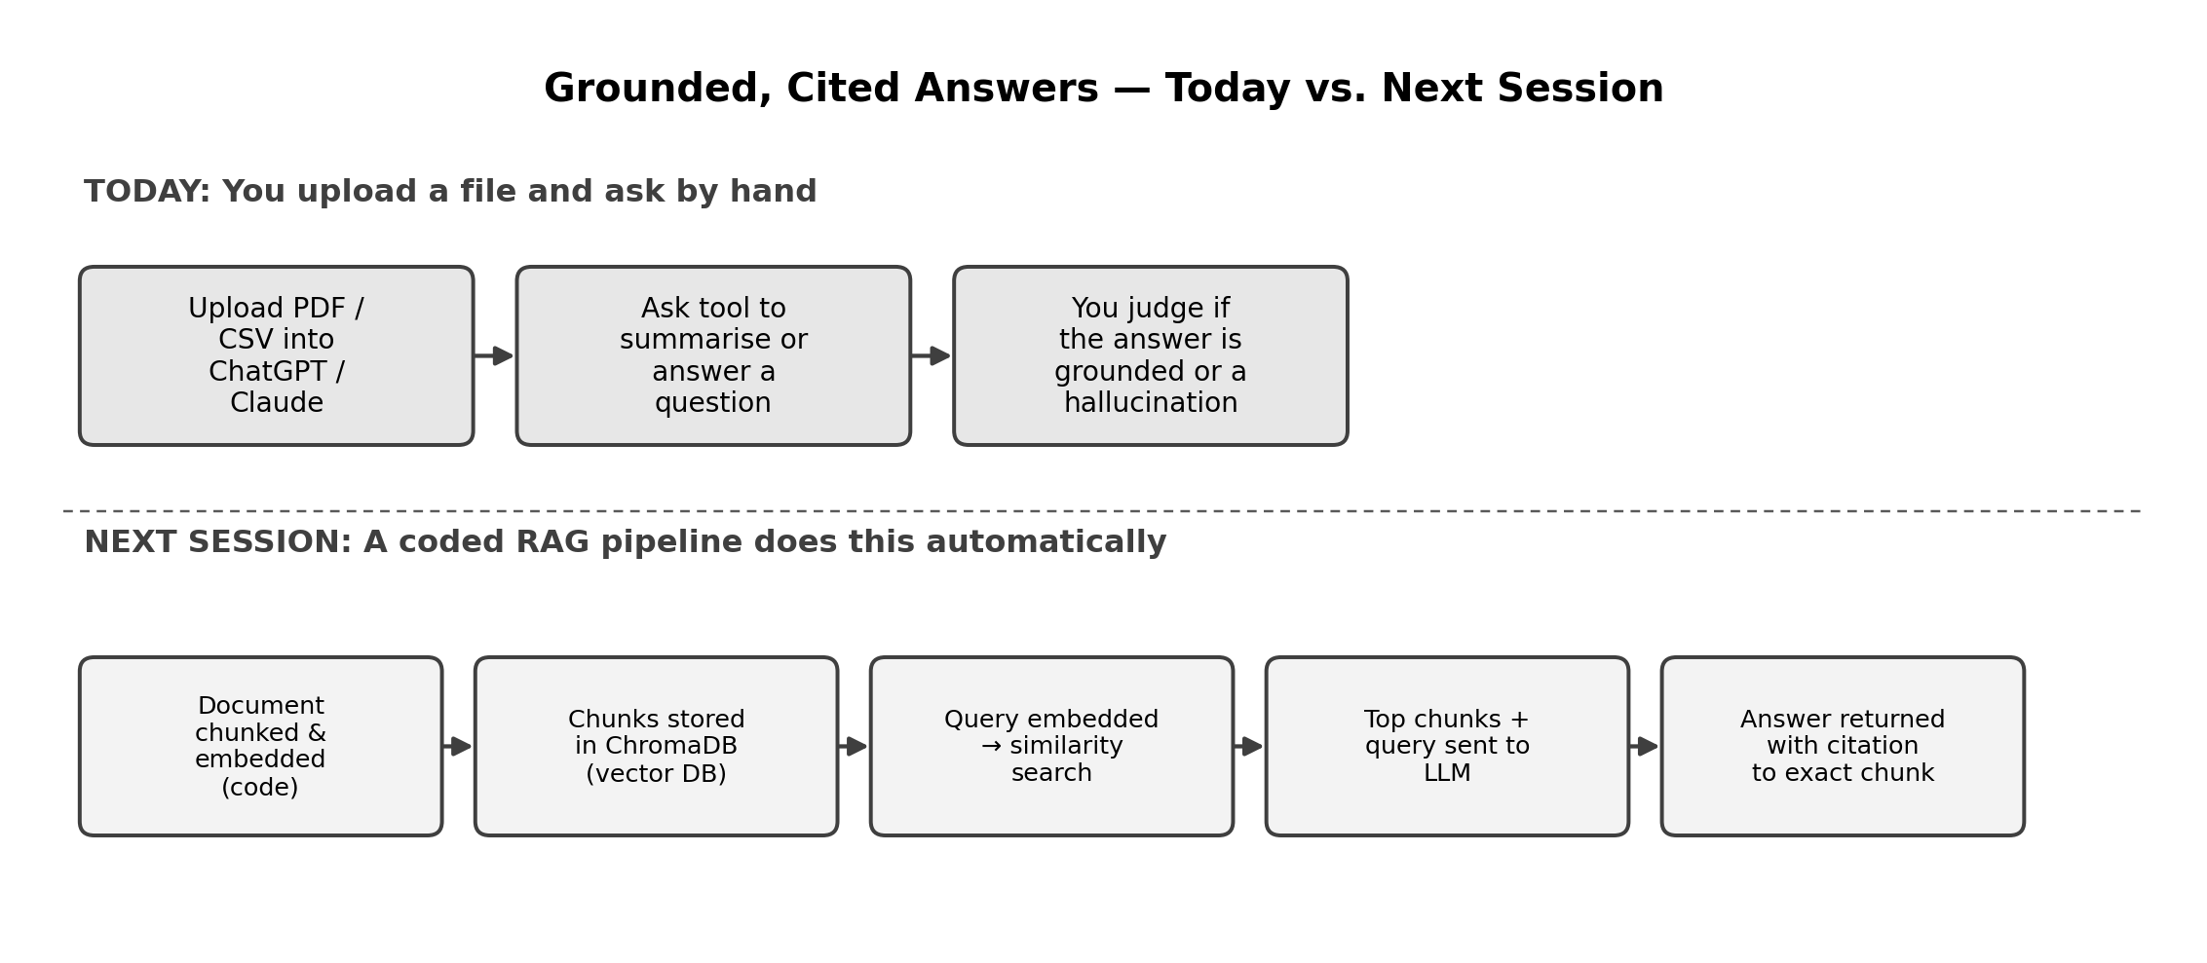

Reflection Space
Your notes

