PROMPT PRACTICE SHEET 4 OF 4 — DAY 1 WRAP-UP
Seeing Multi-Step Reasoning & Agent-Style Chains in Action
25 Hands-On Prompts | Use Cases 1, 6, 9 & 10 | No coding — GUI tools only
What's different about this sheet
So far you've run single prompts. Here, several prompts deliberately chain — the output of one becomes the input to the next, done entirely by hand. This is exactly what a multi-agent pipeline (Module 10) automates: a retrieval agent, an analyst agent, and a writer agent handing off to each other. Today you play all three roles yourself, one prompt at a time.

25 Prompts — Try Each One, Fill In What You Notice
# | Use Case | Prompt to run | What to notice
1 | UC9 | “Extract the key technical requirement from this RFP question in one sentence: Describe your approach to ensuring 99.9% uptime for a national telecom network.” | Step 1 of a manual chain — keep this output for #2.
2 | UC9 | “Using your one-sentence requirement from #1, draft a 100-word RFP response section using generic best practices, no invented facts.” | Step 2 — chaining #1's output as this prompt's input.
3 | UC9 | Now combine #1 and #2 into one single instruction and run it in one prompt. | Compare single-shot vs. two-step chained quality.
4 | UC10 | “You are a workforce skilling assistant. What are the prerequisites for a Nokia CloudBand Engineer certification? Answer honestly if you don't have this specific information.” | Refusal vs. fabrication under pressure for a very specific fact.
5 | UC10 | “Imagine you have access to an internal NCS training catalogue. Answer the same question, but tell me clearly if you're inventing any detail.” | Watch for confidently fabricated specifics, even inside a roleplay frame.
6 | UC1 | “From this alert — Core-MME-07, Signalling Storm, High severity, 3x baseline — extract just the technical symptom in one sentence.” | Step 1 — keep this output for #7.
7 | UC1 | “Using the symptom from #6, and knowing similar incidents were caused by misconfigured retry timers, draft a root-cause hypothesis and a fix.” | Step 2 — chaining domain knowledge across two prompts, like Use Case 1's real pipeline.
8 | UC1 | Ask for both #6 and #7 in one instruction, structured as ‘first do X, then do Y.’ | Single-prompt multi-step instructions vs. manual chaining.
9 | UC6 | “From this note — usage down 30% in 60 days, 2 unresolved tickets, renewal in 15 days — list the 3 distinct risk signals separately.” | Step 1 — keep this output for #10.
10 | UC6 | “Using the 3 risk signals from #9, synthesise them into one churn-risk paragraph with an overall risk level.” | This is exactly the analyst agent's job in a 3-agent pipeline (Module 10).
11 | UC9 | Draft an RFP section, then ask the same tool to review its own draft and flag any claim too specific to state without a source. | A self-review pattern — previews Use Case 9's actual ‘reviewer agent.’
12 | UC10 | Ask for #4's answer as strict JSON: {topic, known_prerequisites, confidence, needs_verification: true/false}. | Structured output ready for a downstream dashboard or system.
13 | UC1 | “Which of your two steps — symptom extraction or root-cause hypothesis — are you less confident about, and why?” | Per-step confidence — tells you where a human should check in an agent pipeline.
14 | UC9 | Act as a retrieval step: given a fictional RFP question, pick the most relevant of 2–3 short fictional past-proposal snippets you invent yourself. | Simulating a retrieval agent's job by hand.
15 | UC9 | Act as the writer step: using only the snippet chosen in #14, draft the RFP answer. | Simulating the hand-off from a retrieval agent to a writer agent.
16 | UC6 | “If the three risk signals from #9 conflicted with each other (usage down, but no complaints), how should the synthesis step handle that disagreement?” | Designing for conflicting evidence — a real multi-agent challenge.
17 | UC10 | “Design a 3-question quiz to check whether a learner understood today's practice Sheets 1–5.” | Using the tool to generate its own downstream teaching material.
18 | UC1 | Combine #6 and #7's logic into one well-formed prompt using the instruction + context + input + output-format formula from Sheet 6. | The full prompt formula applied to a 2-step reasoning task.
19 | UC9 | “In the RFP answer from #15, flag any single sentence that would need a human reviewer's sign-off before sending to a client.” | Identifying the human-in-the-loop checkpoint — Module 10's routing-layer idea.
20 | UC10 | “If a learner's question is outside what you actually know, what should you do instead of guessing?” | Refusal patterns from Sheet 8, applied here to workforce skilling.
21 | UC6 | Produce the synthesis from #10 twice: once as a paragraph, once as JSON {risk_level, evidence: [], recommended_action}. | Same reasoning, two output formats — check they actually agree with each other.
22 | UC9 | “If you had to hand this task to another AI assistant to double-check, what one instruction would you give it?” | This is literally what an orchestration layer does when routing between agents.
23 | UC1 | “Produce a two-step reasoning trace as a numbered list, labelled Step 1 and Step 2, for the RCA task from #6–7.” | A visible reasoning trace — useful for audit (Sheet 8) and for agent design (Module 9).
24 | UC10 | “Explain in one paragraph why a workforce-skilling assistant should flag out-of-date content rather than serve it.” | Ties back directly to the RAG lesson from Sheet 7.
25 | — | Pick one use case and describe the full journey: a well-formed prompt → grounded in real data → a guardrail added → chained reasoning steps. | This is exactly what Modules 4–10 will help you build in code — write your answer below.

Today vs. Next Session
Today, you manually played the role of every agent in the chain — copying outputs from one prompt into the next. Here's what an orchestration layer automates:

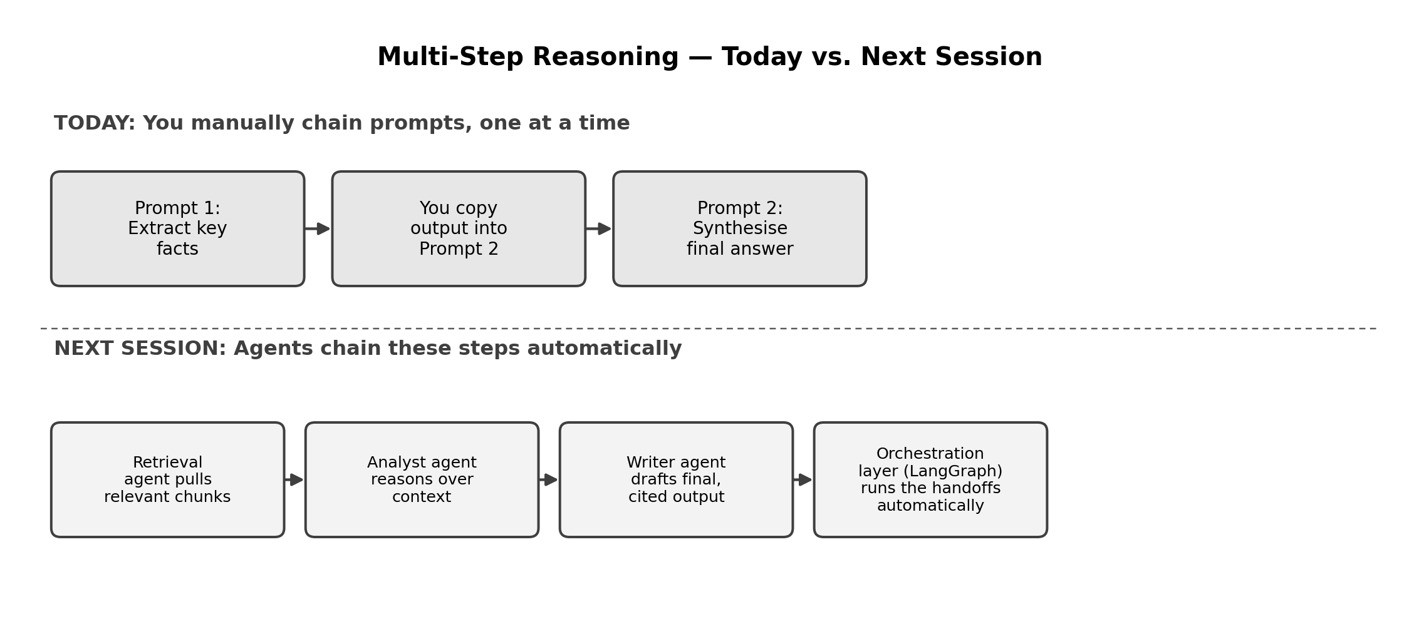

Reflection Space
Your notes

Day 1, Complete
Across nine sheets today, you've moved from “what is GenAI” to manually reasoning through retrieval, grounding, guardrails, and multi-step chains — entirely through GUI tools, with zero code. Every concept you touched by hand today — tokens, chunking, embeddings, RAG, guardrails, agent hand-offs — has a direct, named counterpart waiting in Modules 3 through 10. Next session: VS Code, and building the first of these pipelines for real.

