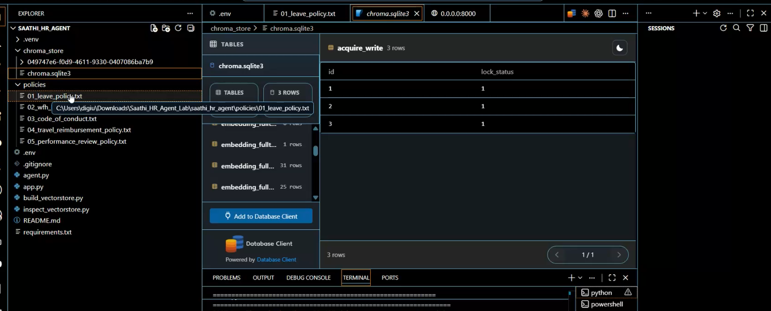
Project link: https://github.com/digibhatia/simple-rag-agent

