DAY 3 — PRACTICE SHEET 1 OF 4
LLM API Anatomy, Parameters & Chat Patterns
Module 3: LLM APIs, Structured Outputs & Tool Use | Hour 1 of 4 | VS Code + Python | 25 Prompts
Before you start
Day 2 gave you SYSTEM_PROMPT and USER_PROMPT as two strings. Today you'll see what's really happening underneath: a growing list of role-tagged messages, and a set of parameters that shape exactly how the model generates its reply. Bring your call_model.py from Day 2, Sheet 2 (with the enterprise SYSTEM_PROMPT) — you'll extend it.

A. Message Roles — What's Actually Being Sent
Every call to a chat model sends a list of messages, each tagged with a role. Sheet 1 (Day 2) only used two: system and user. Multi-turn conversations add a third: assistant, which is the model's own previous reply, sent back so it remembers what it said.
messages = [
{"role": "system", "content": SYSTEM_PROMPT},
{"role": "user", "content": "What is the guaranteed uptime in our SLA?"},
{"role": "assistant", "content": "99.5% monthly, per Clause 4."},
{"role": "user", "content": "And what's the penalty if we miss it?"},
]
# The ENTIRE list is sent again on every call — the model has no memory
# of its own between calls. Your code is what remembers.

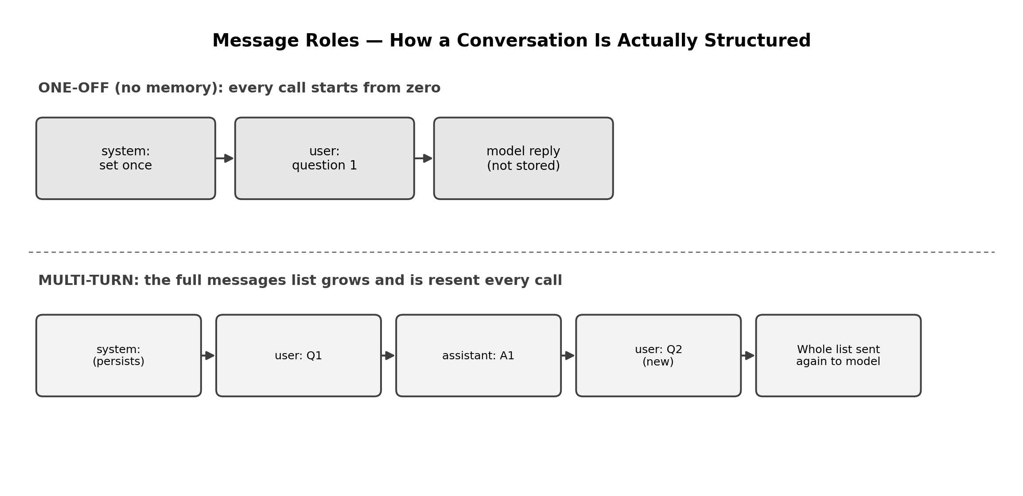

B. Chat Completion Patterns — A Reusable Conversation Class
Rather than manually growing a list every time, wrap it in a small class. This is the pattern behind Use Case 2's stateful customer care agent.
class Conversation:
def __init__(self, system_prompt):
self.messages = [{"role": "system", "content": system_prompt}]

def ask(self, user_text, **params):
self.messages.append({"role": "user", "content": user_text})
response = client.chat.completions.create(
model=MODEL, messages=self.messages, **params
)
reply = response.choices[0].message.content
self.messages.append({"role": "assistant", "content": reply})
return reply

convo = Conversation(SYSTEM_PROMPT)
print(convo.ask("What is the guaranteed uptime?"))
print(convo.ask("And the penalty if we miss it?")) # remembers the first answer

C. Parameters That Shape the Response
Parameter | What it controls
temperature | Randomness. 0.0–0.3 = focused and repeatable. 0.7–1.0 = varied and creative.
max_tokens | Hard cap on how long the reply can be — the response is cut off, not summarised, once hit.
top_p | An alternative way to control randomness by probability mass; usually leave at 1.0 unless you're specifically tuning it.
stop | One or more strings that, if generated, immediately end the response.

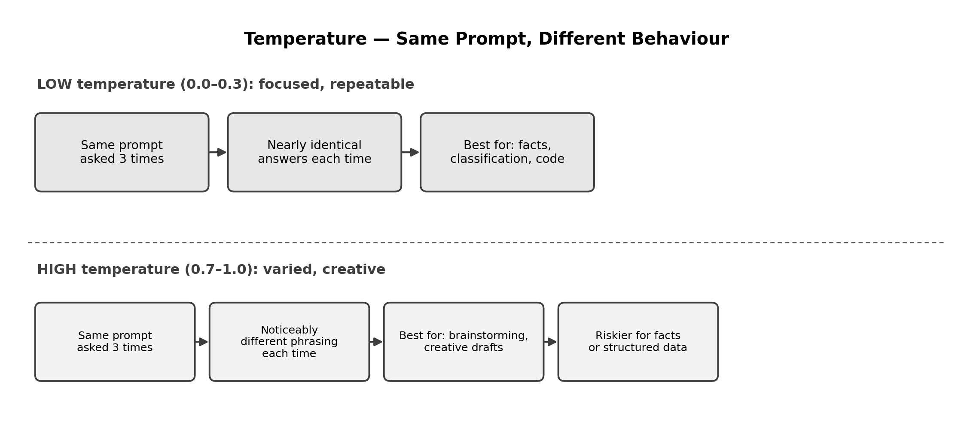

25 Prompts — Try Each One, Fill In What You Notice
# | Use Case | Parameter/Pattern | What to run | What to notice
1 | UC5 | Multi-turn memory | Start a Conversation, ask about guaranteed uptime, then ask ‘and the penalty?’ without repeating context. | Does the second answer correctly use context from the first?
2 | UC5 | No memory (control) | Ask the penalty question in a fresh call_model() call, with no history. | Compare to #1 — does it now fail to know what ‘it’ refers to?
3 | UC1 | temperature=0.0 | Ask an RCA question 3 times with temperature=0.0. | Are the 3 answers nearly identical?
4 | UC1 | temperature=0.9 | Ask the same RCA question 3 times with temperature=0.9. | Compare variation to #3.
5 | UC9 | temperature=0.9 | Draft an RFP sentence with temperature=0.9, three times. | Higher variation may be desirable here — why?
6 | UC4 | temperature=0.0 | Classify a billing dispute with temperature=0.0, three times. | Confirm classification tasks want LOW variation, not high.
7 | UC8 | max_tokens=20 | Ask for a full shift-handover summary but cap max_tokens=20. | Watch the response get cut off mid-sentence, not neatly shortened.
8 | UC8 | max_tokens=200 | Re-run #7 with max_tokens=200. | Compare completeness to #7.
9 | UC3 | stop sequence | Ask to explain EIRP, with stop=[‘.’] (stops at first period). | The reply should cut off after just one sentence.
10 | UC2 | Multi-turn | Conversation: ask about a data pack issue, then ‘what plan am I on?’ (never stated). | Does it correctly say it doesn't know, rather than guessing?
11 | UC6 | temperature comparison | Assess churn risk at temperature=0.0 vs 0.9, same input, compare risk LEVEL specifically. | Does the categorical risk level itself change, or just the wording?
12 | UC1 | Multi-turn | Conversation: describe an alert, ask for causes, then ask ‘which of those is most likely and why?’ | Second answer should reference the specific causes from the first reply.
13 | UC7 | Multi-turn | Conversation: ask a compliance question, then ask an unrelated football question. | Does the system prompt's scope rule still hold mid-conversation?
14 | — | top_p | Ask any factual question with top_p=0.1 vs top_p=1.0 (temperature fixed at 0.7). | Subtler effect than temperature — note if you can detect a difference at all.
15 | UC5 | Multi-turn, 4 turns | Conversation: uptime -> penalty -> exclusions -> ‘summarise everything we discussed.’ | Check the final summary correctly references all 3 prior answers.
16 | UC9 | max_tokens | Draft a 100-word RFP section with max_tokens set deliberately too low (e.g. 40). | Real-world lesson: max_tokens must match your actual content need.
17 | UC4 | stop sequence | Ask for a JSON classification with stop=[‘}’] included. | Does cutting off at the closing brace break the JSON, or land perfectly?
18 | — | Role order test | Manually build a messages list with TWO system messages instead of one. | Does the model handle multiple system messages gracefully?
19 | UC2 | Long conversation | Have a 6-turn conversation, then ask the model to list everything the user has asked so far. | Check its own recall against your own notes of the conversation.
20 | UC1 | temperature=0.0 + max_tokens | Combine both: RCA question, temperature=0.0, max_tokens=60. | Two constraints working together — focused AND concise.
21 | UC6 | Multi-turn | Conversation: give 3 separate customer facts across 3 turns, then ask for an overall risk assessment on the 4th turn. | Tests whether it synthesises facts spread across multiple turns.
22 | — | Cost awareness | Print len(str(messages)) before and after a 5-turn conversation. | Watch the message history — and therefore token cost — grow with every turn.
23 | UC3 | temperature comparison | Explain EIRP at temperature=0.2 vs 1.0 — read both aloud. | Which one would you actually want in a field engineer's reference tool?
24 | UC8 | stop + max_tokens | Format an incident as one table row, with stop=[‘\n’] so it can't run past one line. | Useful pattern for enforcing strict single-line outputs.
25 | — | Reflection | In a comment, write which single parameter (temperature, max_tokens, or stop) you'll reach for most often, and why. | Wrap-up — write your answer in your code file.

D. Reflection Questions (5 minutes)
- 1. Why does Use Case 4 (Billing Dispute Classification) want temperature near 0, while Use Case 9 (RFP drafting) might tolerate higher temperature?
- 2. In #22, how quickly did the message history grow? What does that mean for a very long customer support conversation?
- 3. What real production risk does #7 (max_tokens cutting off mid-sentence) illustrate?

E. Quick Recap
- Every call sends the full messages list — system, then alternating user/assistant turns. The model has no memory of its own; your code maintains it.
- temperature controls randomness: low for facts and classification, higher for creative drafting.
- max_tokens hard-caps length by truncating, not summarising — size it to your actual content.
- stop sequences give you precise control over exactly where a response ends.
- Longer conversations cost more per turn, since the whole history is resent every time — a real design trade-off for long-running chat sessions.

