DAY 3 — PRACTICE SHEET 2 OF 4
Function Calling & the Document Metadata Extractor
Module 3: LLM APIs, Structured Outputs & Tool Use | Hour 2 of 4 | VS Code + Python | 25 Prompts
This hour builds the official design-doc lab
“Build a document metadata extractor using function calling — returns typed JSON with document type, topic, key entities, and effective date.” By the end of this hour you'll have a working extractor tested against Day 1's real starter documents.

A. Function Calling — What It Actually Is
Explain it like I'm 10: Day 2's JSON prompting asked the model nicely to reply in JSON — and it usually did, but nothing forced it to. Function calling is different: you describe a specific tool the model can use, with an exact list of fields it must fill in, and the model returns those fields in a guaranteed structure, ready for your code to use directly — no guessing, no free-form text to parse.

B. Defining a Tool Schema
A tool is a name, a description, and a strict schema for its parameters. This is the exact schema for the design-doc lab.
tools = [
{
"type": "function",
"function": {
"name": "extract_document_metadata",
"description": "Extract structured metadata from a policy or SOP document.",
"parameters": {
"type": "object",
"properties": {
"document_type": {
"type": "string",
"description": "e.g. SOP, SLA, Policy, Manual"
},
"topic": {"type": "string"},
"key_entities": {
"type": "array",
"items": {"type": "string"}
},
"effective_date": {
"type": "string",
"description": "YYYY-MM-DD if stated, else null"
},
},
"required": ["document_type", "topic", "key_entities", "effective_date"],
},
},
}
]

C. The Document Metadata Extractor — Full Lab
import json

def extract_metadata(document_text):
response = client.chat.completions.create(
model=MODEL,
messages=[
{"role": "system", "content": SYSTEM_PROMPT},
{"role": "user", "content": f"Extract metadata from this document:\n{document_text}"},
],
tools=tools,
tool_choice={"type": "function", "function": {"name": "extract_document_metadata"}},
)
tool_call = response.choices[0].message.tool_calls[0]
return json.loads(tool_call.function.arguments)

from chain import sop_text # reuse Day 2, Sheet 3's PDF loader and starter files
metadata = extract_metadata(sop_text)
print(metadata["document_type"], metadata["topic"], metadata["key_entities"], metadata["effective_date"])

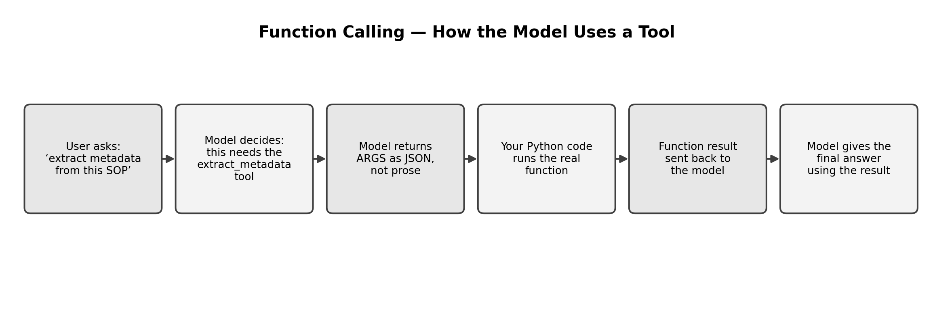

D. JSON Mode — A Simpler Alternative
When you don't need the model to call multiple different tools — just guarantee valid JSON — response_format is simpler than a full tool schema.
response = client.chat.completions.create(
model=MODEL,
messages=[
{"role": "system", "content": SYSTEM_PROMPT},
{"role": "user", "content": "Return JSON: {document_type, topic}. " + sop_text},
],
response_format={"type": "json_object"},
)
data = json.loads(response.choices[0].message.content)

25 Prompts — Try Each One, Fill In What You Notice
# | Use Case | Type | What to run | What to notice
1 | UC3 | Function call | extract_metadata(sop_text) | Check all 4 fields are present and correctly typed.
2 | UC5 | Function call | extract_metadata(sla_text) | Does document_type correctly say ‘SLA’ or ‘Contract’, not ‘SOP’?
3 | UC3 | Field check | Print type(metadata["key_entities"]) for #1's result. | Confirm it's an actual Python list, not a string that looks like one.
4 | — | Missing data | Run extract_metadata() on a short text with NO date mentioned at all. | Does effective_date come back as null / empty, not a fabricated date?
5 | UC3 | tool_choice='auto' | Change tool_choice to "auto" instead of forcing the function, then ask a normal question. | Does the model call the tool anyway, or answer in plain text since it wasn't forced?
6 | UC3 | JSON mode | Run the JSON-mode example for sop_text. | Compare reliability/simplicity to the full function-calling version.
7 | UC4 | New tool schema | Design a new tool classify_dispute(category, confidence, needs_escalation: bool). | Boolean fields work in schemas too — confirm it returns true/false correctly.
8 | UC4 | New tool, run it | Call your new classify_dispute tool on: 'charged twice for same recharge.' | Check needs_escalation makes sense for this specific case.
9 | UC1 | New tool schema | Design a tool log_incident(severity, network_element, needs_dispatch: bool). | Practice designing a schema from scratch for a new use case.
10 | UC1 | New tool, run it | Call log_incident on: 'eNodeB-4471-Pune Cell Down, 0 throughput.' | Verify severity comes back as one of a sensible fixed set of values.
11 | UC3 | Enum constraint | Add "enum": ["SOP", "SLA", "Policy", "Manual"] to document_type in the schema, then re-run #1. | Does constraining the allowed values improve consistency?
12 | UC5 | Enum constraint | Re-run #2 with the same enum constraint added. | Confirm sla_text now reliably returns ‘SLA’, not a synonym.
13 | — | Multiple tools | Give the model BOTH extract_metadata and classify_dispute as available tools for a document-metadata question. | Does it pick the correct tool on its own with tool_choice='auto'?
14 | UC8 | New tool schema | Design a tool format_handover(open_incidents: array, resolved_incidents: array, priority_action: string). | Nested array fields in a schema.
15 | UC8 | New tool, run it | Call format_handover on 2–3 incidents you invent. | Check both arrays are populated correctly, not merged into one.
16 | — | Error case | Deliberately remove "required" from the schema and run extract_metadata on a very short text. | Does the model skip fields it's unsure about when they're not required?
17 | UC3 | Function call | extract_metadata() on a mixed document: paste both sop_text and sla_text together. | How does it handle a document that's really two documents in one?
18 | UC6 | New tool schema | Design a tool assess_churn(risk_level, evidence: array, recommended_action). | Reuse the JSON pattern from Day 2, Sheet 3, now as a proper tool.
19 | UC6 | New tool, run it | Call assess_churn on: usage down 30%, 2 tickets, renewal in 15 days. | Compare reliability to the plain-JSON version from Day 2.
20 | — | JSON mode limitation | Try JSON mode WITHOUT the word 'JSON' anywhere in your prompt. | Many APIs require the word 'JSON' in the prompt for json_object mode — does it error?
21 | UC9 | New tool schema | Design a tool draft_rfp_section(requirement, response_text, confidence). | A tool schema for a drafting task, not just extraction.
22 | UC3 | Consistency check | Run extract_metadata(sop_text) three times. | Compare all 3 results field by field — fully consistent, or minor drift?
23 | — | Cost awareness | Compare response.usage.total_tokens for the function-call version (#1) vs the JSON-mode version (#6). | Which approach costs more tokens for the same task, and why?
24 | UC5 | Real extraction, both docs | Run extract_metadata on both sop_text and sla_text, print side by side. | Two real documents, two real structured results — the actual lab deliverable.
25 | — | Reflection | In a comment, note one NCS deliverable where a strict tool schema matters more than a loose JSON request. | Wrap-up — write your answer in code.

E. Reflection Questions (5 minutes)
- 1. Why does forcing tool_choice to a specific function guarantee structure in a way that asking nicely for JSON does not?
- 2. What did the enum constraint (#11–12) change about reliability, and why might you always want one for a fixed category field?
- 3. In #23, which approach cost more tokens — and does that change your answer for a very high-volume production pipeline?

F. Quick Recap
- Function calling guarantees structure by design — the model must fill in the exact fields you defined, not just try to follow instructions.
- JSON mode is simpler for single-purpose structured replies; function calling is better when the model must choose between multiple possible tools, or you need strict typing and enums.
- Enum constraints on fields like document_type dramatically improve consistency over free-text fields.
- You've now built the actual design-doc lab: a working document metadata extractor tested on both of Day 1's real starter documents.

