DAY 3 — PRACTICE SHEET 3 OF 4
Streaming Responses & the Real-Time Chatbot Handler
Module 3: LLM APIs, Structured Outputs & Tool Use | Hour 3 of 4 | VS Code + FastAPI | 25 Prompts
This hour builds the official design-doc lab
“Build a streaming response handler that delivers real-time answers to the chatbot UI.” You'll first stream to your own terminal, then wrap the same logic in a small FastAPI service — the actual backend pattern behind a live chat UI.

A. Streaming Basics
A normal call waits for the entire reply before returning anything. A streaming call returns the reply piece by piece, as the model generates it — exactly what makes ChatGPT-style interfaces feel instant.
def stream_response(user_prompt):
stream = client.chat.completions.create(
model=MODEL,
messages=[
{"role": "system", "content": SYSTEM_PROMPT},
{"role": "user", "content": user_prompt},
],
stream=True,
)
for chunk in stream:
delta = chunk.choices[0].delta.content
if delta:
print(delta, end="", flush=True)
print()

stream_response("Explain EIRP to a new field engineer.")

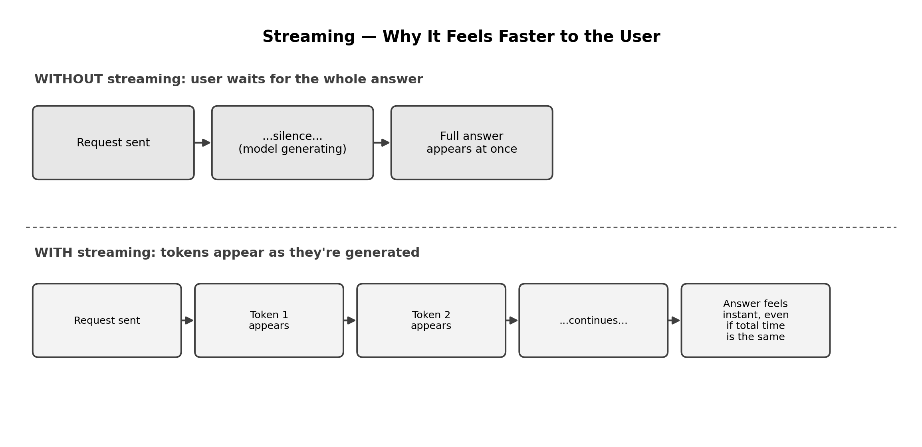

B. Wrapping It in FastAPI — the Real Chatbot Backend
pip install fastapi uvicorn
from fastapi import FastAPI
from fastapi.responses import StreamingResponse

app = FastAPI()

def generate_stream(user_prompt):
stream = client.chat.completions.create(
model=MODEL,
messages=[
{"role": "system", "content": SYSTEM_PROMPT},
{"role": "user", "content": user_prompt},
],
stream=True,
)
for chunk in stream:
delta = chunk.choices[0].delta.content
if delta:
yield delta

@app.get("/chat")
def chat(q: str):
return StreamingResponse(generate_stream(q), media_type="text/plain")

# Run with: uvicorn main:app --reload --port 8000

Test it from a second terminal while the server is running:
curl "http://localhost:8000/chat?q=Explain+EIRP+to+a+field+engineer"
Watch the terminal — curl prints the response as it streams in, the same way a browser would.

25 Prompts — Try Each One, Fill In What You Notice
# | Use Case | Type | What to run | What to notice
1 | UC3 | Stream, terminal | stream_response(‘Explain EIRP to a field engineer.’) | Watch text appear word by word rather than all at once.
2 | UC1 | Stream, terminal | stream_response(‘List 3 causes for a cell-down alert.’) | Time roughly how long until the FIRST word appears vs. the LAST.
3 | — | Compare | Run the same prompt as #2 through the non-streaming call_model() instead. | Total time may be similar, but perceived wait is very different.
4 | — | FastAPI | Start the server, then curl /chat?q=hello | Confirm the basic endpoint works before testing real content.
5 | UC2 | FastAPI | curl “http://localhost:8000/chat?q=Why+did+my+data+run+out+early” | This is literally what a chatbot UI's backend call looks like.
6 | UC8 | FastAPI | curl the endpoint with a shift-handover summary question. | Check streamed output stays coherent when reconstructed end-to-end.
7 | — | Chunk inspection | Modify stream_response to print each raw chunk object (not just delta.content) for the first 3 chunks. | See the raw structure — delta.content is often None for the very first chunk.
8 | UC6 | Stream, terminal | Stream a churn-risk assessment. | Structured output (like risk levels) streamed word-by-word — still readable?
9 | — | Buffering test | Collect all streamed chunks into a single string as they arrive, print the final joined result. | This is how you'd save the full reply after streaming it live.
10 | UC5 | FastAPI | Add a second endpoint /chat-sla that always prepends SLA context to the user's question. | Practice building a second, more specific streaming endpoint.
11 | — | Latency measurement | Time from request start to the FIRST chunk, separately from total time. | This 'time to first token' number is what users actually feel.
12 | UC9 | Stream, terminal | Stream a 100-word RFP draft. | Longer outputs make the streaming benefit more obvious.
13 | — | Error handling | Call the /chat endpoint with an empty q= value. | What happens? Does it error cleanly or crash the server?
14 | UC1 | Stream + temperature | Stream an RCA answer with temperature=0.0 vs 0.9. | Combine Sheet 1's parameter knowledge with streaming.
15 | — | FastAPI docs | Visit http://localhost:8000/docs in a browser while the server runs. | FastAPI auto-generates interactive API documentation — try a request from there.
16 | UC4 | FastAPI | curl the endpoint asking it to classify a billing dispute. | Streaming a short, structured-sounding answer still works, but is it the best use case for streaming?
17 | — | Stream cancellation (concept) | Discuss: what should happen if the browser user navigates away mid-stream? | A real production concern — note it, even without implementing cancellation today.
18 | UC7 | Stream, terminal | Stream an answer that should REFUSE (ask for a compliance officer's phone number). | Confirm refusal behaviour survives streaming, not just non-streaming calls.
19 | — | Multiple clients | Open 2 terminal windows and curl the endpoint at the same time. | Does FastAPI handle both requests, or does one block the other?
20 | UC3 | FastAPI + chain | Adapt generate_stream to accept a document_text parameter and ground the answer in it. | Combine Day 2's grounding pattern with today's streaming.
21 | — | Token counting mid-stream | Count how many chunks arrive for a ~50-word vs ~150-word answer. | Rough proxy for token count — more chunks for longer answers.
22 | UC2 | FastAPI | Add a query parameter for temperature to the /chat endpoint (e.g. ?q=...&temperature=0.2). | Make your endpoint configurable, not hardcoded.
23 | — | Non-streaming fallback | Add a second endpoint /chat-sync that returns the full answer at once, no streaming. | Compare code complexity and response shape to the streaming version.
24 | UC8 | Stream, terminal | Stream a full multi-incident handover summary and time total duration. | Longer, more complex answers benefit most from streaming's perceived speed.
25 | — | Reflection | In a comment, note one NCS deliverable where streaming clearly helps, and one where it probably doesn't matter. | Wrap-up — write your answer in code.

C. Reflection Questions (5 minutes)
- 1. In #2 vs #3, was the TOTAL time actually different, or just how it felt? Why does that distinction matter for UX design?
- 2. What did #13 (empty query) teach you about error handling in a streaming endpoint specifically?
- 3. For which of the 10 NCS Telco+ use cases would streaming matter least, and why?

D. Quick Recap
- stream=True turns a single blocking call into a sequence of chunks, arriving as the model generates them.
- StreamingResponse in FastAPI turns a Python generator directly into a live HTTP stream — the same pattern a chatbot UI's backend actually uses.
- Streaming improves perceived speed (time to first token), even when total generation time is unchanged.
- You've now built the actual design-doc lab: a real-time streaming response handler, tested from both the terminal and a live FastAPI endpoint.

