DAY 3 — PRACTICE SHEET 4 OF 4
Error Handling, Cost Tracking & the Decision Framework
Module 3: LLM APIs, Structured Outputs & Tool Use | Hour 4 of 4 | VS Code + Python | 25 Prompts
Before you start
This closes Module 3: making every pipeline from Day 2 and today production-hardened — resilient to failures, aware of its own cost, and backed by a clear framework for when to prompt, retrieve, or fine-tune.

A. Error Handling and Retries
API calls fail sometimes — rate limits, timeouts, transient errors. A production system retries automatically, waiting a little longer each time (exponential backoff), instead of crashing on the first failure.
import time
from openai import RateLimitError, APIError

def call_model_with_retry(system_prompt, user_prompt, max_retries=4):
for attempt in range(max_retries):
try:
return call_model(system_prompt, user_prompt)
except RateLimitError:
wait = 2 ** attempt
print(f"Rate limited. Waiting {wait}s (attempt {attempt + 1}/{max_retries})...")
time.sleep(wait)
except APIError as e:
wait = 2 ** attempt
print(f"API error: {e}. Waiting {wait}s...")
time.sleep(wait)
raise RuntimeError("Max retries exceeded — giving up.")

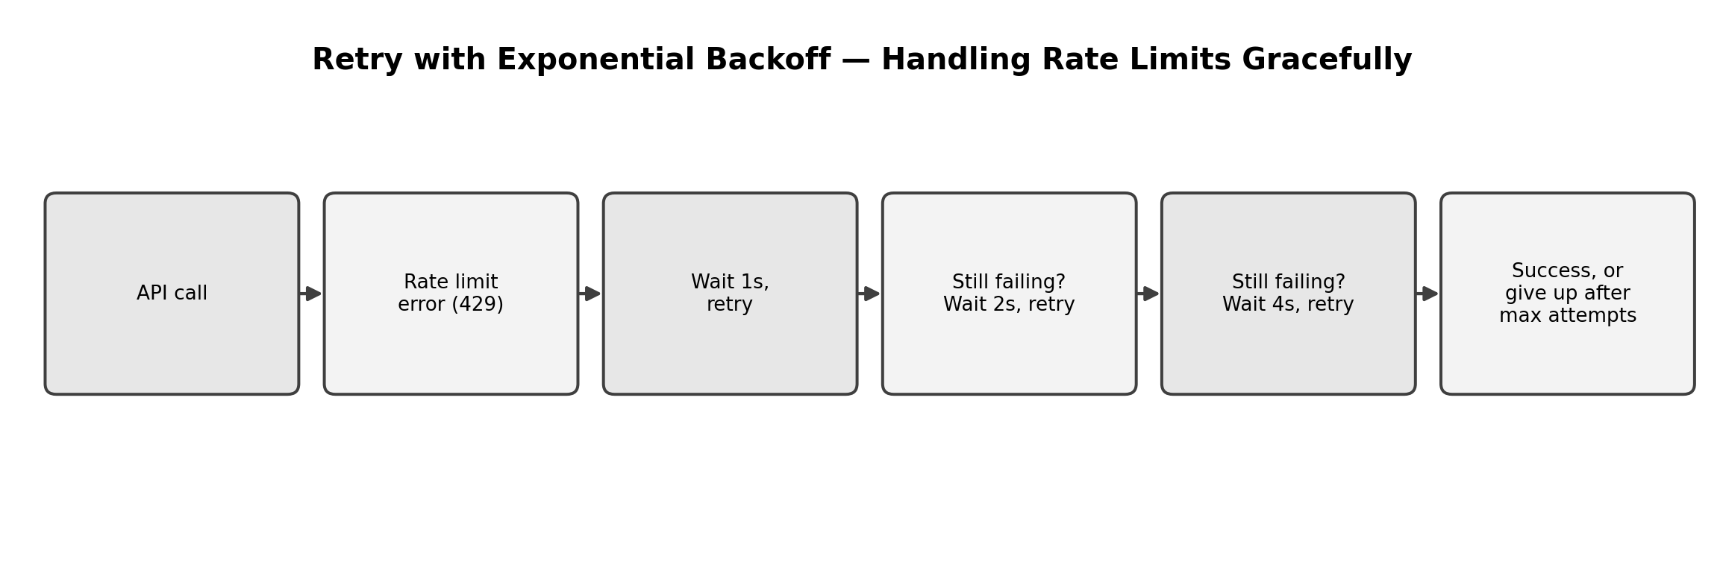

B. Token Counting and Cost Tracking
Every response includes a usage field with exact token counts — no guessing needed.
PRICE_PER_MILLION_INPUT = 0.15 # substitute your model's real published pricing
PRICE_PER_MILLION_OUTPUT = 0.60

def call_model_tracked(system_prompt, user_prompt):
response = client.chat.completions.create(
model=MODEL,
messages=[
{"role": "system", "content": system_prompt},
{"role": "user", "content": user_prompt},
],
)
usage = response.usage
cost = (
(usage.prompt_tokens / 1_000_000) * PRICE_PER_MILLION_INPUT +
(usage.completion_tokens / 1_000_000) * PRICE_PER_MILLION_OUTPUT
)
print(f"Tokens: {usage.prompt_tokens} in / {usage.completion_tokens} out " +
f"| Est. cost: ${cost:.5f}")
return response.choices[0].message.content, cost

C. Budget Guardrails
A simple running tracker that stops the pipeline before it overspends — a coded version of the cost-conscious mindset from Day 1.
class BudgetTracker:
def __init__(self, daily_limit_usd=5.00):
self.daily_limit = daily_limit_usd
self.spent = 0.0

def record(self, cost):
self.spent += cost
if self.spent > self.daily_limit:
raise RuntimeError(f"Budget exceeded: ${self.spent:.2f} > ${self.daily_limit:.2f}")
print(f"Running spend: ${self.spent:.4f} / ${self.daily_limit:.2f}")

budget = BudgetTracker(daily_limit_usd=5.00)
reply, cost = call_model_tracked(SYSTEM_PROMPT, "Explain EIRP.")
budget.record(cost)

D. When to Prompt, Retrieve, or Fine-Tune
A quick, codeable version of the decision framework from Day 1's foundations — useful as a first-pass check before committing engineering time.
def decide_approach(needs_external_facts, facts_change_often, is_stable_style_task):
if not needs_external_facts:
return "PROMPT"
if facts_change_often:
return "RETRIEVE (RAG)"
if is_stable_style_task:
return "FINE-TUNE"
return "RETRIEVE (RAG)" # default safe choice when unsure

print(decide_approach(needs_external_facts=True, facts_change_often=True, is_stable_style_task=False))

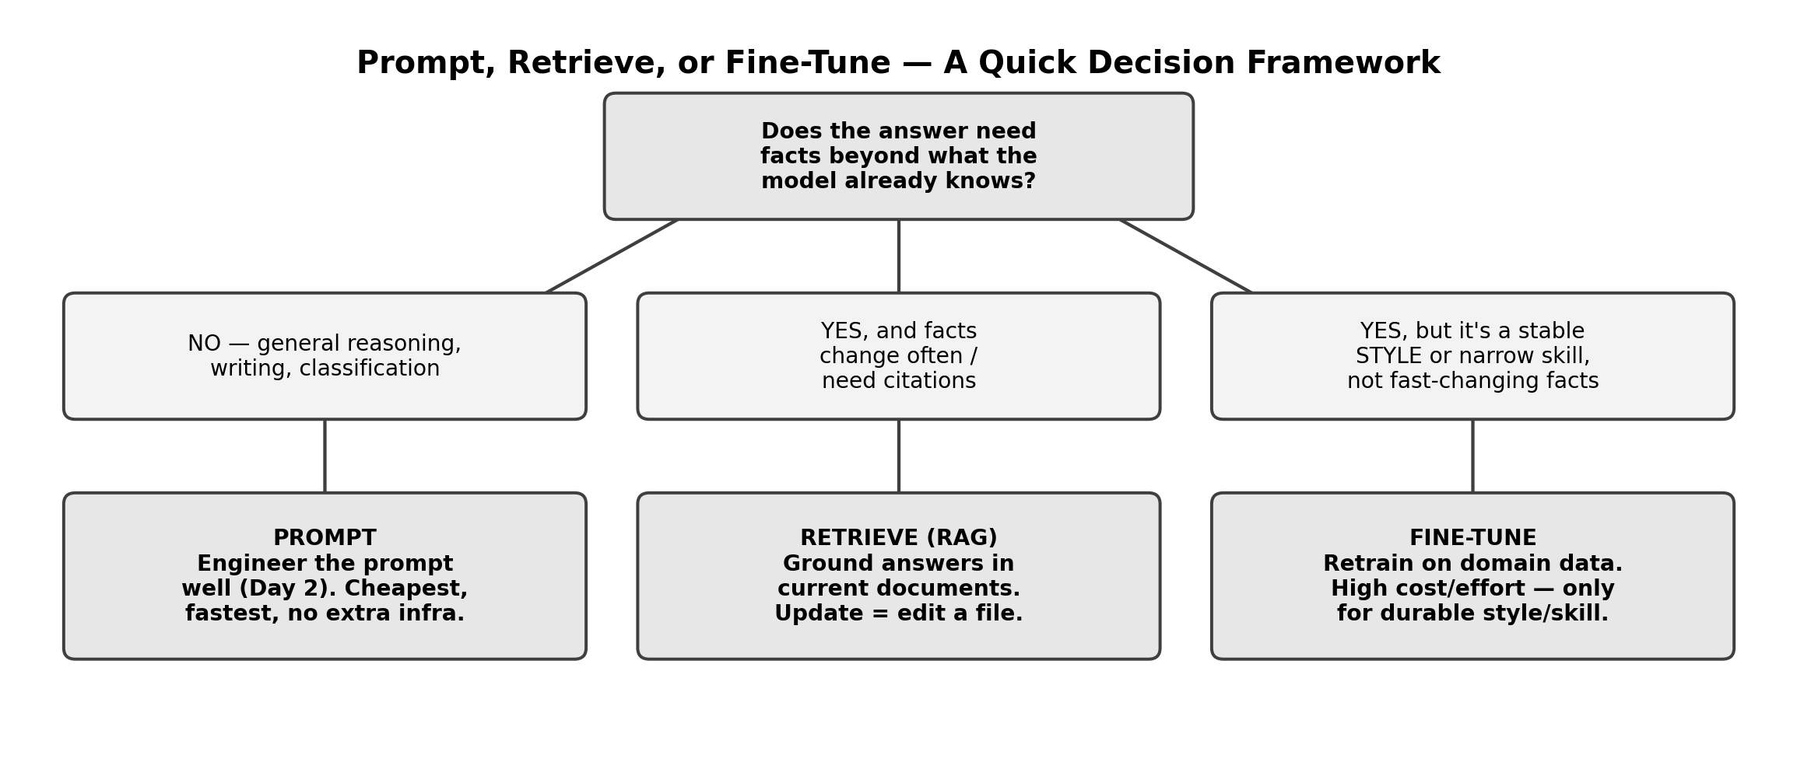

25 Prompts — Try Each One, Fill In What You Notice
# | Use Case | Type | What to run | What to notice
1 | — | Cost tracking | call_model_tracked(SYSTEM_PROMPT, ‘Explain EIRP.’) | Note the exact token counts and estimated cost.
2 | UC1 | Cost tracking | Track cost for a full RCA answer vs. a 1-sentence RCA answer. | Compare cost difference — output length drives cost more than input here.
3 | — | Budget guardrail | Call budget.record() 3 times with small costs, then check budget.spent. | Confirm the running total accumulates correctly.
4 | — | Budget guardrail trip | Set daily_limit_usd=0.001 and try to record a normal-sized cost. | Confirm RuntimeError fires — the guardrail actually stops overspend.
5 | UC9 | Retry logic (simulated) | Temporarily rename MODEL to an invalid string and call call_model_with_retry(). | Watch it retry, then eventually give up cleanly with a clear error.
6 | — | Decision framework | decide_approach(True, True, False) — for Use Case 5 (SLA Q&A). | Should return RETRIEVE — confirm it matches your own reasoning.
7 | — | Decision framework | decide_approach(False, False, False) — for a general writing task. | Should return PROMPT.
8 | — | Decision framework | decide_approach(True, False, True) — for a durable telecom-writing style task. | Should return FINE-TUNE — discuss whether you agree.
9 | UC10 | Decision framework | Apply the framework to Use Case 10 (Workforce Skilling Q&A) yourself, by hand first, then in code. | Does your own judgement match the coded framework's output?
10 | UC7 | Cost tracking | Track cost for a compliance-monitoring style question with a long document pasted in. | Watch input tokens dominate cost when documents are large.
11 | — | Retry + cost combined | Wrap call_model_tracked in the same retry pattern as call_model_with_retry. | Combine two production patterns into one robust function.
12 | UC4 | Budget guardrail | Simulate running 20 billing-dispute classifications and tracking total cost. | Extrapolate: what would 20,000 real tickets cost per month?
13 | — | Error handling | Deliberately pass an invalid API key (temporarily) and call call_model(). | What exception is raised? Is it caught by your retry logic, or should it NOT be retried?
14 | UC6 | Decision framework | decide_approach() for churn-risk scoring — facts change per customer, hourly. | Confirm this lands on RETRIEVE, not FINE-TUNE.
15 | — | Cost comparison | Compare estimated cost for gpt-5.4-nano vs. your current MODEL for the same prompt (check current pricing). | Real trade-off: cheaper model vs. accuracy, from Day 1 Sheet 4.
16 | UC3 | Cost tracking | Track cost for extract_metadata() (function calling) vs. a plain prompt asking the same question. | Does structured tool calling cost meaningfully more or less?
17 | — | Retry backoff timing | Print the wait time for each attempt in call_model_with_retry (1s, 2s, 4s, 8s). | Confirm backoff actually doubles each time, not staying constant.
18 | UC8 | Budget guardrail | Track cumulative cost across 3 shift-handover summaries in one budget tracker instance. | One shared tracker across multiple pipeline calls, not reset each time.
19 | — | Decision framework edge case | decide_approach(True, True, True) — facts change AND it's a stable style task. | Which wins? Check the function's actual priority order in the code.
20 | UC2 | Cost tracking | Track cost across a 5-turn customer care conversation (Sheet 1's Conversation class). | Confirm cost grows each turn as the full history is resent.
21 | — | Max retries reached | Set max_retries=1 and force a failure — confirm the RuntimeError message is clear. | A clear failure message matters as much as the retry logic itself.
22 | UC5 | Decision framework | Apply the framework to whether NCS should fine-tune a model specifically on SLA language. | Discuss: is this a stable style task, or does it need RAG's current-fact grounding instead?
23 | — | Full pipeline | Combine retry + cost tracking + budget guardrail into ONE function, call it on any Day 2 prompt. | This is what a production-ready call actually looks like.
24 | — | Monthly cost estimate | Given today's per-call cost, estimate monthly cost for 500 calls/day. | Turns today's per-prompt numbers into a real budget conversation.
25 | — | Reflection | In a comment, write which of today's 4 patterns (retry, cost tracking, budget guardrail, decision framework) you'd implement FIRST in a real project, and why. | Wrap-up for Module 3 — write your answer in code.

E. Reflection Questions (5 minutes)
- 1. In #13, why is it dangerous to retry EVERY kind of error automatically? Which errors should NOT be retried?
- 2. In #24, does the monthly estimate change your view on which model tier (Day 1, Sheet 4) is worth using for a given use case?
- 3. Where did the decision framework (#19) surprise you, if anywhere?

F. Quick Recap — and Module 3, Complete
- Retries with exponential backoff make a pipeline resilient to transient failures — but not every error should be retried blindly.
- response.usage gives exact token counts every time — turn that into real cost tracking, not guesswork.
- A budget guardrail turns cost awareness into an enforced limit, not just a dashboard number.
- The prompt/retrieve/fine-tune decision framework gives a fast first-pass answer — but the underlying judgement from Day 1 and Day 2 is what actually validates it.
- Module 3 complete: you now have API anatomy, function calling, streaming, and production hardening — the full toolkit before Module 4 opens the real RAG build with embeddings and ChromaDB.

