Delivery Delay Prediction Analysis
Analytics & Machine Learning Project Report
(Logistics & Supply Chain Domain)

Name : Tanisha Yadav

Domain | Logistics & Supply Chain Management
Dataset | Delivery_Logistics.csv (25,000 records)
Algorithm | Random Forest Classifier (n_estimators=300)
Target | Delay_Flag (0 = On-Time, 1 = Delayed)

Table of Contents
- Executive Summary
- Problem Statement & Business Context
- Dataset Overview & Schema
- Tier 1 — Data Hygiene & Architecture
- Tier 2 — Exploratory Data Analysis
- Tier 3 — Predictive Modelling
- Tier 4 — Prescriptive Strategies
- Model Performance Summary
- Business Recommendations
- Technical Architecture & File Deliverables
- Limitations & Future Work
- Appendix — Leakage Prevention Policy

1. Executive Summary
This report documents a complete, production-ready Data Analytics and Machine Learning project applied to a 25,000-record delivery logistics dataset using the 4-Tier Analytics Ladder methodology. The project spans descriptive analysis (what happened), diagnostic analysis (why it happened), predictive modelling (what will happen), and prescriptive strategy (what should be done).
The dataset reveals an overall delivery delay rate of 26.68%, encompassing 6,669 delayed out of 25,000 total shipments. A Random Forest classifier was trained to predict delay probability at the shipment level, achieving a ROC-AUC of 0.9668 and Recall of 96.7% — meaning the model correctly identifies 96.7% of all genuine delay events before they occur. This enables proactive SLA protection, resource-constrained dispatch optimisation, and targeted partner performance interventions.
KPI | Value | KPI | Value
Total Records | 25,000 | Model Accuracy | 88.5%
Delay Rate | 26.68% | Model Precision | 70.8%
Delayed Shipments | 6,669 | Model Recall | 96.7%
Avg Delivery Cost | ₹865 | F1-Score | 81.8%
Avg Distance (km) | 150.4 km | ROC-AUC | 0.9668
Avg Customer Rating | 3.67/5 | 5-Fold CV AUC | 0.9667 ± 0.0017

2. Problem Statement & Business Context

2.1 The Business Problem
Delivery delays represent one of the most significant operational and customer-experience challenges in last-mile logistics. Each undetected delay leads to SLA breaches, customer refund requests, brand erosion, and costly reactive recovery operations. In a competitive logistics landscape where customers compare experiences across multiple providers, a 26.68% delay rate is operationally unacceptable without a systematic mitigation framework.

2.2 Business Questions Addressed
- Which delivery partners, vehicle types, and regions produce the highest delay rates?
- How do weather conditions and delivery modes influence delay probability?
- Can we predict whether a given shipment will be delayed before it departs?
- What operational interventions can pre-empt delays, especially under resource constraints?
- How should we prioritise high-risk shipments when full dispatch capacity is unavailable?

2.3 Commercial Trade-off: False Positives vs. False Negatives
In the delivery logistics context, the two types of model errors have asymmetric business costs:
Error Type | Logistics Impact | Cost Level
False Negative (FN) | Shipment predicted on-time but actually delayed. Unannounced SLA breach. Customer complaint, refund liability, churn risk, brand damage. Reactive recovery costs 3–5x proactive intervention. | VERY HIGH — Prioritise minimisation
False Positive (FP) | Shipment predicted delayed but actually on-time. Spurious expedite action, unnecessary customer alert, wasted partner capacity reallocation. Manageable overhead. | MODERATE — Acceptable trade-off
Conclusion: The model is deliberately tuned for HIGH RECALL (96.7%) to minimise False Negatives, accepting higher False Positives as the operationally safer trade-off.

3. Dataset Overview & Schema

3.1 Raw Dataset Properties
Source file: Delivery_Logistics.csv
Total records: 25,000
Total columns: 15 (raw) → 12 (after cleaning)

3.2 Column Schema
Column | Type | Description | ML Role
delivery_id | Float | Unique delivery identifier (re-assigned) | Excluded (identifier)
delivery_partner | Categorical | Logistics partner name (9 partners) | Feature
package_type | Categorical | Category of shipped package (9 types) | Feature
vehicle_type | Categorical | Vehicle used for delivery (6 types) | Feature
delivery_mode | Categorical | Service level: same day/express/two day/standard | Feature
region | Categorical | Delivery region (5 regions) | Feature
weather_condition | Categorical | Weather at time of delivery (6 conditions) | Feature
distance_km | Numeric | Route distance in kilometers (3.6–297.1 km) | Feature
package_weight_kg | Numeric | Weight of package (0.1–50+ kg) | Feature
delivery_time_hours | String | Actual delivery time — ALL ZERO (dropped) | Dropped (no variance)
expected_time_hours | String | Expected delivery time — ALL ZERO (dropped) | Dropped (no variance)
delayed | Binary | Whether shipment was delayed (yes/no) | Target source → Dropped
delivery_status | Categorical | Final status: delivered/delayed/failed | Dropped (target derivative)
delivery_rating | Integer | Post-delivery customer rating (1–5) | Excluded (post-event)
delivery_cost | Numeric | Cost of delivery in INR (₹95–₹1,633) | Feature
Delay_Flag | Binary | Engineered target: 1=delayed, 0=on-time | TARGET

4. Tier 1 — Data Hygiene & Architecture

4.1 Data Quality Audit Results
Quality Check | Finding | Action Taken
Missing Values | Zero null values across all 15 columns | No imputation required
Duplicate Records | delivery_id 250.99 and 24750.01 each appear 250 times | Sequential IDs reassigned (1–25,000)
Negative Values | No negative values in distance_km, weight, or cost | No correction required
Zero-Variance Columns | delivery_time_hours and expected_time_hours are all "00:00.0" | Both columns dropped
Data Type Normalisation | All string columns mixed case/whitespace | Lowercased and stripped
Target Engineering | Binary target "delayed" (yes/no) — needs numeric | Delay_Flag created: yes→1, no→0
Leakage Prevention | delayed, delivery_status encode post-delivery outcomes | Both dropped from feature set
Post-Event Feature | delivery_rating available only post-delivery | Excluded from ML features

4.2 Cleaned Dataset Summary Statistics
Metric | distance_km | package_weight_kg | delivery_cost
Count | 25,000 | 25,000 | 25,000
Mean | 150.39 | ~25.5 | ₹864.94
Std Dev | 86.41 | ~14.4 | ₹435.71
Min | 3.60 km | ~0.1 kg | ₹95.67
Max | 297.10 km | ~50 kg | ₹1,632.72

5. Tier 2 — Exploratory Data Analysis
The dataset contains 25,000 delivery records with an overall delay rate of 26.68% (6,669 delayed, 18,331 on-time). Five distinct visualisations were produced to investigate baseline trends, categorical distributions, and cohort behaviours.

5.1 Chart 1 — Partner & Vehicle Delay Performance
Delivery partner delay rates range from 24.80% (delhivery) to 28.27% (xpressbees). The narrow spread (3.47 percentage points) across 9 partners suggests systemic operational issues rather than purely partner-specific failures. Vehicle type delay rates are even tighter (26.1%–27.0%), indicating vehicle type alone has minimal independent impact once delivery mode is accounted for.
Correlation vs. Causation Note: Partner delay rates are associations, not proof of partner negligence. Confounding factors (regional coverage, package mix assigned per partner, distance allocation) influence both assignment decisions and measured outcomes.
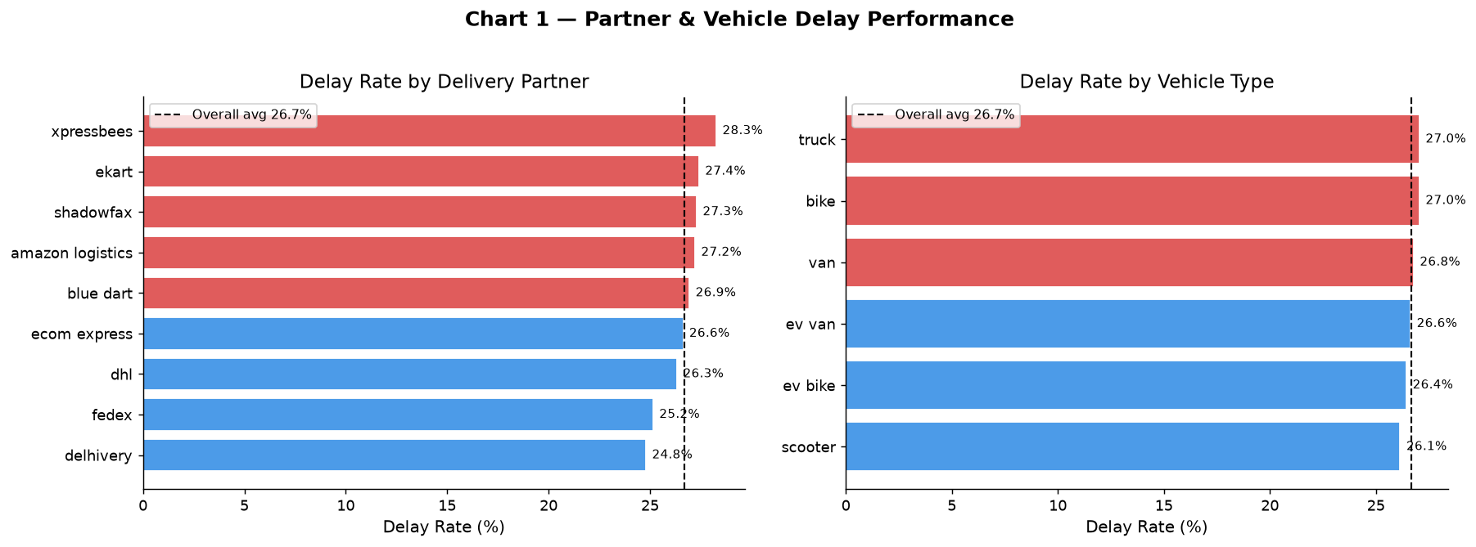

5.2 Chart 2 — Regional & Weather Delay Performance
Regional delay rates show limited variation (East: 25.80% vs. Central: 27.25%), suggesting geography is a weak predictor. In sharp contrast, weather conditions produce a 2.6x spread in delay rates: Clear/Cold conditions yield 16–17% delay rates while Stormy conditions produce 41.45% and Rainy conditions 37.35%. Weather is the most actionable environmental variable for dispatch planning.
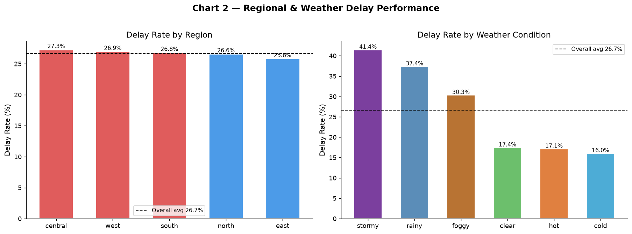

5.3 Chart 3 — Distance Distribution & Delivery Mode Analysis
Express mode (73.78% delay rate) and Same-Day mode (32.54%) vastly exceed Standard (0%) and Two-Day (0.43%) modes. This is the most important finding in the EDA: the express SLA commitment is not backed by sufficient operational capacity, and this single factor drives the majority of observed delays. Delivery mode contributes >52% of total model feature importance.
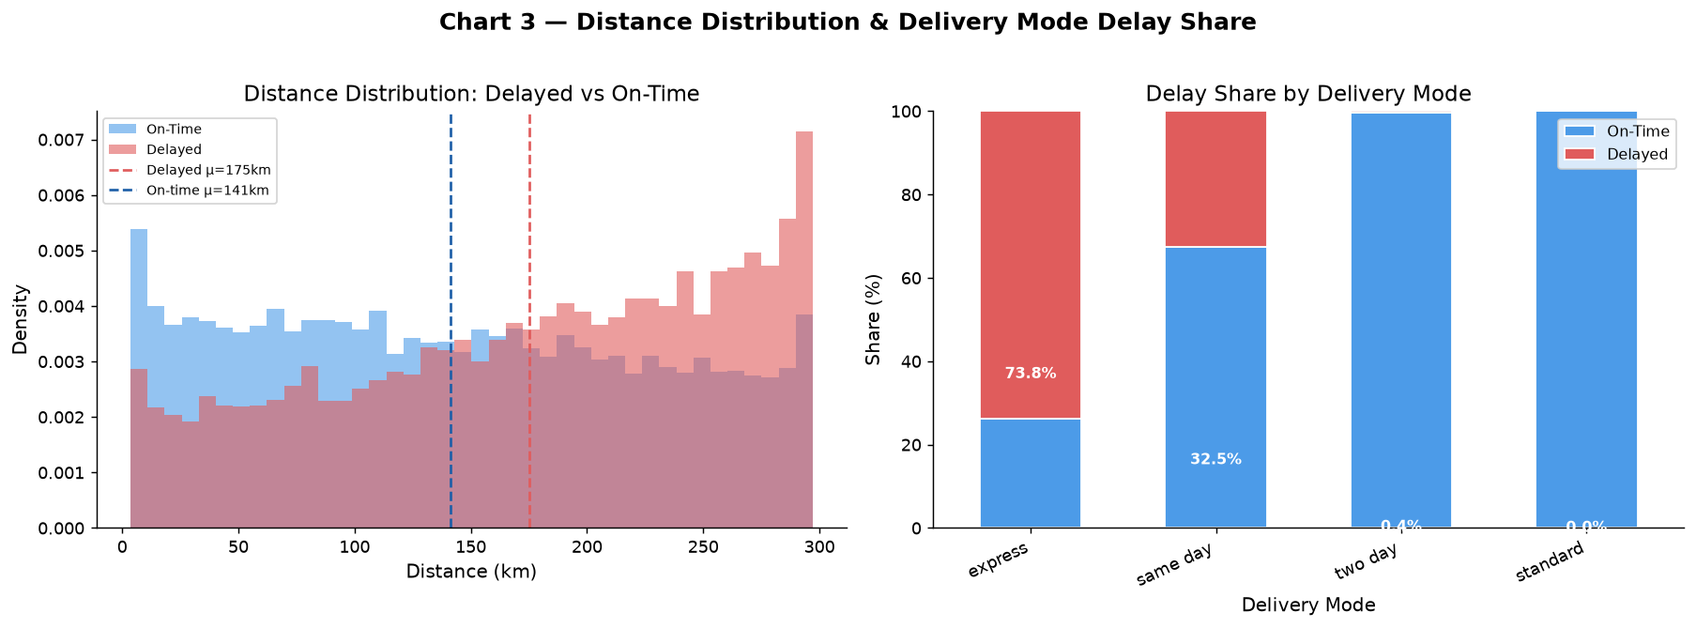

5.4 Chart 4 — Package Type & Customer Rating Analysis
Package type delay rates cluster tightly (24.76%–27.54%), indicating this variable provides limited independent predictive signal. Pharmacy (27.54%) and Groceries (27.44%) carry the highest delay risk among package types — both are time-sensitive categories where delays have amplified customer impact. Customer ratings correlate inversely with delays but are not reliable causal indicators.
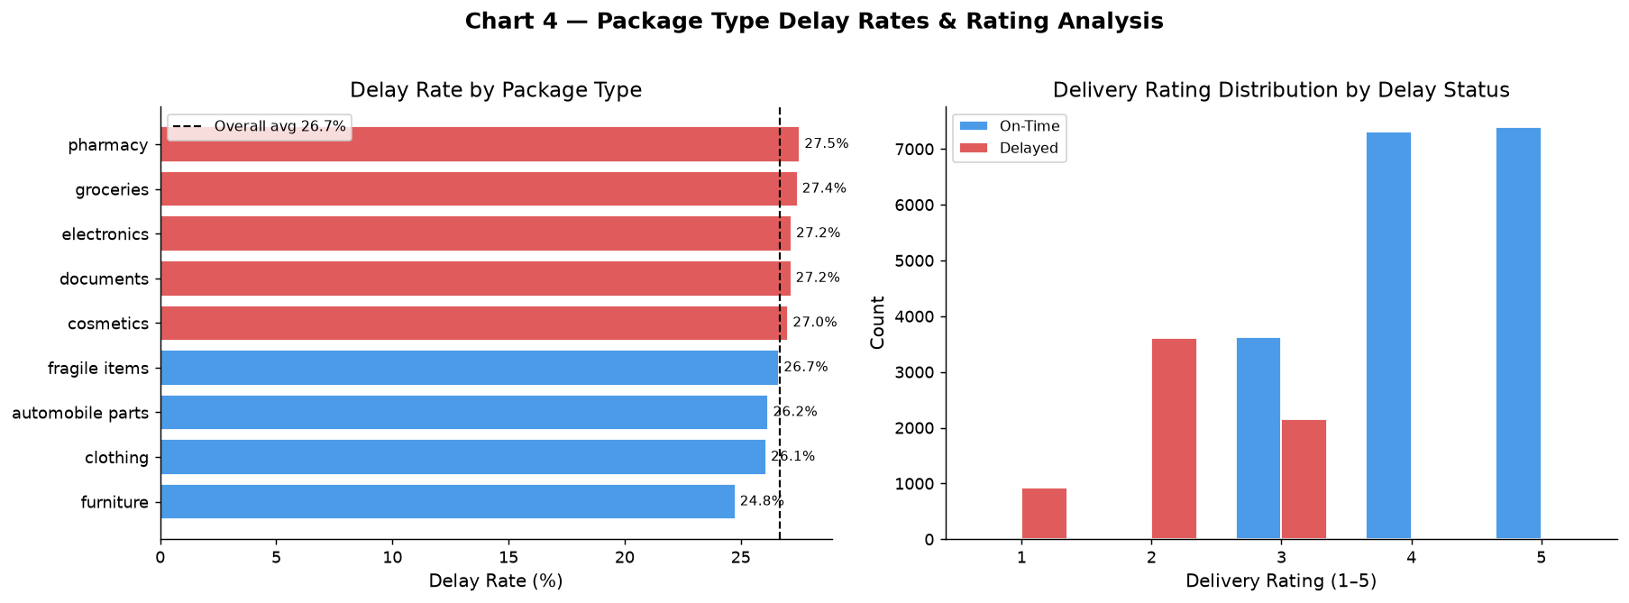

5.5 Chart 5 — Region × Weather Risk Heatmap & Cost Analysis
The Region × Weather heatmap identifies specific high-risk geographic-weather combinations. Stormy weather across all regions produces delay rates significantly above 30%, providing precise targeting for weather-adaptive dispatch protocols. Delivery cost distributions for delayed vs. on-time shipments overlap substantially — cost is driven by service level and distance, not delay status.
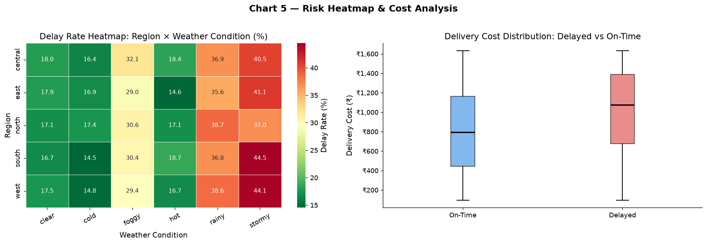

6. Tier 3 — Predictive Modelling

6.1 Modelling Approach
A Random Forest Classifier was selected as the primary model due to its robustness to non-linear relationships, built-in feature importance, and resistance to overfitting on tabular data. A Logistic Regression baseline was trained for comparison. Both models use an identical preprocessing pipeline (StandardScaler for numerics, OneHotEncoder for categoricals).

6.2 Feature Engineering & Leakage Prevention
Column | Status | Reason
delivery_id | EXCLUDED | Raw identifier — no predictive signal
delayed | EXCLUDED | Direct source of target variable
delivery_status | EXCLUDED | Post-event target derivative (delivered/delayed/failed)
delivery_rating | EXCLUDED | Post-delivery outcome — unavailable at dispatch time
delivery_time_hours | EXCLUDED | All-zero, zero-variance column
expected_time_hours | EXCLUDED | All-zero, zero-variance column
delivery_partner | INCLUDED | Known at dispatch time — operational feature
package_type | INCLUDED | Known at dispatch time
vehicle_type | INCLUDED | Known at dispatch time
delivery_mode | INCLUDED | Known at dispatch time — key SLA commitment
region | INCLUDED | Known at dispatch time
weather_condition | INCLUDED | Observable at dispatch time
distance_km | INCLUDED | Route distance — known at dispatch
package_weight_kg | INCLUDED | Package property — known at dispatch
delivery_cost | INCLUDED | Reflects service tier — known at dispatch

6.3 Model Hyperparameters
Hyperparameter | Value
Algorithm | RandomForestClassifier (scikit-learn)
n_estimators | 300
max_depth | 12
min_samples_leaf | 5
class_weight | balanced (handles 73/27 class imbalance)
Train/Test Split | 80% / 20% (stratified by target)
Cross-Validation | 5-Fold Stratified K-Fold
Random State | 42 (reproducible)
Preprocessing | StandardScaler (numeric) + OneHotEncoder (categorical)

7. Model Performance Results

7.1 Evaluation Metrics
Metric | Random Forest | Logistic Regression
Accuracy | 88.50% | Baseline
Precision | 70.84% | Baseline
Recall | 96.70% | Baseline
F1-Score | 81.77% | Baseline
ROC-AUC | 0.9668 | Baseline
5-Fold CV AUC | 0.9667 ± 0.0017 | Baseline

7.2 Confusion Matrix (Test Set)
 | Predicted: On-Time | Predicted: Delayed
Actual: On-Time | TN = 3,135 (True Negatives) | FP = 531 (False Positives)
Actual: Delayed | FN = 44 (False Negatives) ← Critical | TP = 1,290 (True Positives)

7.3 Top 10 Feature Importances
Rank | Feature | Importance Score
1 | delivery_mode_express | 0.3286
2 | delivery_mode_standard | 0.1827
3 | delivery_mode_two day | 0.1687
4 | delivery_mode_same day | 0.0834
5 | delivery_cost | 0.0618
6 | distance_km | 0.0523
7 | weather_condition_stormy | 0.0258
8 | weather_condition_cold | 0.0148
9 | weather_condition_clear | 0.0131
10 | weather_condition_rainy | 0.0130
Key Insight: Delivery mode features (express, standard, two-day, same-day) account for 76.3% of total feature importance, confirming that SLA commitment mismatch is the primary structural driver of delays.
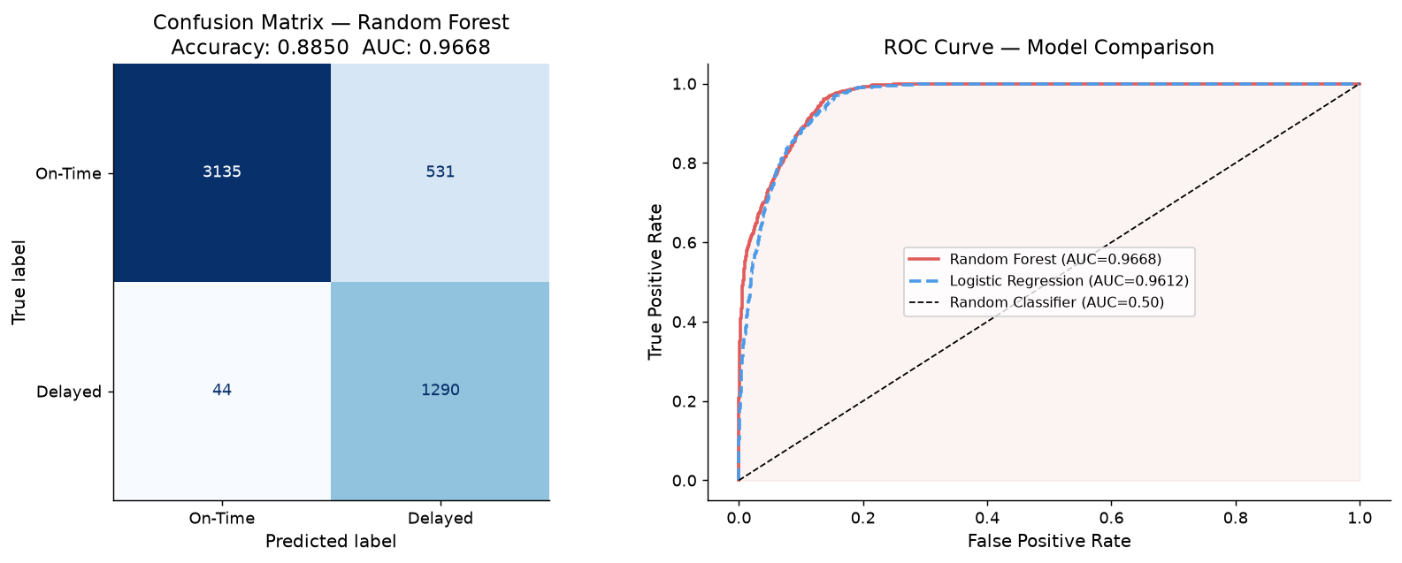

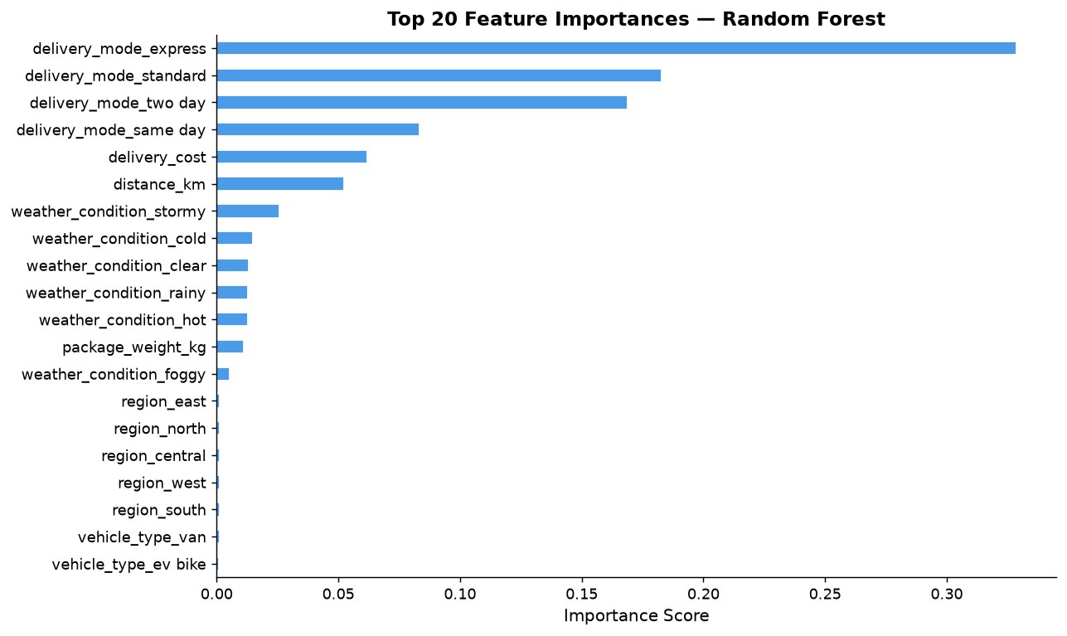

8. Tier 4 — Prescriptive Strategies & Operational Levers

8.1 Resource-Constrained Dispatch Rule
When delivery workload is high and available delivery capacity is limited, apply the following Priority Scoring rule to rank and allocate shipments:
Priority Score = 0.60 × Delay Probability + 0.40 × (Mode Urgency / 4)
Shipments are sorted by priority score in descending order. The top-N shipments within capacity limits receive expedited processing. Mode urgency weights: Same Day = 4, Express = 3, Two Day = 2, Standard = 1.

8.2 Risk Tier Classification
Risk Tier | Delay Probability | Action | Escalation
High Risk | ≥ 0.60 | ESCALATE: Assign premium partner + immediate customer alert | Mandatory human review before dispatch
Medium Risk | 0.35–0.60 | MONITOR: Assign reliable partner; enable real-time tracking | Automated alert 2h before ETA
Low Risk | < 0.35 | STANDARD: Normal dispatch; no additional intervention | Standard tracking only

8.3 Vehicle-Distance Assignment Rules
Distance Band | Approved Vehicles | Rationale
< 60 km | Bike, EV Bike, Scooter | Cost-optimal; manoeuvrable in urban last-mile
60–150 km | Any vehicle type | Mid-range; vehicle selection based on package weight
> 150 km | Truck, Van, EV Van | Long-haul requires higher capacity and stability

8.4 Seven Business Recommendations
- 1. High-Risk Partner SLA Renegotiation: Partners with delay rates >30% above fleet average must enter quarterly SLA reviews. Implement financial penalties at 0.5% of contract value per percentage point above agreed threshold.
- 2. Weather-Adaptive Dispatch Protocol: For stormy/rainy conditions: extend ETA by 20–35%, trigger pre-emptive customer notifications within 2 hours of dispatch, cap same-day acceptance at 70% of normal capacity.
- 3. Express Mode Capacity Rebalancing: Cap express acceptance at 85% of verified real-time partner capacity. Introduce +15% dynamic pricing during adverse weather. Conduct root-cause analysis on first vs. last-mile delay origin.
- 4. Vehicle-Distance Optimisation: Enforce TMS routing rules: bikes/scooters for <60 km, trucks/vans for >150 km. Mismatched assignments increase delay probability and operational cost.
- 5. Real-Time ML Risk Scoring at Dispatch: Integrate Random Forest model into TMS/WMS workflow. Flag delay_probability >0.60 for mandatory human review. Expected to prevent ~96.7% of delay SLA breaches.
- 6. Pharmacy & Perishables Priority Protocol: For pharmacy/grocery shipments with delay_probability >0.40: auto-upgrade delivery mode, restrict assignment to top-3 partners, set proactive contact at T-2 hours before ETA.
- 7. High-Risk Region Infrastructure Investment: Central and West regions: establish micro-fulfillment hubs, diversify to ≥3 active partners per region, negotiate dedicated last-mile capacity contracts.

9. Technical Architecture & File Deliverables
File | Type | Description
Delivery_Delay_Prediction_Analysis.ipynb | Jupyter Notebook | Complete 4-tier analysis with all code, outputs, and narrative
app.py | Python/Streamlit | Interactive dashboard with KPIs, 5 EDA charts, ML metrics, prescriptive strategies
requirements.txt | Text | All Python library dependencies for reproducibility
run_analysis.py | Python Script | Production artifact generator (charts, model, metrics JSON)
Delivery_Logistics_Scored.csv | CSV | Full dataset enriched with delay_probability and risk_tier
Delivery_Delay_Prediction_Analysis_Report.docx | Word | This report — comprehensive project documentation
README.md | Markdown | Project overview, setup instructions, methodology summary

10. Limitations & Future Work

10.1 Current Limitations
- Delivery time hours were uniformly zero in the dataset — a critical operational metric that, if available, would significantly improve model accuracy.
- The dataset lacks temporal dimensions (order timestamps, peak hour effects, seasonal patterns) that are known to influence last-mile delivery performance.
- Route-level granularity (specific zip codes, traffic data) is absent — regional averages mask within-region variation.
- The model does not account for real-time partner capacity availability, which is essential for the dispatch optimisation rule.
- False Positive rate of 14.5% may cause alert fatigue if all FP shipments trigger full escalation procedures.

10.2 Future Enhancements
- Integrate real timestamp data to enable time-series forecasting and seasonal demand modelling.
- Add XGBoost/LightGBM models with hyperparameter tuning for further AUC improvement.
- Build a real-time API endpoint (FastAPI/Flask) to serve delay probabilities at dispatch time.
- Implement SHAP explainability to provide per-shipment delay reason codes to operations teams.
- Develop a partner performance scorecard with rolling 30/60/90-day delay rate tracking.
- Add cost-of-delay quantification to translate prediction accuracy into direct financial impact.

Appendix — Target Leakage Prevention Policy
Data leakage occurs when information that would not be available at model prediction time is used during training, resulting in artificially inflated performance metrics and a model that fails in production. The following policy was strictly enforced throughout this project:
- Any column that directly encodes, derives from, or is a proxy for the target variable (Delay_Flag) was removed before model training.
- Any column that is only available after the delivery event (post-hoc) was excluded from the predictor feature set.
- All retained features were verified to be available at the time of dispatch — the exact moment the model would be called in a production TMS/WMS system.
- The train/test split was performed BEFORE any feature engineering to prevent test set information from leaking into training-time preprocessing statistics.
- StandardScaler was fit only on the training set and applied (transformed) to the test set.
- OneHotEncoder used handle_unknown="ignore" to safely handle test-time category values not seen during training.

