Title: Shaheed Minar
Computer Graphics

1. Introduction
The objective of this project is to create a computer graphics representation of the Shaheed Minar, an iconic monument in Bangladesh, using OpenGL. The project focuses on designing a visually appealing and interactive 2D scene that combines natural elements, buildings, vehicles, and the monument itself. To enhance the realism of the environment, the project incorporates animation functions that allow dynamic elements like moving vehicles, shifting clouds, swaying trees and day-night transitions. The project also demonstrates user interaction through keyboard, mouse, and special key functions, allowing viewers to control or influence certain aspects of the animation. Overall, this project combines fundamental computer graphics techniques, animation principles, and interactive features to simulate a lively and realistic environment around the Shaheed Minar.

2. Project Graph
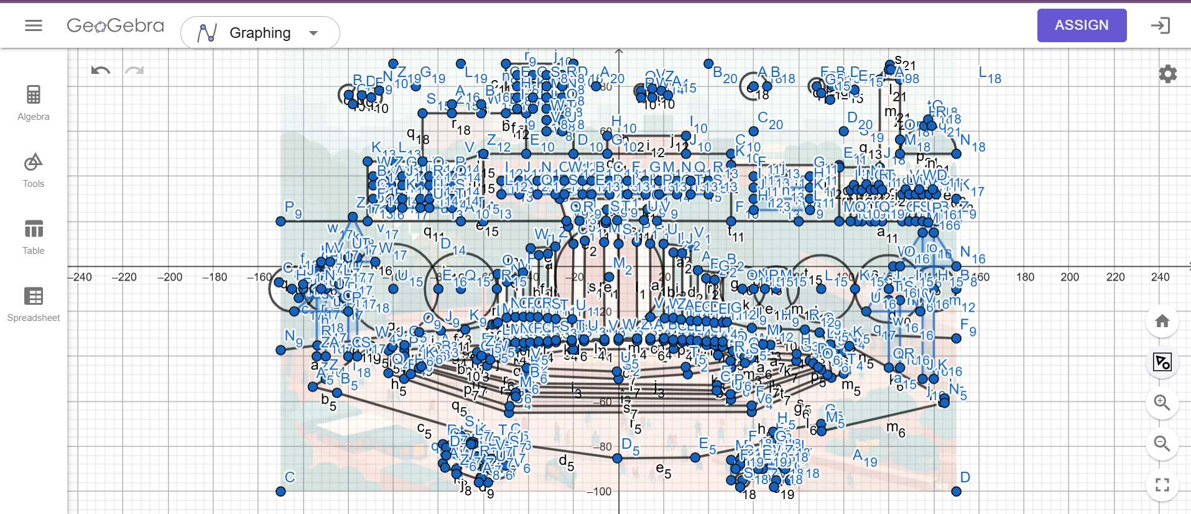

- List of objects

SL# | Object ID | Object Name
1 | Obj1 | Trees
2 | Obj2 | Sky
3 | Obj3 | Clouds
4 | Obj4 | Minar
5 | Obj5 | MinarBase
6 | Obj6 | MinarCircle
7 | Obj7 | MinarStair
8 | Obj8 | smallTree1
9 | Obj9 | smallTree2
10 | Obj10 | bigTree1
11 | Obj11 | Bigtree2
12 | Obj12 | Sun
13 | Obj13 | Car1
14 | Obj14 | Ambulance
15 | Obj15 | Building1
16 | Obj16 | Building2
17 | Obj17 | Building3
18 | Obj18 | Building4
19 | Obj19 | Medical
20 | Obj20 | Mosque
21 | Obj21 | Ground

- List of Functions

SL# | Function Name | Object_ID
1 | minar() | Obj4
2 | minarCircle() | Obj6
3 | minarBase() | Obj5
4 | minarStair() | Obj7
5 | ground() | Obj21
6 | sky() | Obj2
7 | trees() | Obj1
8 | clouds() | Obj3
9 | mosque() | Obj20
10 | medical() | Obj19
11 | bulding1() | Obj15
12 | bulding2() | Obj16
13 | bulding3() | Obj17
14 | bulding4() | Obj18
15 | sun() | Obj12
16 | car1() | Obj13
17 | ambulance() | Obj14
18 | smallTree1() | Obj7
19 | smallTree2() | Obj8
20 | bigTree1() | Obj9
21 | bigTree2() | Obj10

- List of Animated Functions

SL# | Function Name | Function_ID
1 | updateAmbulance() | F1
2 | updateCar1() | F2
3 | timer() | F3
4 | cloudTimer() | F4
5 | keyboard() | F5
6 | specialKey() | F7
7 | mouse() | F6
8 | timer2() | F8

- Conclusion

This project successfully creates an interactive computer graphics scene of the Shaheed Minar using OpenGL. Static objects like the monument, buildings, and trees are combined with animated elements such as moving cars, ambulance, swaying trees, and drifting clouds, along with day-night transitions. Mouse and keyboard interactions allow users to control animations, making the scene more engaging.

Overall, the project demonstrates key computer graphics concepts, animation techniques, and interactivity in a visually appealing way.

Project Proposal

Initial Project Description
Scene- Shaheed Minar

Objects:
Shaheed Minar, Buildings, Trees, Clouds, Sun, Car, Ambulance
Animations:
Trees swaying, Cloud moving, Car moving, Ambulance Moving
Mouse Interaction:
Left click to decrease and Right click to increase car speed
Keyboard Internation:
Left key to toggle day/night, T to toggle tree movement, C to toggle cloud, L and R to change cloud direction, A to toggle ambulance and B to toggle car

