Title: Analyzing Category-Wise Discounts and Pricing Patterns of Chaldal products in E-Commerce
Research Objective Definition:
Research Problem:
The primary aim of this study is to analyze product discounts across multiple categories in an e-commerce dataset. The objectives are:
- Category-wise discount analysis:
  - Identify categories with maximum savings and frequent discounts.
- Savings Impact:
- Examine price variations between original and final prices to understand savings per product and across categories.
- Predictive Modeling:
  - Build models to predict discount percentage and discount availability based on product features such as category and original price
Specific, Measurable, and Data-Driven Goals:
- Quantify average original prices, final prices, and discount percentages per product category.
- Determine the frequency and distribution of discounted products across categories.
- Identify products with the highest discounts and categories with the greatest saving potential.
- Develop predictive models to forecast discount occurrence and discount percentage using category and price features.
- Provide actionable insights into discount trends to support pricing strategies and consumer savings awareness.
Data Collection (Web Scraping):
Source:
The dataset was collected using web scraping from https://chaldal.com, an e-commerce platform offering a diverse range of products relevant to our research.
Scraping Methodology:
We used R programming with the rvest library for data extraction. The collected fields included:
- Category: General product grouping (e.g., "Vegetables," "Frozen Fish").
- ProductName: Specific product names (e.g., "Banana Chompa," "Chicken Eggs").
- SubText: Product descriptors such as weight, quantity, or packaging (e.g., "500 gm").
- DiscountedPrice: Price after applying any discount (or NA for non-discounted products).
- OriginalPrice: Original base price before applying discounts.

Implementation Steps:
- HTML Inspection: Analyzed the structure of Chaldal’s website using browser developer tools, focusing on CSS selectors within div.product.
- Data Extraction: Scraped relevant product details directly into structured rows and handled dynamically rendered prices.
- Save to CSV: Generated the final dataset file (MergedData.csv) containing product-level details.
Code:
library(rvest)
#FRUITS
# URL of the Chaldal Fresh Fruit page
url <- "https://chaldal.com/fresh-fruit"

# Read HTML content of the webpage
webpage <- read_html(url)

# Select product containers
product_nodes <- webpage %>% html_nodes(".product")

# Scrape product names
product_names1 <- product_nodes %>%
html_nodes(".name") %>%
html_text(trim = TRUE)

# Scrape sub texts (brand / quantity)
sub_texts1 <- product_nodes %>%
html_nodes(".subText") %>%
html_text(trim = TRUE)

# Scrape discounted prices
discounted_prices1 <- sapply(product_nodes, function(node) {
node_discount <- node %>% html_nodes(".discountedPrice")
if (length(node_discount) > 0) {
node_discount %>% html_text(trim = TRUE)
} else {
"NA"
}
})

# Scrape original prices
original_prices1 <- sapply(product_nodes, function(node) {
node_price <- node %>% html_nodes(".price")
if (length(node_price) > 0) {
node_price %>% html_text(trim = TRUE)
} else {
"NA"
}
})

# Check lengths
cat("Lengths:\n",
"Product Names:", length(product_names1), "\n",
"Sub Texts:", length(sub_texts1), "\n",
"Discounted Prices:", length(discounted_prices1), "\n",
"Original Prices:", length(original_prices1), "\n")

# Pad vectors to same length
max_length <- max(
length(product_names1),
length(sub_texts1),
length(discounted_prices1),
length(original_prices1)
)

length(product_names1) <- max_length
length(sub_texts1) <- max_length
length(discounted_prices1) <- max_length
length(original_prices1) <- max_length

# Replace NA values
product_names1[is.na(product_names1)] <- "NA"
sub_texts1[is.na(sub_texts1)] <- "NA"
discounted_prices1[is.na(discounted_prices1)] <- "NA"
original_prices1[is.na(original_prices1)] <- "NA"

# Create final data frame with Category column
offers_data1 <- data.frame(
Category = "Fruits",
ProductName = product_names1,
SubText = sub_texts1,
DiscountedPrice = discounted_prices1,
OriginalPrice = original_prices1,
stringsAsFactors = FALSE
)

# Preview data
print(head(offers_data1))

# Save to CSV
write.csv(offers_data1, "OFFER1.csv", row.names = FALSE)

The same approach was applied to all other (13) categories (e.g., Vegetables, Frozen Fish, Beverages, Snacks, etc.), and the resulting files were merged into MergedData.csv.

Data Understanding and Exploration:
Dataset Structure:
The dataset contains product-level data relevant for discounts analysis:
- Variables:
  - Category: Product group (e.g., "Vegetables," "Frozen Fish").
  - ProductName: Name of the product.
  - SubText: Product size, weight, etc.
  - DiscountedPrice: Discounted price (if available).
  - OriginalPrice: Base price before discounts.
- Size: 687 rows × 5 columns.
- Two additional derived features were created during preprocessing:
- FinalPrice: Uses the discounted price if available; otherwise, the original price.
- DiscountPercentage: Calculated as the percentage reduction from original to discounted price for items with discounts.
Exploratory Data Analysis Techniques:
- Descriptive Statistics:
  - Summary statistics for prices (OriginalPrice,FinalPrice) and calculated DiscountPercentage.
  - Product count per category to understand frequency trends.
- Visualizations:
- Boxplots were used to compare original versus final prices across categories.
- Histograms were used to explore the distribution of discount percentages.
Issues Identified During Exploration:
- Missing values (NA) for DiscountedPrice due to non-discounted products.
- Variability in product size descriptors (SubText), requiring normalization.
- Original and discounted prices were initially stored as strings with currency symbols or extra spaces. These were cleaned and converted to numeric values to enable calculations and analysis.

Data Preprocessing:
Key Preprocessing Steps:
- Handle Missing Values:
  - Replaced DiscountedPrice missing values with NA and flagged them using a new variable DiscountFlag (0 = no discount, 1 = discount).
  - Missing values in SubText were replaced with "Unknown" to maintain consistent formatting across products.
- Price Formatting:
- Original and discounted prices were stored as strings containing currency symbols, spaces, or commas. These were cleaned and converted to numeric values to allow calculations of discounts, averages, and predictive modeling.
- Derived Features:
- FinalPrice and DiscountPercentage were created to support analysis and modeling.
- Categorical Variables:
- Category was stored as character strings and later converted to factors for modeling. This ensures that predictive models like Random Forest treat categories correctly.

- Import Libraries & Load Dataset
Code:
library(readr)
library(dplyr)
library(ggplot2)
library(tidyr)

data <- read.csv("MergedData.csv", stringsAsFactors = FALSE)
head(data)
Output:
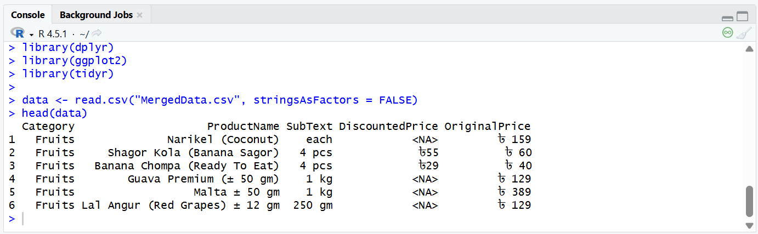

- Clean Dataset
Code:
# Remove leading/trailing whitespace
data$OriginalPrice <- trimws(data$OriginalPrice)
data$DiscountedPrice <- trimws(data$DiscountedPrice)

# Convert price values to numeric
data$OriginalPrice <- parse_number(data$OriginalPrice)
data$DiscountedPrice <- parse_number(data$DiscountedPrice)

# Remove rows with NA OriginalPrice
data <- data[!is.na(data$OriginalPrice), ]

# Replace missing SubText with "Unknown"
data$SubText[data$SubText == ""] <- "Unknown"

head(data)
Output:
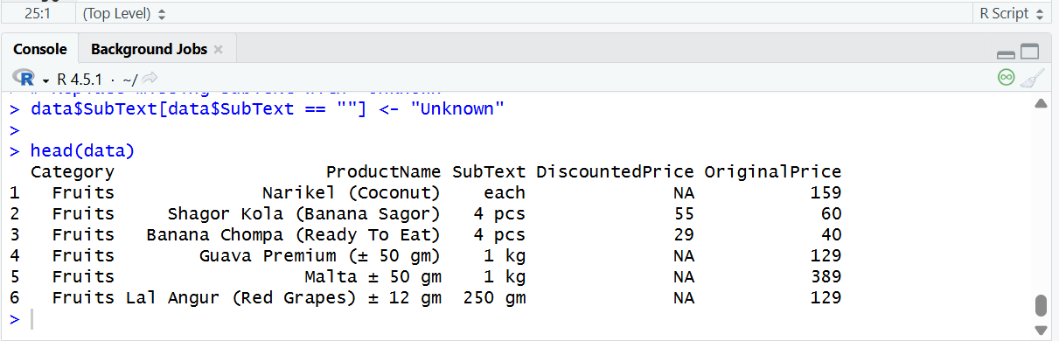
- Add discount flag & Final Price of products
Code:
# Add Discount Flag
# 1 = discount available, 0 = no discount
data$DiscountFlag <- ifelse(is.na(data$DiscountedPrice), 0, 1)

# Add Final Price
# Use discounted price if available, otherwise original price
data$FinalPrice <- ifelse(
is.na(data$DiscountedPrice),
data$OriginalPrice,
data$DiscountedPrice
)
head(data)
Output:
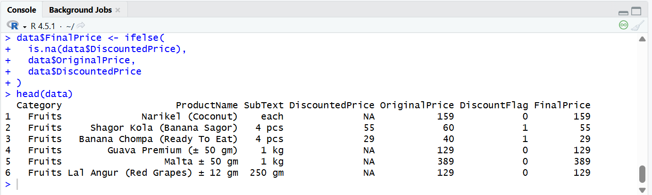

- Calculate Discount Percentage
Code:
# Only calculate if a discount is available
data$DiscountPercentage <- ifelse(
data$DiscountFlag == 1,
round(((data$OriginalPrice - data$DiscountedPrice) / data$OriginalPrice) * 100),
NA
)

head(data,10)
Output:
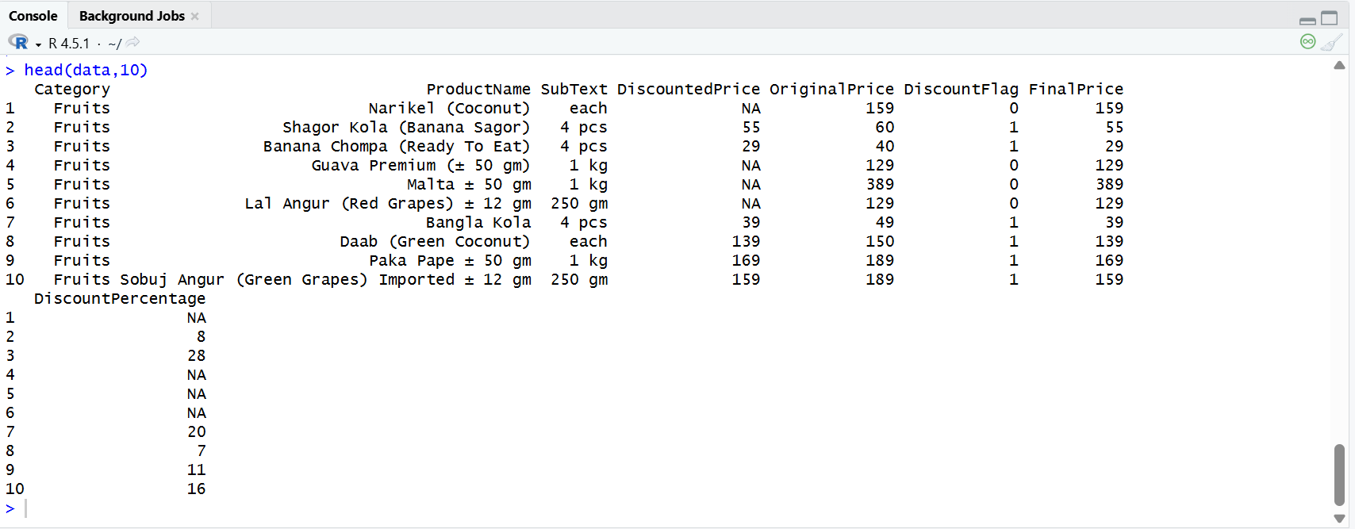
Code Description of Data Preprocessing:

This preprocessing code systematically prepares the dataset for analysis by handling missing values, cleaning data entries, and engineering new features essential for understanding product discounts. Initially, the OriginalPrice and DiscountedPrice columns are stripped of extra spaces and parsed into numeric format, converting values from formats with currency symbols like ৳ to clean numerical data suitable for computations. Rows with missing OriginalPrice are excluded, ensuring the integrity of essential pricing data for all products. Missing values in the DiscountedPrice column are flagged using the DiscountFlag variable, which distinguishes discounted (1) from non-discounted (0) items. To simplify comparisons, the new FinalPrice column is derived, representing the price customers pay—either the DiscountedPrice for discounted products or the OriginalPrice for non-discounted items. Additionally, the DiscountPercentage column is calculated to quantify savings as a percentage, aiding in the analysis of discount trends. For discounted products, the formula used is:
$$\text{DiscountPercentage}=\left(\frac{\text{OriginalPrice}-\text{DiscountedPrice}}{\text{OriginalPrice}}\right)×100$$
For non-discounted products, this column is left as NA. Lastly, missing entries in the SubText column, which describe product characteristics like weight or packaging, are imputed with the label "Unknown". By ensuring clean, complete, and enriched data, this preprocessing code sets the foundation for robust exploratory analysis, statistical testing, and predictive modeling, facilitating a deeper understanding of discount trends and pricing patterns across product categories.
Descriptive Analysis
- Average Price per Category
Code:
# Average Price per Category
avg_price <- data %>%
group_by(Category) %>%
summarise(
AverageOriginalPrice = mean(OriginalPrice, na.rm = TRUE),
AverageFinalPrice = mean(FinalPrice, na.rm = TRUE)
)
print("Average Price per Category:")
print(avg_price)
Output:
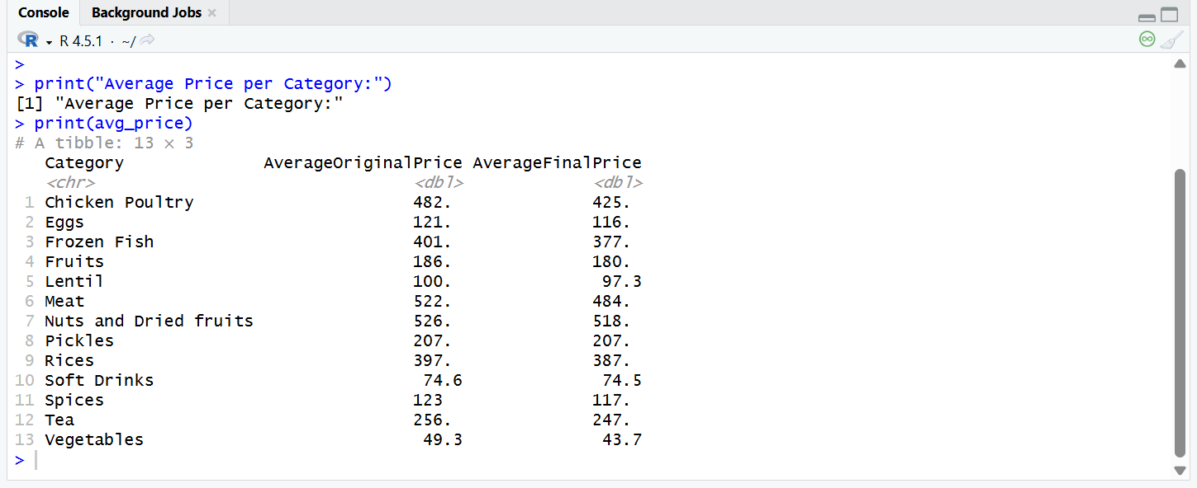
- Price Range per Category
Code:
# Price Range (Min–Max) per Category
price_range <- data %>%
group_by(Category) %>%
summarise(
MinOriginalPrice = min(OriginalPrice, na.rm = TRUE),
MaxOriginalPrice = max(OriginalPrice, na.rm = TRUE),
MinFinalPrice = min(FinalPrice, na.rm = TRUE),
MaxFinalPrice = max(FinalPrice, na.rm = TRUE)
)

print("Price Range per Category:")
print(price_range)

Output:
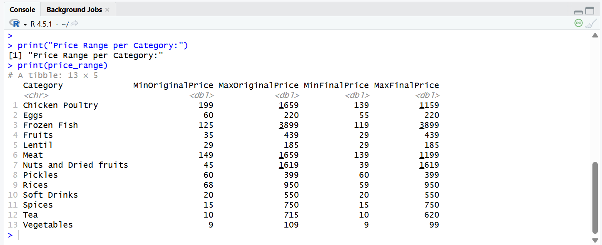
- Dataset summary
Code:
# Summary Statistics
print("Original Price Summary:")
print(summary(data$OriginalPrice))
print("Final Price Summary:")
print(summary(data$FinalPrice))
Output:
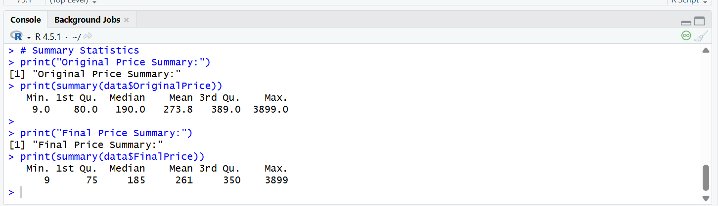

- Number of Products per Category
Code:
# Number of products per category
products_per_category <- data %>%
group_by(Category) %>%
summarise(ProductCount = n()) %>%
arrange(desc(ProductCount))
print(products_per_category)

#Categories with number of unique product
category_variety <- data %>%
group_by(Category) %>%
summarise(UniqueProducts = n_distinct(ProductName)) %>%
arrange(desc(UniqueProducts))
print(category_variety)
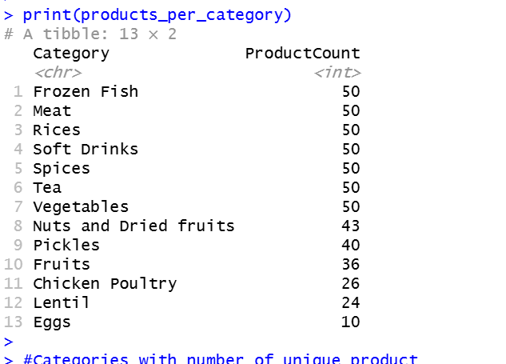
Output:
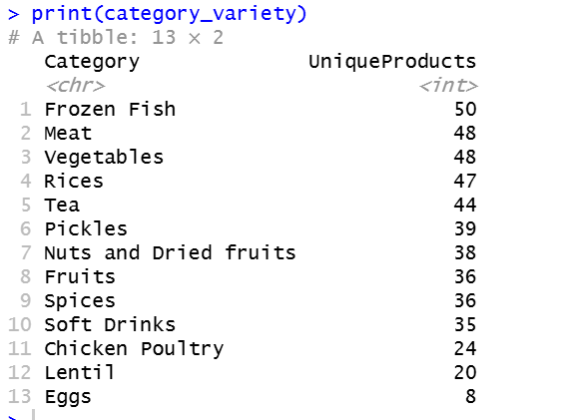
- Count of Discounted Products per Category
Code:
#Count of discounted products per category
discount_count <- data %>%
filter(DiscountFlag == 1) %>%
group_by(Category) %>%
summarise(DiscountedProducts = n()) %>%
arrange(desc(DiscountedProducts))
print(discount_count)
Output:
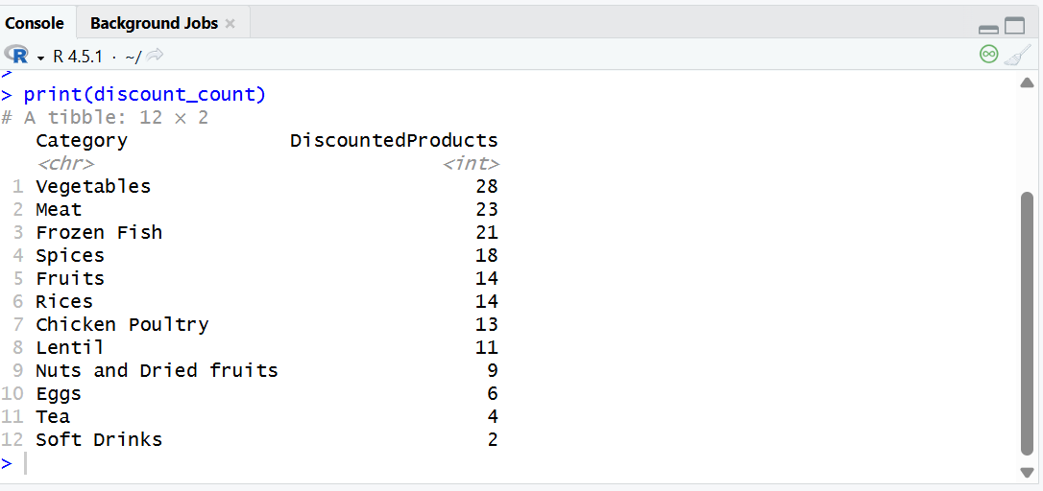
- Average Discount Percentage per Category
Code:
#Average discount percentage per category
avg_discount_percent <- data %>%
filter(DiscountFlag == 1) %>%
group_by(Category) %>%
summarise(
AverageDiscountPercent = mean(DiscountPercentage, na.rm = TRUE)
) %>%
arrange(desc(AverageDiscountPercent))

print(avg_discount_percent)
Output:
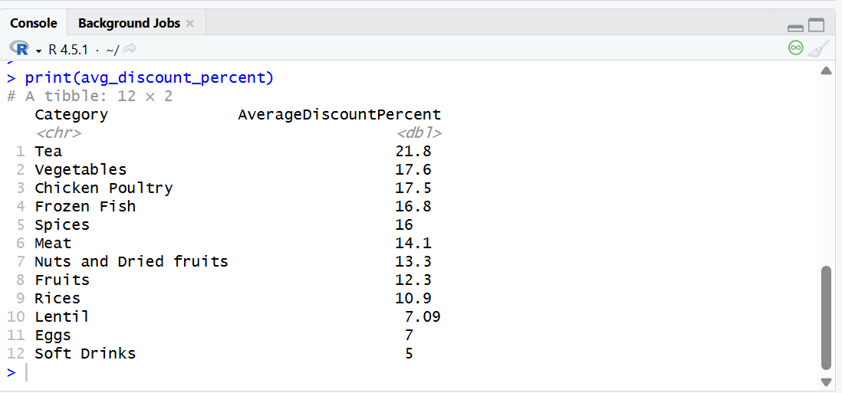
- Discount Frequency by Category
Code:
#Discount frequency by category
discount_frequency <- data %>%
group_by(Category) %>%
summarise(
TotalProducts = n(),
DiscountedProducts = sum(DiscountFlag),
DiscountFrequencyPercent = round((DiscountedProducts / TotalProducts) * 100, 2)
) %>%
arrange(desc(DiscountFrequencyPercent))

print(discount_frequency)
Output:
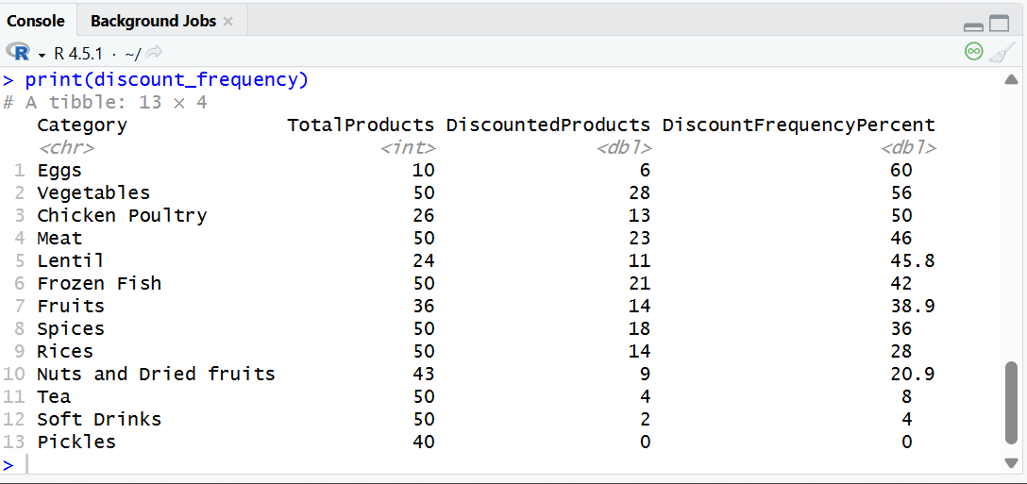
- Overall Discount vs No Discount Distribution
Code:
#Percentage of products with vs without discounts (Overall distribution)
discount_distribution <- data %>%
summarise(
Discounted = sum(DiscountFlag == 1),
NoDiscount = sum(DiscountFlag == 0)
) %>%
pivot_longer(
cols = everything(),
names_to = "DiscountStatus",
values_to = "Count"
) %>%
mutate(Percentage = round((Count / sum(Count)) * 100, 2))
print(discount_distribution)
Output:
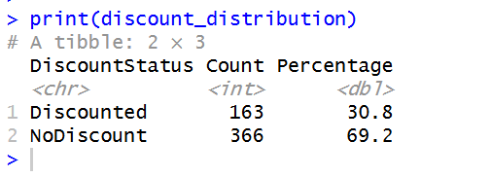
- Top Discounted Products
Code:
#Products with the highest discounts (Top discounted products)
highest_discounts <- data %>%
filter(DiscountFlag == 1) %>%
arrange(desc(DiscountPercentage)) %>%
select(
ProductName,
Category,
OriginalPrice,
DiscountedPrice,
DiscountPercentage
)
head(highest_discounts, 10)

Output:
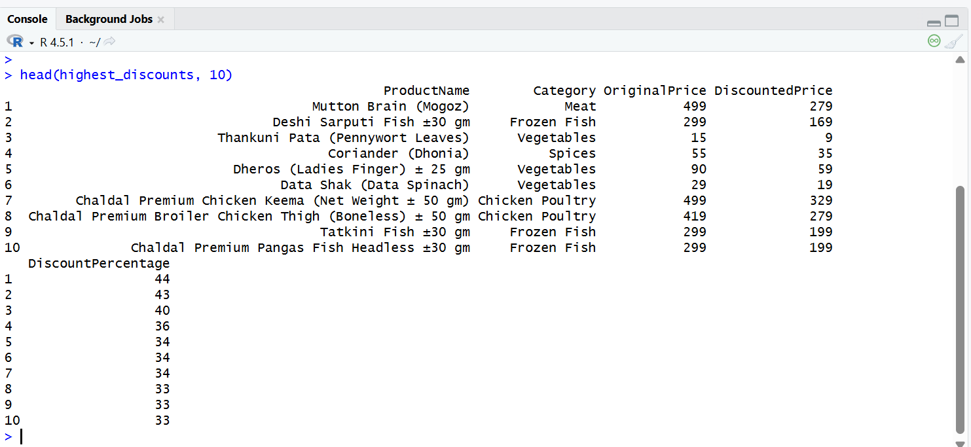
Code Description of Descriptive Analysis:
A comprehensive descriptive analysis was conducted to understand pricing and discount patterns across categories. We calculated the average original and final prices per category to examine typical pricing, and determined the price range to assess variability and extremes. Summary statistics provided insights into the overall distribution of prices. We analyzed the number of products and the variety of unique products per category to understand category representation and diversity. The count and frequency of discounted products per category, along with the average discount percentage, highlighted categories offering the most frequent and substantial savings. Additionally, the overall proportion of discounted versus non-discounted products was computed to assess discount prevalence across the dataset. Finally, the top discounted products were identified to showcase items providing the highest savings to customers. Collectively, these analyses provided a clear picture of pricing trends, discount patterns, and high-savings opportunities across different e-commerce categories.
Data Visualization
- Original Price vs Final Price
Code:
# Prepare data in long format
data_long <- data %>%
select(Category, OriginalPrice, FinalPrice) %>%
pivot_longer(cols = c(OriginalPrice, FinalPrice),
names_to = "PriceType", values_to = "Price")

# Get all unique categories
categories <- unique(data$Category)

# Loop through categories and create a boxplot for each
for(cat in categories){
cat_data <- data_long %>% filter(Category == cat)

p <- ggplot(cat_data, aes(x = PriceType, y = Price, fill = PriceType)) +
geom_boxplot(width = 0.5) +
labs(title = paste("Price Comparison for", cat),
x = "",
y = "Price (Taka)") +
scale_fill_manual(values = c("OriginalPrice" = "lightblue", "FinalPrice" = "lightgreen")) +
theme_minimal() +
theme(legend.position = "none")

print(p)
}
Output:
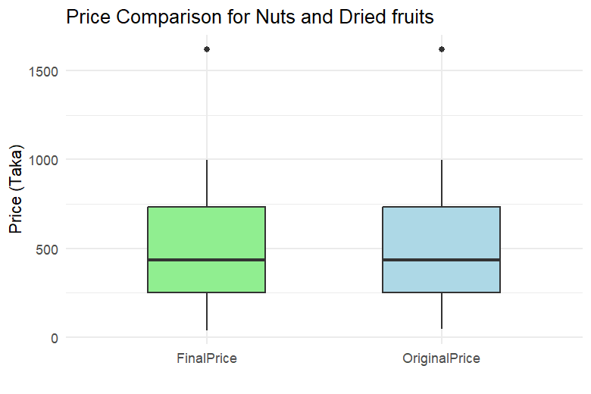
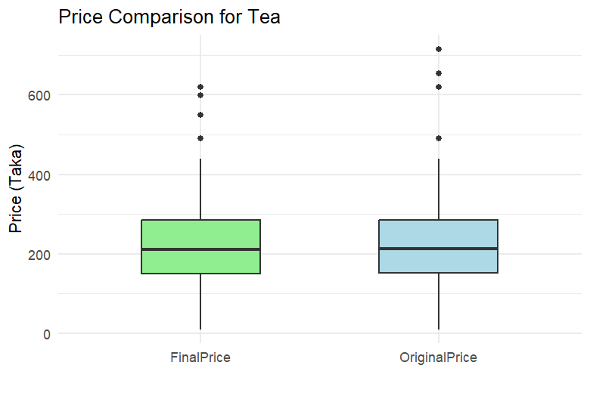
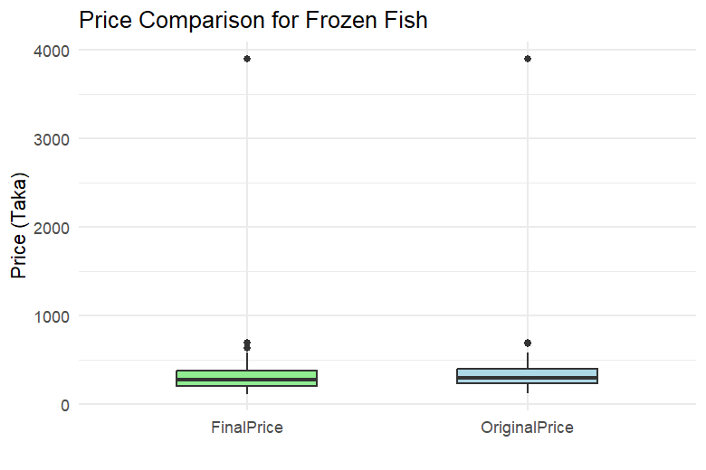
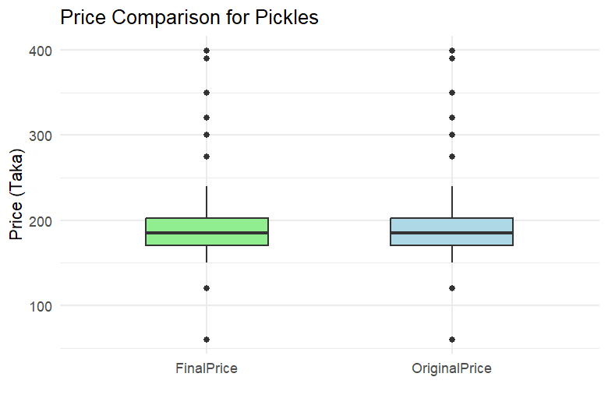
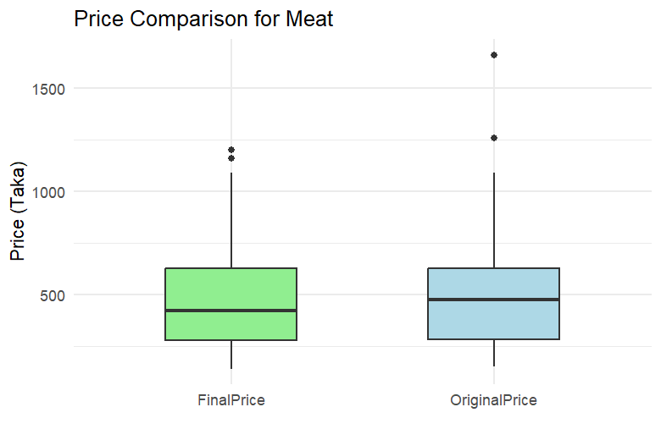
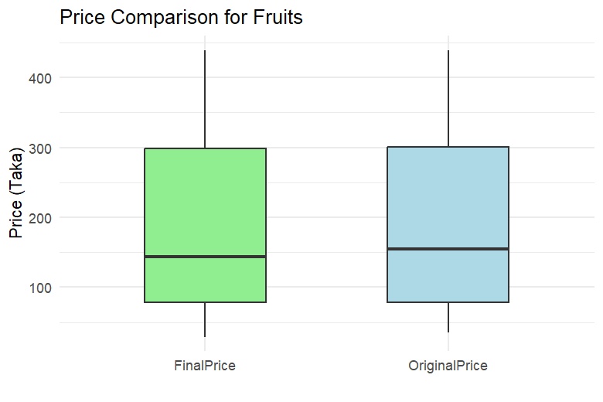
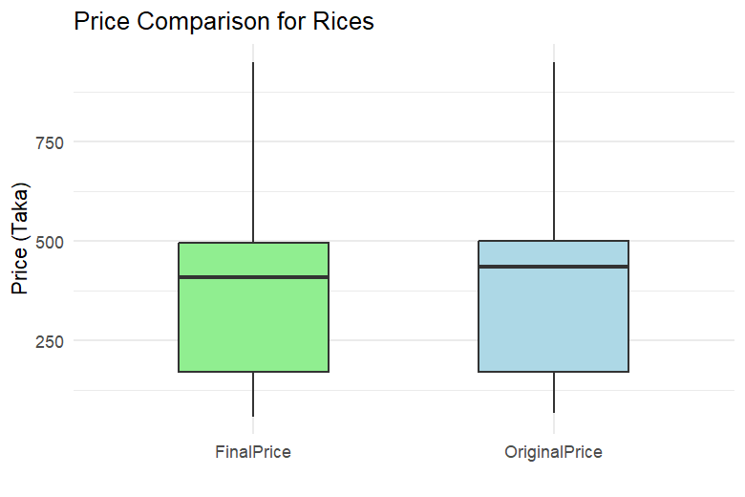
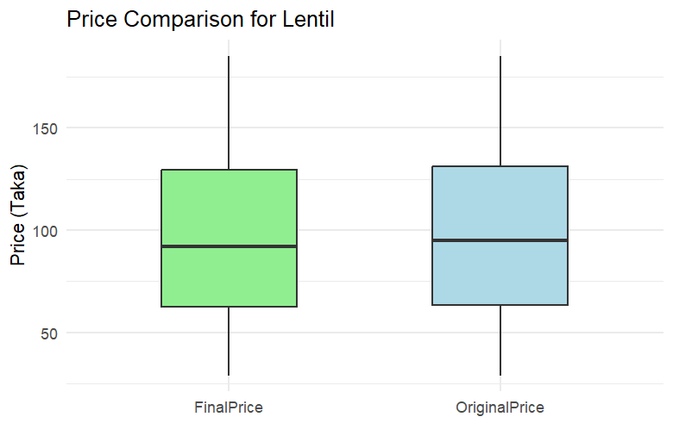
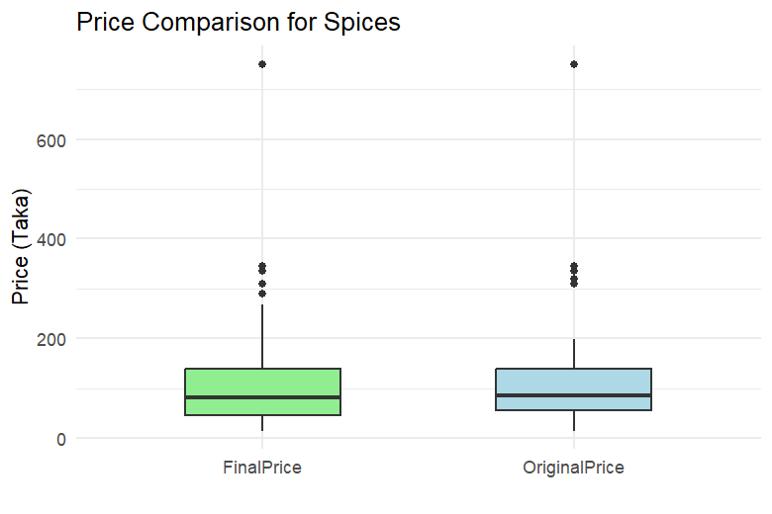
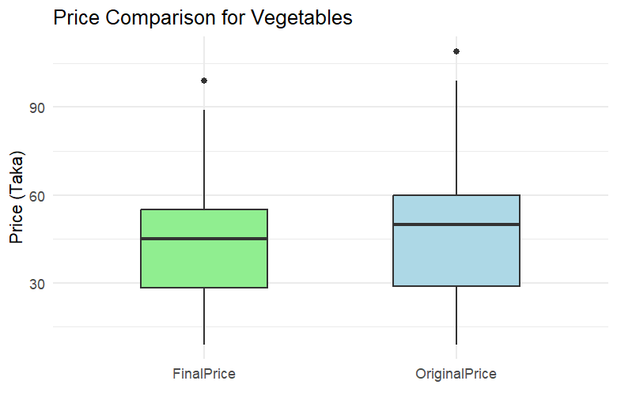
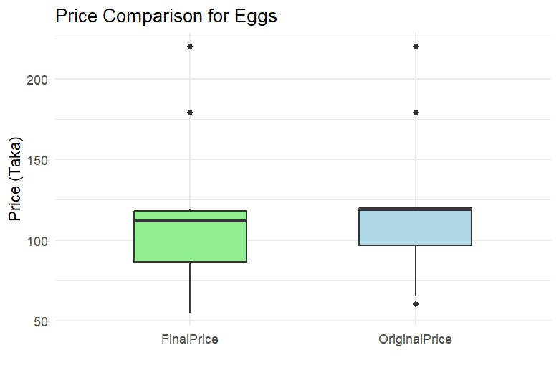
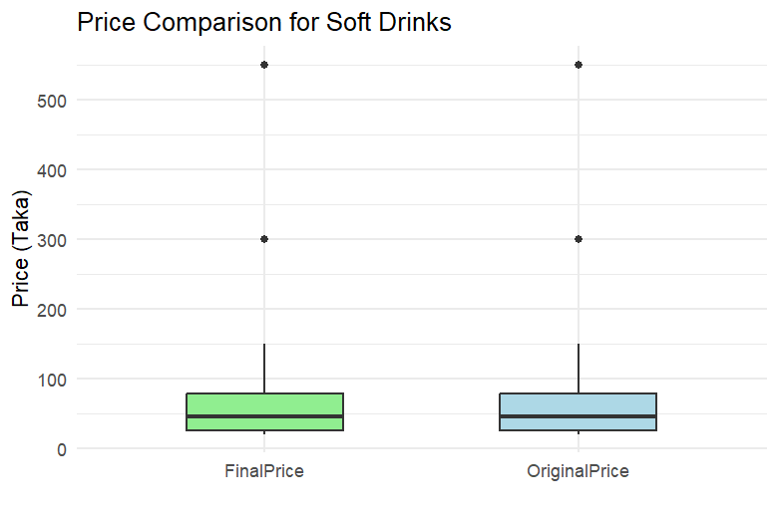
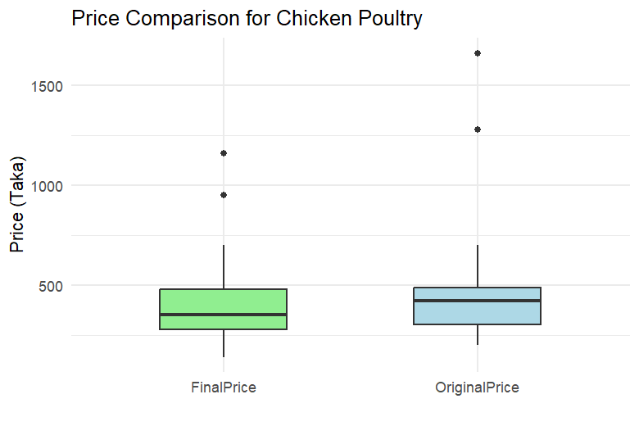

- Discount Percentage Distribution
Code:
#Discount Percentage Distribution by Category

ggplot(data %>% filter(!is.na(DiscountPercentage)), aes(x = DiscountPercentage, fill = Category)) +

geom_histogram(binwidth = 5, position = "dodge") +

labs(title = "Discount Percentage Distribution by Category", x = "Discount Percentage (%)", y = "Count") +

theme_minimal()

Output:

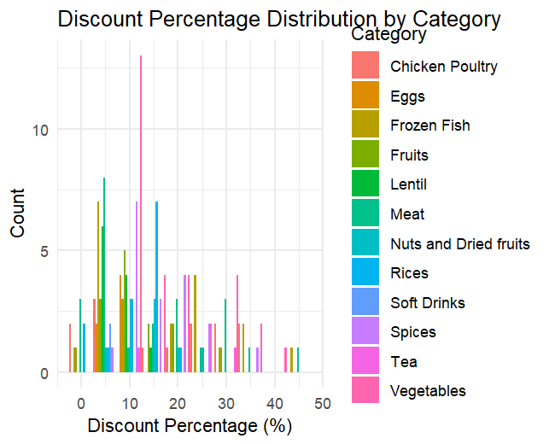
- Original Price vs Discounted Price
Code:
# Boxplot of Original vs Discounted Prices
ggplot(data, aes(x = Category, y = OriginalPrice, fill = Category)) +
geom_boxplot() +
labs(title = "Original Prices by Category", x = "Category", y = "Price") +
theme_minimal()

ggplot(data, aes(x = Category, y = DiscountPercentage, fill = Category)) +
geom_boxplot() +
labs(title = "Discount Percentages by Category", x = "Category", y = "Discount %") +
theme_minimal()

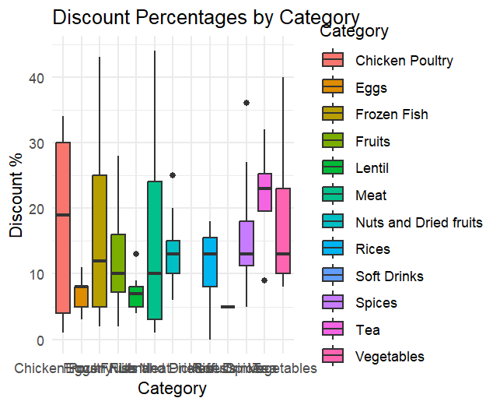
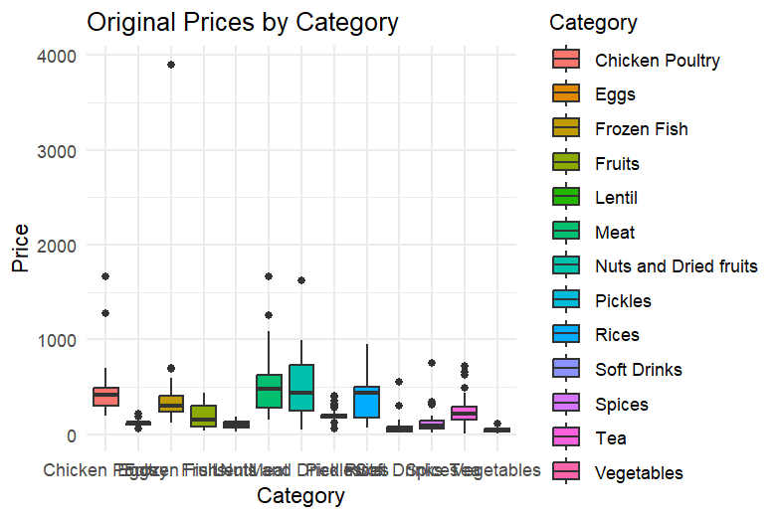
Output:

Code Description of Data Visualization:
Visualizations were used to explore pricing and discount patterns across categories. Boxplots comparing OriginalPrice and FinalPrice highlighted the effect of discounts on product prices per category. Histograms of DiscountPercentage showed how discounts are distributed and their frequency across categories. Additional category-wise boxplots of OriginalPrice and DiscountPercentage provided insights into price ranges, discount magnitudes, and variability within each product category. These visualizations helped identify pricing trends, high-discount categories, and patterns in consumer savings.
Feature Extraction
    - Anova Test: ANOVA is used when we want to compare the means of a continuous variable across multiple groups. FinalPrice & DiscountPercentage is numeric, and Category is a categorical variable with many groups.

Code:

#ANOVA TEST
anova_result <- aov(FinalPrice ~ Category, data = data)
summary(anova_result)

Output:
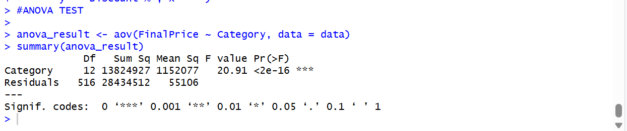

Interpretation:
- The F-statistic of 20.91 indicates strong variation in FinalPrice across categories relative to within-category variation.
- The p-value < 2e-16 is highly significant, providing strong evidence against the null hypothesis.
- This suggests that at least one product category has a significantly different mean FinalPrice compared to others.

Code:

anova_discount <- aov(DiscountPercentage ~ Category,
data = data %>% filter(!is.na(DiscountPercentage)))
summary(anova_discount)

Output:
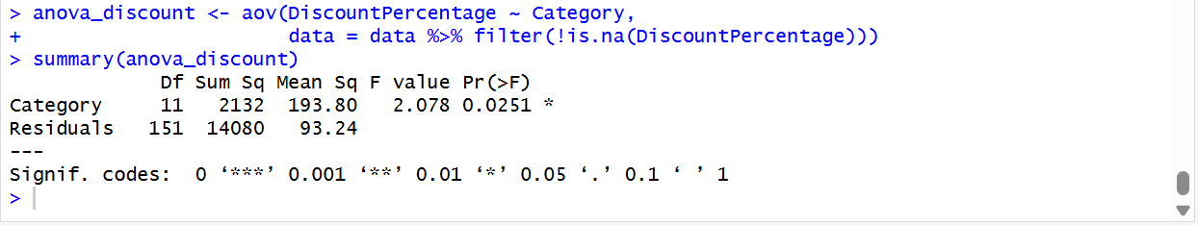

Interpretation:

- The F-statistic of 2.078 suggests moderate variation in discount percentages across categories.
- The p-value of 0.0251 is statistically significant at the 5% level, indicating that at least one category differs meaningfully in its average discount percentage.
- This result allows us to reject the null hypothesis that all categories have the same mean discount percentage. Which means, Product category has a statistically significant effect on discount percentage.

    - Chi Square: The Chi-Square test is used to determine whether there is a significant association between two categorical variables. In this case, Category and DiscountFlag are both categorical. The test checks if the likelihood of a product being discounted depends on its category, or if discounts are distributed independently across categories.

Code:

#CHI SQUARE
discount_table <- table(data$Category, data$DiscountFlag)
chi_result <- chisq.test(discount_table)
print(chi_result)
Output:

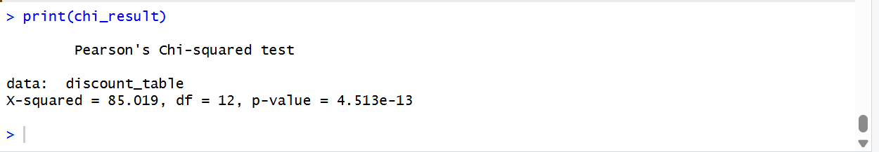
Interpretation:
- The extremely small p-value (< 0.001) indicates strong evidence against the null hypothesis. This means the distribution of discounted vs. non-discounted products is not uniform across categories.
- There is a statistically significant association between product category and discount availability. This suggests that discounting strategies vary meaningfully across categories and may reflect targeted pricing or promotional tactics.
Modelling and Analysis
- Choice of Model:
Random Forest models were used to predict discount percentage and discount availability. It was chosen because it can handle both numerical (OriginalPrice) and categorical (Category) variables and capture non-linear relationships between features and the target variable. It is robust to outliers and can estimate feature importance, making it suitable for predicting discount percentages and discount availability.
- Model Training Procedure:
In the code, the data was first filtered and prepared: Category was converted to a factor, and only relevant columns (Category, OriginalPrice, and target) were selected. The dataset was split into training (70%) and testing (30%) sets using createDataPartition().
Two Random Forest models were built based on the code: a regression model to predict DiscountPercentage and a classification model to predict DiscountFlag.
- Regression Model: DiscountPercentage is a numeric variable representing the actual discount offered on a product. The regression model was trained on Category (factor) and OriginalPrice to predict how large a discount is likely to be. Performance was evaluated using RMSE and R², and predictions were visualized against actual values.
- Classification Model: DiscountFlag is a categorical variable indicating whether a product has a discount (1) or not (0). This model predicts whether a product will receive a discount based on Category and OriginalPrice. The code evaluated the model using a confusion matrix, accuracy, and a heatmap plot.

Code:
#MODELLING

library(dplyr)
library(caret)
library(randomForest)

rf_data <- data %>%
filter(!is.na(DiscountPercentage)) %>%
select(DiscountPercentage, Category, OriginalPrice)

rf_data$Category <- as.factor(rf_data$Category)

set.seed(123)

train_index <- createDataPartition(
rf_data$DiscountPercentage,
p = 0.7,
list = FALSE
)

train_data <- rf_data[train_index, ]
test_data <- rf_data[-train_index, ]

set.seed(123)

rf_model <- randomForest(
DiscountPercentage ~ Category + OriginalPrice,
data = train_data,
ntree = 500,
importance = TRUE
)

print(rf_model)

importance(rf_model)
varImpPlot(rf_model)
rf_pred <- predict(rf_model, test_data)
rf_rmse <- RMSE(rf_pred, test_data$DiscountPercentage)
rf_r2 <- R2(rf_pred, test_data$DiscountPercentage)

rf_rmse
rf_r2

plot(
test_data$DiscountPercentage,
rf_pred,
xlab = "Actual Discount %",
ylab = "Predicted Discount %",
main = "Random Forest: Actual vs Predicted"
)
abline(0, 1, col = "red")

#modeling with flag
rf_data <- data %>%
select(DiscountFlag, Category, OriginalPrice)

rf_data$Category <- as.factor(rf_data$Category)
rf_data$DiscountFlag <- as.factor(rf_data$DiscountFlag)
set.seed(123)

train_index <- createDataPartition(
rf_data$DiscountFlag,
p = 0.7,
list = FALSE
)

train_data <- rf_data[train_index, ]
test_data <- rf_data[-train_index, ]
set.seed(123)

rf_model <- randomForest(
DiscountFlag ~ Category + OriginalPrice,
data = train_data,
ntree = 500,
importance = TRUE
)

print(rf_model)

importance(rf_model)
varImpPlot(rf_model)

rf_pred <- predict(rf_model, test_data)
confusionMatrix(rf_pred, test_data$DiscountFlag)

# Confusion Matrix
cm <- confusionMatrix(rf_pred, test_data$DiscountFlag)
print(cm)

# Accuracy
accuracy <- cm$overall['Accuracy']
print(paste("Accuracy:", round(accuracy * 100, 2), "%"))

# Plot Confusion Matrix using ggplot
cm_table <- as.data.frame(cm$table)
colnames(cm_table) <- c("Reference", "Prediction", "Freq")

ggplot(cm_table, aes(x = Reference, y = Prediction, fill = Freq)) +
geom_tile(color = "white") +
geom_text(aes(label = Freq), vjust = 1) +
scale_fill_gradient(low = "lightblue", high = "steelblue") +
labs(title = "Confusion Matrix", x = "Actual", y = "Predicted") +
theme_minimal()

Result Analysis
      - Regression Model

Result:

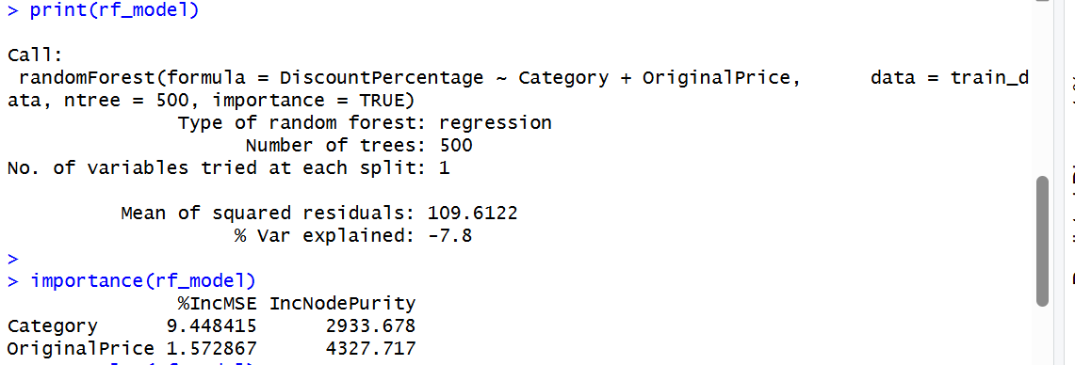

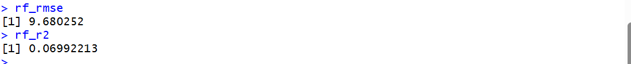
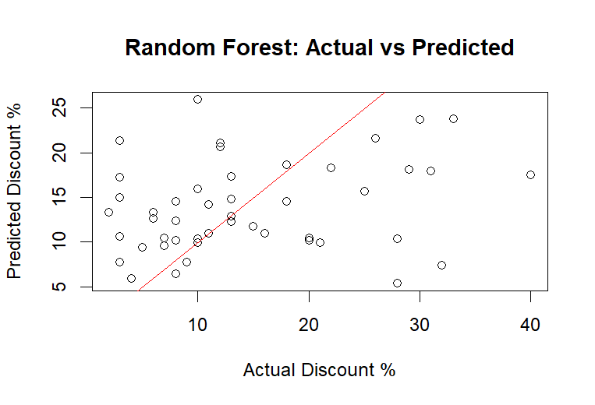

Interpretation:

- Weak Predictive Power – The model explains only about 7% of the variance (R² = 0.07), meaning it struggles to capture the relationship between predictors (Category, OriginalPrice) and DiscountPercentage.
- High Error Rate – With an RMSE of ~9.68, predictions deviate substantially from actual discount percentages, showing limited accuracy.
- Both Category and OriginalPrice contribute to predictions, but their influence is modest, suggesting that additional features (e.g., brand, product type, seasonal effects) are needed to improve performance.
- The scatter of points around the diagonal line shows that many predictions deviate from actual discount percentages, indicating inconsistent model performance. The model tends to underpredict higher discounts, as seen by points falling below the red line in the upper range of actual discounts.

      - Classification Model
Result: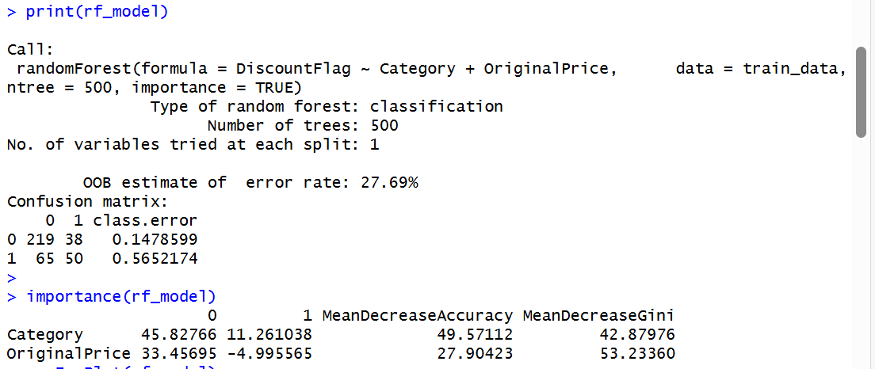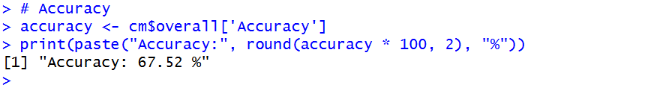
Interpretation:
- The model predicts discount availability fairly well overall. However, it performs much better for non-discounted products (error ~15%) than discounted ones (error ~56%).
- Both Category and OriginalPrice matter, with price driving tree splits and category boosting accuracy.
- The model achieved 67.52% accuracy, meaning it correctly predicted discount presence for about two-thirds of the products. This suggests moderate classification performance, with room for improvement—especially in identifying discounted items more reliably.
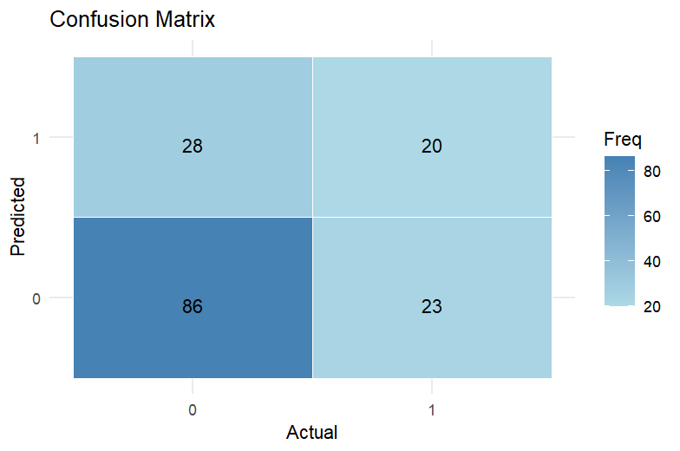
Interpretation of confusion matrix:
- True Positives (20) and True Negatives (86) show correct predictions for both classes.
- False Positives (23) and False Negatives (28) indicate misclassifications, especially for discounted products.
- The model performs better at identifying non-discounted items, but struggles with detecting discounts accurately.

Conclusion
The e-commerce analysis showed that discounts vary significantly across categories, with some offering higher savings and more frequent promotions. ANOVA and Chi-squared tests confirmed strong category-level effects on both prices and discount availability. While descriptive statistics identified products and categories with the greatest saving potential, predictive modeling using Random Forest achieved only moderate accuracy, performing better for non-discounted items than discounted ones. Overall, the study met its objectives by quantifying prices, discount patterns, and savings impact, while highlighting the need for richer features and advanced models to improve discount prediction.

