IDB LAB TASK

1.

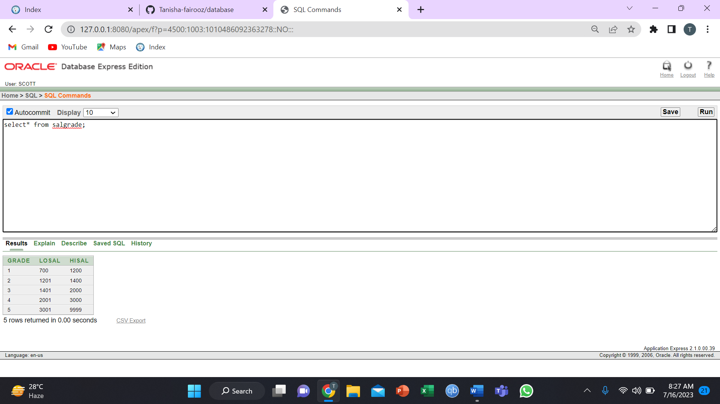

2.

3.

4.

5.

6.

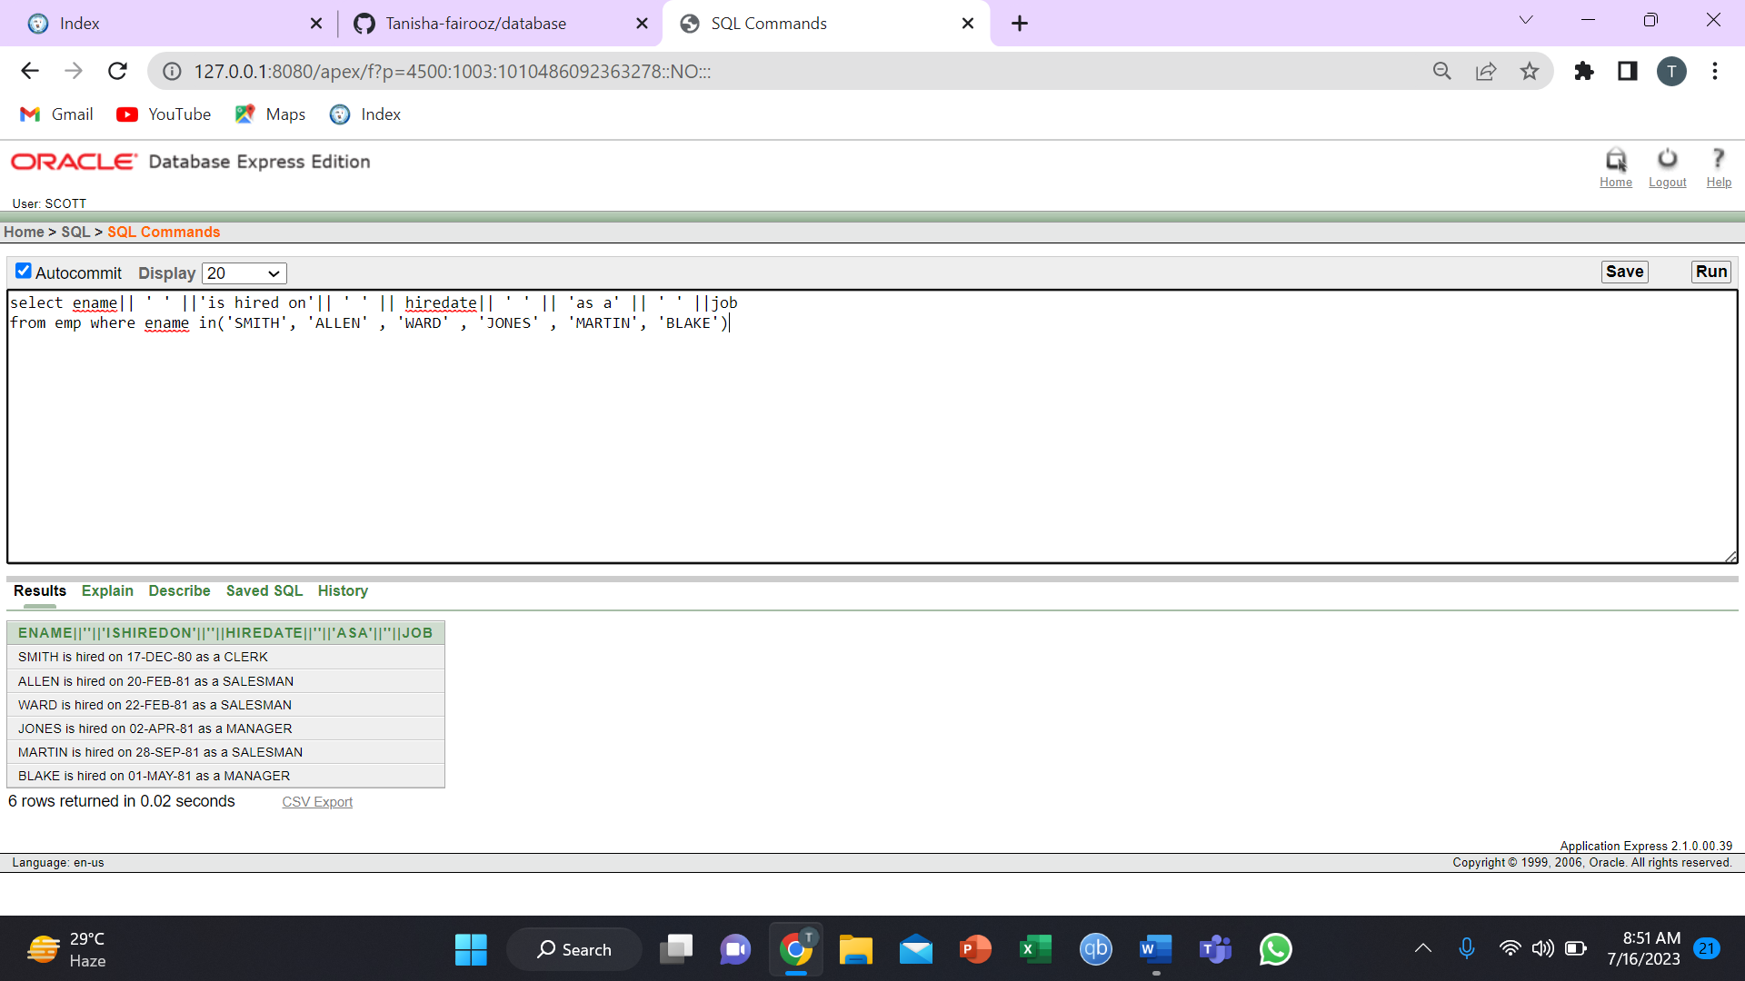

7.

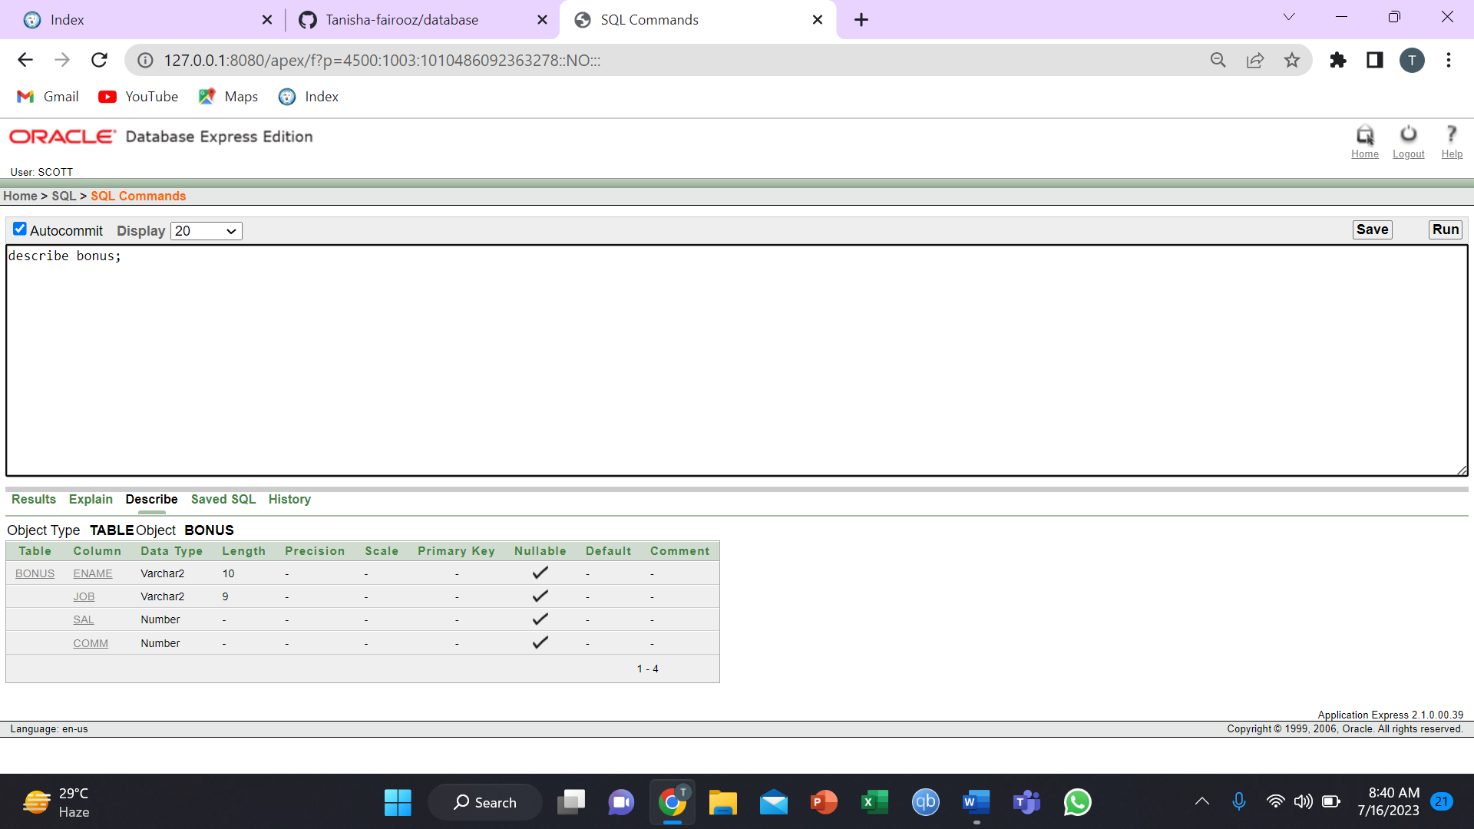

8.

