**IDB LAB-3**

Lecture – 4:

1. Using WHERE clause:

select ename,job, deptno from emp where job='CLERK' ;

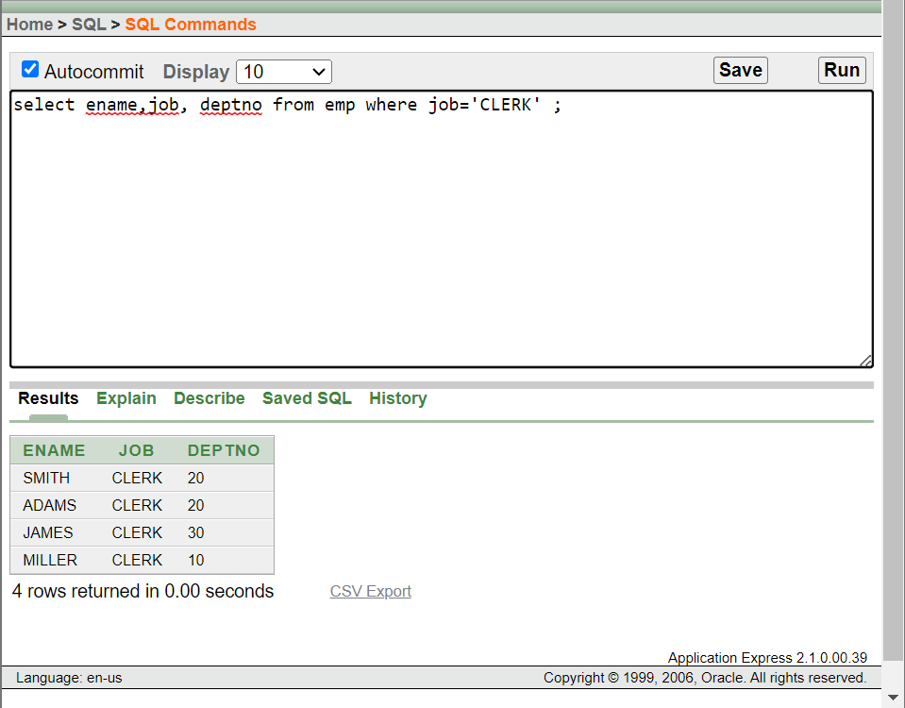

1. Using the Comparison Operators:

select ename, sal, comm from emp where sal<=comm;

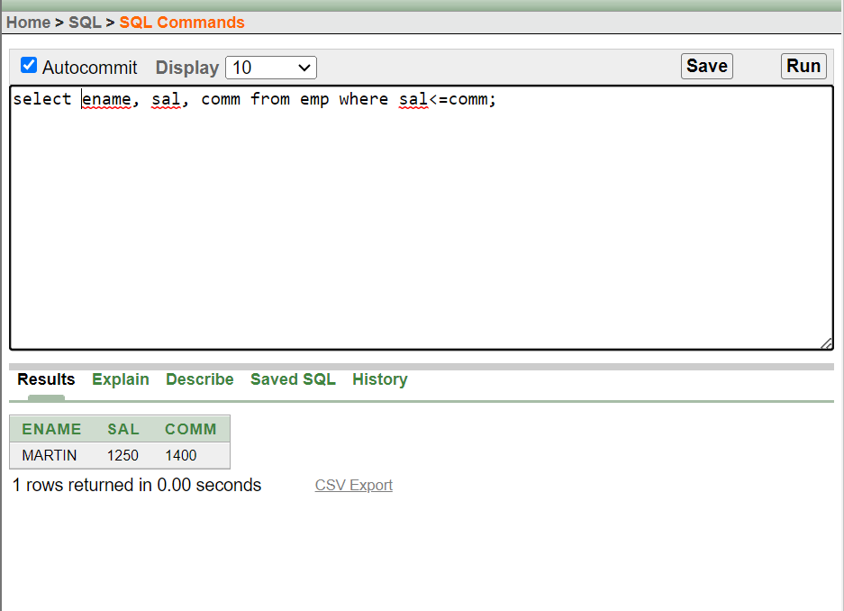

1. Using the BETWEEN Operator

select ename, sal from emp where sal between 1000 and 1500;

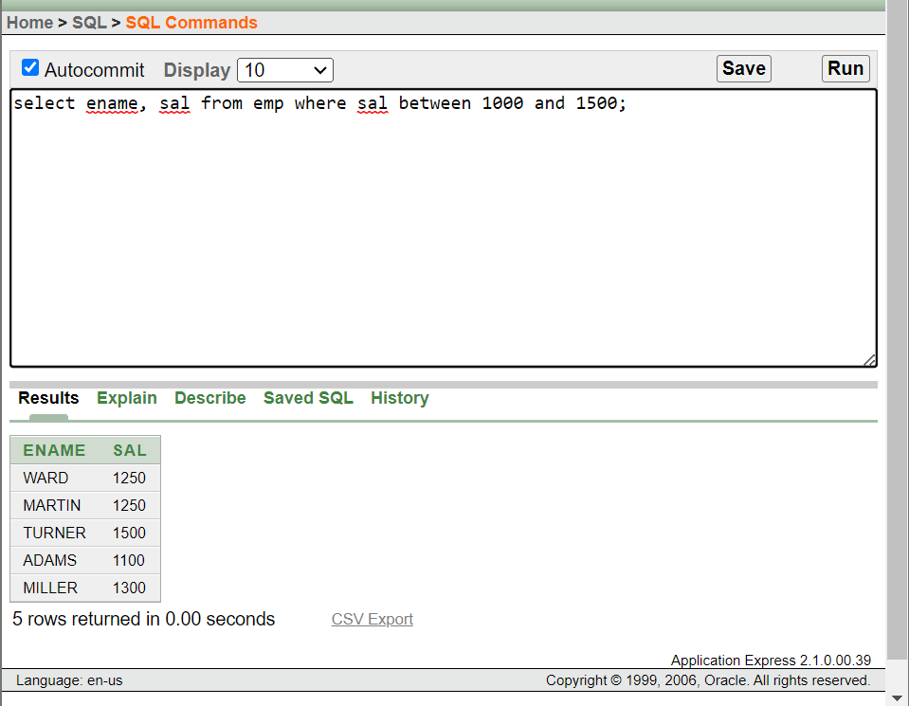

1. Using the IN Operator:

select empno, ename, sal,mgr from emp where mgr in(7902, 7566, 7788);

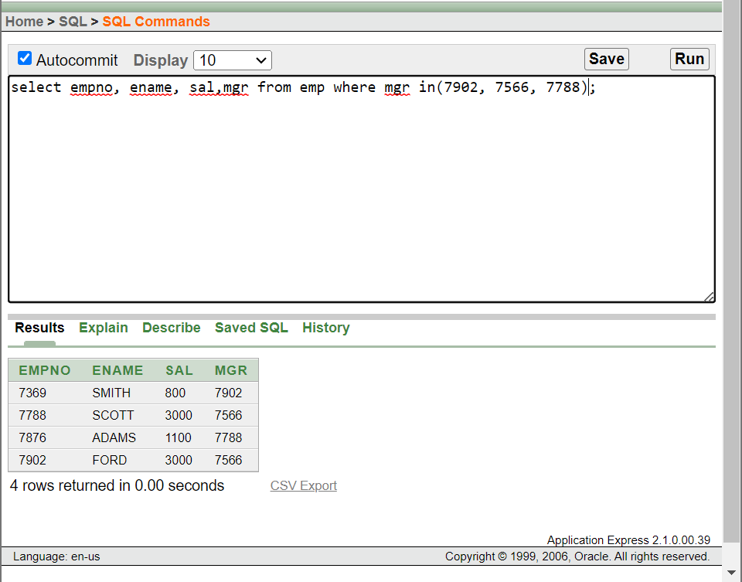

1. Using the LIKE Operator:

i. select ename from emp where ename like 'S%' ;

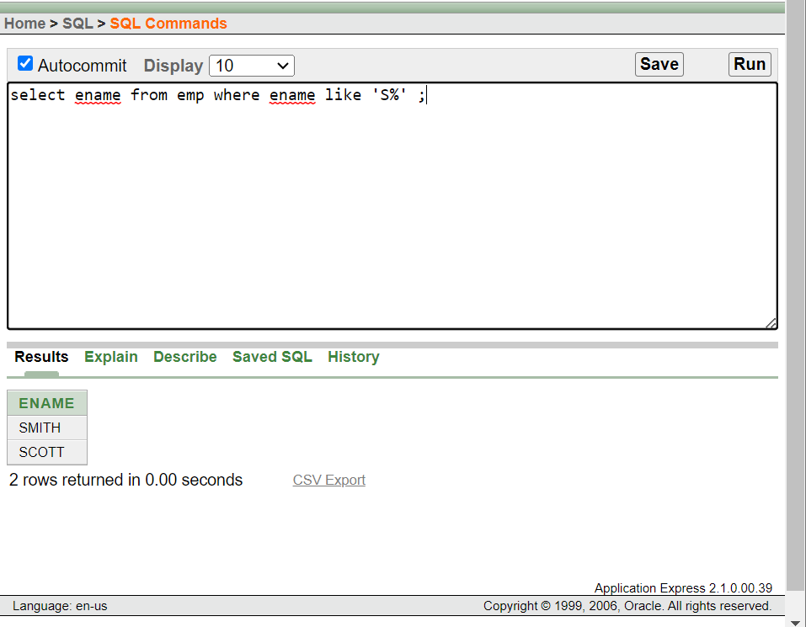

ii. select ename from emp where ename like '_A%' ;

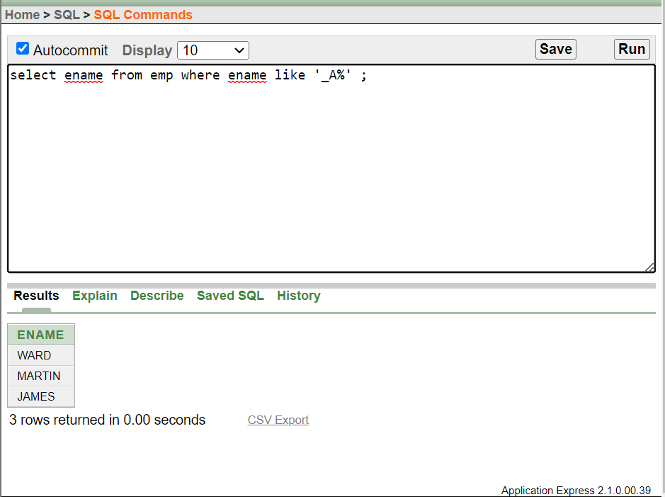

1. Using the IS NULL Operator:

select ename, mgr from emp where mgr is null ;

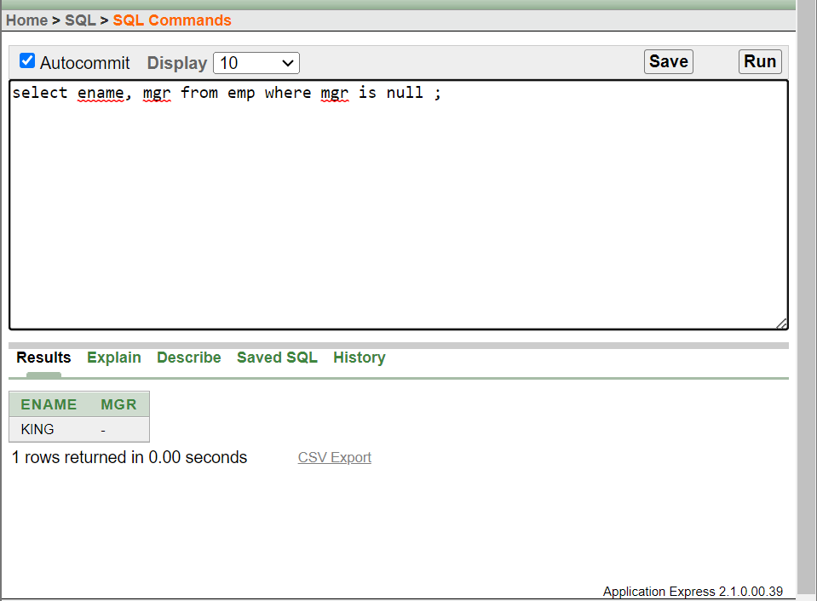

1. Using the AND Operator

select empno, ename , job, sal from emp where sal>=1000 and job= 'CLERK';

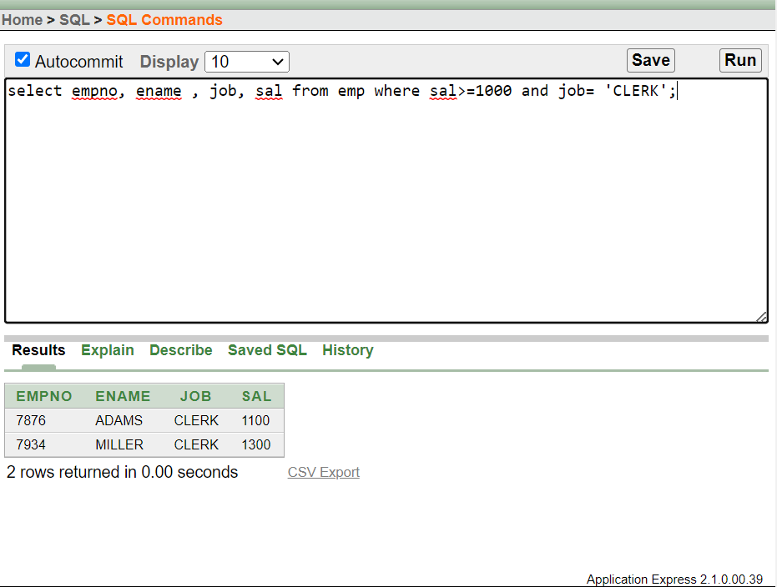

1. Using the OR Operator

select empno, ename , job, sal from emp where sal>=1000 or job= 'CLERK';

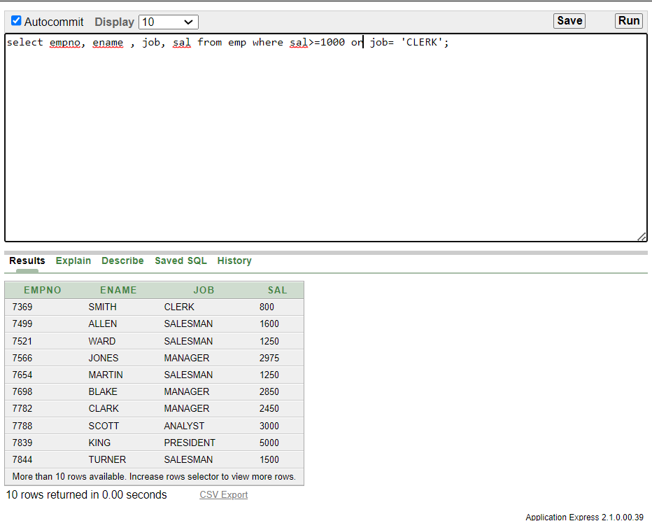

1. Using the NOT Operator

select ename , job from emp where job not in ('CLERK','MANAGER','ANALYST');

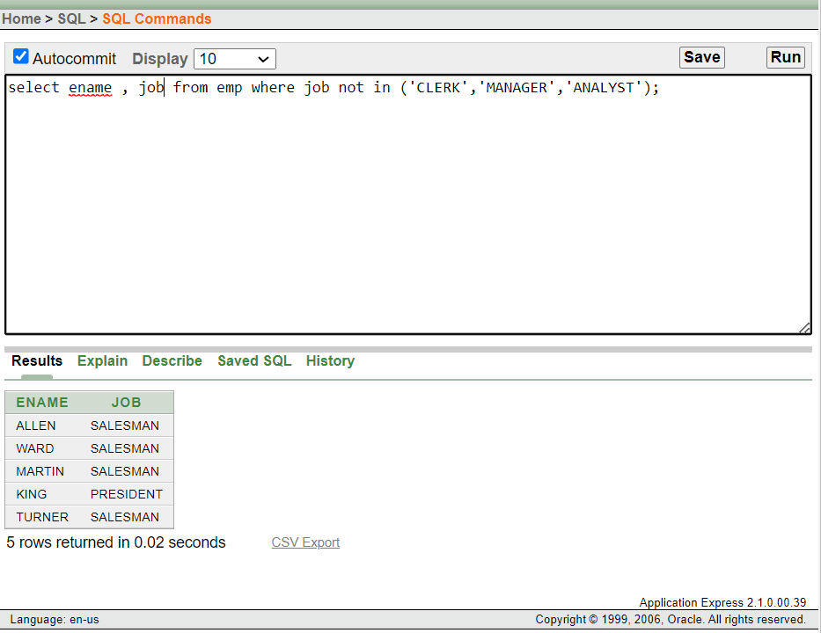

1. Rules of Precedence:

select ename , job, sal from emp where (job='SALESMAN' or job= 'PRESIDENT')

and sal> 1500;

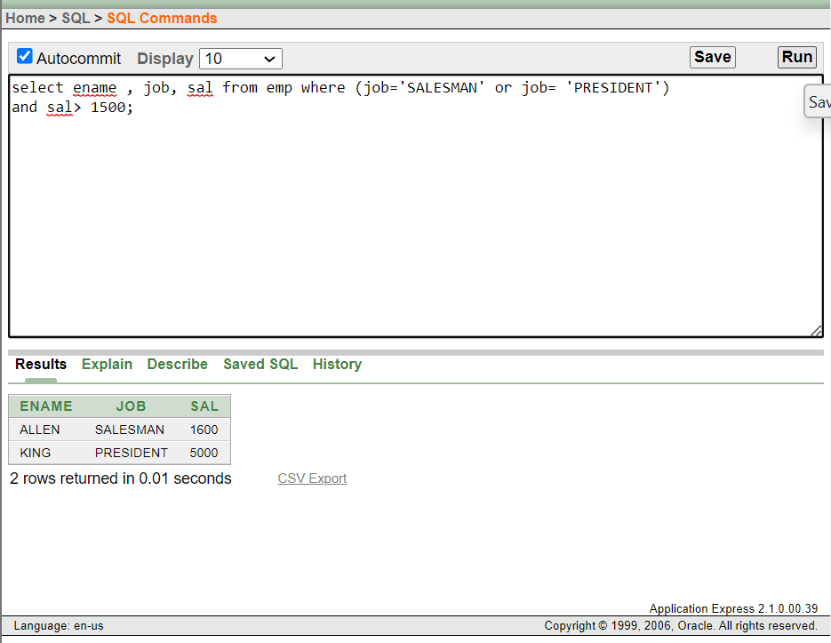

1. Rules of Precedence:

select ename , job, sal from emp where job='SALESMAN' or job= 'PRESIDENT'

and sal> 1500;

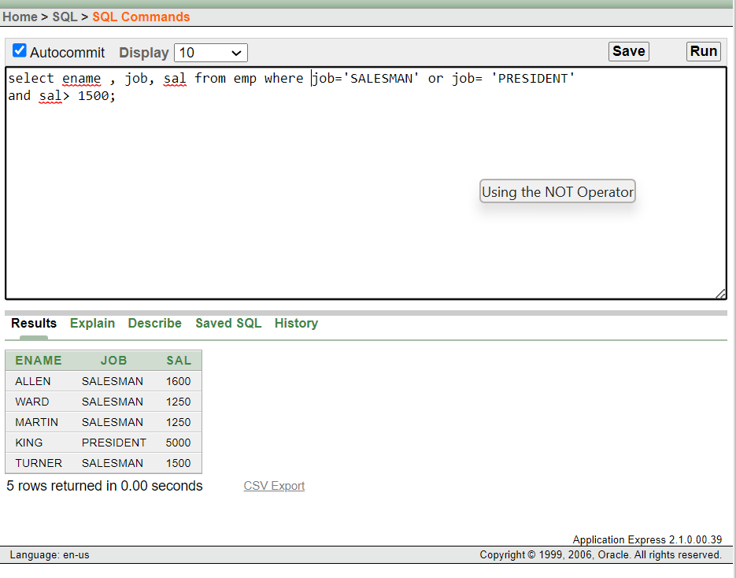

1. ORDER BY Clause:

select ename , job, deptno,hiredate from emp order by hiredate

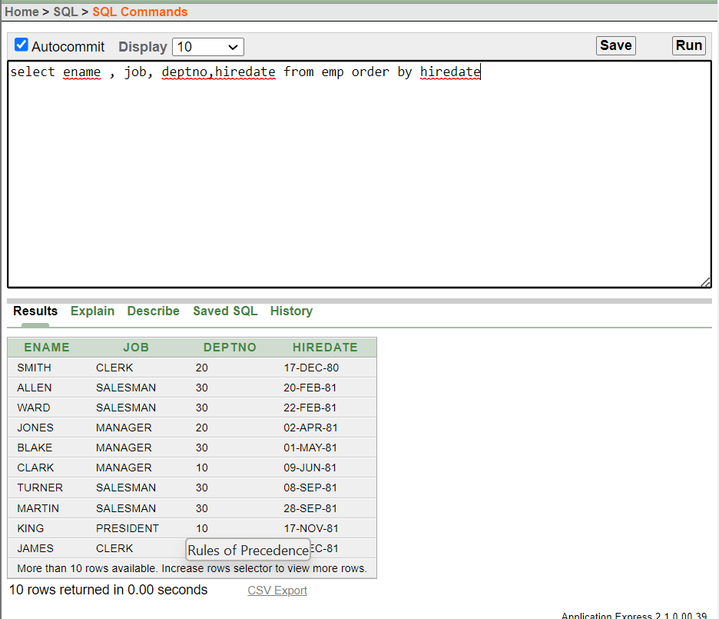

1. Sorting in Descending Order:

select ename , job, deptno,hiredate from emp order by hiredate desc;

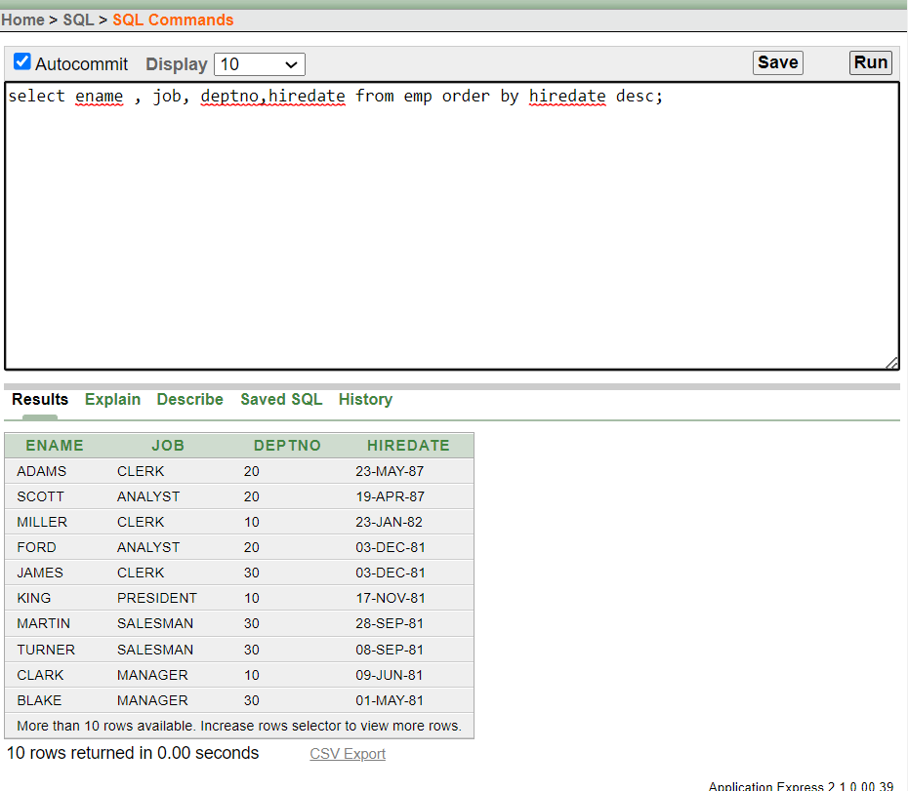

1. Sorting in Column Alias:

select empno, ename, sal*12 annsal from emp order by annsal;

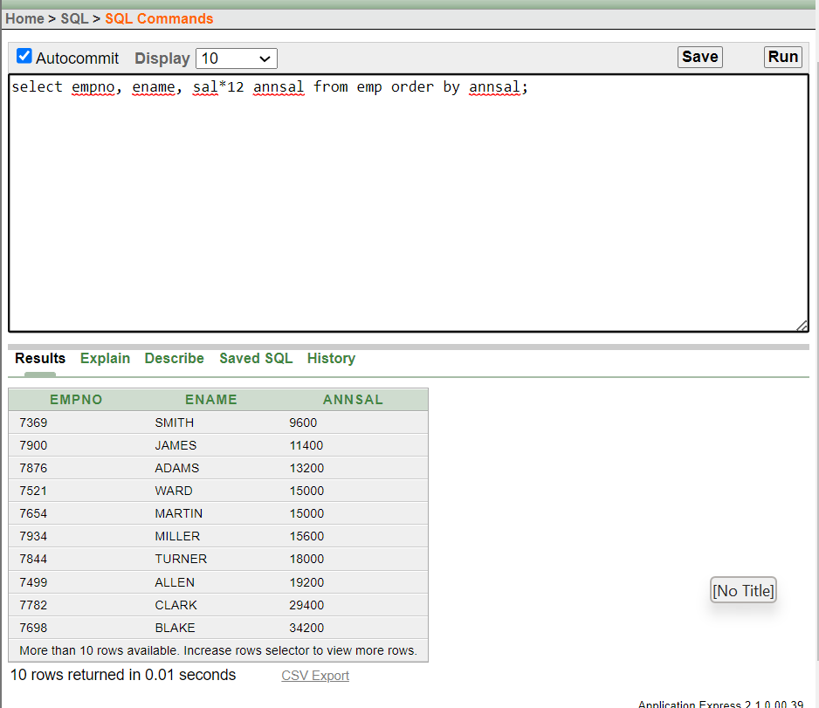

1. Sorting by Multiple Columns:

select ename, deptno, sal from emp order by deptno, sal DESC;

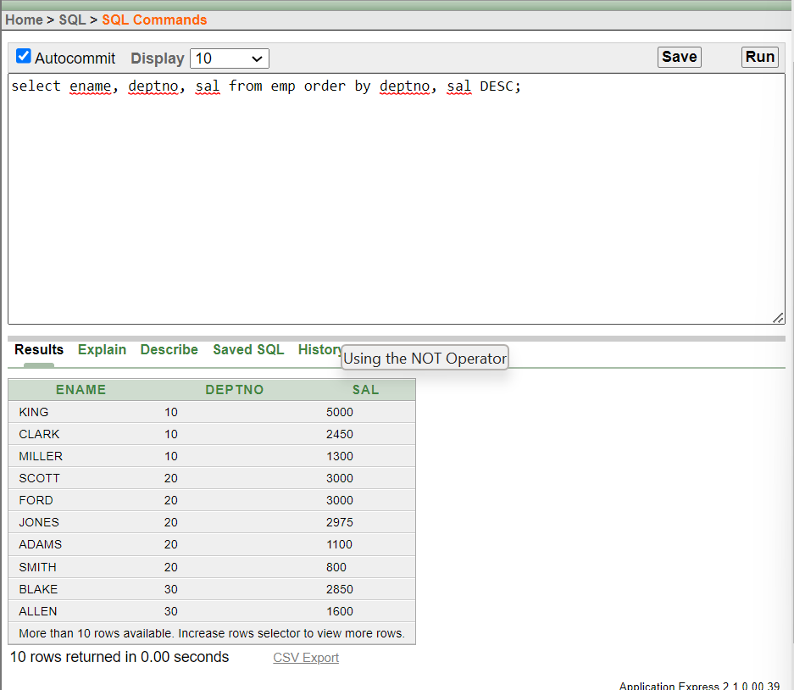

Lecture- 6:

1. Using Case Conversion Functions

select empno, ename, deptno from emp where ename= 'blake';

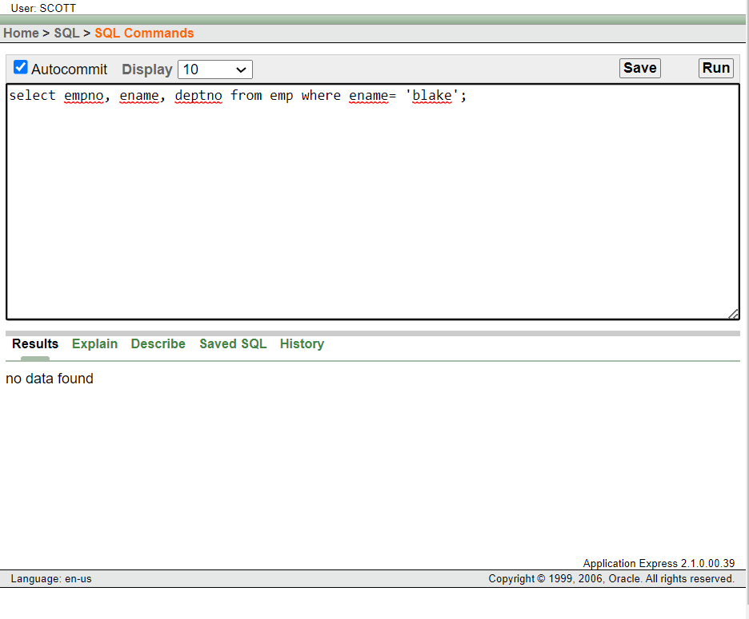

select empno, ename, deptno from emp where lower(ename)= 'blake' ;

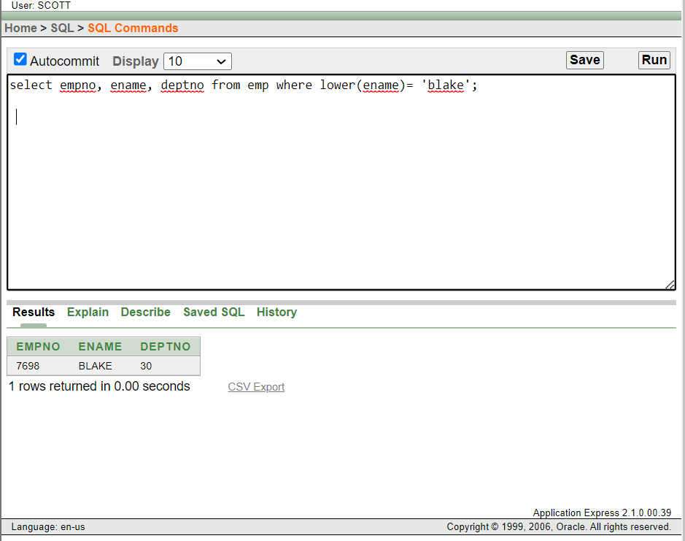

1. Using the Character Manipulation Functions:

select ename, concat(ename,job), length(ename), instr(ename,'A') from emp where substr(job,1,5) = 'SALES' ;

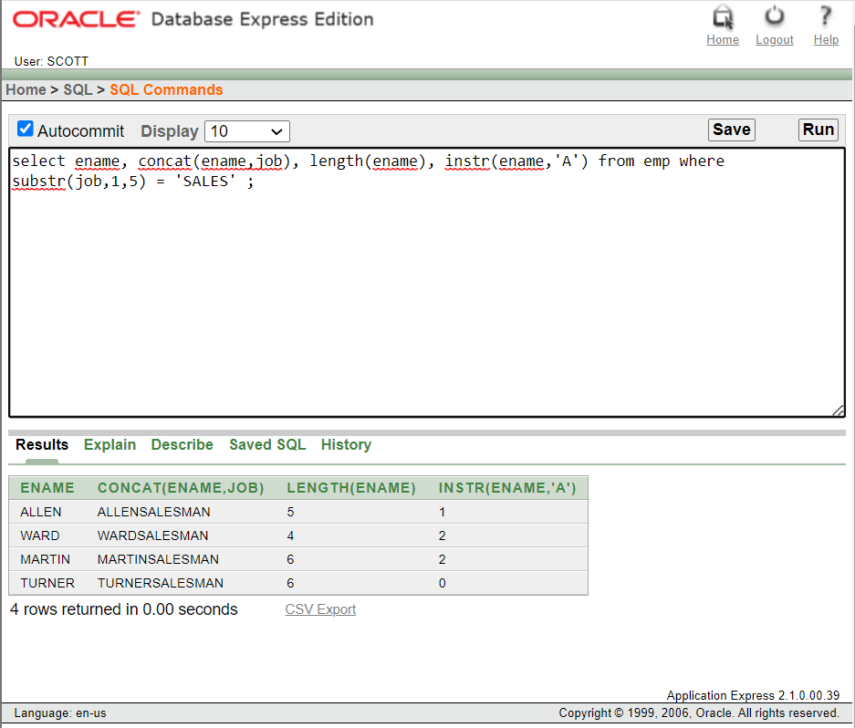

1. Using the ROUND Function:

select round (45.923,2) , round(45.923,0), round (45.923,-1) from dual;

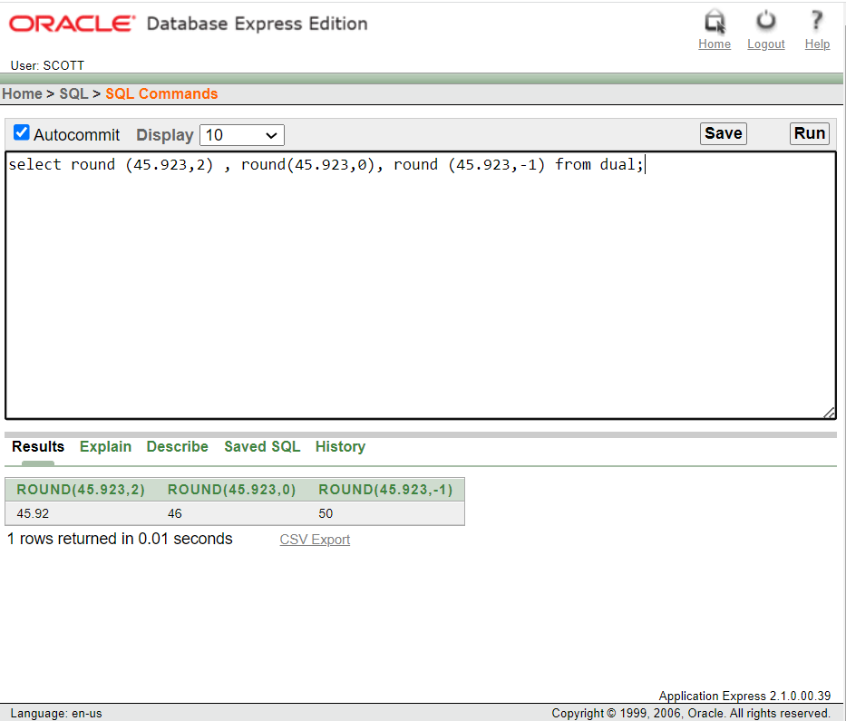

1. Using the TRUNC Function:

select trunc(45.923,2), trunc(45.923), trunc (45.923,-1) from dual;

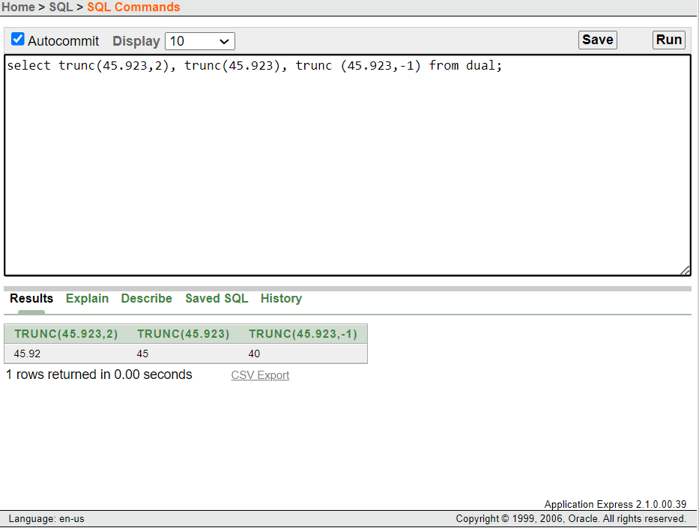

1. Using the MOD Function:

SELECT ename, sal, comm, MOD(sal, comm) from emp where job = 'SALESMAN';

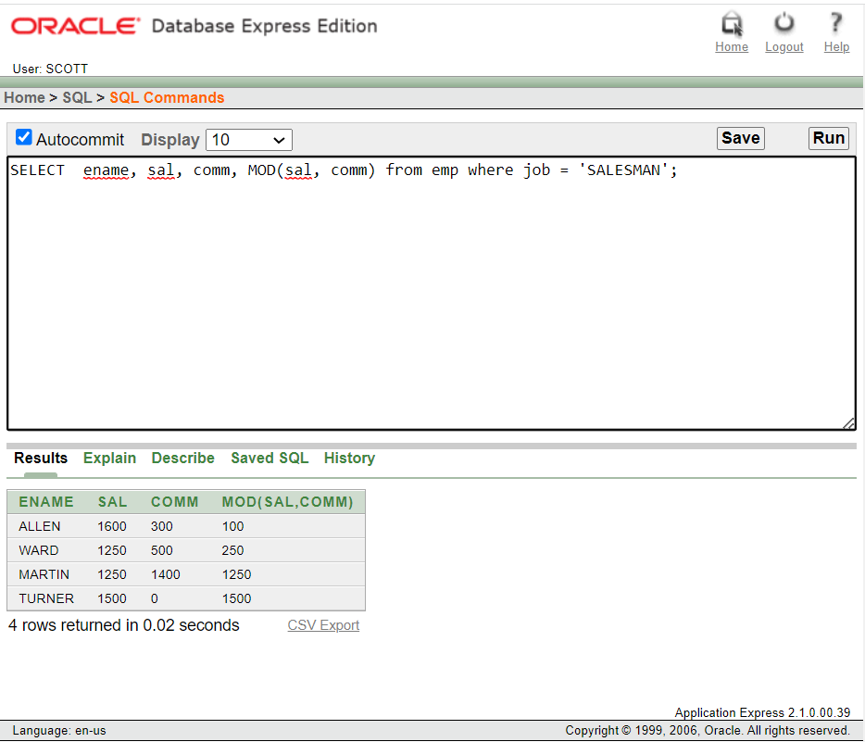

1. Using Arithmetic Operators with Dates:

select ename, (SYSDATE-hiredate)/7 weeks from emp where deptno = 10;

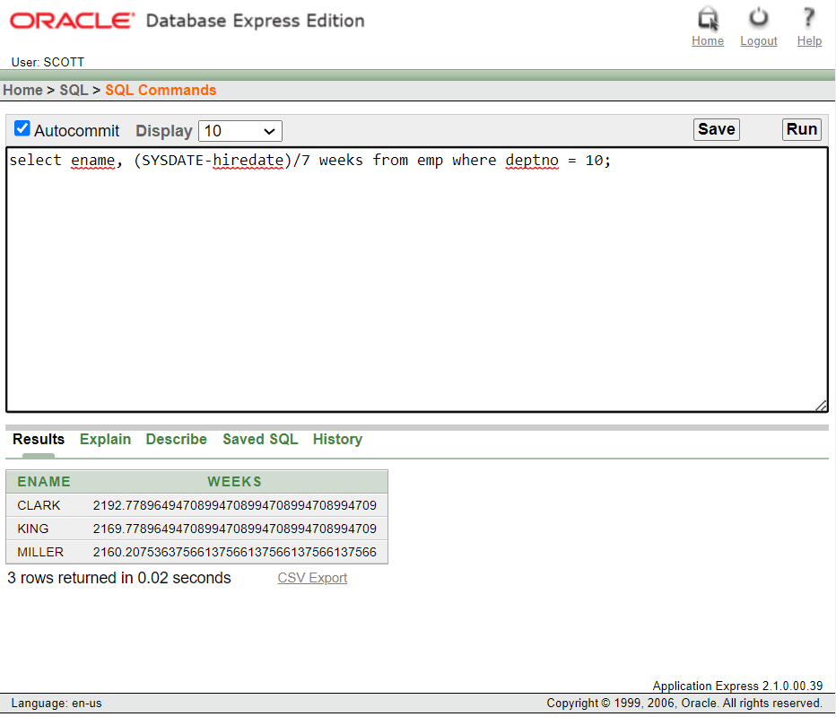

1. Using TO_CHAR Function with Dates:

select ename , TO_CHAR(hiredate, 'fmDD Month YYYY') HIREDATE from emp;

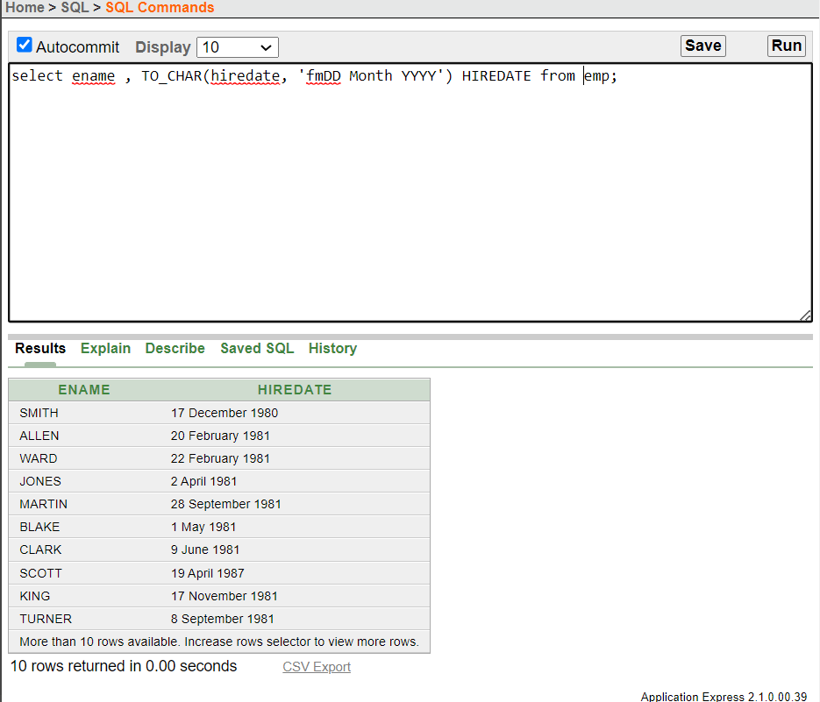

1. Using TO_CHAR Function with Numbers:

select TO_CHAR(sal,'$99,999') salary from emp where ename = 'SCOTT';

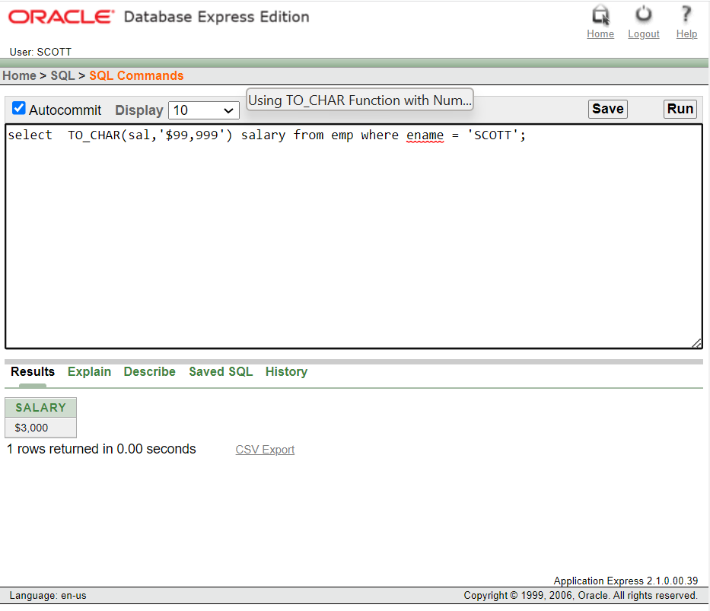

1. Using the NVL Function:

select ename, sal, comm, (sal*12)+NVL(comm,0) from emp;

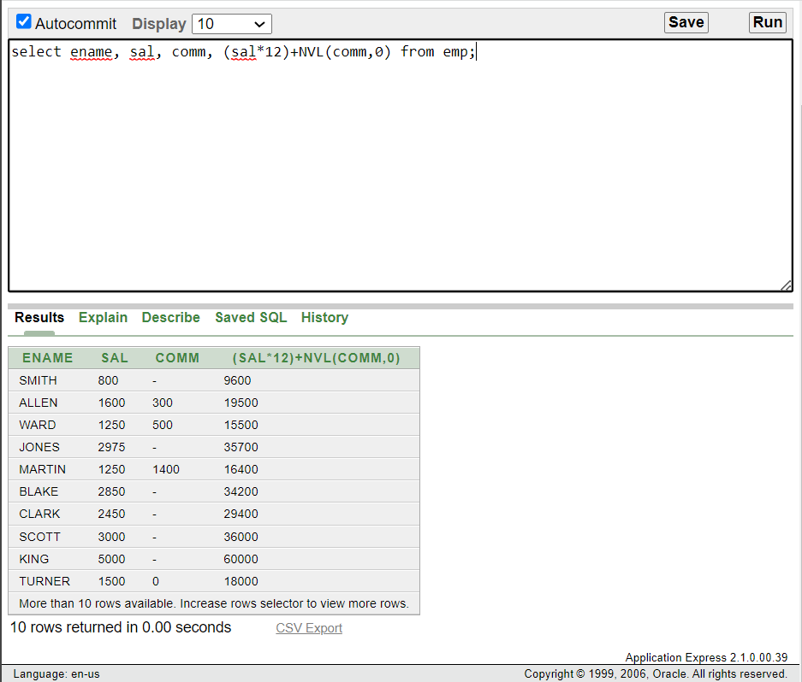

1. Using the DECODE Function:

select job, sal, decode( job, 'ANALYST', SAL*1.1, 'CLERK' , SAL*1.15, 'MANAGER', SAL*1.20, SAL) REVISED_SALARY FROM EMP;

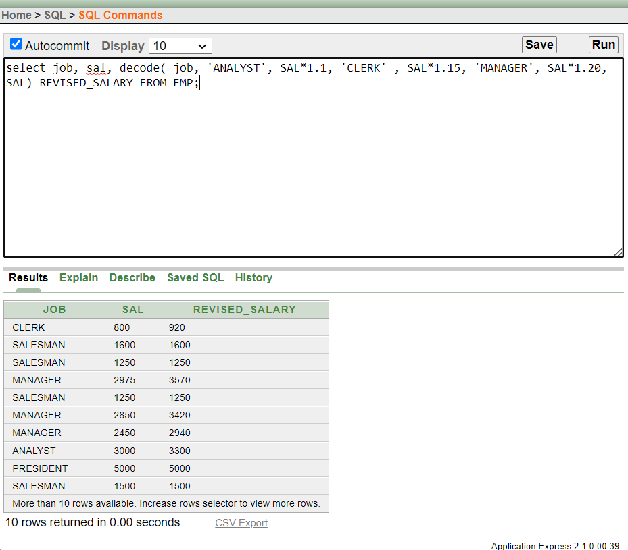

1. Nesting Functions:

select ename, NVL(TO_CHAR(mgr), 'No Manager') from emp where mgr is null;

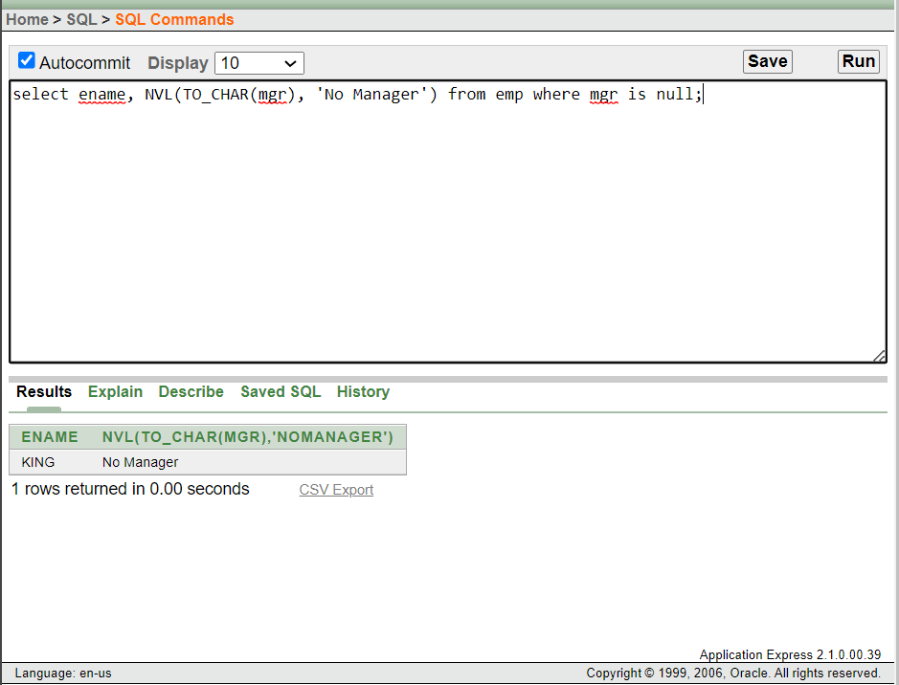

Lecture- 8:

1. Using AVG and SUM Functions:

select avg(sal) , max(sal), min(sal), sum(sal) from emp where job like 'SALES%';

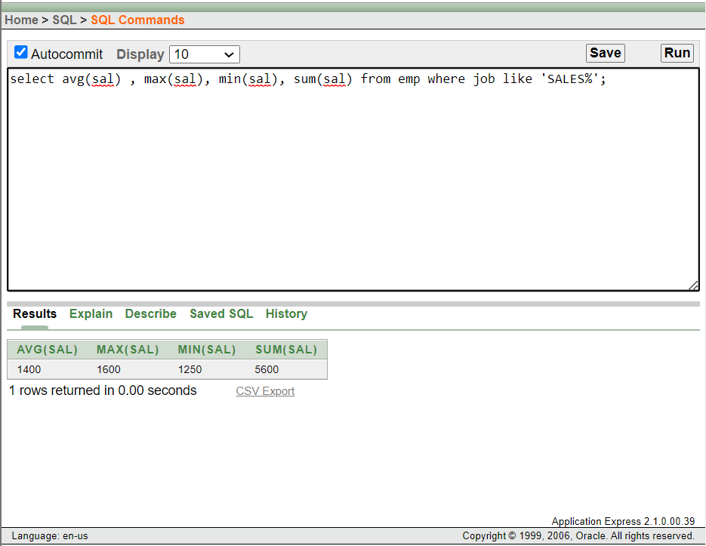

1. Using MIN and MAX Functions:

select min(hiredate), max(hiredate) from emp;

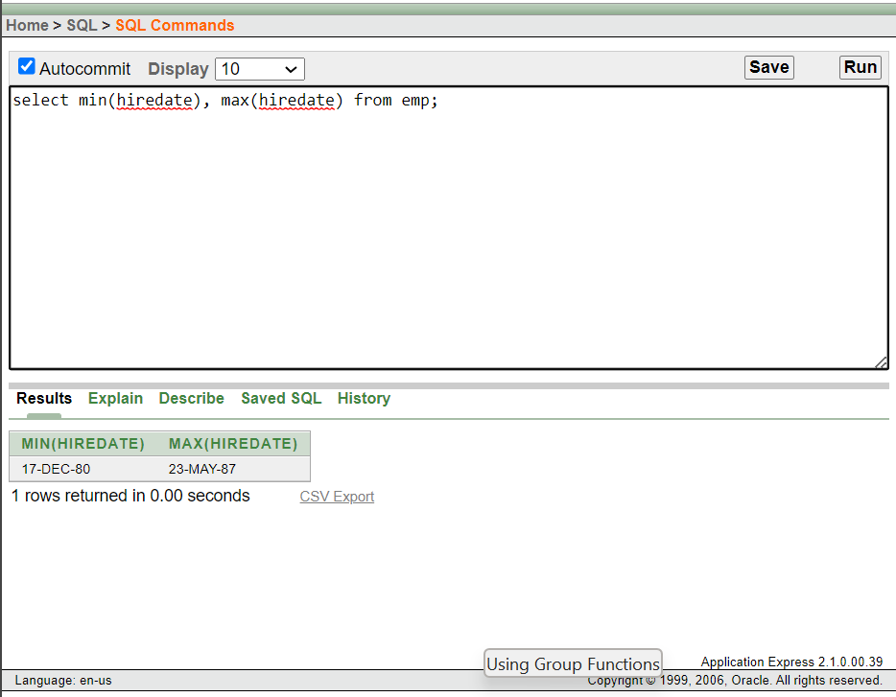

1. Using the COUNT Function:

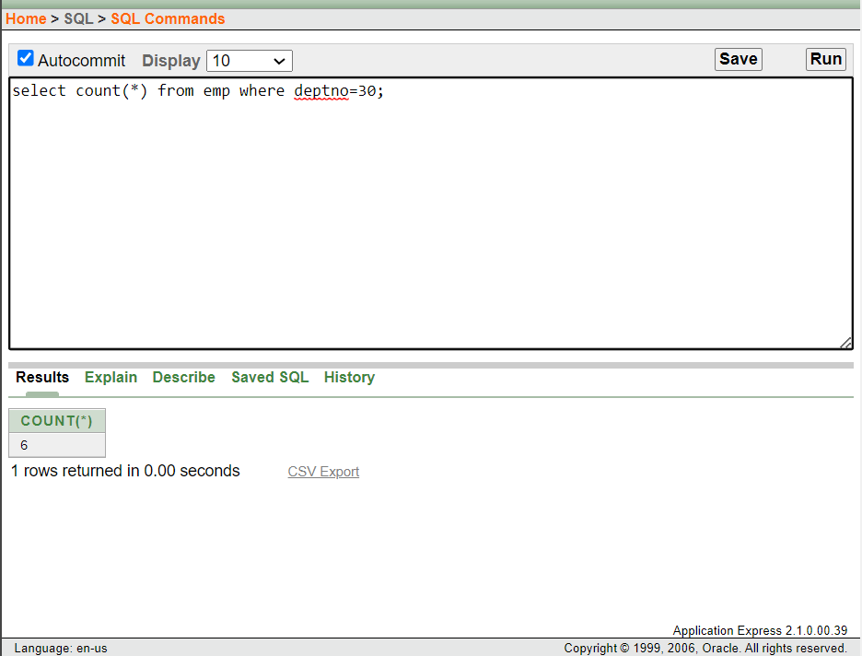

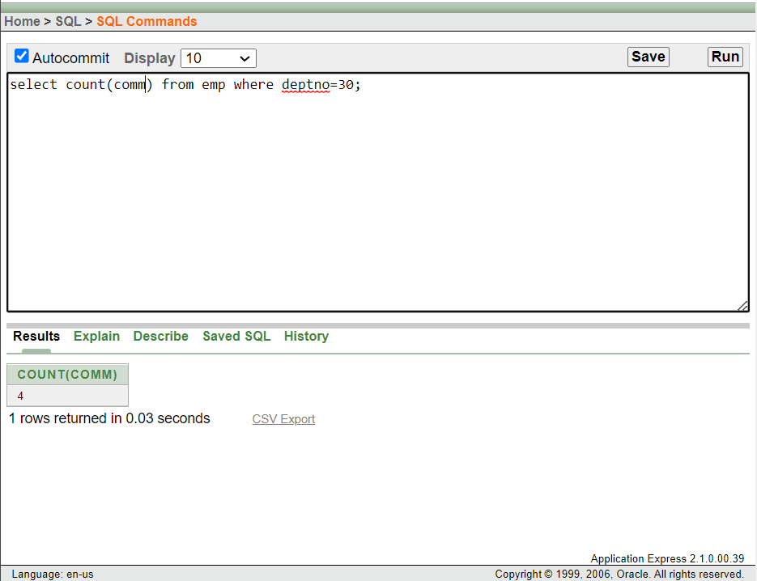

1. Group Functions and Null Values:

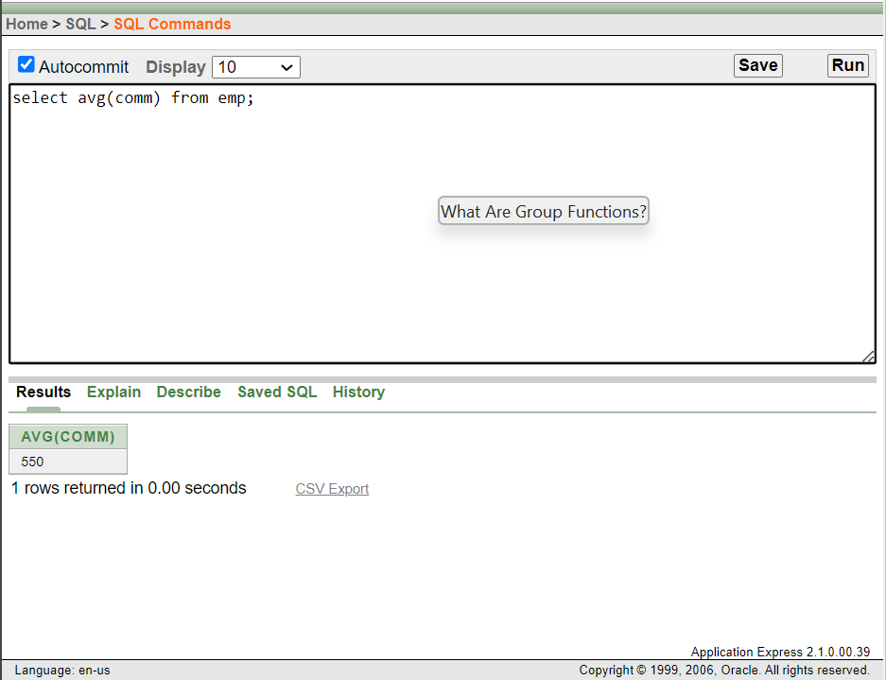

1. Using the NVL Function with Group Functions:

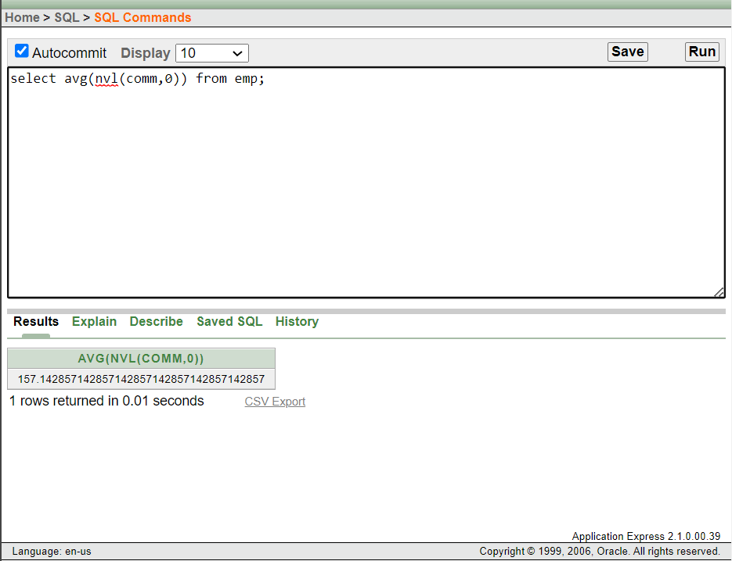

1. Using the GROUP BY Clause:

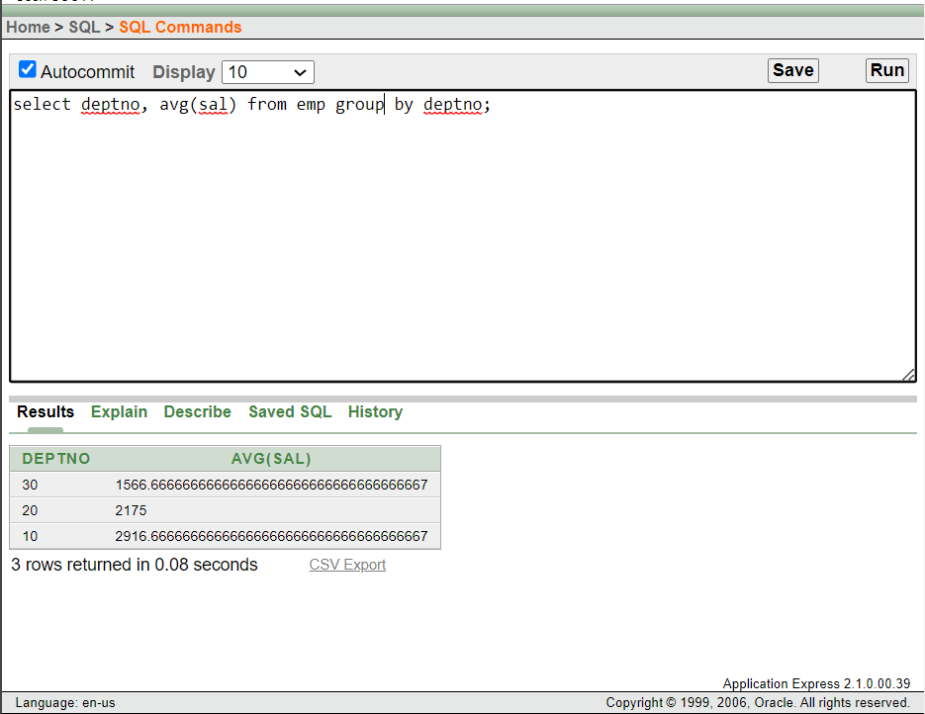

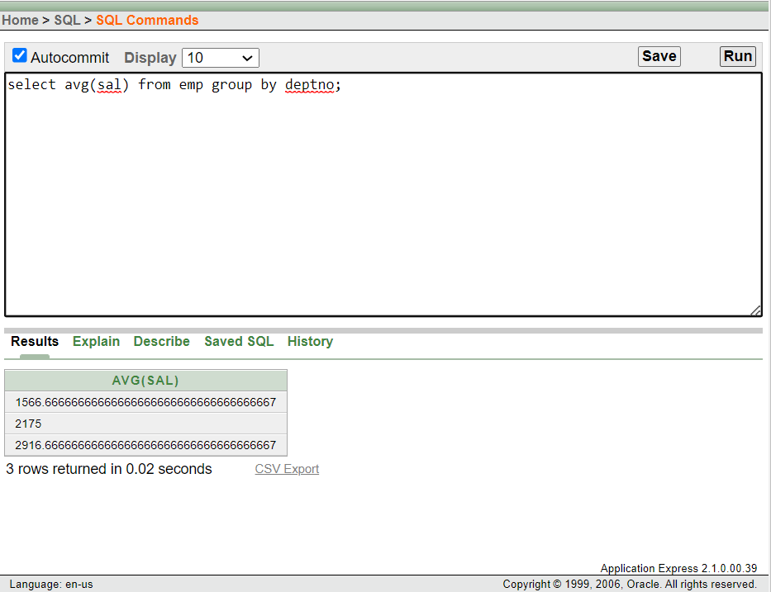

1. Using the GROUP BY Clause on Multiple Columns:

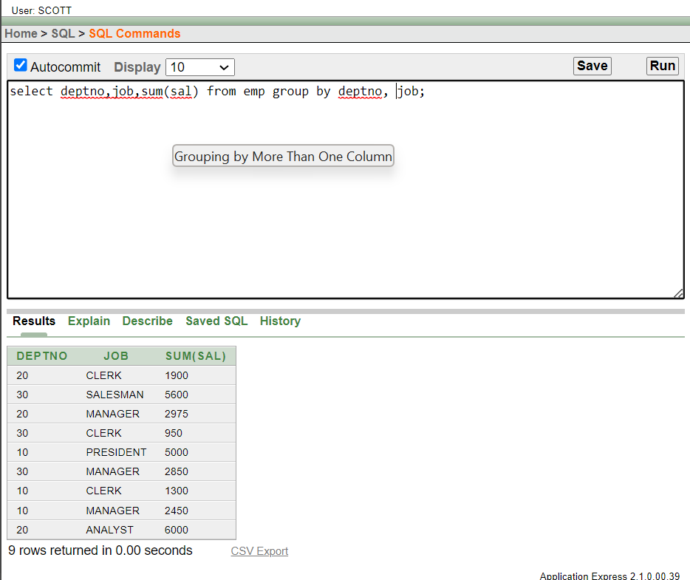

1. Using having clause :

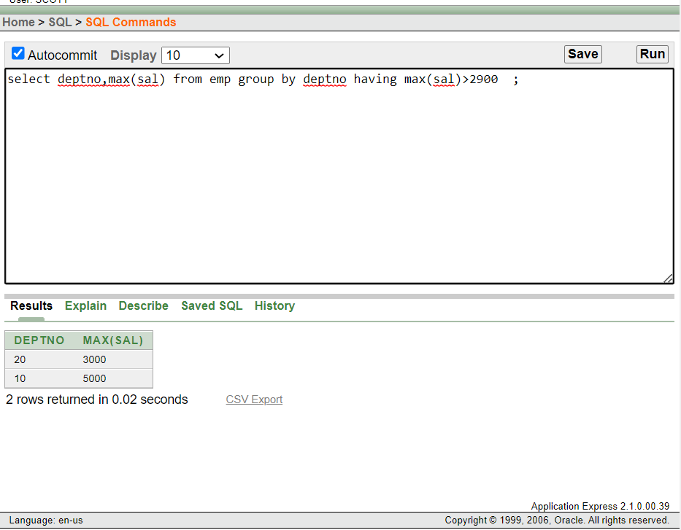

1. Nesting Group function:

