**IDB LAB-4 ( 25/06/23)**

Creating table:

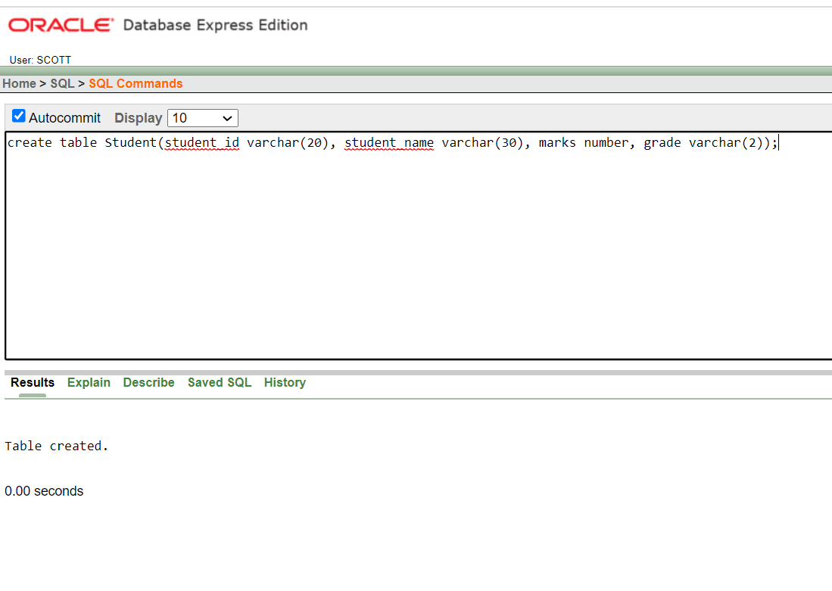

Adding new column:

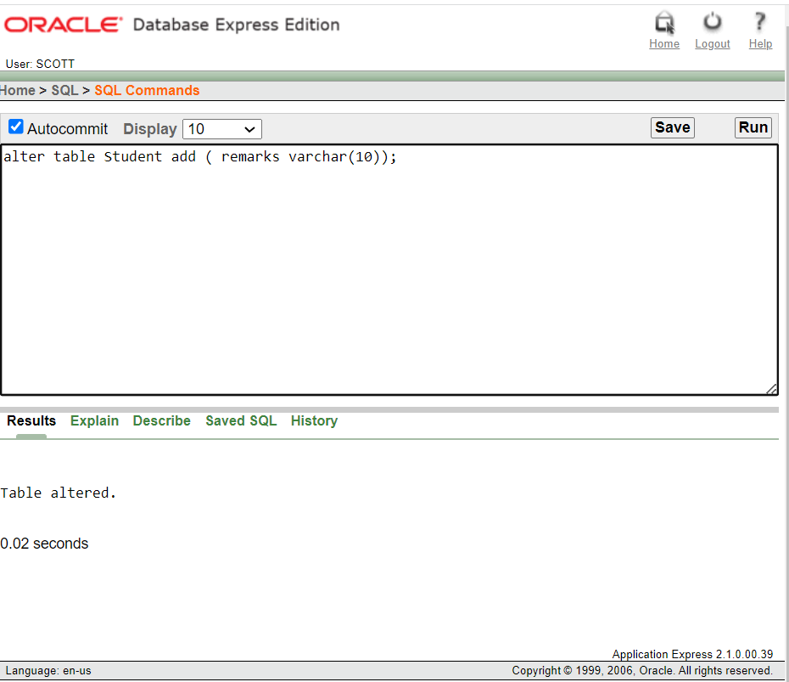

Inserting data:

Showing Table:

