
FALL SEMESTER 2025-26
BEVD301P-ASIC Design Lab
TASK 2
Name : Tanisha Gupta Reg. No:23BVD0030
Slot: L5+L6 Date:29/08/2025

Logic Synthesis and Optimisation
Aim:
To perform logic synthesis and optimisation of 8 bit unsigned divider.
1. To Find Tmin.
2. To find out and compare the performance, area and power of traditional ASIC Design flow before and after power optimisation.
3. To find out and compare performance, area and power of Traditional ASIC Design flow and PLE script after power optimisation.
Tool Used : Cadence Genus tool

Outputs:
Tmax=650 ps , this is the time at which slack=0 in Traditional ASIC Design Flow before power optimisation.
Traditional ASIC Design outputs(before power optimisation) :
Timing:
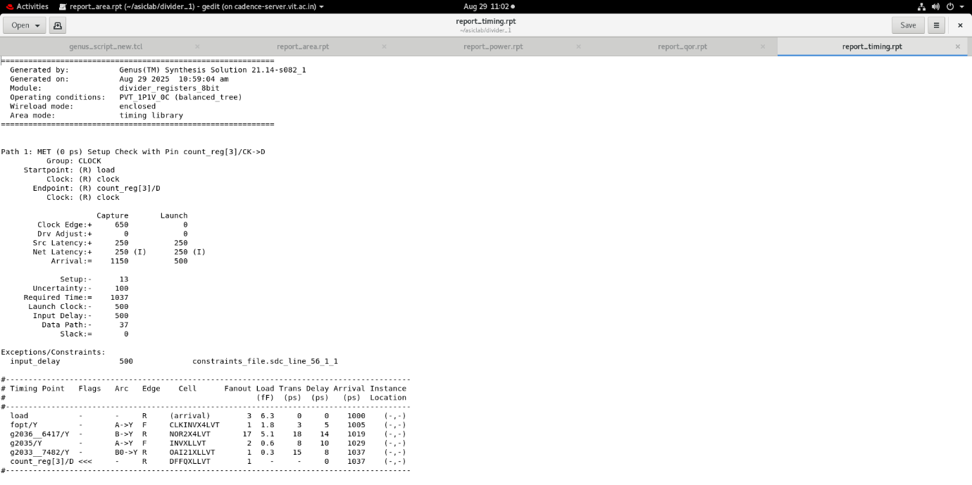
Area:
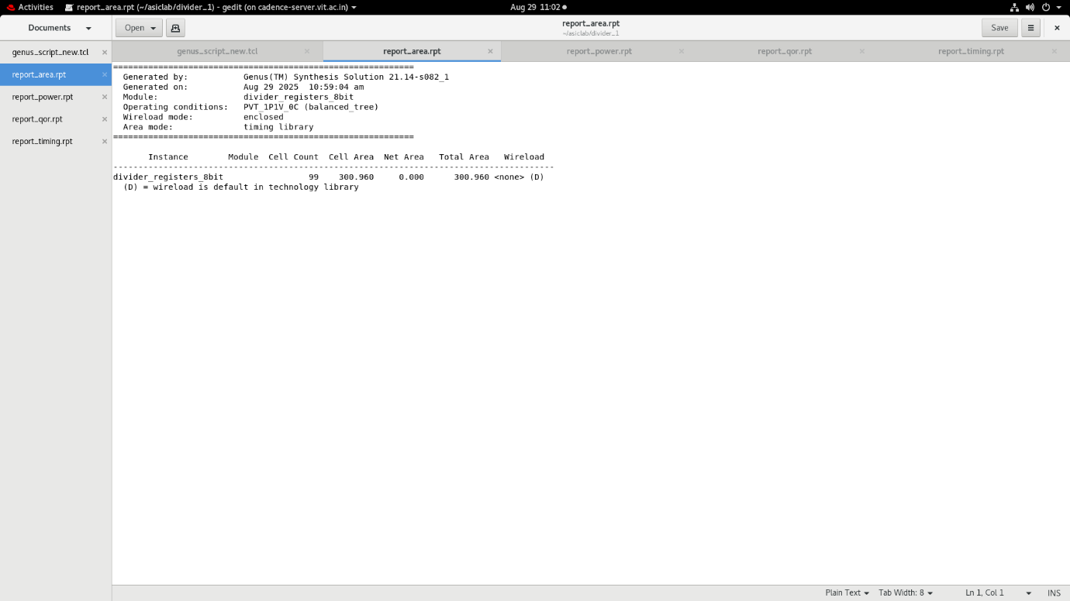

Power:
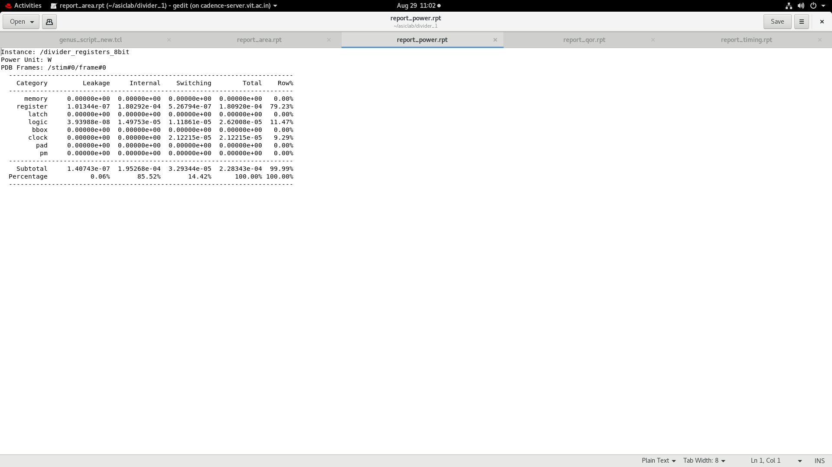
Qor :
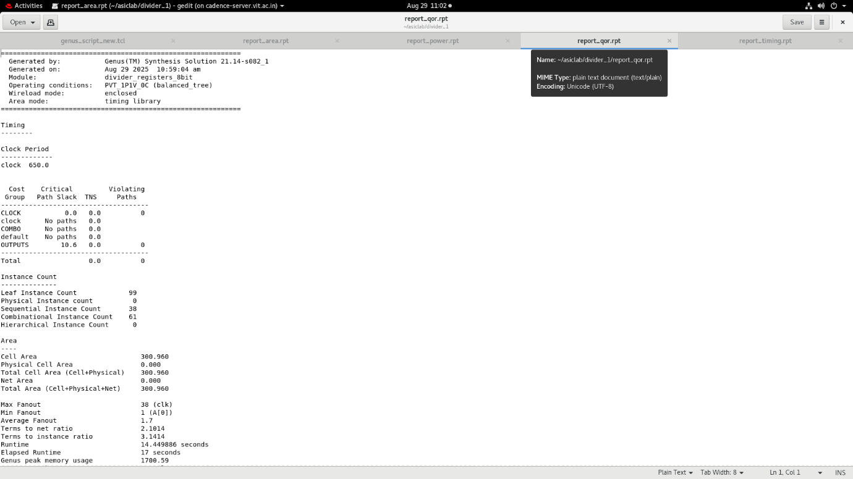

Clock gating:
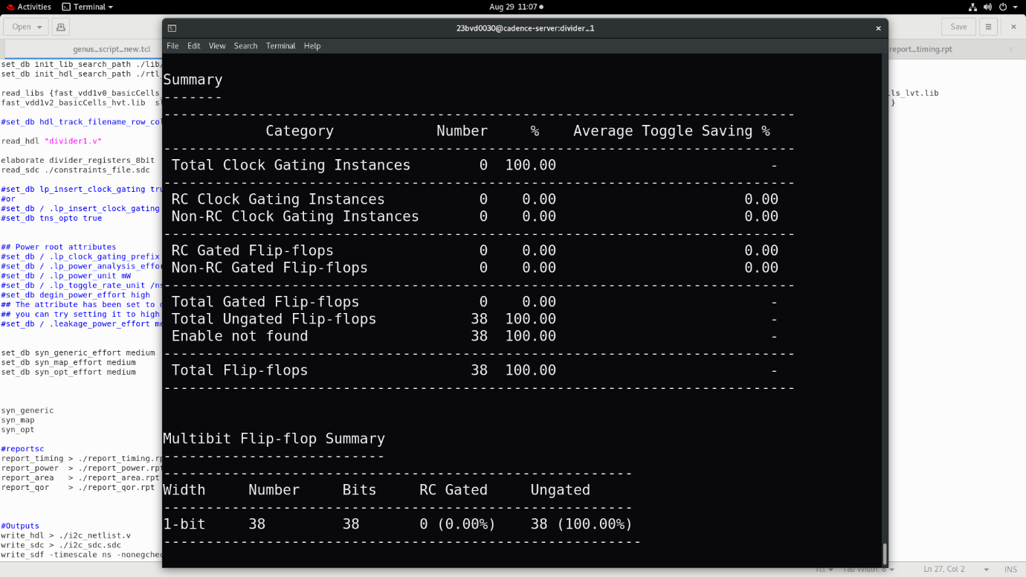
Traditional ASIC Design outputs (After Power Optimisation)
Timing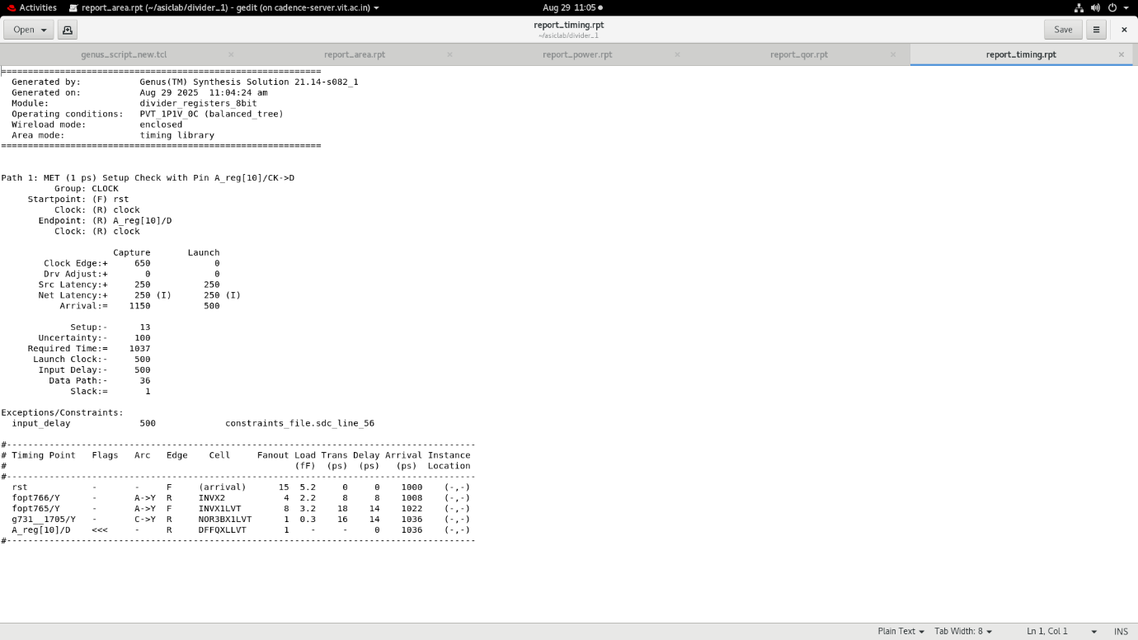

Area
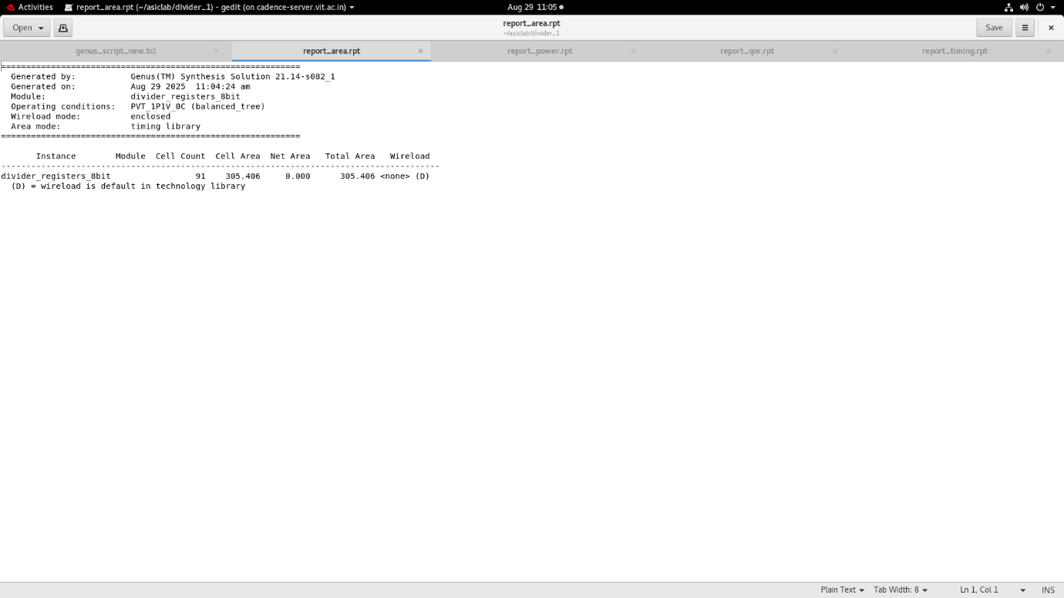Power
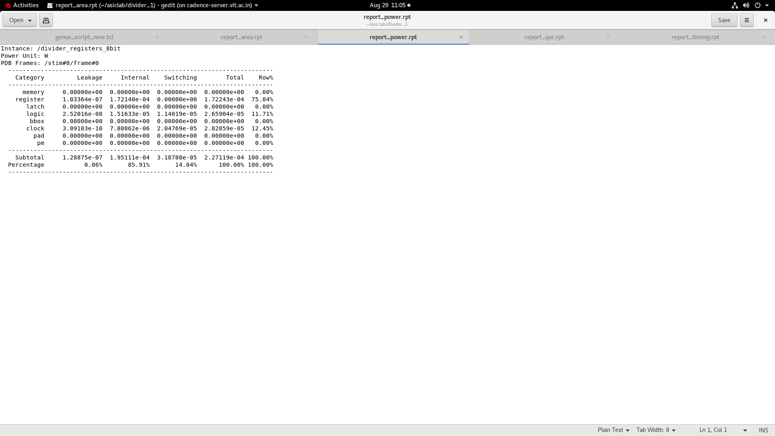

Qor
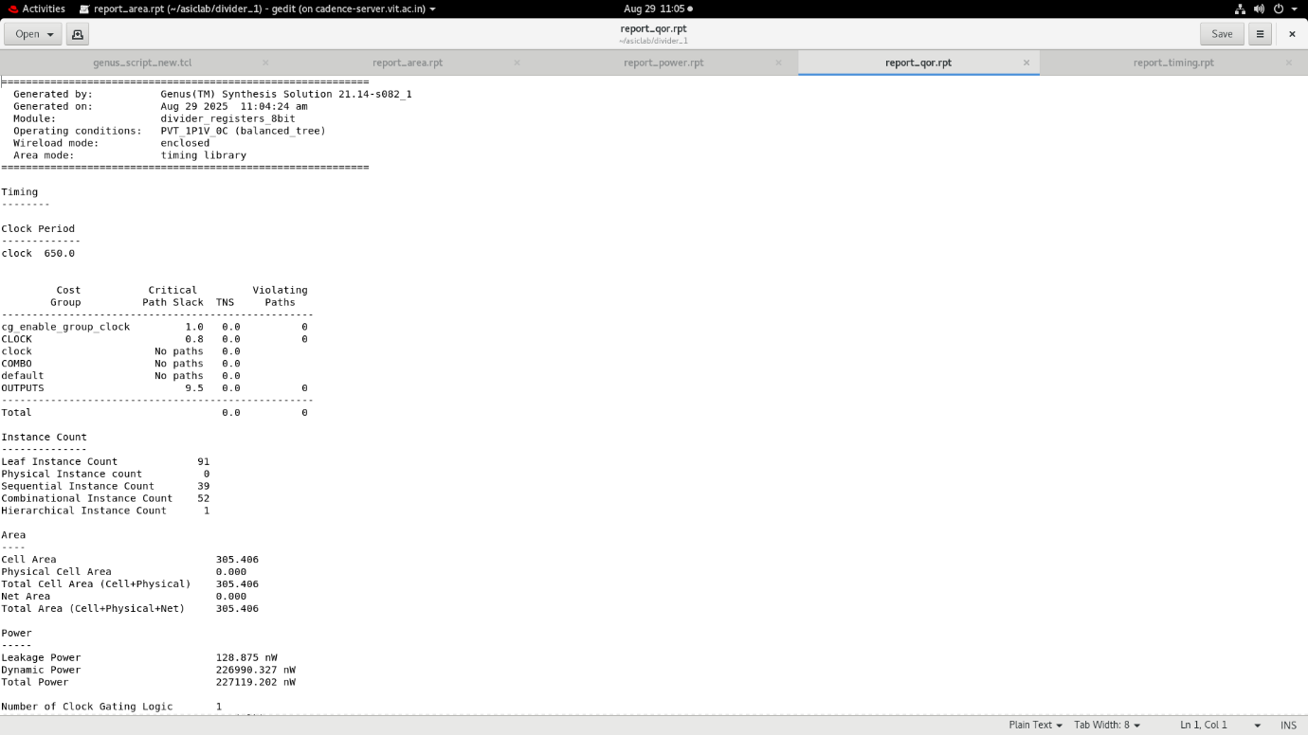
Clock gating
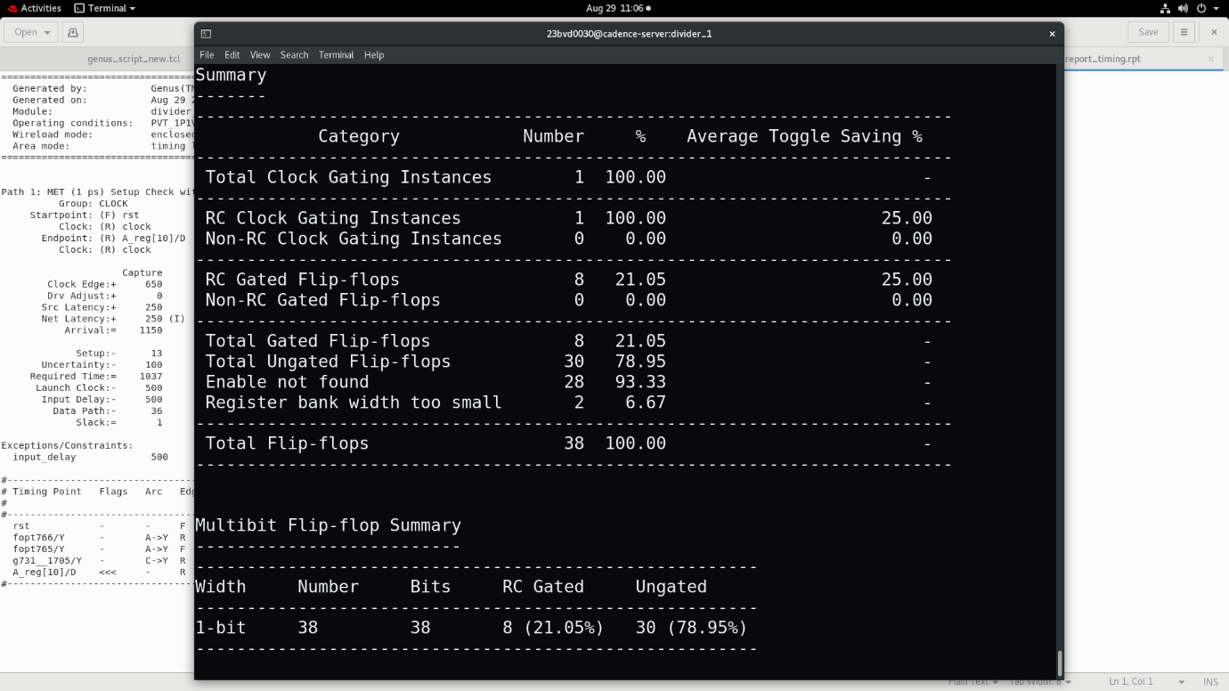

Result:
 | Power (in microwatt) |  |  |  | Performance (in ps) |  |  | Area (in um²)
 | Leakage | Internal | Switching | Total | Input | Output | Clock | Area (in um²)
Before Power Optimization | 0.1407 | 195.268 | 32.934 | 228.343 | 0 | 10.6 | 0 | 300.96
After Power Optimization | 0.1288 | 195.111 | 31.878 | 227.119 | 0 | 9.5 | 0.8 | 305.406

Inferences :
After power optimization, the total power reduced, with leakage and switching power showing noticeable decreases, while internal power remained almost unchanged. The output delay improved, indicating better timing performance, and a small clock delay appeared due to clock gating. The area increased slightly, but this trade-off is acceptable given the power savings and performance improvement. Overall, optimization made the design more power-efficient and faster with minimal area overhead.

PLE Design ( After power optimisation)
Timing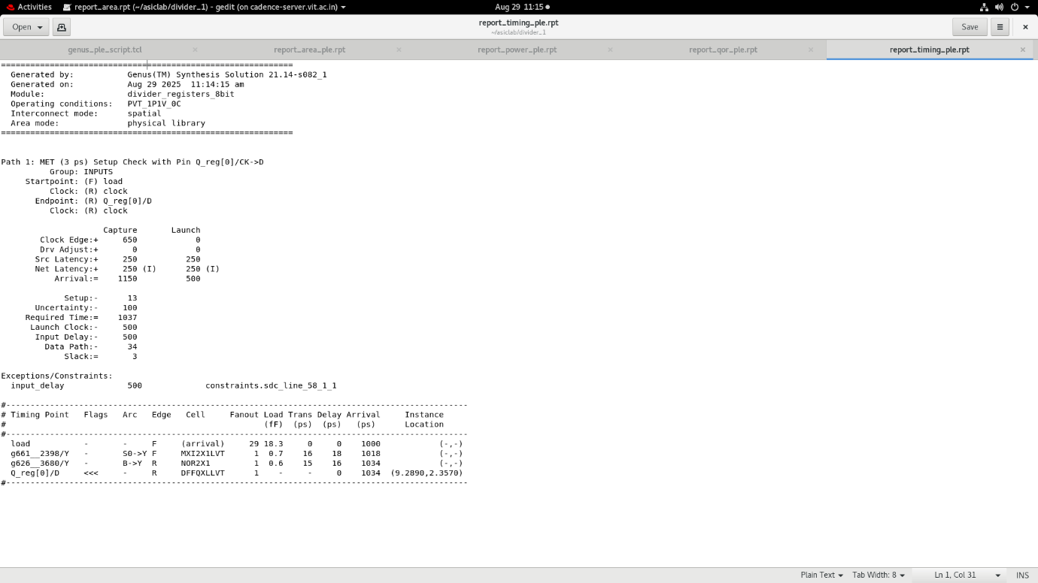
Area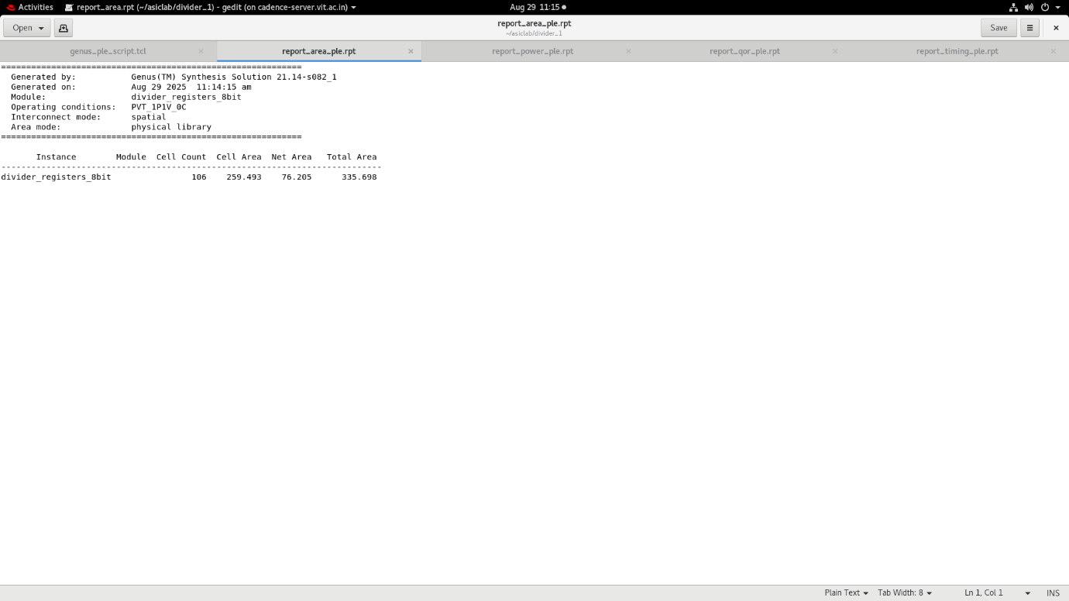
Power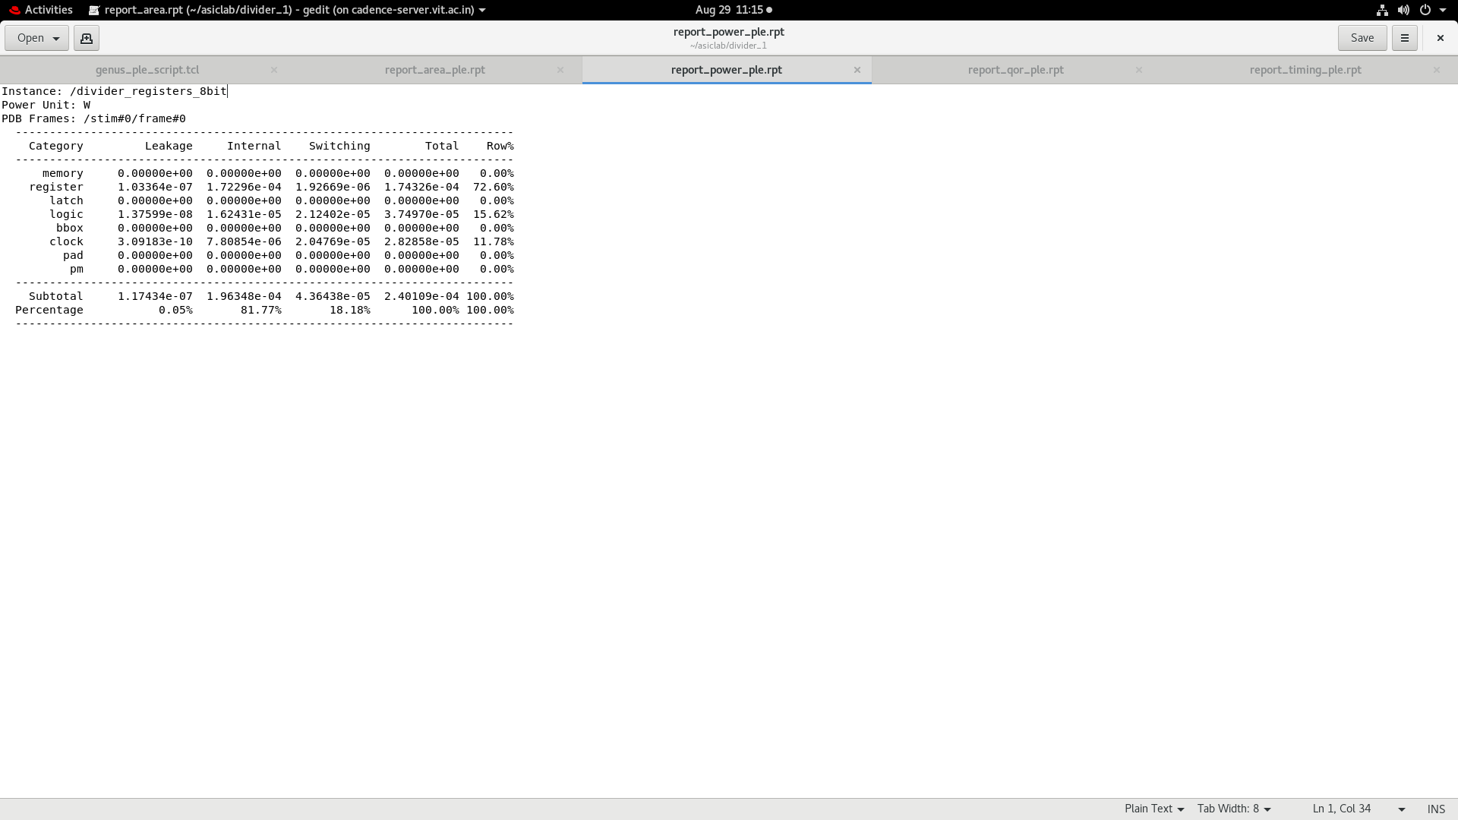
Qor 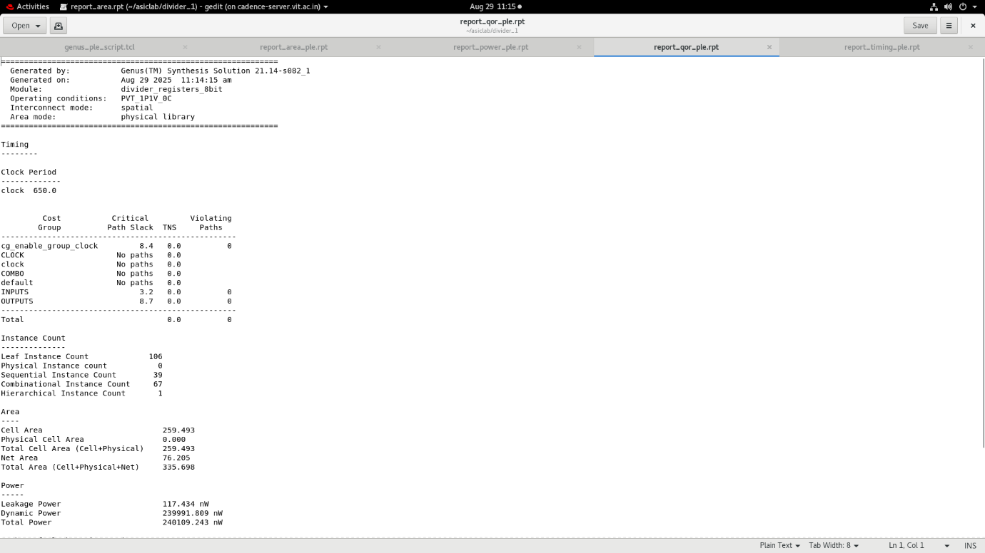
Clock gating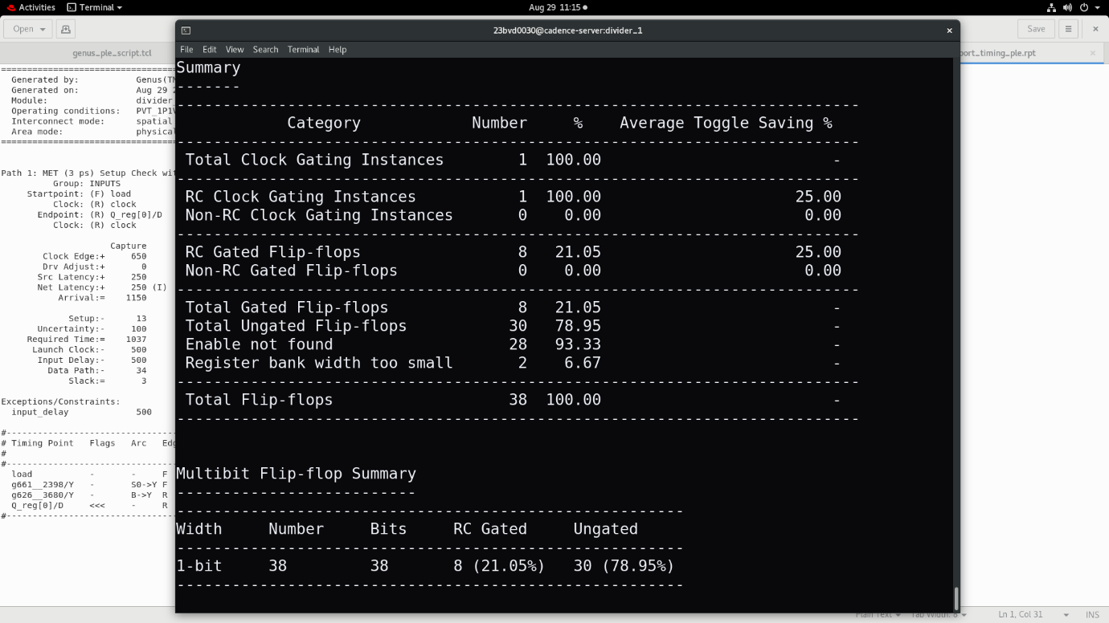

Result2:
 | Power (in microwatt) |  |  |  | Performance (in ps) |  |  | Area (in um²)
 | Leakage | Internal | Switching | Total | Input | Output | Clock | Area (in um²)
Traditional  ASIC Design Flow | 0.1288 | 195.111 | 31.878 | 227.119 | 0 | 9.5 | 0.8 | 305.406
Physical  Layout  Estimation Design Flow | 0.1174 | 196.348 | 43.643 | 240.109 | 3.2 | 8.7 | 0 | 335.698

Inferences:
The comparison of the Traditional ASIC design flow and the Physical Layout Estimation (PLE) flow after power optimization shows that PLE provides better timing performance with a decrease in output delay, but it also introduces input delay and results in higher overall power and larger area. While leakage power decreases, both internal and switching power increase, leading to higher total power consumption. The increase in area comes from placement, routing, and clock-tree overheads, which make PLE results more realistic compared to synthesis-only estimates. Overall, PLE highlights the trade-off of achieving improved timing at the cost of higher power and area.

Conclusion:
Comparing all the flows, the traditional ASIC design before power optimization shows higher power consumption and longer delays, while optimization reduces power and improves timing with only a slight increase in area, making it more efficient overall. When compared with the PLE flow after optimization, the design achieves further improvement in timing but at the expense of higher power and larger area due to physical effects such as placement, routing, and clock-tree overheads. Thus, the traditional optimized flow offers a good balance between power, performance, and area, whereas the PLE flow provides a more realistic estimate of post-layout behavior, highlighting the trade-off of improved timing against increased power and area.

