
FALL SEMESTER 2025-26
BEVD301P-ASIC Design Lab
TASK 3
Name : Tanisha Gupta Reg. No:23BVD0030
Slot: L5+L6 Date:12/9/2025

Gate Level Simulation and Logical Equivalent Check
Aim:
a) Simulating the gate-level netlist generated after synthesizing a 8 bit unsigned divider design using the Cadence simulation environment. The aim is to confirm the functional accuracy of the synthesized netlist and to evaluate the propagation delay from the clock input to the output through gate-level timing simulation.
b) Carry out a Logical Equivalence Check (LEC) with the Cadence Conformal tool to compare the pre-synthesis RTL design and the post-synthesis gate-level netlist of the 16-bit subtractor. The goal is to ensure that the synthesized netlist maintains functional equivalence with the original RTL specification.
Tool Used : Cadence tool

Outputs:
a)Gate Level Simulation
testbench
module tb_eight_bit_divider;
reg clk, rst, start;
reg [7:0] x, y;
wire [7:0] q, p;
wire done;
eight_bit_divider dut (
.clk(clk),
.rst(rst),
.start(start),
.x(x),
.y(y),
.q(q),
.p(p),
.done(done)
);
initial clk = 0;
always #5 clk = ~clk;
initial
begin
$sdf_annotate("./outputs/delays.sdf",tb_eight_bit_divider.DUT,,"sdf.log","MAXIMUM");
End
task run_division;
input [7:0] dividend;
input [7:0] divisor;
begin
@(negedge clk);
x = dividend;
y = divisor;
start = 1;
@(negedge clk);
start = 0;
wait(done);
@(posedge clk);
$display("Dividend=%0d, Divisor=%0d --> Quotient=%0d, Remainder=%0d",
dividend, divisor, q, p);
end
endtask

initial begin
rst = 1; start = 0; x = 0; y = 0;
#50 rst = 0;
run_division(13, 3);
run_division(100, 7);
run_division(50, 5);
run_division(200, 15);
run_division(77, 1);
run_division(55, 0);

#50 $finish;
end
endmodule

run_gls file
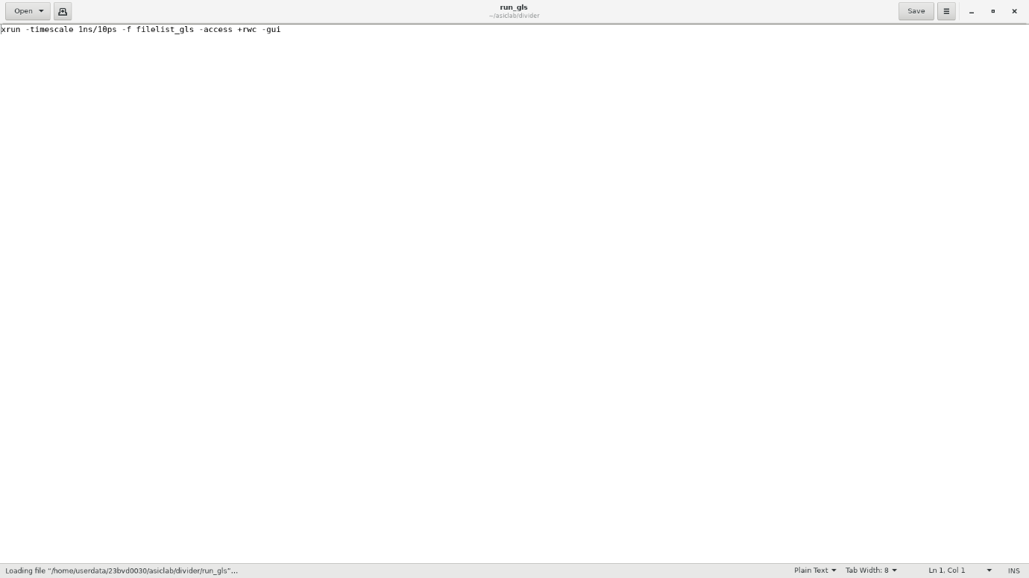
Waveforms
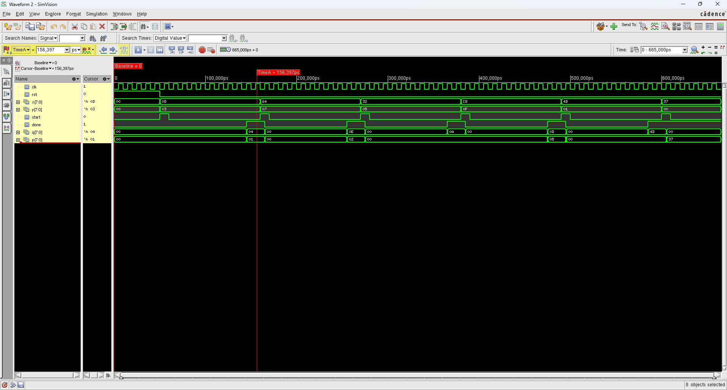

Delay of clock , completion and outputs
a)clk
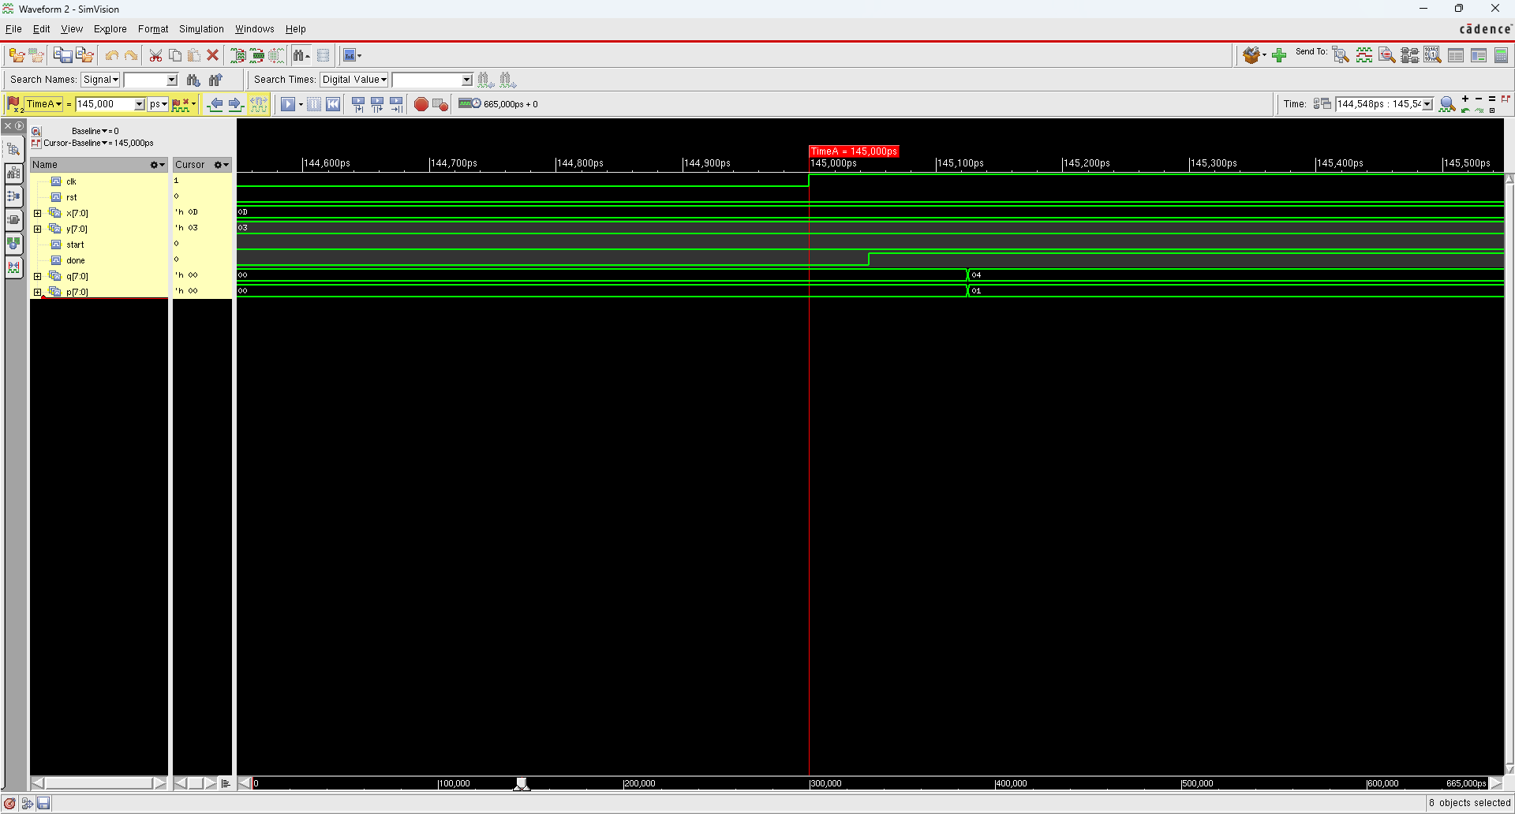
b)done
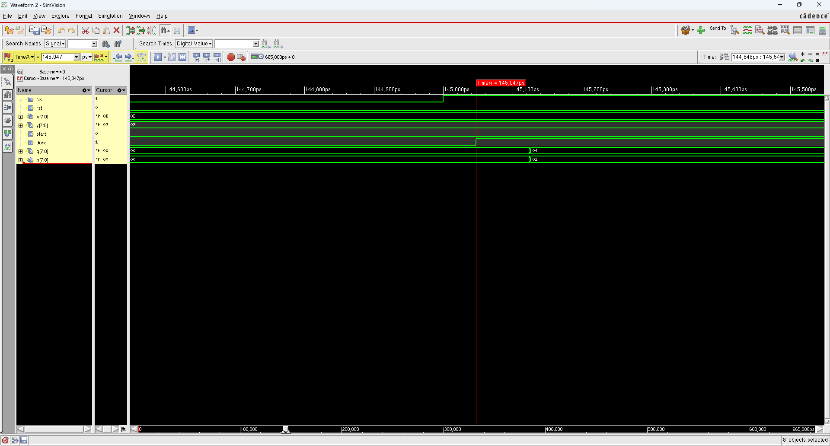
Delay of completion with respect to the clk=145,047-145,000=47ps

c)delay in outputs
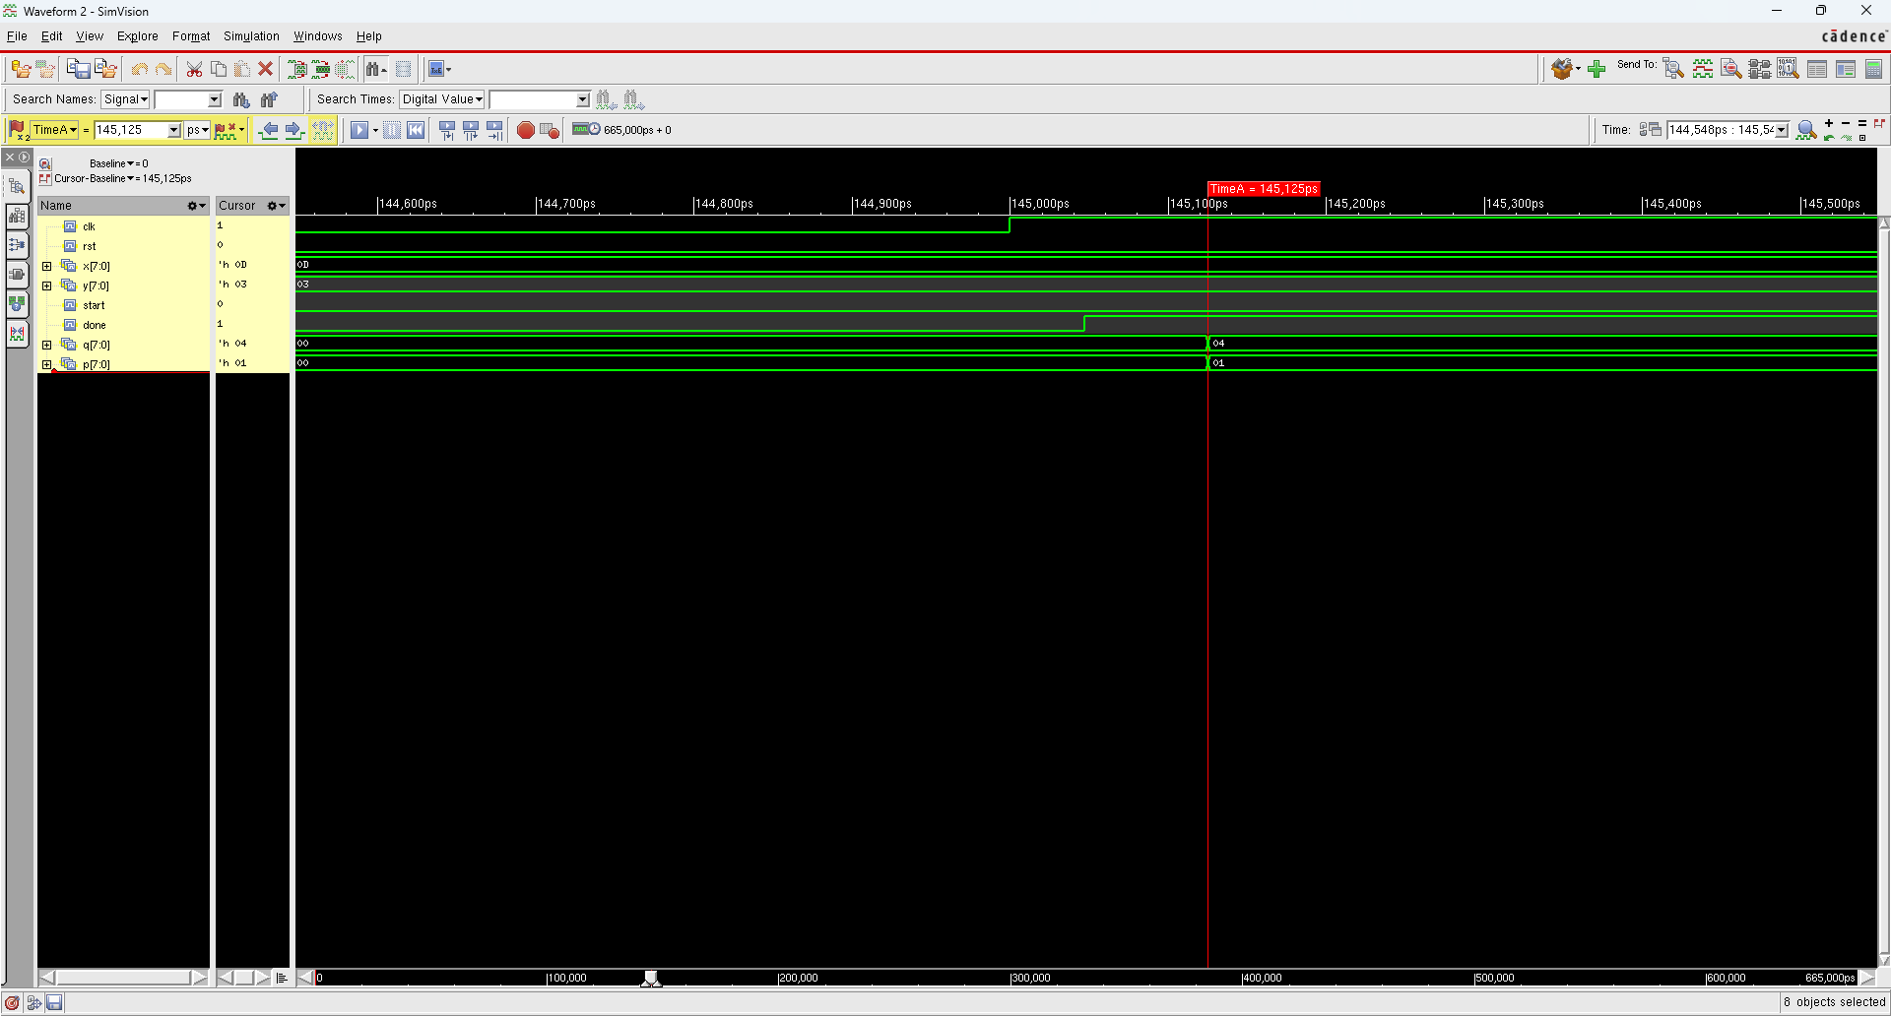
Delay in output with respect to clock=145,125ps-145,000ps=125ps.

b)Logical Equivalence Check
lec.do file
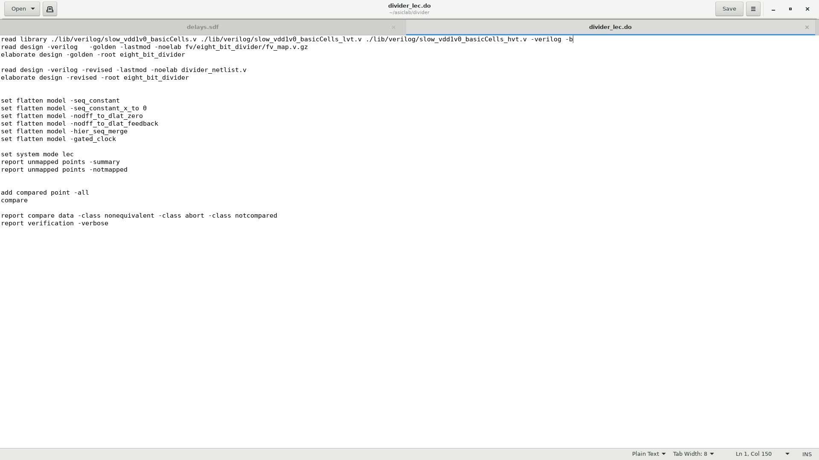
Output:
