Output Screen

**Screen Shot: WELCOME FORM**

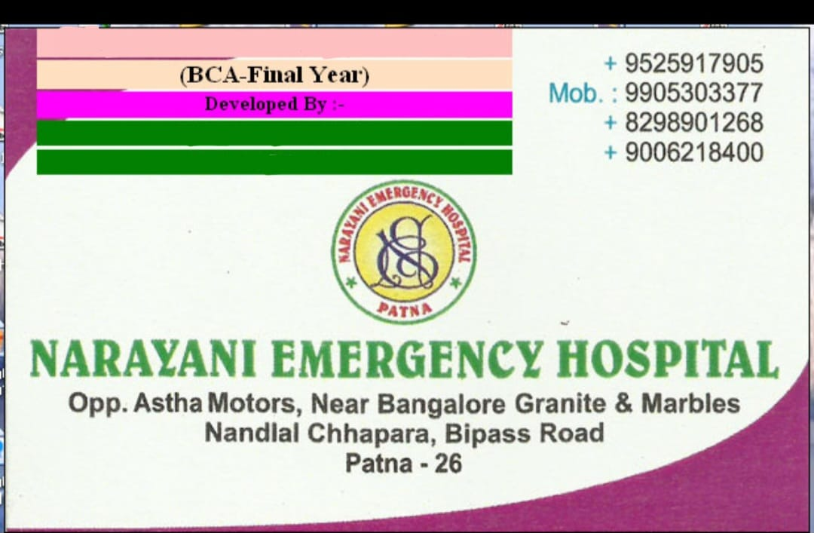

* This is the welcome screen , when you open Hospital Management System then this screen is present.

**Screen Shot: frmLogin.frm**

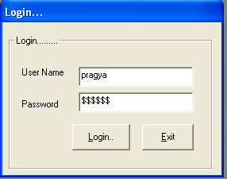

* This is Login form of Hospital Management System. You can type User Name and Password and then click on Login Button for open HMS Application.

**Coding of Loginform:**

Private Sub cmdExit_Click()

If MsgBox("Are you sure to exit?", vbYesNo) = vbYes Then

End

End If

End Sub

'-----------------------------------------------------------------------------

Private Function ValidateFormFields() As Boolean

'-----------------------------------------------------------------------------

If Not ValidateRequiredField(txtUserName, "User Name") Then

ValidateFormFields = False

Exit Function

End If

If Not ValidateRequiredField(txtPassword, "Password") Then

ValidateFormFields = False

Exit Function

End If

ValidateFormFields = True

End Function

Private Sub cmdLogin_Click()

If Not ValidateFormFields Then Exit Sub

On Error GoTo ErrHandler

If Not AuthenticateUser(txtUserName.Text, txtPassword.Text) Then

MsgBox "invalid username & password, please try again", vbOKOnly

Else

Load MDIMain

MDIMain.Caption = "Welecome " & txtUserName.Text & " " & MDIMain.Caption

MDIMain.Show

Unload Me

End If

Exit Sub

ErrHandler:

MsgBox "Error #" & Err.Number & ": '" & Err.Description & "' from '" & Err.Source & "'"

End Sub

Private Sub Form_Load()

Me.Move (Screen.Width - Me.Width) / 2, (Screen.Height - Me.Height) / 2

End Sub

Private Sub txtPassword_Click()

txtPassword.Text = ""

End Sub

Private Sub txtUserName_Click()

txtUserName.Text = ""

txtPassword.Text = ""

End Sub

Private Sub txtUserName_GotFocus()

txtUserName.Text = ""

txtPassword.Text = ""

End Sub

**Screen Shot: MDIManin.frm**

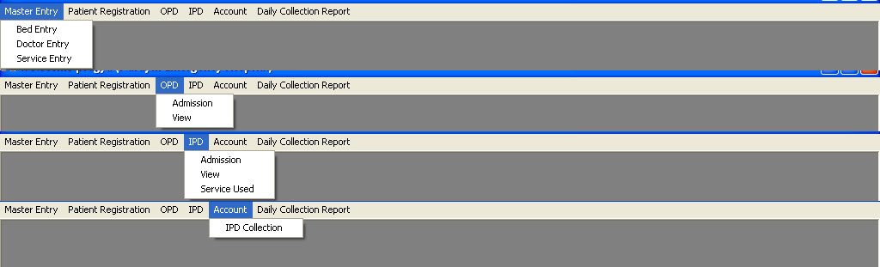

**About this form:** This is MDI form (Multiple Document Interface) in this MDI form almost form are attached. The overall task of Hospital is managed by this MDI form.

**Coding of MDI form:**

Private Sub bedentry_Click(Index As Integer)

frmBedmaster.Show

End Sub

Private Sub dcr_Click(Index As Integer)

frmDailyCollectionReport.Show

End Sub

Private Sub doctorentry_Click(Index As Integer)

frmDoctorMaster.Show

End Sub

Private Sub ipdadmission_Click(Index As Integer)

frmIPDAdmisstion.Show

End Sub

Private Sub ipdcollection_Click(Index As Integer)

frmIPDBillPayment.Show

End Sub

Private Sub ipdserviceused_Click(Index As Integer)

frmIPDServiceUsedByPatient.Show

End Sub

Private Sub ipdView_Click(Index As Integer)

frmvieIPDRegistration.Show

End Sub

Private Sub MDIForm_Unload(Cancel As Integer)

If MsgBox("Are you sure to exit?", vbYesNo) = vbYes Then

End

Else

Cancel = True

End If

End Sub

Private Sub opdadmission_Click(Index As Integer)

frmOPDRegistration.Show

End Sub

Private Sub opdview_Click(Index As Integer)

frmViewOPDRegistration.Show

End Sub

Private Sub patientregistration_Click(Index As Integer)

frmPatientRegistration.Show

End Sub

Private Sub serviceentry_Click(Index As Integer)

frmServiceMaster.Show

End Sub

**Screen Shot: frmBedma** **ster.frm**

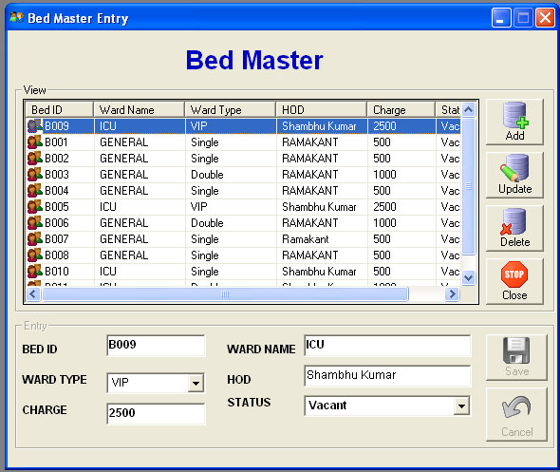

**About this form:** This window is designed for viewing as well as bed record details

That means, how many bed and also which type bed are present in hospital.

**Coding of frmBedmaster.frm:**

Option Explicit

Private Action As String

Private Sub cmdAdd_Click()

EnableFrame True

Action = "ADD"

End Sub

Private Sub EnableFrame(isEnableFrame As Boolean)

frmEntry.Enabled = isEnableFrame

cmdSave.Enabled = isEnableFrame

cmdCancel.Enabled = isEnableFrame

frmView.Enabled = Not isEnableFrame

cmdAdd.Enabled = Not isEnableFrame

cmdUpdate.Enabled = Not isEnableFrame

cmdDelete.Enabled = Not isEnableFrame

cmdClose.Enabled = Not isEnableFrame

End Sub

Private Sub cmdCancel_Click()

'isEnableFrame = False

EnableFrame False

End Sub

Private Sub cmdClose_Click()

End

End Sub

Private Sub cmdDelete_Click()

EnableFrame True

Action = "DEL"

End Sub

Private Sub cmdSave_Click()

On Error GoTo ErrHandler

If ValidateFormFields = True Then

ConnectToDB

mobjCmd.CommandType = adCmdText

Dim query As String

If Action = "ADD" Then

query = "insert into bed_record (BED_ID, WARD_NAME, WARD_TYPE,HOD,CHARGE,STATUS) values ('" & txtBedid.Text & "' , '" & txtWardname.Text & "' , '" & cmbwardtype.Text & "' , '" & txtHOD.Text & "' , " & CDbl(txtchrge.Text) & " , '" & cmbstatus.Text & "')"

ElseIf Action = "UPD" Then

query = "update bed_record set WARD_NAME = '" & txtWardname.Text & "', WARD_TYPE = '" & cmbwardtype.Text & "' , HOD = '" & txtHOD.Text & "' ,CHARGE = " & CDbl(txtchrge.Text) & " ,STATUS = '" & cmbstatus.Text & "' where BED_ID = '" & txtBedid.Text & "'"

ElseIf Action = "DEL" Then

query = "delete from bed_record where BED_ID = '" & txtBedid.Text & "'"

End If

mobjCmd.CommandText = query

mobjCmd.Execute

DisconnectFromDB

MsgBox "Record Successfully Save", vbOKOnly

EnableFrame False

LoadBedMasterList

BlankControl

End If

Exit Sub

ErrHandler:

MsgBox "Error #" & Err.Number & ": '" & Err.Description & "' from '" & Err.Source & "'"

End Sub

Private Sub cmdUpdate_Click()

EnableFrame True

Action = "UPD"

End Sub

Private Sub Form_Load()

EnableFrame False

CenterForm Me

SetupCustLVCols

LoadBedMasterList

End Sub

Private Function ValidateFormFields()

If Not ValidateRequiredField(txtBedid, "Bed ID") Then

ValidateFormFields = False

Exit Function

End If

If Not ValidateRequiredField(txtchrge, "Charge") Then

ValidateFormFields = False

Exit Function

End If

If Not ValidateRequiredField(txtHOD, "HOD") Then

ValidateFormFields = False

Exit Function

End If

If Not ValidateRequiredField(txtWardname, "Ward Name") Then

ValidateFormFields = False

Exit Function

End If

ValidateFormFields = True

End Function

'-----------------------------------------------------------------------------

Private Sub SetupCustLVCols()

'-----------------------------------------------------------------------------

With lvwBedMaster

.ColumnHeaders.Clear

.ColumnHeaders.Add , , "Bed ID", .Width * 0.15

.ColumnHeaders.Add , , "Ward Name", .Width * 0.2

.ColumnHeaders.Add , , "Ward Type", .Width * 0.2

.ColumnHeaders.Add , , "HOD", .Width * 0.2

.ColumnHeaders.Add , , "Charge", .Width * 0.15

.ColumnHeaders.Add , , "Status", .Width * 0.15

End With

End Sub

'-----------------------------------------------------------------------------

Private Sub LoadBedMasterList()

'-----------------------------------------------------------------------------

On Error GoTo ErrHandler

Dim objCurrLI As ListItem

lvwBedMaster.ListItems.Clear

ConnectToDB

ClearCommandParameters

mobjCmd.CommandType = adCmdText

Dim query As String

query = "select * from bed_record"

mobjCmd.CommandText = query

Set mobjRst = mobjCmd.Execute

With mobjRst

Do Until .EOF

Set objCurrLI = lvwBedMaster.ListItems.Add(, , !BED_ID & "", , "Custs")

objCurrLI.SubItems(1) = !WARD_NAME & ""

objCurrLI.SubItems(2) = !WARD_TYPE & ""

objCurrLI.SubItems(3) = !HOD & ""

objCurrLI.SubItems(4) = CStr(!Charge) & ""

objCurrLI.SubItems(5) = !Status

.MoveNext

Loop

End With

With lvwBedMaster

If .ListItems.Count > 0 Then

Set .SelectedItem = .ListItems(1)

lvwBedMaster_ItemClick .SelectedItem

End If

End With

Set objCurrLI = Nothing

Set mobjRst = Nothing

DisconnectFromDB

Exit Sub

ErrHandler:

MsgBox "Error #" & Err.Number & ": '" & Err.Description & "' from '" & Err.Source & "'"

End Sub

Private Sub lvwBedMaster_ItemClick(ByVal Item As MSComctlLib.ListItem)

With Item

txtBedid.Text = .Text

txtchrge.Text = .SubItems(4)

txtHOD.Text = .SubItems(3)

txtWardname.Text = .SubItems(1)

cmbwardtype.Text = .SubItems(2)

cmbstatus.Text = .SubItems(5)

End With

End Sub

Private Sub BlankControl()

txtBedid.Text = ""

txtchrge.Text = ""

txtHOD.Text = ""

txtWardname.Text = ""

End Sub

**Screen Shot: frmDoctorm** **ster.frm**

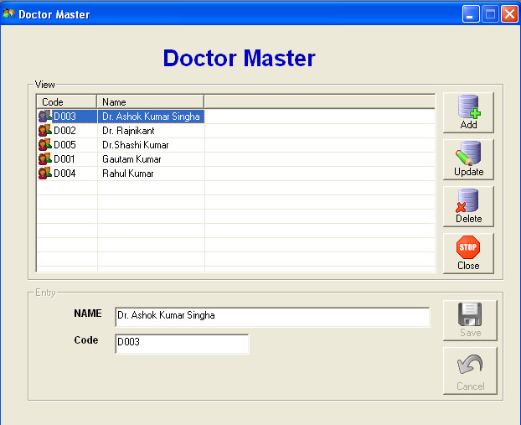

**About Form:** This window is designed for viewing as well as Doctor record details

That means, how many Doctors are working in Narayani Hospital.

**Coding of frmDoctor.frm:**

Option Explicit

Private Action As String

Private Sub cmdAdd_Click()

EnableFrame True

Action = "ADD"

End Sub

Private Sub EnableFrame(isEnableFrame As Boolean)

frmEntry.Enabled = isEnableFrame

cmdSave.Enabled = isEnableFrame

cmdCancel.Enabled = isEnableFrame

frmView.Enabled = Not isEnableFrame

cmdAdd.Enabled = Not isEnableFrame

cmdUpdate.Enabled = Not isEnableFrame

cmdDelete.Enabled = Not isEnableFrame

cmdClose.Enabled = Not isEnableFrame

End Sub

Private Sub cmdCancel_Click()

'isEnableFrame = False

EnableFrame False

End Sub

Private Sub cmdClose_Click()

End

End Sub

Private Sub cmdDelete_Click()

EnableFrame True

Action = "DEL"

End Sub

Private Sub cmdSave_Click()

On Error GoTo ErrHandler

If ValidateFormFields = True Then

ConnectToDB

mobjCmd.CommandType = adCmdText

Dim query As String

If Action = "ADD" Then

query = "insert into Doctor (DID, dname) values ('" & txtCode.Text & "' , '" & txtDName.Text & "')"

'query = "insert into Doctor (dname) values ( '" & txtDName.Text & "')"

ElseIf Action = "UPD" Then

query = "update Doctor set dname = '" & txtDName.Text & "' where did = '" & txtCode.Text & "'"

ElseIf Action = "DEL" Then

query = "delete from Doctor where did = '" & txtCode.Text & "'"

End If

mobjCmd.CommandText = query

mobjCmd.Execute

DisconnectFromDB

MsgBox "Record Successfully Save", vbOKOnly

EnableFrame False

LoadBedMasterList

BlankControl

End If

Exit Sub

ErrHandler:

MsgBox "Error #" & Err.Number & ": '" & Err.Description & "' from '" & Err.Source & "'"

End Sub

Private Sub cmdUpdate_Click()

EnableFrame True

Action = "UPD"

End Sub

Private Sub Form_Load()

EnableFrame False

CenterForm Me

SetupCustLVCols

LoadBedMasterList

End Sub

Private Function ValidateFormFields()

If Not ValidateRequiredField(txtDName, "Name") Then

ValidateFormFields = False

Exit Function

End If

If Not ValidateRequiredField(txtCode, "Code") Then

ValidateFormFields = False

Exit Function

End If

ValidateFormFields = True

End Function

'-----------------------------------------------------------------------------

Private Sub SetupCustLVCols()

'-----------------------------------------------------------------------------

With lvwBedMaster

.ColumnHeaders.Clear

.ColumnHeaders.Add , , "Code", .Width * 0.15

.ColumnHeaders.Add , , "Name", .Width * 0.2

End With

End Sub

'-----------------------------------------------------------------------------

Private Sub LoadBedMasterList()

'-----------------------------------------------------------------------------

Dim objCurrLI As ListItem

lvwBedMaster.ListItems.Clear

ConnectToDB

ClearCommandParameters

mobjCmd.CommandType = adCmdText

Dim query As String

query = "select * from Doctor order by DName"

mobjCmd.CommandText = query

Set mobjRst = mobjCmd.Execute

With mobjRst

Do Until .EOF

Set objCurrLI = lvwBedMaster.ListItems.Add(, , !DID & "", , "Custs")

objCurrLI.SubItems(1) = !DName & ""

.MoveNext

Loop

End With

With lvwBedMaster

If .ListItems.Count > 0 Then

Set .SelectedItem = .ListItems(1)

lvwBedMaster_ItemClick .SelectedItem

End If

End With

Set objCurrLI = Nothing

Set mobjRst = Nothing

DisconnectFromDB

End Sub

Private Sub lvwBedMaster_ItemClick(ByVal Item As MSComctlLib.ListItem)

With Item

txtCode.Text = .Text

txtDName.Text = .SubItems(1)

End With

End Sub

Private Sub BlankControl()

txtCode.Text = ""

txtDName.Text = ""

End Sub

Private Sub txtServiceName_Change()

End Sub

**Screen shot:frmServicemaster.frm**

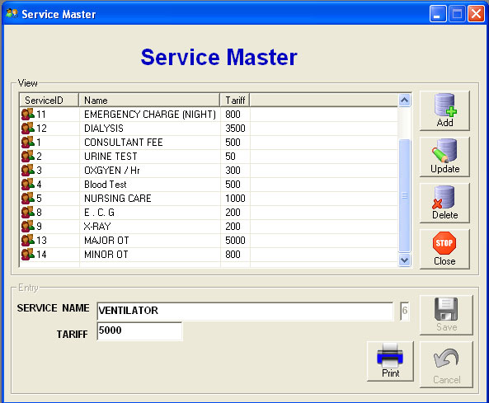

**Coding of Service.frm**

**Option Explicit**

**Private Action As String**

**Private Sub cmdAdd_Click()**

**EnableFrame True**

**Action = "ADD"**

**End Sub**

**Private Sub EnableFrame(isEnableFrame As Boolean)**

**frmEntry.Enabled = isEnableFrame**

**cmdSave.Enabled = isEnableFrame**

**cmdCancel.Enabled = isEnableFrame**

**frmView.Enabled = Not isEnableFrame**

**cmdAdd.Enabled = Not isEnableFrame**

**cmdUpdate.Enabled = Not isEnableFrame**

**cmdDelete.Enabled = Not isEnableFrame**

**cmdClose.Enabled = Not isEnableFrame**

**End Sub**

**Private Sub cmdCancel_Click()**

**'isEnableFrame = False**

**EnableFrame False**

**End Sub**

**Private Sub cmdClose_Click()**

**End**

**End Sub**

**Private Sub cmdDelete_Click()**

**EnableFrame True**

**Action = "DEL"**

**End Sub**

**Private Sub cmdSave_Click()**

**On Error GoTo ErrHandler**

**If ValidateFormFields = True Then**

**ConnectToDB**

**mobjCmd.CommandType = adCmdText**

**Dim query As String**

**Dim lngSID As Integer**

**query = "select max(SID) SID from servicemaster"**

**mobjCmd.CommandText = query**

**Set mobjRst = mobjCmd.Execute**

**If Not mobjRst.EOF Then**

**If IsNull(mobjRst!SID) = True Then**

**lngSID = 0**

**Else**

**lngSID = CInt(mobjRst!SID)**

**End If**

**Else**

**lngSID = 0**

**End If**

**lngSID = lngSID + 1**

**If Action = "ADD" Then**

**query = "insert into servicemaster (sid, sname, tariff) values (" & lngSID & " , '" & txtServiceName.Text & "' , " & CDbl(txtTariff.Text) & ")"**

**ElseIf Action = "UPD" Then**

**query = "update servicemaster set sname = '" & txtServiceName.Text & "', tariff = " & CDbl(txtTariff.Text) & " where sid = " & txtSID.Text**

**ElseIf Action = "DEL" Then**

**query = "delete from SERVICEMASTER where sid = " & txtSID.Text**

**End If**

**mobjCmd.CommandText = query**

**mobjCmd.Execute**

**DisconnectFromDB**

**MsgBox "Record Successfully Save", vbOKOnly**

**EnableFrame False**

**LoadBedMasterList**

**BlankControl**

**End If**

**Exit Sub**

**ErrHandler:**

**MsgBox "Error #" & Err.Number & ": '" & Err.Description & "' from '" & Err.Source & "'"**

**End Sub**

**Private Sub cmdUpdate_Click()**

**EnableFrame True**

**Action = "UPD"**

**End Sub**

**Private Sub Form_Load()**

**EnableFrame False**

**CenterForm Me**

**SetupCustLVCols**

**LoadBedMasterList**

**End Sub**

**Private Function ValidateFormFields()**

**If Not ValidateRequiredField(txtServiceName, "Service Name") Then**

**ValidateFormFields = False**

**Exit Function**

**End If**

**If Not ValidateRequiredField(txtTariff, "Tariff") Then**

**ValidateFormFields = False**

**Exit Function**

**End If**

**ValidateFormFields = True**

**End Function**

**'-----------------------------------------------------------------------------**

**Private Sub SetupCustLVCols()**

**'-----------------------------------------------------------------------------**

**With lvwBedMaster**

**.ColumnHeaders.Clear**

**.ColumnHeaders.Add , , "ServiceID", .Width * 0.15**

**.ColumnHeaders.Add , , "Name", .Width * 0.2**

**.ColumnHeaders.Add , , "Tariff", .Width * 0.2**

**End With**

**End Sub**

**'-----------------------------------------------------------------------------**

**Private Sub LoadBedMasterList()**

**'-----------------------------------------------------------------------------**

**Dim objCurrLI As ListItem**

**lvwBedMaster.ListItems.Clear**

**ConnectToDB**

**ClearCommandParameters**

**mobjCmd.CommandType = adCmdText**

**Dim query As String**

**query = "select * from servicemaster"**

**mobjCmd.CommandText = query**

**Set mobjRst = mobjCmd.Execute**

**With mobjRst**

**Do Until .EOF**

**Set objCurrLI = lvwBedMaster.ListItems.Add(, , !SID & "", , "Custs")**

**objCurrLI.SubItems(1) = !SNAME & ""**

**objCurrLI.SubItems(2) = !TARIFF & ""**

**.MoveNext**

**Loop**

**End With**

**With lvwBedMaster**

**If .ListItems.Count > 0 Then**

**Set .SelectedItem = .ListItems(1)**

**lvwBedMaster_ItemClick .SelectedItem**

**End If**

**End With**

**Set objCurrLI = Nothing**

**Set mobjRst = Nothing**

**DisconnectFromDB**

**End Sub**

**Private Sub lvwBedMaster_ItemClick(ByVal Item As MSComctlLib.ListItem)**

**With Item**

**txtSID.Text = .Text**

**txtServiceName.Text = .SubItems(1)**

**txtTariff.Text = .SubItems(2)**

**End With**

**End Sub**

**Private Sub BlankControl()**

**txtSID.Text = ""**

**txtServiceName.Text = ""**

**txtTariff.Text = ""**

**End Sub**

**Screen Shot:frmPatientregistration.frm**

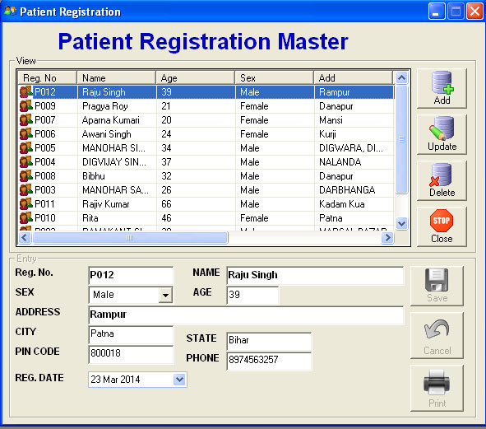

**Coding of** **frmPatientregistration.frm:**

Option Explicit

Private Action As String

Private Sub cmdAdd_Click()

EnableFrame True

Action = "ADD"

End Sub

Private Sub EnableFrame(isEnableFrame As Boolean)

frmEntry.Enabled = isEnableFrame

cmdSave.Enabled = isEnableFrame

cmdCancel.Enabled = isEnableFrame

cmdPrint.Enabled = isEnableFrame

frmView.Enabled = Not isEnableFrame

cmdAdd.Enabled = Not isEnableFrame

cmdUpdate.Enabled = Not isEnableFrame

cmdDelete.Enabled = Not isEnableFrame

cmdClose.Enabled = Not isEnableFrame

End Sub

Private Sub cmdCancel_Click()

'isEnableFrame = False

EnableFrame False

End Sub

Private Sub cmdClose_Click()

End

End Sub

Private Sub cmdDelete_Click()

EnableFrame True

Action = "DEL"

End Sub

Private Sub cmdPrint_Click()

On Error GoTo ErrHandler

ConnectToDB

mobjCmd.CommandType = adCmdText

Dim query As String

Dim strRegDat As String

Dim strAge As String

query = "select * from patient_registration where REGNO = '" & txtRegNo.Text & "'"

mobjCmd.CommandText = query

Set mobjRst = mobjCmd.Execute

Set DRPatientInformation.DataSource = mobjRst

DRPatientInformation.Show

EnableFrame False

BlankControl

Exit Sub

ErrHandler:

MsgBox "Error #" & Err.Number & ": '" & Err.Description & "' from '" & Err.Source & "'"

End Sub

Private Sub cmdSave_Click()

On Error GoTo ErrHandler

If ValidateFormFields = True Then

ConnectToDB

mobjCmd.CommandType = adCmdText

Dim query As String

Dim strRegDat As String

Dim strAge As String

strAge = Format$(DateAdd("yyyy", -(txtAge.Text), Now), "dd MMM yyyy")

strRegDat = Format$(dpRegDate.DateSelected, "dd MMM yyyy")

If Action = "ADD" Then

query = "insert into patient_registration (REGNO, NAME, AGE,SEX,STREET,CITY, STATE, PIN, PHONE,REG_DATE)" _

& "values ('" & txtRegNo.Text & "' , '" & txtName.Text & "' , '" & strAge & "' , '" & cmbSex.Text & "' , '" & txtAddress.Text & "', '" & txtcity.Text & "', '" & txtState.Text & "', '" & txtPinCode.Text & "', '" & txtPhone.Text & "', '" & strRegDat & "')"

ElseIf Action = "UPD" Then

query = "update patient_registration set NAME = '" & txtName.Text & "', AGE = '" & strAge & "' , SEX = '" & cmbSex.Text & "', STREET = '" & txtAddress.Text & "' , CITY = '" & txtcity.Text & "', STATE = '" & txtState.Text & "', PIN = '" & txtPinCode.Text & "', PHONE = '" & txtPhone.Text & "', REG_DATE = '" & strRegDat & "' where REGNO = '" & txtRegNo & "'"

ElseIf Action = "DEL" Then

If MsgBox("Are You Sure To Delete This Record", vbYesNo) = vbYes Then

query = "delete from patient_registration where REGNO = '" & txtRegNo.Text & "'"

Else

query = "select REGNO from patient_registration where REGNO = '" & txtRegNo.Text & "'"

End If

End If

mobjCmd.CommandText = query

mobjCmd.Execute

DisconnectFromDB

MsgBox "Record Successfully Save", vbOKOnly

EnableFrame False

LoadPatientMasterList

BlankControl

End If

Exit Sub

ErrHandler:

MsgBox "Error #" & Err.Number & ": '" & Err.Description & "' from '" & Err.Source & "'"

End Sub

Private Sub cmdUpdate_Click()

EnableFrame True

Action = "UPD"

End Sub

Private Sub Form_Load()

EnableFrame False

CenterForm Me

SetupCustLVCols

LoadPatientMasterList

End Sub

Private Function ValidateFormFields()

If Not ValidateRequiredField(txtRegNo, "Reg No") Then

ValidateFormFields = False

Exit Function

End If

If Not ValidateRequiredField(txtName, "Name") Then

ValidateFormFields = False

Exit Function

End If

If Not ValidateRequiredField(txtAge, "Age") Then

ValidateFormFields = False

Exit Function

End If

If Not ValidateRequiredField(txtAddress, "Address ") Then

ValidateFormFields = False

Exit Function

End If

If Not ValidateRequiredField(txtState, "State ") Then

ValidateFormFields = False

Exit Function

End If

If Not ValidateRequiredField(txtcity, "City ") Then

ValidateFormFields = False

Exit Function

End If

ValidateFormFields = True

End Function

'-----------------------------------------------------------------------------

Private Sub SetupCustLVCols()

'-----------------------------------------------------------------------------

With lvwBedMaster

.ColumnHeaders.Clear

.ColumnHeaders.Add , , "Reg. No", .Width * 0.15

.ColumnHeaders.Add , , "Name", .Width * 0.2

.ColumnHeaders.Add , , "Age", .Width * 0.2

.ColumnHeaders.Add , , "Sex", .Width * 0.2

.ColumnHeaders.Add , , "Add", .Width * 0.2

.ColumnHeaders.Add , , "City", .Width * 0.15

.ColumnHeaders.Add , , "State", .Width * 0.15

.ColumnHeaders.Add , , "Pin", .Width * 0.15

.ColumnHeaders.Add , , "Phone", .Width * 0.15

.ColumnHeaders.Add , , "Reg Date", .Width * 0.15

End With

End Sub

'-----------------------------------------------------------------------------

Private Sub LoadPatientMasterList()

'-----------------------------------------------------------------------------

On Error GoTo ErrHandler

Dim objCurrLI As ListItem

lvwBedMaster.ListItems.Clear

ConnectToDB

ClearCommandParameters

mobjCmd.CommandType = adCmdText

Dim query As String

query = "select REGNO, NAME, AGE,SEX,STREET,CITY, STATE, PIN, PHONE,REG_DATE from patient_registration order by REG_DATE desc, REGNO desc"

mobjCmd.CommandText = query

Set mobjRst = mobjCmd.Execute

With mobjRst

Do Until .EOF

Set objCurrLI = lvwBedMaster.ListItems.Add(, , !REGNO & "", , "Custs")

objCurrLI.SubItems(1) = !Name & ""

objCurrLI.SubItems(2) = DateDiff("yyyy", !AGE, Now) & ""

objCurrLI.SubItems(3) = !SEX & ""

objCurrLI.SubItems(4) = !STREET & ""

objCurrLI.SubItems(5) = !CITY & ""

objCurrLI.SubItems(6) = !State & ""

objCurrLI.SubItems(7) = !PIN & ""

objCurrLI.SubItems(8) = !PHONE & ""

objCurrLI.SubItems(9) = !REG_DATE & ""

.MoveNext

Loop

End With

With lvwBedMaster

If .ListItems.Count > 0 Then

Set .SelectedItem = .ListItems(1)

lvwBedMaster_ItemClick .SelectedItem

End If

End With

Set objCurrLI = Nothing

Set mobjRst = Nothing

DisconnectFromDB

Exit Sub

ErrHandler:

MsgBox "Error #" & Err.Number & ": '" & Err.Description & "' from '" & Err.Source & "'"

End Sub

Private Sub lvwBedMaster_ItemClick(ByVal Item As MSComctlLib.ListItem)

With Item

txtRegNo.Text = .Text

txtName.Text = .SubItems(1)

txtAge.Text = .SubItems(2)

cmbSex.Text = .SubItems(3)

txtAddress.Text = .SubItems(4)

txtcity.Text = .SubItems(5)

txtState.Text = .SubItems(6)

txtPinCode.Text = .SubItems(7)

txtPhone.Text = .SubItems(8)

dpRegDate.DateSelected = .SubItems(9)

End With

End Sub

Private Sub BlankControl()

txtRegNo.Text = ""

txtName.Text = ""

txtAge.Text = ""

txtAddress.Text = ""

txtcity.Text = ""

txtState.Text = ""

txtPinCode.Text = ""

txtPhone.Text = ""

End Sub

**Screen Shot: frmOPD registration:**

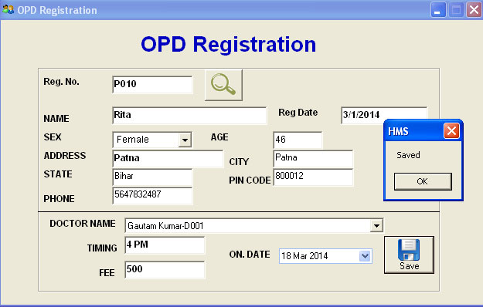

**Coding o**f **frmOPD registration:**

Private Function ValidateFormFields()

If Not ValidateRequiredField(cmbDoctor, "Doctor") Then

ValidateFormFields = False

Exit Function

End If

If Not ValidateRequiredField(txtTiming, "Time") Then

ValidateFormFields = False

Exit Function

End If

If Not ValidateRequiredField(txtFee, "Fee") Then

ValidateFormFields = False

Exit Function

End If

ValidateFormFields = True

End Function

Private Sub cmdSave_Click()

On Error GoTo ErrHandler

'On Error Resume Next

If ValidateFormFields = True Then

ConnectToDB

mobjCmd.CommandType = adCmdText

Dim query As String

Dim OPDNo As Integer

Dim strdocID As Variant

Dim strDID As String

strdocID = Split(cmbDoctor.Text, "-")

strDID = strdocID(1)

query = "select * from OPD_registration where REGNO = '" & txtRegNo.Text & "' and ONDATE = '" & GetFormatedDate(dpRegDate.DateSelected) & "'"

mobjCmd.CommandText = query

Set mobjRst = mobjCmd.Execute

If Not mobjRst.EOF Then

MsgBox "Patient Exist", vbOKOnly

DisconnectFromDB

Exit Sub

End If

query = "select max(OPDID) OPDNO from OPD_registration"

mobjCmd.CommandText = query

Set mobjRst = mobjCmd.Execute

If Not mobjRst.EOF Then

If IsNull(mobjRst!OPDNo) = True Then

OPDNo = 0

Else

OPDNo = CInt(mobjRst!OPDNo)

End If

Else

OPDNo = 0

End If

OPDNo = OPDNo + 1

mobjCmd.CommandText = "insert into OPD_registration(OPDID,DID,ONDATE,TIME,FEE,REGNO,ISCOMPLETE,ISCANCEL) values(" & OPDNo & ",'" & strDID & "', '" & GetFormatedDate(dpRegDate.DateSelected) & "', '" & txtTiming.Text & "', " & CDbl(txtFee.Text) & ", '" & txtRegNo.Text & "', 0,0)"

mobjCmd.Execute

MsgBox "Saved", vbOKOnly

DisconnectFromDB

Call LoadWard

End If

Exit Sub

ErrHandler:

MsgBox "Error #" & Err.Number & ": '" & Err.Description & "' from '" & Err.Source & "'"

End Sub

Private Sub cmdSearch_Click()

'On Error GoTo ErrHandler

On Error Resume Next

ConnectToDB

mobjCmd.CommandType = adCmdText

Dim query As String

Dim strRegDat As String

Dim strAge As String

query = "select * from patient_registration where REGNO = '" & txtRegNo.Text & "'"

mobjCmd.CommandText = query

Set mobjRst = mobjCmd.Execute

If mobjRst.EOF Then

MsgBox "Invalid Reg. No", vbOKOnly

cmdSave.Enabled = False

Else

cmdSave.Enabled = True

With mobjRst

Do Until .EOF

txtName.Text = !Name

txtAge.Text = DateDiff("yyyy", !AGE, Now)

cmbSex.Text = !SEX

txtAddress.Text = !STREET

txtcity.Text = !CITY

txtState.Text = !State

txtPinCode.Text = !PIN

txtPhone.Text = !PHONE

'claderRegDate.Value = !REG_DATE

txtRegDate.Text = !REG_DATE

.MoveNext

Loop

End With

End If

DisconnectFromDB

ErrHandler:

'MsgBox "Error #" & Err.Number & ": '" & Err.Description & "' from '" & Err.Source & "'"

Exit Sub

End Sub

Private Sub Form_Load()

cmdSave.Enabled = False

Call LoadWard

End Sub

Private Sub LoadWard()

'On Error GoTo ErrHandler

ConnectToDB

mobjCmd.CommandType = adCmdText

Dim query As String

Dim strRegDat As String

Dim strAge As String

'query = "select ward_name || ' ' || ward_type || '-' || bed_id WName from bed_record "

query = "select DName || '-' || DID DName from Doctor "

'query = "select bed_no WName from ipd_registration where isdischarge ='0'"

mobjCmd.CommandText = query

Set mobjRst = mobjCmd.Execute

cmbDoctor.Clear

With mobjRst

Do Until .EOF

cmbDoctor.AddItem (!DName)

.MoveNext

Loop

End With

DisconnectFromDB

Exit Sub

End Sub

**Screen Shot: frmViewOPdregistration.frm**

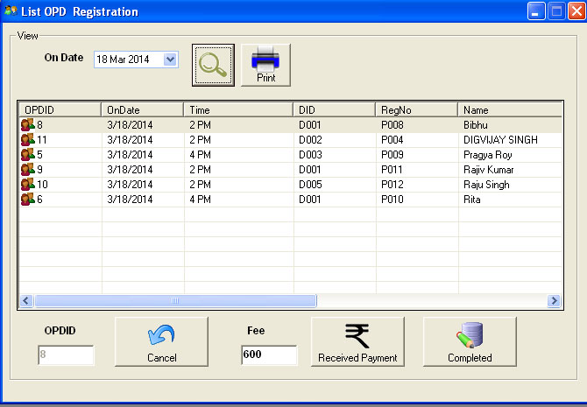

**Screen Shot : report of OPD Registration**

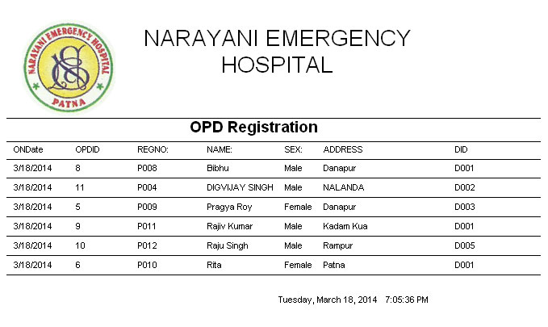

**Coding of** **frmViewOPdregistration.frm:**

Private Sub cmdCancel_Click()

If Not MsgBox("Are You Sure To Cancel This?", vbYesNo) = vbYes Then

Exit Sub

End If

On Error GoTo ErrHandler

'On Error Resume Next

ConnectToDB

mobjCmd.CommandType = adCmdText

Dim query As String

query = "UPDATE OPD_registration SET ISCANCEL = 1 where OPDID = " & txtOPDID.Text & ""

mobjCmd.CommandText = query

mobjCmd.Execute

DisconnectFromDB

Call LoadOPDLIST

Exit Sub

ErrHandler:

MsgBox "Error #" & Err.Number & ": '" & Err.Description & "' from '" & Err.Source & "'"

End Sub

Private Sub cmdPrint_Click()

On Error GoTo ErrHandler

ConnectToDB

ClearCommandParameters

mobjCmd.CommandType = adCmdText

Dim query As String

query = "select * from view_opd_registration where ondate = '" & GetFormatedDate(dpOnDate.DateSelected) & "' order by Name"

mobjCmd.CommandText = query

Set mobjRst = mobjCmd.Execute

Set DROPDList.DataSource = mobjRst

DROPDList.Show

Exit Sub

ErrHandler:

MsgBox "Error #" & Err.Number & ": '" & Err.Description & "' from '" & Err.Source & "'"

End Sub

Private Sub cmdReceivedPayment_Click()

If Not MsgBox("Are You Sure Payment Received?", vbYesNo) = vbYes Then

Exit Sub

End If

On Error GoTo ErrHandler

'On Error Resume Next

ConnectToDB

mobjCmd.CommandType = adCmdText

Dim query As String

query = "UPDATE OPD_registration SET ISPAIDFEE = 1 where OPDID = " & txtOPDID.Text & ""

mobjCmd.CommandText = query

mobjCmd.Execute

'Patient_Account insetion

query = "select max(PAID) PAID from Patient_Account"

mobjCmd.CommandText = query

Set mobjRst = mobjCmd.Execute

Dim PAID As Integer

If Not mobjRst.EOF Then

If IsNull(mobjRst!PAID) = True Then

PAID = 0

Else

PAID = CInt(mobjRst!PAID)

End If

Else

PAID = 0

End If

PAID = PAID + 1

query = "insert into Patient_Account(PAID, REGNO, OnDate , CREDIT , Narrations ) values (" & PAID & ",'" & txtRegNo.Text & "', '" & GetFormatedDate(Date) & "', " & txtFee.Text & ", 'Fee Paid For OPDID : " & txtOPDID.Text & "')"

mobjCmd.CommandText = query

mobjCmd.Execute

DisconnectFromDB

Call LoadOPDLIST

Exit Sub

ErrHandler:

MsgBox "Error # :" & Err.Description

End Sub

Private Sub cmdSearch_Click()

Call LoadOPDLIST

End Sub

Private Sub cmdUpdate_Click()

If Not MsgBox("Are You Sure To Complete This?", vbYesNo) = vbYes Then

Exit Sub

End If

On Error GoTo ErrHandler

'On Error Resume Next

ConnectToDB

mobjCmd.CommandType = adCmdText

Dim query As String

query = "UPDATE OPD_registration SET ISCOMPLETE = 1 where OPDID = " & txtOPDID.Text & ""

mobjCmd.CommandText = query

mobjCmd.Execute

DisconnectFromDB

Call LoadOPDLIST

Exit Sub

ErrHandler:

MsgBox "Error #" & Err.Number & ": '" & Err.Description & "' from '" & Err.Source & "'"

End Sub

Private Sub Form_Load()

Call SetupGrid

End Sub

'-----------------------------------------------------------------------------

Private Sub SetupGrid()

'-----------------------------------------------------------------------------

With lvwBedMaster

.ColumnHeaders.Clear

.ColumnHeaders.Add , , "OPDID", .Width * 0.15

.ColumnHeaders.Add , , "OnDate", .Width * 0.15

.ColumnHeaders.Add , , "Time", .Width * 0.2

.ColumnHeaders.Add , , "DID", .Width * 0.15

.ColumnHeaders.Add , , "RegNo", .Width * 0.15

.ColumnHeaders.Add , , "Name", .Width * 0.2

.ColumnHeaders.Add , , "Sex", .Width * 0.2

.ColumnHeaders.Add , , "Address", .Width * 0.2

.ColumnHeaders.Add , , "Phone", .Width * 0.2

.ColumnHeaders.Add , , "FEE", .Width * 0.2

End With

End Sub

'-----------------------------------------------------------------------------

Private Sub LoadOPDLIST()

'-----------------------------------------------------------------------------

On Error GoTo ErrHandler

Dim objCurrLI As ListItem

lvwBedMaster.ListItems.Clear

ConnectToDB

ClearCommandParameters

mobjCmd.CommandType = adCmdText

Dim query As String

query = "select * from view_opd_registration where ondate = '" & GetFormatedDate(dpOnDate.DateSelected) & "' AND ISCANCEL=0 AND ISCOMPLETE=0 order by Name"

mobjCmd.CommandText = query

Set mobjRst = mobjCmd.Execute

With mobjRst

Do Until .EOF

Set objCurrLI = lvwBedMaster.ListItems.Add(, , !OPDID & "", , "Custs")

objCurrLI.SubItems(1) = !ONDATE & ""

objCurrLI.SubItems(2) = !Time & ""

objCurrLI.SubItems(3) = !DID & ""

objCurrLI.SubItems(4) = !REGNO & ""

objCurrLI.SubItems(5) = !Name & ""

objCurrLI.SubItems(6) = !SEX & ""

objCurrLI.SubItems(7) = !STREET & ""

objCurrLI.SubItems(8) = !PHONE & ""

objCurrLI.SubItems(9) = !FEE & ""

.MoveNext

Loop

End With

With lvwBedMaster

If .ListItems.Count > 0 Then

Set .SelectedItem = .ListItems(1)

lvwBedMaster_ItemClick .SelectedItem

End If

End With

Set objCurrLI = Nothing

Set mobjRst = Nothing

DisconnectFromDB

Exit Sub

ErrHandler:

MsgBox "Error #" & Err.Number & ": '" & Err.Description & "' from '" & Err.Source & "'"

End Sub

Private Sub lvwBedMaster_ItemClick(ByVal Item As MSComctlLib.ListItem)

With Item

txtOPDID.Text = .Text

txtFee.Text = .SubItems(9)

txtRegNo.Text = .SubItems(4)

End With

End Sub

**Screen shot:frmIPDAdmisstion.frm**

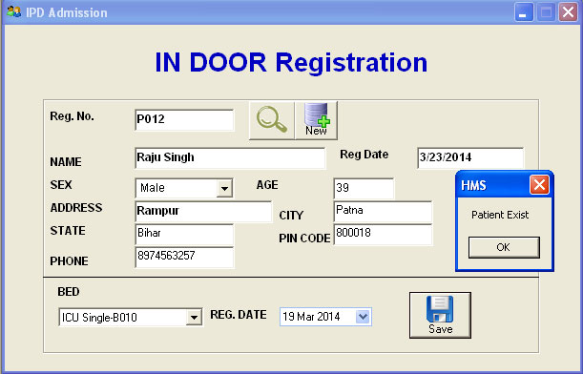

**Coding of frmIPDAdmisstion.frm:**

**Private Sub cmdNew_Click()**

**frmPatientRegistration.Show**

**End Sub**

**Private Sub cmdSave_Click()**

**On Error GoTo ErrHandler**

**'On Error Resume Next**

**ConnectToDB**

**mobjCmd.CommandType = adCmdText**

**Dim query As String**

**Dim IPDNo As Integer**

**Dim strBEDID As Variant**

**Dim strBID As String**

**strBEDID = Split(cmbBed.Text, "-")**

**strBID = strBEDID(1)**

**'strBEDID = strBEDID(1)**

**query = "select * from ipd_registration where REGNO = '" & txtRegNo.Text & "' and isdischarge = 0"**

**mobjCmd.CommandText = query**

**Set mobjRst = mobjCmd.Execute**

**If Not mobjRst.EOF Then**

**MsgBox "Patient Exist", vbOKOnly**

**DisconnectFromDB**

**Exit Sub**

**End If**

**query = "select max(ipd_no) IPDNO from ipd_registration"**

**mobjCmd.CommandText = query**

**Set mobjRst = mobjCmd.Execute**

**If Not mobjRst.EOF Then**

**If mobjRst!IPDNo = Null Then**

**IPDNo = 0**

**Else**

**IPDNo = CInt(mobjRst!IPDNo)**

**End If**

**Else**

**IPDNo = 0**

**End If**

**IPDNo = IPDNo + 1**

**mobjCmd.CommandText = "insert into ipd_registration(ipd_no,regno,bed_no,admitdate, isdischarge) values(" & IPDNo & ",'" & txtRegNo.Text & "', '" & strBID & "', '" & GetFormatedDate(dpRegDate.DateSelected) & "', 0)"**

**mobjCmd.Execute**

**MsgBox "Saved", vbOKOnly**

**DisconnectFromDB**

**Call LoadWard**

**Exit Sub**

**ErrHandler:**

**MsgBox "Error #" & Err.Number & ": '" & Err.Description & "' from '" & Err.Source & "'"**

**End Sub**

**Private Sub cmdSearch_Click()**

**'On Error GoTo ErrHandler**

**On Error Resume Next**

**ConnectToDB**

**mobjCmd.CommandType = adCmdText**

**Dim query As String**

**Dim strRegDat As String**

**Dim strAge As String**

**query = "select * from patient_registration where REGNO = '" & txtRegNo.Text & "'"**

**mobjCmd.CommandText = query**

**Set mobjRst = mobjCmd.Execute**

**If mobjRst.EOF Then**

**MsgBox "Invalid Reg. No", vbOKOnly**

**cmdSave.Enabled = False**

**Else**

**cmdSave.Enabled = True**

**With mobjRst**

**Do Until .EOF**

**txtName.Text = !Name**

**txtAge.Text = DateDiff("yyyy", !AGE, Now)**

**cmbSex.Text = !SEX**

**txtAddress.Text = !STREET**

**txtcity.Text = !CITY**

**txtState.Text = !State**

**txtPinCode.Text = !PIN**

**txtPhone.Text = !PHONE**

**'claderRegDate.Value = !REG_DATE**

**txtRegDate.Text = !REG_DATE**

**.MoveNext**

**Loop**

**End With**

**End If**

**DisconnectFromDB**

**Exit Sub**

**ErrHandler:**

**'MsgBox "Error #" & Err.Number & ": '" & Err.Description & "' from '" & Err.Source & "'"**

**End Sub**

**Private Sub dpDischargeOn_DateChanged(ByVal FromDate As Date, ByVal ToDate As Date)**

**End Sub**

**Private Sub Form_Load()**

**cmdSave.Enabled = False**

**Call LoadWard**

**End Sub**

**Private Sub LoadWard()**

**'On Error GoTo ErrHandler**

**ConnectToDB**

**mobjCmd.CommandType = adCmdText**

**Dim query As String**

**Dim strRegDat As String**

**Dim strAge As String**

**'query = "select ward_name || ' ' || ward_type || '-' || bed_id WName from bed_record "**

**query = "select ward_name || ' ' || ward_type || '-' || bed_id WName from bed_record where bed_id not in (select bed_no from ipd_registration where isdischarge =0)"**

**'query = "select bed_no WName from ipd_registration where isdischarge ='0'"**

**mobjCmd.CommandText = query**

**Set mobjRst = mobjCmd.Execute**

**cmbBed.Clear**

**With mobjRst**

**Do Until .EOF**

**cmbBed.AddItem (!WName)**

**.MoveNext**

**Loop**

**End With**

**DisconnectFromDB**

**Exit Sub**

**End Sub**

**Private Sub txtRegNo_Change()**

**End Sub**

**Screen Shot: frmViewIPDRegistration:**

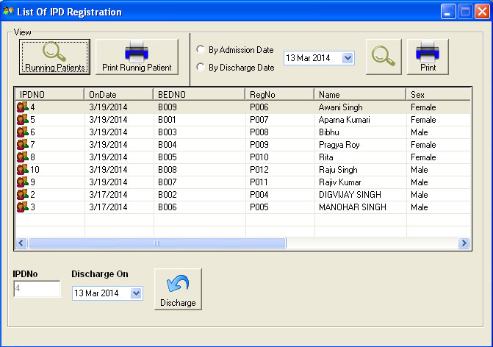

**Screen Shot :Running Patient in IPD**

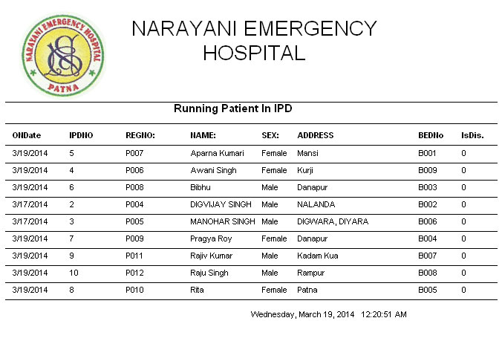

**Screen Shot: Report**

**Coding o**f **frmViewIPDRegistration:**

Option Explicit

Dim intSelection As Integer

Private Sub cmdCancel_Click()

If Not MsgBox("Are You Sure To Selected Patient Has Discharge?", vbYesNo) = vbYes Then

Exit Sub

End If

'On Error GoTo ErrHandler

On Error Resume Next

ConnectToDB

ClearCommandParameters

mobjCmd.CommandType = adCmdText

Dim query As String

'query = "UPDATE ipd_registration SET ISDISCHARGE = 1, DDATE = '" & GetFormatedDate(dpDischargeOn.DateSelected) & "' where IPDNO = " & txtIPDNO.Text & ""

query = "UPDATE ABCV SET ISDISCHARGE = 1, DDATE = '" & GetFormatedDate(dpDischargeOn.DateSelected) & "' where IPDNO = 1"

mobjCmd.CommandText = query

Set mobjRst = mobjCmd.Execute

DisconnectFromDB

MsgBox "Data Successfully Saved", vbOKOnly

Call LoadIPDLIST

End Sub

Private Sub cmdDischarge_Click()

If Not MsgBox("Are You Sure To Selected Patient Has Discharge?", vbYesNo) = vbYes Then

Exit Sub

End If

On Error GoTo ErrHandler

'On Error Resume Next

ConnectToDB

ClearCommandParameters

mobjCmd.CommandType = adCmdText

Dim query As String

query = "UPDATE ipd_registration SET ISDISCHARGE = 1, DISCHARGEDATE = '" & GetFormatedDate(dpDischargeOn.DateSelected) & "' where IPD_NO = " & txtIPDNO.Text & ""

'query = "UPDATE ABCV SET ISDISCHARGE = 1, DDATE = '" & GetFormatedDate(dpDischargeOn.DateSelected) & "' where IPDNO = 1"

mobjCmd.CommandText = query

Set mobjRst = mobjCmd.Execute

DisconnectFromDB

MsgBox "Data Successfully Saved", vbOKOnly

Call LoadIPDLIST

Exit Sub

ErrHandler:

MsgBox "Error # :" & Err.Description

End Sub

Private Sub cmdPrint_Click()

On Error GoTo ErrHandler

ConnectToDB

ClearCommandParameters

mobjCmd.CommandType = adCmdText

Dim query As String

If intSelection = 1 Then

query = "select * from view_ipd_registration where ONDATE = '" & GetFormatedDate(dpOnDate.DateSelected) & "' order by Name Asc"

DRIPDList.Sections("section4").Controls("lblHeader").Caption = "New Admited Patient List In IPD As On " & GetFormatedDate(dpOnDate.DateSelected)

ElseIf intSelection = 2 Then

query = "select * from view_ipd_registration where DDATE = '" & GetFormatedDate(dpOnDate.DateSelected) & "' order by Name Asc"

DRIPDList.Sections("section4").Controls("lblHeader").Caption = "Discharge Patient List From IPD As On " & GetFormatedDate(dpOnDate.DateSelected)

End If

mobjCmd.CommandText = query

Set mobjRst = mobjCmd.Execute

Set DRIPDList.DataSource = mobjRst

DRIPDList.Show

Exit Sub

ErrHandler:

MsgBox "Error #" & Err.Number & ": '" & Err.Description & "' from '" & Err.Source & "'"

End Sub

Private Sub cmdRunningPatient_Click()

intSelection = 0

cmdDischarge.Enabled = True

Call LoadIPDLIST

End Sub

Private Sub cmdRunningPatientPrint_Click()

On Error GoTo ErrHandler

ConnectToDB

ClearCommandParameters

mobjCmd.CommandType = adCmdText

Dim query As String

query = "select * from view_IPD_registration where ISDISCHARGE = 0 order by Name"

mobjCmd.CommandText = query

Set mobjRst = mobjCmd.Execute

Set DRIPDList.DataSource = mobjRst

DRIPDList.Sections("section4").Controls("lblHeader").Caption = "Running Patient In IPD"

DRIPDList.Show

Exit Sub

ErrHandler:

MsgBox "Error #" & Err.Number & ": '" & Err.Description & "' from '" & Err.Source & "'"

End Sub

Private Sub cmdSearch_Click()

Call LoadIPDLIST

End Sub

Private Sub cmdUpdate_Click()

End Sub

Private Sub Form_Load()

Call SetupGrid

End Sub

'-----------------------------------------------------------------------------

Private Sub SetupGrid()

'-----------------------------------------------------------------------------

With lvwBedMaster

.ColumnHeaders.Clear

.ColumnHeaders.Add , , "IPDNO", .Width * 0.15

.ColumnHeaders.Add , , "OnDate", .Width * 0.15

.ColumnHeaders.Add , , "BEDNO", .Width * 0.2

.ColumnHeaders.Add , , "RegNo", .Width * 0.15

.ColumnHeaders.Add , , "Name", .Width * 0.2

.ColumnHeaders.Add , , "Sex", .Width * 0.2

.ColumnHeaders.Add , , "Address", .Width * 0.2

.ColumnHeaders.Add , , "Phone", .Width * 0.2

.ColumnHeaders.Add , , "ISDISCHARGE", .Width * 0.2

End With

End Sub

'-----------------------------------------------------------------------------

Private Sub LoadIPDLIST()

'-----------------------------------------------------------------------------

On Error GoTo ErrHandler

Dim objCurrLI As ListItem

lvwBedMaster.ListItems.Clear

ConnectToDB

ClearCommandParameters

mobjCmd.CommandType = adCmdText

Dim query As String

If intSelection = 0 Then

query = "select * from view_ipd_registration where ISDISCHARGE = 0 order by ONDATE desc "

ElseIf intSelection = 1 Then

query = "select * from view_ipd_registration where ONDATE = '" & GetFormatedDate(dpOnDate.DateSelected) & "' order by Name Asc"

ElseIf intSelection = 2 Then

query = "select * from view_ipd_registration where DDATE = '" & GetFormatedDate(dpOnDate.DateSelected) & "' order by Name Asc"

End If

mobjCmd.CommandText = query

Set mobjRst = mobjCmd.Execute

With mobjRst

Do Until .EOF

Set objCurrLI = lvwBedMaster.ListItems.Add(, , !IPDNo & "", , "Custs")

objCurrLI.SubItems(1) = !ONDATE & ""

objCurrLI.SubItems(2) = !BEDNO & ""

objCurrLI.SubItems(3) = !REGNO & ""

objCurrLI.SubItems(4) = !Name & ""

objCurrLI.SubItems(5) = !SEX & ""

objCurrLI.SubItems(6) = !STREET & ""

objCurrLI.SubItems(7) = !PHONE & ""

objCurrLI.SubItems(8) = !ISDISCHARGE & ""

.MoveNext

Loop

End With

With lvwBedMaster

If .ListItems.Count > 0 Then

Set .SelectedItem = .ListItems(1)

lvwBedMaster_ItemClick .SelectedItem

End If

End With

Set objCurrLI = Nothing

Set mobjRst = Nothing

DisconnectFromDB

Exit Sub

ErrHandler:

MsgBox "Error #" & Err.Number & ": '" & Err.Description & "' from '" & Err.Source & "'"

End Sub

Private Sub lvwBedMaster_ItemClick(ByVal Item As MSComctlLib.ListItem)

With Item

txtIPDNO.Text = .Text

End With

End Sub

Private Sub rbAdmission_Click()

intSelection = 1

cmdDischarge.Enabled = False

End Sub

Private Sub rbByDischage_Click()

intSelection = 2

cmdDischarge.Enabled = False

End Sub

**Screen Shot:frmIPDServiceusedbyPatient.frm:**

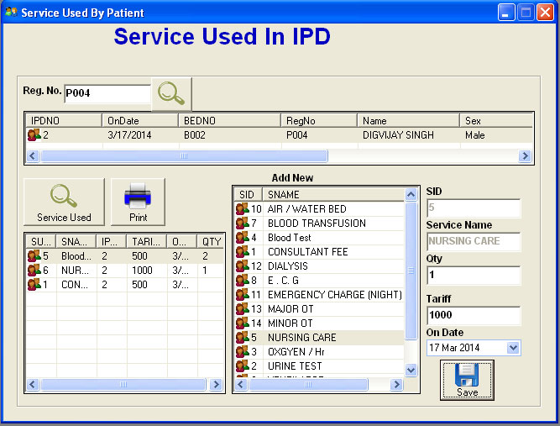

**Screen Shot :Report of IPD List**



**Coding of** **Screen Shot:frmIPDServiceusedbyPatient.frm:**

Option Explicit

Dim listSelectedPatient As ListItem

Private Sub cmdLoadServiceUsed_Click()

Call LoadServiceUsed

End Sub

Private Sub cmdPrint_Click()

If txtIPDNO.Text = "" Then

MsgBox "Please select patient ", vbOKOnly

Exit Sub

End If

On Error GoTo ErrHandler

ConnectToDB

ClearCommandParameters

mobjCmd.CommandType = adCmdText

Dim query As String

query = "select * from VIEW_IPD_SERVICEUSED where IPD_NO = " & txtIPDNO.Text

mobjCmd.CommandText = query

Set mobjRst = mobjCmd.Execute

Set DRIPDSERVICEUSED.DataSource = mobjRst

DRIPDSERVICEUSED.Sections("section4").Controls("lblHeader").Caption = "Service Used By " & listSelectedPatient.SubItems(4) & ", BED NO : " & listSelectedPatient.SubItems(2)

DRIPDSERVICEUSED.Show

Exit Sub

Exit Sub

ErrHandler:

MsgBox "Error #" & Err.Number & ": '" & Err.Description & "' from '" & Err.Source & "'"

End Sub

Private Sub cmdSave_Click()

If txtIPDNO.Text = "" Or txtSID.Text = "" Or txtQty.Text = "" Then

MsgBox "Please select properly patient Service and Qty", vbOKOnly

Exit Sub

End If

Dim objCurrLI As ListItem

On Error GoTo ErrHandler

ConnectToDB

ClearCommandParameters

mobjCmd.CommandType = adCmdText

Dim query As String

query = "select max(SUID) SUID from IPD_SERVICEUSED"

mobjCmd.CommandText = query

Set mobjRst = mobjCmd.Execute

Dim intSUID As Integer

If Not mobjRst.EOF Then

If IsNull(mobjRst!SUID) = True Then

intSUID = 0

Else

intSUID = CInt(mobjRst!SUID)

End If

Else

intSUID = 0

End If

intSUID = intSUID + 1

query = "insert into IPD_SERVICEUSED ( SUID, IPD_NO, SID, TARIFF, ONDATE, QTY) values(" & intSUID & ", " & txtIPDNO.Text & "," & txtSID.Text & ", " & CDbl(txtTariff.Text) & ", '" & GetFormatedDate(dpOnDate.DateSelected) & "'," & CDbl(txtQty.Text) & ")"

mobjCmd.CommandText = query

Set mobjRst = mobjCmd.Execute

DisconnectFromDB

Call LoadServiceUsed

Exit Sub

ErrHandler:

MsgBox "Error #" & Err.Number & ": '" & Err.Description & "' from '" & Err.Source & "'"

End Sub

Private Sub cmdSearch_Click()

Call LoadIPDLIST

End Sub

Private Sub Form_Load()

Call SetupGrid

Call SetupServiceUserGrid

Call SetupServiceMasterGrid

Call LoadServiceMaster

End Sub

'-----------------------------------------------------------------------------

Private Sub SetupGrid()

'-----------------------------------------------------------------------------

With lvwBedMaster

.ColumnHeaders.Clear

.ColumnHeaders.Add , , "IPDNO", .Width * 0.15

.ColumnHeaders.Add , , "OnDate", .Width * 0.15

.ColumnHeaders.Add , , "BEDNO", .Width * 0.2

.ColumnHeaders.Add , , "RegNo", .Width * 0.15

.ColumnHeaders.Add , , "Name", .Width * 0.2

.ColumnHeaders.Add , , "Sex", .Width * 0.2

.ColumnHeaders.Add , , "Address", .Width * 0.2

.ColumnHeaders.Add , , "Phone", .Width * 0.2

.ColumnHeaders.Add , , "ISDISCHARGE", .Width * 0.2

End With

End Sub

'-----------------------------------------------------------------------------

Private Sub LoadIPDLIST()

'-----------------------------------------------------------------------------

On Error GoTo ErrHandler

txtIPDNO.Text = ""

Dim objCurrLI As ListItem

lvwBedMaster.ListItems.Clear

ConnectToDB

ClearCommandParameters

mobjCmd.CommandType = adCmdText

Dim query As String

query = "select * from view_ipd_registration where REGNO = '" & txtRegNo.Text & "' and ISDISCHARGE = 0 "

mobjCmd.CommandText = query

Set mobjRst = mobjCmd.Execute

With mobjRst

Do Until .EOF

Set objCurrLI = lvwBedMaster.ListItems.Add(, , !IPDNo & "", , "Custs")

objCurrLI.SubItems(1) = !ONDATE & ""

objCurrLI.SubItems(2) = !BEDNO & ""

objCurrLI.SubItems(3) = !REGNO & ""

objCurrLI.SubItems(4) = !Name & ""

objCurrLI.SubItems(5) = !SEX & ""

objCurrLI.SubItems(6) = !STREET & ""

objCurrLI.SubItems(7) = !PHONE & ""

objCurrLI.SubItems(8) = !ISDISCHARGE & ""

.MoveNext

Loop

End With

With lvwBedMaster

If .ListItems.Count > 0 Then

Set .SelectedItem = .ListItems(1)

lvwBedMaster_ItemClick .SelectedItem

End If

End With

Set objCurrLI = Nothing

Set mobjRst = Nothing

DisconnectFromDB

Exit Sub

ErrHandler:

MsgBox "Error #" & Err.Number & ": '" & Err.Description & "' from '" & Err.Source & "'"

End Sub

Private Sub lvwBedMaster_ItemClick(ByVal Item As MSComctlLib.ListItem)

Set listSelectedPatient = Item

With Item

txtIPDNO.Text = .Text

End With

End Sub

'-----------------------------------------------------------------------------

Private Sub SetupServiceUserGrid()

'-----------------------------------------------------------------------------

With lvServiceUsede

.ColumnHeaders.Clear

.ColumnHeaders.Add , , "SUID", .Width * 0.15

.ColumnHeaders.Add , , "SNAME", .Width * 0.2

.ColumnHeaders.Add , , "IPDNO", .Width * 0.15

.ColumnHeaders.Add , , "TARIFF", .Width * 0.2

.ColumnHeaders.Add , , "ONDATE", .Width * 0.15

.ColumnHeaders.Add , , "QTY", .Width * 0.15

End With

End Sub

Private Sub txtIPDNO_Change()

'Call LoadServiceUsed

End Sub

Private Sub LoadServiceUsed()

On Error GoTo ErrHandler

Dim objCurrLI As ListItem

lvServiceUsede.ListItems.Clear

ConnectToDB

ClearCommandParameters

mobjCmd.CommandType = adCmdText

Dim query As String

query = "select * from VIEW_IPD_SERVICEUSED where IPD_NO = " & txtIPDNO.Text

mobjCmd.CommandText = query

Set mobjRst = mobjCmd.Execute

With mobjRst

Do Until .EOF

Set objCurrLI = lvServiceUsede.ListItems.Add(, , !SUID & "", , "Custs")

objCurrLI.SubItems(1) = !SNAME & ""

objCurrLI.SubItems(2) = !IPD_NO & ""

objCurrLI.SubItems(3) = !TARIFF & ""

objCurrLI.SubItems(4) = !ONDATE & ""

objCurrLI.SubItems(5) = !QTY & ""

.MoveNext

Loop

End With

Set objCurrLI = Nothing

Set mobjRst = Nothing

DisconnectFromDB

Exit Sub

ErrHandler:

MsgBox "Error #" & Err.Number & ": '" & Err.Description & "' from '" & Err.Source & "'"

End Sub

'-----------------------------------------------------------------------------

Private Sub SetupServiceMasterGrid()

'-----------------------------------------------------------------------------

With lvServiceName

.ColumnHeaders.Clear

.ColumnHeaders.Add , , "SID", .Width * 0.15

.ColumnHeaders.Add , , "SNAME", .Width * 0.2

.ColumnHeaders.Add , , "TARIFF", .Width * 0.15

End With

End Sub

Private Sub LoadServiceMaster()

On Error GoTo ErrHandler

Dim objCurrLI As ListItem

lvServiceName.ListItems.Clear

ConnectToDB

ClearCommandParameters

mobjCmd.CommandType = adCmdText

Dim query As String

query = "select * from SERVICEMASTER order by sName"

mobjCmd.CommandText = query

Set mobjRst = mobjCmd.Execute

With mobjRst

Do Until .EOF

Set objCurrLI = lvServiceName.ListItems.Add(, , !SID & "", , "Custs")

objCurrLI.SubItems(1) = !SNAME & ""

objCurrLI.SubItems(2) = !TARIFF & ""

.MoveNext

Loop

End With

With lvServiceName

If .ListItems.Count > 0 Then

Set .SelectedItem = .ListItems(1)

lvServiceName_ItemClick .SelectedItem

End If

End With

Set objCurrLI = Nothing

Set mobjRst = Nothing

DisconnectFromDB

Exit Sub

ErrHandler:

MsgBox "Error #" & Err.Number & ": '" & Err.Description & "' from '" & Err.Source & "'"

End Sub

Private Sub lvServiceName_ItemClick(ByVal Item As MSComctlLib.ListItem)

With Item

txtSID.Text = .Text

txtServiceName.Text = .SubItems(1)

txtTariff.Text = .SubItems(2)

End With

End Sub

**Screen Shot:frmIPDBillPayment:**

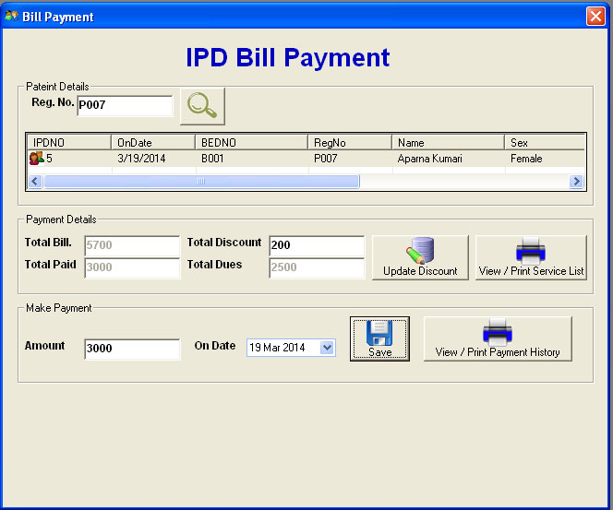

**Coding o**f **frmIPDBillPayment:**

Option Explicit

Dim listSelectedPatient As ListItem

Private Sub cmdPaymentHistoryPrint_Click()

If txtIPDNO.Text = "" Then

MsgBox "Please select patient ", vbOKOnly

Exit Sub

End If

On Error GoTo ErrHandler

ConnectToDB

ClearCommandParameters

mobjCmd.CommandType = adCmdText

Dim query As String

query = "select * from IPD_PAYMENTHISTORY where IPD_NO = " & txtIPDNO.Text

mobjCmd.CommandText = query

Set mobjRst = mobjCmd.Execute

Set DRIPDPAYMENTHISTORY.DataSource = mobjRst

DRIPDPAYMENTHISTORY.Sections("section4").Controls("lblHeader").Caption = "Paid By " & listSelectedPatient.SubItems(4) & ", BED NO : " & listSelectedPatient.SubItems(2) & " For IPD No: " & txtIPDNO.Text

DRIPDPAYMENTHISTORY.Show

Exit Sub

Exit Sub

ErrHandler:

MsgBox "Error #" & Err.Number & ": '" & Err.Description & "' from '" & Err.Source & "'"

End Sub

Private Sub cmdPrint_Click()

If txtIPDNO.Text = "" Then

MsgBox "Please select patient ", vbOKOnly

Exit Sub

End If

On Error GoTo ErrHandler

ConnectToDB

ClearCommandParameters

mobjCmd.CommandType = adCmdText

Dim query As String

query = "select * from VIEW_IPD_SERVICEUSED where IPD_NO = " & txtIPDNO.Text

mobjCmd.CommandText = query

Set mobjRst = mobjCmd.Execute

Set DRIPDSERVICEUSED.DataSource = mobjRst

DRIPDSERVICEUSED.Sections("section4").Controls("lblHeader").Caption = "Service Used By " & listSelectedPatient.SubItems(4) & ", BED NO : " & listSelectedPatient.SubItems(2)

DRIPDSERVICEUSED.Show

Exit Sub

Exit Sub

ErrHandler:

MsgBox "Error #" & Err.Number & ": '" & Err.Description & "' from '" & Err.Source & "'"

End Sub

Private Sub cmdSave_Click()

If txtIPDNO.Text = "" Or txtToPaidAMount.Text = "" Then

MsgBox "Please select patient first and enter to paid amount", vbOKOnly

Exit Sub

End If

On Error GoTo ErrHandler

ConnectToDB

ClearCommandParameters

mobjCmd.CommandType = adCmdText

Dim query As String

query = "select max(IPDPHID) IPDPHID from IPD_PAYMENTHISTORY"

mobjCmd.CommandText = query

Set mobjRst = mobjCmd.Execute

Dim intIPDPHID As Integer

If Not mobjRst.EOF Then

If IsNull(mobjRst!IPDPHID) = True Then

intIPDPHID = 0

Else

intIPDPHID = CInt(mobjRst!IPDPHID)

End If

Else

intIPDPHID = 0

End If

intIPDPHID = intIPDPHID + 1

query = "insert into IPD_PAYMENTHISTORY (IPDPHID, IPD_NO, ONDATE, PAID) values (" & intIPDPHID & ", " & txtIPDNO.Text & ", '" & GetFormatedDate(dpOnDate.DateSelected) & "', " & CDbl(txtToPaidAMount.Text) & ")"

mobjCmd.CommandText = query

mobjCmd.Execute

'Account history

query = "select max(PAID) PAID from PATIENT_ACCOUNT"

mobjCmd.CommandText = query

Set mobjRst = mobjCmd.Execute

Dim intPAID As Integer

If Not mobjRst.EOF Then

If IsNull(mobjRst!PAID) = True Then

intPAID = 0

Else

intPAID = CInt(mobjRst!PAID)

End If

Else

intPAID = 0

End If

intPAID = intPAID + 1

query = "insert into PATIENT_ACCOUNT (PAID, REGNO, ONDATE, NARRATIONS, CREDIT) values (" & intPAID & ", '" & listSelectedPatient.SubItems(3) & "', '" & GetFormatedDate(dpOnDate.DateSelected) & "', 'Paid For IPD No : " & txtIPDNO.Text & "', " & CDbl(txtToPaidAMount.Text) & ")"

mobjCmd.CommandText = query

mobjCmd.Execute

Set mobjRst = Nothing

DisconnectFromDB

Call LoadPaymentDetails

Exit Sub

ErrHandler:

MsgBox "Error #" & Err.Number & ": '" & Err.Description & "' from '" & Err.Source & "'"

End Sub

Private Sub cmdSearch_Click()

Call LoadIPDLIST

End Sub

'-----------------------------------------------------------------------------

Private Sub LoadIPDLIST()

'-----------------------------------------------------------------------------

On Error GoTo ErrHandler

txtIPDNO.Text = ""

Dim objCurrLI As ListItem

lvwBedMaster.ListItems.Clear

ConnectToDB

ClearCommandParameters

mobjCmd.CommandType = adCmdText

Dim query As String

query = "select * from view_ipd_registration where REGNO = '" & txtRegNo.Text & "' and ISDISCHARGE = 0 "

mobjCmd.CommandText = query

Set mobjRst = mobjCmd.Execute

With mobjRst

Do Until .EOF

Set objCurrLI = lvwBedMaster.ListItems.Add(, , !IPDNo & "", , "Custs")

objCurrLI.SubItems(1) = !ONDATE & ""

objCurrLI.SubItems(2) = !BEDNO & ""

objCurrLI.SubItems(3) = !REGNO & ""

objCurrLI.SubItems(4) = !Name & ""

objCurrLI.SubItems(5) = !SEX & ""

objCurrLI.SubItems(6) = !STREET & ""

objCurrLI.SubItems(7) = !PHONE & ""

objCurrLI.SubItems(8) = !ISDISCHARGE & ""

.MoveNext

Loop

End With

Set objCurrLI = Nothing

Set mobjRst = Nothing

DisconnectFromDB

With lvwBedMaster

If .ListItems.Count > 0 Then

Set .SelectedItem = .ListItems(1)

lvwBedMaster_ItemClick .SelectedItem

End If

End With

Exit Sub

ErrHandler:

MsgBox "Error #" & Err.Number & ": '" & Err.Description & "' from '" & Err.Source & "'"

End Sub

Private Sub cmdUpdateDiscount_Click()

If txtIPDNO.Text = "" Then

MsgBox "Please select Patient", vbOKOnly

Exit Sub

End If

On Error GoTo ErrHandler

ConnectToDB

ClearCommandParameters

mobjCmd.CommandType = adCmdText

Dim query As String

query = "update ipd_registration set DISCOUNT = " & txtDiscount.Text & " where IPD_NO = " & txtIPDNO.Text

mobjCmd.CommandText = query

mobjCmd.Execute

Set mobjRst = Nothing

DisconnectFromDB

Call LoadPaymentDetails

Exit Sub

ErrHandler:

MsgBox "Error #" & Err.Number & ": '" & Err.Description & "' from '" & Err.Source & "'"

End Sub

Private Sub Form_Load()

Call SetupGrid

End Sub

'-----------------------------------------------------------------------------

Private Sub SetupGrid()

'-----------------------------------------------------------------------------

With lvwBedMaster

.ColumnHeaders.Clear

.ColumnHeaders.Add , , "IPDNO", .Width * 0.15

.ColumnHeaders.Add , , "OnDate", .Width * 0.15

.ColumnHeaders.Add , , "BEDNO", .Width * 0.2

.ColumnHeaders.Add , , "RegNo", .Width * 0.15

.ColumnHeaders.Add , , "Name", .Width * 0.2

.ColumnHeaders.Add , , "Sex", .Width * 0.2

.ColumnHeaders.Add , , "Address", .Width * 0.2

.ColumnHeaders.Add , , "Phone", .Width * 0.2

.ColumnHeaders.Add , , "ISDISCHARGE", .Width * 0.2

End With

End Sub

Private Sub lvwBedMaster_ItemClick(ByVal Item As MSComctlLib.ListItem)

Set listSelectedPatient = Item

With Item

txtIPDNO.Text = .Text

End With

Call LoadPaymentDetails

End Sub

Private Sub LoadPaymentDetails()

On Error GoTo ErrHandler

ConnectToDB

ClearCommandParameters

mobjCmd.CommandType = adCmdText

Dim query As String

query = "update ipd_registration set TOTALBILL = (select sum(TARIFF * QTY ) from IPD_SERVICEUSED where IPD_NO = " & txtIPDNO.Text & " ) where IPD_NO = " & txtIPDNO.Text

mobjCmd.CommandText = query

mobjCmd.Execute

query = "select * from view_ipd_registration where REGNO = '" & txtRegNo.Text & "'"

mobjCmd.CommandText = query

Set mobjRst = mobjCmd.Execute

With mobjRst

Do Until .EOF

txtTotalBill.Text = !TOTALBILL

txtDiscount.Text = !DISCOUNT

If IsNull(!TOTALPAID) = True Then

txtTotalPaid.Text = "0"

Else

txtTotalPaid.Text = !TOTALPAID

End If

.MoveNext

Loop

End With

Set mobjRst = Nothing

DisconnectFromDB

txtTotalDues.Text = CDbl(txtTotalBill.Text) - (CDbl(txtDiscount.Text) + CDbl(txtTotalPaid.Text))

Exit Sub

ErrHandler:

MsgBox "Error #" & Err.Number & ": '" & Err.Description & "' from '" & Err.Source & "'"

End Sub

**Screen Shot:frmDaillycollctionReport.frm:**

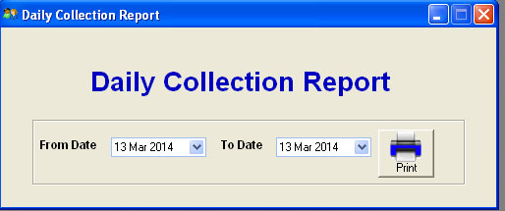

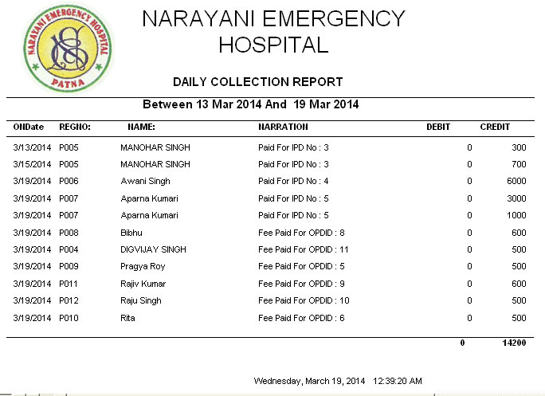

**Coding of frmDaillycollctionReport.frm:**

Private Sub cmdPaymentHistoryPrint_Click()

On Error GoTo ErrHandler

Dim dblTotalCR As Double

Dim dblTotalDR As Double

ConnectToDB

ClearCommandParameters

mobjCmd.CommandType = adCmdText

Dim query As String

query = "select * from VIEW_PATIENT_ACCOUNT where ONDATE >= '" & GetFormatedDate(dpFromDate.DateSelected) & "' and ONDATE <= '" & GetFormatedDate(dpToDate.DateSelected) & "'"

mobjCmd.CommandText = query

Set mobjRst = mobjCmd.Execute

With mobjRst

Do Until .EOF

dblTotalCR = dblTotalCR + CDbl(!CREDIT)

dblTotalDR = dblTotalDR + CDbl(!DEBIT)

.MoveNext

Loop

End With

Set DRDailyCollectionReport.DataSource = mobjRst

DRDailyCollectionReport.Sections("section4").Controls("lblHeader").Caption = "Between " & GetFormatedDate(dpFromDate.DateSelected) & " And " & GetFormatedDate(dpToDate.DateSelected)

DRDailyCollectionReport.Sections("section5").Controls("lblTotalDR").Caption = dblTotalDR

DRDailyCollectionReport.Sections("section5").Controls("lblToalCR").Caption = dblTotalCR

DRDailyCollectionReport.Show

Exit Sub

Exit Sub

ErrHandler:

MsgBox "Error #" & Err.Number & ": '" & Err.Description & "' from '" & Err.Source & "'"

End Sub

Private Sub Frame1_DragDrop(Source As Control, X As Single, Y As Single)

End Sub

